**MINI PROJECT**

**AIM:**

To protect the data during file sharing and messaging through a Wi-Fi Network.

**ALGORITHM:**

1. Start.
2. Implement a server program which will send the message and read the message.
3. Take number of valid clients with whom we have to share the message.
4. Take the ID’s of each Client.
5. Fake the data which you want to send to unknown clients.
6. Start the Server Socket and start accepting the client if the ID matches send the message or else the fake data.
7. Start Clients for those which is matched with ID in server will get the message otherwise the fake data.
8. Stop.

**PROGRAM:**

**Server:**

import java.net.*;

import java.io.*;

class Server

{

public static void main(String args[])throws Exception

{

try

{

Console in = System.console();

ServerSocket ss = new ServerSocket(3210);

Socket con = null;

int[] id = new int[1000];

System.out.print("Server is ready\n Enter message:");

String msg = in.readLine();

String fake = null;

for(int k = 0;k < msg.length();k++)

{

fake = fake + "*";

}

System.out.print("Enter number of clients:");

int n = Integer.parseInt(in.readLine());

System.out.print("Enter IDs of clients:");

for(int i = 0;i < n;i++)

{

id[i] = Integer.parseInt(in.readLine());

}

int j = 0;

for(int k = 0;k < 100;k++)

{

int flag = 0;

for(int l = 0;l < n;l++)

{

if((k+1) == id[l])

{

flag = 1;

}

}

con = ss.accept();

PrintWriter out = new PrintWriter(new OutputStreamWriter(con.getOutputStream()));

if(flag == 1)

{

out.println(msg);

}

else

{

out.println(fake);

}

out.close();

}

ss.close();

con.close();

}

catch(Exception e)

{

System.out.println("Error "+e);

}

}

}

**Client:**

import java.io.*;

import java.net.*;

class Client

{

public static void main(String[] args)throws Exception

{

Socket c = new Socket(InetAddress.getLocalHost(),3210);

BufferedReader br = new BufferedReader(new InputStreamReader(c.getInputStream()));

System.out.println("Message:"+br.readLine());

c.close();

br.close();

}

}

**OUTPUT:**

**Server:**

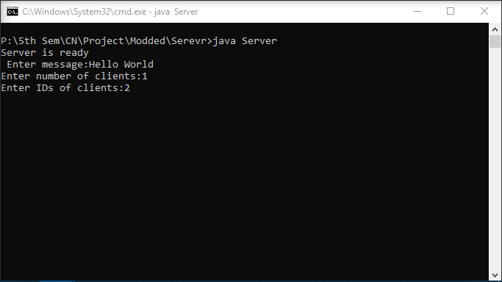

**Client 1:**

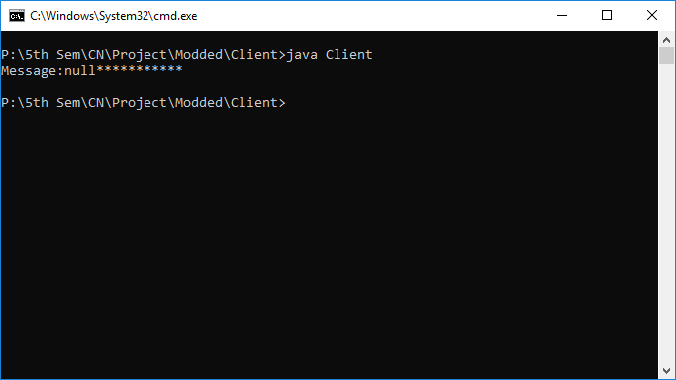

**Client 2:**

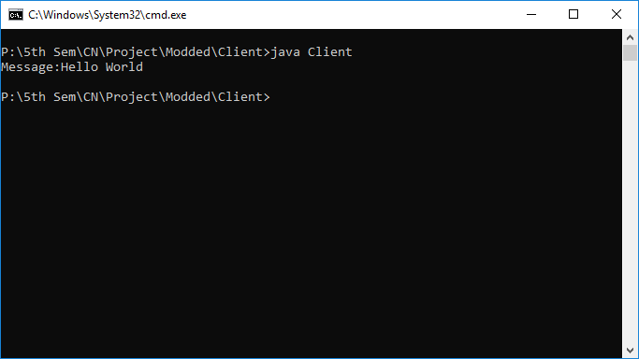

**Client 3:**

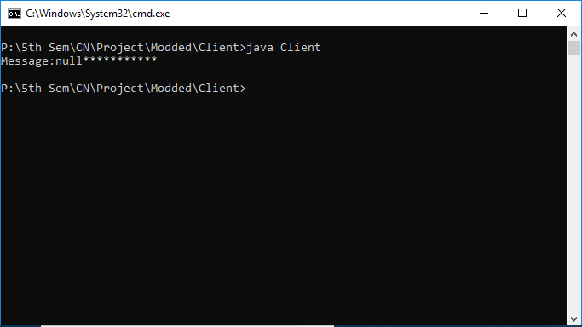

**RESULT:**

Thus the project is implemented successfully and output is verified.