Diagnostic Analysis Report: McDonald's
Prepared by: Gangothri M C
Batch / Team: PTID-CDA-SEP-26-11268
Date: 14-10-2026
Course project CDACL-004 Fast Food Analysis
Company analysed: McDonald's
Project GitHub Link - https://github.com/Gangothri521/Fast_Food_Analysis_project.git

1. Introduction
This project analyses the nutritional profile of menu items in a fast-food dataset covering eight restaurant chains, with McDonald's selected as the focus company. The objective extends beyond describing the figures (descriptive analysis) to explaining why they appear as they do (diagnostic analysis) and to providing evidence-based recommendations.

2. Dataset Description
- Source: a fast-food nutrition table in MySQL containing 512 records across 8 restaurants.
- Columns used: restaurant, item, calories, cal_fat, total_fat, sat_fat, trans_fat, cholesterol, sodium, total_carb, fiber, sugar, protein, vit_a, vit_c and calcium.
- McDonald's subset: 57 menu items.
- Measures: calories, fats, cholesterol, sodium, carbohydrates, fiber, sugar and protein per item; vitamins and calcium are expressed as percentages of the daily value.

Limitations
- No price column is available, so the "average price" analysis specified in the project brief could not be performed; nutrition measures were used instead.
- Vitamin A, vitamin C, calcium and fiber contain missing values for some restaurants (McDonald's vitamin values are complete).
- The original salad column contains the value "Other" for every record and was therefore not usable.
- The dataset contains no portion weights or sales figures, so actual customer purchasing behaviour cannot be determined.
- The results indicate relationships (correlation) and do not establish causation.

3. Data Cleaning
- Removed the columns satish (completely empty), age (all zeros) and salad (no information).
- Removed 1 duplicate Taco Bell record (512 to 511 rows overall).
- Replaced the text value "NA" with null in fiber, protein, vit_a, vit_c and calcium, and converted these columns to numeric types. Blank values were retained as blanks rather than replaced with 0.
- Standardised restaurant names (for example, Mcdonalds to McDonald's).
- Created derived columns: Calorie Category (Low: under 300; Medium: 300 to 600; High: over 600), Is Salad (derived from the item name) and Protein per 100 Cal.

4. Dashboard Overview
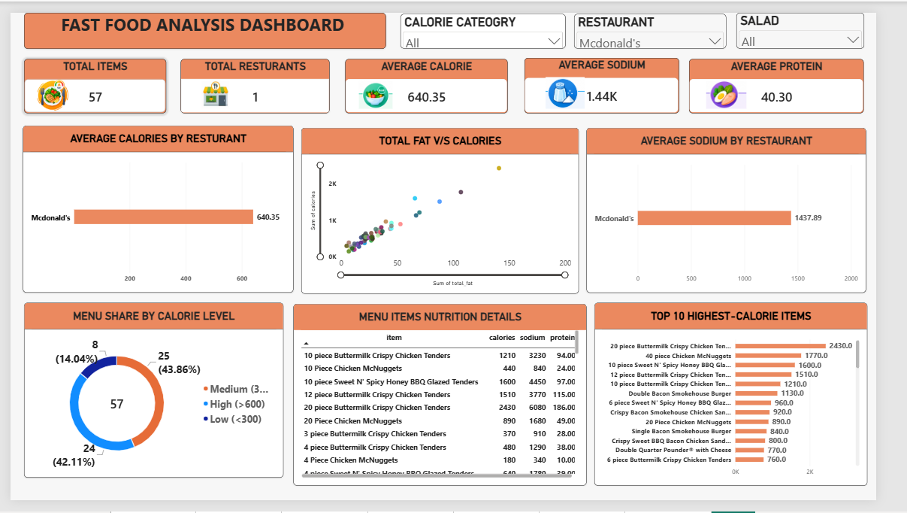

The interactive dashboard consolidates the analysis on a single page. It contains five KPI cards (Total Items, Total Restaurants, Average Calorie, Average Sodium and Average Protein) and three slicers (Calorie Category, Restaurant and Salad). Selecting a slicer value cross-filters every visual simultaneously; in the view shown, the Restaurant slicer is set to McDonald's. The dashboard comprises the following visuals:
- Average Calories by Restaurant (bar chart): compares the mean calories per item across restaurants; with the McDonald's filter applied, it shows a single bar at 640.35.
- Total Fat vs Calories (scatter plot): plots each menu item by total fat (x-axis) and calories (y-axis), revealing the relationship between fat content and energy and highlighting outliers.
- Menu Share by Calorie Level (donut chart): shows the distribution of items across the Low, Medium and High calorie categories, with the total of 57 items displayed at the centre.
- Average Sodium by Restaurant (bar chart): compares the mean sodium per item across restaurants; the McDonald's bar shows 1,437.89 mg.
- Top 10 Highest-Calorie Items (horizontal bar chart): ranks the most energy-dense items, led by the 20-piece Buttermilk Crispy Chicken Tenders at 2,430 calories.
- Menu Item Nutrition Details (table): lists calories, sodium and protein for every item, allowing item-level verification of the aggregate figures.
McDonald's headline figures: 57 items, with an average of 640.35 calories, 1,437.89 mg sodium and 40.30 g protein per item. Across all chains, the corresponding averages are approximately 531 calories, 1,247 mg sodium and 28 g protein, indicating that McDonald's items are heavier and saltier but also considerably higher in protein.

5. Key Findings and Diagnosis
Each finding follows a consistent structure: the supporting chart, the evidence, the underlying reason and the practical implication.

Finding 1: A few very large items produce the extreme calorie values

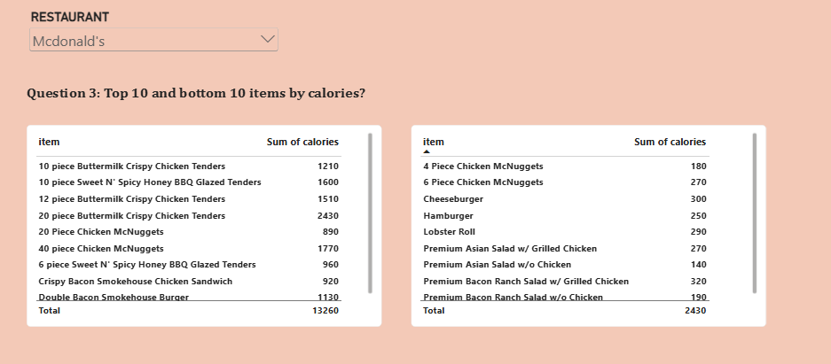

- Chart reading: the visual presents two side-by-side tables for the McDonald's selection, ranking items by calories. The left table lists the highest-calorie items (for example, the 20-piece Buttermilk Crispy Chicken Tenders at 2,430), while the right table lists the lightest items (for example, the Premium Asian Salad without chicken at 140, the 4-piece Chicken McNuggets at 180 and the Premium Bacon Ranch Salad without chicken at 190). Read together, the tables show the full spread of the menu at a glance.
- Evidence: calories range from 140 to 2,430. The highest-calorie items are the 20-piece Buttermilk Crispy Chicken Tenders (2,430), 40-piece Chicken McNuggets (1,770), 10-piece Sweet N' Spicy Honey BBQ Glazed Tenders (1,600), 12-piece Buttermilk Crispy Chicken Tenders (1,510) and 10-piece Buttermilk Crispy Chicken Tenders (1,210).
- Why: these are multi-piece sharing portions recorded as a single item, and they are breaded and fried. Five of the top ten items are chicken products sold in large counts.
- Meaning: sharing items pull the average upward. A customer ordering a single-serve item, such as a Hamburger (250 calories) or a Cheeseburger (300 calories), consumes far fewer calories.

Finding 2: Sodium is very high, especially in fried chicken items

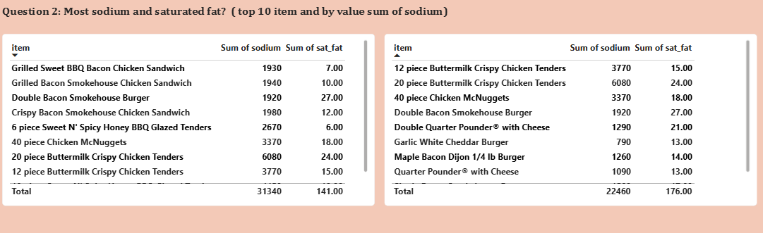
- Chart reading: two tables display total sodium (mg) and saturated fat (g) for each item, so both measures can be compared along the same row. The 20-piece Buttermilk Crispy Chicken Tenders stand out in both, at 6,080 mg of sodium and 24 g of saturated fat, while the Double Bacon Smokehouse Burger records 1,920 mg of sodium and 27 g of saturated fat.
- Evidence: the highest-sodium item is again the 20-piece tenders at 6,080 mg, followed by the 10-piece Sweet N' Spicy Honey BBQ Glazed Tenders (4,450 mg) and the 12-piece Buttermilk Crispy Chicken Tenders (3,770 mg). Six items exceed 2,300 mg (the commonly cited daily limit) and 19 items exceed 1,500 mg.
- Why: breading, seasoned coatings, sauces, cheese and processed meats all contribute salt, and larger portions multiply the effect.
- Meaning: a single item can supply more than twice the recommended daily sodium intake.

Finding 3: Saturated fat is highest in burgers and large tender portions
- Chart reading: the saturated fat column in the tables shown under Finding 2 is used here. Reading across the rows, the highest saturated fat values (27 g for the Double Bacon Smokehouse Burger and 21 g for the Double Quarter Pounder with Cheese) do not always coincide with the highest sodium values, which confirms that the two measures should be assessed separately.
- Evidence: the items highest in saturated fat are the Double Bacon Smokehouse Burger (27 g), 20-piece Buttermilk Crispy Chicken Tenders (24 g), Double Quarter Pounder with Cheese (21 g), 40-piece Chicken McNuggets (18 g) and Single Bacon Smokehouse Burger (17 g).
- Why: double beef patties, bacon and cheese are all rich in saturated fat, which is why multi-layer burgers rank at the top even when their calories are lower than those of the 20-piece tenders.
- Meaning: an item can be a high-risk choice for saturated fat without being the highest in calories; sodium, saturated fat and calories should therefore be evaluated independently.

Finding 4: Salads are much lighter than other items

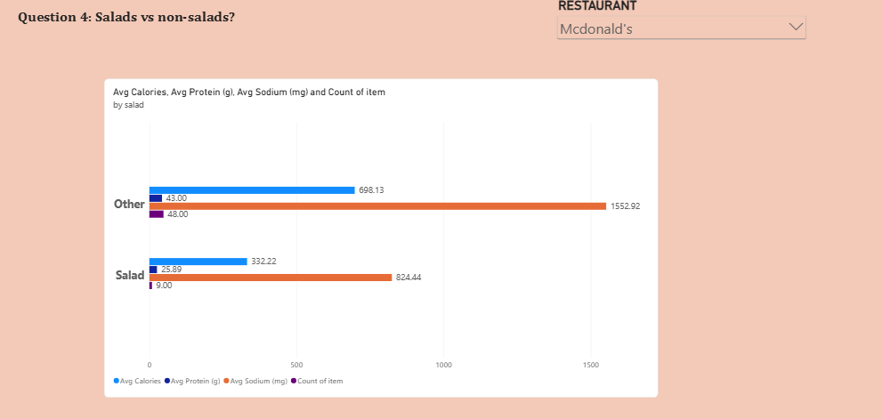
- Chart reading: the clustered horizontal bar chart compares the Salad and Other (non-salad) groups across four measures: average calories, average protein (g), average sodium (mg) and item count. The non-salad bars are roughly twice as long for calories and sodium, while the count bars show that the groups differ in size (48 items against 9). Because all four measures share a single axis, sodium dominates the scale, so values are best read from the data labels.
- Evidence: McDonald's has 9 salads and 48 non-salad items. Salads average 332 calories, 824 mg sodium and 26 g protein, whereas non-salad items average 698 calories, 1,553 mg sodium and 43 g protein.
- Why: salads replace buns, fries, fried coatings and cheese with vegetables, so calories and sodium are roughly halved. Protein is lower because the meat content is lower.
- Meaning: choosing a salad reduces calories and sodium by more than half, although toppings and dressings still matter.

Finding 5: Grilled chicken items give the best protein for their calories

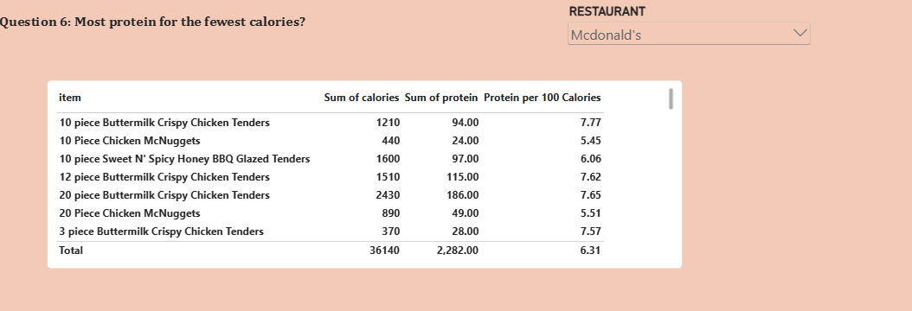
- Chart reading: the table lists each item with its calories, protein (g) and the derived Protein per 100 Calories ratio, which ranks items by protein efficiency rather than by absolute protein. Large fried tender portions deliver high absolute protein (for example, 94 g in the 10-piece Buttermilk Crispy Chicken Tenders) but at 1,210 calories, which gives a ratio of only 7.77, whereas grilled chicken salads and sandwiches rank higher on this ratio.
- Evidence: the top items by protein per 100 calories are the Premium Bacon Ranch Salad with Grilled Chicken (13.13; 42 g protein for 320 calories), Premium Asian Salad with Grilled Chicken (11.48), Premium Southwest Salad with Grilled Chicken (10.57), Artisan Grilled Chicken Sandwich (9.74), and the Grilled Maple Bacon Dijon Chicken Sandwich and Lobster Roll (8.28 each).
- Why: grilled chicken is a lean protein source and avoids the breading and frying that add calories without adding protein.
- Meaning: these are the most nutritionally efficient choices on the menu.

Finding 6: Calories rise strongly with fat, sodium and protein

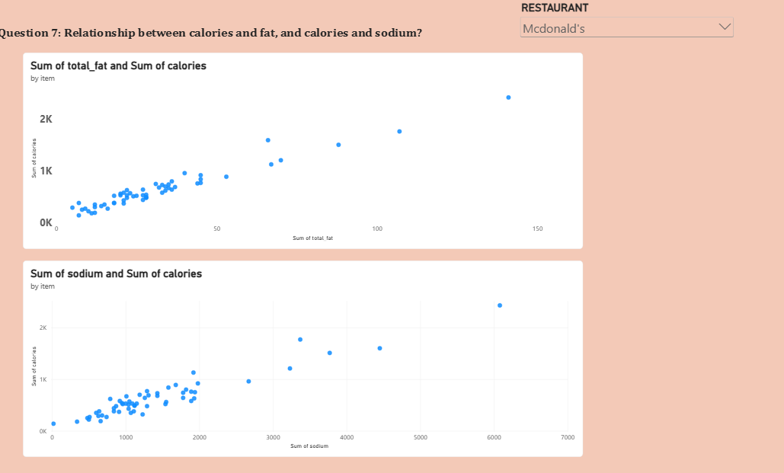
- Chart reading: the visual contains two scatter plots in which every menu item is a single point: total fat (g) against calories in the upper chart, and sodium (mg) against calories in the lower chart. In both, most items form a dense cluster in the lower left, representing typical single-serve items, while a small number of large sharing items extend toward the upper right. The near-linear upward pattern in both charts indicates a strong positive relationship.
- Evidence: both scatter charts show points rising closely along a linear trend. The correlation of calories with total fat is approximately 0.97, with sodium approximately 0.95 and with protein approximately 0.95.
- Why: fat provides 9 calories per gram versus 4 for carbohydrates and protein, so fatty items accumulate calories quickly. Meat-heavy items bring fat, protein and salt together, so these measures increase simultaneously.
- Meaning: reducing fat is the most direct way to reduce an item's calories. Because sodium and fat move together, lowering one often lowers the other.

Finding 7: Almost half of the menu is high calorie

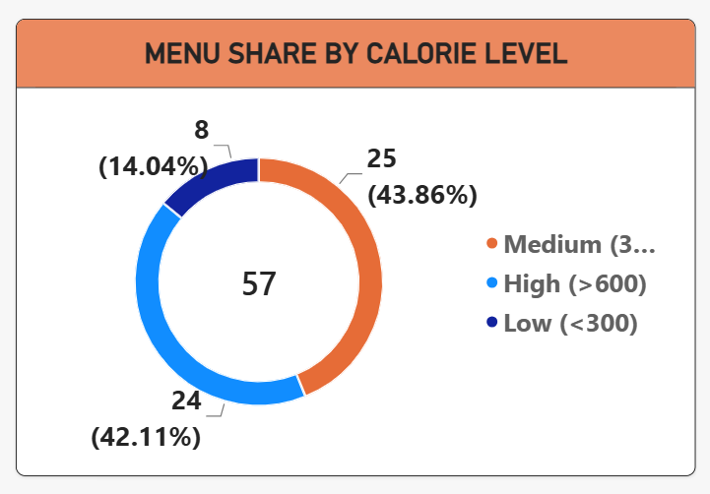
- Chart reading: the donut chart divides the 57 menu items into three calorie categories, with the total shown at the centre. The Medium segment is the largest at 25 items (43.86%), followed closely by the High segment at 24 items (42.11%), while the Low segment is the smallest at 8 items (14.04%). The near-equal Medium and High segments show that the menu is weighted toward heavier items.
- Evidence: of 57 items, 8 (14.04%) are low calorie (under 300), 25 (43.86%) are medium (300 to 600) and 24 (42.11%) are high calorie (over 600).
- Why: the menu is built mainly around burgers, sandwiches and fried chicken, with few light options.
- Meaning: customers have limited low-calorie choices, and nearly one item in two exceeds 600 calories.

6. Summary of Diagnostic Insights
- Large portions drive the highest calorie and sodium values.
- Frying, breading, cheese and bacon drive sodium and saturated fat.
- Fat content is the strongest driver of calories.
- Salads and grilled chicken are the lightest options and offer the highest protein value per calorie.
- The menu is calorie-heavy, with 42% of items above 600 calories.

7. Recommendations
- Separate sharing portions from single servings in menus and nutrition reports so that averages are not distorted.
- Display a sodium warning on items above 1,500 mg, as 19 of 57 items exceed this level.
- Promote grilled options (grilled chicken salads and sandwiches) as the best protein-per-calorie choices.
- Expand the range of light items under 300 calories, as only 8 of 57 items fall in this category.
- Reduce fat in multi-patty burgers, for example through lighter cheese or sauce options, to lower both calories and saturated fat.
- Collect price and sales data in future analyses so that nutrition can be linked to what customers actually purchase and pay.

8. Conclusion
McDonald's menu spans a wide range, from a 140-calorie salad to a 2,430-calorie sharing platter. The extremes arise from large, fried and breaded portions, whereas the lightest and most nutritious choices are salads and grilled chicken items. Calories track fat very closely, and sodium and saturated fat are concentrated in the same heavy items. With clearer labelling and a broader range of lighter options, customers could make healthier choices without losing variety. The principal limitation of this analysis is the absence of price and sales data, which would enable a deeper understanding of customer choices.

