McDonald's Analysis Report
Analysis Report (CDACL-004 Fast Food Analysis)
Prepared by: Gangothri M C
Batch / Team: PTID-CDA-SEP-26-11268
Date: 14-10-2026
Tool: MySQL and Power BI
Project GitHub Link - https://github.com/Gangothri521/Fast_Food_Analysis_project.git

1. Introduction

1.1 Objective
This project analyses the nutritional profile of menu items in a fast-food dataset covering eight restaurant chains, with McDonald's selected as the company of focus. The objective extends beyond describing the figures (descriptive analysis) to explaining why they appear as they do (diagnostic analysis) and to providing evidence-based recommendations.

1.2 Dataset Overview
Source: a fast-food nutrition table in MySQL
- Total records: 512 menu items across 8 restaurants (511 after removing duplicates); McDonald's has 57 items
- Key fields: restaurant, item, calories, cal_fat, total_fat, sat_fat, trans_fat, cholesterol, sodium, total_carb, fiber, sugar, protein, vit_a, vit_c, calcium
- Measures: calories, fats, cholesterol, sodium, carbohydrates, fiber, sugar and protein per item; vitamins and calcium are expressed as percentages of the daily value.

1.3 Tools Used
- MySQL: data source and querying
- Power BI: data cleaning, calculated columns, dashboard and chart visualization
- Microsoft Word / PDF: reporting

1.4 Data Cleaning and Limitations
- Removed the columns satish (completely empty), age (all zeros) and salad (no information, as every value was "Other").
- Removed 1 duplicate Taco Bell record (512 to 511 rows overall). Replaced the text value "NA" with null in fiber, protein, vit_a, vit_c and calcium, and converted these columns to numeric types. Blank values were retained as blanks rather than replaced with 0.
- Created new columns: Calorie Category (Low: under 300; Medium: 300 to 600; High: over 600), Is Salad (derived from the item name) and Protein per 100 Cal.
- Limitation: the dataset has no price column, so the average price analysis in the project brief could not be performed; nutrition measures were used instead.
- Limitation: fiber, vitamin A, vitamin C and calcium contain missing values for some restaurants (McDonald's vitamin values are complete).
- Limitation: the dataset contains no portion weights or sales figures, so actual customer purchasing behaviour cannot be determined.
- Limitation: the results indicate relationships (correlation) and do not establish causation.
Power BI – Dashboard and chart visualization (restaurant filter set to McDonald's).
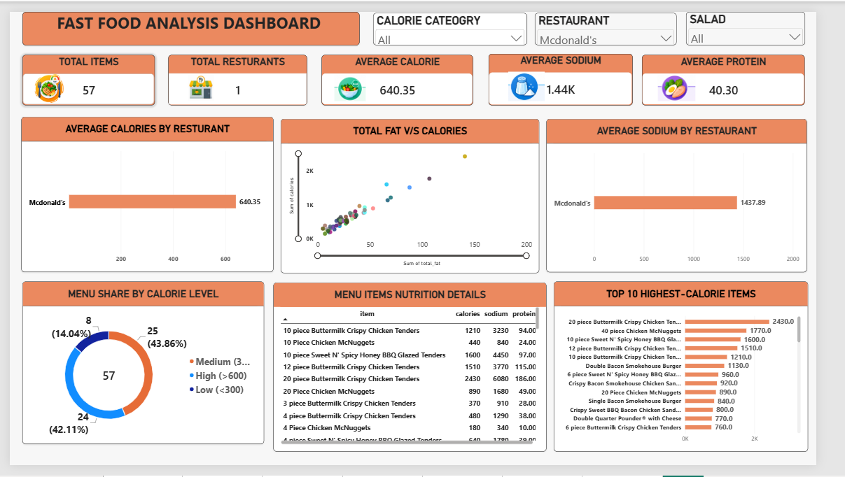
The interactive dashboard consolidates the analysis on a single page. It contains five KPI cards (Total Items, Total Restaurants, Average Calorie, Average Sodium and Average Protein) and three slicers (Calorie Category, Restaurant and Salad). Selecting a slicer value cross-filters every visual simultaneously. It comprises the following visuals:
- Average Calories by Restaurant (bar chart): compares the mean calories per item across restaurants; with the McDonald's filter applied, it shows a single bar at 640.35.
- Total Fat vs Calories (scatter plot): plots each menu item by total fat and calories, revealing the relationship between fat content and energy and highlighting outliers.
- Menu Share by Calorie Level (donut chart): shows the distribution of items across the Low, Medium and High calorie categories, with the total of 57 items at the centre.
- Average Sodium by Restaurant (bar chart): compares the mean sodium per item; the McDonald's bar shows 1,437.89 mg.
- Top 10 Highest-Calorie Items (horizontal bar chart): ranks the most energy-dense items, led by the 20-piece Buttermilk Crispy Chicken Tenders at 2,430 calories.
- Menu Items Nutrition Details (table): lists calories, sodium and protein for every item, allowing item-level verification of the aggregate figures.

2. Key Performance Indicators (KPIs)
Total Items  57 | Average Calories  640.35 | Average Sodium  1,437.89 mg | Average Protein  40.30 g | High-Calorie Items  42.11% | Max Calories  2,430
Dashboard KPIs:

2.1 Supporting Notes
Total Items counts all McDonald's menu items in the table (57). Average Calories, Average Sodium and Average Protein are calculated per item across these 57 items. High-Calorie Items (42.11%) is the share of items above 600 calories (24 of 57). Max Calories (2,430) is the 20-piece Buttermilk Crispy Chicken Tenders. For comparison, the average across all chains is about 531 calories, 1,247 mg sodium and 28 g protein per item, so McDonald's items are heavier and saltier but considerably higher in protein.

3. Charts & Visualizations

3.1 Top 10 and Bottom 10 Items by Calories (Tables)
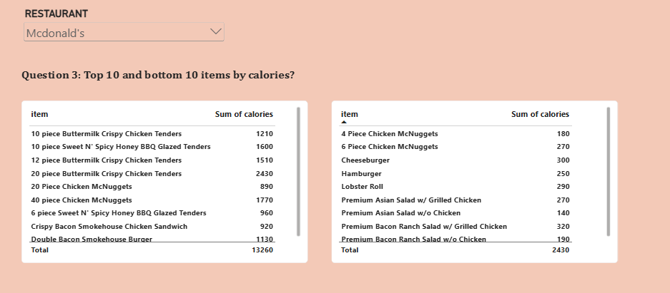
Chart reading: the visual presents two side-by-side tables for the McDonald's selection, ranking items by calories. The left table lists the highest-calorie items, led by the 20-piece Buttermilk Crispy Chicken Tenders at 2,430. The right table lists the lightest items, such as the Premium Asian Salad without chicken at 140, the 4-piece Chicken McNuggets at 180 and the Premium Bacon Ranch Salad without chicken at 190. Read together, the tables show the full spread of the menu at a glance.
Insight: Calories range from 140 to 2,430. The highest items are the 20-piece Buttermilk Crispy Chicken Tenders (2,430), 40-piece Chicken McNuggets (1,770), 10-piece Sweet N' Spicy Honey BBQ Glazed Tenders (1,600), 12-piece Buttermilk Crispy Chicken Tenders (1,510) and 10-piece Buttermilk Crispy Chicken Tenders (1,210). These are multi-piece sharing portions, breaded and fried, and listed as a single item; five of the top ten items are chicken products sold in large counts. Single-serve items such as the Hamburger (250) and Cheeseburger (300) are far lower. The lightest items are the Premium Asian Salad without Chicken (140), 4 Piece Chicken McNuggets (180) and Premium Bacon Ranch Salad without Chicken (190).

3.2 Menu Share by Calorie Level (Donut Chart)
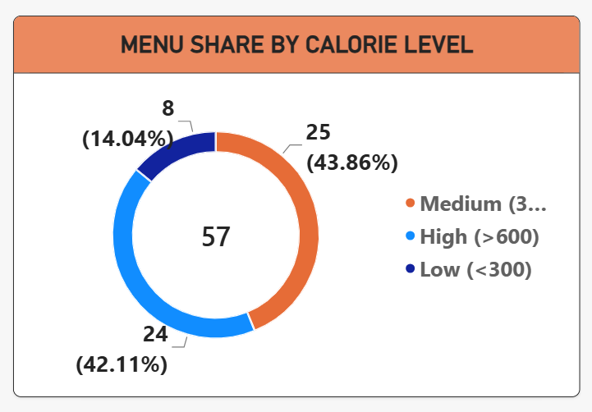
Chart reading: the donut chart divides the 57 menu items into three calorie categories, with the total shown at the centre. The Medium segment is the largest at 25 items (43.86%), followed closely by the High segment at 24 items (42.11%), while the Low segment is the smallest at 8 items (14.04%). The near-equal Medium and High segments show that the menu is weighted toward heavier items.
Insight: Of 57 McDonald's items, 8 (14.04%) are low calorie (under 300), 25 (43.86%) are medium calorie (300 to 600) and 24 (42.11%) are high calorie (over 600). Nearly half of the menu is high calorie because it is built mainly around burgers, sandwiches and fried chicken, with few light options. Customers therefore have limited low-calorie choices.

3.3 Sodium and Saturated Fat (Tables)
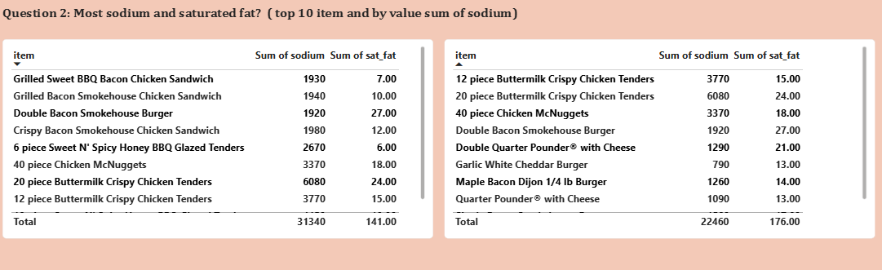
Chart reading: two tables display total sodium (mg) and saturated fat (g) for each item, so both measures can be compared along the same row. The 20-piece Buttermilk Crispy Chicken Tenders stand out in both, at 6,080 mg of sodium and 24 g of saturated fat, while the Double Bacon Smokehouse Burger records 1,920 mg of sodium and 27 g of saturated fat. The highest saturated fat values do not always coincide with the highest sodium values, so the two measures should be assessed separately.
Insight (sodium): The 20-piece tenders have the highest sodium at 6,080 mg, followed by the 10-piece Sweet N' Spicy Honey BBQ Glazed Tenders (4,450 mg) and the 12-piece Buttermilk Crispy Chicken Tenders (3,770 mg). Six items exceed 2,300 mg, the commonly cited daily limit, and 19 items exceed 1,500 mg. Breading, seasoned coatings, sauces, cheese and processed meat all contribute salt, and larger portions multiply the effect.
Insight (saturated fat): the top items are the Double Bacon Smokehouse Burger (27 g), 20-piece tenders (24 g), Double Quarter Pounder with Cheese (21 g), 40-piece McNuggets (18 g) and Single Bacon Smokehouse Burger (17 g). Double patties, bacon and cheese drive saturated fat, which is why multi-layer burgers rank at the top even when their calories are lower than those of the 20-piece tenders.

3.4 Salads vs Non-Salads (Bar Chart)
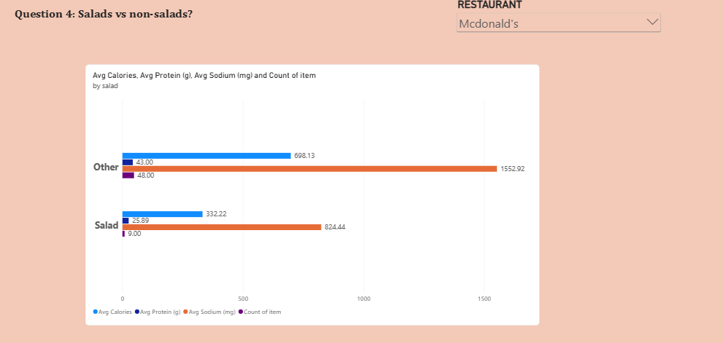
Chart reading: the clustered horizontal bar chart compares the Salad and Other (non-salad) groups across four measures: average calories, average protein (g), average sodium (mg) and item count. The non-salad bars are roughly twice as long for calories and sodium, while the count bars show that the groups differ in size (48 items against 9). Because all four measures share a single axis, sodium dominates the scale, so values are best read from the data labels.
Insight: McDonald's has 9 salads and 48 non-salad items. Salads average 332 calories, 824 mg sodium and 26 g protein, while non-salad items average 698 calories, 1,553 mg sodium and 43 g protein. Salads replace buns, fries, fried coatings and cheese with vegetables, so calories and sodium are roughly halved; protein is lower because there is less meat.

3.5 Protein per 100 Calories (Table)
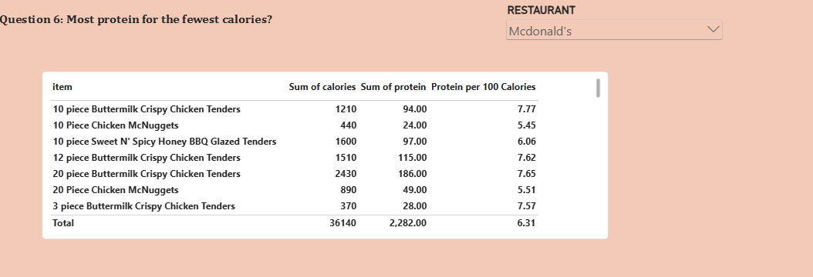
Chart reading: the table lists each item with its calories, protein (g) and the derived Protein per 100 Calories ratio, which ranks items by protein efficiency rather than by absolute protein. Large fried tender portions deliver high absolute protein (for example, 94 g in the 10-piece Buttermilk Crispy Chicken Tenders) but at 1,210 calories, which gives a ratio of only 7.77, whereas grilled chicken salads and sandwiches rank higher on this ratio.
Insight: The best items for protein per 100 calories are the Premium Bacon Ranch Salad with Grilled Chicken (13.13; 42 g protein for 320 calories), Premium Asian Salad with Grilled Chicken (11.48), Premium Southwest Salad with Grilled Chicken (10.57), Artisan Grilled Chicken Sandwich (9.74), and the Grilled Maple Bacon Dijon Chicken Sandwich and Lobster Roll (8.28 each). Grilled chicken is a lean protein source and avoids the breading and frying that add calories without adding protein, so these are the most nutritionally efficient choices on the menu.

3.6 Total Fat vs Calories (Scatter Chart)
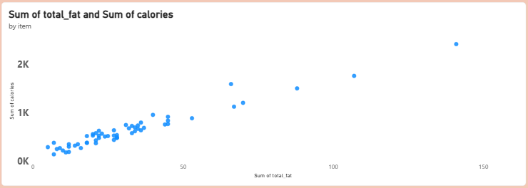
Chart reading: each point is a menu item, plotted by total fat in grams (x-axis) against calories (y-axis). Most items form a dense cluster in the lower left, representing typical single-serve items, while a small number of large sharing items extend toward the upper right. The most extreme point, at roughly 140 g of fat and about 2,400 calories, is the 20-piece tenders.
Insight: The points rise tightly along a linear trend, showing that calories increase strongly with total fat (correlation of about 0.97). Fat provides 9 calories per gram versus 4 for carbohydrates and protein, so fatty items accumulate calories quickly. Reducing fat is therefore the most direct way to reduce an item's calories.

3.7 Sodium vs Calories (Scatter Chart)
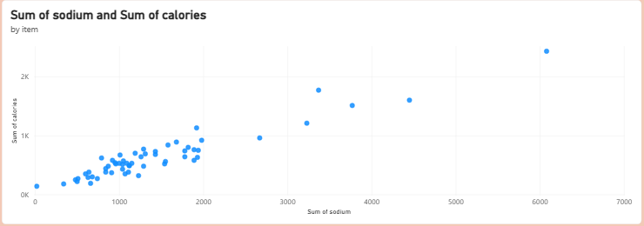
Chart reading: each point is a menu item, plotted by sodium in mg (x-axis) against calories (y-axis). Most items sit between about 500 and 2,000 mg of sodium and below 1,000 calories, while a few large fried items reach 3,000 to 6,000 mg and 1,500 to 2,400 calories. The near-linear upward pattern indicates a strong positive relationship.
Insight: Calories also rise strongly with sodium (correlation of about 0.95) and with protein (about 0.95). Meat-heavy, fried and cheesy items bring fat, salt and protein together, so these measures increase at the same time. Because sodium and fat move together, lowering one often lowers the other. This shows a relationship, not proof of cause.

4. Insights & Findings

4.1 Portion Size
The highest-calorie items are large sharing portions listed as one item, mainly fried chicken pieces. These pull the average up to 640 calories, while single-serve items such as the Hamburger (250) and Cheeseburger (300) are far lower. Averages should therefore be read with sharing portions in mind.

4.2 Sodium
Sodium is very high, especially in fried chicken items. The 20-piece tenders contain 6,080 mg, more than double the commonly cited daily limit, and 19 of 57 items exceed 1,500 mg. The reasons are breading, sauces, cheese and processed meat, multiplied by large portions. A single item can supply more than twice the recommended daily sodium intake.

4.3 Saturated Fat
Saturated fat peaks in multi-patty burgers (up to 27 g in the Double Bacon Smokehouse Burger), even where their calories are lower than those of the largest chicken platters. Double patties, bacon and cheese are all rich in saturated fat. An item can therefore be a high-risk choice for saturated fat without being the highest in calories, so sodium, saturated fat and calories should be judged separately.

4.4 Salads
Salads average 332 calories against 698 for other items, with about half the sodium. Toppings and dressings still matter, but choosing a salad reduces calories and sodium by more than half.

4.5 Protein Value
Grilled chicken salads and sandwiches give the most protein for their calories (up to 13.13 g per 100 calories). McDonald's also has the highest average protein of any chain in this dataset (about 40 g per item), partly because of its large meat portions.

4.6 Fat as the Driver of Calories
Calories follow fat very closely (correlation of about 0.97), with sodium and protein close behind (about 0.95 each). Reducing fat in an item is the most direct way to reduce its calories, and because sodium and fat move together, lowering one often lowers the other.

4.7 Menu Balance
Only 8 of 57 items (14.04%) are low calorie, while 24 (42.11%) are above 600 calories. Customers have limited light choices, and nearly one item in two is a heavy option.

4.8 Diagnostic Summary
Five insights summarise the analysis: large portions drive the highest calorie and sodium values; frying, breading, cheese and bacon drive sodium and saturated fat; fat content is the strongest driver of calories; salads and grilled chicken are the lightest options and give the highest protein value per calorie; and the menu is calorie-heavy, with 42% of items above 600 calories.

5. Recommendations
- Separate sharing portions from single servings: show sharing items apart on menus and in nutrition reports so that averages are not distorted.
- Show sodium warnings: flag items above 1,500 mg, since 19 of 57 items exceed this level and 6 exceed 2,300 mg.
- Promote grilled options: grilled chicken salads and sandwiches give the best protein per calorie and avoid breading and frying.
- Add more light items: only 8 of 57 items are under 300 calories, so a wider range of light choices would improve balance.
- Reduce fat in multi-patty burgers: a lighter cheese or sauce option would lower both calories and saturated fat.
- Collect price and sales data: this would connect nutrition to what customers actually buy and pay, which the current dataset cannot show.

6. Conclusion
McDonald's menu ranges from a 140-calorie salad to a 2,430-calorie sharing platter. The extremes come from large, fried, breaded portions, while the lightest and most nutritious choices are salads and grilled chicken items. Calories follow fat very closely, and sodium and saturated fat are concentrated in the same heavy items. With clearer labelling and a broader range of light options, customers could make healthier choices without losing variety. The principal limitation of this analysis is the lack of price and sales data, which would allow a deeper look at what customers actually choose.

