/* ===============================================================
SECTION 1: KPIs in SQL
=============================================================== */
1) KPI 1: Total number of employees
Select count(*) as total_employee from HR;

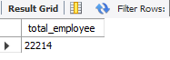

2) KPI 1b: CURRENT employees only (excludes those who left)
Select count (*) AS current_employees from HR where termdate='';
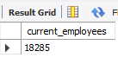
KPI 1c: --Total Employee left
SELECT COUNT(*) AS left_employees FROM HR WHERE termdate !='';
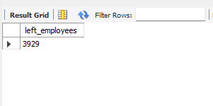
3) KPI 2: Percent of workers working remotely and in HQ (In-Office)
Select location, count(*) as emp_work_mode,
Round (count(*) * 100.0 / (select Count(*) from HR),2) as per_of_total from HR group by location;
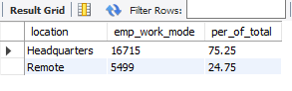
4) KPI 3: Average age of employees
select round(AVG(Age), 1) AS average_age from HR;
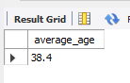
5) KPI 3b: Average age, current employees only
select round(AVG(Age), 1) AS average_age_current from HR where termdate='';
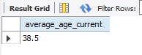
/* =======================================================
SECTION 2: LINE CHART Hiring Rate By Year
======================================================== */
select
year(str_to_date(hire_date, '%d-%m-%Y')) AS hire_year,
count(*) AS employees_hired
from HR
group by hire_year
order by hire_year;
Here we convert date into STR_TO_DATE because we need hire_year instead of hire_date and this filed into DB in VARCHAR. So due to that we convert it.
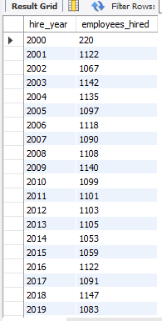

/* ===============================================================
SECTION 3: DONUT CHART Gender Split
=============================================================== */
select gender, count(*) as emp_count,
round(count(*) * 100.0 /(select count(*) from HR),2) as per_total from HR
group by gender;
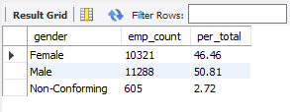

/* ===============================================================
SECTION 4: BAR CHARTS - By State, By Department, By Race
=============================================================== */
4a. Employees by State-
select location_state, count(*) as count_of_location_state from HR group by location_state order by count_of_location_state desc;
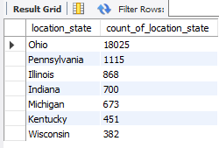

4b. Employees by Department-
select department, count(*) as count_of_department_emp from HR group by department order by count_of_department_emp desc;
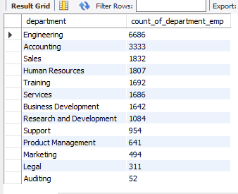
4c. Employees by Race-
select race, count(*) as count_race_wise from HR group by race order by count_race_wise desc;
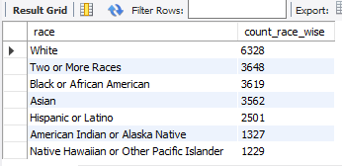

Count & Percentage Employees by Race –
select race,count(*) as count_race_wise,
round(count(*) * 100.0 / ( select count(*) from HR),2) as per_of_total
from HR group by race order by count_race_wise desc;

