CloudChain: Integrating Ethereum Blockchain for Secure & Scalable Cloud Services

Cloud Computing provides heavy computation and storage services at cheaper cost where user can upload high storage data to cloud instead of saving in local machine and can access this data from anywhere but this advantage raise a security issue of user’s data as its store at third party cloud server away from user hands. Cloud server attack or its internal employees can access and alter user’s data. In such alteration there is no proper tool available for user to know about data alteration attack.

To avoid such data tamper or unauthorised access prevention encryption technologies can provide some security but not fully secured as its keys can be break or hack.

To overcome from above issues we are combining cloud power with Blockchain Ethereum technology which has inbuilt support to fight against data tamper with the help of POW (proof of work) and hashcode verification. Blockchain store each record as block/transaction and associate each block with unique hashcode and while storing new record Blockchain will verify hashcode of all previous blocks like chain, if data not tamper then it will result into same hashcode and verification get successful, if data alter then result into mismatch hashcode and data tamper will be detected.

In propose work we are using following technologies

1. Cloud services: web service will be run in cloud to provide access interface to user and this cloud will provide all computing power to web application to compute user interaction
2. IPFS: interplanetary file system (IPFS): cloud may access this IPFS to store user data as we cannot store huge data to Blockchain as this may increase GAS prices. So cloud will encrypt file and then store this file in IPFS, IPFS will return hashcode address of file stored location and this hashcode will get saved in Blockchain
3. Blockchain: Blockchain will be used to store all hashcode address of user files stored in IPFS. So any attacker and cloud server must know the process of getting hashcode from Blockchain to access or tamper file which is next to impossible.

Blockchain will store data or access using smart contracts which will design using Solidity programming. This smart contract contains function which can be called to store or access data from Blockchain and for propose application we have designed following contract

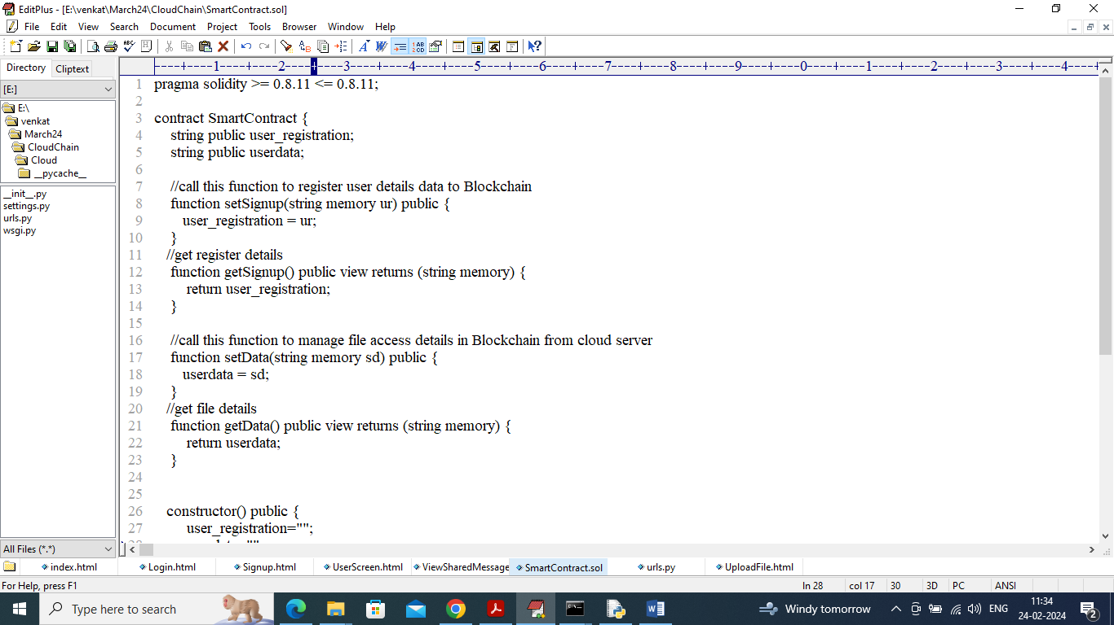

In above contract we define function to store and get user and their file data and now we need to deploy above contract to Ethereum using below points

1. First go inside ‘hello-eth/node-modules/bin’ folder and then look for ‘runBlockchain.bat’ file and then double click on that file to get below page
2. 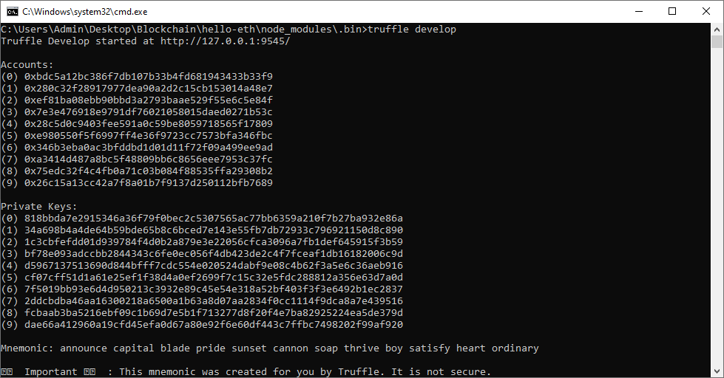
3. In above screen Ethereum started with default keys and account and now type command as ‘migrate’ and press enter key to get below output
4. 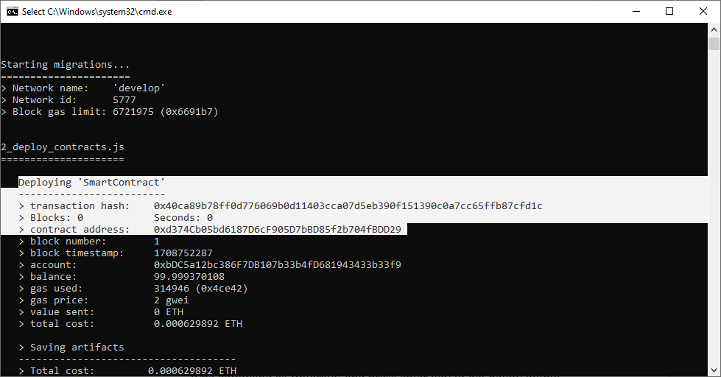
5. In above screen in white colour text can see ‘Smart Contract’ deployed and got contract address also and this address need to specify in PYTHON code to call contract to store and get data from Ethereum. In below screen showing python code calling smart contract
6. 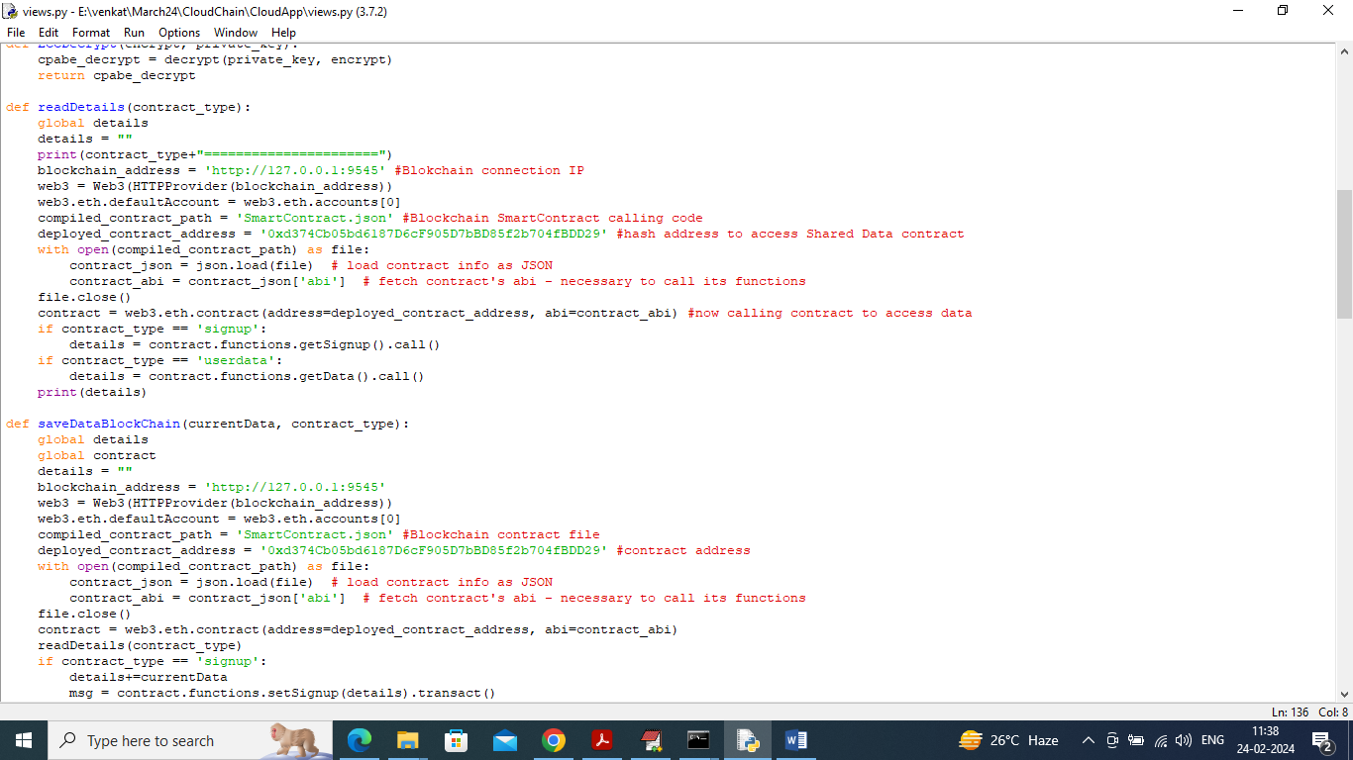
7. In above screen read red colour comments to know about contract calling from python. Now contract deployed and running and let it run.

Now double click on ‘start_IPFS.bat’ file to start IPFS server and get below page

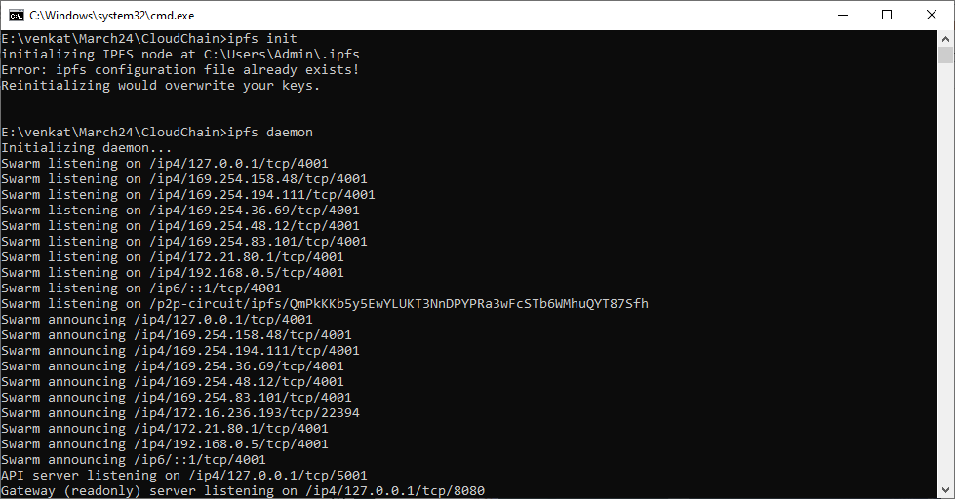

In above screen IPFS server started and now double click on ‘runServer.bat’ file to start dummy cloud server and get below page. In this project to show cloud and Blockchain services we are asking user to signup, login and then can upload and download file by using above Blockchain, cloud services.

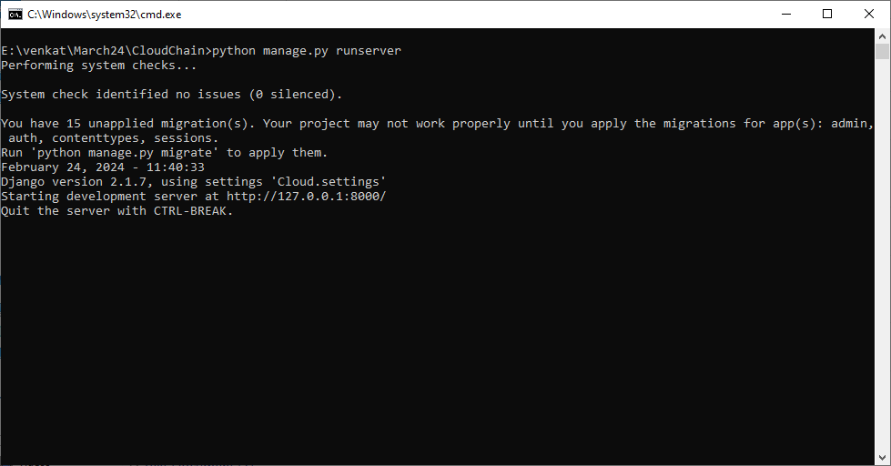

In above screen cloud server started and now open browser and enter URL as <http://127.0.0.1:8000/index.html> and press enter key to get below page.

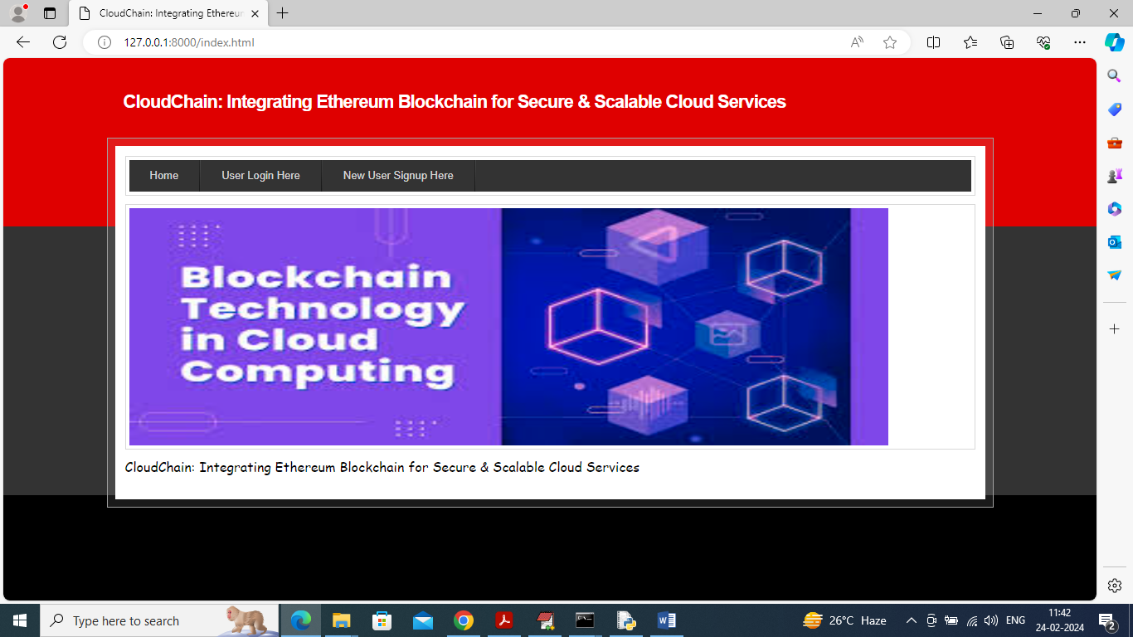

In above screen click on ‘New User Sign up’ link to get below page

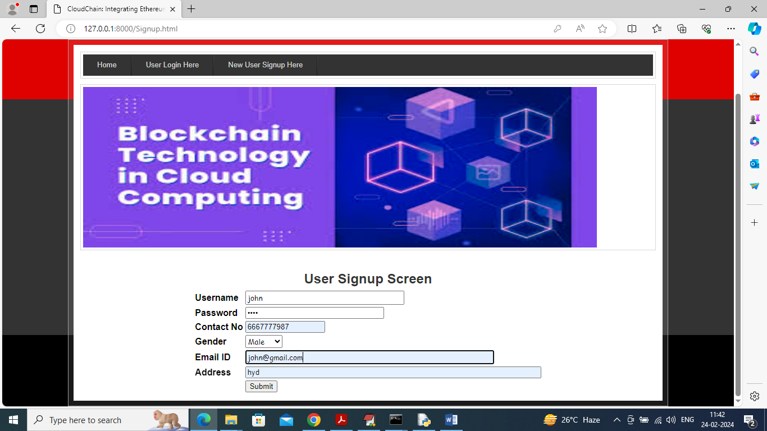

In above screen user is entering sign up details and then press button to get below page

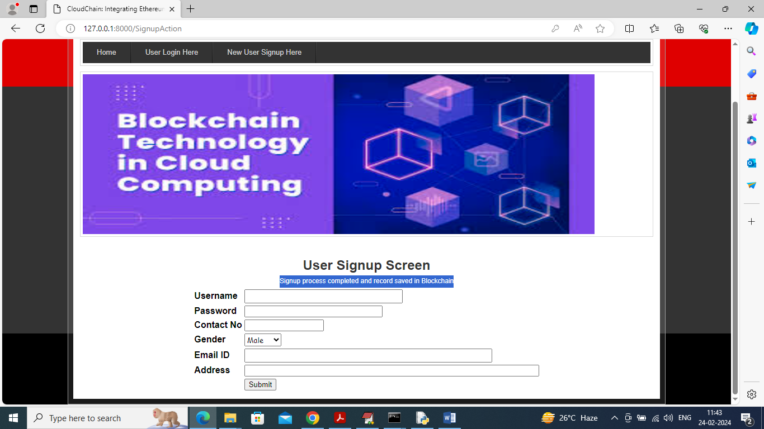

In above screen user sign up completed and now click on ‘User Login’ link to get below page

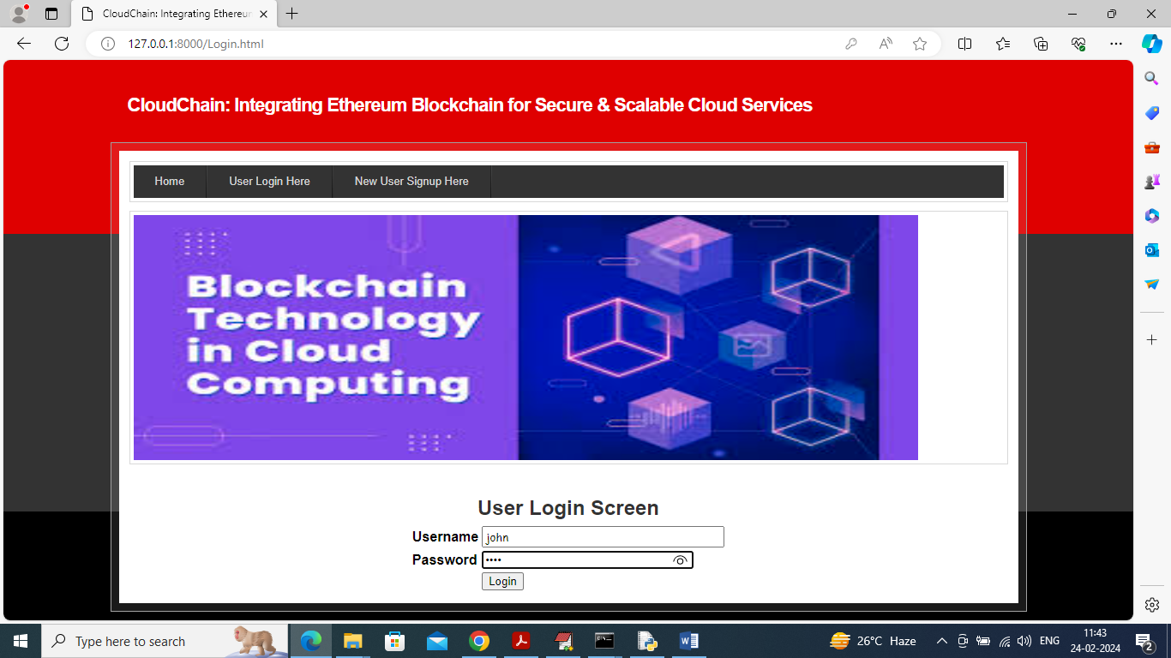

In above screen user is login and after login will get below page

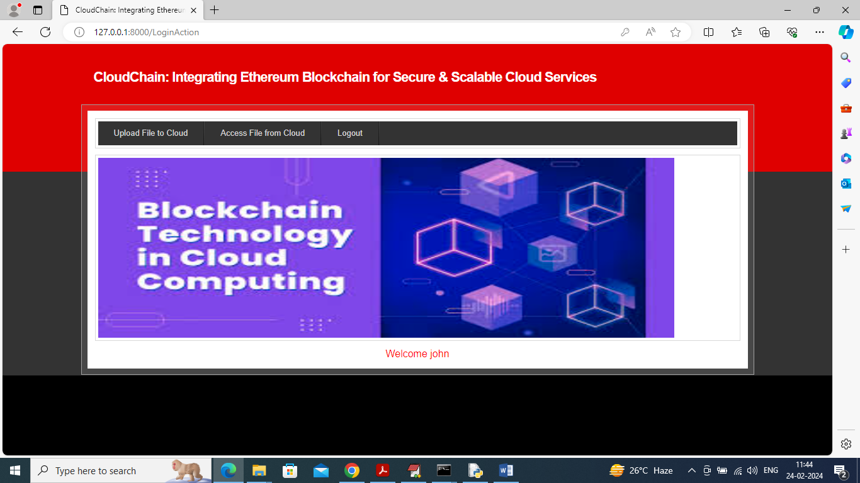

In above screen user can click on ‘Upload File to Cloud’ link to upload all his data to cloud and get below page. All uploaded file will get encrypted using advance ECC algorithm

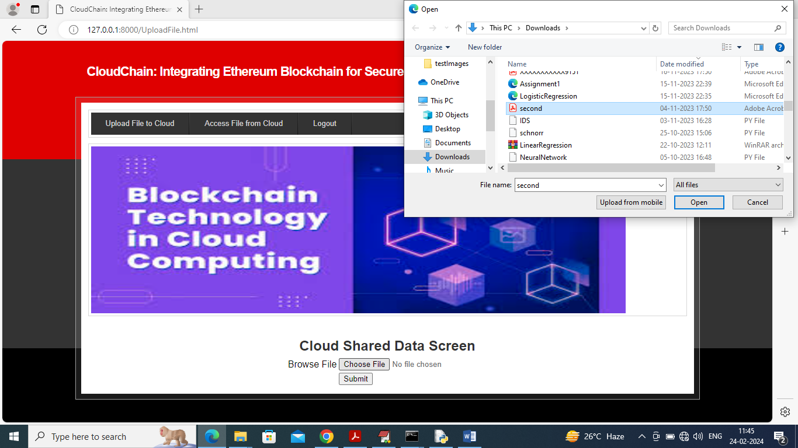

In above screen user just need to select any file and then click on “open” and “submit” button to saved file in IPFS, cloud and Blockchain using project concept and get below output

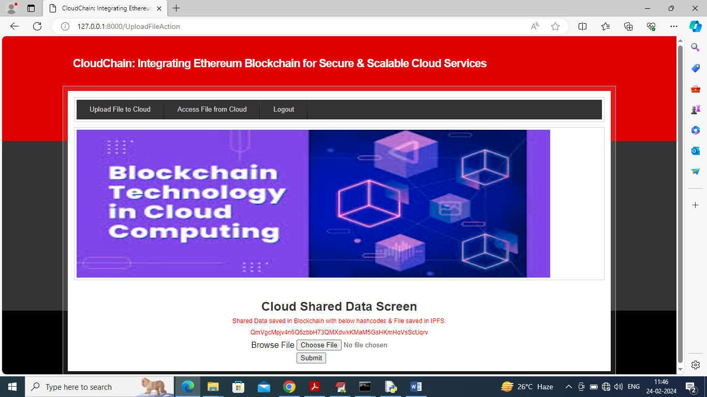

In above screen can see file saved in Blockchain and the address of the file also showing in hash code format and to access that file user can click on ‘Access File from Cloud’ link to get list of all files

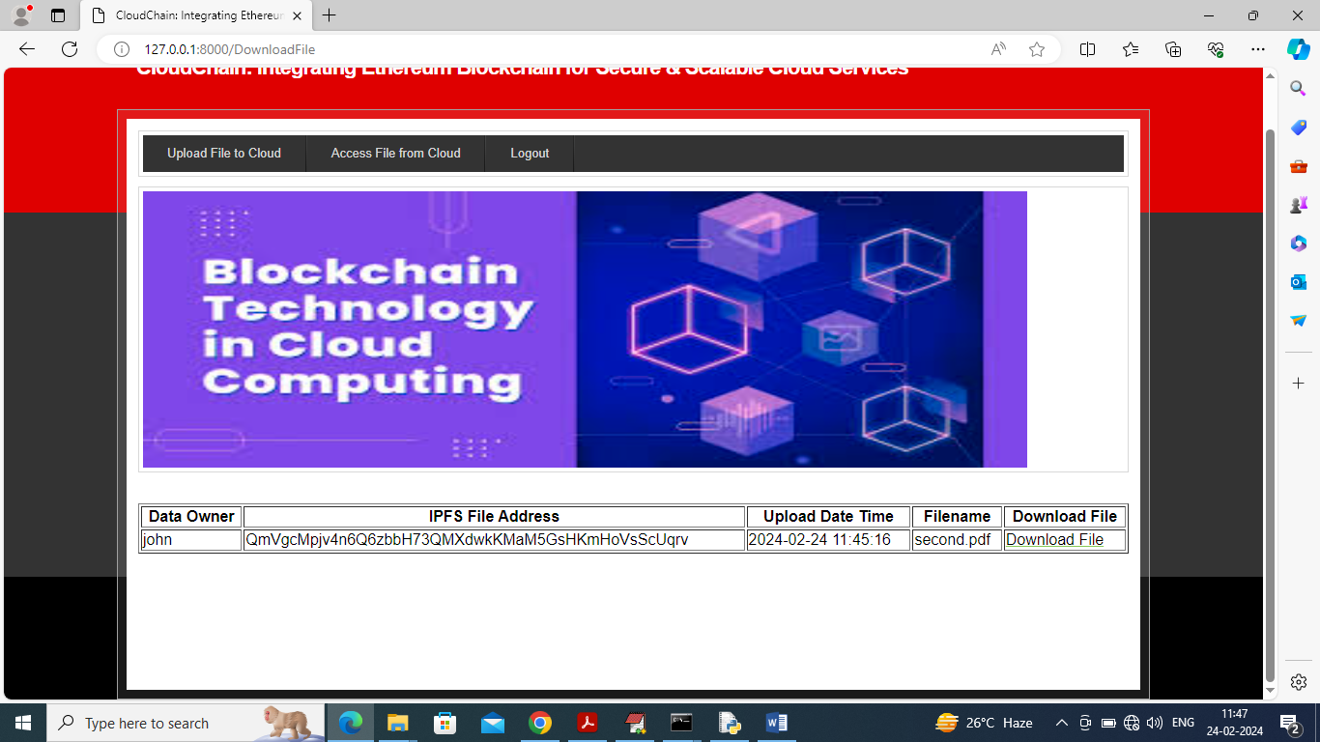

In above screen user can see all uploaded file in tabular format and can click on ‘Download’ link to download file in decrypted format and get below output

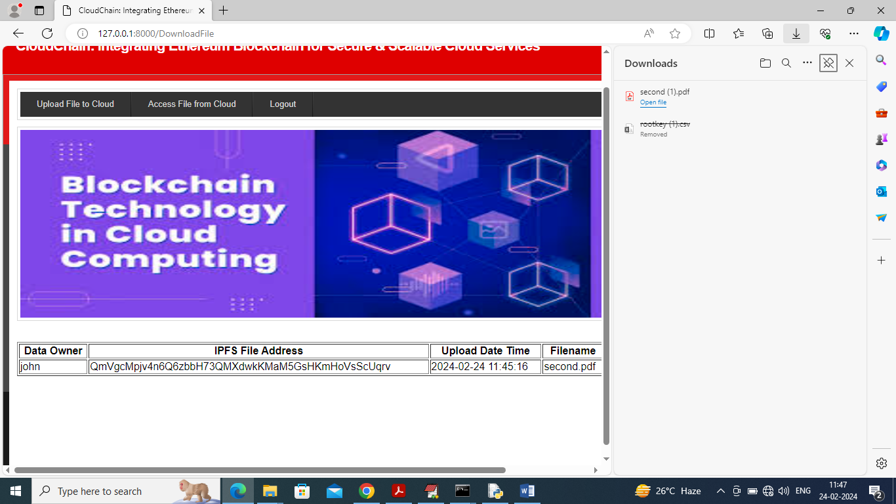

In above screen in right panel can see file is downloaded and you can open in decrypted format.

Similarly by following above screens user can upload and saved in decentralized manner.