1.Write a program to stimulate following CPU scheduling Algorithms.

A)FCFS

B)SJF

a)First Come First Service(FCFS)

Source code:

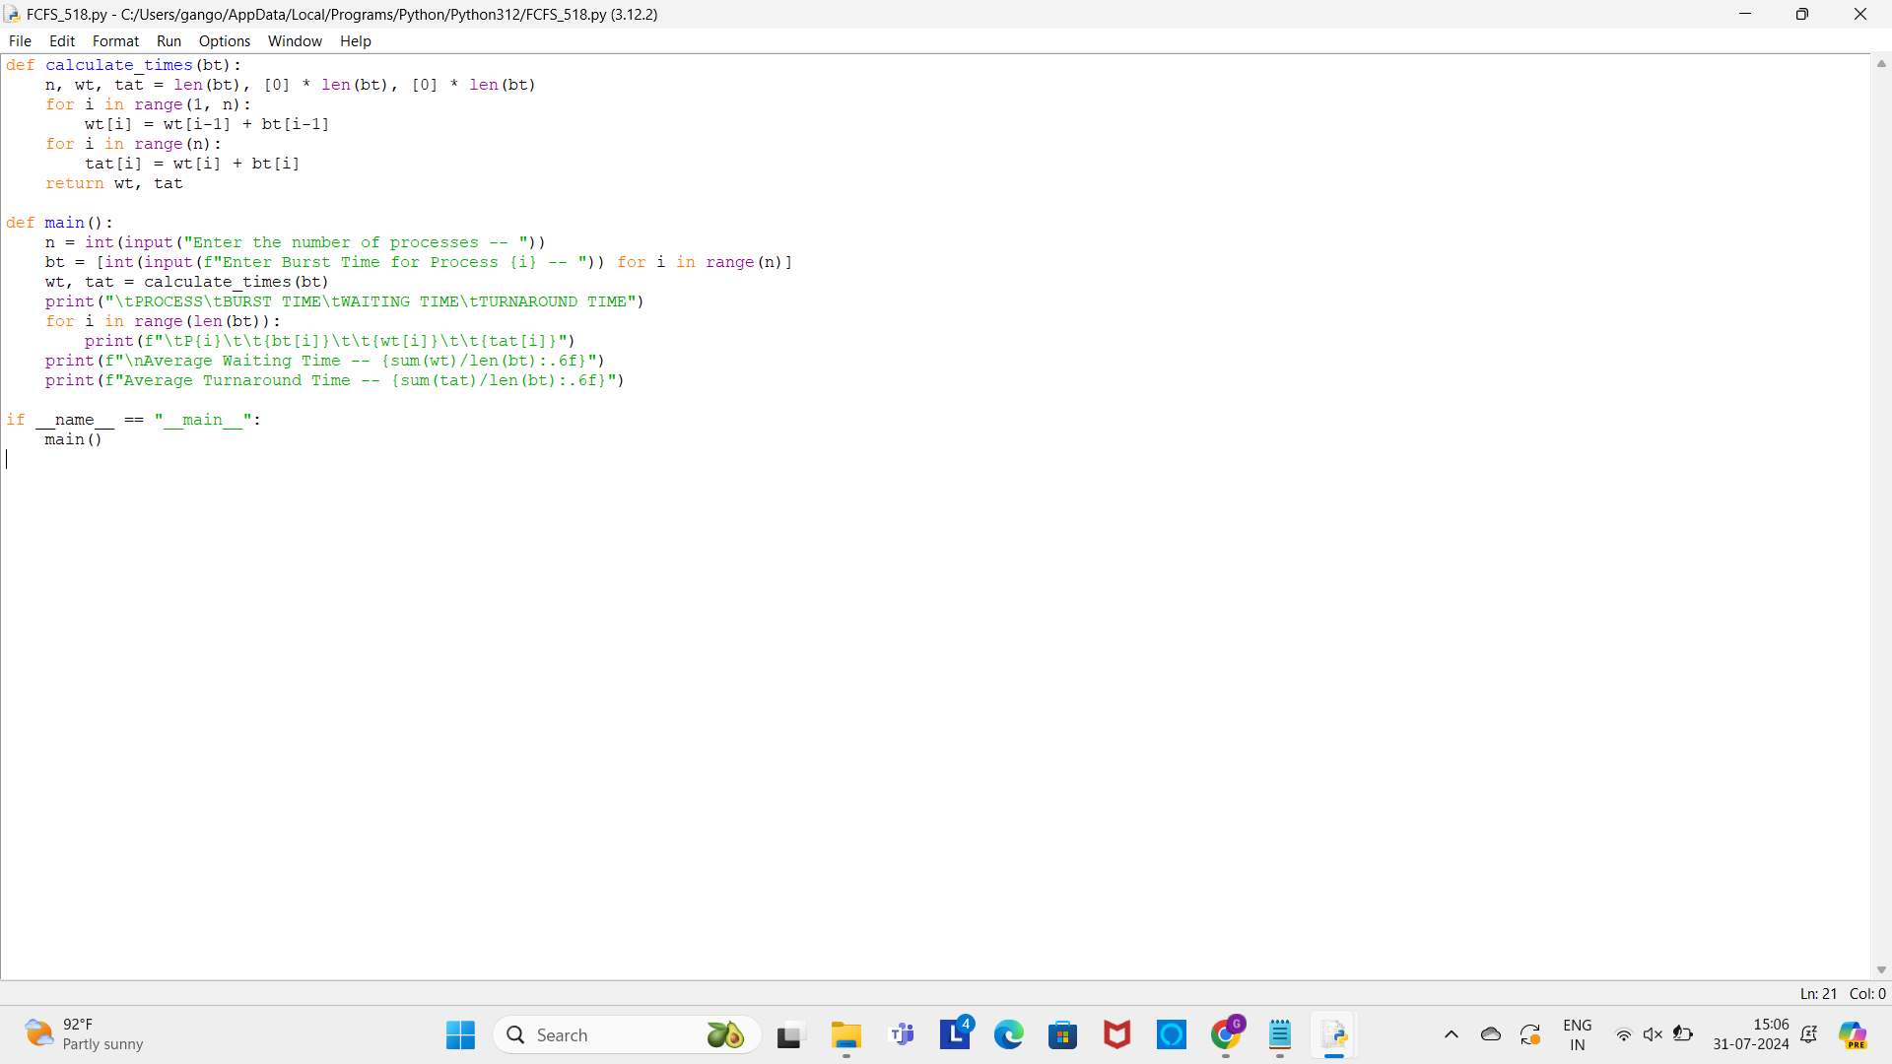

Output: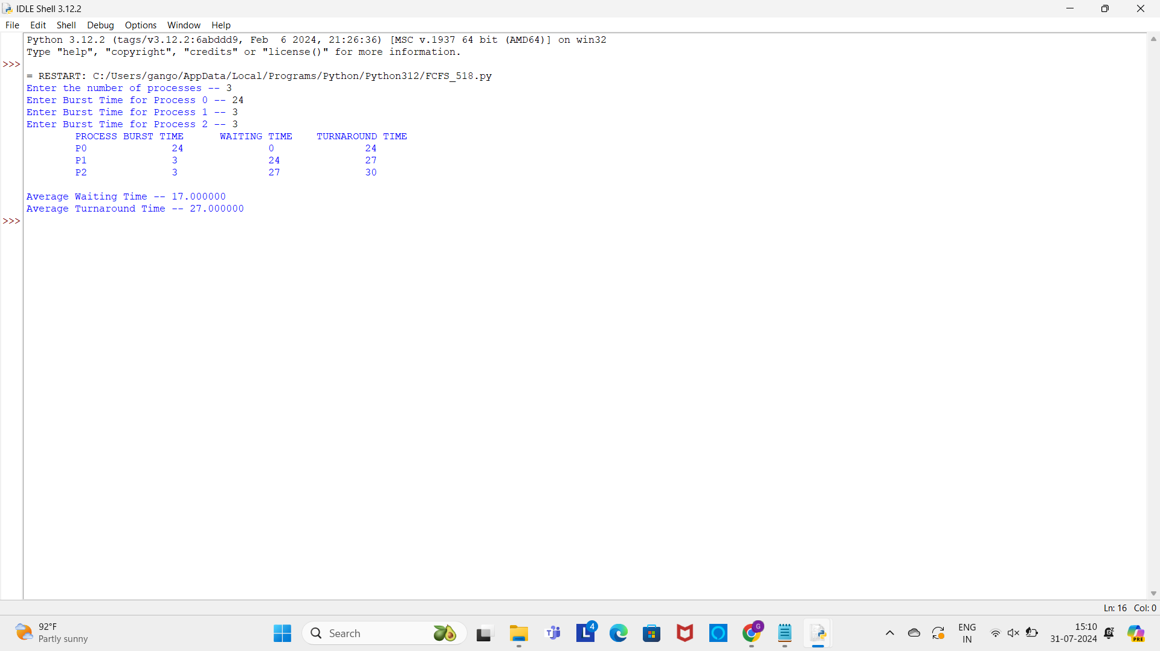

b)Shortest Job First(SJF)

Source code:

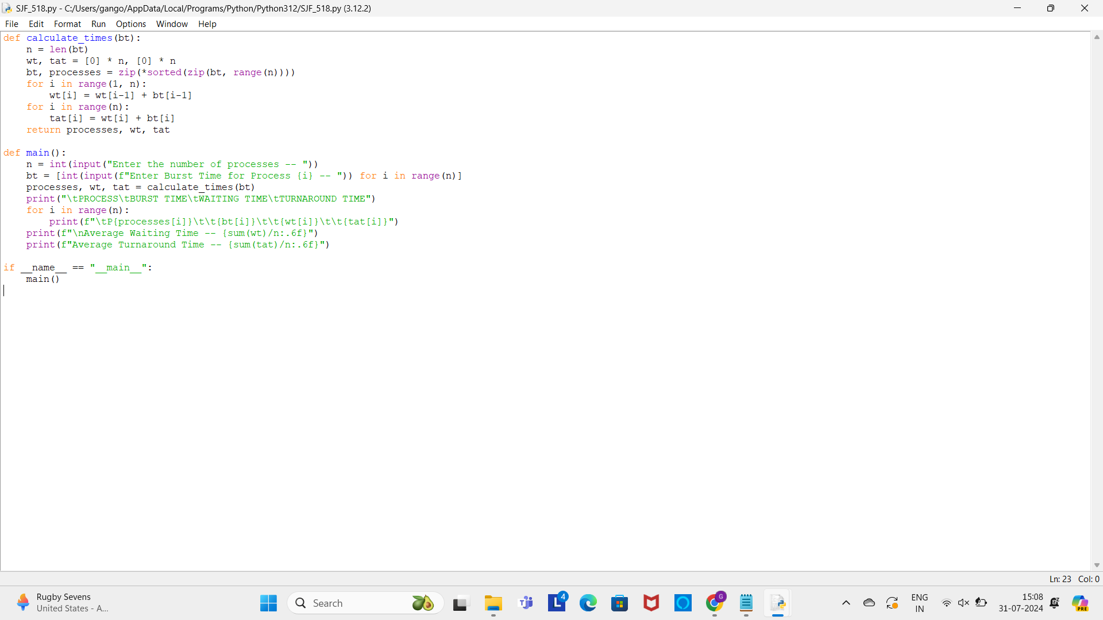

Output:

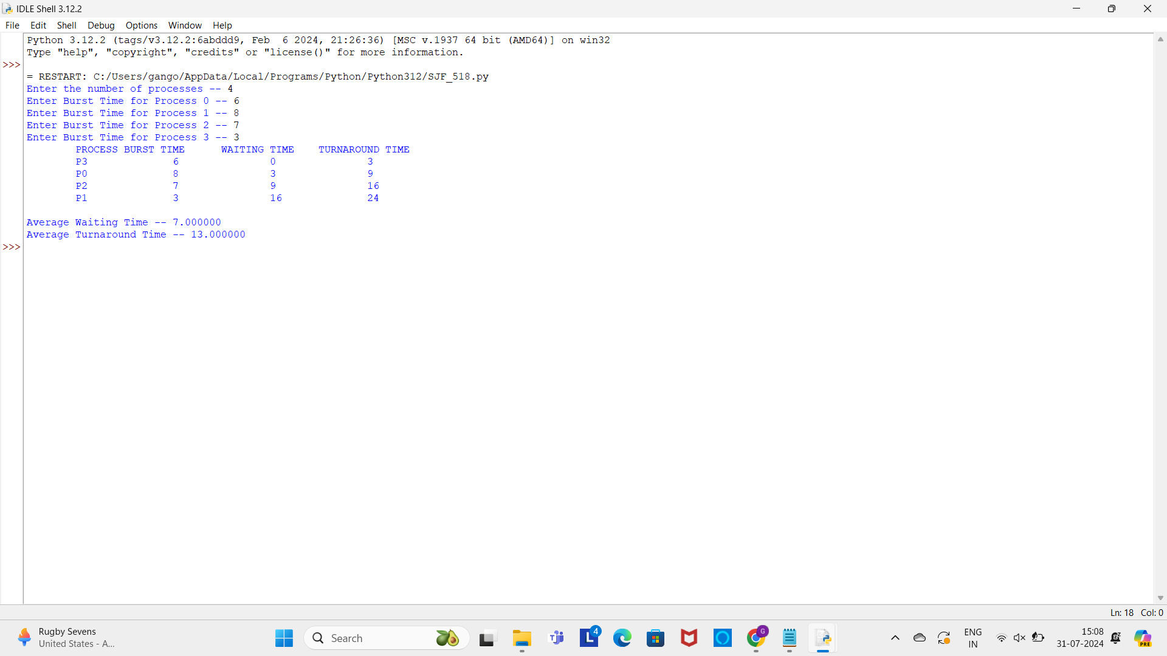

Conclusion:

In this operating System lab ,we executed a program a CPU scheduling algorithms of FCFS and SJF by using python is successfully executed.