PRODUCT + TECHNICAL DESIGN

Loan Officer
Workflow App
Implementation-ready plan for a secure, responsive system that manages customers, loans, and time-sensitive actions.

DOCUMENT | VALUE
Status | Development baseline
Audience | Product, engineering, QA, security, operations
Architecture | React PWA + ASP.NET Core + relational SQL
Delivery model | MVP first; modular monolith; cloud-hosted

Decision principle
Ship one excellent responsive web application before adding native clients, microservices, or advanced automation.

DOCUMENT MAP
SECTION | OUTPUT
01–03 | Scope, users, workflows
04–06 | Requirements, UX, architecture
07–09 | Data, API, automation
10–12 | Security, quality, delivery
13 | Acceptance criteria and open decisions

01

Purpose and Product Definition
Provide loan officers one trusted workspace for customer records, loan progress, and required follow-up.

Product goals
- Show every officer what requires attention now, next, and overdue.
- Keep customer and loan context available on phone and desktop.
- Standardize recurring tasks without removing human control.
- Protect sensitive data with role-based access and complete audit history.
- Support incremental delivery and future integrations.

MVP success measures
MEASURE | TARGET
Task visibility | 100% of open actions classified as upcoming, due, or overdue
Primary workflow | Customer → loan → action completed in ≤ 60 seconds
Responsive use | No horizontal scrolling at supported phone widths
Reliability | 99.9% monthly service availability target
Auditability | All material record changes attributed and timestamped

Scope boundary
IN MVP | NOT IN MVP
Customer profiles | Loan origination or underwriting engine
Loan records and stage tracking | Payment processing
Action creation, assignment, recurrence | Full document management suite
Dashboard, search, filters | Native iOS / Android applications
Email and in-app reminders | Microservices
Administration, roles, audit | Automated lending decisions

02

Users, Roles, and Access
ROLE | PRIMARY CAPABILITIES | DEFAULT DATA SCOPE
Loan Officer | Manage assigned customers, loans, actions, notes | Assigned portfolio
Team Lead | Reassign work, review workload, view team reporting | Team portfolio
Administrator | Manage users, roles, action templates, settings | Organization
Auditor / Read-only | Inspect records and audit history | Granted organization scope

Authorization model
- Organization is the top-level tenant boundary.
- Every customer, loan, action, note, and audit event carries OrganizationId.
- Policies combine role, organization, team, ownership, and record assignment.
- Server-side authorization is mandatory; UI hiding is convenience only.
- Sensitive exports, reassignment, and role changes require elevated permissions.

Permission examples
ACTION | OFFICER | LEAD | ADMIN | AUDITOR
View assigned records | Yes | Yes | Yes | Granted
Create / edit customer | Yes | Yes | Yes | No
Reassign action | Own only | Yes | Yes | No
Configure templates | No | No | Yes | No
View audit trail | Own records | Team | All | Yes
Manage users | No | No | Yes | No

Security default
Deny access unless a policy explicitly grants it. Never rely on client-supplied organization or ownership identifiers.

03

Core Workflows

A. Start the day
- Open dashboard.
- Review overdue, due today, and upcoming action counts.
- Filter by priority, customer, loan stage, or assignee.
- Open an action and view customer + loan context.
- Complete, reschedule, comment, or reassign.

B. Add a customer and loan
- Search for duplicates by name, email, phone, or loan number.
- Create customer with required contact fields and consent flags.
- Create loan under the customer; assign owner and stage.
- Generate required actions from the selected loan workflow template.
- Confirm next action and due date.

C. Manage required actions
- Create manually or generate from a template.
- Assign owner, due date, priority, and workflow status.
- Record comments and outcomes.
- Complete, cancel, or reschedule with reason.
- Preserve history; do not overwrite prior completion events.

D. Escalate overdue work
- Worker finds incomplete actions past their due threshold.
- System records escalation attempt.
- Officer receives notification.
- Lead receives notification when configured threshold is reached.
- Dashboard updates from the same authoritative query rules.
Workflow invariant
A loan can exist without an open action only when its stage explicitly allows it. Otherwise warn the user and surface it in data-quality reporting.

04

Functional Requirements
ID | AREA | REQUIREMENT | PRIORITY
FR-01 | Dashboard | Show overdue, due today, upcoming, and unassigned actions. | Must
FR-02 | Dashboard | Filter by assignee, team, priority, customer, loan stage, and date. | Must
FR-03 | Customer | Create, view, edit, archive, and search customer profiles. | Must
FR-04 | Customer | Detect possible duplicates before creation. | Must
FR-05 | Loan | Create and manage multiple loans per customer. | Must
FR-06 | Loan | Track owner, stage, type, amount, key dates, and status history. | Must
FR-07 | Actions | Create, assign, prioritize, comment, complete, cancel, and reschedule. | Must
FR-08 | Actions | Support action templates and recurring generation. | Must
FR-09 | Notify | Send in-app and email reminders with delivery history. | Must
FR-10 | Audit | Record material creates, edits, assignments, and status changes. | Must
FR-11 | Admin | Manage users, roles, teams, templates, and organization settings. | Must
FR-12 | Reports | Export filtered action and pipeline summaries. | Should
FR-13 | Files | Attach lightweight supporting files or links. | Should
FR-14 | Integrations | Expose stable APIs and event hooks for future systems. | Should

Required record states
ENTITY | STATES
Customer | Active, Archived
Loan | Draft, Active, On Hold, Closed, Canceled
Loan stage | Organization-configurable ordered pipeline
Action workflow | Not Started, In Progress, Waiting on Customer, Waiting on Third Party, Completed, Canceled
Notification | Pending, Sent, Failed, Suppressed

05

Experience and Interface Design
Fast scanning, low-friction forms, and consistent action placement across screen sizes.

Primary navigation
DESKTOP | PHONE
Left rail: Dashboard, Customers, Loans, Actions, Reports, Admin | Bottom navigation: Home, Customers, Actions, More
Persistent global search | Search at top of each list
Detail view with side context panel | Stacked detail sections with sticky primary action

MVP screens
SCREEN | REQUIRED CONTENT
Sign in | Identity provider redirect, error and support states
Dashboard | Counts, prioritized action list, filters, quick create
Customers | Search, list, duplicate hints, create/edit
Customer detail | Profile, loans, open actions, notes, audit summary
Loan detail | Overview, stage, dates, actions, notes, status history
Action detail | Context, status, due date, owner, comments, history
Administration | Users, roles, teams, templates, settings

Design rules
- Use one primary action per view; keep destructive actions secondary.
- Show validation inline and preserve entered data after errors.
- Use text labels with status color; never communicate by color alone.
- Use optimistic UI only where conflict and rollback are understood.
- Target WCAG 2.2 AA keyboard, contrast, focus, and screen-reader behavior.
- Support 320 px minimum viewport and current evergreen browsers.
Mobile priority
The phone experience is not a reduced desktop page. Optimize for today’s actions, customer lookup, quick notes, and one-handed completion.

06

Solution Architecture
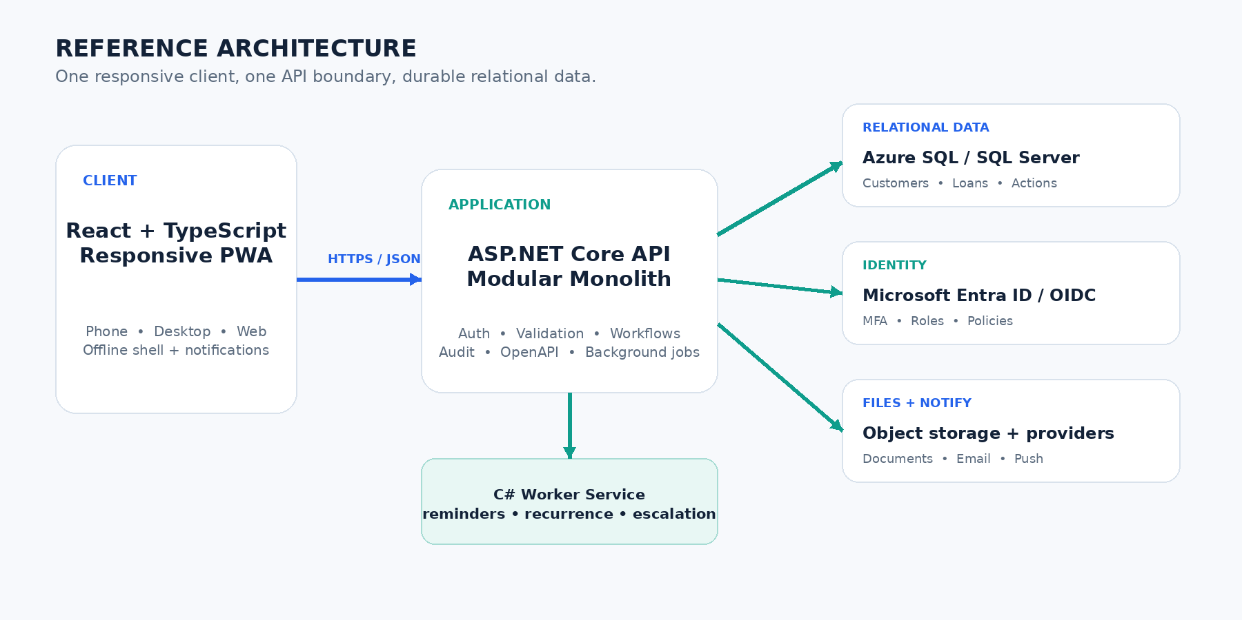

Technology baseline
LAYER | TECHNOLOGY | LANGUAGE
Client | React responsive PWA | TypeScript / HTML / CSS
API | ASP.NET Core on .NET LTS | C#
Data access | Entity Framework Core | C# / LINQ
Database | Azure SQL or SQL Server | SQL
Background work | .NET Worker Service | C#
Contracts | OpenAPI + generated client | JSON / TypeScript
Hosting | Azure App Service or containers | IaC + CI/CD

Application modules
MODULE | RESPONSIBILITY
Identity & Access | User context, roles, organization policies
Customers | Profiles, contacts, duplicate detection, archive
Loans | Loan records, stage transitions, ownership, history
Actions | Task lifecycle, assignment, recurrence, completion
Notifications | Templates, preferences, delivery, retries
Reporting | Dashboard queries, exports, data quality
Administration | Users, teams, templates, settings
Audit | Append-only security and business events

07

Data Design
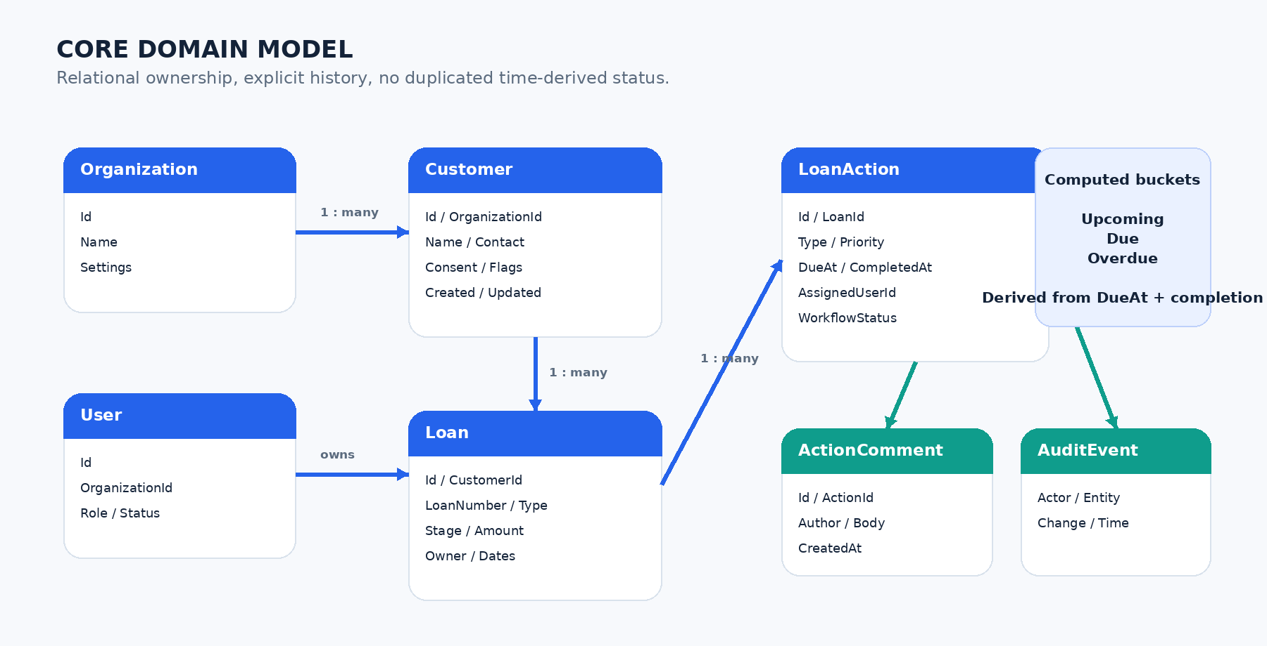

Minimum entity fields
ENTITY | REQUIRED FIELDS
Customer | Id, OrganizationId, ExternalRef?, FirstName, LastName, Email?, Phone?, Status, ConsentFlags, CreatedAt, UpdatedAt, RowVersion
Loan | Id, OrganizationId, CustomerId, LoanNumber, Type, StageId, Status, Amount?, OwnerUserId, OpenedAt?, TargetCloseAt?, ClosedAt?, RowVersion
LoanAction | Id, OrganizationId, LoanId, TypeId, Title, Description?, WorkflowStatus, Priority, AssignedUserId?, DueAt, CompletedAt?, CreatedAt, RowVersion
ActionEvent | Id, ActionId, EventType, ActorUserId, Reason?, OldValue?, NewValue?, OccurredAt
Notification | Id, ActionId?, RecipientUserId, Channel, TemplateKey, Status, Attempts, SentAt?, ErrorCode?
AuditEvent | Id, OrganizationId, ActorUserId?, EntityType, EntityId, Operation, ChangedFields, OccurredAt, CorrelationId

Database rules
- Use foreign keys and unique organization-scoped indexes.
- Store timestamps in UTC using DateTimeOffset-compatible columns.
- Use optimistic concurrency tokens on editable records.
- Archive business records; hard-delete only under approved retention workflows.
- Index open actions by OrganizationId, AssignedUserId, DueAt, Priority, and status.
- Keep audit and action event history append-only.
08

API and Contract Design

API standards
- REST over HTTPS with JSON request and response bodies.
- Version route or media contract before breaking changes.
- Generate OpenAPI at build time and publish with each environment.
- Generate a typed TypeScript client; do not hand-copy DTOs.
- Use consistent error objects with code, message, field errors, and correlation ID.
- Require pagination and server-side filtering for lists.

Primary endpoints
METHOD | ROUTE | PURPOSE
GET | /api/v1/dashboard | Action counts and prioritized work list
GET / POST | /api/v1/customers | Search or create customers
GET / PUT | /api/v1/customers/{id} | Read or update customer
GET / POST | /api/v1/customers/{id}/loans | List or create loans
GET / PUT | /api/v1/loans/{id} | Read or update loan
POST | /api/v1/loans/{id}/stage | Transition stage with reason
GET / POST | /api/v1/actions | Search or create actions
GET / PUT | /api/v1/actions/{id} | Read or update action
POST | /api/v1/actions/{id}/complete | Complete with outcome
POST | /api/v1/actions/{id}/reschedule | Change due date with reason
POST | /api/v1/actions/{id}/comments | Add comment
GET | /api/v1/audit | Authorized audit search

Error contract
{
"code": "action.concurrent_update",
"message": "The action changed after it was opened.",
"fieldErrors": {},
"correlationId": "..."
}
09

Action Rules and Automation

Time classification
BUCKET | RULE
Overdue | Incomplete and DueAt is before start of current business day
Due today | Incomplete and DueAt falls within current business day
Upcoming | Incomplete and DueAt is after today but within configured horizon
Later | Incomplete and DueAt is beyond upcoming horizon
Completed | CompletedAt is present or workflow status is Completed

Rule requirements
- Resolve business day using organization time zone, not browser time zone.
- Do not persist Upcoming, Due, or Overdue as authoritative state.
- Persist workflow status separately from time classification.
- Require a reason for cancellation, reopening, reassignment, and rescheduling.
- Make generation and reminder jobs idempotent.
- Use a unique job key to prevent duplicate recurring actions.

Initial background jobs
JOB | CADENCE | OUTPUT
Generate recurring actions | Hourly | Create missing action instances
Reminder delivery | Every 15 minutes | Send eligible in-app / email reminders
Overdue escalation | Hourly | Notify officer and configured lead
Daily digest | Organization-configured local time | Summarize due and overdue work
Data quality scan | Nightly | Find active loans without required next action

Idempotency rule
Every scheduled operation must be safe to execute more than once. Retries may change delivery history, never business outcome.

10

Security, Privacy, and Compliance
CONTROL | REQUIREMENT
Authentication | OIDC identity provider, MFA, short-lived tokens, secure session handling
Authorization | Policy-based access at every API boundary and query
Tenant isolation | OrganizationId enforced server-side and covered by automated tests
Transport | TLS only; HSTS; secure headers; restricted CORS
Storage | Encryption at rest; managed keys where available
Secrets | Managed secret store; never source control or client bundles
Audit | Append-only material events with actor, time, entity, and correlation ID
Data minimization | Store only business-required sensitive data
Retention | Configurable archive / purge policy with legal approval
Uploads | Type, size, and malware controls; private object storage
Operations | Central logs, alerting, backup tests, incident runbook

Threats to test
- Cross-tenant record access through modified IDs or filters.
- Privilege escalation through role or assignment updates.
- Mass assignment of server-managed fields.
- Stored script injection through notes and comments.
- Duplicate action generation and repeated notifications.
- Sensitive data exposure in logs, exports, URLs, or analytics.
Compliance checkpoint
Before production, legal and security owners must confirm applicable lending, privacy, retention, accessibility, and notification rules for the operating jurisdictions.

11

Quality Attributes and Operations
AREA | BASELINE
Availability | 99.9% monthly target excluding planned maintenance
Performance | P95 API reads < 500 ms; writes < 800 ms under agreed load
Page experience | Primary interactive view usable within 2.5 s on normal mobile network
Scale | Initial design supports 100k customers and 1M actions per organization tier
Recovery | Daily backup minimum; point-in-time recovery where supported
RPO / RTO | Provisional: 15 minutes / 4 hours; business approval required
Observability | Structured logs, traces, metrics, correlation IDs, job dashboards
Accessibility | WCAG 2.2 AA acceptance target
Compatibility | Current Chrome, Edge, Safari, Firefox; responsive 320 px+

Environments
ENVIRONMENT | PURPOSE | DATA
Local | Developer iteration | Generated or sanitized only
Development | Shared integration | Synthetic
Test / QA | Regression and acceptance | Synthetic representative dataset
Staging | Production-like release validation | Sanitized or synthetic
Production | Live operation | Restricted real data

Delivery pipeline
- Pull request: lint, compile, unit tests, dependency and secret scans.
- Build immutable client, API, and worker artifacts.
- Apply database migrations through controlled release step.
- Deploy to staging; run API, UI, accessibility, and smoke tests.
- Approve production release; deploy with rollback plan.
- Verify health, metrics, and critical workflow after deployment.
12

Testing and Delivery Plan

Test strategy
LEVEL | COVERAGE
Unit | Domain rules, classification, recurrence, authorization helpers, validation
Integration | Database mappings, tenant filters, transactions, background job idempotency
Contract | OpenAPI compatibility and generated TypeScript client
API | Authentication, authorization, validation, concurrency, pagination
UI | Core flows, responsive layouts, keyboard, error and empty states
End-to-end | Create customer → loan → action → reminder → completion
Security | Cross-tenant access, OWASP controls, dependency and secret scans
Performance | Dashboard, search, action queries, notification batches

Phased delivery
PHASE | DELIVERABLES | EXIT
0 — Foundation | Repo, CI/CD, environments, identity, design system, database shell, observability | Authenticated shell deploys to dev
1 — Core records | Customers, loans, search, roles, audit baseline | Officers manage assigned portfolio
2 — Action engine | Dashboard, action lifecycle, templates, recurrence, reminders | Daily work is operable end to end
3 — Hardening | Reporting, exports, accessibility, performance, security review, recovery drill | Production readiness approved
4 — Expansion | Integrations, richer files, advanced analytics, optional native wrapper | Prioritized by measured usage

Recommended team
ROLE | FOCUS
Product owner / SME | Rules, priority, acceptance, stakeholder decisions
Technical lead | Architecture, standards, review, delivery risk
2–3 full-stack engineers | React, API, data, tests
QA / automation engineer | Test plan, regression, accessibility
UX designer | Responsive flows, design system, usability
Security / DevOps support | Identity, cloud, pipeline, controls, operations

13

Development Start Checklist

Definition of Ready
- MVP scope and named product owner approved.
- Organization, team, ownership, and role rules decided.
- Loan stages and required action templates documented.
- Operating time zones, business-day rules, and reminder rules approved.
- Identity provider, hosting environment, and database selected.
- Data classification, retention, and export rules approved.
- Wireframes accepted for dashboard and three core detail pages.

MVP acceptance criteria
ID | ACCEPTANCE
AC-01 | Authorized officer can create and find a customer without duplicate confusion.
AC-02 | Authorized officer can create a loan and assign its owner and stage.
AC-03 | Required actions are generated once from the selected workflow template.
AC-04 | Dashboard correctly classifies open actions in organization local time.
AC-05 | Officer can complete, reschedule, comment, and reassign where authorized.
AC-06 | Unauthorized users cannot access another organization or restricted portfolio.
AC-07 | Material changes appear in audit history with actor and timestamp.
AC-08 | Reminder retries do not duplicate actions or corrupt completion state.
AC-09 | Core workflows pass phone, desktop, keyboard, and screen-reader testing.
AC-10 | Production deployment, backup restore, monitoring, and rollback are validated.

Open decisions
DECISION | OWNER | NEEDED BEFORE
Azure SQL vs. PostgreSQL | Technical lead | Schema implementation
Identity provider and user provisioning | Security / IT | Authentication work
Exact loan stages and transition rules | Product owner | Loan module
Action templates by loan type | Business SME | Action engine
Notification channels and consent rules | Product / Legal | Reminder release
Retention, archive, and export policy | Legal / Security | Production
Required external system integrations | Product / Architecture | Post-MVP roadmap

