# One-Class Slab Support Vector Machine

Rahul ReddyMuppidi-IIT2018103

Lokesh Naik- IIT2018104

A Pratyush-IIT2018124

Mallampalli Maheswarnath-IIT2018137

Gowni Sai Pavan-IIT2018139

B Tech(IT)-6th sem,IIIT Allahabad

**Introduction**

Abstract—This work introduces the one-class slab SVM (OC-SSVM), a one-class classifier that aims at improving the performance of the one-class SVM. The proposed strategy reduces the false positive rate and increases the accuracy of detecting

instances from novel classes.One-class classifiers are useful in applications where collecting samples from negative classes is challenging, but gathering instances from a target class is easy. An ensemble of one-

class classifiers can solve the open-set recognition problem.

1. **Explanation**

Unlike the OCSVM, the proposed OCSSVM approach encloses the normal region of the target class in feature space by using two parallel hyperplanes. When an

instance falls inside the normal region or the slab created by the hyperplanes, the OCSSVM labels it as a sample from the target class, and negative otherwise. Below picture provides an overview of this new algorithm.

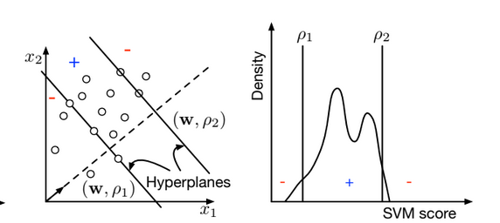

figure(1) [1]

Their strategy consists of mapping the data to a feature space via kernel methods. Subsequently, it finds a hyperplane in this new feature space that maximizes the margin between the origin and the data.

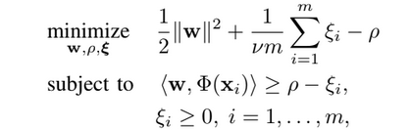

where m is the number of total training samples from the target class; ν is an upper-bound on the fraction of outliers and a lower bound on the fraction of support vectors (SV); xi is the i-th training sample feature vector; w is the hyperplane normal vector.

1. **Results**

We are using MCC for comparing results.

The Matthews correlation coefficient (**MCC**) or phi coefficient is used in **machine learning** as a measure of the quality of binary (two-class) classifications.

We can calculate the MCC from confusion matrix by using below formula

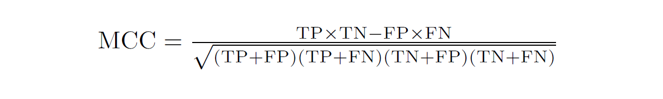

Results compared in below table

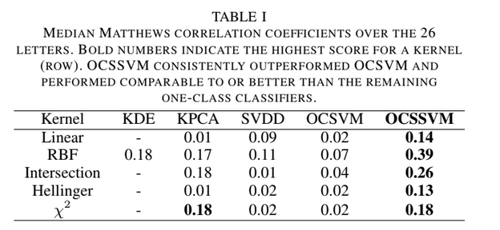

fig(2)[1]

The experiments trained a one-class classifier for each class in the datasets. Recall that one-class classifiers only use positive samples for training. To evaluate the performance of the one-class classifiers, the experiments used the remaining

classes as negative samples (i.e., novel class instances). The tested datasets are unbalanced in this setting since there are more instances from the negative class compared to the positive class.

1. **Conclusion**

Although it is trained only on positive samples we can still see improvement in performance.

**References**

[1]-Fragoso, Victor & Scheirer, Walter & Hespanha, Joao & Turk, Matthew. (2016). One-Class Slab Support Vector Machine.