SCIENTIFIC EQUATION PARSER & ANALYSIS TOOL

A PROJECT REPORT

In partial fulfilment of the requirements for the award of the degree of

BACHELOR OF TECHNOLOGY
in

COMPUTER SCIENCE AND ENGINEERING
By
G. V. RISHITHA (22001A0509)
N. NAGA SWETHA (22001A0541)
T. JYOTHIRMAYEE (22001A0504)

Under the guidance of
Dr. K. F. BHARATI M.Tech, Ph.D.
Professor of Computer Science and Engineering JNTUACEA
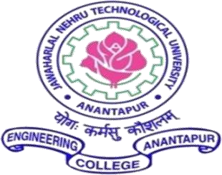

DEPARTMENT OF COMPUTER SCIENCE AND ENGINEERING JAWAHARLAL NEHRU TECHNOLOGICAL UNIVERSITY ANANTAPUR COLLEGE OF ENGINEERING (Autonomous)
ANANTHAPURAMU-515002 ANDHRA PRADESH
2025-26

JAWAHARLAL NEHRU TECHNOLOGICAL UNIVERSITY ANANTAPUR COLLEGE OF ENGINEERING (Autonomous)
Ananthapuramu, Andhra Pradesh-515002

DEPARTMENT OF COMPUTER SCIENCE AND ENGINEERING

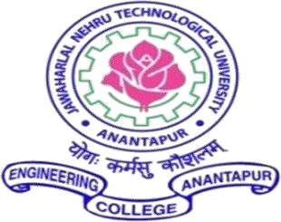

CERTIFICATE

This is to certify that the project entitled “SCIENTIFIC EQUATION PARSER & ANALYSIS TOOL” is a Bonafide work done by G. V. Rishitha – 22001A0509, N.Naga Swetha - 22001A0541, T. Jyothirmayee - 22001A0504, in partial fulfilment of the requirements for the award of the degree of Bachelor of Technology in Computer Science and Engineering, from Jawaharlal Nehru Technological University Anantapur College of Engineering, Ananthapuramu during the year 2025 -2026.

Signature of Project Guide Signature of H.O.D

Dr. K.F. Bharati, M.Tech, Ph.D., Dr. R.Raja Sekhar, M.Tech, Ph.D.,
Professor, Professor & H.O.D
Department of CSE, Department of CSE,
JNTUA College of Engineering, JNTUA College of Engineering,
Ananthapuramu– 515002 Ananthapuramu– 515002

Internal Examiner External Examiner

VISION & MISSION

Vision:
To become a center of excellence in computer science education and research by imparting students with latest technical skills through high quality teaching methodologies supplemented with practical orientation to face the challenges in the field of computer science and engineering for the benefit of the society.

Mission:
- To educate and train next generation computer professionals with strong theoretical and practical foundations in computer science discipline
- To amplify the hidden technical skills in the graduates by cultivating research and apply attitude in the field of computer science and engineering.
- To instill value-based professional behavior and strong ethical morals in the graduates and motivate them to apply their knowledge to the benefit of the society

