AI AGENT

An AI agent is a computer program or system that can **perceive its environment**, make decisions, and take actions to achieve specific goals using artificial intelligence techniques.

Ex: Automate mails

Online shopping platform can recommend products, answer customer questions, process orders.

1.logical AI 2.data-driven AI

**In Simple terms:**

An AI agent is like a smart helper that:

1.Senses what’s happening around it (input/data).

2.Thinks about what it means (processes the data).

3.Acts based on that thinking to do something useful.

**Key Components of an AI Agent:**

1. **Perception** – Collects data from the environment (e.g., sensors, user input).
2. **Decision-making** – Uses algorithms to decide what to do next.
3. **Action** – Executes tasks to influence the environment.
4. **Learning (optional)** – Improves performance over time by learning from data or experience.

**Examples:**

* A self-driving car navigating traffic.
* A chatbot handling customer queries.
* A virtual assistant like Siri or Alexa.

Types of agents:

**1. Simple Reflex Agents**

* **How they work**: Respond directly to current perceptions using pre-defined rules ("if condition, then action").
* **Example**: A thermostat that turns on heating if the temperature drops below a set point.

**2. Model-Based Reflex Agents**

* **How they work**: Use an internal model of the world to handle more complex environments and keep track of unobservable states.
* **Example**: A robot vacuum that remembers the layout of a room to clean more efficiently.

**3. Goal-Based Agents**

**How they work**: Decide actions by considering future outcomes and selecting actions that help achieve specific goals.

* **Example**: A chess-playing AI that plans several moves ahead to win the game.

**4. Utility-Based Agents**

* **How they work**: Use a "utility function" to measure the desirability of different states and choose the one that maximizes overall satisfaction.
* **Example**: A ride-hailing app agent that assigns drivers to maximize efficiency and user satisfaction.

**5. Learning Agents**

* **How they work**: Can learn from experience and improve their performance over time using feedback.
* **Example**: A recommendation system that gets better as it learns your preferences.

N8n is an opensource workflow automation tool that allow us to connect various apps and services without writing much(or any) code.

**Key Features of n8n:**

* **Node-based workflow builder**: Create workflows using "nodes" that represent different services, functions, or logic.
* **Supports 350+ integrations**: Connects to APIs, databases, CRMs, cloud services (like Google Sheets, Slack, GitHub, etc.).
* **Custom code support**: Write custom JavaScript in "Function" nodes.
* **Triggers and Webhooks**: Start workflows from events like HTTP requests, cron jobs, or app-specific triggers.
* **Self-hosted or cloud**: You can run it locally, on your server, or use n8n.cloud.

**Task : create workflow to send top 5 tech news links to the mail**

* Manual or Schedule->(cronjobs)
* Process start
* Get the news from internet🡪web strapping
* Editing the content
* For changing data as per next step (top 5)
* Mail send

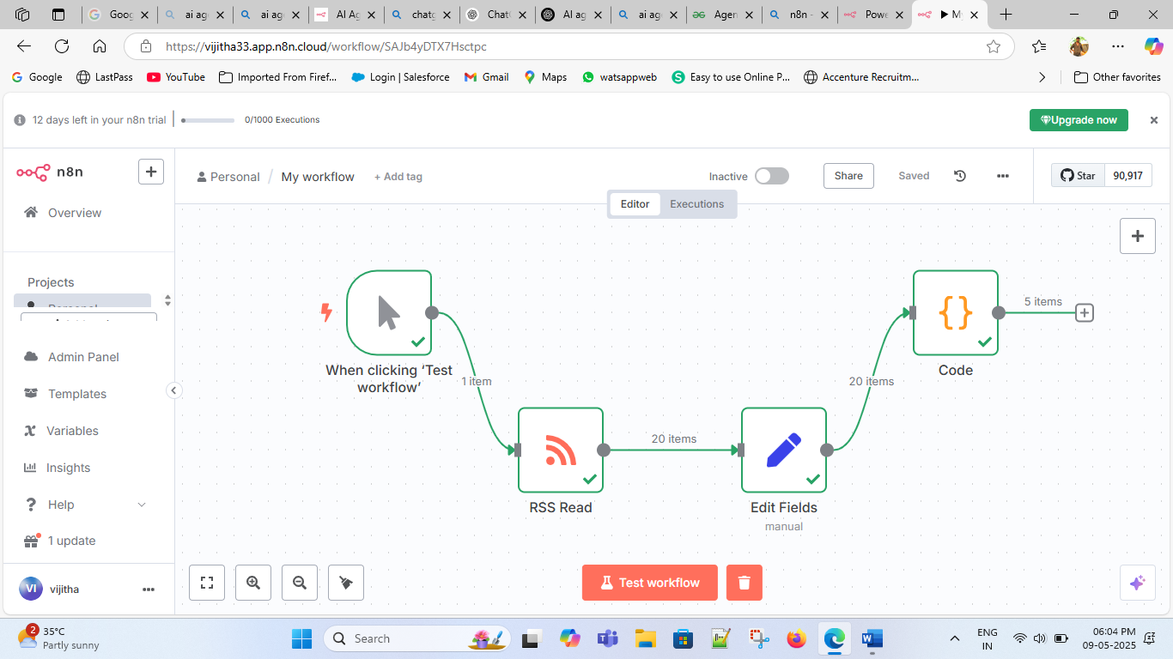

Step 1: start workflow by selecting Trigger node

Step 2: To feed “url” into the rss feed which will provide top tech news from the internet.

Step 3: Now we need to select the required fields in the edit fields node which we will get in the display

Step 4: now we need to write code to get top 5 tech news as a single item which we need to send to mail to get all requred fields.

Step: We need to select Mail node to send mail to the specifc mail address.