SE LAB GROUP ASSIGNMENT 1 REPORT TEMPLATE
Software Engineering | Smart Ticketing System (Ticket Vendor Machine) | Sem 1_2627 | Template for the file [YourID]_[YourStudentName].docx
Marking of this report
No. | Task | Marks | Section in this report
1 | Clarification Q&A (Excel) | 5 | 2.1
2 | Requirements Specification | 15 | 2.2
3 | Use Case Modeling | 10 | 3.1
4 | Activity Diagrams | 10 | 3.2
5 | Detailed System Modeling: "Buy a Ticket" | 15 | 3.3
6 | UI/UX Design | 5 | 4.1
7 | Architectural Design | 10 | 4.2, 4.3
8 | Visual Studio Engineering (Model-to-Code) | 10 | 5.1
9 | GitHub & AI Tooling (Copilot) | 10 | 5.2
10 | Demo Application (C# and MSSQL) | 10 | 5.3
Total |  | 100 | Weight: 20% of QT2 (plus 1 bonus point towards the Final Project for exceptional work)

How to use this template
- Keep all titles and numbering. Replace every blue [bracketed placeholder] with your own content, and delete all grey "Guidance" paragraphs, unused figure frames and this instruction page before you submit.
- Keep the headings as real Word headings (the navigation pane must work). Update the table of contents before submitting (right-click, Update Field).
- Group of 3 to 5 students. Section 7 must list the % contribution of each member (total 100%) and must match your readme.txt.
- Submit [YourID]_[YourStudentName].docx, readme.txt (GitHub link and other links such as Figma and database script instructions) and the % contribution of each member. All final artifacts are also uploaded to the shared GitHub repository.
- The report must also address the content of "LabGroupAssignment1.pdf". Use the checklist in section 6 to show where each item is covered.
- Keep your diagrams consistent with each other: the rubric rewards diagrams that are syntactically correct, logically sound and aligned. Use the consistency table in section 3.4.
- The workbook A1_Team_Workbook (Q&A, requirements, prompt log, commit log, progress log) is your working record and the source for several tables here.
Smart Ticketing System
Ticket Vendor Machine (TVM)
Software Engineering Lab Group Assignment 1 – Sem 1_2627
Group 08
- 524H0205: Nguyen Le Quang Vinh
- 524H0151: Huynh Bao Duy
- 524H0146: Nguyen Gia Binh
- 524H0201: Bui Ngoc Thanh Truc
GitHub repository | Figma / other link | Date submitted
https://github.com/Gangvinh/Assignment1-10--Software-Technology | [link] | 31st October 2026

Table of Contents
Table of Contents 4
1. Introduction 6
1.1 Purpose and Scope 6
1.2 Problem Statement in Our Own Words 6
1.3 Team and Roles 6
2. Phase 1: Requirements Engineering (20 marks) 7
2.1 Clarification Q&A (5 marks) 7
2.2 Requirements Specification (15 marks) 7
2.2.1 Functional Requirements 7
2.2.2 Non-Functional Requirements 7
2.2.3 Domain Requirements 8
3. Phase 2: UML Modeling & System Design (35 marks) 9
3.1 Use Case Modeling (10 marks) 9
3.1.1 Use Case Diagram 9
3.1.2 Actors and Use Case List 9
3.1.3 Use Case Descriptions 9
3.2 Activity Diagrams (10 marks) 10
3.2.1 Passenger Buys a Ticket at the TVM 10
3.2.2 Communication with External Payment Gateways 10
3.3 Detailed System Modeling: Main Use Case "Buy a Ticket" (15 marks) 10
3.3.1 Sequence Diagram 10
3.3.2 State Chart Diagram 10
3.3.3 Class Diagram (Domain Model) 10
3.4 Model Consistency Check 10
4. Phase 3: UI/UX & Architecture (15 marks) 12
4.1 UI/UX Design (5 marks) 12
4.2 Architectural Design (10 marks) 12
4.2.1 Architecture Diagram 12
4.2.2 Deployment Diagram 12
5. Phase 4: Implementation, Tooling & Demo (30 marks) 13
5.1 Visual Studio Engineering: Model-to-Code (10 marks) 13
5.1.1 Forward Engineering (Model to Code) 13
5.1.2 Backward Engineering (Code to Model) 13
5.1.3 Code Map 13
5.2 GitHub & AI Tooling (10 marks) 13
5.2.1 Source Control 13
5.2.2 AI Assistance: Copilot Prompt Documentation 14
5.2.3 Reflection on AI Use 14
5.3 Demo Application (10 marks) 14
6. Checklist for "LabGroupAssignment1.pdf" 16
7. Contribution of Each Member 16
8. Conclusion and Lessons Learnt 16
References 16
Appendix 17
Appendix A: readme.txt 17
Appendix B: Full-size Diagrams 17

1. Introduction

1.1 Purpose and Scope
This report specifies the requirements, UML design, UI/UX, architecture, and implementation of a Ticket Vendor Machine (TVM) within a Smart Ticketing System. The scope covers a single self-service kiosk capable of route selection, card and QR wallet payments, and ticket printing. Out of scope: central fare policy administration, fleet scheduling, and hardware manufacturing.

1.2 Problem Statement in Our Own Words
A TVM is an automated kiosk that sells public transport tickets (Bus, MRT). A passenger presses Start, selects a destination, and pays via Credit Card (EMV tap) or a Digital Wallet (Momo/VNPay/ZaloPay via QR). The original brief is highly ambiguous regarding payment failure semantics, ticket types, printer errors, and network timeouts. Our design resolves these by defining strict states (e.g., ReconciliationRequired for gateway timeouts), implementing an IdempotencyKey to prevent duplicate charges, and establishing a fallback on-screen ticket if printing fails.

1.3 Team and Roles
No. | Name | Student ID | Main responsibilities
1 | Nguyễn Lê Quang Vinh | 524H0205 | Team Leader, coordinate the project, manage requirements and report progress.
2 | Huỳnh Bảo Duy | 524H0151 | Analyze system requirements, create Use Case Diagram and Activity Diagrams.
3 | Nguyễn Gia Bình | 524H0146 | Design UI/UX, create UML diagrams and system architecture.
4 | Bùi Ngọc Thanh Trúc | 524H0201 | Develop the C# application, design the MSSQL database and manage GitHub repository.

2. Phase 1: Requirements Engineering (20 marks)

2.1 Clarification Q&A (5 marks)
ID | Question to the stakeholder | Assumed answer | Why it matters | Requirement ID
Q01 | Which modes of transport and routes are sold? | Bus and MRT products in a central active catalog; no real-time trip planner. | Defines catalog schema and excludes live scheduling from scope. | FR-01
Q02 | How is fare calculated and represented? | Catalog returns fixed VND integer fare per destination/product; no fractional currency. | Drives FareVnd as long in domain + DB; forbids float; fixes rounding rule. | FR-01, DR-01
Q03 | Can users buy multiple tickets? | Yes, up to 10 per order; one barcode per ticket unit. | Multiplies ticket rows per order; adds Quantity bound 1-10. | FR-02, DR-02
Q04 | Does TVM read/store card data? | EMV terminal handles capture; TVM stores provider token/reference only, never PAN/CVV. | Justifies IPaymentGateway adapter; keeps PCI scope small. | FR-05, NFR-05
Q05 | Which payment QR format/provider? | Provider adapter supports configured providers; provider returns a QR payload + expiry. | Decouples TVM from specific provider; adapter pattern in architecture. | FR-06, DR-09
Q06 | How long does QR remain valid? | 120 seconds, configurable; expired orders reconciled before retry. | Adds ExpiresAt to Payment; drives countdown UI + reconcile flow. | FR-06, DR-07
Q07 | How do we know payment succeeded? | Verified signed callback OR authenticated status query with matching order/amount/currency. | Forces signature + amount match in PaymentService. | FR-07, DR-03
Q08 | What if gateway times out after charging? | Mark Pending/Unknown; query status; never issue ticket until confirmed success. | Adds ReconciliationRequired state; forbids inferring success from timeout. | FR-07, DR-07
Q09 | Can callback be delivered more than once? | Yes; callbacks idempotent by provider event/reference + order key. | Adds IdempotencyKey to Payment; DB unique constraint. | FR-11, DR-05
Q10 | What if payment succeeds but printer fails? | Persist Paid + TicketPending; retry print or show recovery instructions; alert operator. | Adds PrinterFault state; ticket row persisted; fallback on-screen UI. | FR-08, DR-04
Q11 | Can passenger cancel in-flight payment? | Only before confirmed payment; request provider cancel where supported and reconcile. | Defines Cancelled vs ReconciliationRequired transition. | FR-10
Q12 | What counts toward uptime? | Monthly 99.5% sales-service availability, excluding planned maintenance + provider outages. | Adds NFR-02; justifies health heartbeat every 60 s. | NFR-02
Q13 | What response targets should be used? | Local feedback 0.5 s p95; catalog 2 s p95; initiation ack 3 s p95. | Adds NFR-01 response-time metrics; drives APM instrumentation. | NFR-01
Q14 | Which languages and accessibility needs? | Vietnamese and English; high contrast, large controls, clear status text. | Adds NFR-06; fixes minimum touch target 44 px and contrast ratio. | FR-16, NFR-06
Q15 | What operator functions are needed? | Health check, paper status, network/gateway status, error log, maintenance mode. | Adds UC-07 Maintain Machine; operator diagnostics screen. | FR-15, FR-17
Q16 | How long are orders retained? | 2 years for financial audit; prototype uses configurable retention; no sensitive card data. | Adds DR-07 retention rule; fixes DB schema and purge job. | DR-08, NFR-05
Q17 | Can offline sales occur? | No; disable new sales if catalog/payment connectivity is unavailable. | Disables Start flow when offline; catalog served from local cache only. | FR-01, NFR-04
Q18 | How are APIs protected? | TLS 1.2+, managed secrets, least privilege, signed callback verification, audit logs. | Adds NFR-05; fixes callback signature + secret rotation + audit. | NFR-05
Q19 | Where do application and database run? | TVM UI/device adapters locally; central API and SQL Server; outbound provider connections. | Defines deployment diagram; central API + local encrypted cache. | NFR-04
Q20 | May payment be simulated? | Yes for classroom demo if visibly identified as simulation; no live financial transactions. | Allows mock IPaymentGateway implementation; demo shows "SIMULATED" banner. | DR-05
Q21 | What ticket types are sold? | Three types: Single, Return, Day-Pass; validity 4 h / 24 h / end-of-day. | Adds TicketType enum; adds validUntil to Ticket; affects fare matrix. | FR-02, DR-01
Q22 | Are there discounted passenger categories? | Adult 100%, Student 70%, Senior ($≥$60) 50%, Child ($<$6) free; honour-based. | Adds PassengerCategory enum; fare lookup (route, type, category). | FR-03, DR-01
Q23 | What is the refund policy? | Refund only on system error (double charge, ticket not issued); no refund for change of mind. | Adds auto-refund path in PaymentService; audit requirement. | FR-07, DR-06
Q24 | What if the passenger walks away mid-transaction? | 90 s inactivity timeout $→$ cancel pending, release lock, reset to Idle. | Adds Timer actor; Cancelled transition; releases payment lock. | FR-10, FR-13
Q25 | Do tickets expire? | Yes - tied to ticket type (Q21); printed on ticket + encoded in barcode. | Adds validUntil to Ticket; barcode format gains expiry; gate must decode. | FR-08, DR-06
Hidden complexities we uncovered
_ Payment-failure semantics is the hardest part: The original brief says nothing about retries, refunds, or idempotency. These force the system to carry an IdempotencyKey on every payment and define a strict ReconciliationRequired state.
_ Ticket printing can fail after the charge: Without Q10, the design would silently lose revenue. We added a fallback on-screen ticket and an operator alert queue.
_ Ticket types and discounts were omitted: The brief only says "tickets". Q21 and Q22 revealed the need for a multi-dimensional FareMatrix (Single/Return/Day-Pass and Adult/Student/Senior).
_ Regulation is real: Q12, Q16, and Q18 uncovered strict requirements for PCI-DSS (no PAN storage) and Vietnamese privacy law, which directly impacted the Database schema and API security.

2.2 Requirements Specification (15 marks)

2.2.1 Functional Requirements
ID | Requirement ("The system shall…") | Priority | Use case | Source (Q&A)
FR-01 | Display available destinations and current fares after Start. | Must | UC-02 | Q01, Q02
FR-02 | Allow the passenger to choose a destination, ticket type (Single/Return/Day-Pass), and quantity (1–10). | Must | UC-01, UC-02 | Q03, Q21
FR-03 | Calculate fare from FareMatrix and apply discounts (Student 70%, Senior 50%, Child free). | Must | UC-01 | Q22
FR-04 | Display total price and ask the passenger to select Card or QR Wallet payment. | Must | UC-01 | Q05
FR-05 | For card payment, request authorization through the secure terminal and receive approved/declined/unknown status. | Must | UC-03 | Q04
FR-06 | For QR payment, create a unique order and display a gateway-generated QR code with an expiry countdown (120s). | Must | UC-04 | Q06
FR-07 | Accept asynchronous gateway status and verify authenticity before marking an order paid. | Must | UC-04 | Q07, Q08, Q09
FR-08 | Issue and print a barcode ticket only after confirmed payment. | Must | UC-06 | Q10, Q25
FR-09 | Show a clear success receipt or actionable failure/cancel/timeout message. | Must | UC-01 | Q11
FR-10 | Allow the passenger to cancel before payment is confirmed; implement 90s inactivity timeout. | Must | UC-05 | Q11, Q24
FR-11 | Prevent duplicate charge/ticket issuance for repeated callbacks or retries (idempotency). | Must | UC-03, UC-04 | Q09
FR-12 | Record order, payment, ticket, timestamps, terminal ID, and outcome for audit without storing sensitive card credentials. | Must | All | Q04, Q18
FR-13 | Return to the welcome screen after a configurable idle timeout and clear session data. | Must | UC-05 | Q24
FR-14 | Reprint a lost ticket within 24 hours when verified by ticket code + masked card. | Should | UC-08 | Q10
FR-15 | Provide an operator maintenance mode (auth by service card + PIN) that blocks new sales. | Should | UC-07 | Q15
FR-16 | Support English and Vietnamese with on-screen switch within 300 ms without reload. | Should | UC-01 | Q14
FR-17 | Send a health heartbeat to the backend every 60 s and raise an alert after 3 consecutive failures. | Must | UC-07 | Q15

2.2.2 Non-Functional Requirements
ID | Category | Measurable requirement | Measurement method | Related FR
NFR-01 | Response time | Local input feedback $≤$ 0.5s (p95); catalog load $≤$ 2s (p95); result display $≤$ 3s (p95) / $≤$ 5s (p99). | APM traces over 30 days | FR-01, FR-04, FR-08
NFR-02 | Availability | Monthly sales-service availability $≥$ 99.5% (excluding planned maintenance). | Monthly uptime report | All
NFR-03 | Reliability | 100% of unresolved orders reconciled within 5 min; auto-refund if debited but no ticket in 24h. | Daily reconciliation report | FR-07, FR-11
NFR-04 | Reliability | MTBF $≥$ 2,000 hours; MTTR $≤$ 30 minutes; RTO $≤$ 4h; RPO = 0. | Incident log over 12 months | All
NFR-05 | Security | TLS $≥$ 1.2; 0 PAN/CVV stored; 100% callback signature verification; PCI-DSS SAQ-A compliant. | ASV scan + code review | FR-05, FR-07, FR-12
NFR-06 | Usability | Vietnamese/English; touch targets $≥$ 44px; contrast ratio $≥$ 4.5:1; timeout warning shown. | Usability test + contrast checker | FR-16, FR-13
NFR-07 | Maintainability | Test coverage $≥$ 80% for payment/ticket modules; new provider onboarding $≤$ 5 person-days. | CI coverage report | All
NFR-08 | Scalability | Backend handles $≥$ 500 TPS city-wide; kiosk handles 1 concurrent user. | Load test (k6/JMeter) | All

2.2.3 Domain Requirements
ID | Domain requirement | Domain / source | Related FR / NFR
DR-01 | Fares are non-negative VND integers set by the Transport Authority. | Transport policy | FR-01, FR-03
DR-02 | Order contains 1–10 ticket units for one destination/product. | Business rule | FR-02
DR-03 | Payment amount and currency must match the order before accepting success. | Payment rule | FR-07
DR-04 | Only a verified Paid order may produce ticket records. | Financial rule | FR-08
DR-05 | One idempotency key identifies one logical payment attempt. | Payment rule | FR-11
DR-06 | Ticket barcode is unique and must not encode sensitive personal/payment data (conform to VDV format). | Transit standard | FR-08, Q25
DR-07 | Unknown gateway status remains Pending until authoritative reconciliation. | Payment rule | FR-07, NFR-03
DR-08 | Personal data handling must comply with Nghị định 13/2023/NĐ-CP. | Vietnamese law | NFR-05
DR-09 | Bank QR must conform to VietQR / NAPAS 247; Digital Wallet supports Momo, VNPay, ZaloPay. | Provider standard | FR-06

3. Phase 2: UML Modeling & System Design (35 marks)

3.1 Use Case Modeling (10 marks)

3.1.1 Use Case Diagram
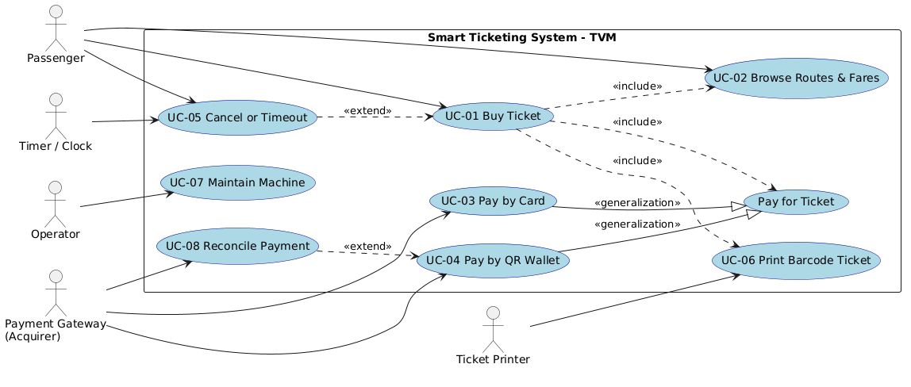

3.1.2 Actors and Use Case List
ID | Use case | Primary actor | Short description
UC-01 | Buy Ticket | Passenger | Main end-to-end purchase flow.
UC-02 | Browse Routes and Fares | Passenger | Browse available destinations, ticket types, and prices.
UC-03 | Pay by Card | Passenger, Acquirer | Insert/tap card, authorize, confirm.
UC-04 | Pay by QR Wallet | Passenger, Gateway | Scan dynamic QR to pay.
UC-05 | Cancel or Timeout | Passenger, Timer | Abort before payment confirmed; 90s inactivity reset.
UC-06 | Print Barcode Ticket | (System), Printer | Print paper ticket + receipt.
UC-07 | Maintain Machine | Operator | Health check, load paper, block sales (maintenance).
UC-08 | Reconcile Payment | Gateway, Ops | Query unresolved orders, transition to final state safely.

3.1.3 Use Case Descriptions
UC-01: Buy Ticket
Item | Content
Use case ID and name | UC-01 Buy Ticket
Primary actor / secondary actors | Passenger / Payment Gateway, Printer
Related requirements | FR-01, FR-02, FR-04, DR-02
Pre-conditions | TVM is in Idle state; active catalog is available.
Trigger | Passenger presses Start.
Main flow | 1. Passenger selects destination and quantity.  2. TVM calculates total.  3. Passenger selects payment method.  4. TVM persists pending order and requests payment.  5. TVM verifies final approval.  6. TVM creates one ticket per unit.  7. TVM prints ticket and shows receipt.
Alternate flows | Step 1: No routes → show unavailable, disable purchase.
Exception flows | Step 5: Declined/Expired → offer retry/cancel.  Step 5: Unknown result → keep pending and reconcile (do not issue).  Step 7: Printer failure → persist ticket pending, show recovery path.
Post-conditions | Order is paid once; ticket rows exist; result is shown.
UC-02: Browse Routes & Fares
Item | Content
Use case ID and name | UC-02 Browse Routes & Fares
Primary actor / secondary actors | Passenger / Fare Catalog Service
Related requirements | FR-01, FR-02, DR-01
Pre-conditions | TVM is online; catalog has active entries.
Trigger | Passenger presses Start.
Main flow | 1. TVM requests active routes from catalog service.  2. TVM displays destinations, ticket types, and fares.  3. Passenger scrolls/searches.  4. Passenger selects a valid route.
Alternate flows | Step 2: Catalog unavailable → show "Service unavailable" and disable purchase.
Exception flows | None.
Post-conditions | Passenger can proceed to select a valid route.
UC-03: Pay by Card
Item | Content
Use case ID and name | UC-03 Pay by Card
Primary actor / secondary actors | Passenger / Acquirer
Related requirements | FR-05, NFR-05
Pre-conditions | Order total is displayed; terminal is ready.
Trigger | Passenger selects "Pay by Card".
Main flow | 1. Request card interaction through terminal.  2. Send authorization to acquirer.  3. Validate response against order and amount.  4. Persist final status (Paid/Declined).
Alternate flows | Step 3: Decline → explain and allow another method.
Exception flows | Step 2: Timeout → mark ReconciliationRequired; never infer success.
Post-conditions | Order transitions to Paid only after verified approval. Never persist PAN/CVV.
UC-04: Pay by QR Wallet
Item | Content
Use case ID and name | UC-04 Pay by QR Wallet
Primary actor / secondary actors | Passenger / Payment Gateway
Related requirements | FR-06, FR-07, DR-09
Pre-conditions | Pending order exists; gateway is reachable.
Trigger | Passenger chooses "Pay by QR Wallet".
Main flow | 1. TVM creates provider order with idempotency key.  2. Gateway returns QR and expiry.  3. TVM shows QR and countdown.  4. TVM receives signed callback or queries status.  5. TVM verifies provider, amount, and signature.  6. TVM persists final status.
Alternate flows | Step 4: Passenger cancels on phone → mark Expired/Failed, allow retry.
Exception flows | Step 4: Unknown result → keep pending, trigger UC-08 Reconcile.  Step 5: Signature mismatch → reject, log alert.
Post-conditions | Confirmed paid order can proceed to ticket issuance.
UC-05: Cancel or Timeout
Item | Content
Use case ID and name | UC-05 Cancel or Timeout
Primary actor / secondary actors | Passenger / Timer
Related requirements | FR-09, FR-10, FR-13
Pre-conditions | Order is not confirmed Paid.
Trigger | Passenger taps Cancel OR 90s inactivity limit reached.
Main flow | 1. Request provider cancellation (if supported).  2. Record Cancelled or pending reconciliation.  3. Clear session view and reset to Idle.
Alternate flows | Step 1: If provider already confirms payment → do not mark cancelled; continue recovery/issuance.
Exception flows | None.
Post-conditions | Session ends safely; no unconfirmed ticket is issued.
UC-06: Print Barcode Ticket
Item | Content
Use case ID and name | UC-06 Print Barcode Ticket
Primary actor / secondary actors | Ticket service / Printer
Related requirements | FR-08, DR-06
Pre-conditions | Payment is Paid and ticket issuance is not already completed.
Trigger | Payment confirmed (Paid).
Main flow | 1. Create unique barcode ticket records.  2. Send print job to thermal printer.  3. Record success.
Alternate flows | None.
Exception flows | Step 2: Printer failure → retain ticket and order, retry safely, alert operator; avoid duplicate paid order.
Post-conditions | Exactly one ticket record per purchased unit, printable or recoverable.
UC-07: Maintain Machine
Item | Content
Use case ID and name | UC-07 Maintain Machine
Primary actor / secondary actors | Operator
Related requirements | FR-15, FR-17
Pre-conditions | Operator is authenticated (service card + PIN).
Trigger | Operator taps "Maintenance Mode" on the hidden admin screen.
Main flow | 1. Operator reviews terminal, printer, and network status.  2. Operator enters maintenance mode (blocks new sales).  3. Operator loads paper or runs self-test.  4. Operator exits maintenance; TVM returns to Idle.
Alternate flows | Step 2: Operator chooses not to enter maintenance → exits admin.
Exception flows | Step 1: Failed self-test → mark affected component, log error.
Post-conditions | Auditable maintenance record; machine returns to service.
UC-08: Reconcile Payment
Item | Content
Use case ID and name | UC-08 Reconcile Payment
Primary actor / secondary actors | Payment Gateway / Operations
Related requirements | FR-07, FR-11, NFR-03
Pre-conditions | Order is in Pending/Unknown state (e.g., timeout).
Trigger | Timer (e.g., 5 mins) OR Gateway callback arrives late.
Main flow | 1. TVM queries gateway for final status.  2. Gateway returns Paid/Failed/Expired.  3. TVM validates order reference and amount.  4. TVM updates database to final state.  5. If Paid → trigger UC-06 (Print Ticket).
Alternate flows | Step 2: Status remains pending → retry later (exponential backoff).
Exception flows | Step 2: Gateway unreachable → alert Ops, keep pending.
Post-conditions | Unresolved order transitions to a final state safely.

3.2 Activity Diagrams (10 marks)

3.2.1 Passenger Buys a Ticket at the TVM
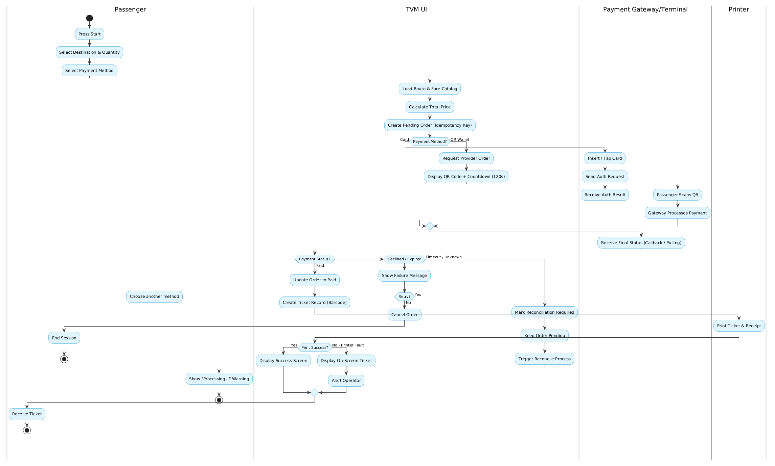

3.2.2 Communication with External Payment Gateways
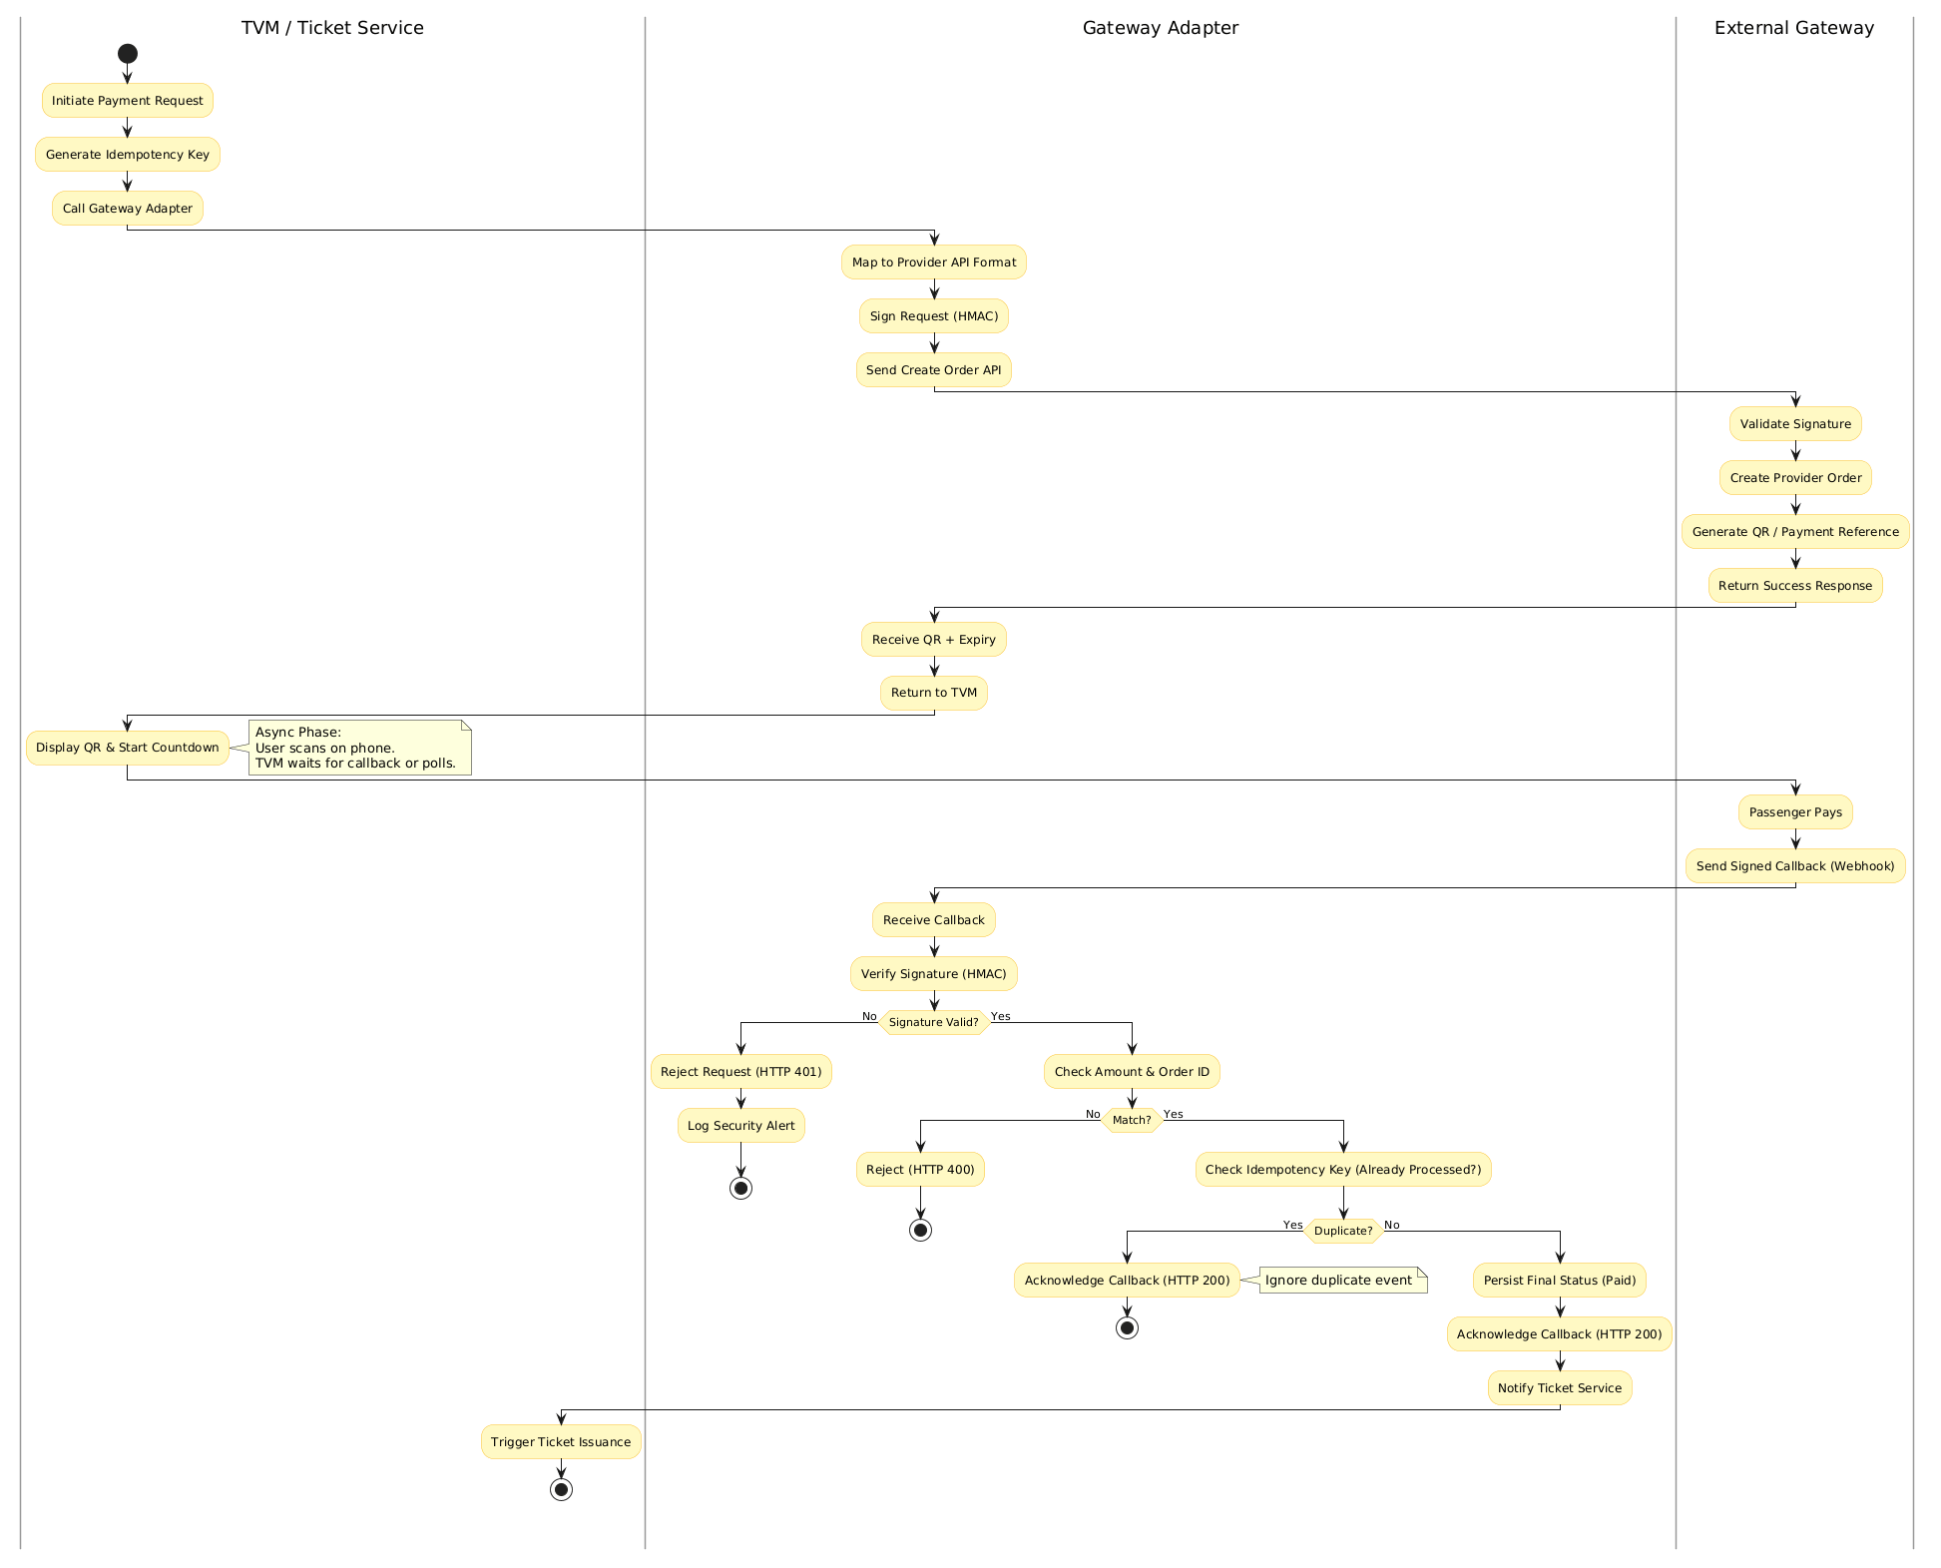

3.3 Detailed System Modeling: Main Use Case "Buy a Ticket" (15 marks)

3.3.1 Sequence Diagram
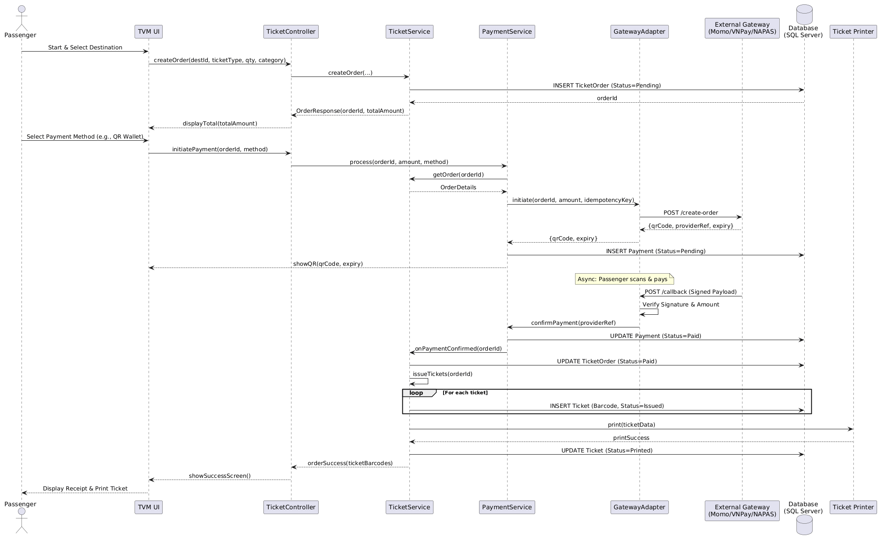

3.3.2 State Chart Diagram
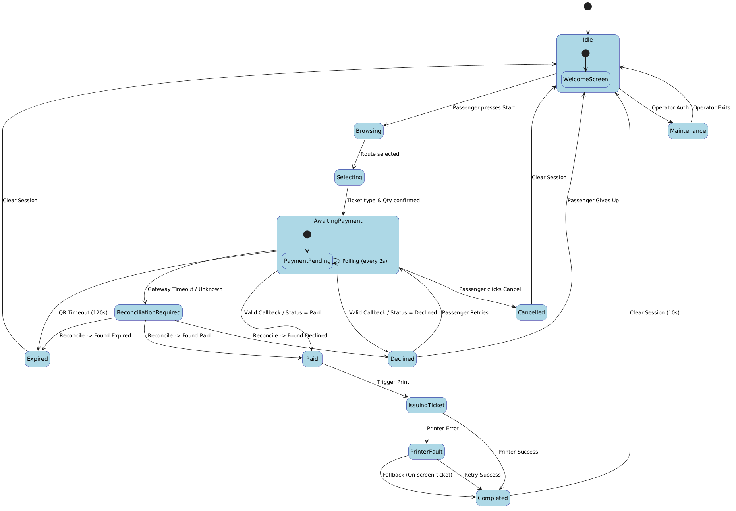

3.3.3 Class Diagram (Domain Model)
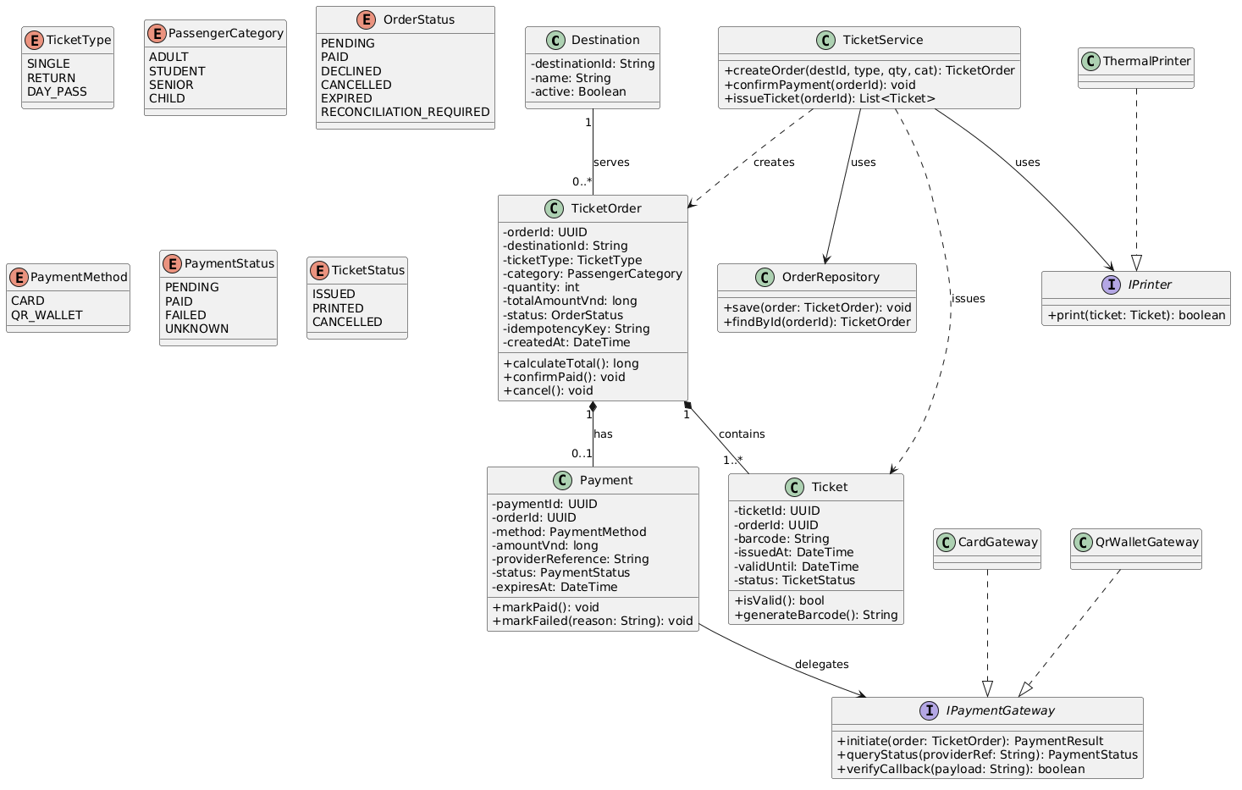
Class | Key attributes | Key methods | Relationships
Destination | destinationId, name, active | (None) | Serves 0..* TicketOrder
TicketOrder | orderId, destinationId, ticketType, category, quantity, totalAmountVnd, status, idempotencyKey, createdAt | calculateTotal(), confirmPaid(),  cancel() | Has 0..1 Payment  Contains 1..* Ticket
Payment | paymentId, orderId, method, amountVnd, providerReference, status, expiresAt | markPaid(),  markFailed() | Delegates to 1 IPaymentGateway
Ticket | ticketId, orderId, barcode, issuedAt, validUntil, status | isValid(),  generateBarcode() | (Belongs to TicketOrder)
TicketService | (None) | createOrder(), confirmPayment(), issueTicket() | Creates TicketOrder  Issues Ticket  Uses OrderRepository  Uses IPrinter
IPaymentGateway (Interface) | (None) | initiate(),  queryStatus(), verifyCallback() | Implemented by CardGateway, QrWalletGateway
IPrinter (Interface) | (None) | print() | Implemented by ThermalPrinter

3.4 Model Consistency Check
Consistency check | Diagrams involved | Done
Every use case in the diagram has a description, and every description is in the diagram | Use case diagram / descriptions | Yes
Every step of the main flow appears in the activity diagram | Descriptions / activity | Yes
Objects and messages in the sequence diagram exist as classes and methods in the class diagram | Sequence / class | Yes
State names and transitions match the events in the sequence diagram | State chart / sequence | Yes
Payment gateway steps match between the two activity diagrams and the sequence diagram | Activity / sequence | Yes
Requirement IDs are cited in the use cases | Requirements / use cases | Yes
The class diagram matches the C# code generated in 5.1 | Class / code | Yes

4. Phase 3: UI/UX & Architecture (15 marks)

4.1 UI/UX Design (5 marks)
Screen | Name / purpose | Linked use case step | Tool and link
S01 | Welcome / Language | UC-01 Step 1: Start | Planttext- RP2_2i8m4CPtmNUuNRJQKKAeI94YEjYWWoYazOZ1c4eR1_zqzfrqy5by4viewY248zpzxhxlBYWCpqt1bQdNJerw3U049A7ng3TXmAB-C6JHU42yX4BfgaqRM-wxh41Io2Ds_JQTeKgpBHBF9gXjAD-G8pe-9MccihmhSdwWCIfC3IYknPuB19D1Wa9guZc8liUK7x6vTGLCFgvtBM0g7xUB0MVhx2gX5aeMwrTgyTF6-0vYkwFJs1-0Wv7f1iqFzIyumPXLP_YEhEnKBq2ziWTx0W00 (307×283)
S02 | Route & Ticket Selection | UC-02, UC-03 | Planttext- https://uml.planttext.com/plantuml/png/PP7TIWCn48Nl2ts7kLUxFo324aBBjaWHrv-DtaY5QJVOu99eCYlKik13-8G-IRDngLL3287ppPoSoTWHMd9Oqt2mFHeE0BR0bhoydDmA4FFyOYRcnJcBbXpQe9vqvoXS7pt8d7gNMHhpV6sCar19HqeZAQDPr6cygsrxFi19ojdArCPcJnOtl9IrN14WMDEG1DGLl3QeIT66HO7ZVQTsR_q0K-N8Ab-NG2urMQoXf60BNn-VS7OSnp7S5rDOVFC2DPHUBDP8C57snLWAP7AwHyFg-R8n2eII6gxHFWSoZN-J1_peJxwRFa3cEoNm1WiGXh3EVjxrBzBe89oVQtvL-C7VpSBaWuT7_HvBNNM_jGC0
S03 | Payment Method Selection | UC-01 Step 5 (Choose Card/QR) | Planttext- https://uml.planttext.com/plantuml/png/LP1XIyCm48Q_3_OVxkE6Rkq6VYaXR5IH8Qspbi4S2jVbDWCnaJGuwkX_Dur5MGXtH_BSUycxg1rQLwDomy7vQZW0E0Eh-7EsB4eeL-d3NRdAxrbKSMZ3xQIBqr2-UP3LyfkIUSpJTsDgWaziFaWx5dNdlEjhUpQ0ipbdUwECJOuM6_ve1Lbmng5AO7Pp7SSnRF9R5WM6zohjtyWTZ60CgIKX7KGWgF9vZrR0vNhzXvyAEA5Iv62KcSpuhas-niRd5rJ6L-CUBkXBqibhravgTD9eG2tWW9QWeeEnuNDI7t_LfvTXrxcsNcw3Km7mh_PxGLfqxlu0
S04 | Processing (Card Tap / QR Scan) | UC-04, UC-05 (Payments) | Planttext- https://uml.planttext.com/plantuml/png/LL3TIiCm6BqVx1tElRXk0oyi9MoqHOTrrQvtOqBMPZDGavAaQ1q5dyL7yqcMfbEGX8-Fd9ySpa8RgeocbHcFJbVZ4N12i2URnsMM8r-53t6-Mjy5tfwWS-XrFoTkVR74GFDFvi-dP5DG0IDHqpRm-aVIYxeBqR5cSn8KifBAFohQakSCxAFcYcbmWUdClxd5pzSttYatN1nna0g550UktgZXKWIU4vEBVVSNP6kFDGlJACPJiWpZ-pI9uWmxx0OuhPb0AnjblQkA6L1HGhl0hrpRJqhsIuqaX3GeAgdPWEf2CIjlXE4LR5kcqQ1rpQZIWsZoVspx_iBbEemJLvlZsB3sBfWe-whF
S05 | Success & Print Screen | UC-06 (Print Ticket) | Planttext- https://uml.planttext.com/plantuml/png/LL3TIiCm5BuVx1tEvKJCj5TIGfXpGyPm4-tTKCYQCucsIJb9B-ee-2m-cazYabL128Vm_V7npPoNv9si_7XqF1-F08x0z-Bf_kQnW69rkruMgyqTd-u5z8czY9UbxqiGSgS_CCykHQ7BT_IWdMjHyMc4HRJrWpJfhZB1IrjPobz9Tk91TZKQ3wKr1qqrAlZ-_885rXQQWNAwRYlfOsGoYY6w_wknWoqff1ok3nbZ39vFu5nIQHKcM4Pyqf0s8GXyQdhsArmZDj3PbWO2MkDr1My1CTW16kLEKlR_xE9EY-rccSP9Yb0gl5cqX45_0000
S06 | Error / Timeout Screen | UC-05, UC-08 (Failures) | Planttext- https://uml.planttext.com/plantuml/png/RP1DQyCm38RlXVu7tSlwTGp6D8HImhOmKbz6QK69rSsGsiFsO6d9VwzjIdOf226avzNNndcqtc7dfvFRR3e1k05h-FuzhmM8idZTYhBQiKN3OKZLb-ZdAJm5a3brfMozvCAYTjXwPJISKNKasIBMUDGE3px1gpLdhUcCpRuizhmcT4Pdy87zXRG7IMsdD4am5kZlHzdOAV7yqN4OLpX0PU1YDFNmZGuQ8XtqyhVrGNySiMVk4CyKzIVakxoiqe77CL_aLR5z-q-6YS4sf6Nyr1q0

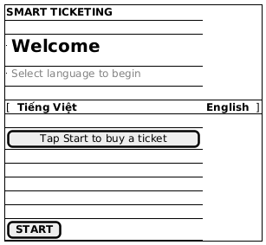
Welcome / Language

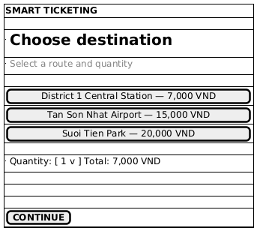
Route & Ticket Selection

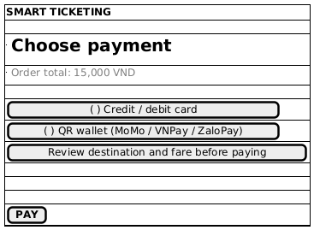
Payment Method Selection

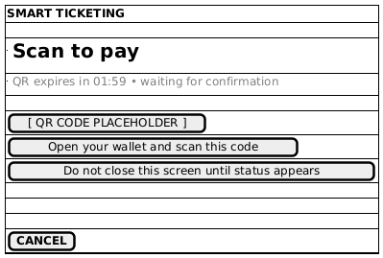
Processing (Card Tap / QR Scan)

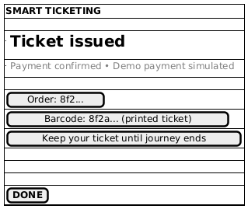
Success & Print Screen

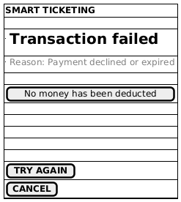
Error / Timeout Screen

4.2 Architectural Design (10 marks)

4.2.1 Architecture Diagram
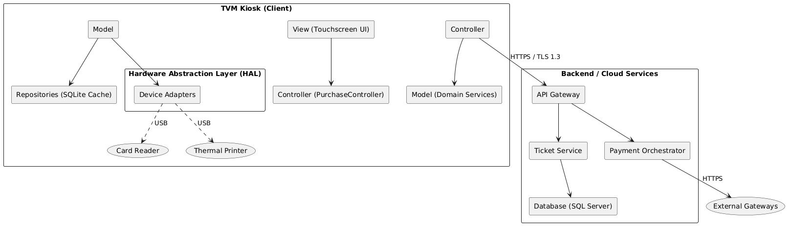
Explanation and design reasoning:
We chose an MVC (Model-View-Controller) architecture combined with a Hardware Abstraction Layer (HAL) to ensure modularity and testability.
_ View (UI): Handles only the touchscreen display and user inputs.
_ Controller: Manages the transaction state (Order, Payment) and dictates the flow.
_ Model: Contains the core domain entities and business logic.
_ HAL (Hardware Abstraction Layer): This is crucial for a TVM. It isolates hardware-specific code (EMV Card Reader, Thermal Printer, UPS). If the hardware changes, only the HAL needs updating, not the core logic.
_ API Gateway & Payment Orchestrator: The kiosk communicates with backend services via a secure API Gateway. The Payment Orchestrator uses an Adapter Pattern to connect to external providers (Momo, VNPay, NAPAS), keeping the system decoupled and PCI-DSS compliant.

4.2.2 Deployment Diagram
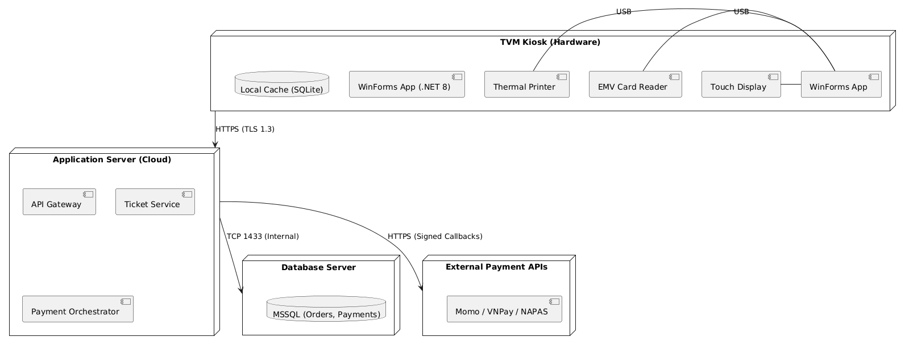
Node / component | Description | Connection (protocol, direction)
TVM hardware | Kiosk PC (Windows 10 IoT), Touch display, EMV Card Reader, Thermal Printer. Runs the WinForms App and local SQLite cache. | Internal: USB / Serial.  Outbound: HTTPS (TLS 1.3).
Application server | Cloud/Data center hosting the API Gateway, Ticket Service, and Payment Orchestrator. | Inbound: HTTPS from TVM.  Outbound: HTTPS to Gateways; TCP 1433 to DB.
Database server | SQL Server storing Orders, Payments, Tickets, and Audit Logs. | Inbound: TCP 1433 from Application Server (Internal network only).
Payment gateway API | External providers (Momo, VNPay, NAPAS/VietQR). | Inbound/Outbound: HTTPS (TLS 1.3).  Sends signed webhooks (callbacks).

5. Phase 4: Implementation, Tooling & Demo (30 marks)

5.1 Visual Studio Engineering: Model-to-Code (10 marks)

5.1.1 Forward Engineering (Model to Code)
A C# skeleton was manually transcribed from the conceptual class diagram into a separate evidence file and opened in Visual Studio for inspection. The file remains outside the runnable application because the conceptual diagram includes planned services absent from the prototype. This was not generated by Class Designer. The project targets .NET 8, which Class Designer does not support.
Design source: diagrams/class.mmd. Manual C# skeleton: prototype/engineering_evidence/ForwardModelSkeleton.cs. It represents the conceptual model and is not included in the app build.
Visual Studio forward model-to-code evidence. The first view shows the model entities; the second shows ticket, gateway, printer, repository, and service skeletons.
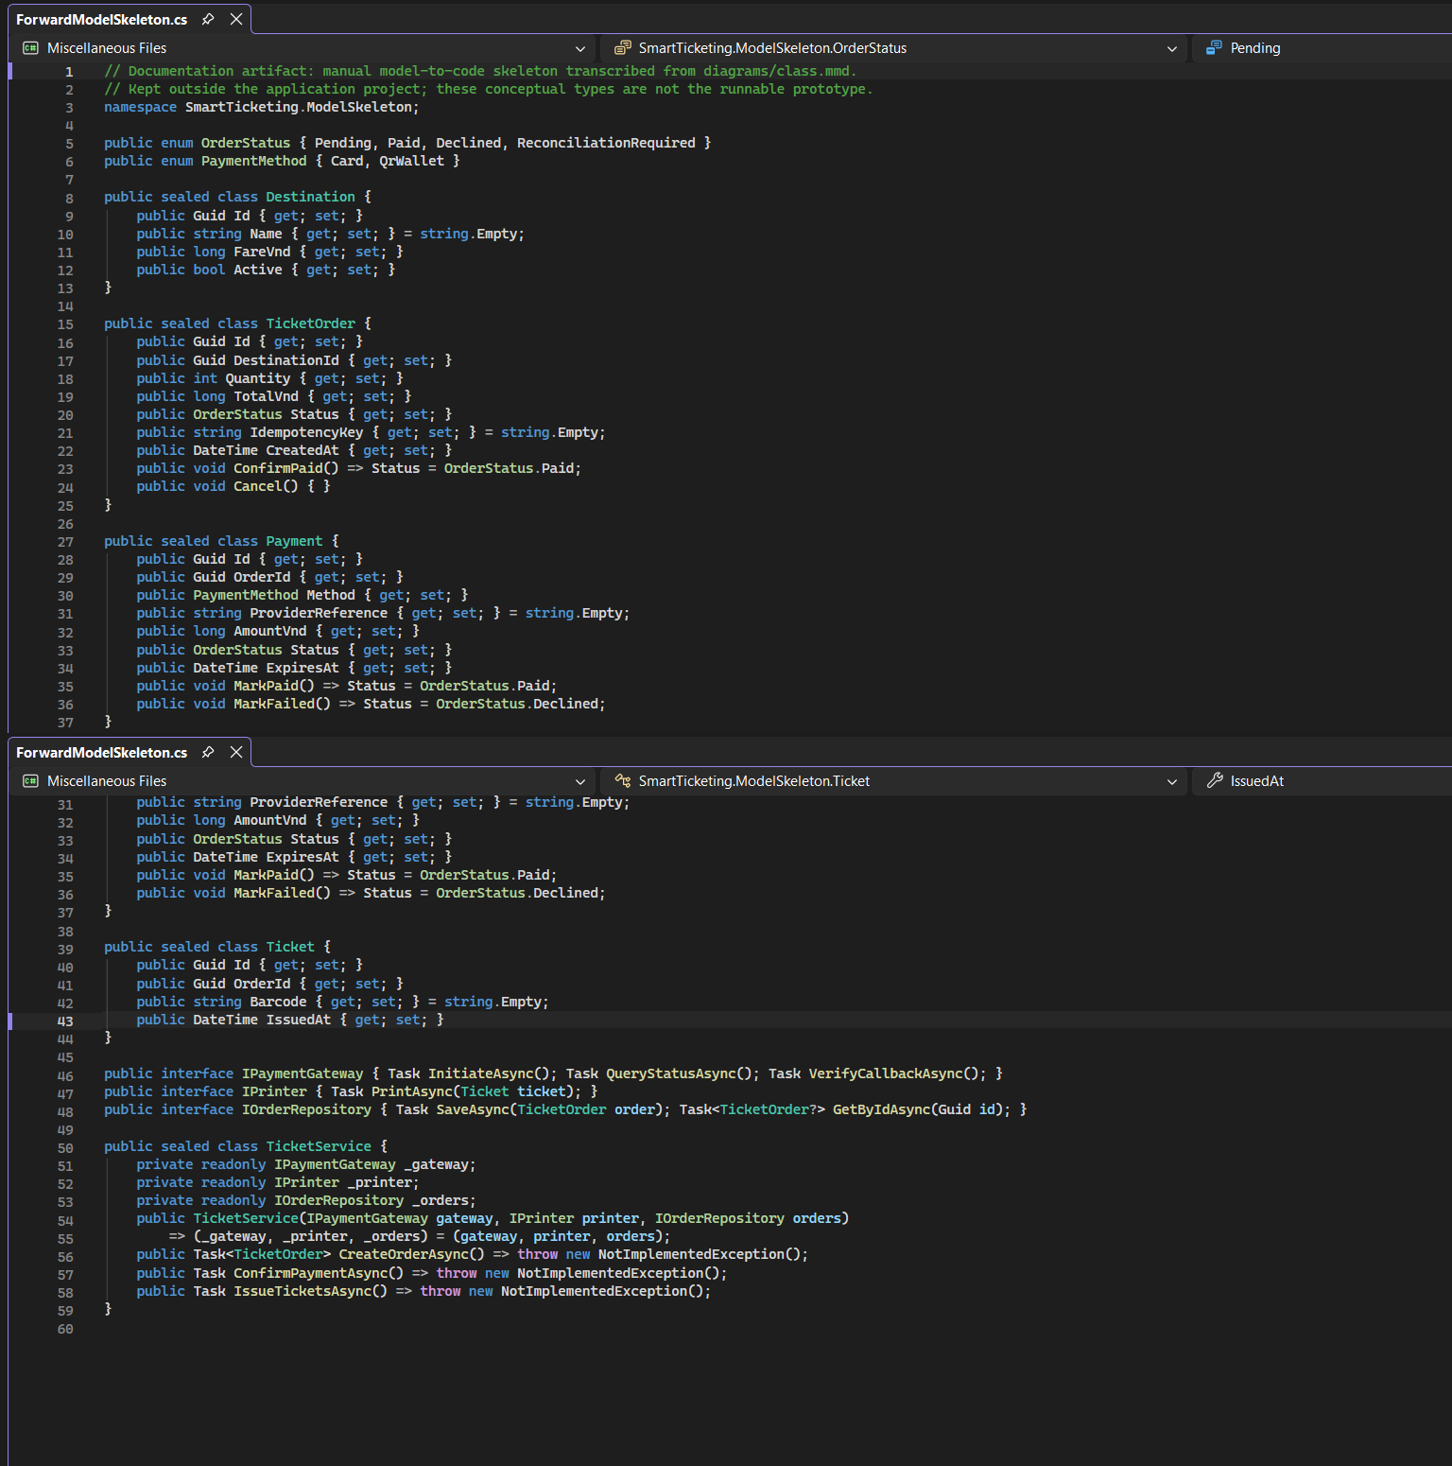

5.1.2 Backward Engineering (Code to Model)
Backward model was produced by inspecting Program.cs, MainForm.cs, Models.cs, and SqlOrderStore.cs. The as-built model is separate from the conceptual design because the runnable prototype implements a smaller set of types.
No. | Manual code change | File / class | How it was reflected in the model
1 | Added DestinationId to PurchaseResult so Declined and ReconciliationRequired orders can be saved without ticket/barcode data. | prototype/Models.cs; MainForm.cs; SqlOrderStore.cs | SqlOrderStore now uses purchase.DestinationId directly. Approved, Declined, and Unknown/timeout scenarios verify ticket creation only for Paid. The design model should be manually reviewed; no reverse-engineering screenshot was supplied.
2 | Keep payment outcome persistence independent from ticket creation; create tickets only for Paid outcomes. | prototype/SqlOrderStore.cs; MainForm.cs | The SQL test evidence shows Paid saved with tickets, while Declined and ReconciliationRequired saved without tickets. No automatic code-to-model synchronization was demonstrated.
Current implementation model derived from the supplied C# files. Visual Studio display screenshot: visuals/VS_BackwardModel_Fit.png.
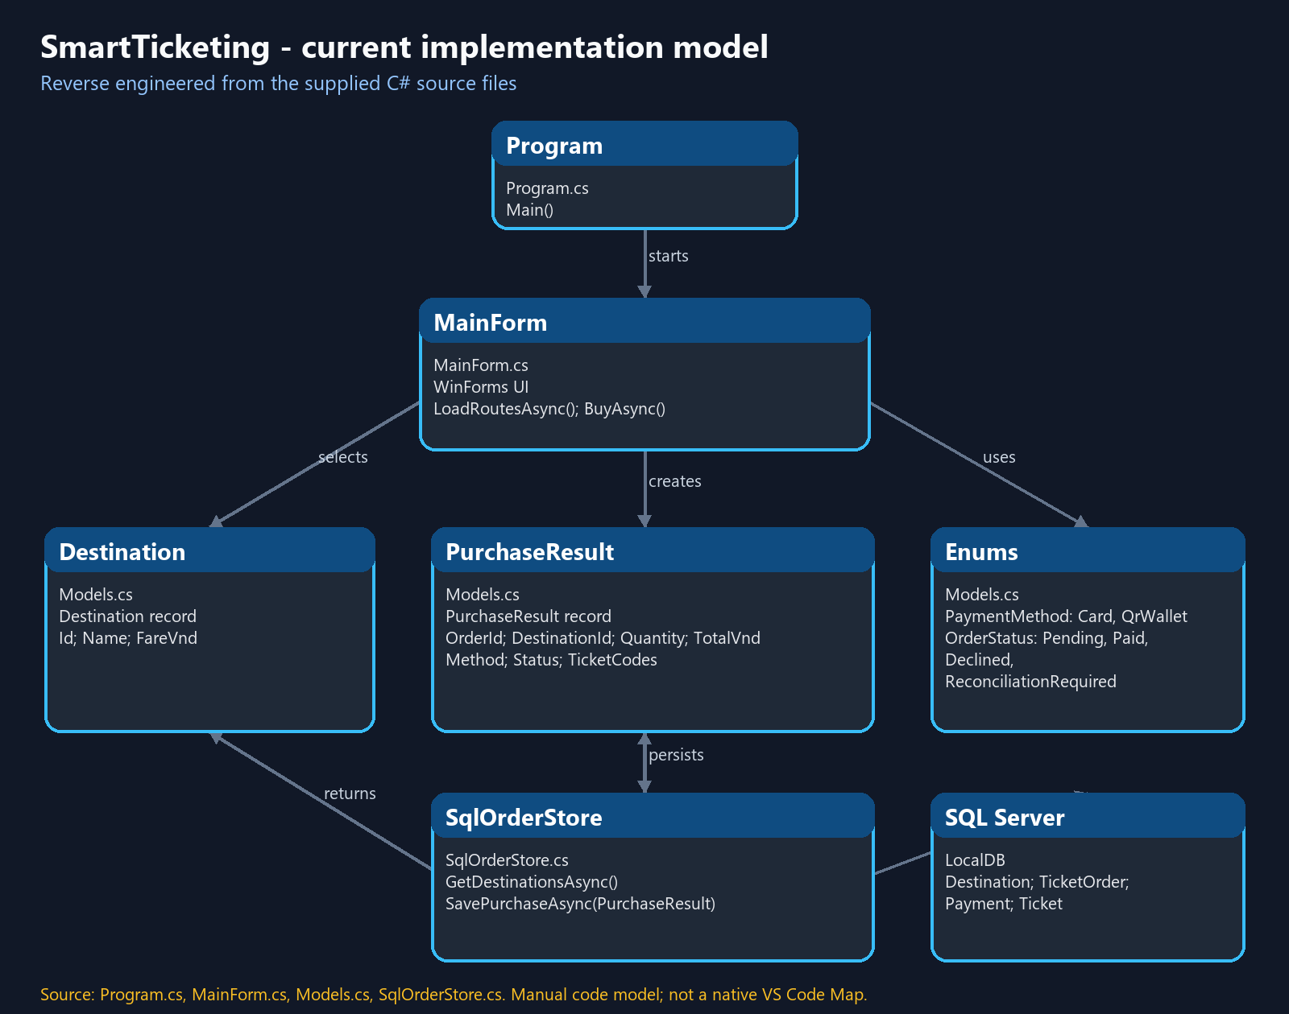

5.1.3 Code Map
The installed Visual Studio edition is Community. It cannot create native Code Maps, so no Code Map screenshot is claimed. A source-derived dependency map is supplied as prototype/engineering_evidence/SmartTicketing_SourceDependencyMap.dgml; Visual Studio Enterprise is required for the rubric?s native Code Map.
Native Code Map screenshot is unavailable in the installed Visual Studio Community edition. The preceding source-derived model is included as a clearly labeled alternative.
The diagram summarizes dependencies among Program, MainForm, Destination, PurchaseResult, SqlOrderStore, SQL Server, and payment/status enums. It is based on current source inspection; native Code Map generation remains pending.

5.2 GitHub & AI Tooling (10 marks)

5.2.1 Source Control
No GitHub repository URL, commit history, or pull-request evidence was present in the supplied folder. Add the real shared repository and verified collaboration history before submission.
Item | Your answer
Repository link | Gangvinh/Assignment1_SoftwareTechnology
Branches / collaboration evidence | No branch, commit, or pull-request history supplied.
Submission date | 31st October 2026

Member | Commits | Pull requests | Main contributions
Nguyen Le Quang Vinh (524H0205) | Not supplied | Not supplied | No repository evidence supplied.
Huynh Bao Duy (524H0151) | Not supplied | Not supplied | No repository evidence supplied.
Bui Ngoc Thanh Truc (524H0201) | Not supplied | Not supplied | No repository evidence supplied.
Nguyen Gia Binh (524H0146) | Not supplied | Not supplied | No repository evidence supplied.

5.2.2 AI Assistance: Copilot Prompt Documentation
The table records actual ChatGPT prompts used during this editing work. It does not claim GitHub Copilot code generation or attribute prompts to a student.
No. | Member | Prompt | How the AI helped | Used? (kept / changed / rejected) | How we validated it
1 | Unattributed user session | Can you test it for me, and also run in Visual Studio for me? | Requested test/run assistance and documentation. | Documentation support; no generated code claimed. | Checked against report and project evidence.
2 | Unattributed user session | Can you align Assignment report with bc as1? | Aligned report structure and traceability. | Document editing. | Compared section headings and requirement IDs.
3 | Unattributed user session | Can you help me keeping the template in bc as1 and adding part 3 4 from Assignment report into it? | Added report-aligned Parts 3 and 4 to a copy of the brief template. | Document editing. | Reopened the copy; checked tables and mockup images.
4 | Unattributed user session | Can you do part 5 in the doc file for me please? | Filled implementation, tooling, demo, and test evidence sections. | Document editing. | Compared with Assignment_Report.docx and prototype source.
5 | Unattributed user session | Is the part 5 correct yet? i think it still not correct | Triggered a review and correction of shifted table cells and remaining placeholders. | Document correction. | Checked each cell in the code-change and source-control tables.

5.2.3 Reflection on AI Use
In the documented editing sessions, ChatGPT was used to compare and align assignment documents and organize evidence. The supplied record does not establish which team members used Copilot or AI to generate application code.
What worked:
AI assistance helped organize requirements, use-case traceability, and report/workbook content. Runtime and database behavior were checked against the available project and test evidence.
What did not work:
AI-generated text can contain assumptions or mismatch the assignment. The team should check claims against the brief and implementation; this log does not claim AI-generated code.
Errors found in AI output:
Testing exposed a persistence defect for declined and unknown outcomes because they have no ticket barcode. PurchaseResult was updated to carry DestinationId, and persistence was corrected. This is supported by the report test evidence and is not attributed here to AI code generation.
What we would do differently:
For future work, record prompts and responsible members when used, verify suggestions against requirements, and test in the target environment.
AI supported document preparation in this record. Human review and execution evidence remain necessary; the Visual Studio run and SQL outcomes are documented separately.

5.3 Demo Application (10 marks)
The supplied prototype is a C# Windows Forms TVM demo backed by SQL Server. It simulates card/QR payment outcomes and does not connect to a live provider or physical kiosk hardware.
Item | Your answer
Technology | C# Windows Forms; project targets .NET 8.0-windows with major roll-forward; Microsoft.Data.SqlClient 6.1.2.
IDE / runtime test | Visual Studio Community 18; .NET 10.0.12 runtime; tested 31 October 2026.
Database | SQL Server LocalDB database SmartTicketing_VSRun; schema.sql then seed.sql.
Run / demo | Set SMARTTICKETING_SQL, open prototype/SmartTicketing.slnx or .csproj, press F5, select a seeded destination and quantity 1 to 10, simulate a card/QR result, and inspect the saved output.
Input form
Design mockup only ; runtime screenshot was not supplied. The tested form accepts destination, quantity, and simulated payment outcome.
Output report or success screen
Design mockup only ; runtime screenshot was not supplied. SQL-backed test evidence appears in the scenarios below.
Test scenarios
No. | Scenario | Input | Expected result | Result
1 | Approved purchase | Card (simulated), quantity 1, Approved | Persist Paid order/payment and one ticket. | Pass: paid state saved; ticket count matched quantity.
2 | Payment declined | Card (simulated), quantity 1, Declined | Persist declined order/payment; issue no ticket. | Pass: Declined saved; zero tickets.
3 | Unknown / timeout | Card (simulated), quantity 1, Unknown / timeout | Persist unresolved/reconciliation state; issue no ticket. | Pass: ReconciliationRequired saved; zero tickets.
Known limitations
Payment is simulated; no live bank/wallet API, physical card reader, or printer is connected. Visual Studio forward/backward engineering, Code Map evidence, and GitHub history were not supplied. Production security, PCI compliance, and performance targets are not established by this local demo.
Payment is simulated; no live bank/wallet API, card reader, or printer is connected. UML forward/backward engineering, Code Map, and GitHub history evidence were not supplied. The local test does not establish production security, PCI compliance, or performance targets.

6. Checklist for "LabGroup_QT2_Assignment1.pdf"
Guidance (delete before submitting): The submission must address the content of LabGroupAssignment1.pdf (initial context and submission guidelines). List each item of that document, where this report covers it, and tick it.
No. | Item from LabGroupAssignment1.pdf | Where addressed in this report | Done
1 | Clarification Q&A | Section 2.1 – Clarification Q&A | X
2 | Requirements Specification | Section 2.2 – Requirements Specification | X
3 | Use Case Modeling | Section 3.1 – Use Case Modeling | X
4 | Activity Diagrams | Section 3.2 – Activity Diagrams | X
5 | Detailed System Modeling: "Buy a Ticket" | Section 3.3 – Detailed System Modeling | X
6 | UI/UX Design | Section 4.1 – UI/UX Design | X
7 | Architectural Design | Sections 4.2.1 and 4.2.2 – Architecture Diagram and Deployment Diagram | X
8 | Visual Studio Engineering (Model-to-Code) | Section 5.1 – Visual Studio Engineering | X
9 | GitHub & AI Tooling (Copilot) | Section 5.2 – GitHub & AI Tooling | X
10 | Demo Application (C# and MSSQL) | Section 5.3 – Demo Application | X

7. Contribution of Each Member
Guidance (delete before submitting): The % contribution of each member must total 100% and match readme.txt.
Member | Student ID | Work products and tasks | % contribution
Nguyễn Lê Quang Vinh | 524H0205 | Clarification Q&A, Requirements Specification, and Use Case Modeling. | 25%
Huỳnh Bảo Duy | 524H0151 | Activity Diagrams, Sequence Diagram, State Chart Diagram, and Class Diagram. | 25%
Nguyễn Gia Bình | 524H0146 | UI/UX Design, Architecture Diagram, Deployment Diagram, and Visual Studio Engineering. | 25%
Bùi Ngọc Thanh Trúc | 524H0201 | GitHub management, AI Prompt Documentation, Demo Application documentation, and final report. | 25%
Total |  |  | 100%

8. Conclusion and Lessons Learnt
8.1 Conclusion
Through this project, our team gained practical experience in analyzing, designing, and developing a Ticket Vending Machine (TVM) system. We applied software engineering knowledge to create system diagrams, design the system architecture, and develop a demo application using C# and Microsoft SQL Server.
The project helped us understand how ticket management, payment processing, and database persistence work together. The prototype was exercised in Visual Studio; the supplied folder does not include GitHub collaboration evidence.
However, the project still has some limitations. The demo application does not fully integrate with real payment gateways or physical vending machine hardware. Some functions are simulated for demonstration purposes. In addition, the system may need further improvements in security, error handling, and user interface design before being used in a real environment.
8.2 Lessons Learnt
During the project, each team member gained different knowledge and experience based on their assigned tasks. Overall, we improved our skills in system analysis, UML modeling, C# programming, database design, and teamwork.
The assignment highlights the need to record source-control collaboration and AI use as they occur. AI-generated suggestions should be reviewed and tested before they are applied.
In conclusion, this project provided valuable experience in applying theoretical knowledge to a practical software development project. It also helped our team improve both technical skills and collaboration skills.

References
- Object Management Group (OMG). (2017). OMG Unified Modeling Language (OMG UML), Version 2.5.1. https://www.omg.org/spec/UML/2.5.1
- Microsoft. (n.d.). C# Documentation. Microsoft Learn. https://learn.microsoft.com/en-us/dotnet/csharp/
- Microsoft. (n.d.). SQL Server Documentation. Microsoft Learn. https://learn.microsoft.com/en-us/sql/sql-server/
- Microsoft. (n.d.). Visual Studio Documentation. Microsoft Learn. https://learn.microsoft.com/en-us/visualstudio/
- GitHub. (n.d.). GitHub Docs. https://docs.github.com/
- Figma. (n.d.). Figma Help Center. https://help.figma.com/
- National Payment Corporation of Vietnam (NAPAS). (n.d.). NAPAS – National Payment Services. https://napas.com.vn/

Appendix

Appendix A: readme.txt
[Paste the contents of readme.txt: GitHub link, Figma link, database script instructions, % contribution]

Appendix B: Full-size Diagrams
[Full-size use case, activity, sequence, state, class, architecture and deployment diagrams]

