 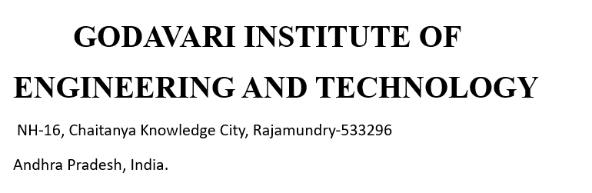

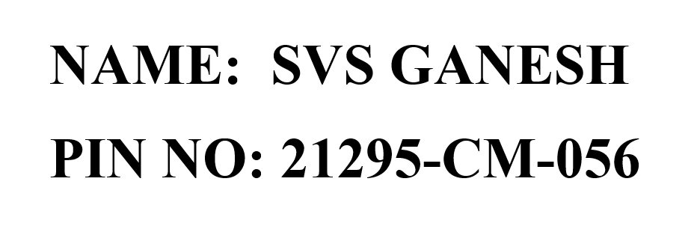

**TRAIN TICKET BOOKING**

**Description :**

The "Train Ticket Booking" project is a user-friendly application developed using Python and Tkinter. This application provides a seamless platform for users to search for train routes, view available seats, and book tickets effortlessly. With an intuitive graphical user interface (GUI) designed using Tkinter, users can easily navigate through various options, select their preferred train, and complete the booking process with minimal steps. The "Train Ticket Booking" project is a user-friendly application built with Python and Tkinter, offering an intuitive platform for users to search, view, and book train tickets. Leveraging Python's capabilities, the application manages train data, seat availability, and real-time bookings, while Tkinter provides a seamless graphical interface for easy navigation and booking completion.

Behind the scenes, the project utilizes Python's powerful programming capabilities to manage train data, handle seat availability, and process bookings in real-time. The application integrates database functionalities to store and retrieve train schedules, seat details, and user bookings securely. Error handling and validation mechanisms are also implemented to ensure data integrity and provide users with informative feedback throughout the booking process. Overall, this "Train Ticket Booking" project showcases the versatility of Python and Tkinter in developing robust and user-centric applications for managing and booking train tickets.

**Platforms and Software used:**

* Python.
* Tkinter.
* Visual Studio Code.
* Google Chrome.
* Laptop.
* Windows 11 operating system.

**Role of platforms and software:**

* **Python:** Python's robust programming capabilities were leveraged to implement real-time booking processes, validate user inputs, and execute error handling mechanisms to ensure data integrity and user-friendly interactions. Overall, Python played a pivotal role in orchestrating the backend operations and logic of the "Train Ticket Booking" project, while Tkinter complemented by creating an intuitive graphical interface for users to interact with the application effortlessly.
* **VS Code:** Visual Studio Code (VS Code) was utilized as the primary Integrated Development Environment (IDE) for developing the "Train Ticket Booking" project using Python and Tkinter. VS Code provided a powerful and customizable environment that facilitated efficient coding, debugging, and testing of the application. Its built-in support for Python allowed developers to write, execute, and debug Python scripts seamlessly within the IDE.
* **Google chrome:** Google Chrome browser was used to test and validate the "Train Ticket Booking" project developed using Python and Tkinter. As a web application running locally, the project utilized a browser-based interface created with Tkinter, which allowed users to interact with the application and perform various booking operations. Google Chrome's developer tools were instrumental in inspecting and debugging the web elements, ensuring the proper rendering and functionality of the graphical user interface (GUI).
* **Laptops:** The laptop served as the primary hardware platform for developing and executing the "Train Ticket Booking" project using Python and Tkinter. Developers utilized the laptop's computing power and resources to write, edit, and run Python scripts, design the graphical user interface (GUI) using Tkinter, and integrate database functionalities to manage train data and bookings effectively.
* **Windows 11 operating system:** The Windows 11 operating system served as the foundational platform for developing and deploying the "Train Ticket Booking" project using Python and Tkinter. Developers leveraged the features and capabilities of Windows 11 to install and run the necessary development tools, including Python interpreter, Tkinter library, and Integrated Development Environments (IDEs) like Visual Studio Code or PyCharm.

**Advantages:**

* Python's straightforward syntax and readability facilitate faster development cycles, allowing for efficient coding, testing, and debugging.
* Python's vast standard library and rich ecosystem of third-party libraries provide pre-built solutions for various functionalities, reducing development time and effort.
* Tkinter's cross-platform nature ensures that the application can be run seamlessly across different operating systems, enhancing the project's accessibility and reach.
* Tkinter's intuitive and user-friendly graphical user interface (GUI) toolkit allows developers to create visually appealing and interactive interfaces with ease.
* Python's robust backend capabilities enable efficient data management, real-time processing, and secure database interactions, ensuring reliable and responsive performance.

**Disadvantages:**

* Tkinter might not be suitable for very large or complex applications. As the project grows, maintaining and extending it could become challenging.
* Tkinter provides basic GUI components, which might result in a less visually appealing or modern user interface compared to other GUI frameworks.
* Tkinter's appearance and behavior can vary across different operating systems, potentially leading to inconsistent user experiences.
* Python is an interpreted language, which might not offer the same level of performance as compiled languages for computationally intensive tasks.
* Python and Tkinter applications might be more susceptible to certain types of vulnerabilities if not properly secured and validated.

**Applications:**

Certainly! Here are some potential applications and features for a train ticket booking project developed using Python and Tkinter:

* Tkinter can be used to create an intuitive and user-friendly interface where customers can easily search for train schedules, select seats, and make payments.
* Implementing real-time updates using Python can provide users with accurate information on seat availability, train schedules, and ticket prices
* Python's robustness and Tkinter's capability can be leveraged to integrate secure payment gateways, ensuring safe and hassle-free transactions for users.
* The application can have features to manage bookings, including ticket cancellations, rescheduling, and generating e-tickets or boarding passes.
* A chatbot or FAQ section can be integrated within the application to assist users with queries, providing a seamless customer support experience.

These applications and features can be tailored and expanded based on the specific requirements, scope, and complexity of the train ticket project using Python and Tkinter, ensuring a comprehensive, user-friendly, and secure banking solution.

**Project Life Cycle:**

The Waterfall model is a linear and sequential approach to software development, consisting of distinct phases that must be completed sequentially before moving on to the next phase. Here's how the Waterfall model could be applied to a train ticket project using Python and Tkinter.

Provide ongoing support for the banking system, addressing any issues or bugs that arise.Implement updates or new features as needed based on user feedback or changing requirements.

Remember, the Waterfall model is rigid and doesn't easily accommodate changes once the project is underway. So, thorough planning and documentation are crucial.

While the Waterfall model provides a structured and systematic approach to software development, it may not be as flexible or adaptive to changes compared to agile methodologies. Therefore, careful planning, thorough documentation, and stakeholder involvement are essential to ensure the success of a banking system project using Python and Tkinter within the Waterfall model's framework.

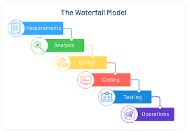

**Conclusion:**

In conclusion, developing a train ticket using Python and Tkinter using the Waterfall model provides a structured and systematic approach to software development. This method ensures thorough planning, design, implementation, testing, and deployment stages, resulting in a robust and reliable banking application. However, it's essential to note that the Waterfall model may lack flexibility for adapting to changes during the development process, so comprehensive initial planning and detailed documentation are critical for success. Due to its sequential nature, the Waterfall model may result in longer development cycles compared to more iterative approaches.

In summary, to balance its advantages with its limitations and adapt the approach as needed based on project requirements and constraints.