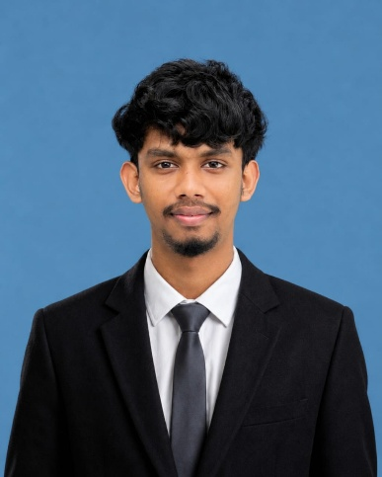
H.G.C.KODITHUWAKKU
Software Engineer | IT Undergraduate

+94 715568760 | ganiduchalinda@gmail.com| linkedin.com/in/ganidu-chalinda-b39a49329/ | https://github.com/Ganidu2004 | Matara, Sri Lanka

SUMMARY

HND in Information Technology undergraduate at SLIATE, ATI Galle with hands-on experience in full-stack web development using React.js, Node.js, and NOSQL. A collaborative team player & Leadership with a passion for building real-world software solutions and a strong drive to grow into a professional Software Engineer. Seeking a software engineering internship to apply technical skills, contribute to a development team, and accelerate a long-term career in software development.

TECHNICAL SKILLS Programming Languages: Java Script, Python , Java, C#, Dart

Frontend: React.js, HTML, CSS3, Tailwind CSS, Vite, flutter(Bloc/Provider)
Backend: Node.js, Express.js
Databases: MongoDB, Supabase, Firebase, SQL(Xamp)
Tools & Platforms: Git, GitHub, Postman, VS Code, Android Studio
Cloud & Deployment: Render, Vercel, Dynu
Other: JWT Authentication, REST API Design, Responsive UI/UX, Agile Development

EDUCATION

Higher National Diploma in Information Technology 2024 – Present
Sri Lanka Institute of Advanced Technological Education (SLIATE), ATI Galle
Relevant Coursework: Software Engineering, Database Systems, Web Application Development, Object-Oriented Programming, Computer Networks

G.C.E. Advanced Level Examination 2023 (2024)
Technology Stream |
ICT — C | Science for Technology (SFT) — C | Engineering Technology (ET) — C

G.C.E. Ordinary Level Examination 2019
Index No: 92183174 | Results: 3A,4B, 1C, 1S

PROJECTS

. 1. HealthChat Application
- Tech Stack: Python, LangChain, Grok API (xAI Console), VS Code, .venv

- Live Demo: https://healthchat-application-tgt1.onrender.com/

- Architected an AI healthcare assistant providing context-aware, reliable responses to medical queries.
- Integrated xAI's Grok API (via xAI Console) to power the core assistant, delivering high-speed processing and advanced reasoning capabilities.

- Leveraged LangChain to structure dynamic prompt templates, manage conversational context, and enforce assistant guardrails.

- Optimized prompt engineering patterns to minimize hallucinations and guarantee strict adherence to medical safety and formatting guidelines.

2 - E-Items LK Web Application
Tech Stack: React.js, Node.js, Express.js, MongoDB, REST APIs, Render, Git
Live Demo: https://e-items-lk-1.onrender.com/
- Developed a full-stack e-commerce platform for dynamic product management and intuitive item browsing.
- Designed a fully responsive UI ensuring smooth user experience across mobile, tablet, and desktop devices.
- Built RESTful backend APIs and database schemas for efficient searching, filtering, and data operations.
- Deployed on Render cloud platform, maintaining automated CI/CD deployment and high application availability.

CERTIFICATIONS

- Gateway English Academy certification
- Diploma in English-Sri Lanka English Language Graduates' Association

EXTRACURRICULAR ACTIVITIES

- Active personal project developer —deployed the healthchat application
- Continuously building and deploying real-world web applications to sharpen full-stack engineering skills.

LANGUAGES

- Sinhala — Native
- English — Professional Working Proficiency

REFERENCES

Mr.Chamal Samarasekara  Lecturer, Sri Lanka Institute of Advanced  Technology Education (SLIATE)  ATI GALLE, | Mrs. D.N.P. Attanayake  Senior Lecturer, Sri Lanka Institute of  Advanced Technology Education (SLIATE)  ATI GALLE,  Email: priyangika@sliate.ac.lk  Phone: +94 71 802 6983

