SIMATS ENGINEERING (SAVEETHA SCHOOL OF ENGINEERING)
Department of Artificial Intelligence and Data Science
ASSESSMENT TOOL 1 – ANALYTICAL PROBLEM SOLVING

Course Code: | DSA0313 | Course Title: | Natural Language Processing
CO Assessed: | CO2 – Manipulation | Assessment: | Assessment Tool 1 – ANALYTICAL PROBLEM SOLVING
Weightage: | 35% of CIA
CO2 Statement: | Design inflectional, derivational, finite-state parsing, stemming algorithms and for analyse morphological methods. (BL-3)
Student Name: | N.Ganitha | Reg. No.: | 192425235
Section / Batch: | 2024 | Date: | 2-11-2026

Code of Conduct
I N. Ganitha(192425235) certify that this submission is my original work and that I have adhered to the guidelines specified for this assessment. I understand that any violation of academic integrity rules will result in disciplinary action.
Signature of the Student: N.Ganitha

Instructions
- Read all questions carefully before attempting the answers.
- Answer all five questions. Each question carries equal marks.
- Show all intermediate steps, calculations, probability computations, tagging decisions, and justifications wherever applicable.
- Duration: 30 minutes.

Section / Topic | Focus | Q Nos
English Word Classes, Part of Speech Tagging | Morphological decomposition of connected, connecting, and connection; identification of roots, suffixes, inflectional vs. derivational forms, and normalization for document indexing. | Q1
English Word Classes, Tagsets for English, Rule-Based Part of Speech Tagging | Morphological parsing of unhappy, happiness, and happily; identification of prefixes, suffixes, base forms, and semantic effects of derivational morphology. | Q2
Counting Words, Part of Speech Tagging, English Word Classes | Stemming and root extraction for played, player, and playing; handling grammatical variations and word formation changes for search preprocessing. | Q3
Finite-State Morphological Analysis, Rule-Based Part of Speech Tagging, Transformation-Based Tagging | Finite-state parsing of writes, writing, and written; modeling regular and irregular verb inflections and root normalization. | Q4
English Word Classes, Rule-Based Part of Speech Tagging, Counting Words | Porter Stemmer-based processing of relational, relation, and relate; application of derivational suffix removal and stem extraction for retrieval. | Q5

Annexure A – ANALYTICAL PROBLEM SOLVING
1. Given the input words: “connected”, “connecting”, “connection”, design a morphological analysis pipeline for a document indexing system.
- Apply rules to decompose each word into root and suffix components.
- Differentiate between inflectional and derivational forms within the dataset.
- Normalize all variants to a common base form for efficient retrieval.
- Determine the parsed structure and normalized output for each word.
- Write a Python program to implement the above morphological analysis pipeline. The program should accept the given input words, perform decomposition, classify each suffix as inflectional or derivational, normalize the words to their common base form, and display the parsed structure and normalized output in a tabular format.

1. Aim
To design a morphological analysis pipeline that decomposes the words “connected”, “connecting”, and “connection” into root and suffix components, classifies suffixes as inflectional or derivational, and normalizes the words for efficient document retrieval.

2. Morphological Analysis
- Root word: connect
- Inflectional suffixes: -ed and -ing change the grammatical form of a word without changing its basic meaning or word class.
- Derivational suffix: -ion forms the noun “connection” from the verb “connect”.
- Normalization: All three words are mapped to the common base form connect for this indexing example.

3.Parsed Structure and Output

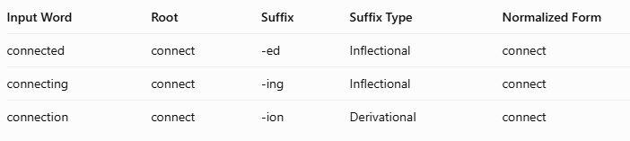4. Python Program
def morphological_analysis(words):
results = []
rules = {
"connected": ("connect", "-ed", "Inflectional"),
"connecting": ("connect", "-ing", "Inflectional"),
"connection": ("connect", "-ion", "Derivational")
}
for word in words:
if word in rules:
root, suffix, suffix_type = rules[word]
normalized = root
results.append(
(word, root, suffix, suffix_type, normalized)
)
print("{:<15} {:<12} {:<10} {:<15} {:<15}".format(
"Word", "Root", "Suffix", "Suffix Type", "Normalized"
))
print("-" * 70)
for row in results:
print("{:<15} {:<12} {:<10} {:<15} {:<15}".format(*row))
words = ["connected", "connecting", "connection"]
morphological_analysis(words)

5. Expected Output
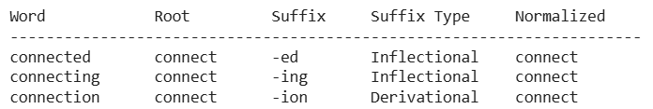

6. Result
The morphological analysis pipeline successfully decomposes the three input words into their root and suffix components, identifies inflectional and derivational suffixes, and normalizes all variants to connect. This improves document indexing by allowing a search for “connect” to retrieve documents containing “connected”, “connecting”, and “connection”.

2.Given the input words: “unhappy”, “happiness”, “happily”, design a morphological parsing module for sentiment analysis.
- Identify prefixes, suffixes, and base forms using rule-based decomposition.
- Ensure semantic consistency across derived word forms.
- Classify each transformation as inflectional or derivational.
- Produce the root and morphological breakdown for each word.
- Write a Python program to implement the above morphological parsing module. The program should accept the given input words, identify the prefixes, suffixes, and base forms, classify each transformation as inflectional or derivational, and display the morphological breakdown and normalized root word in a tabular format.

1. Aim
To design a rule-based morphological parsing module for sentiment analysis that identifies prefixes, suffixes, and base forms in the words “unhappy”, “happiness”, and “happily”, classifies transformations, and normalizes the words for consistent sentiment processing.

2. Morphological Analysis
- Base word: happy
- Prefix: un- indicates a negative meaning.
- Suffixes: -ness converts an adjective into a noun, while -ly converts an adjective into an adverb.
- Derivational transformation: All three words are formed through derivational processes; none uses an inflectional suffix.
- Normalization: The words are mapped to happy as a shared lexical base. For sentiment analysis, unhappy must retain its negative meaning rather than being treated as equivalent in sentiment to happy.

3. Morphological Breakdown

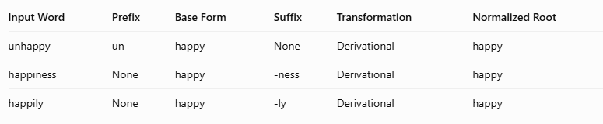4. Python Program

def morphological_parsing(words):
rules = {
"unhappy": ("un-", "happy", "None", "Derivational"),
"happiness": ("None", "happy", "-ness", "Derivational"),
"happily": ("None", "happy", "-ly", "Derivational")
}
print("{:<12} {:<10} {:<12} {:<10} {:<15} {:<12}".format(
"Word", "Prefix", "Base Form", "Suffix",
"Transformation", "Root"
))
print("-" * 75)
for word in words:
if word in rules:
prefix, base, suffix, transformation = rules[word]
print("{:<12} {:<10} {:<12} {:<10} {:<15} {:<12}".format(
word, prefix, base, suffix, transformation, base
))
words = ["unhappy", "happiness", "happily"]
morphological_parsing(words)

5. Expected Output
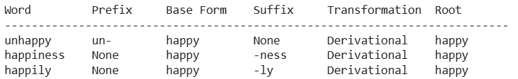

6. Result
The morphological parsing module successfully identifies prefixes, suffixes, and base forms for all three words. It classifies each transformation as derivational and normalizes the words to the common root happy, supporting consistent lexical processing in sentiment analysis. However, sentiment analysis should preserve the negative meaning of unhappy instead of assigning the same sentiment to all three words.

3. Given the input words: “played”, “player”, “playing”, design a stemming-based preprocessing module for a search engine.
- Apply morphological rules to strip affixes and identify the base form.
- Handle both grammatical variations and word formation changes.
- Ensure consistent root extraction across all forms.
- Determine the stem and classification for each input word.
- Develop a Python program for a stemming-based preprocessing module used in a search engine. The program should process the input words "played", "player", "playing" by applying appropriate stemming rules to remove prefixes/suffixes where applicable, identify the stem of each word, distinguish between grammatical inflections and word-formation changes, and generate a structured output showing the original word, extracted stem, removed affix (if any), transformation type (inflectional/derivational), and the final normalized form suitable for indexing and information retrieval.

1. Aim
To develop a stemming-based preprocessing module for a search engine that removes suffixes from “played”, “player”, and “playing”, identifies their stems, classifies transformations as inflectional or derivational, and generates normalized forms for efficient information retrieval.

2. Stemming Analysis
- played: Remove -ed to obtain play. Inflectional form.
- player: Remove -er to obtain play. Derivational form because it refers to a person who plays.
- playing: Remove -ing to obtain play. Inflectional form.
- Normalized form: All three words are mapped to play for search indexing.

3. Python Program
def stemming_analysis(words):
rules = {
"played": ("play", "-ed", "Inflectional"),
"player": ("play", "-er", "Derivational"),
"playing": ("play", "-ing", "Inflectional")
}
print("{:<12} {:<12} {:<12} {:<15} {:<12}".format(
"Word", "Stem", "Removed Affix",
"Transformation", "Normalized"
))
print("-" * 70)
for word in words:
if word in rules:
stem, affix, transformation = rules[word]
normalized = stem
print("{:<12} {:<12} {:<12} {:<15} {:<12}".format(
word, stem, affix, transformation, normalized
))
words = ["played", "player", "playing"]
stemming_analysis(words)

4. Expected Output
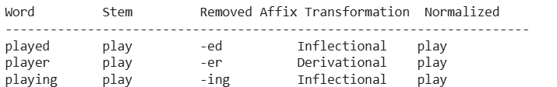

5. Result
The stemming module successfully extracts the common stem play from all three words and classifies their transformations. The normalized forms improve search engine indexing by allowing documents containing “played”, “player”, or “playing” to be matched through the common index term play.
4. Given the input words: “writes”, “writing”, “written”, design a finite-state morphological parsing module for a text processing system.
- Apply state transitions to represent suffix transformations and irregular forms in verb inflection.
- Differentiate between regular and irregular inflectional patterns within the dataset.
- Ensure consistent mapping of all forms to a common root representation.
- Determine the state transitions, morphological breakdown, and normalized output for each word.
- Develop a Python program that implements a finite-state morphological parser for the input words "writes", "writing", "written". The program should construct a finite-state transition model to process regular suffixes and irregular verb forms, identify the corresponding root word, classify each input as a regular or irregular inflection, trace the sequence of state transitions during parsing, and display the state transition path, morphological components, root form, and normalized representation for each input word in a well-formatted output.

1. Aim
To develop a finite-state morphological parser that analyzes “writes”, “writing”, and “written” using state transitions, identifies regular and irregular verb inflections, and normalizes all forms to the common root write.

2. Morphological Analysis
- writes: write + -s — regular inflection.
- writing: write + -ing — regular inflection with spelling change (drop final e).
- written: irregular past participle of write.
- Normalized root: write.

3. State Transitions
- q0: Start state.
- q1: Recognize the input word.
- q2: Identify suffix or irregular form.
- q3: Extract root and classify inflection.
- q4: Final state with normalized output.
Transition path: q0 → q1 → q2 → q3 → q4

4. Python Program
def finite_state_parser(words):
rules = {
"writes": ("write", "-s", "Regular Inflection"),
"writing": ("write", "-ing", "Regular Inflection"),
"written": ("write", "irregular", "Irregular Inflection")
}
print("{:<10} {:<25} {:<12} {:<12} {:<22} {:<12}".format(
"Word", "State Path", "Root", "Component",
"Classification", "Normalized"
))
print("-" * 100)
for word in words:
if word in rules:
root, component, classification = rules[word]
if word == "written":
path = "q0->q1->q2->q3->q4"
else:
path = "q0->q1->q2->q3->q4"

print("{:<10} {:<25} {:<12} {:<12} {:<22} {:<12}".format(
word, path, root, component,
classification, root
))
words = ["writes", "writing", "written"]
finite_state_parser(words)

5. Expected Output
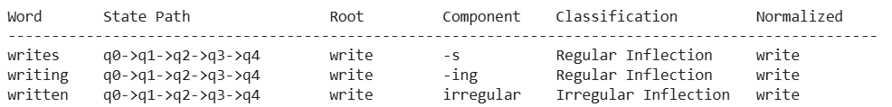

6. Result
The finite-state morphological parser identifies the root write for all three input words, distinguishes regular suffix-based inflections from the irregular form written, and generates a normalized representation for text indexing and retrieval.

5. Given the input words: “relational”, “relation”, “relate”, design a Porter Stemmer-based preprocessing module for document retrieval.
- Apply stemming rules step-by-step to remove derivational suffixes and obtain base forms.
- Handle variations in suffix patterns while preserving semantic consistency.
- Ensure uniform root extraction across all derived forms.
- Determine the stemming steps, intermediate forms, and final stem for each input word.
- Develop a Python program that implements the Porter Stemming algorithm for the input words "relational", "relation", "relate". The program should apply the Porter stemming rules sequentially to remove derivational suffixes, display the intermediate form obtained after each stemming step, handle different suffix patterns while preserving the word meaning, and generate the final stem for each word. The output should clearly present the original word, applied stemming rule(s), intermediate forms, and the final normalized stem in a structured format suitable for document retrieval applications.

1. Aim
To implement a Porter Stemmer-based preprocessing module that removes derivational suffixes from “relational”, “relation”, and “relate”, displays intermediate stemming steps, and produces normalized stems for efficient document retrieval.

2. Stemming Analysis
The Porter Stemming algorithm applies suffix-removal rules in stages. It is a rule-based algorithm and may produce stems that are not complete dictionary words.
- relational: relational → relate → relat
- relation: relation → relat
- relate: relate → relat
The common final stem is relat, which helps match these word variants during document retrieval.

3. Python Program
from nltk.stem import PorterStemmer
ps = PorterStemmer()
words = ["relational", "relation", "relate"]
steps = {
"relational": "ational -> ate; final e removed",
"relation": "ion removed (after t)",
"relate": "final e removed"}
print("{:<15} {:<35} {:<20} {:<15}".format(
"Original Word", "Stemming Rules", "Intermediate Form", "Final Stem"))
print("-" * 90)
for word in words:
stem = ps.stem(word)
if word == "relational":
intermediate = "relate -> relat"
elif word == "relation":
intermediate = "relat"
else:
intermediate = "relat"
print("{:<15} {:<35} {:<20} {:<15}".format(
word, steps[word], intermediate, stem ))

4. Expected Output

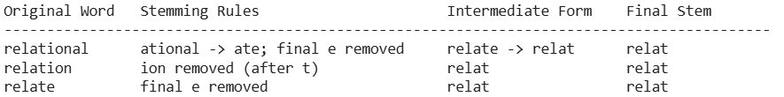

5. Result
The Porter Stemmer successfully reduces all three words to the common stem relat. This normalization helps a document retrieval system match different word forms under the same index term. The intermediate forms illustrate the relevant suffix-removal rules, while the final stems are generated by the Porter Stemmer implementation.
Rubrics for Calculation

Numerical Problems
Criteria | Weightage | Level 4 (Exemplary) | Level 3 (Proficient) | Level 2 (Developing) | Level 1 (Beginning)
Problem Understanding | 20% | Clearly interprets problem, identifies all parameters and requirements accurately | Understands problem with minor gaps | Partial understanding; misses key elements | Misinterprets or unable to understand problem
Method Selection | 20% | Selects most appropriate method/formula with strong justification | Selects correct method with minor errors | Inappropriate or partially correct method | Unable to select method
Solution Process | 25% | Logical, systematic steps with correct approach throughout | Mostly correct steps with minor mistakes | Disorganized steps; multiple errors | No clear process
Accuracy of Calculation | 20% | All calculations accurate; correct final answer | Minor calculation errors | Frequent errors; incorrect final answer | No valid calculations
Interpretation of Results | 15% | Clearly interprets results with units and engineering relevance | Basic interpretation with minor omissions | Limited or unclear interpretation | No interpretation

Q. No. / Criteria Level | Problem Understanding | Method Selection | Solution Process | Accuracy of Calculation | Interpretation of Results | Sub. Total | Total %
1
2
3
4
5

Faculty In-charge | Course Coordinator | Program Director
Signature: _______________ | Signature: _______________ | Signature: _______________
Date: ___________________ | Date: ___________________ | Date: ___________________

