SIMATS ENGINEERING (SAVEETHA SCHOOL OF ENGINEERING)
Department of Artificial Intelligence and Data Science
ASSESSMENT TOOL 2 – SCENARIO BASED

Course Code: | DSA0313 | Course Title: | Natural Language Processing
CO Assessed: | CO2 – Manipulation | Assessment: | Assessment Tool 2 – SCENARIO BASED
Weightage: | 35% of CIA
CO5 Statement: | Design inflectional, derivational, finite-state parsing, stemming algorithms and for analyse morphological methods. (BL-3)
Student Name: | N. Ganitha | Reg. No.: | 192425235
Section / Batch: | 2024 | Date: | 4-11-2026

Code of Conduct
I N. Ganitha(192425235) certify that this submission is my original work and that I have adhered to the guidelines specified for this assessment. I understand that any violation of academic integrity rules will result in disciplinary action.
Signature of the Student: N.Ganitha

Instructions
- Read all questions carefully before attempting the answers.
- Answer all five questions. Each question carries equal marks.
- Show all intermediate steps, calculations, probability computations, tagging decisions, and justifications wherever applicable.
- Duration: 30 minutes.

Section / Topic | Focus | Q Nos
English Word Classes, Tagsets for English, Part of Speech Tagging | Morphological decomposition of analyzing, analysis, and analytical; identification of roots, affixes, inflectional and derivational forms, and normalization for indexing. | Q1
English Word Classes, Tagsets for English, Stochastic Part of Speech Tagging | Morphological parsing of disagree, agreement, and agreeable; identification of prefixes, suffixes, base forms, and semantic effects of derivation. | Q2
Counting Words, English Word Classes, Part of Speech Tagging | Morphology-based normalization of govern, government, and governance for topic modeling, clustering, and lexical standardization. | Q3
Rule-Based Part of Speech Tagging, Transformation-Based Tagging | Morphological analysis of activate, activation, and reactivation; identification of derivational layers, word-class changes, and semantic shifts. | Q4
Rule-Based Part of Speech Tagging, English Word Classes, Part of Speech Tagging | Inflectional normalization of create, creates, and creating; extraction of root forms and classification of tense/aspect transformations. | Q5
Annexure A – SCENARIO BASED
1. A large-scale search engine indexing system processes user queries containing word variants such as “analyzing, “analysis”, and “analytical”. The system must improve retrieval accuracy by grouping semantically related terms under a unified representation. Design a morphological processing approach to decompose each input word into root and affixes, distinguish between inflectional and derivational forms, and normalize them for indexing. Apply the process to the given inputs and determine the root form along with the morphological structure of each word.
- Develop a Python program to implement a rule-based morphological processing system for the input words "analyzing", "analysis", and "analytical". The program should identify the root word and separate the corresponding prefixes or suffixes using suitable morphological rules, classify each word as an inflectional or derivational form, normalize all related variants to a common representation for indexing, and generate a structured report showing the original word, extracted root, identified affix(es), transformation type, and normalized output to support efficient search engine retrieval.
Aim: To identify roots and affixes, classify transformations, and normalize related words for search engine indexing.

Python program
words = ["analyzing", "analysis", "analytical"]
rules = {
"analyzing": {
"root": "analyze",
"prefix": "None",
"suffix": "-ing",
"type": "Inflectional",
"normalized": "analy",
"structure": "analyze + ing (drop e)" },
"analysis": {
"root": "analys",
"prefix": "None",
"suffix": "-is",
"type": "Irregular lexical form",
"normalized": "analy",
"structure": "analys + is"},
"analytical": {
"root": "analyt",
"prefix": "None",
"suffix": "-ical",
"type": "Derivational",
"normalized": "analy",
"structure": "analyt + ical"}}
print("MORPHOLOGICAL ANALYSIS REPORT")
for word in words:
r = rules[word]
print("\nOriginal Word:", word)
print("Root:", r["root"])
print("Prefix:", r["prefix"])
print("Suffix:", r["suffix"])
print("Transformation:", r["type"])
print("Structure:", r["structure"])
print("Normalized Form:", r["normalized"])
Output:
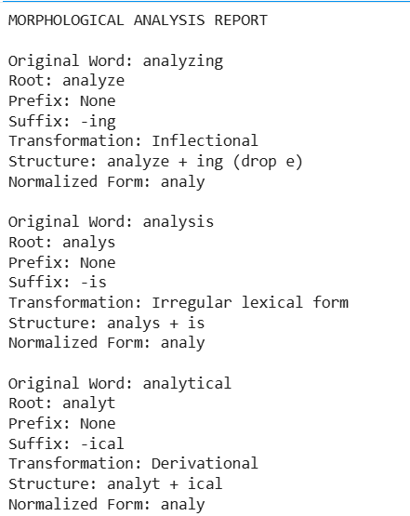
Result: The words are mapped to a common search-family key, analy. This is a custom indexing key, not the standard English lemma. -ing is inflectional, while -ical is derivational; analysis requires an irregular lexical rule.

2. An AI-based sentiment analysis platform receives product reviews containing words like “disagree”, “agreement”, and “agreeable”. The system must interpret sentiment consistently despite variations in word formation. Develop a morphological parsing strategy to identify prefixes, suffixes, and base forms, while capturing how derivational changes influence meaning. Process the given inputs to extract roots and classify each transformation, ensuring accurate semantic interpretation across all word forms.
- Develop a Python program to create a morphological parser for the input words "disagree", "agreement", and "agreeable". The program should detect and separate prefixes, suffixes, and the base word using rule-based morphological analysis, examine how derivational modifications alter the meaning of the root word, classify each transformation according to its morphological type, and produce a comprehensive output containing the original word, identified prefix, root word, suffix, transformation category, semantic interpretation, and normalized base form for use in sentiment analysis applications.
Aim: To develop a Python program using rule-based morphological analysis to identify prefixes, suffixes, and root words in the words “disagree”, “agreement”, and “agreeable”, classify their morphological transformations, interpret their meanings, and normalize them into base forms for sentiment analysis.
Python Program
def morphological_parser(word):
rules = {
"disagree": {
"prefix": "dis",
"root": "agree",
"suffix": "",
"type": "Prefixation",
"meaning": "Expresses disagreement or opposition",
"base": "agree"},
"agreement": {
"prefix": "",
"root": "agree",
"suffix": "ment",
"type": "Suffixation",
"meaning": "The state or result of agreeing",
"base": "agree},
"agreeable": {
"prefix": "",
"root": "agree",
"suffix": "able",
"type": "Suffixation",
"meaning": "Pleasant or acceptable",
"base": "agree"}}
if word in rules:
result = rules[word]
print("\nOriginal Word:", word)
print("Prefix:", result["prefix"] or "None")
print("Root Word:", result["root"])
print("Suffix:", result["suffix"] or "None")
print("Transformation:", result["type"])
print("Semantic Meaning:", result["meaning"])
print("Normalized Base Form:", result["base"])
else:
print("Word not found in morphological rules.")
words = ["disagree", "agreement", "agreeable"]
for word in words:
morphological_parser(word)
Output:
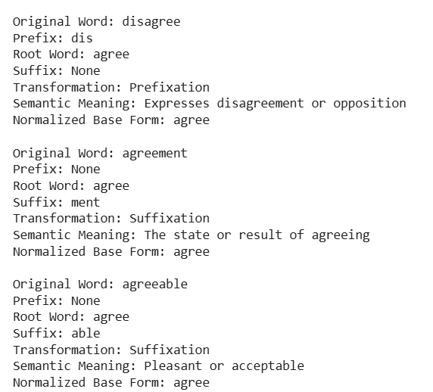

Result: The morphological parser separates the given words into their prefixes, roots, and suffixes. It classifies derivational transformations and normalizes all three words to the base form “agree”, helping a sentiment analysis system recognize related word forms consistently. However, sentiment interpretation should consider context because disagree can express negative polarity while agreement and agreeable may carry positive or neutral meanings.

3. A text analytics pipeline in a news aggregation system handles documents containing terms such as “govern”, “government”, and “governance”. The system must standardize these variations for topic modeling and clustering. Construct a morphology-based normalization mechanism that decomposes each word into its root and affixes, identifies derivational layers, and maps them to a common base form. Apply the approach to the input words and derive the normalized representation along with their morphological breakdown.
- Develop a Python program to implement a morphology-based normalization module for the input words "govern", "government", and "governance". The program should perform morphological decomposition to identify the root word and successive derivational suffixes, determine the derivational level associated with each word, normalize all variants to a common lexical representation, and generate a structured output displaying the original word, root form, detected affix(es), derivational hierarchy, normalized representation, and the final output used for topic modeling and document clustering.

Aim: To develop a Python program to implement a morphology-based normalization module that identifies root words and derivational suffixes in “govern”, “government”, and “governance”, determines their derivational levels, and maps them to a common base form for topic modeling and document clustering.

Python Program
def morphological_normalization(word):
rules = {
"govern": {
"root": "govern",
"affix": "None",
"level": "Level 0 - Root word" },
"government": {
"root": "govern",
"affix": "-ment",
"level": "Level 1 - Noun formation" },
"governance": {
"root": "govern",
"affix": "-ance",
"level": "Level 1 - Noun formation"}}
if word in rules:
data = rules[word]
print("\nOriginal Word:", word)
print("Root Form:", data["root"])
print("Detected Affix:", data["affix"])
print("Derivational Hierarchy:", data["level"])
print("Normalized Representation:", data["root"])
print("Topic Modeling Output:", data["root"])
else:
print("Word not found")
words = ["govern", "government", "governance"]
for word in words:
morphological_normalization(word)
Output:
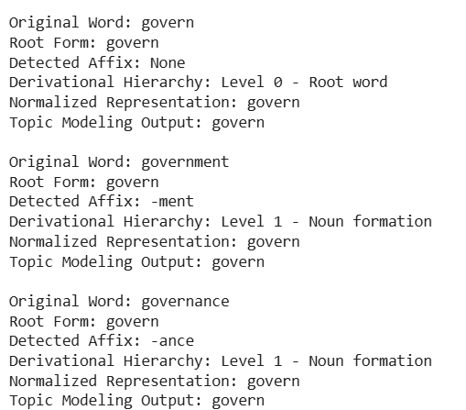

Result: The Python program successfully identifies the root form as “govern” and detects the derivational suffixes -ment and -ance in “government” and “governance”. All three words are normalized to the common representation “govern”, helping standardize terms for topic modeling and document clustering.

4.A document classification system processes input words such as “activate”, “activation”, and “reactivation” to improve semantic grouping and indexing.
Construct a morphological parsing strategy to identify prefixes, suffixes, and root forms while distinguishing derivational layers.
Analyze how prefix addition and suffix transformation affect meaning and word class.
Apply the process to decompose each word and map them to a unified base representation.
Derive the morphological structure and normalized root for each input word.
- Develop a Python program to implement a morphological parsing and normalization system for the input words "activate", "activation", and "reactivation". The program should detect and separate prefixes, root words, and suffixes using rule-based morphological parsing, identify the sequence of derivational transformations that produce each word, analyze the effect of each morphological modification on the word class and semantic meaning, and generate a structured report showing the original word, prefix (if present), root word, suffix, derivational sequence, normalized base form, and final parsed representation for use in document classification and semantic indexing.

Aim: To develop a Python program using rule-based morphological parsing to identify prefixes, suffixes, and root forms in “activate”, “activation”, and “reactivation”, analyze derivational transformations and their effects on word class and meaning, and normalize the words to a common base representation for document classification and semantic indexing.

Python Program
def morphological_parser(word):
rules = {
"activate": {
"prefix": "None",
"root": "act",
"suffix": "-ivate",
"sequence": "act -> activate",
"word_class": "Verb",
"meaning": "To make something active",
"base": "activate" },
"activation": {
"prefix": "None",
"root": "act",
"suffix": "-ivation",
"sequence": "act -> activate -> activation",
"word_class": "Noun",
"meaning": "The process of making something active",
"base": "activate"},
"reactivation": {
"prefix": "re-",
"root": "act",
"suffix": "-ivation",
"sequence": "act -> activate -> activation -> reactivation",
"word_class": "Noun",
"meaning": "The process of making something active again",
"base": "activate"} }
if word in rules:
data = rules[word]
print("\nOriginal Word:", word)
print("Prefix:", data["prefix"])
print("Root Word:", data["root"])
print("Suffix:", data["suffix"])
print("Derivational Sequence:", data["sequence"])
print("Word Class:", data["word_class"])
print("Semantic Meaning:", data["meaning"])
print("Normalized Base Form:", data["base"])
print("Final Parsed Representation:",
data["prefix"] + " + " + data["root"] + " + " + data["suffix"])
else:
print("Word not found in rules")
words = ["activate", "activation", "reactivation"]
for word in words:
morphological_parser(word)

Output
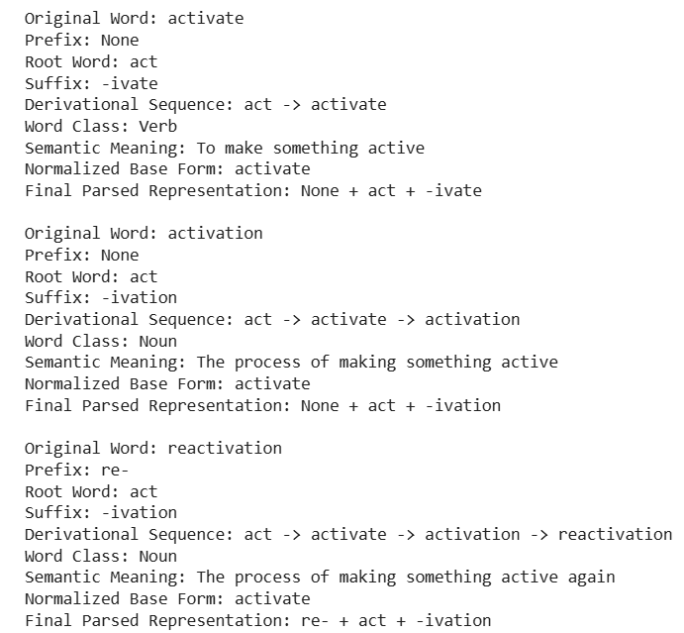

Result: The Python program successfully parses the words “activate”, “activation”, and “reactivation” using rule-based morphological analysis. It identifies the root act, detects derivational changes, and explains how the prefix re- indicates repetition while the suffix -ion forms a noun from a verb. All three words are mapped to the common normalized representation activate for document classification and semantic indexing.

5. A search optimization module processes input words such as “create”, “creates”, and “creating” to ensure consistent retrieval across grammatical variations. Design a morphology-based normalization approach focusing on inflectional transformations such as tense and aspect.
Identify suffix patterns and map all variations to a common base form without altering meaning.
Apply the process to extract root forms and classify each transformation.
Determine the morphological breakdown and normalized output for each word.
- Develop a Python program to implement an inflectional morphology-based normalization module for the input words "create", "creates", and "creating". The program should recognize grammatical suffixes corresponding to different inflectional forms, identify the underlying root word by applying appropriate normalization rules, classify each input according to its grammatical feature (e.g., base form, third-person singular, present participle), and produce a structured output containing the original word, identified suffix, grammatical category, extracted root, normalized base form, and the final normalized representation to support efficient search optimization and information retrieval.

Aim: To develop a Python program for inflectional morphology-based normalization that identifies suffixes in “create”, “creates”, and “creating”, extracts their root forms, classifies their grammatical categories, and maps them to a common base form for efficient search optimization and information retrieval.

Python Program

def normalize_word(word):
rules = {
"create": {
"suffix": "None",
"category": "Base form",
"root": "create"},
"creates": {
"suffix": "-s",
"category": "Third-person singular",
"root": "create"
},
"creating": {
"suffix": "-ing",
"category": "Present participle",
"root": "create"
}
}
if word in rules:
data = rules[word]
print("\nOriginal Word:", word)
print("Identified Suffix:", data["suffix"])
print("Grammatical Category:", data["category"])
print("Extracted Root:", data["root"])
print("Normalized Base Form:", data["root"])
print("Final Normalized Representation:", data["root"])
else:
print("Word not found")
words = ["create", "creates", "creating"]
for word in words:
normalize_word(word)

Output

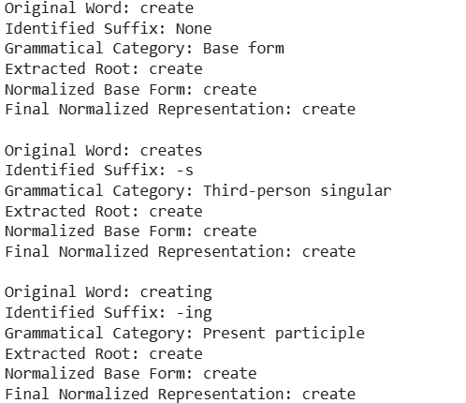

Result: The Python program successfully identifies the inflectional suffixes -s and -ing, classifies the grammatical forms, and normalizes all three words to the common base form create. This improves consistency in search optimization and information retrieval while preserving the underlying lexical meaning.

Rubrics for Calculation

Criteria | Weightage (%) | Level 4 (Exemplary) | Level 3 (Proficient) | Level 2 (Developing) | Level 1 (Beginning)
Understanding of Scenario | 20% | Demonstrates clear and complete understanding of the scenario and context | Shows good understanding with minor gaps | Partial understanding; misses key aspects | Misinterprets or fails to understand the scenario
Identification of Key Issues | 20% | Accurately identifies all relevant issues and factors involved | Identifies most key issues with minor omissions | Identifies limited issues; some irrelevant points | Unable to identify key issues
Application of Concepts | 25% | Applies appropriate concepts effectively to address the scenario | Applies concepts with minor errors | Limited or partially correct application | Unable to apply relevant concepts
Decision Making | 20% | Makes well-reasoned, logical decisions with strong rationale | Makes reasonable decisions with some justification | Makes weak decisions with limited justification | No clear decisions made or rationale provided
Clarity of Response | 15% | Response is clear, structured, and logically presented | Generally clear with minor issues | Somewhat unclear or poorly structured | Disorganized and difficult to understand

Q. No. / Criteria Level | Understanding of Scenario | Identification of Key Issues | Application of Concepts | Decision Making | Clarity of Response | Sub. Total | Total %
1
2
3
4
5

Faculty In-charge | Course Coordinator | Program Director
Signature: _______________ | Signature: _______________ | Signature: _______________
Date: ___________________ | Date: ___________________ | Date: ___________________

