Learn to Build your own News Aggregator Web App
In this project we are using various machine learning algorithms such as random Forest, Naïve Bayes, Logistic Regression and ANN (artificial neural networks) to classify news in 40 different topics such as
['ARTS', 'ARTS & CULTURE', 'BLACK VOICES', 'BUSINESS', 'COLLEGE', 'COMEDY', 'CRIME', 'CULTURE & ARTS', 'DIVORCE', 'EDUCATION', 'ENTERTAINMENT', 'ENVIRONMENT', 'FIFTY', 'FOOD & DRINK', 'GOOD NEWS', 'GREEN', 'HEALTHY LIVING', 'HOME & LIVING', 'IMPACT', 'LATINO VOICES', 'MEDIA', 'MONEY', 'PARENTING', 'PARENTS', 'POLITICS', 'QUEER VOICES', 'RELIGION', 'SCIENCE', 'SPORTS', 'STYLE', 'STYLE & BEAUTY', 'TASTE', 'TECH', 'THE WORLDPOST', 'TRAVEL', 'U.S. NEWS', 'WEDDINGS', 'WEIRD NEWS', 'WELLNESS', 'WOMEN', 'WORLD NEWS', 'WORLDPOST']
In all algorithms ANN is giving better prediction accuracy and we to train all algorithms we have used same dataset given by you.
To implement this project we have designed following modules
- User Signup: using this module all users can signup to application and all user details will get saved inside MYSQL database
- User Login: using this module user can login to application
- Upload Dataset: after login user can upload dataset to application and then application will clean all news and then normalize and then split dataset into train and test where 80% dataset will be used for training and 20% for testing
- Train 4 Classifications Model: processed dataset will be input to above discuss 4 algorithms to train a model and this model will be applied on 20% test data to calculate prediction accuracy
- Classify News: using this module user can enter any news text and then system will classify that news into one of above 43 topics
To run project first copy content from DB.txt file and then paste in MYSQL to create database and now double click on ‘runServer.bat’ file to start python WEB SERVER and get below output
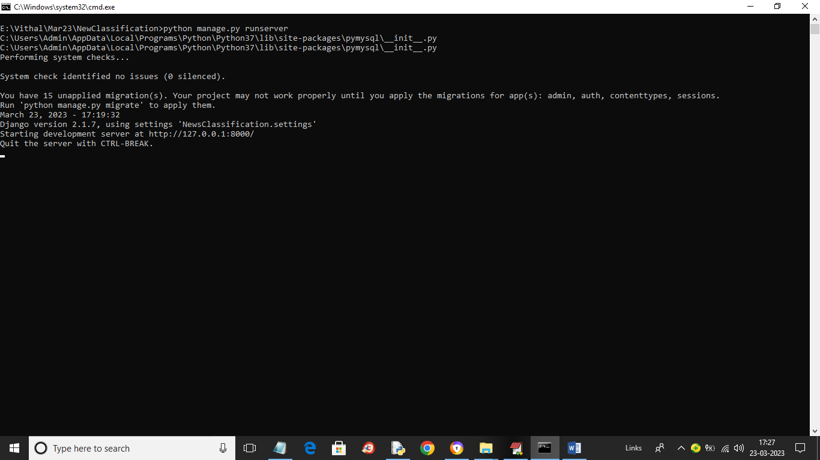
In above screen python server is started and now open browser and enter URL as http://127.0.0.1:8000/index.html and press enter key to get below page
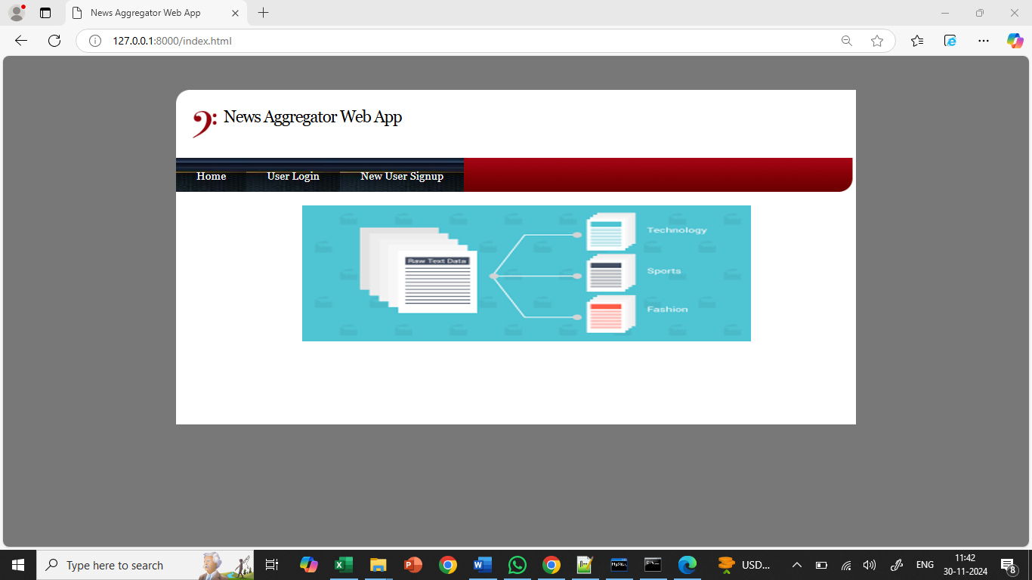
In above screen click on ‘New User Signup’ link to get below signup page
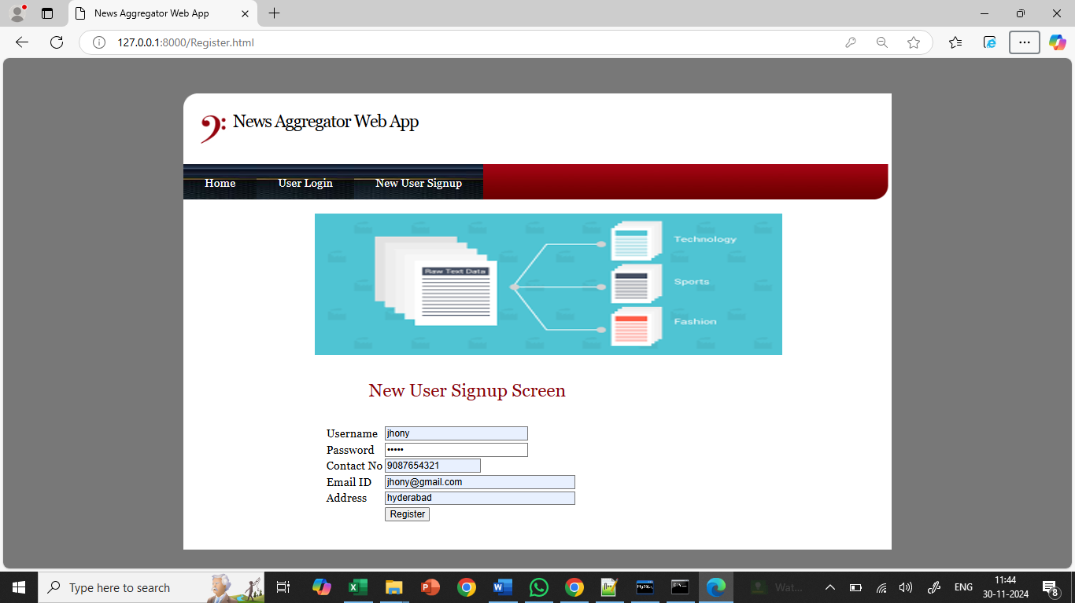
In above screen user is signing up and then press button to get below page
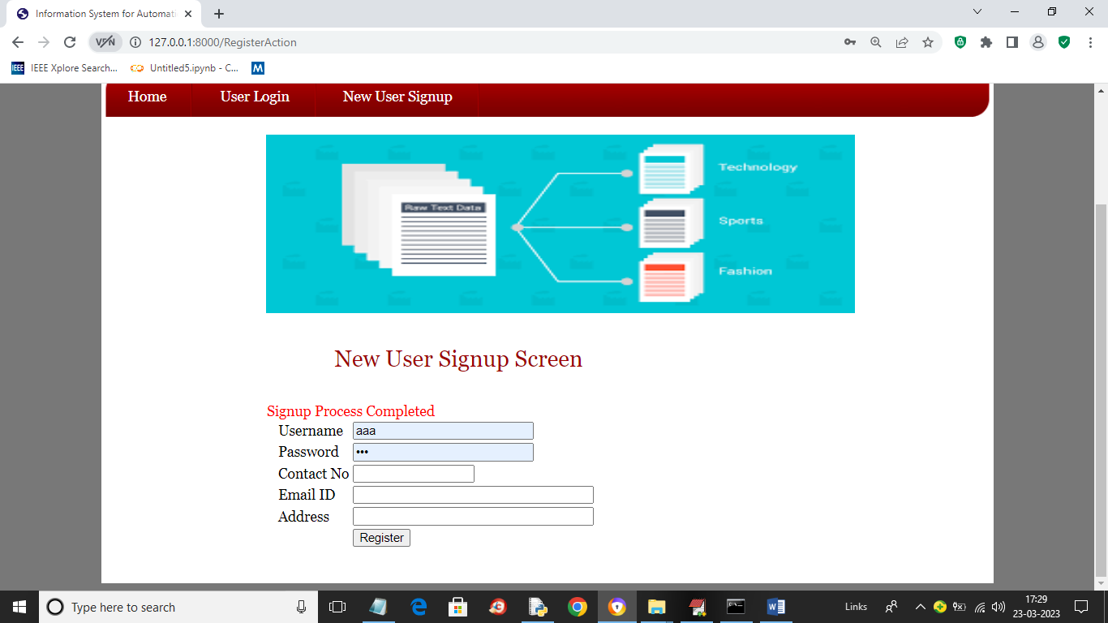
In above screen signup process completed and now click on ‘User Login’ link to get below login page
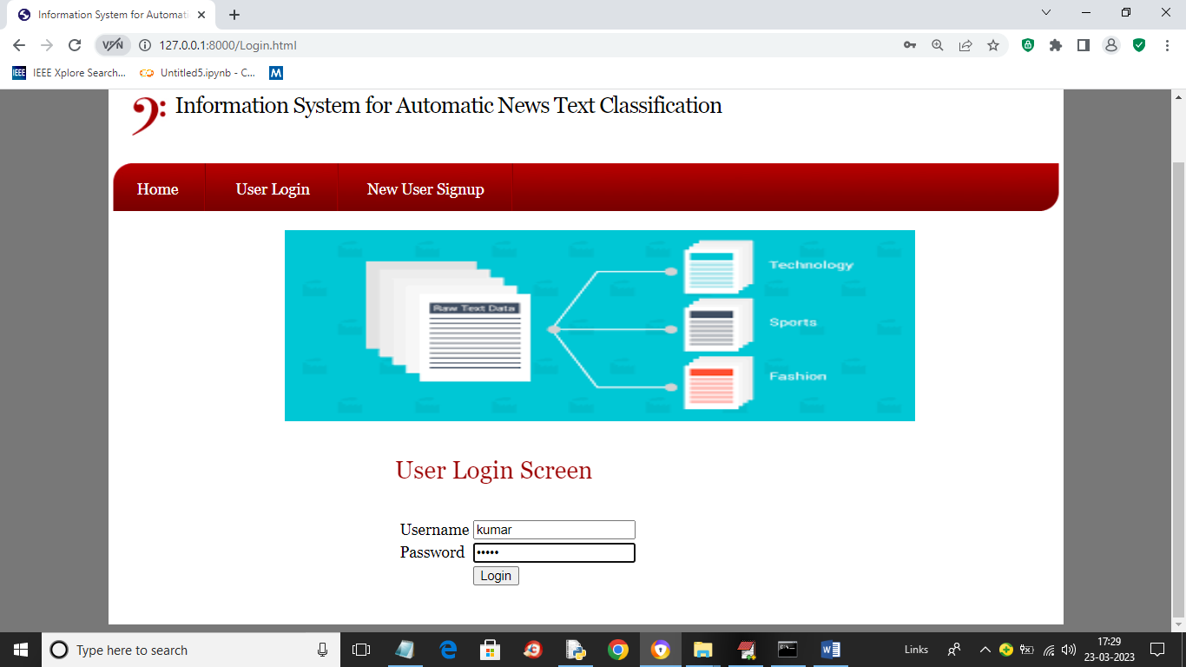
In above screen user is login and after login will get below page
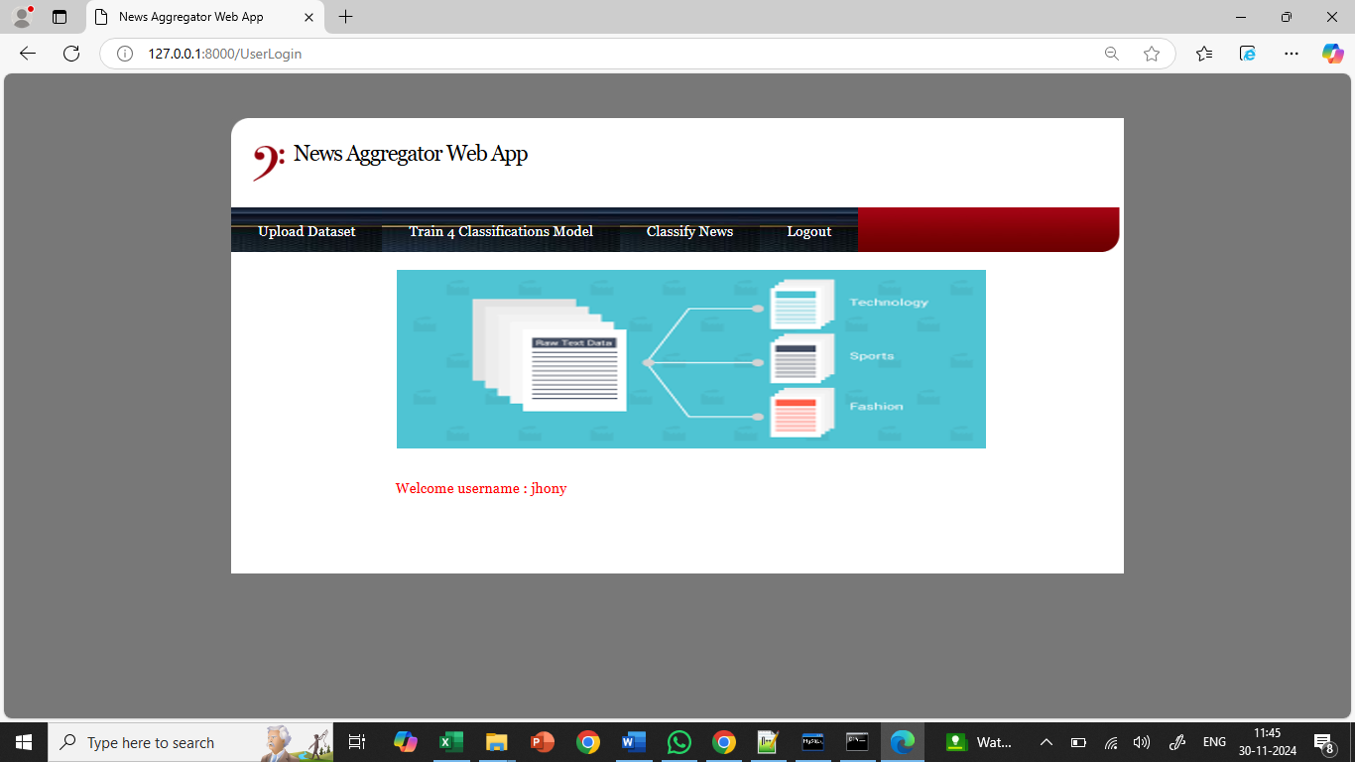
In above screen user can click on ‘Upload Dataset’ button to load dataset and get below output
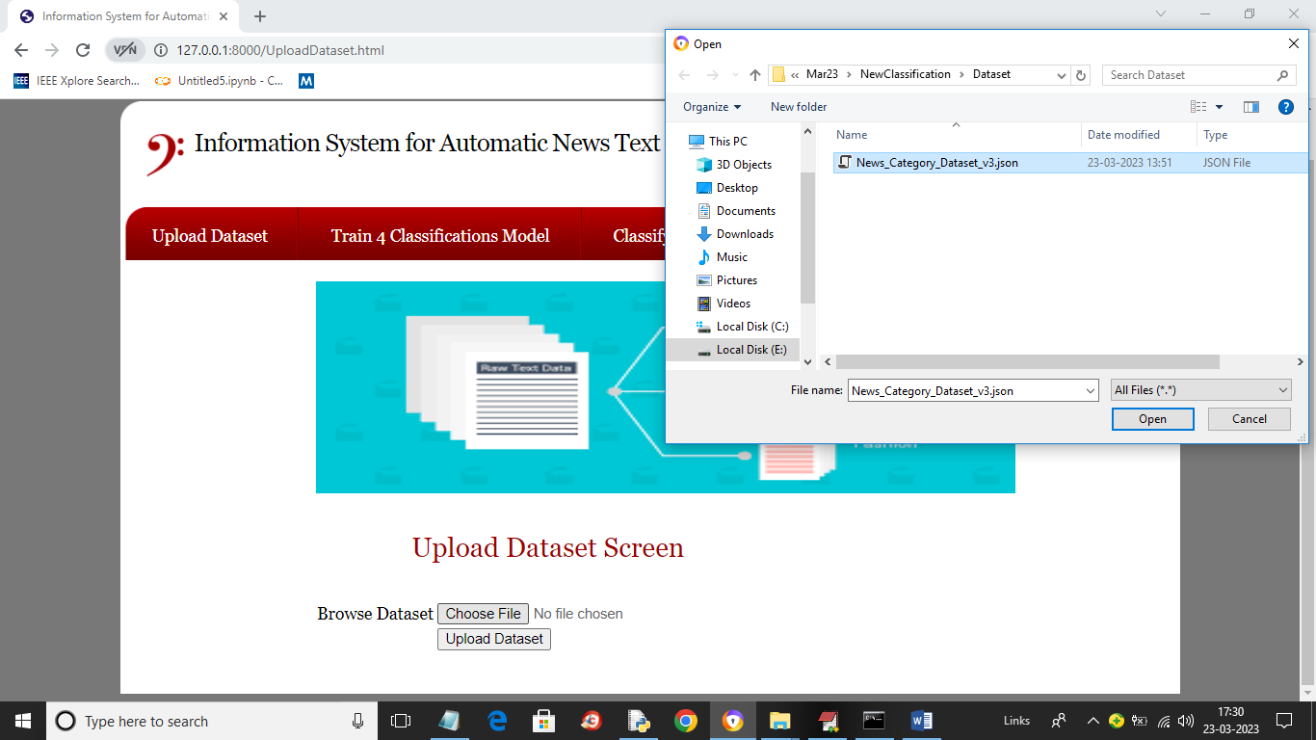
In above screen click on ‘Choose File’ button and upload dataset and this dataset you can find inside code under ‘Dataset’ folder and then click on ‘Open’ and ‘Upload Dataset’ link to load dataset and get below output
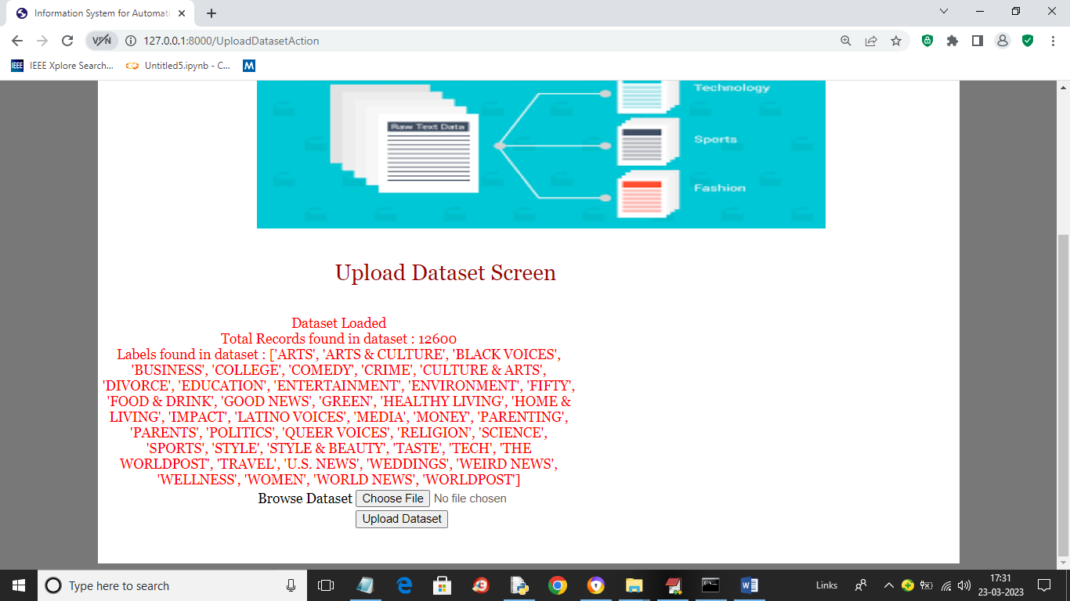
In above screen dataset loaded and in red colour text we can see dataset contains 12600 records and showing different news topics found in dataset and now click on ‘Train 4 Classifications Models’ link to get below output
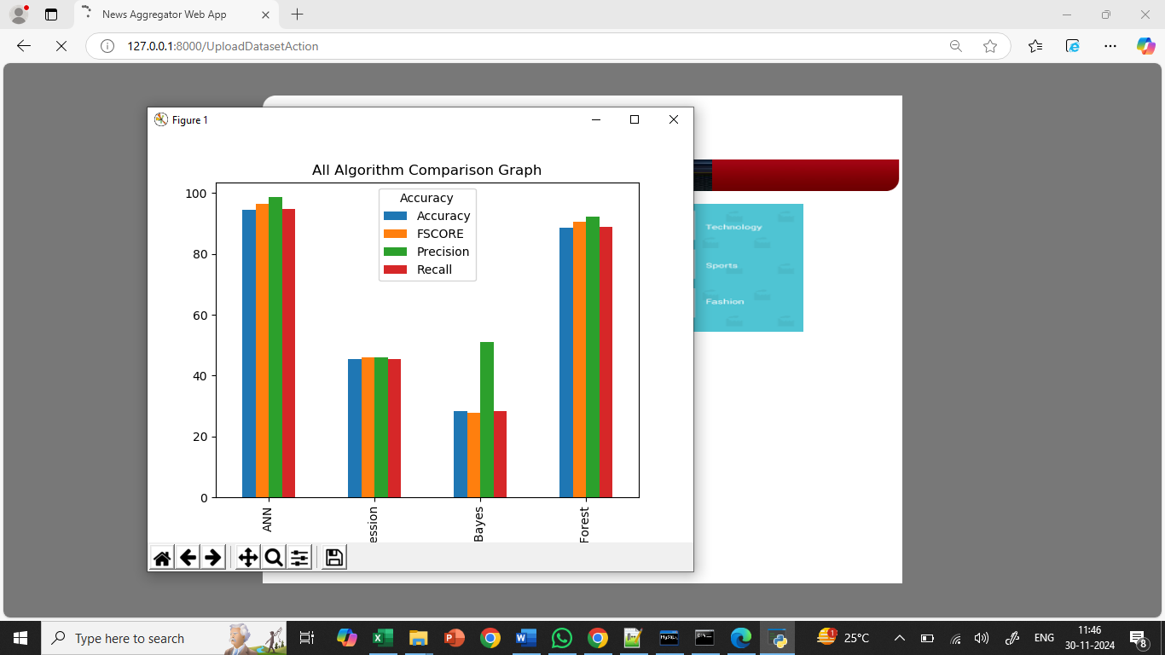
In above graph x-axis represents algorithm names and y-axis represents accuracy and other metrics in different colour bars and in all algorithms ANN got high accuracy and now close above graph to get below output
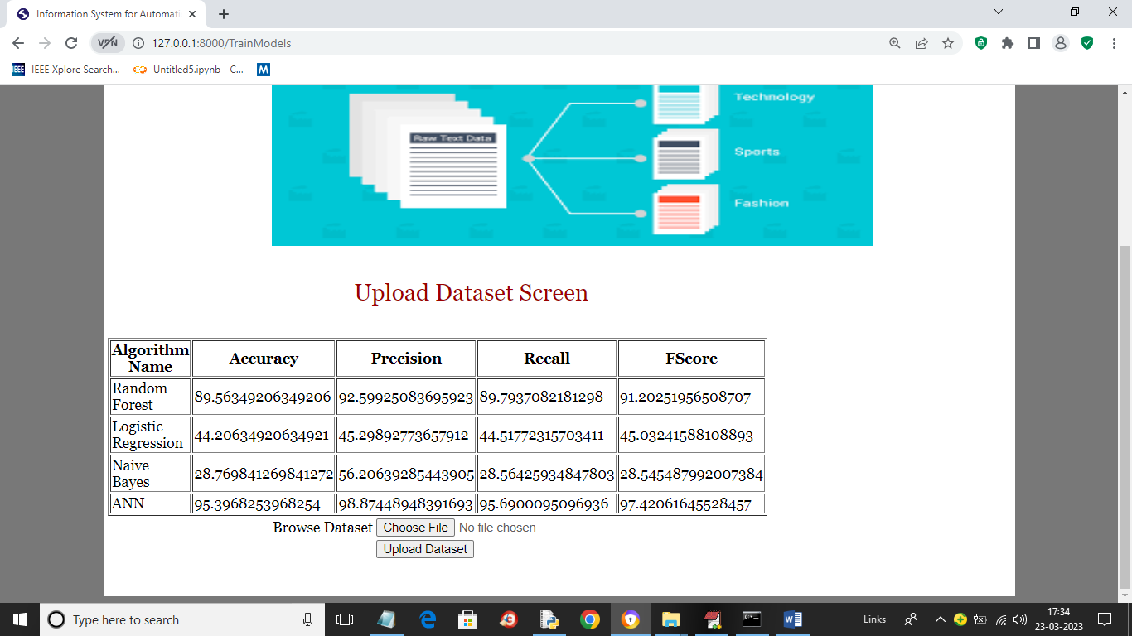
In above screen in tabular format we can see performance of each algorithm and we showing metrics like accuracy, precision, recall and FSCORE. Now click on ‘Classify News’ link to get below page
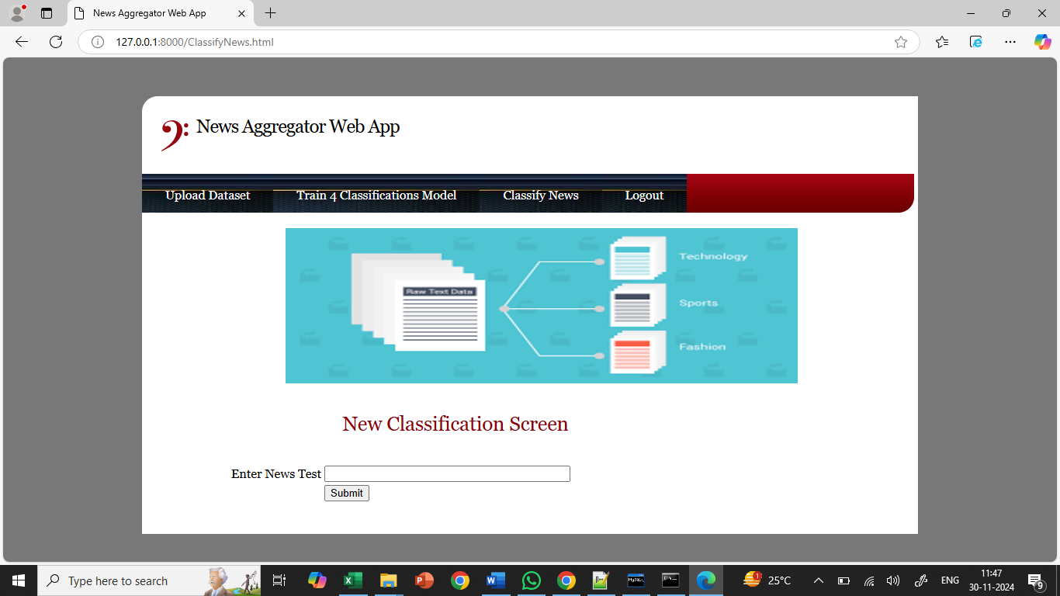
In above screen in text area entered some news or copy one line from ‘testNews.txt’ file (available in code folder) and paste in above field like below screen
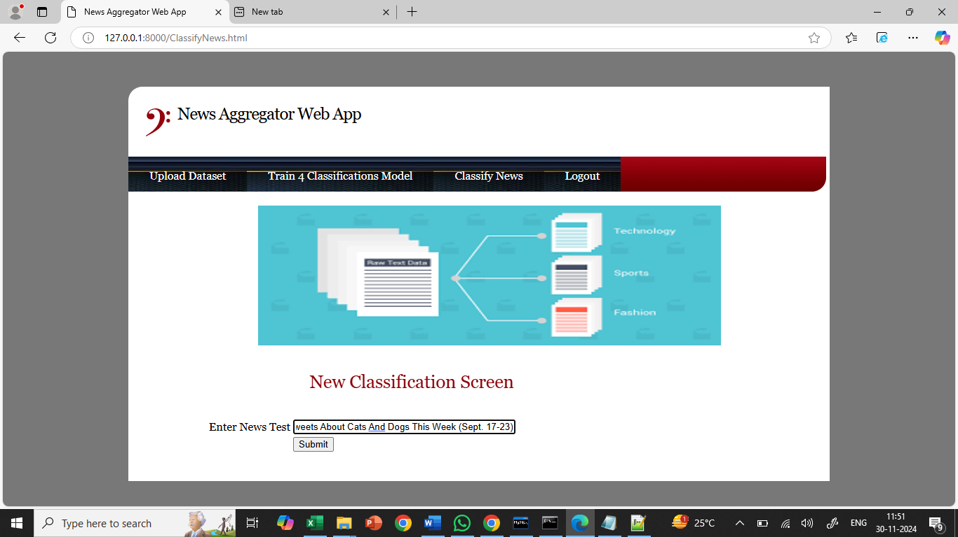
In above screen I entered some News Text and press ‘Submit’ button to get below page
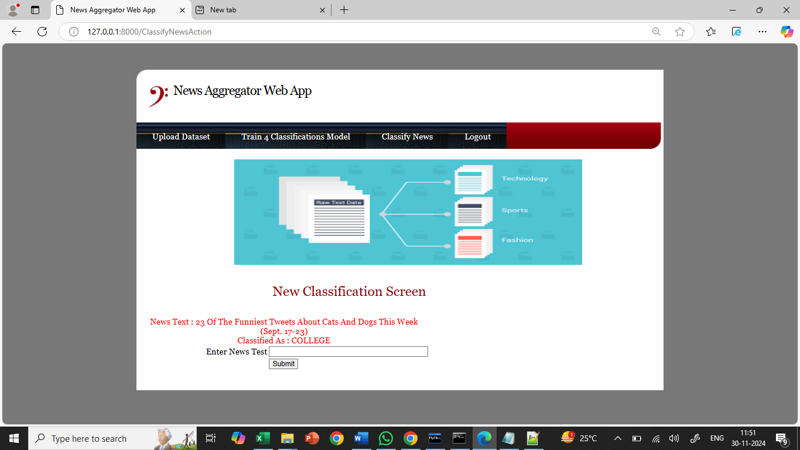
In above screen in red colour text displaying News Text and then in blue colour text you can News classified as ‘World News’. Similarly you can enter and classify news and below are the other output
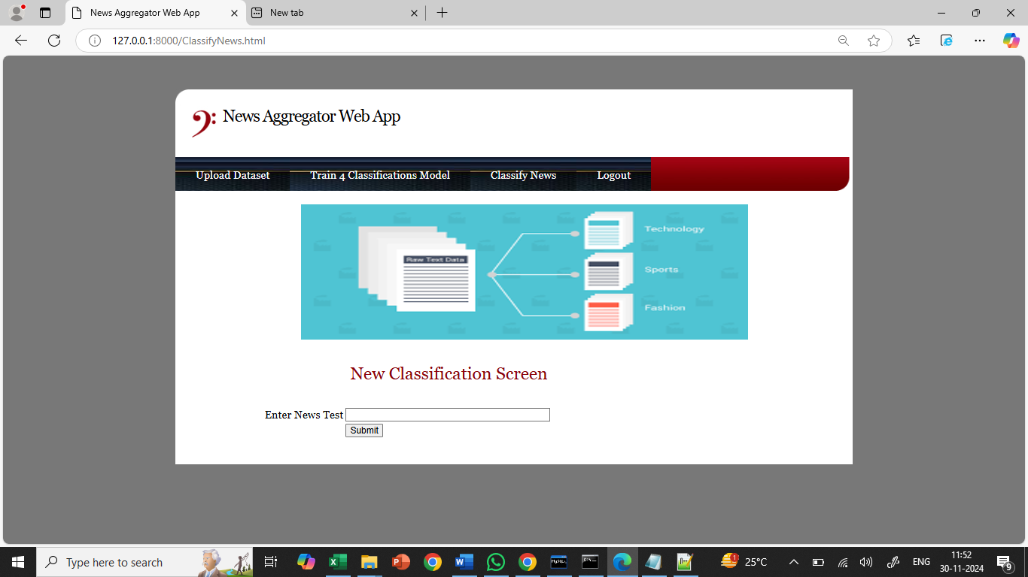
In above screen entered another news and below is the output
