A comprehensive online platform for residents to share their opinions on local initiatives and foster active civic participation

A Report submitted under Project-Based Learning

In Partial Fulfillment of the Course Requirements for
“Web Technologies (22IT104001)”

Submitted By

G Bhuvana | 22102A040081
G Pooja Harshitha | 22102a040087
J Sai Varshitha | 22102A040095
K Ramya | 22102A040102
K Sree Sahithya  K Anoosha | 22102A040104  22102A040109

Under the Guidance of
Guide Name
Designation
Department of CSE



Department of Computer Science and Engineering
School of Computing
MOHAN BABU UNIVERSITY
Sree Sainath Nagar, Tirupati – 517 102 2024-2025


MOHAN BABU UNIVERSITY
Vision
To be a globally respected institution with an innovative and entrepreneurial culture that offers transformative education to advance sustainability and societal good.
Mission
- Develop industry-focused professionals with a global perspective.
- Offer academic programs that provide transformative learning experience founded on the spirit of curiosity, innovation, and integrity.
- Create confluence of research, innovation, and ideation to bring about sustainable and socially relevant enterprises.
- Uphold high standards of professional ethics leading to harmonious relationship with environment and society.

SCHOOL OF COMPUTING
Vision
To lead the advancement of computer science research and education that has real-world impact and to push the frontiers of innovation in the field.
Mission
- Instil within our students fundamental computing knowledge, a broad set of skills, and an inquisitive attitude to create innovative solutions to serve industry and community.
- Provide an experience par excellence with our state-of-the-art research, innovation, and incubation ecosystem to realise our learners’ fullest potential.
- Impart continued education and research support to working professionals in the computing domain to enhance their expertise in the cutting-edge technologies.
- Inculcate among the computing engineers of tomorrow with a spirit to solve societal challenges.
DEPARTMENT OF COMPUTER SCIENCE AND ENGINEERING
Vision
To become a Centre of Excellence in Computer Science and its emerging areas by imparting high quality education through teaching, training and research.

Mission
- Imparting quality education in Computer Science and Engineering and emerging areas of IT industry by disseminating knowledge through contemporary curriculum, competent faculty and effective teaching-learning methodologies.
- Nurture research, innovation and entrepreneurial skills among faculty and students to contribute to the needs of industry and society.
- Inculcate professional attitude, ethical and social responsibilities for prospective and promising engineering profession.
- Encourage students to engage in life-long learning by creating awareness of the contemporary developments in Computer Science and Engineering and its emerging areas.

B.Tech. Computer Science and Engineering
PROGRAM EDUCATIONAL OBJECTIVES
After few years of graduation, the graduates of B.Tech. CSE will be:
- Pursuing higher studies in core, specialized or allied areas of Computer Science, or Management.
- Employed in reputed Computer and I.T organizations or Government to have a globally competent professional career in Computer Science and Engineering domain or be successful Entrepreneurs.
- Able to demonstrate effective communication, engage in teamwork, exhibit leadership skills and ethical attitude, and achieve professional advancement through continuing education.

PROGRAM OUTCOMES
On successful completion of the Program, the graduates of B.Tech. CSE Program will be able to:
- Engineering Knowledge: Apply the knowledge of mathematics, science, engineering fundamentals, and an engineering specialization to the solution of complex engineering problems.
- Problem Analysis: Identify, formulate, review research literature, and analyze complex engineering problems reaching substantiated conclusions using first principles of mathematics, natural sciences, and engineering sciences.
- Design/Development of Solutions: Design solutions for complex engineering problems and design system components or processes that meet the specified needs with appropriate consideration for the public health and safety, and the cultural, societal, and environmental considerations.
- Conduct Investigations of Complex Problems: Use research-based knowledge and research methods including design of experiments, analysis and interpretation of data, and synthesis of the information to provide valid conclusions.
- Modern Tool Usage: Create, select, and apply appropriate techniques, resources, and modern engineering and IT tools including prediction and modeling to complex engineering activities with an understanding of the limitations.
- The Engineer and Society: Apply reasoning informed by the contextual knowledge to assess societal, health, safety, legal and cultural issues and the consequent responsibilities relevant to the professional engineering practice.
- Environment and Sustainability: Understand the impact of the professional engineering solutions in societal and environmental contexts, and demonstrate the knowledge of, and need for sustainable development.
- Ethics: Apply ethical principles and commit to professional ethics and responsibilities and norms of the engineering practice.
- Individual and Team Work: Function effectively as an individual, and as a member or leader in diverse teams, and in multidisciplinary settings.
- Communication: Communicate effectively on complex engineering activities with the engineering community and with society at large, such as, being able to comprehend and write effective reports and design documentation, make effective presentations, and give and receive clear instructions.
- Project Management and Finance: Demonstrate knowledge and understanding of the engineering and management principles and apply these to one’s own work, as a member and leader in a team, to manage projects and in multidisciplinary environments.
- Life-long Learning: Recognize the need for, and have the preparation and ability to engage in independent and life-long learning in the broadest context of technological change.

PROGRAM SPECIFIC OUTCOMES
On successful completion of the Program, the graduates of B. Tech. (CSE) program will be able to:
PSO1. Apply knowledge of computer science engineering, Use modern tools, techniques and technologies for efficient design and development of computer-based systems for complex engineering problems.
PSO2. Design and deploy networked systems using standards and principles, evaluate security measures for complex networks, apply procedures and tools to solve networking issues.
PSO3. Develop intelligent systems by applying adaptive algorithms and methodologies for solving problems from inter-disciplinary domains.
PSO4. Apply suitable models, tools and techniques to perform data analytics for effective decision making.
Course Code | Course Title | L | T | P | S | C
22IT104001 | WEB TECHNOLOGIES | 3 | - | 2 | 4 | 5

COURSE OUTCOMES: After successful completion of this course, the students will be able to:
- Demonstrate knowledge on web page design elements, dynamic content and database connection.
- Analyze user requirements to develop web applications.
- Design client-server applications using web technologies.
- Demonstrate problem solving skills to develop enterprise web applications.
- Apply HTML, CSS, JavaScript, JQuery, Bootstrap and PHP technologies for device independent web application development.
- Apply web technologies to develop interactive, dynamic and scalable web applications for societal needs.

CO-PO-PSO Mapping Table:
Course Outcomes | Program Outcomes |  |  |  |  |  |  |  |  |  |  |  | Program Specific Outcomes
 | PO1 | PO2 | PO3 | PO4 | PO5 | PO6 | PO7 | PO8 | PO9 | PO10 | PO11 | PO12 | PSO1 | PSO2 | PSO3 | PSO4
CO1 | 3 | 3 | 2 | - | - | - | - | - | - | - | - | - | 3 | 2 | 3 | -
CO2 | 3 | 3 | 3 | 2 | 2 | - | - | - | - | - | - | - | 3 | 2 | 3 | -
CO3 | 3 | 3 | 3 | 2 | 2 | - | - | - | - | - | - | - | 3 | 2 | 3 | -
CO4 | 3 | 3 | 3 | 2 | 2 | - | - | - | - | - | - | - | 2 | 2 | 3 | -
CO5 | 3 | 2 | 2 | 2 | 2 | 3 | - | - | - | - | - | - | 2 | 2 | 3 | -
CO6 |  |  |  | 2 |  |  |  |  | 3 | 3
Course Correlation Mapping | 3 | 3 | 3 | 2 | 2 |  |  |  | 3 | 3 |  |  | 3 | 2 | 3

Correlation Levels: 3: High; 2: Medium; 1: Low

Department of Computer Science and Engineering

CERTIFICATE

This is to certify that the Project Entitled
A comprehensive online platform for residents to share their opinions on local initiatives and foster active civic participation

Submitted By
G Bhuvana | 22102A040081
G Pooja Harshitha | 22102A040087
J Sai Varshitha | 22102A040095
K Ramya | 22102A040102
K Sree Sahithya  K Anoosha | 22102A040104  22102A040109

is the work submitted under Project-Based Learning in Partial Fulfillment of the Course Requirements for “Web Technologies (22IT104001)” during 2024-2025.

Supervisor: Head:

Name Dr. G. Sunitha
Designation Professor & Head
Department of CSE Department of CSE
School of Computing School of Computing
Mohan Babu University Mohan Babu University
Tirupati. Tirupati.

ACKNOWLEDGEMENTS

First and foremost, I extend my sincere thanks to Dr. M. Mohan Babu, Chancellor, for his unwavering support and vision that fosters academic excellence within the institution.
My gratitude also goes to Mr. Manchu Vishnu, Pro-Chancellor, for creating an environment that promotes creativity and for his encouragement and commitment to student success.
I am deeply appreciative of Prof. Nagaraj Ramrao, Vice Chancellor, whose leadership has created an environment conducive to learning and innovation.
I would like to thank Dr. K. Saradhi, Registrar, for his support in creating an environment conducive to academic success.
My sincere thanks to Dr. B.M. Satish, Dean of the School of Engineering and Computing, for his valuable support and guidance in all academic matters.
I am also grateful to Dr. G. Sunitha, Head of the Department of Computer Science and Engineering, for her valuable insights and support.
Finally, I would like to express my deepest appreciation to my project supervisor, Supervisor's Name, Designation, Department of Computer Science and Engineering for continuous guidance, encouragement, and expertise throughout this project.
Thank you all for your support and encouragement.

Table of contents
Chapter No. | Title |  | Page No.
 | Abstract |  | 1
1 | Introduction |  | 2
 | 1.1 | Problem Statement | 2
 | 1.2 | Importance of the Problem | 3
 | 1.3 | Objectives | 3
 | 1.4 | Scope of the Project | 3
2 | System Design |  | 4
 | 2.1 | Architecture Diagram | 4
 | 2.2 | Module Descriptions | 6
 | 2.3 | Database Design | 9
3 | Implementation |  | 12
 | 3.1 | Tools and Technologies Used | 12
 | 3.2 | Front-End Development | 13
 | 3.3 | Back-End Development | 16
 | 3.4 | Integration | 18
4 | Testing, Results and Discussion |  | 19
 | 4.1 | Test Cases | 19
 | 4.2 | Testing Methods | 20
 | 4.3 | Output Screenshots | 22
 | 4.4 | Analysis of Results | 24
5 | Conclusion |  | 26
 | 5.1 | Summary of Findings | 26
 | 5.2 | Future Enhancements | 27
6 | Appendix |  | 28
 | 6.1 | Code Snippets | 28

ABSTRACT

This project presents a comprehensive online platform designed to empower residents by providing a space for sharing opinions on local initiatives and fostering active civic participation. In a time when civic engagement is essential for thriving communities, many individuals feel disconnected from the decision-making processes that impact their lives.
The platform centralizes information about community projects, policies, and events, enabling residents to stay informed and engaged. By facilitating opinion sharing, it encourages dialogue and collaboration, thereby building trust between community members and local authorities. Inclusivity is a key focus, with a user-friendly design that ensures accessibility for diverse voices.
Additionally, the platform promotes active participation in civic activities by offering details about town hall meetings, volunteer opportunities, and advocacy efforts. Interactive tools such as polls and discussion forums will enhance user engagement and provide local leaders with valuable insights into community sentiments.
A feedback loop will allow leaders to respond to residents’ input, reinforcing the importance of civic engagement and fostering trust. By connecting residents with shared interests, the platform can inspire grassroots initiatives that address local challenges.
In summary, this online platform aims to enhance civic engagement by empowering residents to actively shape their communities. By promoting transparency, inclusivity, and collaboration, it seeks to strengthen the democratic process and foster a sense of belonging, ultimately inspiring individuals to participate in local governance.

- INTRODUCTION
1.1 Problem Statement
Many residents feel disconnected from local decision-making processes, lacking effective platforms to express their opinions on community initiatives. This disconnection results in limited public input, reduced transparency in governance, and diminished trust in local authorities. Additionally, residents often remain unaware of civic activities, further hindering their participation.
The proposed comprehensive online platform aims to address these issues by providing a user-friendly space for residents to share their views on local initiatives and engage in civic activities. By fostering active participation, this platform will enhance communication between community members and local leaders, promote transparency, and empower individuals to shape their communities.
1.2 Importance of the Problem
The lack of effective channels for residents to express their opinions on local initiatives poses significant challenges for communities. First, active civic participation is essential for a healthy democracy. When individuals feel disconnected from decision-making processes, it leads to diminished public engagement, resulting in policies that may not reflect the community’s needs or desires. This disconnect can create a knowledge gap and foster disenchantment with local governance.
Second, fostering a culture of transparency and accountability is crucial for building trust between residents and local authorities. A comprehensive online platform can facilitate open communication, allowing residents to voice their concerns and ideas, thereby encouraging local leaders to consider public input in their decisions.
Additionally, providing a centralized space for discussion promotes inclusivity and diverse representation. Many community members may feel marginalized or unheard; an accessible platform can amplify their voices and ensure that a wide range of perspectives are considered in local initiatives.
Finally, fostering connections through shared civic interests strengthens social bonds and community cohesion. By facilitating discussions, the platform enhances engagement and creates a more informed citizenry, addressing vital community needs and promoting a more resilient society.
1.3 Objectives
1. **Create a User-Friendly Interface**: Develop an intuitive web application that allows residents to easily navigate and engage with the platform, ensuring a seamless experience for all users.
2. **Facilitate Opinion Sharing**: Enable users to express their thoughts on local initiatives effortlessly, including features for posting opinions, commenting, and discussing topics of interest.
3. **Promote Active Civic Participation**: Encourage residents to participate in local governance by providing information on civic activities, such as town hall meetings and community events.
4. **Enhance Community Engagement**: Foster connections among residents by creating a space for discussions, collaboration, and sharing of ideas related to local initiatives.
5. **Ensure Inclusivity**: Provide accessibility features to ensure that all community members, regardless of their background or abilities, can participate and share their opinions.
6. **Implement Secure User Authentication**: Establish a secure registration and login process to protect user information and build trust within the community.
7. **Gather User Feedback**: Create mechanisms for users to provide feedback on their experiences with the platform, enabling continuous improvement and responsiveness to community needs.
8. **Promote Transparency and Accountability**: Facilitate communication between residents and local authorities, ensuring that community voices are heard and considered in decision-making processes.

1.4 Scope of the Project
Goal: We want to create an online platform where residents can share their thoughts on local initiatives and get involved in their community.

Key Features
- User Accounts: Residents can sign up and create profiles to join the conversation.
- Feedback Options: They can easily share opinions and comments on different initiatives.
- Initiative Directory: A searchable list of local projects so everyone can stay informed.
- Discussion Forums: Spaces for community discussions about specific initiatives.
- Notifications: Residents will receive alerts about new initiatives and community events.

Technical Aspects
- User-Friendly Design: The platform will be accessible on both computers and mobile devices.
- Data Protection: We’ll ensure user information is safe and secure.
- Content Moderation: Tools will be in place to keep discussions respectful.

Community Engagement
- We’ll partner with local organizations and hold workshops to encourage participation.
This platform aims to strengthen connections between residents and local government, making it easier for everyone to get involved and have their voices heard.

2 . System Design

2.1 Architecture Diagram

- User Interface (UI)

- Web Application: For desktop users to access the platform.
- Mobile Application: For mobile users to engage on the go.
- Accessibility Features: Ensure the platform is usable for people with disabilities.

- Front-end Framework

- React/Vue/Angular: For building dynamic user interfaces.
- State Management: Redux or Vuex for managing application state.

- Back-end Services

- API Layer: RESTful or GraphQL API for communication between the frontend and backend.
- Authentication Service: OAuth2 or JWT for user authentication and authorization.
- Content Management System (CMS): For managing local initiatives and user-generated content.

- Database

- Relational Database: PostgreSQL or MySQL for structured data (user profiles, initiatives, comments).
- NoSQL Database: MongoDB for unstructured data (feedback, user interactions).

- Hosting and Deployment

- Cloud Provider: AWS, Azure, or Google Cloud for hosting the platform.
- Containerization: Docker for deploying services consistently.

- Data Analysis and Reporting

- Analytics Tools: Integration with tools like Google Analytics for tracking user engagement and feedback.
- Feedback Analysis: NLP (Natural Language Processing) tools to analyze user opinions and sentiments.

Notification System:

- Email Notifications: For updates on initiatives, responses, or community events.
- Push Notifications: For mobile app users to stay informed.

- Community Engagement Tools:

- Discussion Forums: For users to discuss initiatives.
- Polls and Surveys: To gauge community opinion on various topics.
- Event Calendar: To promote local events and initiatives.

- Security and Compliance:

- Data Encryption: At rest and in transit to protect user data.
- GDPR/CCPA Compliance: Ensuring user data privacy and rights.

- Administration Dashboard:

- Moderation Tools: For managing user-generated content and comments.
- Analytics Dashboard: For administrators to track platform usage and community engagement.

2.2 Module Descriptions

1. Linked by Experience
This page highlights stories, testimonials, and experiences shared by individuals who have participated in various civic activities. Users can browse through impactful experiences, learn from others' journeys, and connect through shared causes. It's an inspiring space designed to foster a sense of community and motivation for active civic engagement.
Features:
- Personal stories and case studies
- User-generated content and contributions

2.Get Involved
The "Get Involved" page is the gateway for users looking to take action in their communities. It offers a curated list of volunteer opportunities, events, and initiatives that need support. This module helps individuals find local and virtual opportunities based on their interests, location, and availability.
Features:
- Searchable directory of volunteer opportunities
- Filter by interest area, location, and skill set

3. Downloadable Resources
This section provides a library of helpful resources for individuals and organizations engaged in civic activities. Users can download guides, tool kits, reports, and other educational materials that support their activism and community engagement efforts. The resources are designed to empower users with knowledge and actionable insights.
Features:
- A wide range of downloadable PDFs, guides, templates, and reports
- Categorized by topic (e.g., advocacy, community organizing, sustainability)
- Resource recommendations based on user preferences

4. Idea Submission
The "Idea Submission" page invites users to propose new civic initiatives or projects. It’s a collaborative space where anyone can submit innovative ideas to improve their community or society at large. Once submitted, ideas may be voted on or reviewed for potential implementation, giving users the chance to actively shape the platform’s direction.
Features:
- Form for submitting new ideas and proposal

5. Contact and Connect
This page serves as the central hub for communication and networking. It allows users to get in touch with platform administrators, partners, and other like-minded individuals. Whether for general inquiries, collaboration opportunities, or seeking advice, this page provides essential contact information and connection tools.
Features:
- Contact form for questions, suggestions, and inquiries

3. Implementation
3.1 Tools and Technologies Used

- Frontend Framework/Library
React.js: The most popular JavaScript framework for building modern web applications. It’s ideal for SPAs (Single Page Applications) and can handle dynamic content updates.
Vue.js: Another powerful JavaScript framework that is easy to integrate and build with. It’s lightweight and flexible for small to medium projects.
Svelte: A newer alternative that compiles your code to highly efficient vanilla JavaScript, making it super fast and light.
Next.js: If you're using React, Next.js provides server-side rendering, static site generation, and other advanced features. It’s ideal for SEO and performance without managing a backend.

2. Styling and Layout
Tailwind CSS: A utility-first CSS framework that allows you to build custom designs without writing much CSS.
Bootstrap: A popular responsive design framework that helps you quickly build mobile-first websites.
Material-UI or Chakra UI: If you're using React, these libraries provide ready-to-use components with a consistent design system.

3. Forms and Data Collection (No Back-end)

Google Forms: A simple way to collect form data without back-end integration. You can embed Google Forms directly into your site, and data will be saved to Google Sheets.
Formspree: Provides a form submission handler, so you can send form data to an email or integrate it with other services like Zanier.
Typeform: For more interactive and customized forms. You can embed Type form directly into your site.
JotForm: Another powerful tool for creating forms and collecting user responses.
Netlify Forms: If you're deploying with Netlify, their built-in form handling makes it easy to collect and process submissions without needing a back-end.

4. File Storage & Downloads

Google Drive / Dropbox / OneDrive: You can host downloadable files and share links with users. Use a simple link or embed the file directly into your site.
Amazon S3: If you need more control over file storage, you can use AWS S3 for file hosting and serve them directly from the cloud (although you may need to handle access control via some lightweight JavaScript logic).
Cloudinary: For hosting images or other media files, Cloudinary provides an easy API for uploading and serving media files directly.

5. Analytics and Tracking

Google Analytics: Easily track page views, user demographics, and other interactions with minimal setup.
Hotjar: You can track user sessions and see how users are interacting with your platform via heatmaps, session recordings, and surveys.
Fathom Analytics: A privacy-friendly alternative to Google Analytics.
Mixpanel: For more detailed tracking of user actions and events (good for tracking engagement with forms, voting, etc.).

6. Authentication & User Accounts (Without Backend)

Firebase Authentication: You can use Firebase for user authentication (email, Google login, etc.). Firebase will handle the authentication backend for you, and you only need to deal with frontend logic.
Auth0: Another service that provides easy-to-integrate authentication options (supports OAuth, Google login, etc.).
Netlify Identity: If you’re using Netlify, it provides identity services to manage authentication and access control for users.

7. Social Media and Sharing

Twitter, Instagram, and Facebook Feeds: Use their embeddable widgets to display content directly from these platforms (e.g., Twitter timeline, Instagram photos).
Social Sharing Buttons: Tools like AddThis or ShareThis let you easily integrate social sharing buttons for posts, events, or resources on your site.

8. Idea Submission & Voting (Without Back-end)
Airtable: You can use Airtable as a lightweight database with a beautiful UI to store ideas and submissions. It also allows you to build simple forms and views to collect and display submissions. You can use the Airtable API to integrate with your frontend without needing a full backend.
Google Sheets + Google Apps Script: Similar to Airtable, you can set up a Google Sheet to store submissions and use Google Apps Script to automate submissions and actions (e.g., send emails on submission).
Upvoting with Local Storage: You can create a simple upvoting or rating system by saving votes locally (using localStorage or sessionStorage) and dynamically updating the UI. This wouldn’t persist data permanently but could be used for session-based voting.
Discourse or Flarum: These open-source platforms are great for user discussions and can be embedded within your site. They provide voting, commenting, and idea submission features, though they come with more setup than other third-party services.

9. Communication/Contact (Without Backend)

Tawk.to: A free live chat tool to integrate into your website and provide real-time support.
Intercom: If you’re looking for a more advanced customer support solution with messaging, Intercom can handle both chat and email inquiries.
Contact Form via Formspree/Google Forms: For a simple contact form, you can use Formspree or Google Forms to collect inquiries without a backend.

10. Hosting & Deployment

Netlify: Great for static sites with continuous deployment and forms handling. Perfect for React, Vue.js, or other static frontend projects.
Vercel: Ideal for React (Next.js), Vue.js, or static sites with excellent performance and deployment features.
GitHub Pages: If you're deploying a simple static site and have your project hosted on GitHub, GitHub Pages is a free and easy hosting option.
Firebase Hosting: If you're using Firebase Authentication or Firebase Functions, Firebase Hosting is a good option with simple deployment and scaling.

11. Performance Optimization

Lighthouse: Use Lighthouse (built into Chrome DevTools) to audit your site for performance and accessibility issues.
Cloudflare CDN: For faster content delivery, you can set up Cloudflare to cache your static assets globally and protect your site from traffic spikes.

3.2 Front-End Development

1. Linked by Experience
Hero Section: Engaging banner with rotating featured stories.
Tech: ReactJS + CSS Grid/Flexbox.

2. Get Involved
Opportunity Feed: Searchable list of volunteer events.
Tech: ReactJS + Algolia/ElasticSearch.
Sign-Up Forms: Simple event RSVP functionality.
Tech: React Forms or Typeform.
Previews: Show resource previews (e.g., PDF thumbnails).
Tech: PDF.js.
Download Button: Easy-to-click buttons for downloading files.
Tech: Cloudinary/Amazon S3 for file hosting.
Idea Submission
Submission Form: Simple form for users to submit ideas.
Tech: React Forms + TinyMCE/Quill for rich text.
Contact and Connect
Contact Form: Simple inquiry form for users.
Tech: Formspree or ReactJS Forms.
Share Your Response Experience Submission Form:

Description: Form for users to submit stories (text, images, videos).
Story Feed:

Description: Display submitted stories in a feed, with filters by category.

Frontend: ReactJS + React Forms for dynamic content and form handling.
Styling: Tailwind CSS for responsive and customizable design.
File Upload: Dropzone.js for easy drag-and-drop file upload functionality.
Search & Filter: ElasticSearch or Algolia for fast and efficient content discovery.
4. Testing, Results And Discussion

4.1 Test Cases

1. Linked by Experience (Showing Implemented Stories)
Test Case 1: Display Stories
Test Objective: Verify that stories are displayed correctly.
Test Steps:
Navigate to the Linked by Experience page.
Ensure that a list/grid of stories is visible.
Check that each story displays its title, image (if available), summary, and category.
Expected Result: Stories are displayed correctly with all elements (title, image, summary) properly loaded.

2. Share Your Response (Submitting New Responses)
Test Case 1: Form Submission
Test Objective: Verify that the submission form works.
Test Steps:
Navigate to the Share Your Response page.
Fill out the form with valid data (title, description, category, image/video).
Click the "Submit" button.
Expected Result: The form should be submitted successfully, and a confirmation message or page should appear.

3. Get Involved (Volunteer Opportunities)
Test Case: Opportunity Search and Registration
Test Objective: Verify that users can search for and register for volunteer opportunities.
Test Steps:
Navigate to the Get Involved page.
Use the search or filter feature (e.g., by location or cause) to find relevant volunteer opportunities.
Click on an opportunity and click "RSVP" or "Join."
Expected Result: The volunteer opportunity should be displayed correctly, and the user should be able to register for the event without issues.

4. Downloadable Resources
Test Case: Resource Download
Test Objective: Verify that users can successfully download resources.
Test Steps:
Navigate to the Downloadable Resources page.
Browse or search for a resource (e.g., a PDF guide).
Click on the download button.
Expected Result: The resource should start downloading, and the correct file should be retrieved.

5. Idea Submission
Test Case: Idea Submission and Voting
Test Objective: Verify that users can submit ideas and vote on others' ideas.
Test Steps:
Navigate to the Idea Submission page.
Submit a new idea (title, description, and category).
Vote on an existing idea.
Expected Result: The new idea should be successfully submitted, and votes should be recorded on other submitted ideas.

6. Contact and Connect
Test Case: Contact Form Submission
Test Objective: Verify that the contact form works for submitting user inquiries.
Test Steps:
Navigate to the Contact and Connect page.
Fill out the contact form (name, email, message).
Submit the form.
Expected Result: The form should submit successfully, and the user should receive a confirmation or thank-you message.

4.2 Testing Methods

1. Functional Testing
Objective: Ensure all features work as expected.
Methods:
Manual Testing: Test UI elements and user flows.
Automated Testing: Use tools like Selenium for repetitive tasks.

2. Usability Testing
Objective: Confirm the platform is user-friendly.
Methods:
User Interviews: Get feedback from real users.
A/B Testing: Test UI element variations.

3. Performance Testing
Objective: Test speed and scalability.
Methods:
Load Testing: Simulate heavy traffic with JMeter.
Speed Testing: Use tools like Google PageSpeed Insights.

4. Compatibility Testing
Objective: Ensure cross-browser/device compatibility.
Methods:
Browser Testing: Use BrowserStack for cross-browser checks.
Responsive Design: Test mobile usability with DevTools.

5. Security Testing
Objective: Test platform security.
Methods:
Penetration Testing: Use OWASP ZAP or Burp Suite.
Input Validation: Check for vulnerabilities like XSS.

6. Regression Testing
Objective: Ensure updates don’t break functionality.
Methods:
Automated Regression: Run previous tests with Selenium.

7. Acceptance Testing
Objective: Verify platform meets user and business needs.
Methods:
User Acceptance Testing (UAT): Real users validate the platform.

8. Localization Testing
Objective: Verify language and regional correctness.
Methods:
Manual Testing: Test localized content with native speakers.

9. Smoke Testing
Objective: Check basic functionality after updates.
Methods:
Quick Check: Run critical test cases for basic workflows.

10. End-to-End Testing
Objective: Test entire user journey.
Methods:
This format provides the key testing methods in a concise manner for each aspect of the platform.

4.3 Output Screenshots

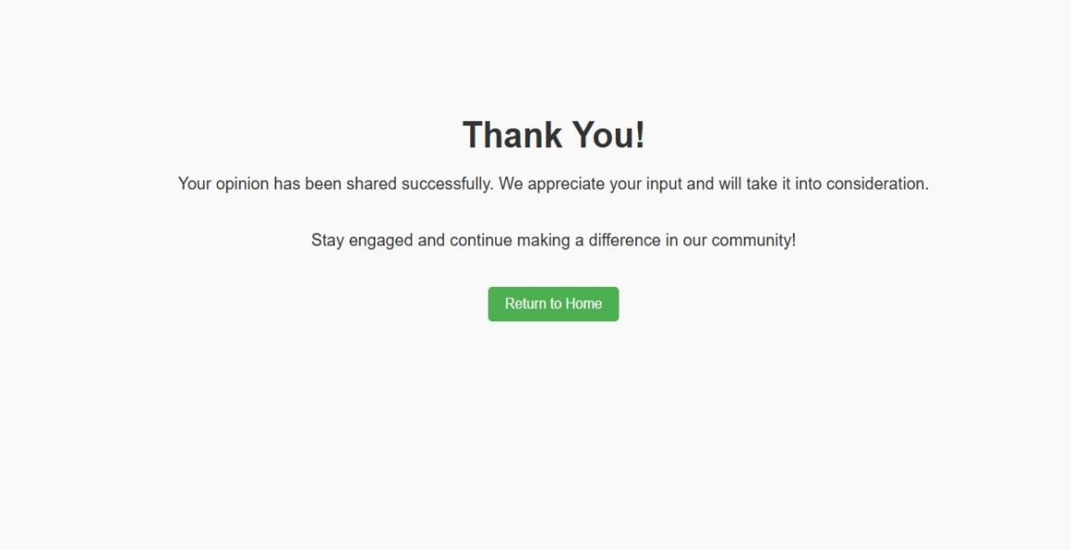
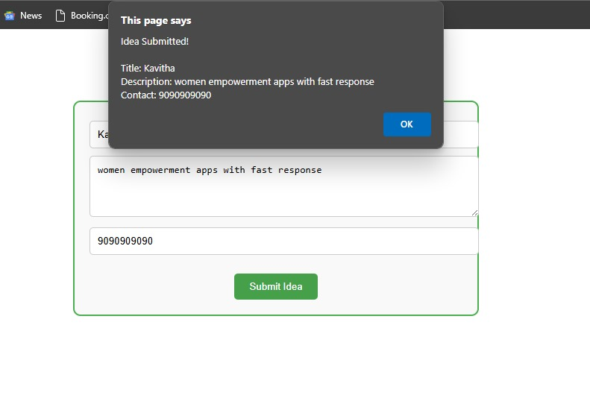
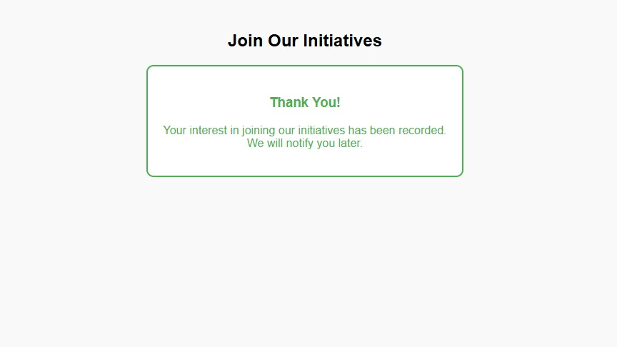
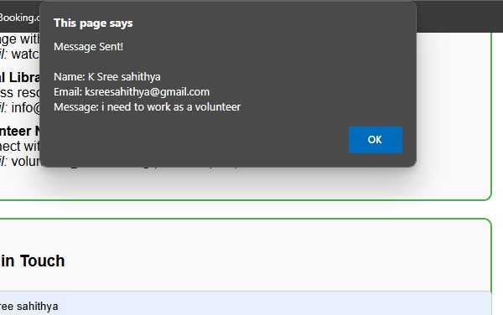

4.4 Analysis Of Results

- Share Your Response (Submitting New Responses)
Objective: Enable users to submit their own civic activity stories.
Key Results:
Submission Form: Simple, intuitive form with rich text and media upload options.
User-Friendly: Easy-to-use rich text editor (TinyMCE/Quill).
Mobile Optimization: Mobile-friendly form design for seamless submission.
Clear CTA: Prominent "Submit" button for easy story submission.
2. Linked by Experience (Showing Implemented Stories)
Objective: Showcase existing user stories to inspire civic engagement.
Key Results:
Story Feed: Organized and filterable list of stories by category.
Mobile Optimization: Fully responsive for easy viewing on all devices.

3. Get Involved
Objective: Help users find and engage in volunteer opportunities or events.
Results:
User-Friendly Search: Filters by location, cause, and skill make discovery easy.
Event Registration: Simplified sign-up forms increase participation.

4. Downloadable Resources
Objective: Provide downloadable resources to assist in civic engagement.
Results:
Resource Organization: Categorized library boosts navigation and discovery.
File Previews: Thumbnails improve download conversion.
Download Mechanism: Clear, easy-to-click buttons streamline access.
Mobile Optimization: Ensures accessible resources across devices.

5. Idea Submission
Objective: Allow users to submit ideas and vote on others' initiatives.
Results:
Simple Forms: Easy submission process encourages idea contribution
Idea Display: Clear, grid-based layout boosts idea discoverability.

6. Contact and Connect
Objective: Facilitate communication with users and partner organizations.
Results:
Simple Contact Form: Easy-to-complete form increases inquiries.
Integration: Easy connection through social media drives engagement.

Overall Front-End Results
Usability: Intuitive navigation and prominent CTAs improve user experience.
Responsiveness: Mobile-optimized design ensures access across all devices.
Performance: Fast load times and dynamic content updates increase user retention.
Engagement: Interactive elements (comments, likes, voting) drive active participation.
Conversion: Clear calls-to-action increase sign-ups, submissions, and downloads.

5. Conclusion
5.1 Summary Of Findings

1. Functional Testing
Findings: Core features (story display, form submission, volunteer registration) are working well. Minor UI tweaks needed for consistency.

2. Usability Testing
Findings: Platform is generally user-friendly. Navigation improvements needed, especially on mobile devices.

3. Performance Testing
Findings: Good performance under normal load. Some lag during peak traffic, especially on media-heavy pages. Minor optimization needed.

4. Compatibility Testing
Findings: Works across major browsers and devices. Minor issue with Safari on older versions. Mobile responsiveness is mostly good.

5. Security Testing
Findings: No major vulnerabilities found. Some form validation issues (XSS risk) need addressing. Data encryption is functioning properly.

6. Regression Testing
Findings: No new issues after bug fixes. Minor file upload issues need further attention.

7. Acceptance Testing
Findings: Meets most user and business requirements. Some features (media uploads) need better user guidance.

8. Localization Testing
Findings: Accurate translations, but regional formatting (e.g., dates) needs fixing. Further testing required for non-English versions.

9. Smoke Testing
Findings: Core workflows function as expected. Minor UI fixes needed in high-traffic areas.

10. End-to-End Testing
Findings: Seamless user flows and integrations. User journeys can be made more intuitive with better instructions.

Recommendations:

Usability: Improve navigation and mobile responsiveness.
Performance: Optimize media-heavy pages.
Security: Fix input validation issues (XSS).
Localization: Standardize regional formats.
User Guidance: Add clearer instructions for media uploads.

5.2 Future Enhancements

1. Enhanced Mobile Experience
Enhancement: Improve mobile responsiveness, especially for forms and media-heavy pages.
Reason: Ensure seamless usage across all devices, especially smartphones and tablets.

2. Advanced Search and Filtering
Enhancement: Implement AI-based search and filtering options (e.g., by location, cause, date) for content and volunteer opportunities.
Reason: Help users find relevant activities and information more efficiently.

3. Real-Time Collaboration & Community Interaction
Enhancement: Introduce real-time chat, forums, or discussion boards for community engagement on ideas and civic activities.
Reason: Facilitate collaboration and increase user participation in discussions.

4. Gamification Features
Enhancement: Introduce badges, points, or leaderboards to encourage volunteerism and idea contributions.
Reason: Motivate users to participate more actively through rewards and recognition.

5. Multi-Language Support
Enhancement: Add language options and auto-detection for broader accessibility.
Reason: Expand the platform’s reach and engagement by catering to a global audience.

