PYTHON ACTIVITY-BASED LEARNING REPORT
Case Study 9: Password Policy Validation Engine
Name: Ganji Sreevalli
Roll Number: 26000900
Branch: CSE (AIML)
Subject: Python Programming
1. Problem Statement
To develop a Python program that validates a password according to a set of predefined rules. The program checks the password length and whether it contains uppercase letters, lowercase letters, digits, and special characters.
2. Objectives
- To accept a password from the user.
- To check whether the password contains at least eight characters.
- To check for uppercase and lowercase letters.
- To check for digits and special characters.
- To display whether the password satisfies all the defined rules.
3. Assumptions
- The minimum password length is eight characters.
- The password must contain at least one uppercase letter.
- The password must contain at least one lowercase letter.
- The password must contain at least one digit.
- The password must contain at least one character from !@#$%^&*()-_+=?.
- The program checks these rules only; it does not measure overall password strength or verify whether a password has been compromised.
4. Algorithm
- Start the program.
- Read a password from the user.
- Initialize flags for uppercase, lowercase, digit, and special character checks.
- Examine each character in the password.
- Set the appropriate flag when a required character is found.
- Check whether the password has at least eight characters.
- If all conditions are satisfied, display VALID.
- Otherwise, display INVALID.
- Stop the program.
5. Flowchart
6. Pseudocode
START
INPUT password

SET has_upper = FALSE
SET has_lower = FALSE
SET has_digit = FALSE
SET has_special = FALSE

FOR each character in password
CHECK whether character is uppercase
CHECK whether character is lowercase
CHECK whether character is a digit
CHECK whether character is a special character
END FOR

IF length >= 8 AND all flags are TRUE
DISPLAY "VALID"
ELSE
DISPLAY "INVALID"
END IF

STOP
7. Python Source Code

# Case Study 9: Password Policy Validation Engine

print("===== PASSWORD VALIDATION SYSTEM =====")

password = input("Enter a password to validate: ")

has_upper = False
has_lower = False
has_digit = False
has_special = False

special_characters = "!@#$%^&*()-_+=?"

for character in password:
if character.isupper():
has_upper = True
elif character.islower():
has_lower = True
elif character.isdigit():
has_digit = True
elif character in special_characters:
has_special = True

print("\n===== VALIDATION RESULTS =====")
print("Minimum 8 characters:", len(password) >= 8)
print("Contains uppercase letter:", has_upper)
print("Contains lowercase letter:", has_lower)
print("Contains digit:", has_digit)
print("Contains special character:", has_special)

if (
len(password) >= 8
and has_upper
and has_lower
and has_digit
and has_special
):
print("\nPassword Status: VALID")
else:
print("\nPassword Status: INVALID")

print("======================================")

8. Test Cases
Test case | Sample input | Expected result
1 | Sree@123 | VALID
2 | sree@123 | INVALID — no uppercase letter
3 | SREE@123 | INVALID — no lowercase letter
4 | Sree@abc | INVALID — no digit
5 | Sree1234 | INVALID — no special character
6 | Sr@1 | INVALID — fewer than eight characters
9. Output Screenshots
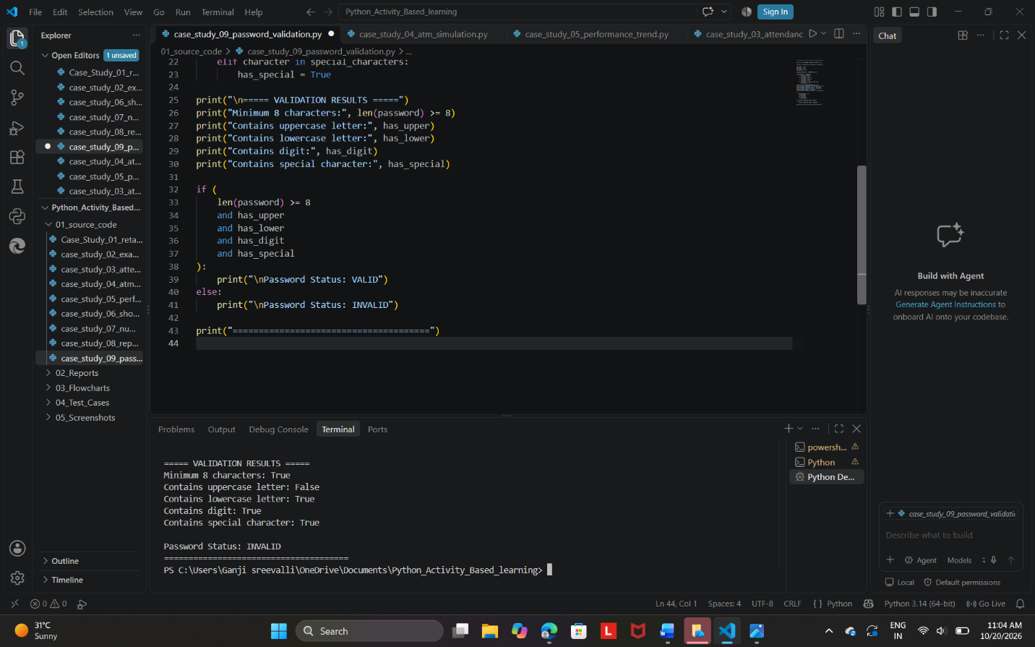

Expected output:
===== PASSWORD VALIDATION SYSTEM =====

===== VALIDATION RESULTS =====
Minimum 8 characters: True
Contains uppercase letter: True
Contains lowercase letter: True
Contains digit: True
Contains special character: True

Password Status: VALID
======================================
10. Conclusion
The Password Policy Validation Engine was developed successfully using Python. It checks password length and required character types and displays whether the password meets the specified rules. This activity demonstrates the use of loops, conditional statements, string methods, and Boolean variables in Python.

