PYTHON ACTIVITY-BASED LEARNING REPORT
Case Study 6: Multi-Product Shopping Budget Constraint
Name: Ganji Sreevalli
Roll Number: 26000900
Branch: CSE (AIML)
Subject: Python Programming
1. Problem Statement
To develop a Python program that allows a customer to select products from a list while staying within a fixed budget. The program calculates the total cost and remaining budget and prevents purchases that exceed the available budget.
2. Objectives
- To display available products and their prices.
- To accept the customer's product selections.
- To ensure that the total cost does not exceed the budget.
- To calculate the total shopping cost.
- To display the remaining budget.
3. Assumptions
- The shopping budget is ₹700.
- The available products are Notebook, Pen, School Bag, Water Bottle, and Pencil Box.
- Each product is considered as one item.
- The customer enters yes or no for each product.
- A product is added only if its price does not exceed the remaining budget.
- Product prices are fixed for this program.
4. Algorithm
- Start the program.
- Define the products, prices, and shopping budget.
- Initialize the total cost to zero.
- Display the available products.
- Ask the customer whether to buy each product.
- If the customer selects yes, check whether the product fits within the budget.
- Add the product if sufficient budget is available.
- Display the selected products, total cost, and remaining budget.
- Stop the program.
5. Flowchart
6. Pseudocode
START
SET budget = 700
SET total = 0
CREATE empty selected_items list

DISPLAY available products

FOR each product
INPUT customer choice
IF choice is "yes"
IF total + product price <= budget
ADD product to selected_items
INCREASE total by product price
ELSE
DISPLAY "Budget exceeded"
END IF
END IF
END FOR

DISPLAY selected_items
DISPLAY total
DISPLAY budget - total
STOP
7. Python Source Code

# Case Study 6: Multi-Product Shopping Budget Constraint

print("===== SHOPPING BUDGET SYSTEM =====")

products = {
"Notebook": 50,
"Pen": 10,
"School Bag": 500,
"Water Bottle": 100,
"Pencil Box": 80
}

budget = 700
total = 0
selected_items = []

print("Your budget is Rs.", budget)
print("\nAvailable Products:")

for name, price in products.items():
print(name, "- Rs.", price)

for name, price in products.items():
choice = input(
"\nDo you want to buy " + name + "? (yes/no): "
).lower()

if choice == "yes":
if total + price <= budget:
selected_items.append((name, price))
total += price
print("Added:", name)
else:
print("Cannot add", name, "- budget exceeded.")

print("\n===== SHOPPING SUMMARY =====")

if len(selected_items) == 0:
print("No products selected.")
else:
for name, price in selected_items:
print(name, "- Rs.", price)

print("Total Cost: Rs.", total)
print("Remaining Budget: Rs.", budget - total)
print("================================")

8. Test Cases
Test case | Product selections | Expected result
1 | Notebook, Pen, School Bag, Water Bottle | Total ₹660; remaining ₹40
2 | School Bag, Pencil Box | Total ₹580; remaining ₹120
3 | All products selected | Pencil Box is rejected after the first four products; total ₹660
4 | No products selected | Total ₹0; remaining ₹700
5 | Notebook and Pen selected | Total ₹60; remaining ₹640
9.Output Screenshots
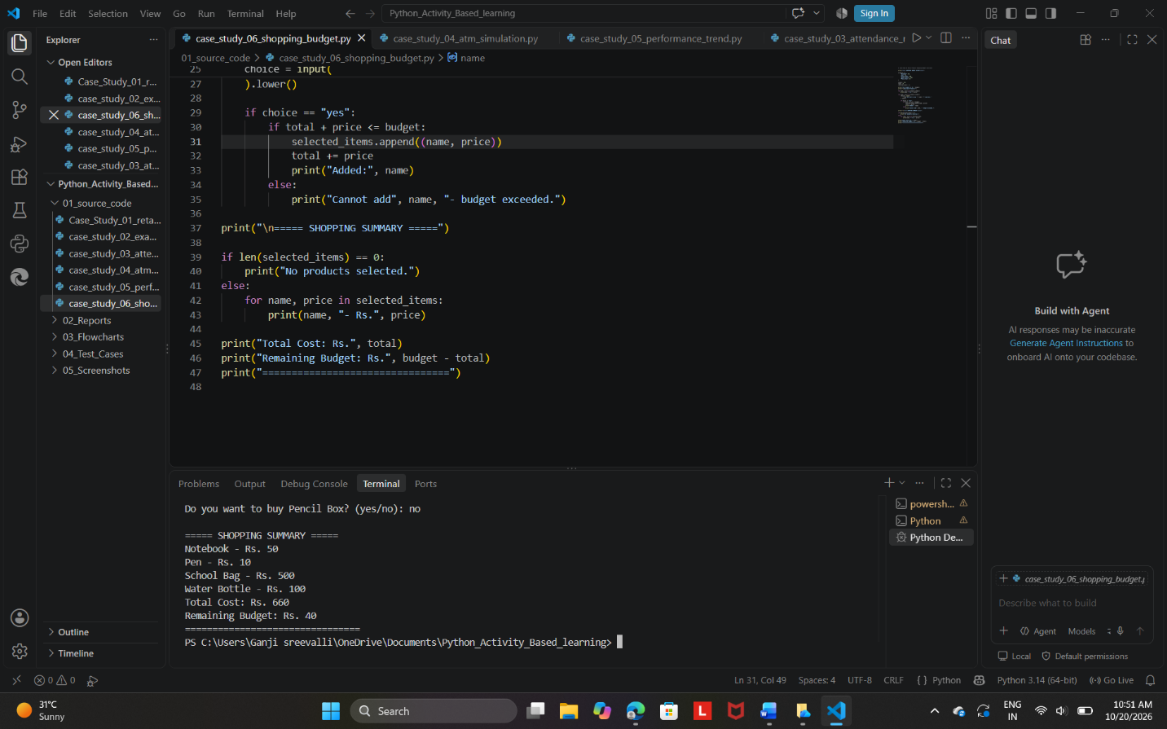

Expected output summary:
===== SHOPPING SUMMARY =====
Notebook - Rs. 50
Pen - Rs. 10
School Bag - Rs. 500
Water Bottle - Rs. 100
Total Cost: Rs. 660
Remaining Budget: Rs. 40
================================
10. Conclusion
The Multi-Product Shopping Budget Constraint program was developed successfully using Python. It accepts product selections, checks the budget before adding each product, calculates the total shopping cost, and displays the remaining budget. This program demonstrates the use of dictionaries, lists, loops, conditional statements, and arithmetic operations.

