PYTHON ACTIVITY-BASED LEARNING
FLOWCHARTS
Name: Ganji Sreevalli | Roll Number: 26000900
Branch: CSE (AIML) | Subject: Python Programming

1. Retail Billing with Multiple Discount Rules
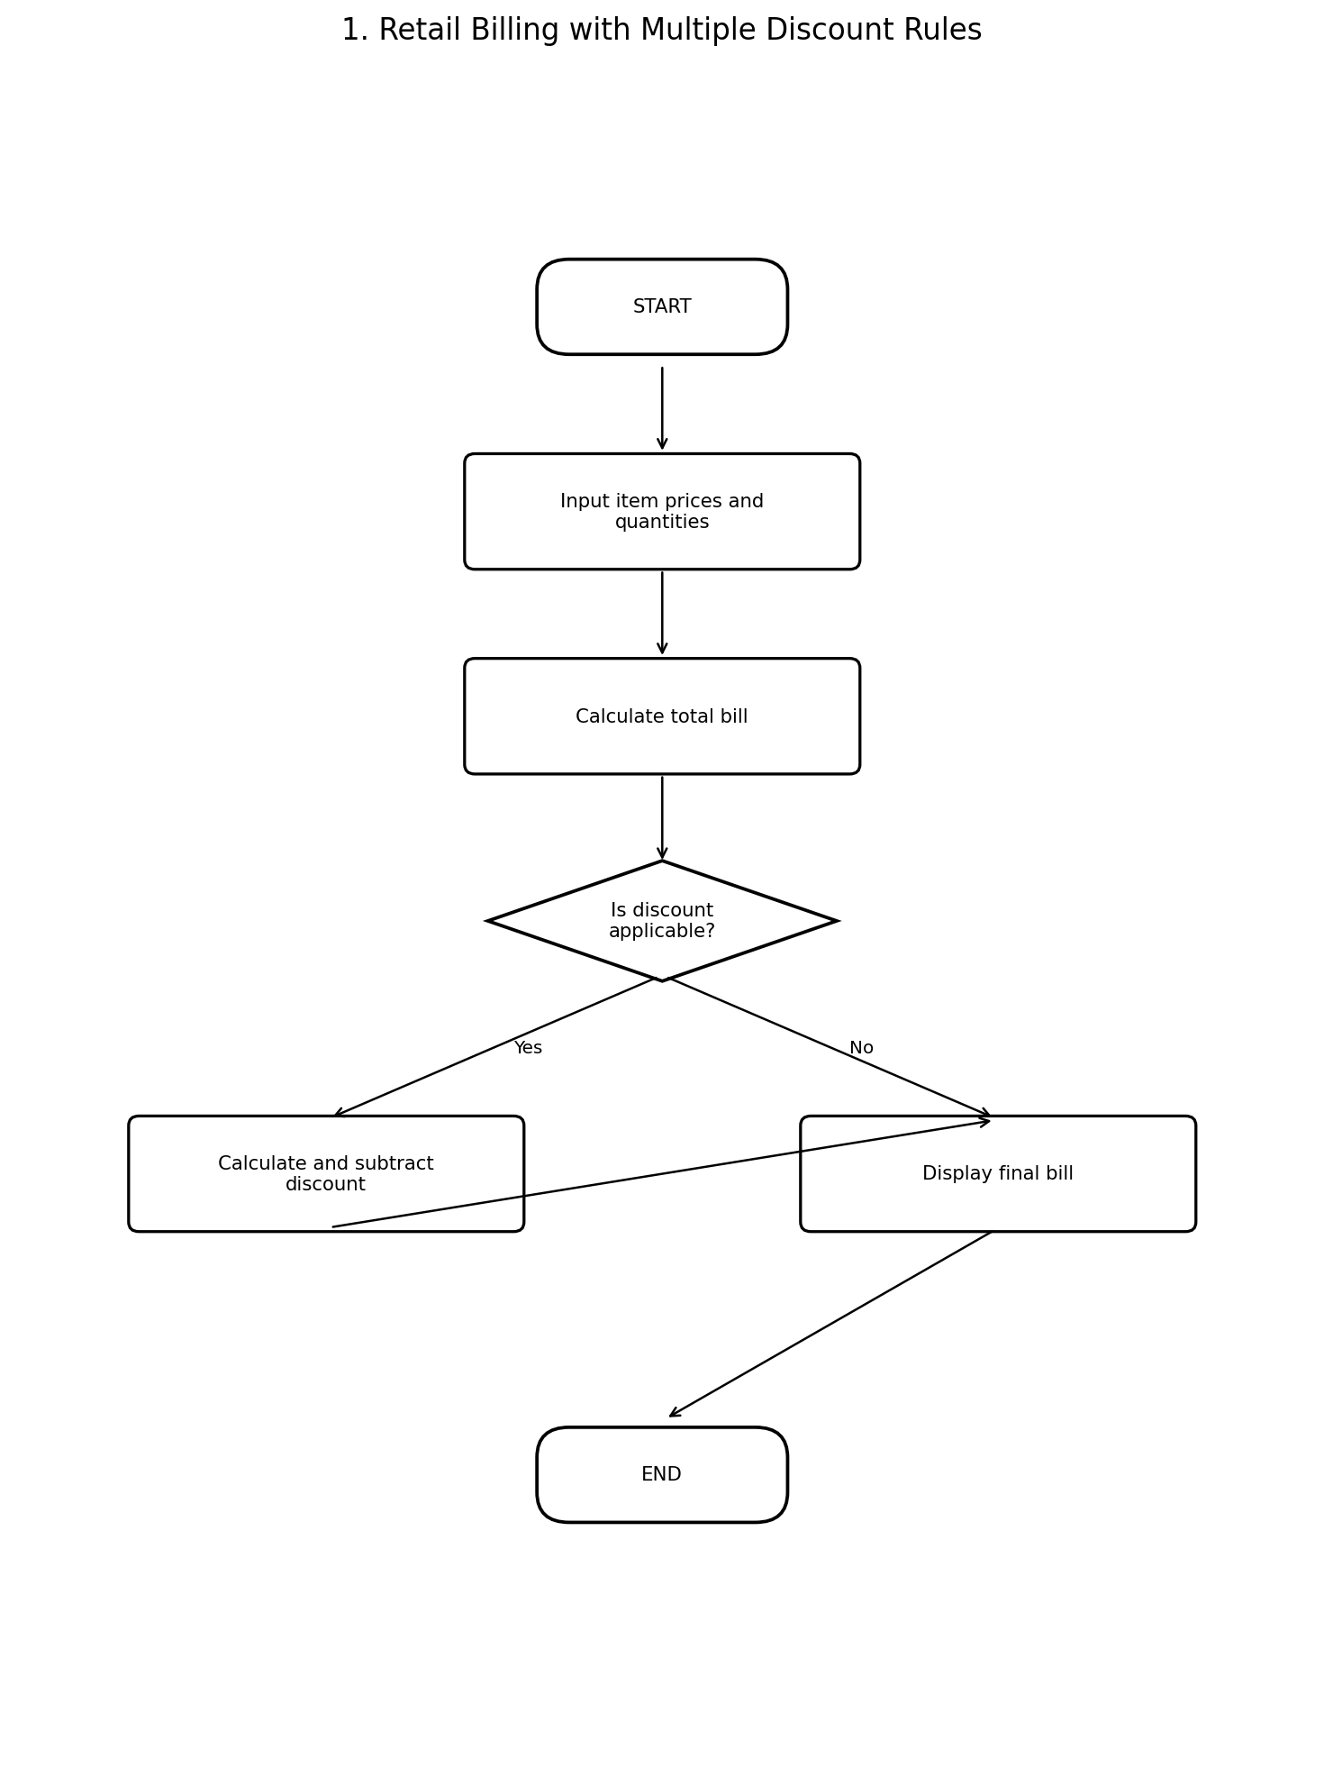

2. Examination Result and Grace-Mark Validation
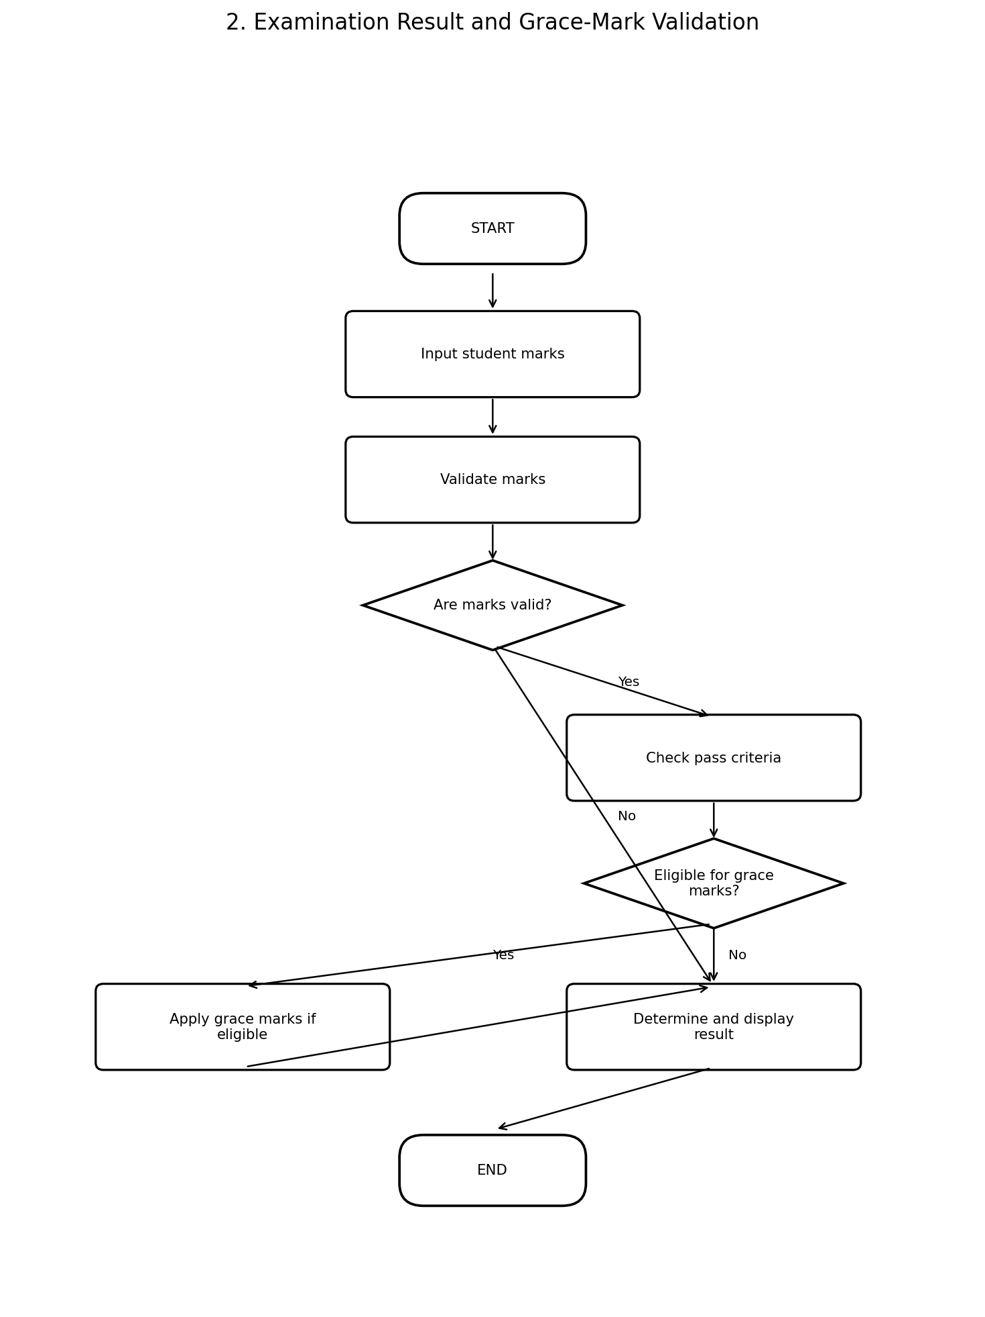

3. Attendance Recovery Computation
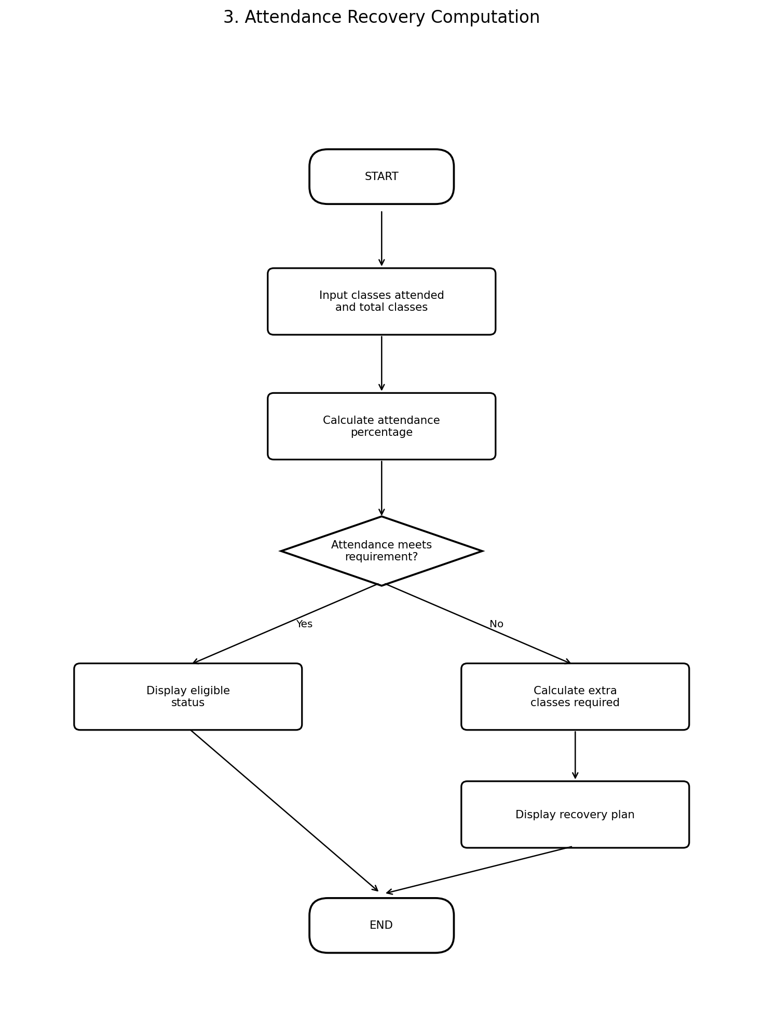

4. ATM Transaction Sequence Simulation
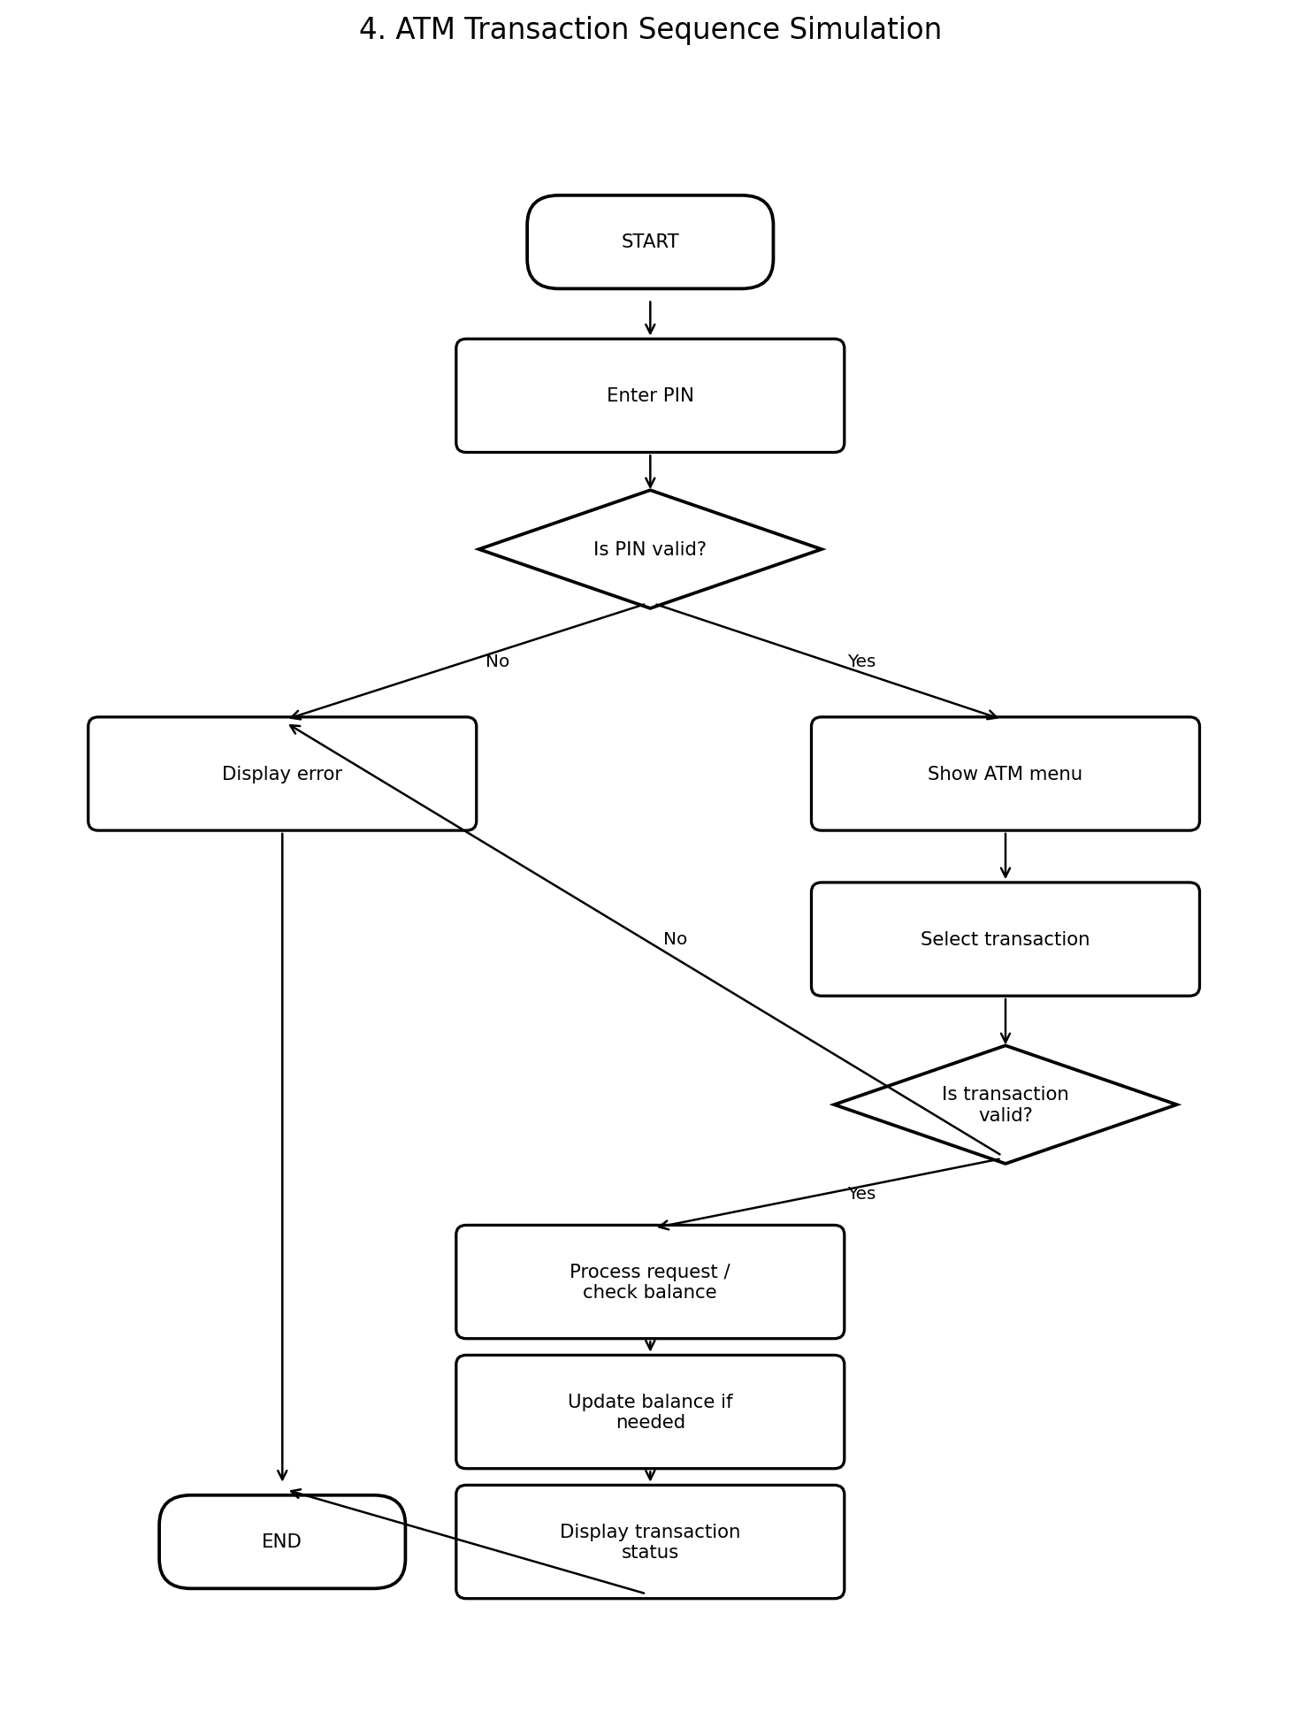

5. Student Performance Trend Analysis
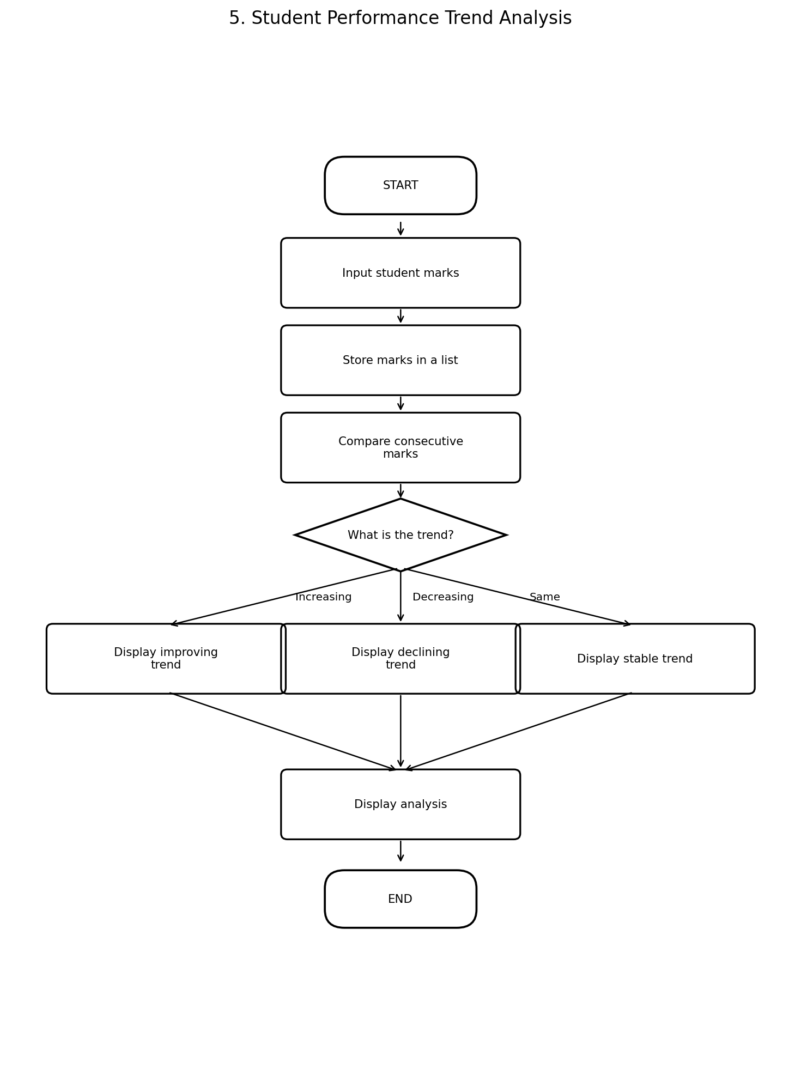

6. Multi-Product Shopping Budget Constraint
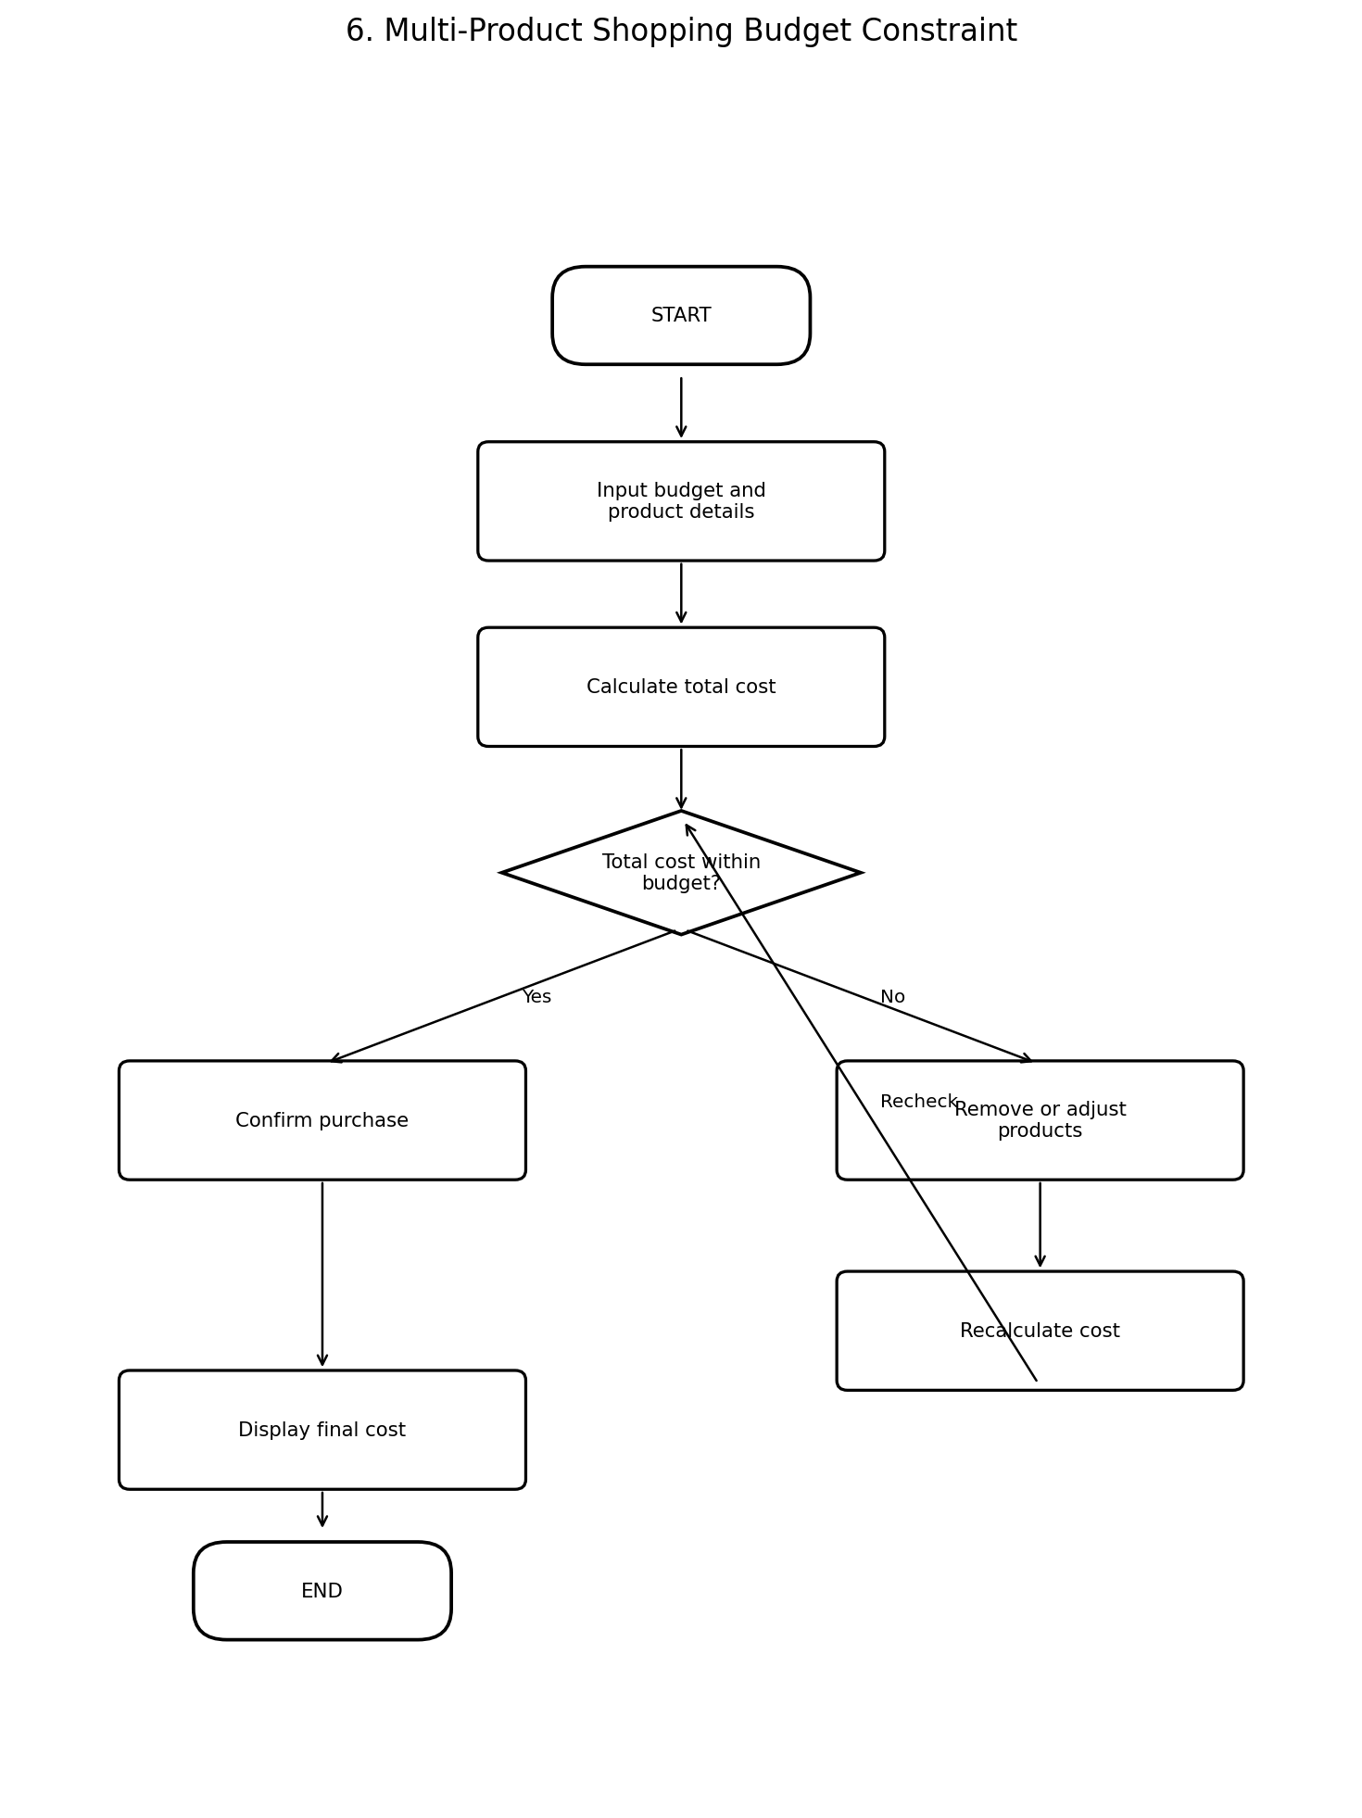

7. Advanced Numeric Pattern Generator
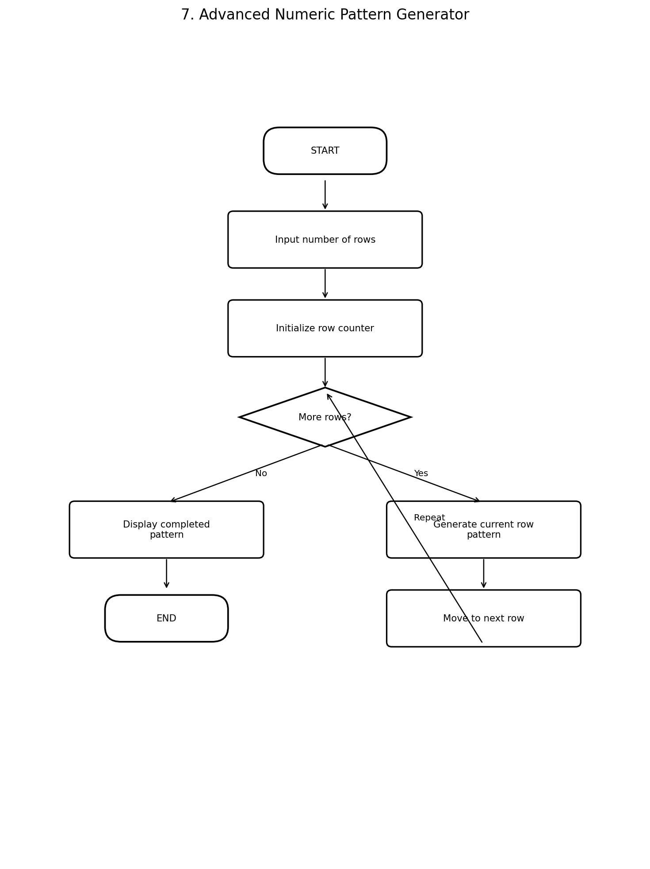

8. Repeated Transaction Detection
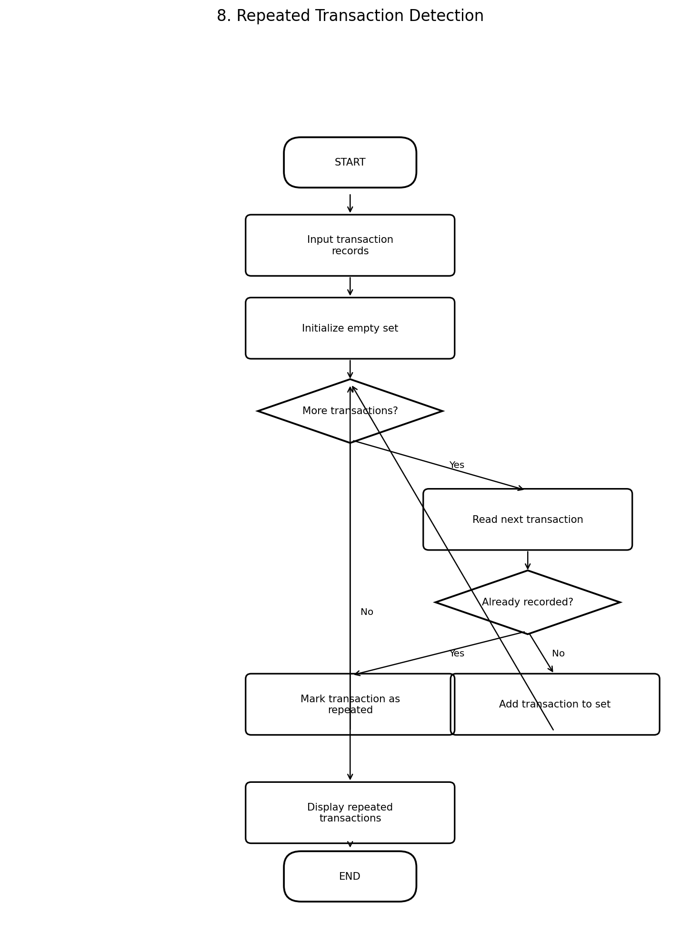

9. Password Policy Validation Engine
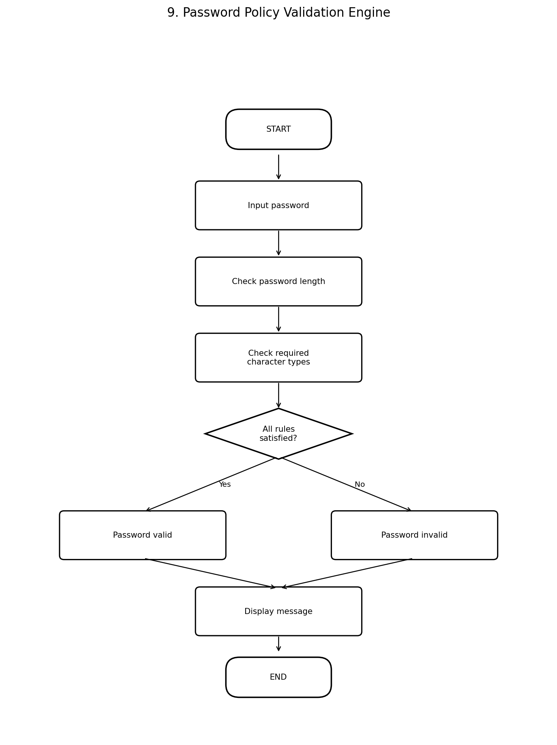

10. Text Compression Using Character Runs
