PYTHON ACTIVITY-BASED LEARNING REPORT
Case Study 8: Repeated Transaction Detection
Name: Ganji Sreevalli
Roll Number: 26000900
Branch: CSE (AIML)
Subject: Python Programming
1. Problem Statement
To develop a Python program that identifies repeated transaction IDs from a list of transactions. The program displays all transactions, identifies repeated IDs, and calculates the total number of transactions, unique transactions, and repeated transaction IDs.
2. Objectives
- To store transaction IDs in a list.
- To detect repeated transaction IDs.
- To identify unique transactions.
- To count total and unique transactions.
- To practice lists, sets, loops, and conditional statements in Python.
3. Assumptions
- Transaction IDs are represented as strings.
- Identical transaction IDs are considered repeated.
- The sample transaction list is predefined.
- A repeated transaction ID is counted once in the repeated-ID summary, even if it occurs more than twice.
- The program identifies repeated IDs; it does not delete transactions or prove that a real financial transaction is fraudulent.
4. Algorithm
- Start the program.
- Create a list of transaction IDs.
- Create an empty set named seen.
- Create an empty set named repeated.
- Check each transaction ID in the list.
- If the ID already exists in seen, add it to repeated.
- Otherwise, add it to seen.
- Display all transactions and repeated IDs.
- Display the total transaction count, unique transaction count, and repeated-ID count.
- Stop the program.
5. Flowchart
Start → Create transaction list → Initialize seen and repeated sets → Read each transaction ID → Check whether it exists in seen → If yes, add it to repeated; otherwise, add it to seen → Repeat for all transactions → Display results → Stop.
6. Pseudocode
START
CREATE transaction list
CREATE empty seen set
CREATE empty repeated set

FOR each transaction ID
IF transaction ID is in seen
ADD transaction ID to repeated
ELSE
ADD transaction ID to seen
END IF
END FOR

DISPLAY all transactions
DISPLAY repeated transaction IDs
DISPLAY total transactions
DISPLAY unique transactions
DISPLAY number of repeated IDs
STOP
7. Python Source Code

# Case Study 8: Repeated Transaction Detection

print("===== REPEATED TRANSACTION DETECTION =====")

transactions = [
"TXN101",
"TXN102",
"TXN103",
"TXN102",
"TXN104",
"TXN101",
"TXN105"
]

seen = set()
repeated = set()

for transaction_id in transactions:
if transaction_id in seen:
repeated.add(transaction_id)
else:
seen.add(transaction_id)

print("All Transactions:")
for transaction_id in transactions:
print(transaction_id)

print("\nRepeated Transactions:")

if repeated:
for transaction_id in sorted(repeated):
print(transaction_id)
else:
print("No repeated transactions found.")

print("Total Transactions:", len(transactions))
print("Unique Transactions:", len(seen))
print("Repeated Transaction IDs:", len(repeated))

print("==========================================")

8. Test Cases
Test case | Transaction IDs | Expected result
1 | TXN101, TXN102, TXN103, TXN102, TXN104, TXN101, TXN105 | Repeated IDs: TXN101, TXN102
2 | TXN201, TXN202, TXN203 | No repeated IDs
3 | TXN301, TXN301, TXN301 | One repeated ID: TXN301
4 | Empty list | No transactions; no repeated IDs
9. Output Screenshots
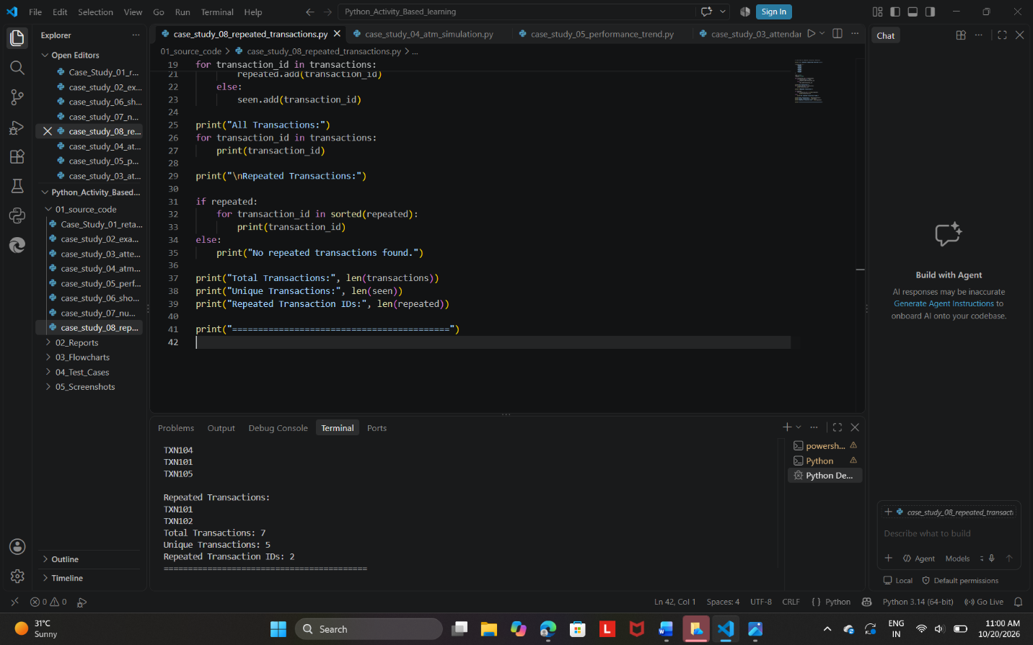

Expected output summary:
Repeated Transactions:
TXN101
TXN102
Total Transactions: 7
Unique Transactions: 5
Repeated Transaction IDs: 2
10. Conclusion
The Repeated Transaction Detection program was developed successfully using Python. It identifies repeated transaction IDs using sets and displays useful transaction counts. This activity demonstrates the use of lists, sets, loops, and conditional statements. The program can help identify duplicate IDs in a sample transaction list, although further checks would be needed to confirm actual duplicate financial transactions.

