PYTHON ACTIVITY-BASED LEARNING REPORT
Case Study 10: Text Compression Using Character Runs
Name: Ganji Sreevalli
Roll Number: 26000900
Branch: CSE (AIML)
Subject: Python Programming
1. Problem Statement
To develop a Python program that compresses text by counting consecutive repeated characters. The program represents each group of repeated characters using the character followed by its count and displays the original and compressed text lengths.
2. Objectives
- To accept text from the user.
- To identify consecutive repeated characters.
- To count the occurrences of each consecutive character.
- To generate compressed text using character counts.
- To compare the lengths of the original and compressed text.
3. Assumptions
- The input is treated as a sequence of characters.
- Only consecutive occurrences of the same character are grouped together.
- Each character group is represented by the character followed by its count.
- The program is a simple demonstration of run-length encoding.
- Compression may not reduce the length of every input.
4. Algorithm
- Start the program.
- Accept text from the user.
- Check whether the input is empty.
- If it is empty, display a message requesting text.
- Otherwise, initialize the compressed string and a character counter.
- Compare each character with the previous character.
- If they match, increase the counter.
- If they differ, add the previous character and its count to the compressed string, then reset the counter.
- Add the final character and its count.
- Display the original text, compressed text, and their lengths.
- Stop the program.
5. Flowchart
Start → Enter text → Check whether text is empty → If empty, display a message → Otherwise, initialize counter → Compare consecutive characters → Count matching characters → Store each character and count → Display compressed text and lengths → Stop.
6. Pseudocode
START
INPUT text

IF text is empty
DISPLAY "Please enter some text"
ELSE
SET compressed = ""
SET count = 1

FOR each character after the first
IF current character = previous character
INCREASE count
ELSE
ADD previous character and count to compressed
RESET count to 1
END IF
END FOR

ADD final character and count to compressed

DISPLAY original text
DISPLAY compressed text
DISPLAY original length
DISPLAY compressed length
END IF

STOP
7. Python Source Code

# Case Study 10: Text Compression Using Character Runs

print("===== TEXT COMPRESSION SYSTEM =====")

text = input("Enter text to compress: ")

if text == "":
print("Please enter some text.")

else:
compressed = ""
count = 1

for i in range(1, len(text)):
if text[i] == text[i - 1]:
count += 1
else:
compressed += text[i - 1] + str(count)
count = 1

compressed += text[-1] + str(count)

print("Original Text:", text)
print("Compressed Text:", compressed)
print("Original Length:", len(text))
print("Compressed Length:", len(compressed))

print("====================================")

8. Test Cases
Test case | Input | Expected compressed text
1 | aaabbcccc | a3b2c4
2 | aaaa | a4
3 | abcd | a1b1c1d1
4 | aabbaa | a2b2a2
5 | Empty input | Displays a message requesting text
9. Output Screenshots
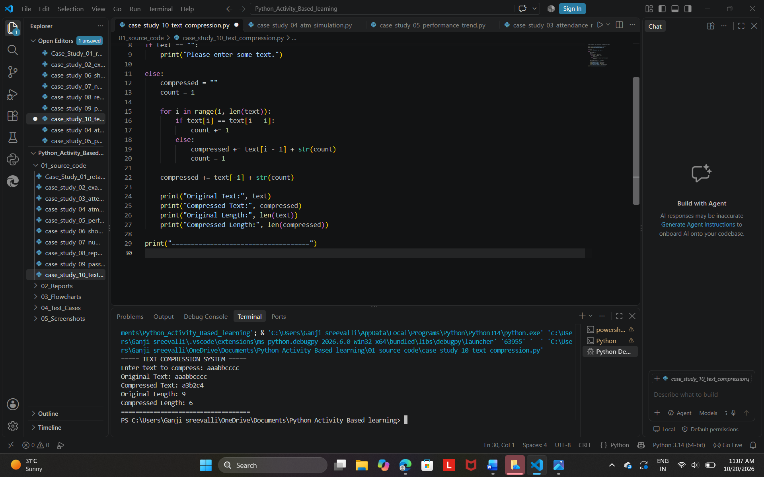

Expected output:
===== TEXT COMPRESSION SYSTEM =====
Enter text to compress: aaabbcccc
Original Text: aaabbcccc
Compressed Text: a3b2c4
Original Length: 9
Compressed Length: 6
====================================
10. Conclusion
The Text Compression Using Character Runs program was developed successfully using Python. It identifies consecutive repeated characters, counts their occurrences, and generates a compressed representation. This activity demonstrates the use of loops, conditional statements, strings, and counters. It also shows that simple compression methods may not shorten every input.

