PYTHON ACTIVITY-BASED LEARNING REPORT
Case Study 5: Student Performance Trend Analysis
Name: Ganji Sreevalli
Roll Number: 26000900
Branch: CSE (AIML)
Subject: Python Programming
1. Problem Statement
To develop a Python program that analyzes a student's marks across multiple tests, calculates the average marks, and identifies whether the student's performance is improving, declining, or stable.
2. Objectives
- To accept marks for multiple tests.
- To calculate the average marks.
- To compare the first and last test marks.
- To identify the student's performance trend.
- To practice loops, lists, conditional statements, and exception handling in Python.
3. Assumptions
- The number of tests must be greater than zero.
- Marks must be between 0 and 100.
- The program compares the first test with the last test to identify the trend.
- Higher last-test marks indicate improvement; lower marks indicate decline.
- Equal first and last test marks indicate a stable trend.
4. Algorithm
- Start the program.
- Read the number of tests.
- Validate the number of tests.
- Accept marks for each test and validate them.
- Store the marks in a list.
- Calculate the average marks.
- Compare the first and last test marks.
- Display the marks, average, and performance trend.
- Stop the program.
5. Flowchart
6. Pseudocode
START
INPUT number_of_tests
IF number_of_tests <= 0
DISPLAY error message
ELSE
INPUT and validate marks for each test
STORE marks in a list
CALCULATE average
IF last mark > first mark
DISPLAY "Improving"
ELSE IF last mark < first mark
DISPLAY "Declining"
ELSE
DISPLAY "Stable"
END IF
DISPLAY marks and average
END IF
STOP
7. Python Source Code

# Case Study 2: Examination Result and Grace-Mark Validation

PASS_MARK = 35
MAX_GRACE_MARKS = 5
NUMBER_OF_SUBJECTS = 5

marks = []80

print("===== EXAMINATION RESULT SYSTEM =====")

# Input marks for five subjects
for i in range(NUMBER_OF_SUBJECTS):
while True:
try:
mark = int(input(f"Enter marks for Subject {i + 1} (0-100): "))

if 0 <= mark <= 100:
marks.append(mark)
break
else:
print("Please enter marks between 0 and 100.")

except ValueError:
print("Invalid input. Please enter a whole number.")

# Find subjects in which the student failed
failed_subjects = []

for i in range(NUMBER_OF_SUBJECTS):
if marks[i] < PASS_MARK:
failed_subjects.append(i)

grace_used = 0

# Apply grace marks only if exactly one subject was failed
if len(failed_subjects) == 1:
index = failed_subjects[0]
marks_needed = PASS_MARK - marks[index]

if marks_needed <= MAX_GRACE_MARKS:
marks[index] = PASS_MARK
grace_used = marks_needed

# Calculate total and percentage after grace marks
total = sum(marks)
percentage = total / NUMBER_OF_SUBJECTS

# Display the result
print("\n========== RESULT ==========")

for i in range(NUMBER_OF_SUBJECTS):
print(f"Subject {i + 1}: {marks[i]}")

print("Grace Marks Used:", grace_used)
print("Total Marks:", total, "/", NUMBER_OF_SUBJECTS * 100)
print("Percentage:", round(percentage, 2), "%")

if all(mark >= PASS_MARK for mark in marks):
print("Final Result: PASS")
else:
print("Final Result: FAIL")

print("============================")

8. Test Cases
Test case | Input marks | Expected result
1 | 60, 70, 85 | Improving
2 | 90, 75, 60 | Declining
3 | 70, 80, 70 | Stable
4 | 80 | Need at least two tests to identify trend
5 | Number of tests = 0 | Error message
9.Output Screenshots
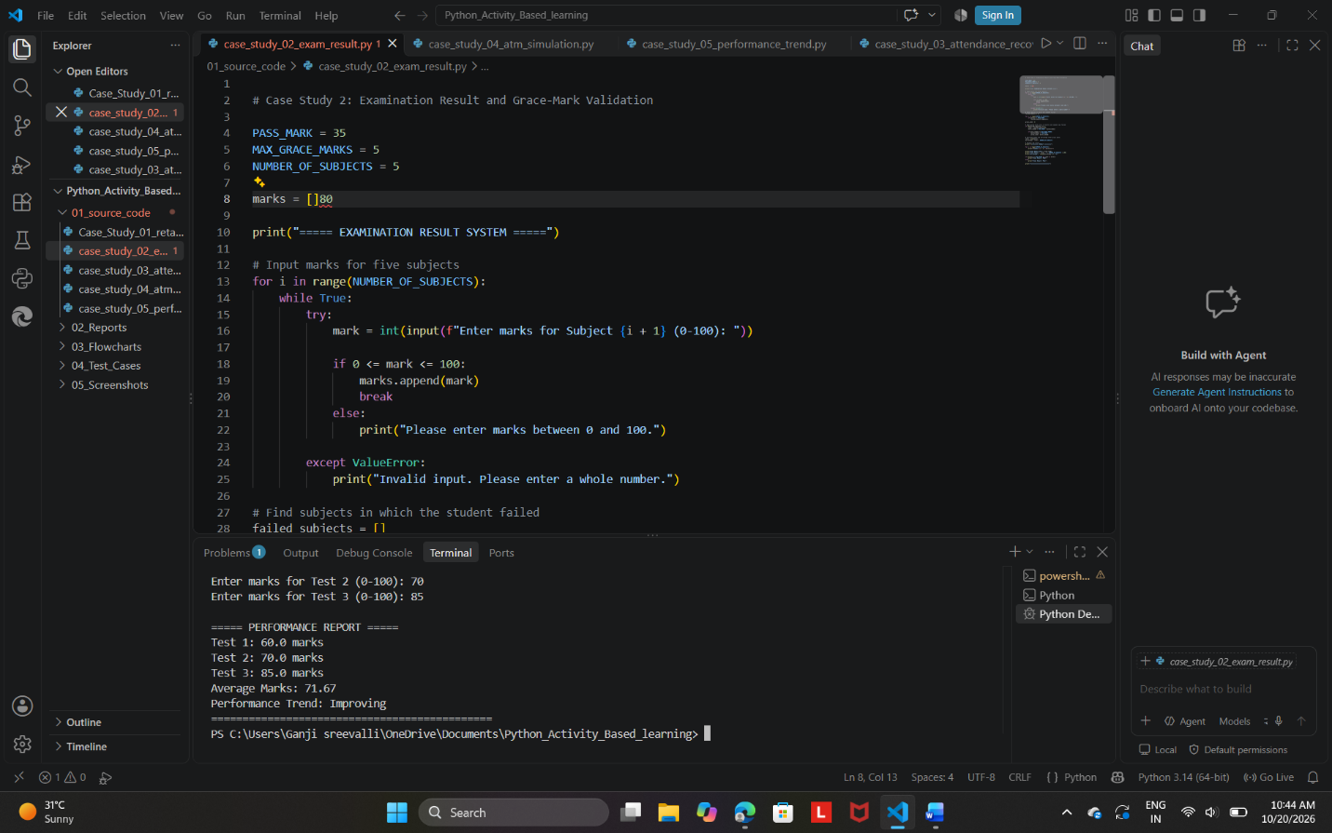

Expected output:
===== PERFORMANCE REPORT =====
Test 1: 60.0 marks
Test 2: 70.0 marks
Test 3: 85.0 marks
Average Marks: 71.67
Performance Trend: Improving
10. Conclusion
The Student Performance Trend Analysis program was developed successfully using Python. It accepts and validates marks, calculates the average, and identifies the performance trend by comparing the first and last tests. This program demonstrates the use of lists, loops, conditional statements, and exception handling.

