PYTHON ACTIVITY-BASED LEARNING REPORT
Case Study 7: Advanced Numeric Pattern Generator
Name: Ganji Sreevalli
Roll Number: 26000900
Branch: CSE (AIML)
Subject: Python Programming
1. Problem Statement
To develop a Python program that generates a numeric pattern based on the number of rows entered by the user. The program validates the input and displays an increasing number pattern.
2. Objectives
- To accept the number of rows from the user.
- To validate the input.
- To generate a numeric pattern using nested loops.
- To understand the use of for loops and conditional statements.
- To handle invalid input.
3. Assumptions
- The number of rows must be between 1 and 10.
- The input must be a whole number.
- Each row starts with 1.
- Each subsequent row contains one additional number.
- Invalid inputs display an error message.
4. Algorithm
- Start the program.
- Ask the user to enter the number of rows.
- Check whether the input is a valid whole number.
- Check whether the number of rows is between 1 and 10.
- If valid, use an outer loop to control the rows.
- Use an inner loop to print numbers from 1 to the current row number.
- Display the completed pattern.
- Stop the program.
5. Flowchart
6. Pseudocode
START
INPUT rows

IF input is invalid
DISPLAY error message
ELSE IF rows < 1 OR rows > 10
DISPLAY range error
ELSE
FOR i FROM 1 TO rows
FOR j FROM 1 TO i
DISPLAY j without a new line
END FOR
MOVE to next line
END FOR
DISPLAY success message
END IF

STOP
7. Python Source Code

# Case Study 7: Advanced Numeric Pattern Generator

print("===== NUMERIC PATTERN GENERATOR =====")

try:
rows = int(input("Enter the number of rows (1-10): "))

if rows < 1 or rows > 10:
print("Please enter a number between 1 and 10.")

else:
print("\nGenerated Number Pattern:\n")

for i in range(1, rows + 1):
for j in range(1, i + 1):
print(j, end=" ")
print()

print("\nPattern generated successfully!")

except ValueError:
print("Invalid input. Please enter a whole number.")

print("=====================================")

8. Test Cases
Test case | Input | Expected result
1 | 5 | Displays a pattern with 5 rows
2 | 1 | Displays one row containing 1
3 | 10 | Displays a pattern with 10 rows
4 | 0 | Displays a range error
5 | 11 | Displays a range error
6 | hello | Displays an invalid-input message
9. Output Screenshots
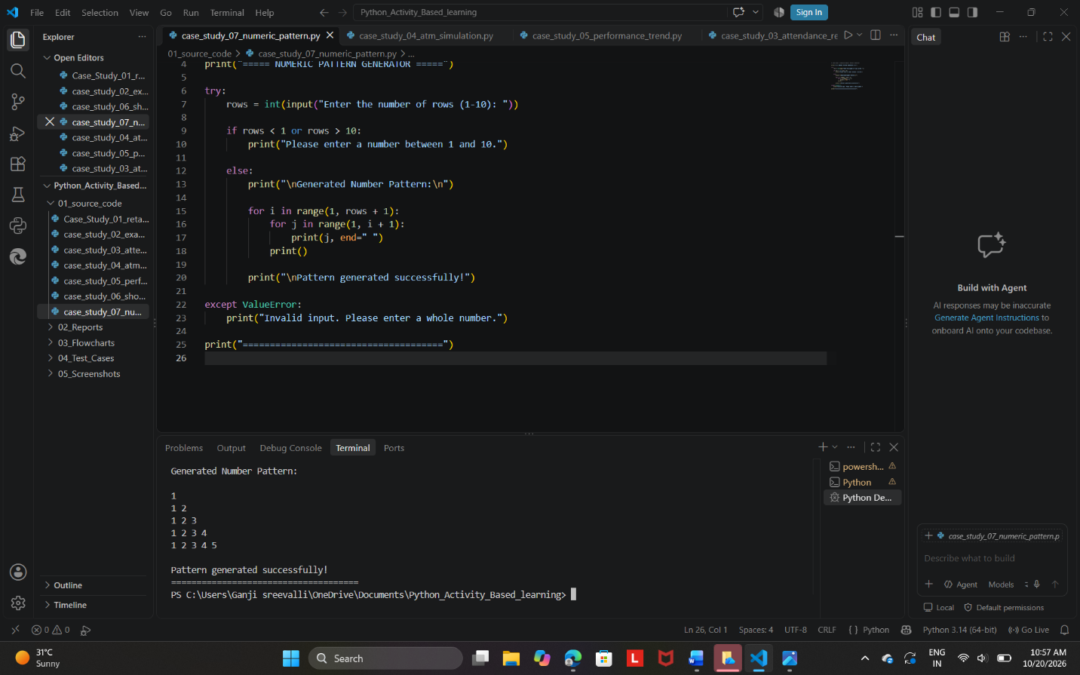

Expected output:
Generated Number Pattern:

1
1 2
1 2 3
1 2 3 4
1 2 3 4 5

Pattern generated successfully!
10. Conclusion
The Advanced Numeric Pattern Generator was developed successfully using Python. The program uses nested loops to generate an increasing numeric pattern and conditional statements to validate the input. This activity improves understanding of loops, input validation, and exception handling in Python.

