PYTHON ACTIVITY-BASED LEARNING
Case Study 4: ATM Transaction Sequence Simulation
Name: Ganji Sreevalli
Roll Number: 26000900
Branch: CSE (AIML)
Subject: Python Programming
1. Problem Statement
To develop a Python program that simulates an ATM transaction system. The program allows users to check their account balance, deposit money, withdraw money, and view transaction history. It also validates transaction amounts and prevents withdrawals that exceed the available balance.
2. Objectives
- To simulate basic ATM operations using Python.
- To display the current account balance.
- To deposit money and update the balance.
- To withdraw money after checking the available balance.
- To maintain a record of transactions.
- To validate user inputs and handle invalid entries.
- To understand the use of loops, conditional statements, lists, and exception handling.
3. Assumptions
- The initial account balance is Rs. 5,000.
- The user can check the balance, deposit money, withdraw money, and view transaction history.
- Deposit and withdrawal amounts must be greater than zero.
- A withdrawal cannot exceed the available balance.
- Transactions are stored temporarily while the program is running.
- This program is an educational simulation and does not connect to a real bank account.
4. Algorithm
- Start the program.
- Initialize the account balance to Rs. 5,000.
- Create an empty list to store transaction history.
- Display the ATM menu.
- Ask the user to enter a menu choice.
- If the choice is 1, display the current balance.
- If the choice is 2, accept a deposit amount, validate it, and update the balance.
- If the choice is 3, accept a withdrawal amount, validate it, check the available balance, and update the balance.
- If the choice is 4, display the transaction history.
- If the choice is 5, display a thank-you message and stop the program.
- If the choice is invalid, display an error message.
- Repeat the menu until the user chooses to exit.
5. Flowchart
6. Pseudocode
START

Set balance = 5000
Create empty transaction_history list

REPEAT:
Display ATM menu
Input choice

IF choice = 1:
Display balance

ELSE IF choice = 2:
Input deposit amount
IF amount <= 0:
Display invalid amount
ELSE:
Add amount to balance
Record deposit
Display updated balance

ELSE IF choice = 3:
Input withdrawal amount
IF amount <= 0:
Display invalid amount
ELSE IF amount > balance:
Display insufficient balance
ELSE:
Subtract amount from balance
Record withdrawal
Display updated balance

ELSE IF choice = 4:
Display transaction history

ELSE IF choice = 5:
Display thank-you message
EXIT LOOP

ELSE:
Display invalid choice

UNTIL user exits

STOP
7. Python Source Code

# Case Study 4: ATM Transaction Sequence Simulation

balance = 5000.0
transaction_history = []

print("===== ATM TRANSACTION SYSTEM =====")

while True:
print("\n1. Check Balance")
print("2. Deposit Money")
print("3. Withdraw Money")
print("4. View Transaction History")
print("5. Exit")

choice = input("Enter your choice (1-5): ")

if choice == "1":
print("Current Balance: Rs.", round(balance, 2))

elif choice == "2":
try:
amount = float(input("Enter deposit amount: Rs. "))

if amount <= 0:
print("Amount must be greater than zero.")
else:
balance += amount
transaction_history.append(
f"Deposited Rs. {amount:.2f}"
)
print("Deposit successful.")
print("Updated Balance: Rs.", round(balance, 2))

except ValueError:
print("Please enter a valid amount.")

elif choice == "3":
try:
amount = float(input("Enter withdrawal amount: Rs. "))

if amount <= 0:
print("Amount must be greater than zero.")
elif amount > balance:
print("Insufficient balance.")
else:
balance -= amount
transaction_history.append(
f"Withdrew Rs. {amount:.2f}"
)
print("Withdrawal successful.")
print("Updated Balance: Rs.", round(balance, 2))

except ValueError:
print("Please enter a valid amount.")

elif choice == "4":
print("\n===== TRANSACTION HISTORY =====")

if len(transaction_history) == 0:
print("No transactions yet.")
else:
for transaction in transaction_history:
print(transaction)

elif choice == "5":
print("Thank you for using the ATM.")
break

else:
print("Invalid choice. Please select 1 to 5.")

print("=================================")

8. Test Cases
Test | Operation | Input | Expected Result
1 | Check balance | Choice 1 | Balance is Rs. 5,000
2 | Deposit | Rs. 1,000 | Balance becomes Rs. 6,000
3 | Withdraw | Rs. 500 | Balance becomes Rs. 5,500
4 | Withdraw more than balance | Rs. 10,000 | Insufficient balance message
5 | Invalid deposit | Rs. 0 | Amount must be greater than zero
6 | View history | Choice 4 | Recorded transactions are displayed
7 | Exit | Choice 5 | Thank-you message is displayed
9. Output Screenshots
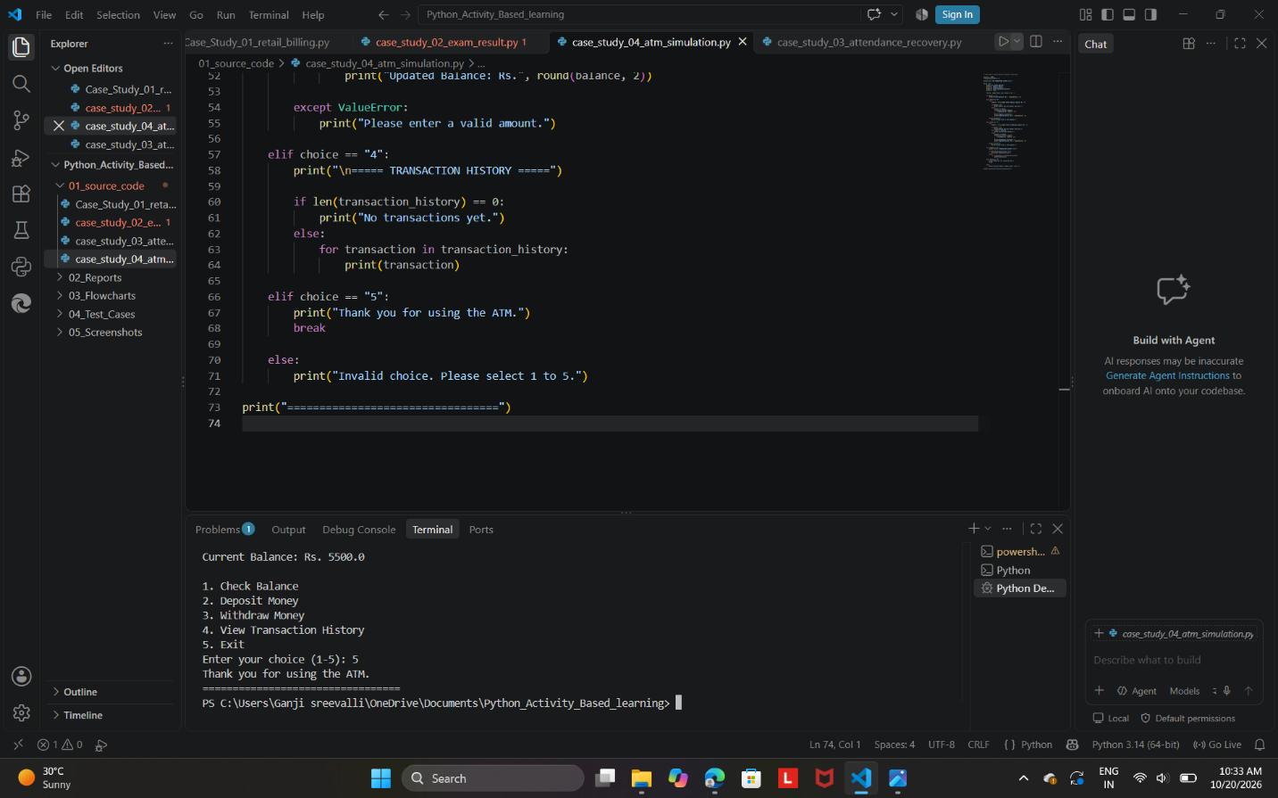

10. Conclusion
The ATM Transaction Sequence Simulation project demonstrates how Python can simulate basic banking operations. It allows users to check balances, deposit and withdraw money, and view transaction history. It also validates inputs and prevents withdrawals that exceed the available balance. The project uses variables, loops, conditional statements, lists, and exception handling to solve a practical problem.

