PYTHON ACTIVITY-BASED LEARNING
Case Study 3: Attendance Recovery Computation
Name: Ganji Sreevalli
Roll Number: 26000900
Branch: CSE (AIML)
Subject: Python Programming
1. Problem Statement
To develop a Python program that calculates a student's current attendance percentage, checks whether the student meets the minimum required attendance of 75%, and determines how many additional classes the student must attend continuously to achieve the required attendance percentage.
2. Objectives
- To accept the total number of classes held and classes attended.
- To validate the attendance inputs entered by the user.
- To calculate the current attendance percentage.
- To check whether the student satisfies the 75% attendance requirement.
- To calculate the number of additional classes needed to reach 75% attendance.
- To display the attendance percentage and appropriate status messages.
3. Assumptions
- The minimum required attendance is 75%.
- The total number of classes held must be greater than zero.
- The number of classes attended cannot be negative.
- The number of classes attended cannot exceed the total number of classes held.
- The student must attend every additional class without missing any to achieve the required attendance.
- The inputs must be whole numbers.
- These rules are assumptions for this learning exercise and may differ from the official attendance regulations of an institution.
4. Algorithm
- Start the program.
- Set the required attendance percentage to 75%.
- Accept the total number of classes held.
- Accept the number of classes attended.
- Validate the entered values.
- If the total number of classes is zero or negative, display an error message.
- If the attended classes are negative or greater than the total classes, display an error message.
- Calculate the current attendance percentage.
- If the attendance is 75% or more, display that the attendance requirement is satisfied and no additional classes are needed.
- Otherwise, use a loop to calculate the number of additional classes that must be attended continuously to reach 75%.
- Display the current attendance percentage, attendance status, and additional classes required.
- Stop the program.
5. Flowchart
6. Pseudocode
START

Set REQUIRED_ATTENDANCE = 75

Input total_classes
Input attended_classes

IF input is not a whole number:
Display invalid input message

ELSE IF total_classes <= 0:
Display total classes error

ELSE IF attended_classes < 0
OR attended_classes > total_classes:
Display invalid attended classes message

ELSE:
Calculate percentage =
(attended_classes / total_classes) * 100

Display percentage

IF percentage >= REQUIRED_ATTENDANCE:
Display attendance requirement satisfied
Set additional_classes = 0

ELSE:
Set additional_classes = 0

WHILE attendance after additional classes
is less than 75%:
Increase additional_classes by 1

Display additional_classes

STOP
7. Python Source Code

# Case Study 3: Attendance Recovery Computation

REQUIRED_ATTENDANCE = 75

print("===== ATTENDANCE RECOVERY SYSTEM =====")

try:
total_classes = int(input("Enter total classes held: "))
attended_classes = int(input("Enter classes attended: "))

if total_classes <= 0:
print("Total classes must be greater than zero.")

elif attended_classes < 0 or attended_classes > total_classes:
print("Invalid number of attended classes.")

else:
percentage = attended_classes / total_classes * 100

print("Current attendance:", round(percentage, 2), "%")

if percentage >= REQUIRED_ATTENDANCE:
print("Status: Attendance requirement satisfied.")
print("Additional classes needed: 0")

else:
# Calculate the minimum classes to attend consecutively
additional_classes = 0

while (
(attended_classes + additional_classes)
/ (total_classes + additional_classes) * 100
< REQUIRED_ATTENDANCE
):
additional_classes += 1

print("Status: Attendance is below 75%.")
print("Additional classes to attend:",
additional_classes)

except ValueError:
print("Please enter whole numbers only.")

print("======================================")

8. Test Cases
Test | Total Classes | Classes Attended | Expected Result
1 | 40 | 25 | 62.5%; 20 additional classes needed
2 | 40 | 30 | 75%; no additional classes needed
3 | 50 | 40 | 80%; no additional classes needed
4 | 0 | 0 | Error: total classes must be greater than zero
5 | 40 | 45 | Error: invalid number of attended classes
6 | 40 | -2 | Error: invalid number of attended classes
9. Output Screenshots
Run the Python program using the test cases above. Take a screenshot showing the program output and insert it in this section.
Sample input:
- Total classes held: 40
- Classes attended: 25
Expected output:
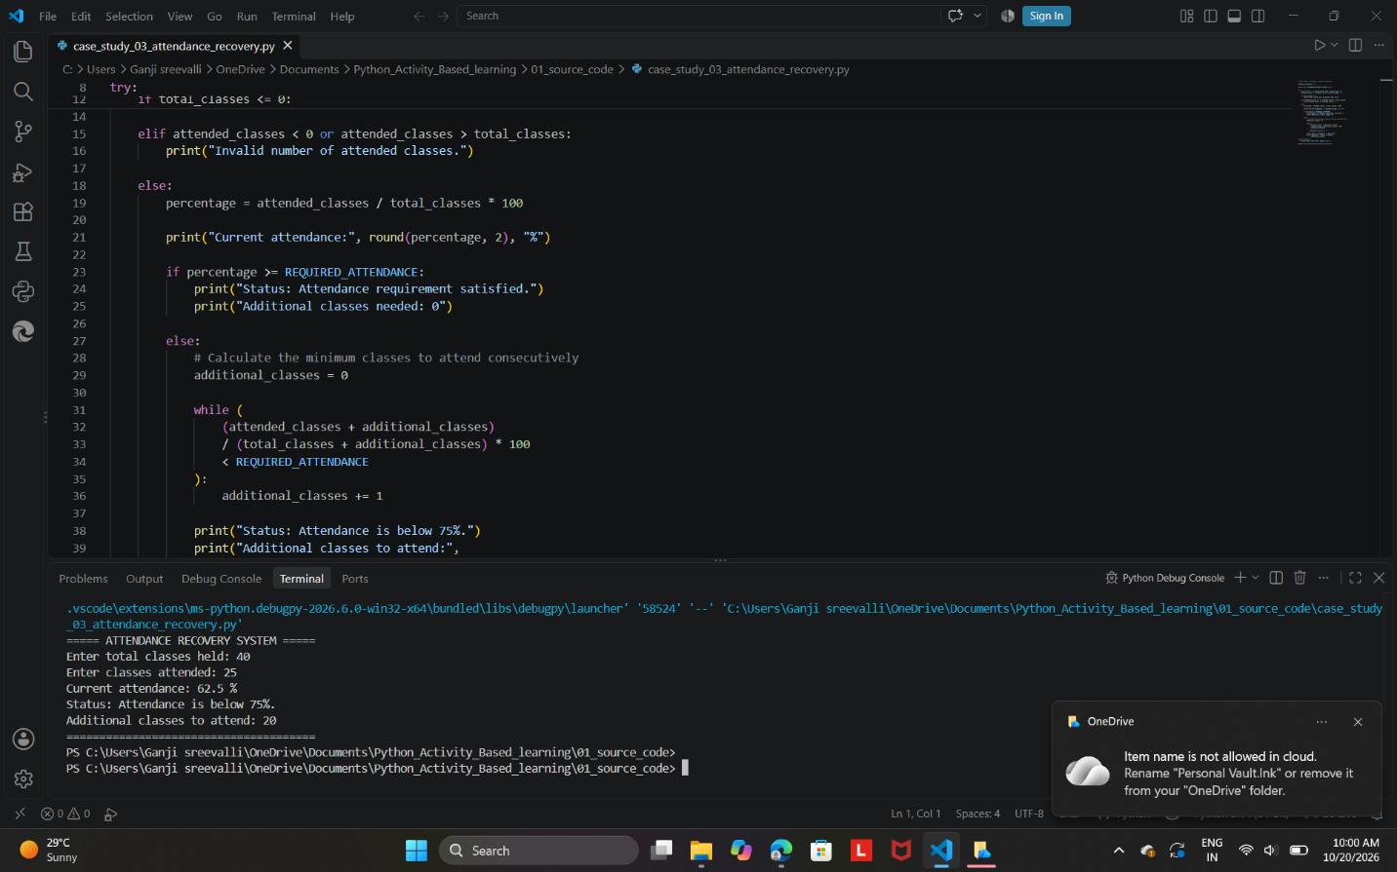

10. Conclusion
The Attendance Recovery Computation program demonstrates how Python can be used to calculate a student's attendance percentage and determine the number of additional classes required to achieve 75% attendance. It validates user inputs and displays suitable messages for valid and invalid entries. This project uses variables, arithmetic operations, conditional statements, loops, and exception handling to solve a practical problem in an educational institution.

