WEB DEVELOPMENT WEB DEVACTIVITY-BASED LEARNING
Name: Ganji Sreevalli
Roll Number: 26000900
Branch: CSE (AI & ML)
Subject: Web Development
1. College Fest Website
Aim: To design and develop a College Fest Website using HTML and CSS to display college fest events, schedules, highlights, and organizers.
Software Used: HTML, CSS, Web Browser.

Procedure:
- Created the webpage structure using HTML.
- Used CSS to add colours, styles, and layout.
- Opened the HTML file in a web browser to view the webpage.
- Then we get the page
- Now we can see the page

Output: 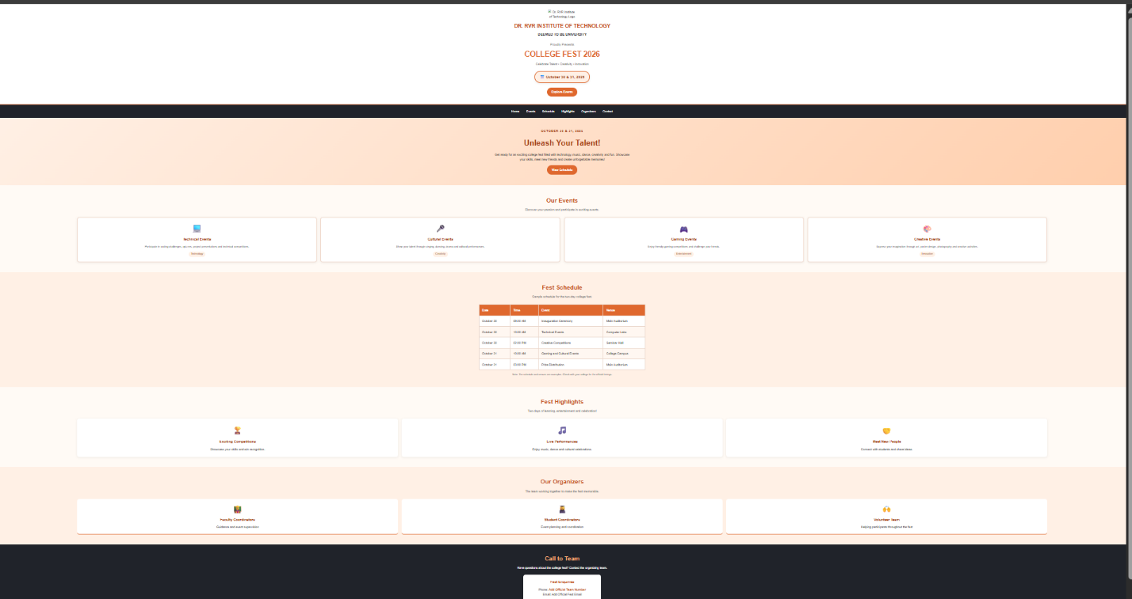Result: The College Fest Website was successfully created and displayed in the web browse.2. College Information Website
Aim: To design and develop a College Information Website using HTML and CSS to present information about the college.
Software Used: HTML, CSS, Web Browser.
Procedure:
- Created the webpage structure using HTML.
- Applied CSS styles to improve the appearance and layout.
- Opened the HTML file in a web browser to view the webpage.
Output:
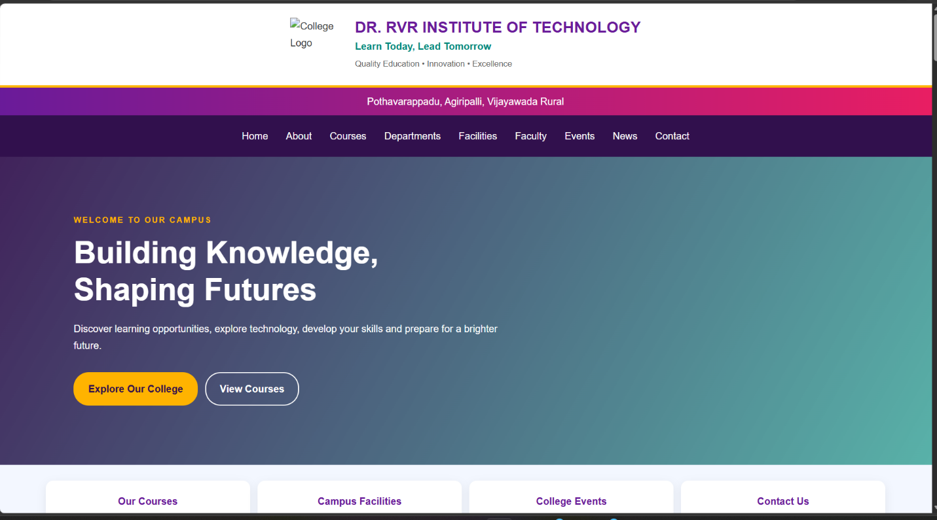

Result: The College Information Website was successfully created and displayed in the web browser.

3. Personal Profile Website
Aim: To design and develop a Personal Profile Website using HTML and CSS to display personal information, education, skills, and other relevant details.
Software Used: HTML, CSS, Web Browser.
Procedure:
- Created the webpage structure using HTML.
- Used CSS to style the webpage.
- Opened the HTML file in a web browser to view the webpage.
Output:
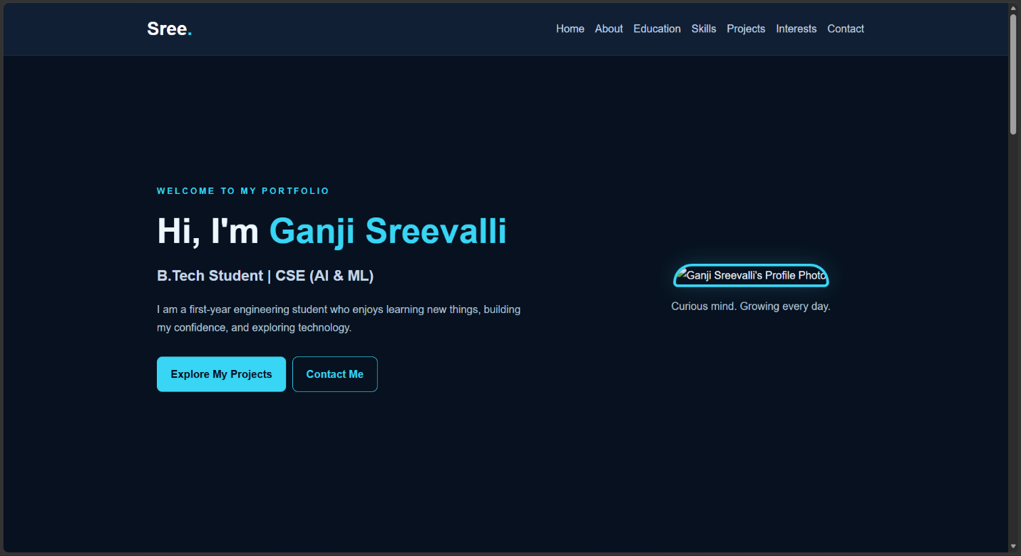

Result: The Personal Profile Website was successfully created and displayed in the web browser.

THANK FOR VISITING MY REPORT!

