**Medical Chat bot**

**Chatbot System run in my local**

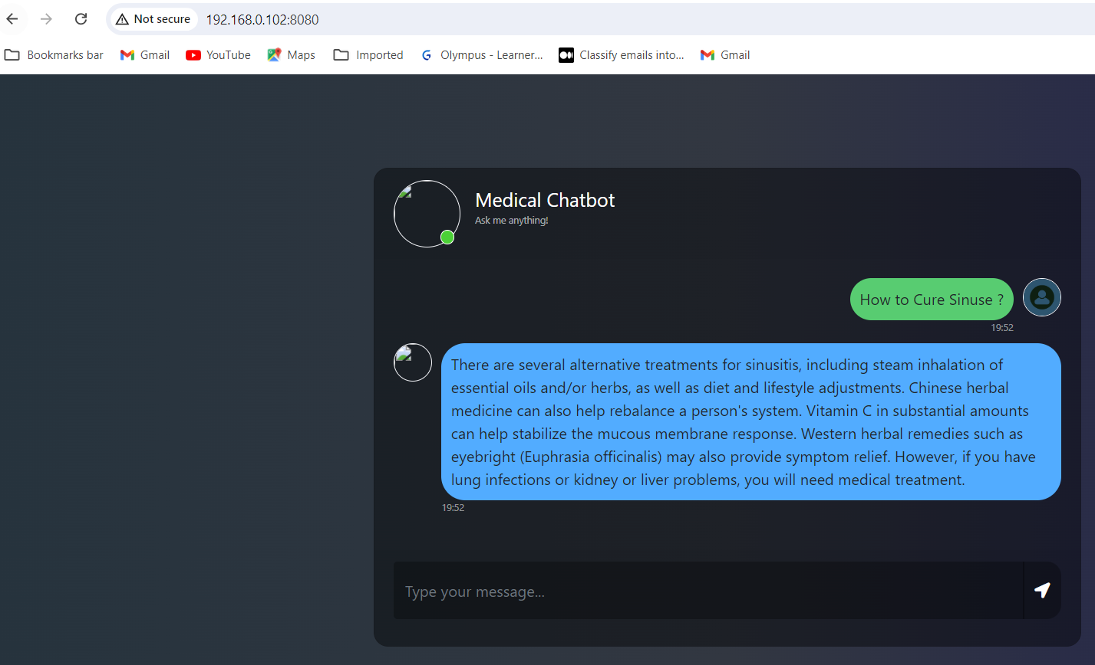

**Building and Deploying my Application with Docker**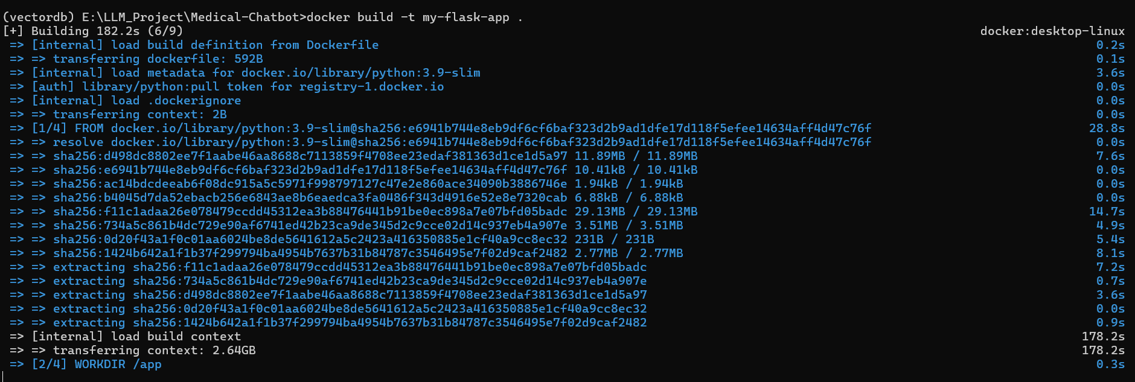

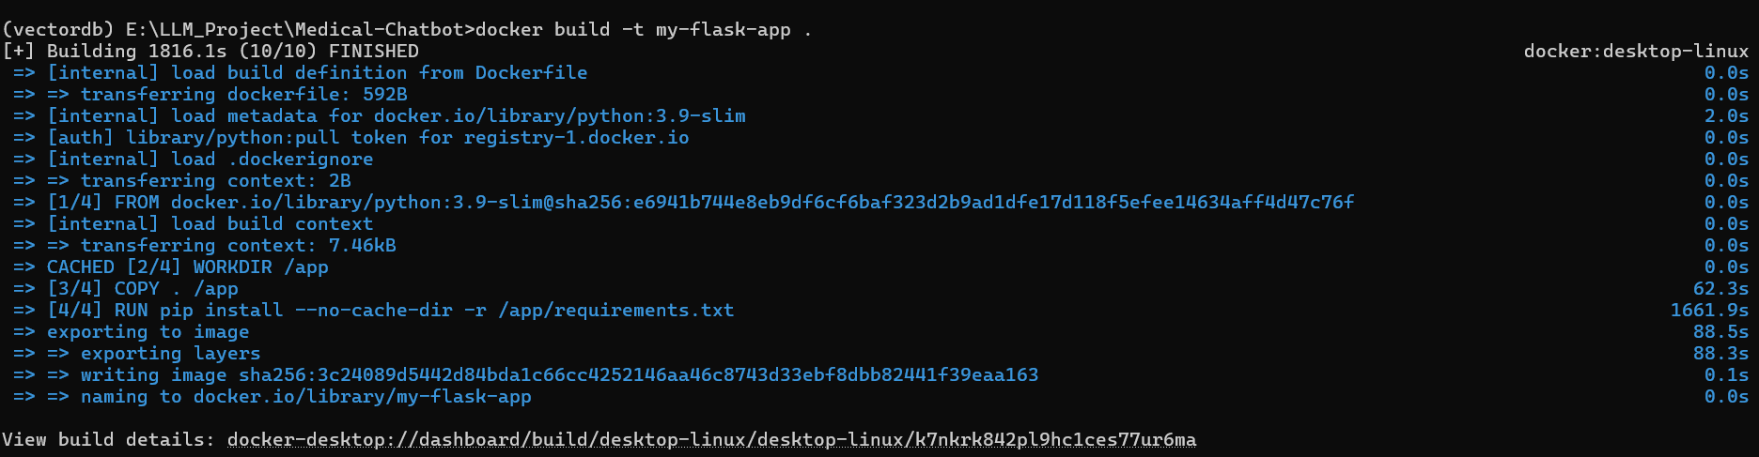

**Starting my Docker Journey**

**Launching and Running my Chatbot Web Application from Docker**

