|  |  |  |
| --- | --- | --- |
|  | Expected Result true | Expected Result false |
| a=b | A, b= v1, V2 | A, b= ~v1, ~v2 |
| a>b | A: increase b: decrease |  |
| A<b | A: decrease b: increase |  |
| A=b+c |  |  |
|  |  |  |
|  |  |  |
| V=change or not change |  |  |

Conflict conditions:

1) Increase and decrease

2) v1 and v2={change or not change}

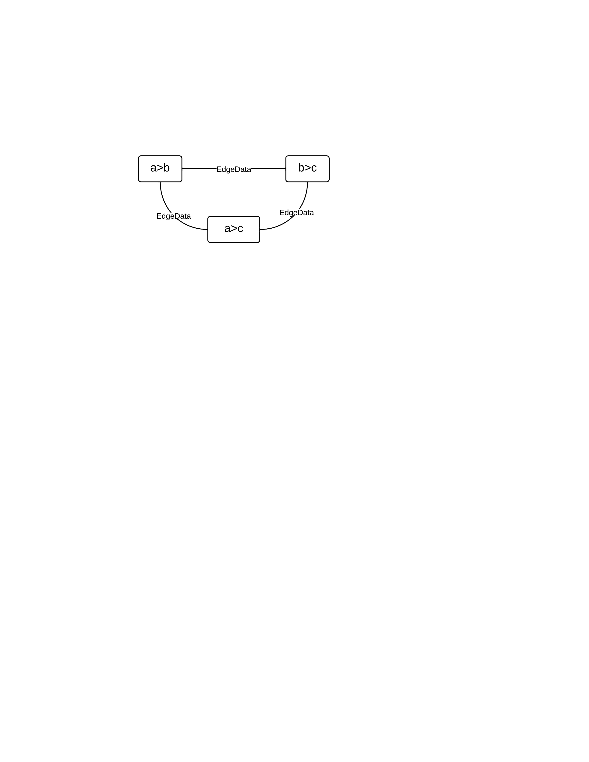

|  |  |  |  |  |  |  |  |  |  |  |  |  |  |  |  |  |  |  |  |  |  |  |  |  |  |  |  |  |  |
| --- | --- | --- | --- | --- | --- | --- | --- | --- | --- | --- | --- | --- | --- | --- | --- | --- | --- | --- | --- | --- | --- | --- | --- | --- | --- | --- | --- | --- | --- |
| EdgeData (a>b) (b>c)   |  |  |  |  |  |  |  |  |  |  |  |  |  |  |  |  |  |  |  |  |  |  |  |  |  |  |  |  |  | | --- | --- | --- | --- | --- | --- | --- | --- | --- | --- | --- | --- | --- | --- | --- | --- | --- | --- | --- | --- | --- | --- | --- | --- | --- | --- | --- | --- | --- | | leftMap   |  |  |  | | --- | --- | --- | | BinNode | InfeasibleDetectData | | | trend | isUsed | | a |  |  | | b |  |  | |  |  |  |   rightMap   |  |  |  | | --- | --- | --- | | BinNode | InfeasibleDetectData | | | trend | isUsed | | a |  |  | | c |  |  | |  |  |  | | |
| Check conflict of one edge  1. get common binNode from leftMap and rightMap, e.g, a=insect({a,b}, {a,c})  2.check if the trend of a is conflict, e.g., both increase and decrease |