Forest-change domain generalization
Stage 2: data validation and evaluation design
Attributing transfer loss in Earth observation foundation models: humid tropical source forests to dry and montane forests in Rwanda.
04-762 Machine Learning for Earth Observation | Research track
Bruno Payang Ganontha (bpayang) and Aichetou Abari Ilior (aabariil)
Repository: github.com/GanonthaBr/MLEO-capstone-project

Decision: refine the implementation; keep the research question
The Stage 1 question remains whether forest-change models transfer across forest environments, and how seasonality, event characteristics and terrain relate to transfer loss. Stage 2 narrows the implemented task to persistent forest-to-agricultural conversion versus stable forest in Amazonia. It establishes an access and evaluation pipeline, not a foundation-model or Rwanda transfer result.
Assumption tested: readily accessible imagery and annual land-cover maps would provide enough independent, temporally suitable change examples. Access and numerical quality were demonstrated, but independence and label timing remain limiting. Ten patches reduce to two development groups; annual references do not date changes precisely. The data are sufficient for a pipeline demonstration, not for the full research claim.

1. Sources, access and references
This assessment revisits the needs in Stage 1 Tables 3–4 rather than re-ranking all candidate datasets. Google Earth Engine (GEE) performs filtering and small-area extraction; GeoTIFFs and acquisition metadata are exported to Google Drive and read in Colab. Full satellite archives are not downloaded.
Data need / source | Verified use and remaining gap
Optical imagery: NASA HLS S30 v2.0 [1] | GEE asset NASA/HLS/HLSS30/v002. Six 30 m bands: B2, B3, B4, B8A, B11, B12. Source imagery: June–July 2021 and June–August 2023. Read and mask checks pass for ten development pairs.
Source reference: MapBiomas Amazonia Collection 6 [2] | Annual land cover, 1985–2023; use classification_2020 through classification_2023. Provisional references, not field-verified truth. Public access confirmed.
Rwanda target imagery | Akagera access pilot near 30.6333 E, 1.7500 S: 2024 and 2025 HLS images loaded. No verified change labels; woodland and park interpretation remain provisional. Not used in this baseline.
Terrain and ecosystem screening | Copernicus DEM and WorldCover 2021 were screening aids in the pilot, not change labels. Terrain-stratified coverage, complete version/rights records and scientific suitability checks are incomplete.
Target labels / event timing | RSA or other partner references have not been demonstrated. No protected Rwanda reference sample exists. Exact disturbance timing remains unresolved.
Partner-independent fallback | Public HLS + attributed MapBiomas support a narrower Amazonia-only proxy-reference study. This cannot answer Rwanda transfer; formal scope revision would follow course change rules.

Exact MapBiomas asset:
projects/mapbiomas-public/assets/amazon/lulc/collection6/
mapbiomas_collection60_integration_v1

Rights, provenance and reference meaning
The HLS catalog states NASA promotes full and open data sharing [1]. The official MapBiomas toolkit states that data may be used, shared and adapted under CC BY 4.0 with attribution [2]. Retain dataset versions, source links and the modified-label description when sharing derived maps. Dataset access does not by itself verify ecological suitability. No partner-restricted data were used in the baseline.
MapBiomas attribution: MapBiomas Project – Collection 6 of the Annual Series of Land Use and Land Cover Maps of Amazonia, accessed 9 November 2026 through the MapBiomas platform/toolkit. The binary labels in this study are derived modifications. HLS attribution: NASA EOSDIS LP DAAC, HLS S30 v2.0, DOI 10.5067/HLS/HLSS30.002.
Reference construction: class 0 requires forest formation (3) in all four years. Class 1 requires forest in 2020–2021 and pasture (15), agriculture (18), or mosaic of uses (21) in both 2022 and 2023. All other pixels are ignored (255). The rule favors persistent agricultural conversion and excludes stable nonforest, temporary disturbance and many other changes.
Annual, model-derived maps may contain classification and boundary errors. Forest formation is not a guarantee of dense humid forest at every site. Agreement with these labels does not establish independently verified change accuracy. The 2021–2023 image interval is wider than the nominal 2021–2022 transition; 2023 persistence improves screening but does not resolve exact acquisition-to-event timing.
Evidence: data/data_manifest.csv; data/amazon_stage2_recovery_manifest.csv; data/amazon_stage2_recovery_acquisitions.csv; Forest_Change_Pilot.ipynb.

2. Collection and numerical quality
A fixed candidate grid searched four source blocks (nine locations each). Initial screening accepted one patch, encountered nine imagery-selection timeouts and rejected 26 candidates for insufficient provisional class support. A batch-export recovery retained the screening thresholds and recovered all nine timeout candidates. The resulting ten sample bundles each contain before/after imagery, provisional labels, a joint-valid mask and metadata. Original and recovery IDs remain traceable.
Image selection used a local MGRS tile, a cloud-metadata shortlist of six acquisitions per period, and patch-level valid coverage to rank candidates. Pixel-heavy quality calculations were moved to batch exports after interactive timeouts. Quality filters excluded cloud, adjacent cloud/shadow, shadow, snow/ice and high-aerosol flags, and required data in all six bands. HLS reflectance was used as supplied by GEE, without applying an additional scale factor.
Patches use a snapped 30 m UTM grid, 224 × 224 pixels (6.72 km square), with nearest-neighbor categorical labels. Imagery includes six reflectance bands, two solar-angle bands and one validity band; only reflectance enters the model. B01 uses EPSG:32722 and B02 EPSG:32721. The audit checks shared shape, CRS and transform across all four rasters, date windows, label codes, finite eligible features and consistency of exported and recomputed masks.
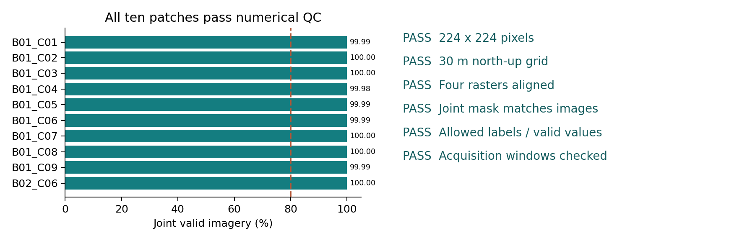
M1. Data quality and alignment. Every development bundle passes numerical checks. Joint-valid imagery ranges from 99.9801% to 100%; the dashed line is the 80% acceptance rule. Equal raster grids establish array alignment, not verified subpixel registration. Validity flags do not prove complete absence of atmospheric effects.

Acceptance and eligible support
Acceptance required joint imagery coverage of at least 80%, at least 500 usable stable-forest pixels and at least 50 usable conversion pixels. All ten recovered/original development patches pass. Across 501,760 grid pixels, 274,612 are eligible for supervised evaluation: 269,352 stable forest and 5,260 conversion (1.92%). Remaining pixels are ignored or invalid; near-complete imagery coverage must not be confused with near-complete reference coverage.
An earlier Amazonia pilot (amazon_001) has 32,650 eligible pixels and 100% joint imagery coverage but is excluded from these ten-patch baseline results. The inspected Akagera pilot originally had a 224 × 225 footprint; the notebook consistently cropped imagery and masks to 224 × 224. Neither pilot is an untouched final-evaluation sample.
Evidence: checks/amazon_stage2_recovery_audit.csv; checks/amazon_001_quality.json; design/pilot_access_disclosure.csv; notebook audit and feature-construction cells.

3. Coverage, dependence and sufficiency
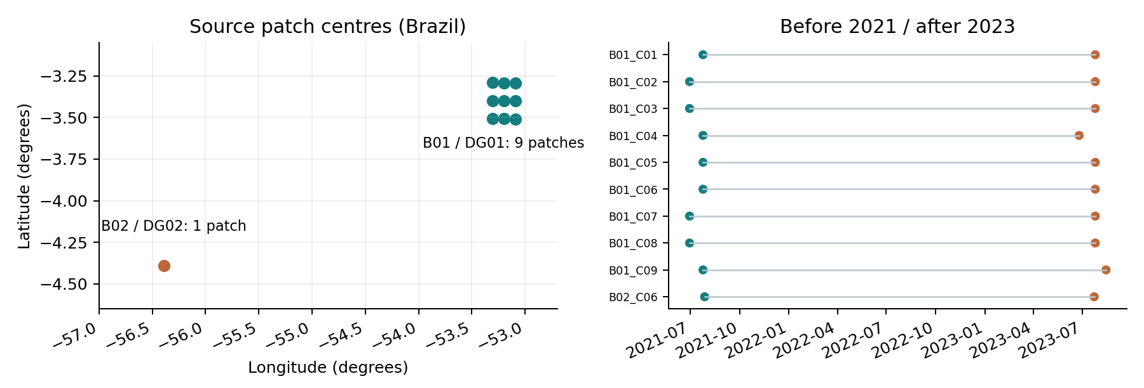
M2. Geographic and temporal coverage. Coordinates are computed from the exported UTM transforms. This is a local coordinate plot, not a mapped ecological boundary. Ten source patches occupy two blocks, with 2021 before dates and 2023 after dates. Neither the inspected Amazonia pilot nor Akagera contributes to these baseline groups.
Development group | Patches | Eligible pixels | Stable | Conversion
B01 / DG01 | 9 | 226,323 | 221,179 | 5,144 (2.27%)
B02 / DG02 | 1 | 48,289 | 48,173 | 116 (0.24%)
Total | 10 | 274,612 | 269,352 | 5,260 (1.92%)

The nine B01 patches share source acquisitions and belong to one spatial block; they are not nine independent replicates. B01 uses tile 22MBB and B02 tile 21MWR. Group construction joins patches sharing a geographic block, an exact source image ID, or an overlapping geographic bounding box. This produces two conservative dependency groups. It does not prove that all ecological or disturbance-event dependencies have been eliminated.

Biases and unsupported conditions
Selection required positive conversion support and favored relatively clear observations. Therefore the sample is not a probability sample of Amazonia, and metrics cannot estimate whole-region accuracy or converted area. Ignored land-cover types are outside the scored task. The two groups have very different positive prevalence; B02 contains only 116 positive pixels, which may represent fewer independent events. No event-level count or independent reference validation has been established.
All acquisitions fall within June–September search windows, but matching calendar seasons does not establish matching local phenology. Dense-humid source interpretation, Rwanda montane coverage, season-crossed pairs and terrain strata are not sufficiently verified. These conditions cannot yet be used to attribute transfer loss.

Sufficiency decision
Sufficient for a limited pipeline and grouped-baseline demonstration; insufficient for the planned domain-generalization study. Pixel counts are reported as prediction support, not sample size for uncertainty. The study needs more separated source and target units, verified event timing and protected reference data before testing the main question. With only two groups, report both fold results and their range; do not construct confidence intervals by treating pixels as independent.
Evidence: checks/amazon_stage2_shared_acquisitions.csv; results/grouped_logistic_development_v1/dependency_checks.csv; development_fold_assignments.csv in the same results folder.

4. Evaluation roles and leakage controls
The baseline uses leave-one-group-out development evaluation. For each fold, the held-out group is excluded from both preprocessing and fitting. All eligible pixels in the remaining group are used; no random pixel split or subsampling is performed. A StandardScaler is fitted within the training pipeline. Threshold 0.5 and model settings were fixed before scores were examined.
Development fold | B01 / DG01: 9 patches | B02 / DG02: 1 patch
Hold out DG01 | VALIDATION: 226,323 pixels | TRAIN: 48,289 pixels
Hold out DG02 | TRAIN: 226,323 pixels | VALIDATION: 48,289 pixels
Protected final evaluation | NOT ASSIGNED | NOT ASSIGNED
M3. Implemented development roles and missing protected role. Both groups are reused across development folds. There is no reserved test group. The blank final-evaluation role is a disclosed gap, not a completed alternative test design.
Leakage check | Finding and interpretation
Shared imagery / geographic overlap | Related patches are merged before folds; saved checks report zero exact image IDs crossing each fold boundary. Bounding-box checks are conservative. Event-level dependence remains unresolved.
Preprocessing / selection | Scaler fitted on training pixels only. Fixed model, class weighting and threshold; no score-based tuning. Candidate selection uses reference classes and limits generality.
Future information / reference circularity | The retrospective task uses both dates. Future annual labels are used only to build provisional reference masks, not predictor features. Persistence screening still affects the evaluated population.
Target and pretrained-model overlap | Akagera is excluded from baseline fitting/evaluation. No foundation model is used, so pretraining leakage is not tested here; it must be assessed before future model comparisons.

Development assignment SHA-256:
a975ef30a4c48207650cea3281bb5a6bb12cf7e29ca202b226e77fd94087db40

This hash identifies development_fold_assignments.csv only; it is not a protected-manifest hash. No design/protected_manifest.csv, final-test custodian, protected-data guard execution or committed final split is evidenced. All inspected source and target pilots are disclosed as development/access samples. New protected units must be assigned before their labels or model outputs are inspected.
For later experiments, use source-development folds for model and threshold selection. Proposed selection metric: equal-group mean average precision, with conversion precision, recall, F1 and IoU as secondary measures; break ties in favor of the simpler model. Apply group-level uncertainty only when adequate independent support exists. Protected target performance must not influence selection.
Record consistency: the uploaded evaluation_design.md and README.md predate the baseline and still describe one source patch. The executed notebook and saved run configuration/assignments establish the completed design reported here. Those documentation files require synchronization before repository submission.

5. Baseline results and reproducibility
The untuned baseline uses 18 predictors: six bands before, six after and six signed differences. Logistic regression settings: C=1, balanced class weights, lbfgs, max_iter=1000, tolerance 1e-4 and recorded seed 42. The comparator predicts the training-fold majority class and assigns a constant training prevalence score. No foundation-model training or Rwanda performance evaluation has occurred.
Held-out group / model | AP | Bal. acc. | Precision | Recall | F1 | IoU
DG01 logistic | 0.4402 | 0.8780 | 0.1023 | 0.9497 | 0.1848 | 0.1018
DG02 logistic | 0.2887 | 0.8724 | 0.2597 | 0.7500 | 0.3858 | 0.2390
Equal-group logistic mean | 0.3645 | 0.8752 | 0.1810 | 0.8498 | 0.2853 | 0.1704
Equal-group constant mean | 0.0126 | 0.5000 | 0 | 0 | 0 | 0

AP denotes average precision. Means give equal weight to the two held-out groups; mean F1 is not calculated from mean precision and recall. AP exceeds the constant comparator in both groups, but precision at the fixed threshold is low. DG01 has 42,846 false positives and 259 false negatives; DG02 has 248 and 29. High balanced accuracy does not imply that most conversion predictions are correct.
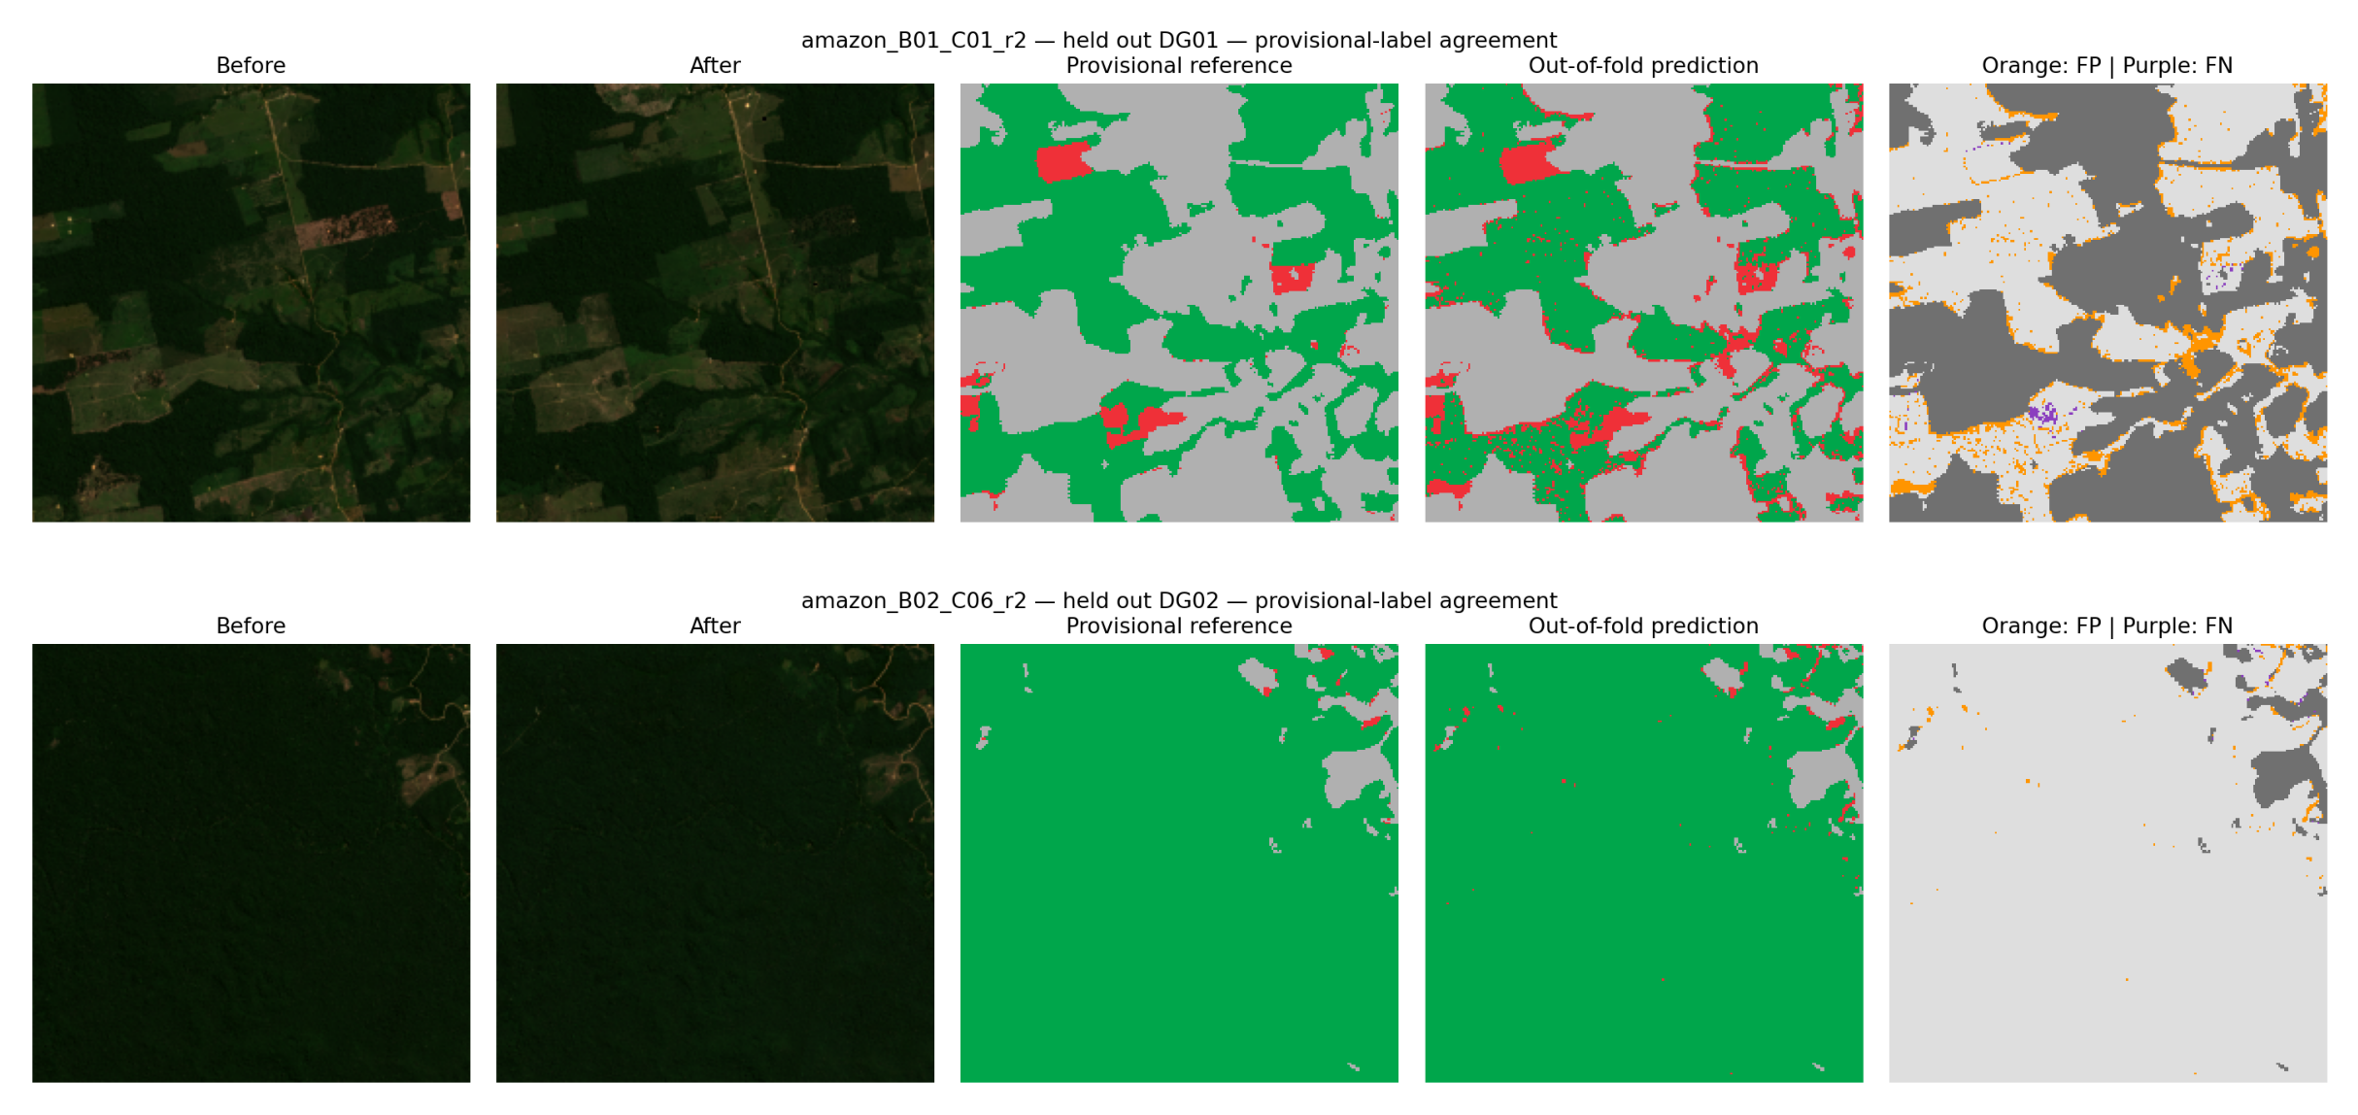
M4. Out-of-fold reference agreement and errors. Top: B01_C01; bottom: B02_C06. Columns show before, after, provisional reference, prediction and disagreement. Green = stable, red = conversion, grey = ignored; orange = false positive and purple = false negative against the provisional labels. B01 shows boundary-associated and scattered positive disagreements. The images alone cannot determine whether each disagreement is a model error or a reference error.
Both fits converged (48 and 45 iterations). Fit times were 1.13 s and 3.57 s; the recorded full run took 21.87 s including outputs. Runtime is environment-specific. Recorded versions: Python 3.13.18, NumPy 2.4.6, pandas 2.2.3, rasterio 1.5.2, scikit-learn 1.6.1 and joblib 1.6.0. Deprecation warnings were recorded, not convergence failures.
All files listed in the supplied run output manifest matched their SHA-256 values during report preparation. This integrity check is not an independent training rerun. The teammate rerun remains NOT YET RUN. Predeclared criteria in its record require matching data/splits, integer confusion counts or an agreed numerical tolerance, matching leakage checks and no protected-data access.
Evidence: results/grouped_logistic_development_v1/{metrics.csv, config.json, environment.json, runtime_and_fit_checks.csv, run_summary.json, output_manifest.csv}; predictions/ and figures/; Forest_Change_Pilot.ipynb.

6. Remaining research plan
Main comparison. Retain the proposal's Prithvi and CROMA candidates, but verify checkpoint, band, scale, temporal and modality requirements before declaring them eligible. Compare the fixed logistic baseline with compatible frozen-encoder and fine-tuned variants on identical grouped development data. An input-incompatible model will be omitted or its change documented; no architecture comparison is claimed now.
Order | Work and decision rule
1. Close data and split gaps | Verify forest type and event timing, add separated source/target units and obtain independent reference review. Assign new protected units, custodian, manifest hash and access guard before inspection. If support remains inadequate, narrow the research scope rather than split pixels.
2. Establish fair comparisons | Keep imagery, reference rules and evaluation units fixed across eligible models. Use development-only model selection. Retain the current baseline unchanged as the initial control.
3. Test transfer explanations | Measure source-to-target differences in AP, conversion F1 and IoU; stratify by season pairing, independently defined event size and terrain when sample support permits. Treat associations as descriptive, not causal attribution.
4. Bound resources and stop | CPU for auditing and logistic controls; one available Colab GPU for eligible encoder experiments. Proposed cap: one frozen and one fine-tuned configuration per eligible model, up to three seeds if feasible. Stop when this matrix is complete or compute allocation is exhausted. No protected-score-driven retries.
5. Final evaluation / fallback | Evaluate protected data once in Stage 4 after choices are frozen. If Rwanda references remain inadequate, deliver a narrower Amazonia grouped proxy-label study, explain the unanswered transfer question and seek any required acknowledgment.

Interpretation. Consistent target losses across adequately supported units would motivate analysis of environmental and reference differences. Similar source and target performance would provide no evidence of a transfer gap within the tested conditions. Differences that disappear after reference correction would weaken an environmental explanation. Neither two-group development scores nor visually plausible maps can establish these conclusions.

References and evidence basis
[1] NASA LP DAAC, HLS S30 v2.0, DOI: 10.5067/HLS/HLSS30.002. Google Earth Engine catalog: NASA_HLS_HLSS30_v002. Accessed 9 Nov. 2026.
[2] MapBiomas Project, Collection 6: Annual Land Use and Land Cover Maps of Amazonia, 1985–2023. Official user-toolkit documents collection availability, attribution and CC BY 4.0 data terms. Accessed 9 Nov. 2026.
[3] Scikit-learn, LogisticRegression and preprocessing pipelines, official documentation. The executed environment used version 1.6.1; settings and versions are preserved in the run files.
[4] Team, Capstone Project Proposal, 20 Sep. 2026; CMU Africa, 04-762 Stage 2 handout, Fall 2026. Research motivation and planned model comparison are retained from Stage 1; the literature review has not been expanded or revalidated here.
Primary empirical evidence: uploaded Forest_Change_Pilot.ipynb and MLEO_STAGE2_SUBMISSION archive, baseline run grouped_logistic_development_v1. Results were produced in the team's Colab session. Report preparation checked saved artifacts and figures; it did not rerun authenticated GEE collection or model fitting.

