Program 1: Java Basics (Loops, Conditions, Arrays)

import java.util.Scanner;
public class JavaBasics {
public static void main(String[] args) {
Scanner scanner = new Scanner(System.in);
System.out.print("Enter a number: ");
int num = scanner.nextInt();
// Condition
if(num % 2 == 0)
System.out.println(num + " is Even");
else
System.out.println(num + " is Odd");
// Loop
System.out.println("\nNumbers from 1 to " + num);
for(int i = 1; i <= num; i++) {
System.out.print(i + " ");
}
// Array
int[] marks = {75, 82, 90, 68, 88};
System.out.println("\n\nStudent Marks:");
for(int mark : marks) {
System.out.println(mark);
}
scanner.close();
}
}
Output:
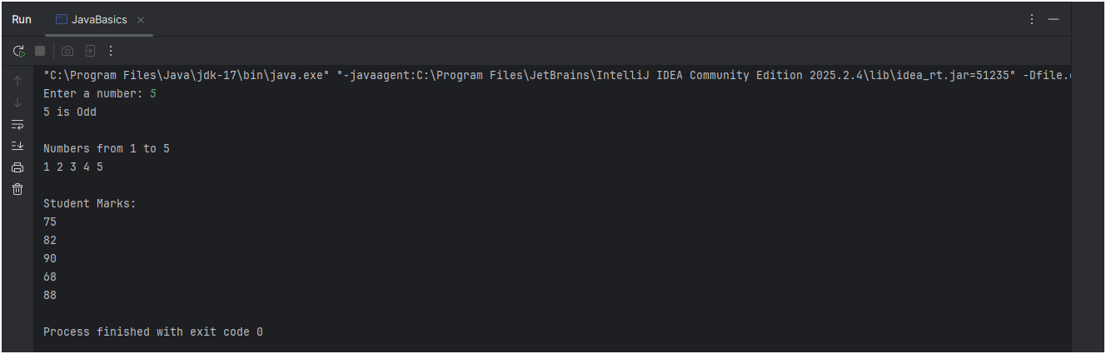

Program 2: Encapsulation (Getters and Setters)

Student.java
public class Student {

private String name;
private int age;

// Getter
public String getName() {
return name;
}

// Setter
public void setName(String name) {
this.name = name;
}

// Getter
public int getAge() {
return age;
}

// Setter
public void setAge(int age) {
this.age = age;
}
}

EncapsulationMain.java
public class EncapsulationMain {

public static void main(String[] args) {

Student s = new Student();

s.setName("Ganraj");
s.setAge(21);

System.out.println("Student Name: " + s.getName());
System.out.println("Student Age: " + s.getAge());
}
}

Output: 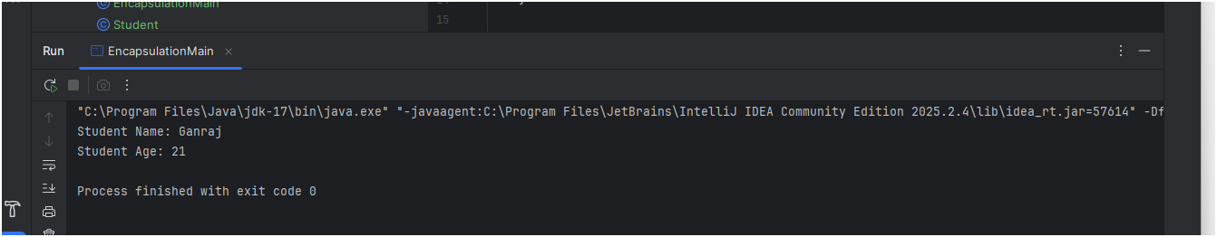

Program 3: Inheritance and Polymorphism
Animal.java
public class Animal {

public void sound() {
System.out.println("Animal makes a sound");
}
}
Dog.java
public class Dog extends Animal {

@Override
public void sound() {
System.out.println("Dog barks");
}
}
Cat.java
public class Cat extends Animal {

@Override
public void sound() {
System.out.println("Cat meows");
}
}

Main.java
public class Main {

public static void main(String[] args) {

Animal a1 = new Dog();
Animal a2 = new Cat();

a1.sound();
a2.sound();
}
}

Output:
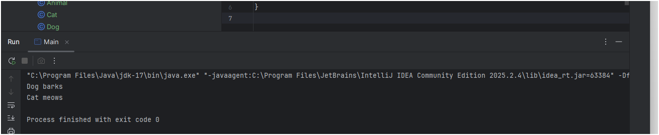

OOP Concepts Used
1. Class
A class is a blueprint used to create objects. It defines the attributes (variables) and behaviors (methods) of an object.
Example:
public class Student {
}

2. Object
An object is an instance of a class that can access the class's properties and methods.
Example:
Student s = new Student();

3. Encapsulation
Encapsulation is the process of hiding data by declaring variables as private and providing controlled access using public getter and setter methods. It improves security and maintains data integrity.
Example:
private String name;
public void setName(String name){
this.name = name;
}
public String getName(){
return name;
}

4. Inheritance
Inheritance allows one class to acquire the properties and methods of another class using the extends keyword. It promotes code reuse and establishes an "is-a" relationship between classes.
Example:
class Dog extends Animal

5. Polymorphism
Polymorphism allows a parent class reference to refer to child class objects. The appropriate overridden method is executed at runtime, enabling flexible and reusable code.
Example:
Animal a = new Dog();
a.sound();

