Assignment 1 - R3: Scaling Study and Report
Joshua Ganschow
CSC718
Prof. Abid Mehmood

Run Conditions
The following conditions are held constant through the runs:
- Number of jobs: 32
- Job type and workload
  - A simple job with enough computation required to make the single-worker run take a few seconds
- Input data
  - The only thing that changes is the number of workers
  - The bound on the queue stays as 32, allowing all jobs to be queued. This makes the bottleneck solely the speed at which jobs are being completed, negligible additional overhead for waiting for queue operations.
- Timing method
  - Using `clock_gettime` from `time.h`
- Computing environment
  - Ryzen 7 7700X (8 core) running Fedora Linux
  - Compiled using the GNU C Compiler
Each scenario gets run 10 times and averaged to get the clock time. The first three runs of the program are included in each screenshot.

Results Table
Number of workers | Execution time (s) | Speedup (T(1)/T(N)) | Screenshot number
1 | 2.06359 | 1 | 1
2 | 1.068267 | 1.93172 | 2
4 | 0.546278 | 3.77755 | 3
8 | 0.289393 | 7.13075 | 4

Execution Evidence
- 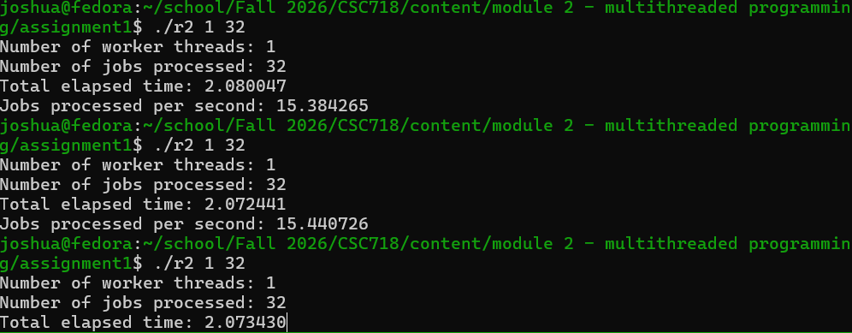
- 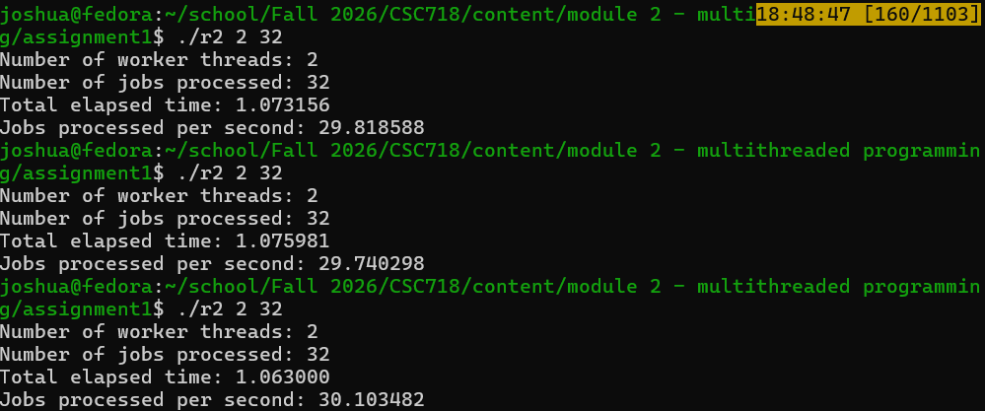
- 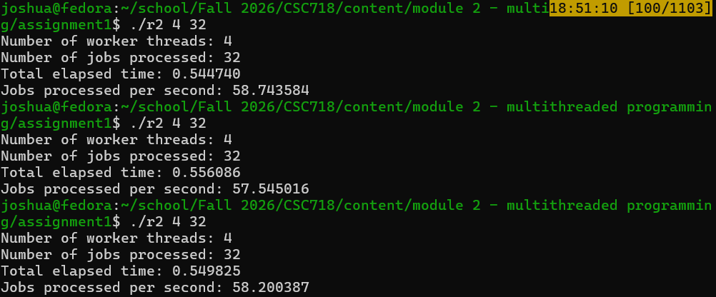
- 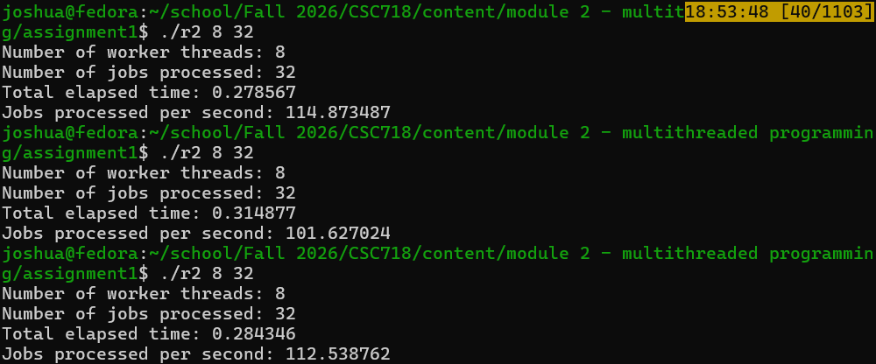

Technical Discussion
Seeing the speedups, we get nearly ideal numbers. The version with two workers takes roughly ½ as much time, with four workers we see a ~3.8x speedup, with eight we see 7.1x speedup. We can account for it not being exactly ideal because there is inherent overhead with enqueueing and dequeuing. Namely, shared variables are used among all workers for tracking and synchronizing. This requires a protected (critical) section surrounded with an operation to unlock and re-lock a mutex.
Additionally, due to the nature of the testing, identical jobs are enqueued for each of the M jobs. This means that it is more likely that multiple threads are reaching the critical section at nearly the exact same time. A real-world scenario with varying job workloads will not have the same problem, in general. This becomes clearer when we observe that, as the program is run with more threads, the returns slowly diminish (2 threads are almost exactly 2x faster, 4 is slightly further from 4x, and 8 is even further from 8x). This gives more reason to believe that the competition for the mutex and access to the queue is causing a bottleneck.

