4-BIT CARRY LOOK AHEAD ADDER

**PROGRAM:**

module CLA_Adder(a,b,cin,sum,cout);  
input[3:0] a,b;  
input cin;  
output [3:0] sum;  
output cout;  
wire p0,p1,p2,p3,g0,g1,g2,g3,c1,c2,c3,c4;  
assign p0=(a[0]^b[0]),  
p1=(a[1]^b[1]),   
p2=(a[2]^b[2]),  
p3=(a[3]^b[3]);  
assign g0=(a[0]&b[0]),  
g1=(a[1]&b[1]),  
g2=(a[2]&b[2]),  
g3=(a[3]&b[3]);  
assign c0=cin,  
c1=g0|(p0&cin),  
c2=g1|(p1&g0)|(p1&p0&cin),  
c3=g2|(p2&g1)|(p2&p1&g0)|(p1&p1&p0&cin),  
c4=g3|(p3&g2)|(p3&p2&g1)|(p3&p2&p1&g0)|(p3&p2&p1&p0&cin);  
assign sum[0]=p0^c0,  
sum[1]=p1^c1,  
sum[2]=p2^c2,  
sum[3]=p3^c3;  
assign cout=c4;  
endmodule

**#39**

WAVEFORMS: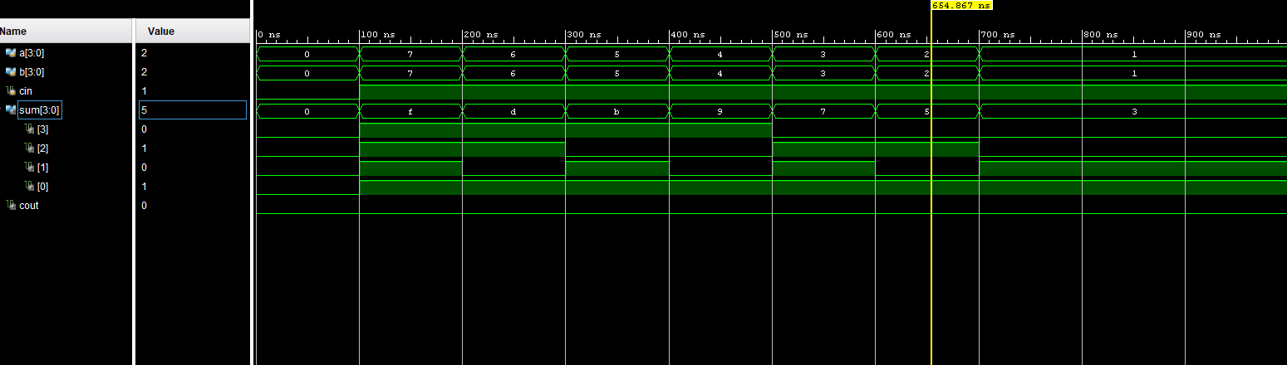

**RTL SIMULATION:**

