FULL_SUBTRACTOR

**PROGRAM:**

module fullsub(a, b, c, borrow, difference);

input a;

input b;

input c;

output borrow;

output difference;

wire d,e,f;

xor(difference,a,b,c);

and(d,~a,b);

and(e,b,c);

and(f,~a,c);

or(borrow,d,e,f);

endmodule

**WAVEFORMS:**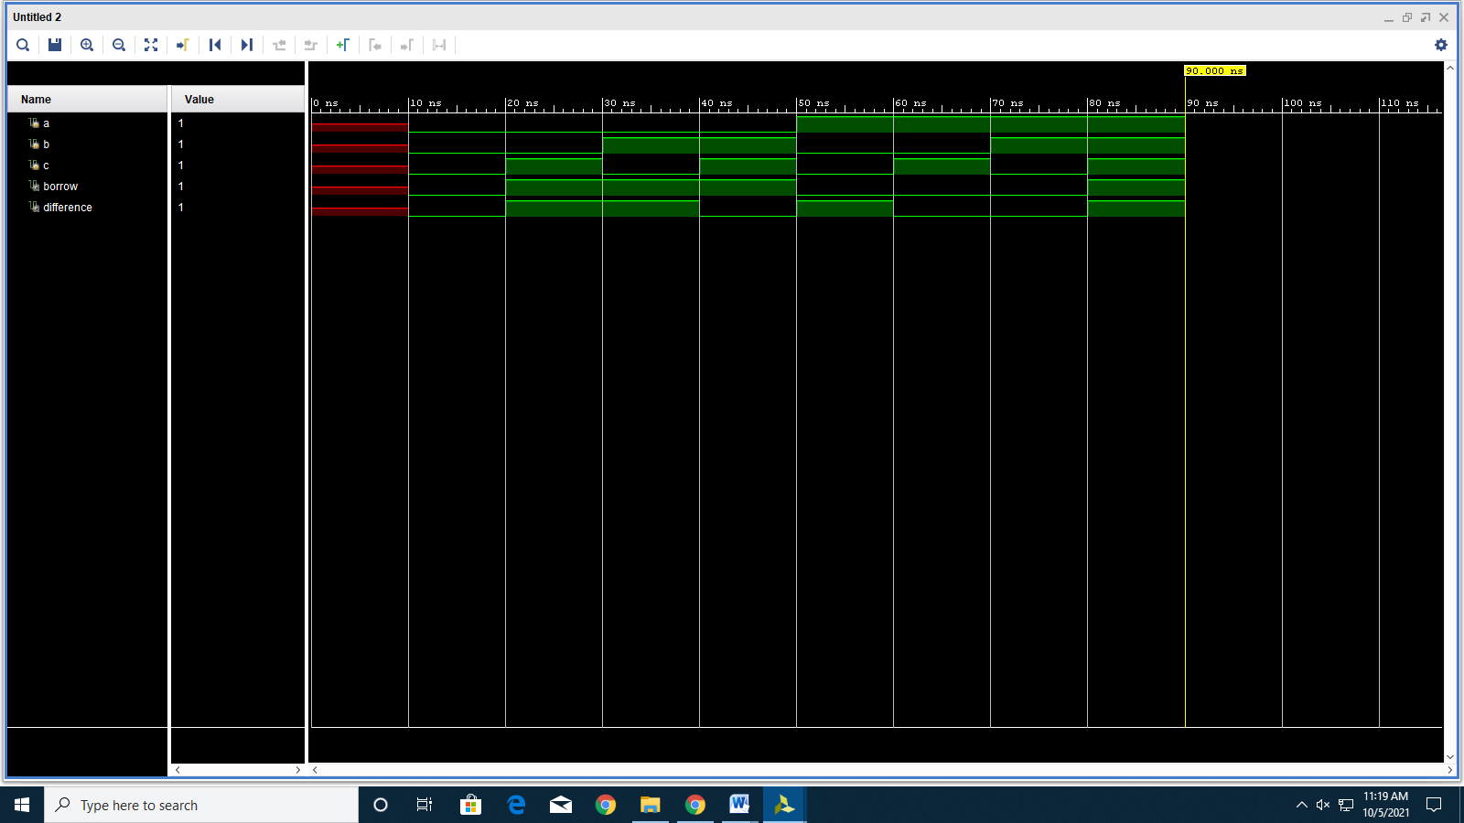

RTL SIMULATION:

