HALF ADDER

PROGRAM:

module half_adder  (

   i_bit1,

   i_bit2,

   o_sum,

   o_carry

   );

  input  i_bit1;

  input  i_bit2;

  output o_sum;

  output o_carry;

  assign o_sum   = i_bit1 ^ i_bit2;

  assign o_carry = i_bit1 & i_bit2;

end module

**Waveforms:**

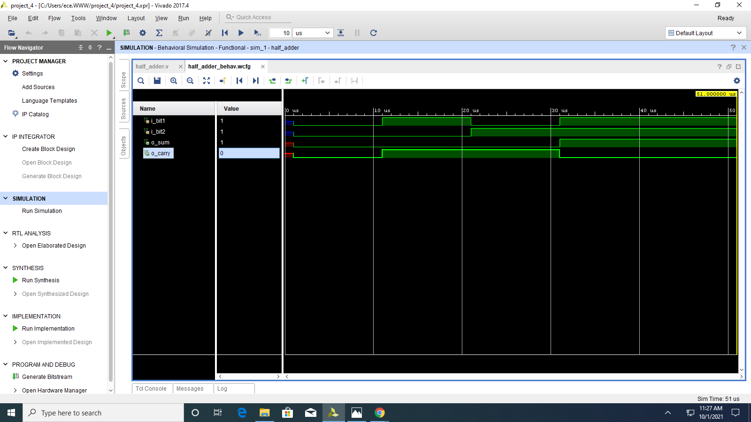

**RTL SIMULATION**:

