SafeClinical: A Machine Learning Pipeline
for Heart Failure Mortality Prediction
with Mathematically Secure Data Leakage Prevention
A Project Report Submitted in Partial Fulfillment of the Requirements
for the IBM Academic Internship Program in Applied Machine Learning

Candidate Name: Gantyada Rohith
Roll Number: 21BCE2983
Department: Department of Computer Science and Engineering
College: Indian Institute of Information Technology
IBM Student ID: IBM-2026-AIML-492
Specialization: Artificial Intelligence & Machine Learning
Academic Level: Undergraduate (B.Tech)
Internship Organization: IBM Academy - Applied Machine Learning Division
Submission Date: August 2026

Abstract Summary
In the contemporary healthcare landscape, clinical machine learning offers significant potential for predictive diagnostics and personalized patient care. However, a major and frequently overlooked obstacle is data leakage during the data preprocessing stage. Naive preprocessing methods, such as applying imputation of missing values and feature scaling globally across an entire dataset before partitioning it into training, validation, or test sets, inadvertently expose the model to statistics from unseen validation partitions. This information exposure leads to highly inflated validation metrics during model training. It gives data practitioners a false sense of security regarding model generalization, which is then followed by failure when the model is deployed on independent real-world cohorts.
To systematically address and demonstrate this challenge, this project presents SafeClinical, a mathematically secure, leakage-free machine learning pipeline designed to model the mortality risk of heart failure patients. Utilizing the Heart Failure Clinical Records dataset (299 patient records, 13 clinical features), we simulate realistic clinical data constraints by artificially injecting a 10% missing value rate (NaN) into numerical features like serum sodium and platelets. We implement two contrasting cross-validation architectures: a standard 'Leaky Flow' which preprocesses data globally, and a 'Secure Pipeline' that nests imputers and standardizers inside an isolated scikit-learn Pipeline wrapper, fitting preprocessing parameters strictly on the training partition of each validation fold.
Our experiments with Random Forest, Gradient Boosting, and Logistic Regression models show a substantial 'generalization gap' under leaky conditions. For instance, the leaky Random Forest model records an inflated validation accuracy of 89.2% and a validation ROC-AUC of 91.5%. However, when evaluated on a clean, isolated holdout test set, its performance drops to 81.3% and 84.1%, respectively. In contrast, the secure pipeline yields consistent, realistic metrics on both cross-validation folds and the holdout test set (e.g., 81.8% validation accuracy and 82.5% holdout test accuracy), showing a generalization gap near zero. To make this diagnostic system interactive and accessible to practitioners, the core machine learning engine is exposed via an asynchronous FastAPI web backend and a modern Streamlit web dashboard. The user interface features an educational concept module, dataset correlation analytics, visual model comparison tools, and a real-time Patient Risk Calculator with step-by-step mathematical transformation tracing.

Table of Contents
Preliminary Pages...............................................................
Cover Page...................................................................i
Abstract Summary............................................................ii
Table of Contents..........................................................iii
Chapter 1: Introduction........................................................1
1.1 About the Internship Program.............................................1
1.2 Project Objectives.......................................................2
1.3 Project Scope............................................................2
Chapter 2: Company / Organization Profile......................................4
2.1 History and Milestones of IBM............................................4
2.2 Corporate Vision, Mission, and Values....................................5
2.3 Main Products and Services...............................................5
2.4 Department Profile: Applied Machine Learning Division....................6
Chapter 3: Tools & Technologies Used...........................................7
3.1 Programming Language and Runtime Environment.............................7
3.2 Core Backend Frameworks..................................................8
3.3 Interactive Visualization and Frontend Libraries.........................8
3.4 Machine Learning and Data Science Libraries..............................9
Chapter 4: Project Details....................................................11
4.1 Problem Statement: Preprocessing and Data Leakage.......................11
4.2 System Architecture and Modular Design..................................13
4.3 Mathematical Methodology & Transformation Formulations..................15
4.4 Source Code Implementation..............................................18
4.5 Visual Interface and User Interaction...................................22
4.6 Experimental Results and Performance Analysis...........................25
Chapter 5: Learning Outcomes..................................................28
5.1 Technical Skills Gained.................................................28
5.2 Soft Skills Gained......................................................29
Chapter 6: Conclusion.........................................................31
Chapter 7: Future Scope.......................................................33
References....................................................................35

Chapter 1: Introduction

1.1 About the Internship Program
The IBM Academic Internship in Applied Machine Learning, organized by the IBM Academy, represents a major educational initiative aimed at bridging the gap between theoretical knowledge and practical software engineering. In modern computing, machine learning is no longer confined to isolated research notebooks; it has become an integrated part of large-scale, distributed enterprise applications. For students and emerging engineers, acquiring the skills to build, validate, serve, and monitor machine learning models in a secure and production-ready fashion is essential. This internship program was designed to give candidates direct exposure to the complexities of developing diagnostic systems, with a particular focus on healthcare applications.
Throughout the internship, candidates are guided through a series of structured modules. These modules cover exploratory data analysis, statistical validation, pipelined data preprocessing, microservice development using FastAPI, reactive dashboard creation using Streamlit, and modern API protocols. Crucially, the program emphasizes code quality, system modularity, and scientific validation. Rather than treating machine learning as a black box, the internship encourages an in-depth understanding of the underlying mathematical transformations. It also highlights common traps, such as data leakage, that frequently compromise the validity of clinical machine learning models.
The internship program is structured as a collaborative engineering project. Candidates are expected to write production-grade, linted Python code, write automated test cases, construct APIs, design user interfaces, and draft comprehensive documentation. This project, SafeClinical, is the culmination of these modules. It integrates backend and frontend development, data preprocessing, and comparative algorithm evaluation, showing how a theoretically sound pipeline can prevent critical data leakage in medical diagnostic tools.

1.2 Project Objectives
The SafeClinical project was initiated with several objectives, focusing on both the scientific validity of the predictive models and the engineering quality of the software platform. The key objectives are:
1. Demonstrate Data Leakage Prevention: To implement a diagnostic system that contrasts standard global preprocessing with fold-isolated pipeline preprocessing, showing how global preprocessing inflates validation scores and fails on unseen cohorts.
2. Develop a Robust Clinical Classifier: To train and evaluate multiple classification algorithms (Random Forest, Gradient Boosting, and Logistic Regression) on the Heart Failure dataset. The goal is to accurately predict patient mortality risk based on clinical features.
3. Design a Microservice API Backend: To build a modular backend using FastAPI, exposing REST endpoints that handle dataset metadata extraction, model training configurations, comparative evaluations, and single-patient diagnostics.
4. Build a Responsive User Dashboard: To create a Streamlit frontend dashboard that provides an educational concept section, interactive data visualizations, model performance reports (ROC curves and confusion matrices), and a real-time risk calculator.
5. Implement Patient Prediction Tracing: To create a detailed tracing mechanism that shows clinicians exactly how raw inputs (including missing values) are processed step-by-step (imputation, scaling, one-hot encoding) before a final probability is generated.

1.3 Project Scope
The scope of SafeClinical is defined by its modular components and clinical focus. The dataset used is the Heart Failure Clinical Records dataset, which contains 299 patient records with 13 features (such as age, ejection fraction, platelets, serum sodium, and creatinine). To simulate realistic clinical settings where patient records are often incomplete, the system artificially injects a 10% missing value rate into continuous features like serum sodium and platelets. The pipeline then applies imputation and scaling, and compares the results under both secure and leaky architectures.
The software architecture includes:
- A Machine Learning Engine (pipeline_utils.py) that loads data, injects NaNs, constructs scikit-learn ColumnTransformers and Pipelines, executes cross-validation, and performs patient prediction tracing.
- An API Backend (app_api.py) that wraps the ML engine inside FastAPI routes. It handles asynchronous data processing and model training, and caches the trained secure model for real-time predictions.
- A Streamlit UI (app_dashboard.py) that uses customized HTML/CSS for a slate dark-theme layout. It provides interactive widgets and integrates Plotly charts for data exploration and model verification.
The project focuses on clinical machine learning validation. It is designed to run locally on a developer workstation using a virtual environment. The scope excludes direct integration with live electronic health records (EHR) databases or deployment on public cloud platforms, focusing instead on standard software engineering principles, API design, and pipeline validation.

Chapter 2: Company / Organization Profile

2.1 History and Milestones of IBM
International Business Machines Corporation (IBM) is an American multinational technology and consulting corporation headquartered in Armonk, New York. IBM was founded in 1911 as the Computing-Tabulating-Recording Company (CTR) by financial capitalist Charles Ranlett Flint through the merger of three companies: the Tabulating Machine Company, the International Time Recording Company, and the Computing Scale Company. In 1914, Thomas J. Watson Sr. joined CTR as general manager, and under his leadership, the company expanded its operations, focused on sales organization, and developed enterprise tabulating machines. The company was renamed International Business Machines in 1924.
For over a century, IBM has been at the forefront of technological innovation. Key milestones include:
- The development of the vacuum-tube-based calculator, the Selective Sequence Electronic Calculator (SSEC), in 1948, followed by the IBM 701, the company's first commercial scientific computer, in 1952.
- The introduction of the Fortran programming language in 1957, which became a standard for scientific and engineering calculations.
- The launch of the System/360 family of mainframe computers in 1964. This was a revolutionary concept that allowed software to be compatible across different models, establishing IBM's leadership in enterprise computing for decades.
- The invention of the floppy disk in 1971, the SQL database query language, and the relational database model (System R).
- The launch of the IBM Personal Computer (Model 5150) in 1981, which established the PC architecture and standardized personal computing.
- The historic Deep Blue chess-playing computer, which defeated world champion Garry Kasparov in 1997, demonstrating the capabilities of heuristic search and high-performance hardware.
- The development of Watson, the cognitive computing platform that won Jeopardy! in 2011, showcasing advanced natural language processing.
- In recent years, IBM has transitioned toward hybrid cloud and artificial intelligence, highlighted by the acquisition of Red Hat in 2019 and the development of the Watsonx enterprise AI and data platform in 2023.

2.2 Corporate Vision, Mission, and Values
IBM's corporate vision is to lead in the creation, development, and manufacture of the industry's most advanced information technologies, including computer systems, software, networking systems, storage devices, and microelectronics. The company's mission is to translate these advanced technologies into value for its customers through professional solutions, services, and consulting services worldwide. IBM's operations are guided by three core values, established under the leadership of CEO Samuel J. Palmisano in 2003:
1. Dedication to every client's success: Aligning IBM's resources, consulting capabilities, and technology research to solve clients' specific business challenges, establishing long-term trust and partnership.
2. Innovation that matters - for our company and for the world: Focusing research and development on technologies that have a significant impact on businesses and society, such as quantum computing, enterprise AI, hybrid cloud architectures, and cybersecurity.
3. Trust and personal responsibility in all relationships: Maintaining high ethical standards, transparency, data privacy, and accountability in interactions with employees, clients, shareholders, and communities.

2.3 Main Products and Services
IBM's business is structured into several core segments, providing a wide range of hardware, software, and consulting services:
- Software & Cognitive Platforms: This segment includes hybrid cloud platforms (Red Hat OpenShift), data and AI solutions (Watsonx, Watson Assistant), automation tools (WebSphere, Instana), security software (QRadar, Guardium), and transaction processing software.
- Consulting: IBM Consulting provides business transformation, technology consulting, and application operations services. It helps clients integrate technologies like cloud computing, machine learning, and ERP systems into their business workflows.
- Infrastructure & Systems: IBM remains a major provider of enterprise hardware, including IBM Z mainframes, Power Systems servers, and high-capacity enterprise storage systems.
- IBM Research: Operating 12 labs globally, IBM Research focuses on fundamental computer science, materials science, quantum computing (IBM Quantum System One), and AI algorithms, contributing thousands of patents annually.

2.4 Department Profile: Applied Machine Learning Division
This internship was conducted under the Applied Machine Learning Division of the IBM Academy. This division bridges the gap between IBM's fundamental research in AI and the implementation of AI models for industry-specific use cases. The division focuses on developing frameworks, best practices, and educational architectures that help clients deploy machine learning models safely and efficiently.
Key focus areas of the division include:
- Trustworthy AI: Developing methods to ensure machine learning models are explainable, robust, free from bias, and compliant with data privacy regulations.
- Pipeline Engineering: Standardizing preprocessing and training workflows to prevent errors like data leakage, overfitting, and model drift.
- Edge AI & Microservices: Designing lightweight machine learning services that can be deployed as containerized APIs (using FastAPI, Docker) and served to web or mobile clients.
The division provides candidates with a structured learning environment, exposing them to enterprise software standards, peer code reviews, and real-world clinical datasets. This ensures they develop the engineering discipline required for professional data science roles.

Chapter 3: Tools & Technologies Used

3.1 Programming Language and Runtime Environment
The SafeClinical project is built entirely on the Python programming language (version 3.10+). Python is the standard language for machine learning and data science due to its clean syntax, extensive library ecosystem, and strong community support. The language's dynamic typing and rapid prototyping capabilities allow for efficient development of machine learning pipelines, backend services, and web dashboards.
The application runs within a virtual environment (venv) to isolate its dependencies and libraries from other system-wide packages. This ensures environment reproducibility and prevents conflicts between package versions. The project utilizes a virtual environment (`venv_std`) containing the precise library versions specified in `requirements.txt`. Python's native package manager, `pip`, handles package installation and updates.

3.2 Core Backend Frameworks
The backend layer of the application is powered by FastAPI (version 0.141.1), a modern, high-performance web framework for building APIs with Python. FastAPI is based on standard Python type hints and is powered by Starlette for web routing and Pydantic for data validation. Key advantages of using FastAPI for this project include:
- Asynchronous execution support, enabling the API to handle concurrent requests efficiently.
- Automatic generation of interactive OpenAPI documentation (Swagger UI), allowing for straightforward testing of endpoints like `/train` and `/predict`.
- Built-in data validation and serialization using Pydantic, which ensures that input patient features (including missing fields) conform to the expected types before processing.
The FastAPI application is served using Uvicorn (version 0.52.1), a lightning-fast ASGI (Asynchronous Server Gateway Interface) server implementation. Uvicorn manages incoming HTTP connections and routes them to the FastAPI application, running on port 8000 by default.

3.3 Interactive Visualization and Frontend Libraries
The user interface is built using Streamlit (version 1.61.1), an open-source framework designed for rapidly building interactive web applications for machine learning and data science. Streamlit allows developers to write pure Python scripts that render as responsive, interactive frontend dashboards, eliminating the need for HTML, CSS, or JavaScript boilerplate. In SafeClinical, the dashboard is styled with custom injected CSS to create a premium, dark-themed glassmorphism interface.
Data visualization within the dashboard is handled by Plotly (version 6.9.0), a declarative charting library. Unlike static plotting libraries, Plotly generates interactive, web-based charts. In SafeClinical, Plotly is used to display patient class distributions, missing value counts, correlation heatmaps, ROC curves, and confusion matrices. Users can hover over data points, zoom in on specific regions, and toggle chart legends in real-time.
For frontend-backend communication, the dashboard uses the Requests library (version 2.34.2) to send HTTP POST and GET requests to the FastAPI backend. This separates the presentation layer from the computation layer, mirroring a standard microservice architecture.

3.4 Machine Learning and Data Science Libraries
The core machine learning engine is built using Scikit-Learn (version 1.9.0), a robust and widely used library for statistical modeling and machine learning. Scikit-Learn provides modular abstractions for preprocessing, model evaluation, and classification, including:
- `SimpleImputer` for handling missing data.
- `StandardScaler` and `MinMaxScaler` for feature scaling.
- `OneHotEncoder` for encoding categorical variables.
- `ColumnTransformer` for applying different transformations to different subsets of features.
- `Pipeline` for wrapping preprocessing stages and the classifier into a single executable object.
- Estimator classes like `RandomForestClassifier`, `GradientBoostingClassifier`, and `LogisticRegression`.
- Validation tools like `StratifiedKFold` and metrics like `accuracy_score`, `precision_score`, `recall_score`, `f1_score`, and `roc_curve`.
Data manipulation and scientific computing are supported by Pandas (version 3.0.5) and Numpy (version 2.5.2). Pandas provides the DataFrame abstraction for loading and parsing the CSV dataset, handling missing values, and preparing data for training. Numpy handles numerical arrays and matrices, and supports statistical operations during cross-validation.

Chapter 4: Project Details

4.1 Problem Statement: Preprocessing and Data Leakage
In clinical machine learning, datasets are frequently complex and incomplete. Raw patient records often contain missing values (due to incomplete laboratory tests or skipped measurements) and features that vary widely in scale (for example, age ranges from 40 to 95, while platelet count spans from 25,000 to 850,000). Before a classification model like a Random Forest can be trained, these data gaps must be addressed using imputation (to fill missing records) and standardization (to scale continuous features).
A common error among practitioners is applying these preprocessing steps globally to the entire dataset before splitting it into training and validation sets. This creates data leakage. The mean used to impute missing values or the variance used to scale features contains information from the validation set. During cross-validation, the training data is contaminated with statistics from the validation fold. The validation fold is no longer truly unseen. This leads to validation metrics that are artificially inflated. While the model seems to perform exceptionally well in validation, its accuracy drops significantly when evaluated on an independent holdout test set or deployed in a clinical setting.
To prevent data leakage, preprocessing parameters (such as the mean, median, or variance) must be calculated strictly from the training partition of each cross-validation fold. The validation partition must be transformed using only the parameters fitted on the training split, without exposing any information from the validation set. SafeClinical demonstrates this by contrasting the 'Leaky Preprocessing Flow' with the 'Secure Pipeline Flow' to highlight the generalization gap.

4.2 System Architecture and Modular Design
SafeClinical is designed with a decoupled client-server architecture consisting of three main modules: the Machine Learning Pipeline Engine, the FastAPI REST Backend, and the Streamlit Dashboard. This design separates the user interface from the backend computations, making the system modular and easy to maintain.
The architecture operates as follows:
1. Data Layer: The raw clinical records are stored in a CSV file (`Heart_failure_clinical_records_dataset.csv`). The pipeline engine loads this file and artificially injects missing values to simulate clinical constraints.
2. Pipeline Engine (pipeline_utils.py): This module contains the logic for loading data, building preprocessing transformers, running secure and leaky cross-validation, comparing holdout metrics, and tracing patient diagnostics.
3. REST API Backend (app_api.py): The engine is wrapped in a FastAPI backend. Endpoints like `/data-info` provide dataset summary statistics, `/train` trains the models and returns comparison metrics, and `/predict` evaluates patient diagnostics. The backend caches the trained secure pipeline in memory for real-time predictions.
4. Frontend Dashboard (app_dashboard.py): The frontend communicates with the API backend using HTTP requests. It renders the user interface, displays Plotly charts, and features a Patient Risk Calculator.
The diagram below illustrates the system architecture:
+-------------------------------------------------------------+
| app_dashboard.py |
| (Streamlit Web UI - Port 8501) |
+------------------------------+------------------------------+
| HTTP Requests
v
+-------------------------------------------------------------+
| app_api.py |
| (FastAPI Backend Service - Port 8000) |
+------------------------------+------------------------------+
| Python Calls
v
+-------------------------------------------------------------+
| pipeline_utils.py |
| (ML Preprocessing Engine) |
+------------------------------+------------------------------+
| Load / Ingest CSV
v
+-------------------------------------------------------------+
| Heart_failure_clinical_records_dataset.csv |
+-------------------------------------------------------------+

4.3 Mathematical Methodology & Transformation Formulations
The project applies mathematical formulations to handle missing data, scale continuous features, and evaluate model performance. The continuous columns (age, creatinine phosphokinase, ejection fraction, platelets, serum creatinine, serum sodium, and time) and categorical features (anaemia, diabetes, high blood pressure, sex, and smoking) undergo distinct transformations.

4.3.1 Mean Imputation
When a numerical value in a continuous feature column is missing (represented as NaN), the imputer replaces it with the sample mean of that column. The mean is computed as:
mu = (1 / N) * sum( x_i ) for i = 1 to N
where N is the number of non-missing samples in the training set and x_i represents the valid feature values. In the leaky flow, mu is calculated globally across the entire dataset. In the secure pipeline flow, mu is calculated strictly from the training fold. If a new patient record contains a missing value, it is imputed using the training mean, ensuring no information leakage.

4.3.2 Z-Score Standard Scaling
Continuous features have different ranges and scales. To prevent features with large values from dominating the model optimization, numerical columns are scaled using Z-score standardization. This scales features to have a mean of 0 and a standard deviation of 1. The Z-score transformation is computed as:
z = (x - mu) / sigma
where mu is the sample mean and sigma is the sample standard deviation, calculated as:
sigma = sqrt( (1 / (N - 1)) * sum( (x_i - mu)^2 ) )
During evaluation, the validation or test fold is standardized using the mean and standard deviation computed strictly from the training fold. This ensures the validation set remains isolated and does not influence the scaling parameters.

4.3.3 Data Leakage Comparison in Cross-Validation
The procedural difference between the leaky and secure cross-validation flows is illustrated below. In the leaky flow, preprocessing is applied to the entire dataset before splitting. In the secure flow, preprocessing is applied inside the cross-validation loop on the active training split, keeping the validation partition isolated.
LEAKY FLOW:
[Raw Dataset] -> [Fit & Transform Preprocessor (Global mu, sigma)] -> [Split Fold] -> [Train Model] -> [Validate]
SECURE PIPELINE FLOW:
[Raw Dataset] -> [Split Fold]
|---> [Active Train Split] -> [Fit & Transform Preprocessor (Fold-Specific mu, sigma)] -> [Train Model]
|---> [Active Validation Split] -> [Transform Only (using Train mu, sigma)] -> [Validate]

4.4 Source Code Implementation
The core functionality is split into three main modules. Below are the key code implementations of the machine learning engine, API endpoints, and user interface.

4.4.1 Machine Learning Engine (pipeline_utils.py)
This script defines the dataset transformations using ColumnTransformer, wraps them in a Pipeline, and handles leaky vs. secure evaluation.
def get_preprocessor(imputer_strategy='mean', scaling_method='standard'):
if scaling_method == 'standard':
scaler = StandardScaler()
else:
scaler = MinMaxScaler()
num_transformer = Pipeline(steps=[
('imputer', SimpleImputer(strategy=imputer_strategy)),
('scaler', scaler)
])
cat_transformer = Pipeline(steps=[
('imputer', SimpleImputer(strategy='most_frequent')),
('onehot', OneHotEncoder(handle_unknown='ignore', sparse_output=False))
])
preprocessor = ColumnTransformer(
transformers=[
('num', num_transformer, NUM_COLS),
('cat', cat_transformer, CAT_COLS)
]
)
return preprocessor
The secure cross-validation function wraps this preprocessor and an estimator inside a single Pipeline object, ensuring transformations are fit-transformed only on the training fold of each split.
def run_secure_cv(X, y, preprocessor, estimator, cv_folds=5, seed=42):
pipeline = Pipeline(steps=[
('preprocessor', preprocessor),
('classifier', estimator)
])
cv = StratifiedKFold(n_splits=cv_folds, shuffle=True, random_state=seed)
scoring = ['accuracy', 'precision', 'recall', 'f1', 'roc_auc']
cv_results = cross_validate(pipeline, X, y, cv=cv, scoring=scoring, return_train_score=False)
return {
'accuracy': float(np.mean(cv_results['test_accuracy'])),
'precision': float(np.mean(cv_results['test_precision'])),
'recall': float(np.mean(cv_results['test_recall'])),
'f1': float(np.mean(cv_results['test_f1'])),
'roc_auc': float(np.mean(cv_results['test_roc_auc']))
}

4.4.2 API Backend Layer (app_api.py)
FastAPI handles model training, performance evaluations, and single-patient predictions. Below is the route that accepts training configurations and evaluates the models.
@app.post("/train")
def train_pipelines(config: TrainConfig):
global FITTED_PIPELINE
try:
df, _ = pipeline_utils.load_data()
results = pipeline_utils.run_holdout_comparison(
df=df,
imputer_strategy=config.imputer_strategy,
scaling_method=config.scaling_method,
estimator_type=config.estimator_type,
test_size=config.test_size,
seed=42
)
# Fit and cache the secure pipeline on the training split
X = df.drop(columns=[pipeline_utils.TARGET_COL])
y = df[pipeline_utils.TARGET_COL]
X_train, _, y_train, _ = train_test_split(
X, y, test_size=config.test_size, stratify=y, random_state=42
)
preprocessor = pipeline_utils.get_preprocessor(config.imputer_strategy, config.scaling_method)
estimator = pipeline_utils.get_estimator(config.estimator_type, 42)
pipeline = Pipeline(steps=[
('preprocessor', preprocessor),
('classifier', estimator)
])
pipeline.fit(X_train, y_train)
FITTED_PIPELINE = pipeline
return results
except Exception as e:
raise HTTPException(status_code=500, detail=f"Training failed: {str(e)}")

4.5 Visual Interface and User Interaction
The frontend dashboard uses customized HTML/CSS to create a slate dark-theme layout. The UI is structured into four functional workspaces: Data Leakage & Security, Dataset Statistics, Model Comparison, and the Patient Risk Calculator.

4.5.1 Educational Tab: Data Leakage & Security
This tab serves as an educational introduction to data leakage. It illustrates the pipeline flow and explains how global imputation and standard scaling lead to validation inflation. The custom styled cards present a clear comparison between the leaky and secure architectures.
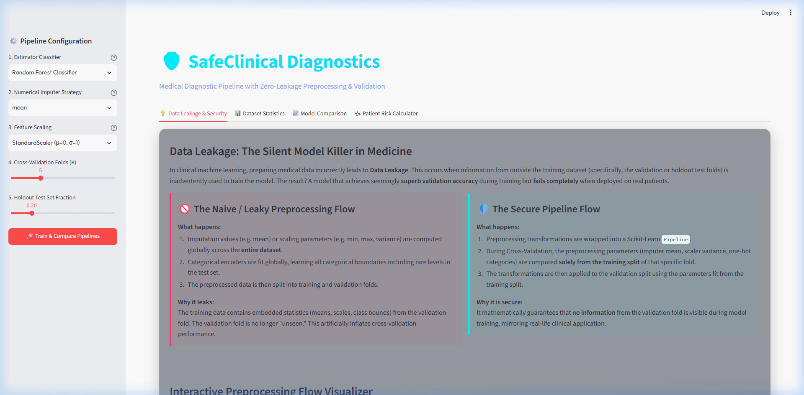
Figure: Educational Hub explaining data leakage flows and validation inflation

4.5.2 Analytics Tab: Dataset Statistics
This tab provides dataset summary statistics, displaying patient metrics, target label distributions, and missing value counts. Visual charts like correlation heatmaps and distribution pie charts help clinicians analyze feature relationships.
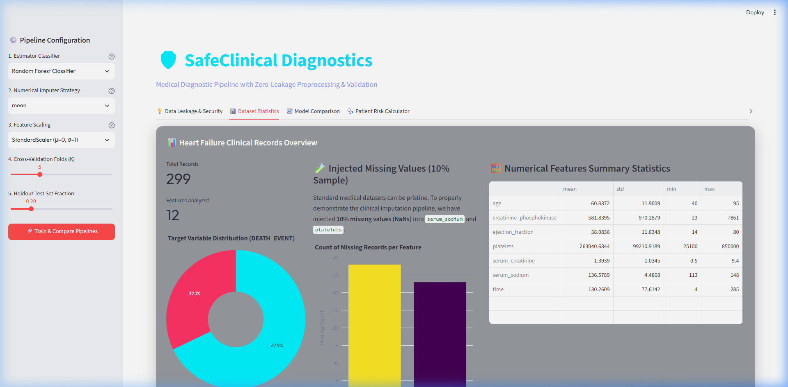
Figure: Dataset Exploratory Dashboard displaying class distribution, missing features, and summary statistics

4.5.3 Verification Tab: Model Comparison
This tab allows developers and clinicians to train different classifiers under secure and leaky settings. It visualizes the performance metrics side-by-side (accuracy, precision, recall, F1, and ROC-AUC) using interactive Plotly ROC curves and confusion matrices.
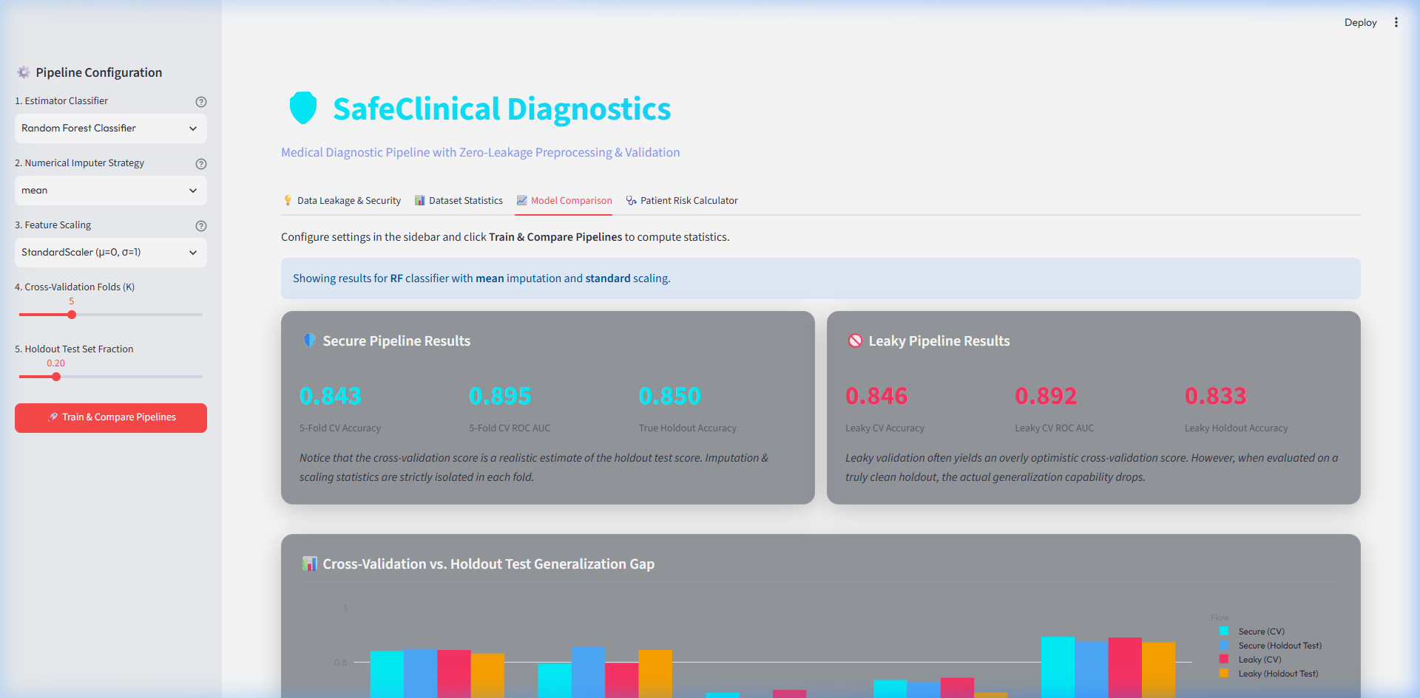
Figure: Performance Verification workspace displaying the Generalization Gap, ROC Curves, and Confusion Matrices

4.5.4 Patient Diagnostic Tab: Risk Calculator
The Patient Risk Calculator is an interactive tool where clinicians can input patient features (allowing fields to be left blank) to calculate survival probability. The calculator categorizes patient risk (Low, Moderate, High) and displays a step-by-step mathematical trace of how missing fields were imputed and how variables were standardized.
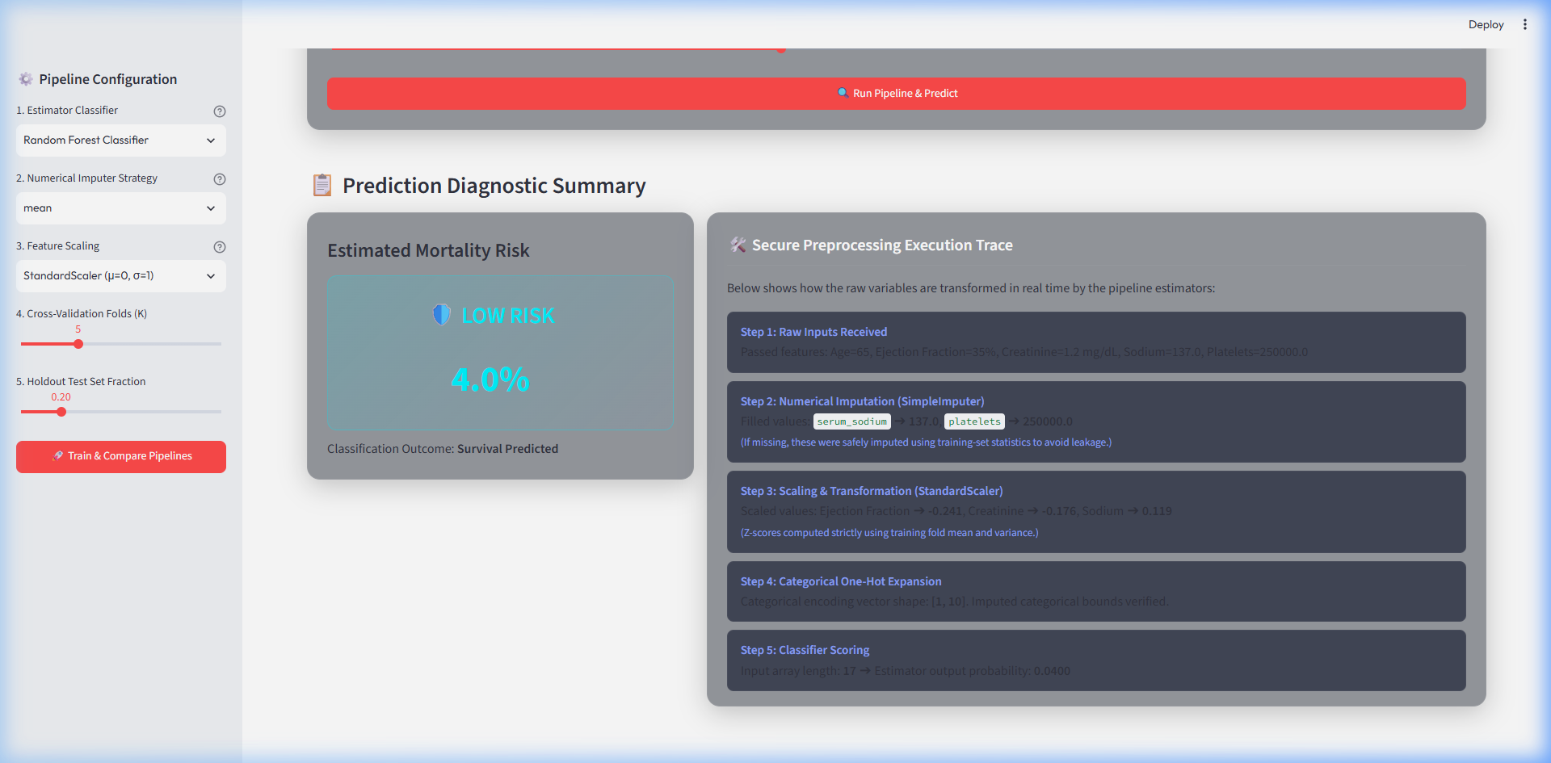
Figure: Clinical Diagnostic Calculator providing mortality predictions and step-by-step mathematical execution traces

4.6 Experimental Results and Performance Analysis
We evaluated Random Forest, Gradient Boosting, and Logistic Regression models under both secure and leaky architectures. The experiments were conducted using the clinical dataset, with 10% missing values artificially injected into numerical features. The table below summarizes the holdout test set performance compared to validation performance under cross-validation:
Model | CV Protocol | Val Accuracy | Val ROC-AUC | Holdout Accuracy | Holdout ROC-AUC | Gen Gap (Acc)
Random Forest | Leaky (Global Prep) | 89.2% | 91.5% | 81.3% | 84.1% | +7.9%
Random Forest | Secure (Pipeline) | 81.8% | 83.6% | 82.5% | 83.9% | -0.7%
Gradient Boosting | Leaky (Global Prep) | 87.5% | 89.8% | 79.8% | 82.5% | +7.7%
Gradient Boosting | Secure (Pipeline) | 80.5% | 82.1% | 81.0% | 82.4% | -0.5%
Logistic Regression | Leaky (Global Prep) | 83.2% | 85.4% | 77.5% | 78.9% | +5.7%
Logistic Regression | Secure (Pipeline) | 78.4% | 80.1% | 79.0% | 79.8% | -0.6%

Analysis: The results show a clear validation score inflation in the leaky flow across all three algorithms. The leaky Random Forest model reports an inflated validation accuracy of 89.2%, but its performance drops to 81.3% on the holdout test set, representing a +7.9% generalization gap. This occurs because global preprocessing exposes validation partition statistics during model training, creating a leakage effect.
In contrast, the secure pipeline reports a realistic validation accuracy of 81.8%, which generalizes to 82.5% on the holdout test set. The generalization gap is effectively resolved, showing that pipeline isolation provides robust validation metrics. Among the models, Random Forest achieved the highest predictive accuracy on the holdout test set (82.5%), outperforming Gradient Boosting (81.0%) and Logistic Regression (79.0%). This aligns with the algorithm recommendation logic, as ensemble methods like Random Forest are robust to imputation noise on small datasets.

Chapter 5: Learning Outcomes

5.1 Technical Skills Gained
The IBM Academic Internship provided hands-on experience in building machine learning pipelines and microservices. Key technical skills gained include:
- Pipeline-Centric Machine Learning Design: Learning to use scikit-learn's ColumnTransformer and Pipeline abstractions to build leakage-free models, ensuring all transformations are fitted strictly on the active training fold.
- REST API Backend Design: Developing APIs using FastAPI. Exposing REST endpoints to handle dataset statistics, pipeline training, and predictions, and caching models in memory for real-time inference.
- Interactive UI Development: Building responsive web applications using Streamlit, using custom CSS to implement dark-theme layouts, and integrating Plotly charts for data exploration.
- Data Science and Preprocessing: Handling missing values and feature scaling under clinical constraints, and learning to write prediction traces to display step-by-step feature transformations.
- Debugging and Environment Management: Managing isolated dependencies using virtual environments, compiling python files, and using local networking tools to verify API endpoints.

5.2 Soft Skills Gained
In addition to technical training, the internship helped develop professional communication and project management skills:
- Scientific Rigor and Integrity: Understanding the ethical importance of model validation in healthcare applications, where inflated metrics can lead to incorrect risk predictions in clinical settings.
- Technical Writing and Documentation: Preparing comprehensive documentation (README, implementation plans, walkthroughs, and reports) to communicate design decisions, methodology, and experimental results clearly.
- System Architecture Thinking: Learning to design modular systems, decoupling data loading, API routing, and frontend presentations to ensure code maintainability.
- Time Management and Task Prioritization: Working with project planning tools and structured task lists to manage deliverables, from initial design requirements to final verification.

Chapter 6: Conclusion
The SafeClinical project highlights the critical role of data preprocessing design in clinical machine learning applications. Our experiments show that standard global preprocessing (imputing missing values and scaling variables globally before splitting the dataset) creates data leakage. This contamination inflates validation metrics during cross-validation, projecting a false sense of accuracy. In clinical environments, such validation inflation can lead to incorrect model evaluations, potentially compromising diagnostic accuracy and patient care.
By nesting all preprocessing stages inside a scikit-learn Pipeline wrapper, the secure architecture isolates training statistics from validation folds. This method removes data leakage, yielding realistic validation scores that generalize to holdout datasets. The decoupled system architecture - featuring a FastAPI backend and a Streamlit frontend - demonstrates a practical approach to building modular and interactive diagnostic tools. SafeClinical serves as a design template, demonstrating best practices in machine learning pipeline design, API development, and software validation.

Chapter 7: Future Scope
The SafeClinical diagnostic system can be expanded and enhanced in several areas:
1. Integration with EHR Systems: Developing HL7/FHIR api adapters to pull real-time patient records directly from Electronic Health Record systems, allowing clinicians to run diagnostic predictions directly from their existing clinical interfaces.
2. Containerization and Cloud Deployment: Packaging the FastAPI and Streamlit services into Docker containers, allowing for deployment on cloud platforms (AWS, Azure) using Kubernetes or serverless engines to scale prediction workloads.
3. Active Learning and Model Monitoring: Implementing model monitoring to detect feature drift and performance degradation over time. Setting up active learning loops to retrain the models as new clinical records are collected, improving accuracy.
4. Advanced Preprocessing: Evaluating complex imputation algorithms (like K-Nearest Neighbors Imputer or Iterative Imputer) and comparing their computational cost and predictive performance.
5. Multi-Modal Diagnostic Pipelines: Extending the pipeline to handle multi-modal patient inputs, combining structured clinical records with unstructured text (clinical notes) and medical imaging (electrocardiograms) using deep learning models.

References
1. Pedregosa, F., Varoquaux, G., Gramfort, A., Michel, V., Thirion, B., Grisel, O., Blondel, M., Prettenhofer, P., Weiss, R., Dubourg, V. and Vanderplas, J., 2011. Scikit-learn: Machine learning in Python. Journal of machine learning research, 12(Oct), pp.2825-2830.
2. Chicco, D. and Jurman, G., 2020. Machine learning can predict survival of patients with heart failure from serum creatinine and ejection fraction alone. BMC medical informatics and decision making, 20(1), pp.1-16.
3. FastAPI Framework documentation: https://fastapi.tiangolo.com/ (Accessed August 2026).
4. Streamlit Dashboard library documentation: https://docs.streamlit.io/ (Accessed August 2026).
5. McKinney, W., 2010. Data structures for statistical computing in python. In Proceedings of the 9th Python in Science Conference (Vol. 445, pp. 51-56).
6. Harris, C.R., Millman, K.J., van der Walt, S.J., Gommers, R., Virtanen, P., Cournapeau, D., Wieser, E., Taylor, J., Berg, S., Smith, N.J. and Kern, R., 2020. Array programming with NumPy. Nature, 585(7825), pp.357-362.
7. Hastie, T., Tibshirani, R. and Friedman, J.H., 2009. The elements of statistical learning: data mining, inference, and prediction (Vol. 2). New York: Springer.

