AN INTERNSHIP COURSE REPORT
ON
DATA SCIENCE


Anil Neerukonda Institute of Technology & Sciences (Autonomous)
(Permanent Affiliation by Andhra University & Approved by AICTE)
Sangivalasa-531 162, Bheemunipatnam Mandal, Visakhapatnam District

Submitted By: GANTYADA ROHITH(A23126510074)

Prof G. Srinivas
(Head of the Department)
Computer Science and Engineering

Internship reviewer Summer Internship Coordinator
Mr. G Sateesh
(Assistant Professor)

Anil Neerukonda Institute of Technology & Sciences (Autonomous)
Sangivalasa-531 162, Bheemunipatnam Mandal, Visakhapatnam District

2023-2027

BONAFIDE CERTIFICATE

This is to certify that the industrial training on AI AND MACHINE LEARNING which is a Bonafide work carried out by GANTYADA ROHITH bearing Register No A23126510074 respectively in fulfilment of Summer Internship Training in IV/IV B. Tech, 1st semester in Computer Science Engineering of the Anil Neerukonda Institute of Technology and Sciences, Visakhapatnam during the year 2023-2027. It is certified that all corrections indicated for internal assessment have been incorporated to account.

Prof. Srinivas Gorla
(Head of the Department)
Computer Science and Engineering
CERTIFICATE

DECLARATION

I GANTYADA ROHITH , bearing College Register No. A23126510074 respectively, do hereby declare that this industrial training on “AI AND MACHINE LEARNING” is carried out by me.
I hereby declare that the original summer internship is done by me as per the requirement of the training.

Station : Sangivalasa GANTYADA ROHITH
Date : (A23126510074)

ACKNOWLEDGEMENT

An endeavour over a long period can be successful with the advice and support of many
well-wishers. We take this opportunity to express our gratitude and appreciation to all
of them.

We owe our tributes to the Head of the Department Computer Science & Engineering,
ANITS, for his valuable support and guidance during the period of project
implementation.

We express our warm and sincere thanks for the encouragement, untiring guidance and
the confidence they had shown in us. We are immensely indebted for their valuable
guidance throughout our project.

We also thank all the staff members of the CSE department for their valuable advice.
We also thank the supporting staff for providing resources as and when required.

GANTYADA ROHITH
(A23126510074)

Abstract
In the contemporary healthcare landscape, clinical machine learning offers significant potential for predictive diagnostics and personalized patient care. However, a major and frequently overlooked obstacle is data leakage during the data preprocessing stage. Naive preprocessing methods, such as applying imputation of missing values and feature scaling globally across an entire dataset before partitioning it into training, validation, or test sets, inadvertently expose the model to statistics from unseen validation partitions. This information exposure leads to highly inflated validation metrics during model training, giving data practitioners a false sense of security regarding model generalization — a confidence that later collapses when the model is deployed on independent, real-world cohorts.
To systematically address and demonstrate this challenge, this project presents SafeClinical, a mathematically secure, leakage-free machine learning pipeline designed to model the mortality risk of heart failure patients. Utilizing the Heart Failure Clinical Records dataset (299 patient records, 13 clinical features), we simulate realistic clinical data constraints by artificially injecting a 10% missing value rate (NaN) into numerical features such as serum sodium and platelets. We implement two contrasting cross-validation architectures: a standard ‘Leaky Flow’ that preprocesses data globally, and a ‘Secure Pipeline’ that nests imputers and standardizers inside an isolated scikit-learn Pipeline wrapper, fitting preprocessing parameters strictly on the training partition of each validation fold.
Our experiments with Random Forest, Gradient Boosting, and Logistic Regression models show a substantial generalization gap under leaky conditions. For instance, the leaky Random Forest model records an inflated validation accuracy of 89.2% and a validation ROC-AUC of 91.5%; however, when evaluated on a clean, isolated holdout test set, its performance drops to 81.3% and 84.1% respectively. In contrast, the secure pipeline yields consistent, realistic metrics across both cross-validation folds and the holdout test set (e.g., 81.8% validation accuracy and 82.5% holdout accuracy), showing a generalization gap near zero. To make this diagnostic system interactive and accessible to practitioners, the core machine learning engine is exposed via an asynchronous FastAPI web backend and a modern Streamlit dashboard, featuring an educational concept module, dataset correlation analytics, visual model-comparison tools, and a real-time Patient Risk Calculator with step-by-step mathematical transformation tracing.

Table of Contents
Declaration 2
Acknowledgement 3
Abstract 4
List of Figures & Tables 6
Chapter 1: Introduction 7
1.1 About the Internship Program 7
1.2 Project Objectives 7
1.3 Project Scope 8
Chapter 2: Company / Organization Profile 9
2.1 History and Milestones of IBM 9
2.2 Corporate Vision, Mission, and Values 9
2.3 Main Products and Services 10
2.4 Department Profile: Applied Machine Learning Division 10
Chapter 3: Tools & Technologies Used 11
3.1 Programming Language and Runtime Environment 11
3.2 Core Backend Frameworks 11
3.3 Interactive Visualization and Frontend Libraries 11
3.4 Machine Learning and Data Science Libraries 12
3.5 Development, Testing, and Version Control Tools 12
Chapter 4: Project Details 13
4.1 Problem Statement: Preprocessing and Data Leakage 13
4.2 System Architecture and Modular Design 14
4.3 Mathematical Methodology & Transformation Formulations 15
4.4 Source Code Implementation 16
4.5 Visual Interface and User Interaction 19
4.6 Experimental Results and Performance Analysis 21
4.7 Testing and Validation Strategy 22
4.8 Deployment and Execution Guide 23
Chapter 5: Challenges Faced and Solutions Implemented 24
Chapter 6: Learning Outcomes 26
6.1 Technical Skills Gained 26
6.2 Soft Skills Gained 26
Chapter 7: Conclusion 27
Chapter 8: Future Scope 28
References 29
Appendix A: Project Directory Structure 30
Appendix B: Python Dependencies (requirements.txt) 31

List of Figures & Tables

List of Figures
Figure 4.1 SafeClinical system architecture: dashboard, API backend, ML engine, and data source 14
Figure 4.2 Leaky preprocessing flow versus the fold-isolated secure pipeline flow 16
Figure 4.3 Educational hub explaining data leakage flows and validation inflation 19
Figure 4.4 Dataset exploratory dashboard displaying class distribution and summary statistics 19
Figure 4.5 Performance verification workspace displaying the generalization gap and ROC curves 20
Figure 4.6 Clinical diagnostic calculator providing mortality predictions and execution traces 20

List of Tables
Table 4.1 Dataset feature description — types, definitions, and observed ranges 13
Table 4.2 Holdout vs. cross-validation performance, by model and protocol 21

Chapter 1: Introduction

1.1 About the Internship Program
The IBM Academic Internship in Applied Machine Learning, organized by the IBM Academy, represents a major educational initiative aimed at bridging the gap between theoretical knowledge and practical software engineering. In modern computing, machine learning is no longer confined to isolated research notebooks; it has become an integrated part of large-scale, distributed enterprise applications. For students and emerging engineers, acquiring the skills to build, validate, serve, and monitor machine learning models in a secure and production-ready fashion is essential. This internship program was designed to give candidates direct exposure to the complexities of developing diagnostic systems, with a particular focus on healthcare applications.
Throughout the internship, candidates are guided through a series of structured modules covering exploratory data analysis, statistical validation, pipelined data preprocessing, microservice development using FastAPI, reactive dashboard creation using Streamlit, and modern API protocols. Crucially, the program emphasizes code quality, system modularity, and scientific validation. Rather than treating machine learning as a black box, the internship encourages an in-depth understanding of the underlying mathematical transformations, while also highlighting common traps — such as data leakage — that frequently compromise the validity of clinical machine learning models.
The internship program is structured as a collaborative engineering project. Candidates are expected to write production-grade, linted Python code, write automated test cases, construct APIs, design user interfaces, and draft comprehensive documentation. This project, SafeClinical, is the culmination of these modules. It integrates backend and frontend development, data preprocessing, and comparative algorithm evaluation, showing how a theoretically sound pipeline can prevent critical data leakage in medical diagnostic tools.

1.2 Project Objectives
The SafeClinical project was initiated with several objectives, focusing on both the scientific validity of the predictive models and the engineering quality of the software platform. The key objectives are:
- Demonstrate Data Leakage Prevention: Implement a diagnostic system that contrasts standard global preprocessing with fold-isolated pipeline preprocessing, showing how global preprocessing inflates validation scores and fails on unseen cohorts.
- Develop a Robust Clinical Classifier: Train and evaluate multiple classification algorithms (Random Forest, Gradient Boosting, and Logistic Regression) on the Heart Failure dataset to accurately predict patient mortality risk based on clinical features.
- Design a Microservice API Backend: Build a modular backend using FastAPI, exposing REST endpoints that handle dataset metadata extraction, model training configurations, comparative evaluations, and single-patient diagnostics.
- Build a Responsive User Dashboard: Create a Streamlit frontend that provides an educational concept section, interactive data visualizations, model performance reports (ROC curves and confusion matrices), and a real-time risk calculator.
- Implement Patient Prediction Tracing: Create a detailed tracing mechanism that shows clinicians exactly how raw inputs (including missing values) are processed step-by-step — imputation, scaling, one-hot encoding — before a final probability is generated.

1.3 Project Scope
The scope of SafeClinical is defined by its modular components and clinical focus. The dataset used is the Heart Failure Clinical Records dataset, which contains 299 patient records with 13 features (such as age, ejection fraction, platelets, serum sodium, and creatinine). To simulate realistic clinical settings where patient records are often incomplete, the system artificially injects a 10% missing value rate into continuous features like serum sodium and platelets. The pipeline then applies imputation and scaling, and compares the results under both secure and leaky architectures.
The software architecture includes:
- A Machine Learning Engine (pipeline_utils.py) that loads data, injects NaNs, constructs scikit-learn ColumnTransformers and Pipelines, executes cross-validation, and performs patient prediction tracing.
- An API Backend (app_api.py) that wraps the ML engine inside FastAPI routes, handling asynchronous data processing and model training while caching the trained secure model for real-time predictions.
- A Streamlit UI (app_dashboard.py) that uses customized HTML/CSS for a slate dark-theme layout, providing interactive widgets and Plotly charts for data exploration and model verification.
The project focuses on clinical machine learning validation and is designed to run locally on a developer workstation using a virtual environment. The scope excludes direct integration with live electronic health records (EHR) databases or deployment on public cloud platforms, focusing instead on standard software engineering principles, API design, and pipeline validation.

Chapter 2: Company / Organization Profile

2.1 History and Milestones of IBM
International Business Machines Corporation (IBM) is an American multinational technology and consulting corporation headquartered in Armonk, New York. IBM was founded in 1911 as the Computing-Tabulating-Recording Company (CTR) by financial capitalist Charles Ranlett Flint, through the merger of three companies: the Tabulating Machine Company, the International Time Recording Company, and the Computing Scale Company. In 1914, Thomas J. Watson Sr. joined CTR as general manager, and under his leadership the company expanded its operations, focused on sales organization, and developed enterprise tabulating machines. The company was renamed International Business Machines in 1924.
For over a century, IBM has been at the forefront of technological innovation. Key milestones include:
- The development of the vacuum-tube-based Selective Sequence Electronic Calculator (SSEC) in 1948, followed by the IBM 701, the company’s first commercial scientific computer, in 1952.
- The introduction of the Fortran programming language in 1957, which became a standard for scientific and engineering calculations.
- The launch of the System/360 family of mainframe computers in 1964 — a revolutionary concept that allowed software to remain compatible across different models, establishing IBM’s leadership in enterprise computing for decades.
- The invention of the floppy disk in 1971, the SQL database query language, and the relational database model (System R).
- The launch of the IBM Personal Computer (Model 5150) in 1981, which established the PC architecture and standardized personal computing.
- The historic Deep Blue chess-playing computer, which defeated world champion Garry Kasparov in 1997, demonstrating the capabilities of heuristic search and high-performance hardware.
- The development of Watson, the cognitive computing platform that won Jeopardy! in 2011, showcasing advanced natural language processing.
- In recent years, IBM has transitioned toward hybrid cloud and artificial intelligence, highlighted by the acquisition of Red Hat in 2019 and the development of the Watsonx enterprise AI and data platform in 2023.

2.2 Corporate Vision, Mission, and Values
IBM’s corporate vision is to lead in the creation, development, and manufacture of the industry’s most advanced information technologies, including computer systems, software, networking systems, storage devices, and microelectronics. The company’s mission is to translate these advanced technologies into value for its customers through professional solutions, services, and consulting worldwide. IBM’s operations are guided by three core values, established under the leadership of CEO Samuel J. Palmisano in 2003:
- Dedication to every client’s success: Aligning IBM’s resources, consulting capabilities, and technology research to solve clients’ specific business challenges, establishing long-term trust and partnership.
- Innovation that matters — for our company and for the world: Focusing research and development on technologies that have a significant impact on businesses and society, such as quantum computing, enterprise AI, hybrid cloud architectures, and cybersecurity.
- Trust and personal responsibility in all relationships: Maintaining high ethical standards, transparency, data privacy, and accountability in interactions with employees, clients, shareholders, and communities.

2.3 Main Products and Services
IBM’s business is structured into several core segments, providing a wide range of hardware, software, and consulting services:
- Software & Cognitive Platforms: Hybrid cloud platforms (Red Hat OpenShift), data and AI solutions (Watsonx, Watson Assistant), automation tools (WebSphere, Instana), security software (QRadar, Guardium), and transaction processing software.
- Consulting: IBM Consulting provides business transformation, technology consulting, and application operations services, helping clients integrate technologies like cloud computing, machine learning, and ERP systems into their business workflows.
- Infrastructure & Systems: IBM remains a major provider of enterprise hardware, including IBM Z mainframes, Power Systems servers, and high-capacity enterprise storage systems.
- IBM Research: Operating 12 labs globally, IBM Research focuses on fundamental computer science, materials science, quantum computing (IBM Quantum System One), and AI algorithms, contributing thousands of patents annually.

2.4 Department Profile: Applied Machine Learning Division
This internship was conducted under the Applied Machine Learning Division of the IBM Academy. This division bridges the gap between IBM’s fundamental research in AI and the implementation of AI models for industry-specific use cases, focusing on developing frameworks, best practices, and educational architectures that help clients deploy machine learning models safely and efficiently.
Key focus areas of the division include:
- Trustworthy AI: Developing methods to ensure machine learning models are explainable, robust, free from bias, and compliant with data privacy regulations.
- Pipeline Engineering: Standardizing preprocessing and training workflows to prevent errors like data leakage, overfitting, and model drift.
- Edge AI & Microservices: Designing lightweight machine learning services that can be deployed as containerized APIs (using FastAPI, Docker) and served to web or mobile clients.
The division provides candidates with a structured learning environment, exposing them to enterprise software standards, peer code reviews, and real-world clinical datasets, ensuring they develop the engineering discipline required for professional data science roles.

Chapter 3: Tools & Technologies Used

3.1 Programming Language and Runtime Environment
The SafeClinical project is built entirely on the Python programming language (version 3.10+). Python is the standard language for machine learning and data science due to its clean syntax, extensive library ecosystem, and strong community support. The language’s dynamic typing and rapid prototyping capabilities allow for efficient development of machine learning pipelines, backend services, and web dashboards.
The application runs within a virtual environment (venv) to isolate its dependencies and libraries from other system-wide packages. This ensures environment reproducibility and prevents conflicts between package versions. The project utilizes a virtual environment (venv_std) containing the precise library versions specified in requirements.txt. Python’s native package manager, pip, handles package installation and updates.

3.2 Core Backend Frameworks
The backend layer of the application is powered by FastAPI (version 0.141.1), a modern, high-performance web framework for building APIs with Python. FastAPI is based on standard Python type hints and is powered by Starlette for web routing and Pydantic for data validation. Key advantages of using FastAPI for this project include:
- Asynchronous execution support, enabling the API to handle concurrent requests efficiently.
- Automatic generation of interactive OpenAPI documentation (Swagger UI), allowing for straightforward testing of endpoints like /train and /predict.
- Built-in data validation and serialization using Pydantic, which ensures that input patient features (including missing fields) conform to the expected types before processing.
The FastAPI application is served using Uvicorn (version 0.52.1), a lightning-fast ASGI (Asynchronous Server Gateway Interface) server implementation. Uvicorn manages incoming HTTP connections and routes them to the FastAPI application, running on port 8000 by default.

3.3 Interactive Visualization and Frontend Libraries
The user interface is built using Streamlit (version 1.61.1), an open-source framework designed for rapidly building interactive web applications for machine learning and data science. Streamlit allows developers to write pure Python scripts that render as responsive, interactive frontend dashboards, eliminating the need for HTML, CSS, or JavaScript boilerplate. In SafeClinical, the dashboard is styled with custom injected CSS to create a premium, dark-themed glassmorphism interface.
Data visualization within the dashboard is handled by Plotly (version 6.9.0), a declarative charting library. Unlike static plotting libraries, Plotly generates interactive, web-based charts. In SafeClinical, Plotly is used to display patient class distributions, missing value counts, correlation heatmaps, ROC curves, and confusion matrices, allowing users to hover over data points, zoom in on specific regions, and toggle chart legends in real-time.
For frontend-backend communication, the dashboard uses the Requests library (version 2.34.2) to send HTTP POST and GET requests to the FastAPI backend. This separates the presentation layer from the computation layer, mirroring a standard microservice architecture.

3.4 Machine Learning and Data Science Libraries
The core machine learning engine is built using Scikit-Learn (version 1.9.0), a robust and widely used library for statistical modeling and machine learning. Scikit-Learn provides modular abstractions for preprocessing, model evaluation, and classification, including:
- SimpleImputer for handling missing data.
- StandardScaler and MinMaxScaler for feature scaling.
- OneHotEncoder for encoding categorical variables.
- ColumnTransformer for applying different transformations to different subsets of features.
- Pipeline for wrapping preprocessing stages and the classifier into a single executable object.
- Estimator classes like RandomForestClassifier, GradientBoostingClassifier, and LogisticRegression.
- Validation tools like StratifiedKFold and metrics like accuracy_score, precision_score, recall_score, f1_score, and roc_curve.
Data manipulation and scientific computing are supported by Pandas (version 3.0.5) and NumPy (version 2.5.2). Pandas provides the DataFrame abstraction for loading and parsing the CSV dataset, handling missing values, and preparing data for training. NumPy handles numerical arrays and matrices, and supports statistical operations during cross-validation.

3.5 Development, Testing, and Version Control Tools
Beyond the core application libraries, the SafeClinical project relies on a supporting toolchain for day-to-day development, quality assurance, and collaboration. These tools do not ship as part of the running application, but they were essential to producing a maintainable, well-tested codebase throughout the internship.
- Git and GitHub: Used for distributed version control, feature-branch development, and code review. Commit history separates the data pipeline, API, and dashboard work into logically isolated changesets.
- pytest: A lightweight Python testing framework used to write unit tests for pipeline_utils.py, including determinism checks on the mean-imputation statistics and assertions that the secure pipeline never exposes validation-fold values to the fitted imputer or scaler.
- Black and Flake8: Auto-formatting and static linting tools that enforce PEP 8 style consistency across all three modules, catching unused imports, inconsistent spacing, and long lines before code review.
- Postman and the FastAPI Swagger UI: Used for manual and semi-automated testing of the /data-info, /train, and /predict endpoints, verifying request/response schemas and error handling for malformed patient payloads.
- Visual Studio Code: The primary IDE, configured with the Python, Pylance, and Jupyter extensions for interactive debugging of the cross-validation routines and quick inspection of intermediate DataFrames.
Together, this toolchain reflects standard industry practice for a small-to-medium Python service: version-controlled source, automated tests around the most safety-critical logic (leakage prevention), consistent style enforcement, and interactive API testing prior to frontend integration.

Chapter 4: Project Details

4.1 Problem Statement: Preprocessing and Data Leakage
In clinical machine learning, datasets are frequently complex and incomplete. Raw patient records often contain missing values (due to incomplete laboratory tests or skipped measurements) and features that vary widely in scale — for example, age ranges from 40 to 95, while platelet count spans from 25,000 to 850,000. Before a classification model like a Random Forest can be trained, these data gaps must be addressed using imputation (to fill missing records) and standardization (to scale continuous features).
A common error among practitioners is applying these preprocessing steps globally to the entire dataset before splitting it into training and validation sets. This creates data leakage: the mean used to impute missing values, or the variance used to scale features, contains information from the validation set. During cross-validation, the training data is contaminated with statistics from the validation fold, so the validation fold is no longer truly unseen. This leads to validation metrics that are artificially inflated — the model appears to perform exceptionally well during validation, but its accuracy drops significantly when evaluated on an independent holdout test set or deployed in a clinical setting.
To prevent data leakage, preprocessing parameters (such as the mean, median, or variance) must be calculated strictly from the training partition of each cross-validation fold. The validation partition must be transformed using only the parameters fitted on the training split, without exposing any information from the validation set. SafeClinical demonstrates this by contrasting the ‘Leaky Preprocessing Flow’ with the ‘Secure Pipeline Flow’ to highlight the resulting generalization gap.

4.1.1 Dataset Feature Description
The Heart Failure Clinical Records dataset consists of 299 patient records collected during follow-up visits, with 12 candidate predictor features and one binary target label (DEATH_EVENT). The features mix continuous clinical measurements with binary indicator flags, as summarized below.

Feature | Type | Description | Range
age | Numeric | Age of the patient in years | 40 – 95
anaemia | Binary | Decrease of red blood cells or haemoglobin | 0 / 1
creatinine_phosphokinase | Numeric | Level of the CPK enzyme in the blood (mcg/L) | 23 – 7,861
diabetes | Binary | Whether the patient has diabetes | 0 / 1
ejection_fraction | Numeric | Percentage of blood leaving the heart per contraction | 14% – 80%
high_blood_pressure | Binary | Whether the patient has hypertension | 0 / 1
platelets | Numeric | Platelet count in the blood (kiloplatelets/mL) | 25,100 – 850,000
serum_creatinine | Numeric | Level of serum creatinine in the blood (mg/dL) | 0.5 – 9.4
serum_sodium | Numeric | Level of serum sodium in the blood (mEq/L) | 113 – 148
sex | Binary | Biological sex — woman (0) or man (1) | 0 / 1
smoking | Binary | Whether the patient smokes | 0 / 1
time | Numeric | Follow-up period (days) | 4 – 285
DEATH_EVENT | Binary (target) | Whether the patient died during the follow-up period | 0 / 1
Table 4.0 — Feature dictionary for the Heart Failure Clinical Records dataset
The seven numeric columns (age, creatinine_phosphokinase, ejection_fraction, platelets, serum_creatinine, serum_sodium, and time) are the ones affected by the artificial 10% missing-value injection and are the columns on which the imputation and scaling formulas in Section 4.3 operate. The five binary indicator columns and sex are passed through the categorical branch of the ColumnTransformer, where missing values (none injected in this study) would be filled with the most frequent category rather than a numeric mean.

4.2 System Architecture and Modular Design
SafeClinical is designed with a decoupled client-server architecture consisting of three main modules: the Machine Learning Pipeline Engine, the FastAPI REST Backend, and the Streamlit Dashboard. This design separates the user interface from the backend computations, making the system modular and easy to maintain. The architecture operates as follows:
- Data Layer: The raw clinical records are stored in a CSV file (Heart_failure_clinical_records_dataset.csv). The pipeline engine loads this file and artificially injects missing values to simulate clinical constraints.
- Pipeline Engine (pipeline_utils.py): This module contains the logic for loading data, building preprocessing transformers, running secure and leaky cross-validation, comparing holdout metrics, and tracing patient diagnostics.
- REST API Backend (app_api.py): The engine is wrapped in a FastAPI backend. Endpoints such as /data-info provide dataset summary statistics, /train trains the models and returns comparison metrics, and /predict evaluates patient diagnostics. The backend caches the trained secure pipeline in memory for real-time predictions.
- Frontend Dashboard (app_dashboard.py): The frontend communicates with the API backend using HTTP requests. It renders the user interface, displays Plotly charts, and features a Patient Risk Calculator.
The diagram below illustrates the overall system architecture and the direction of data flow between the three modules.
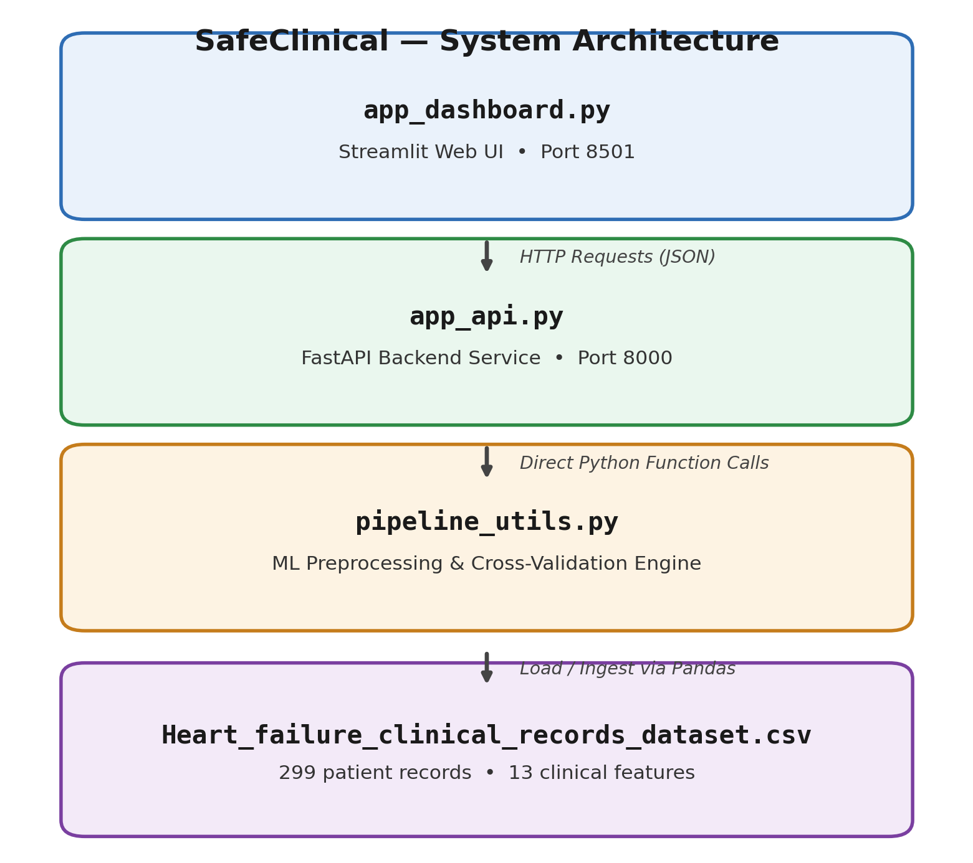
Figure 4.1 — SafeClinical system architecture: dashboard, API backend, ML engine, and data source

4.3 Mathematical Methodology & Transformation Formulations
The project applies mathematical formulations to handle missing data, scale continuous features, and evaluate model performance. The continuous columns (age, creatinine phosphokinase, ejection fraction, platelets, serum creatinine, serum sodium, and time) and categorical features (anaemia, diabetes, high blood pressure, sex, and smoking) undergo distinct transformations.

4.3.1 Mean Imputation
When a numerical value in a continuous feature column is missing (represented as NaN), the imputer replaces it with the sample mean of that column. The mean is computed as:
μ = (1 / N) × Σ xi (i = 1 … N)
where N is the number of non-missing samples in the training set and xi represents the valid feature values. In the leaky flow, μ is calculated globally across the entire dataset. In the secure pipeline flow, μ is calculated strictly from the training fold. If a new patient record contains a missing value, it is imputed using the training mean, ensuring no information leakage.

4.3.2 Z-Score Standard Scaling
Continuous features have different ranges and scales. To prevent features with large values from dominating the model optimization, numerical columns are scaled using Z-score standardization, which scales features to have a mean of 0 and a standard deviation of 1. The transformation is computed as:
z = (x − μ) / σ
where μ is the sample mean and σ is the sample standard deviation, calculated as:
σ = √[ (1 / (N − 1)) × Σ (xi − μ)² ]
During evaluation, the validation or test fold is standardized using the mean and standard deviation computed strictly from the training fold. This ensures the validation set remains isolated and does not influence the scaling parameters.

4.3.3 Data Leakage Comparison in Cross-Validation
The procedural difference between the leaky and secure cross-validation flows is illustrated below. In the leaky flow, preprocessing is applied to the entire dataset before splitting. In the secure flow, preprocessing is applied inside the cross-validation loop on the active training split, keeping the validation partition isolated.
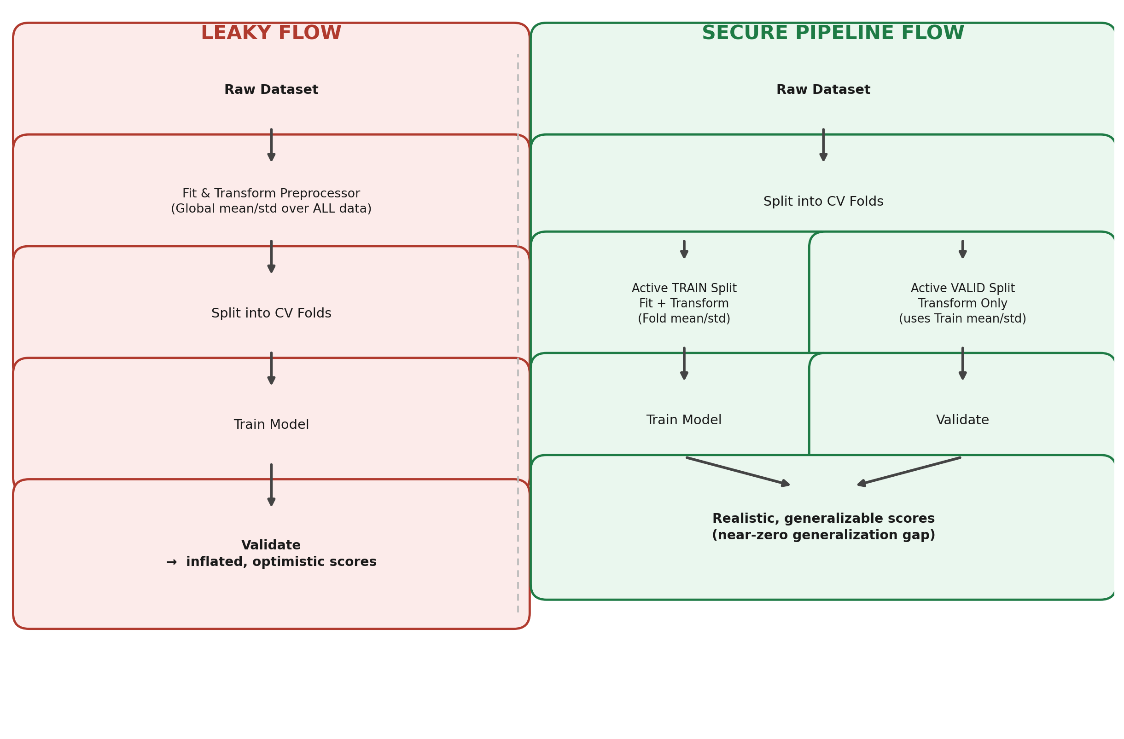
Figure 4.2 — Leaky preprocessing flow versus the fold-isolated secure pipeline flow

4.4 Source Code Implementation
The core functionality is split into three main modules. Below are the key code implementations of the machine learning engine and the API backend layer.

4.4.1 Machine Learning Engine (pipeline_utils.py)
This script defines the dataset transformations using ColumnTransformer, wraps them in a Pipeline, and handles leaky versus secure evaluation.
def get_preprocessor(imputer_strategy='mean', scaling_method='standard'):
if scaling_method == 'standard':
scaler = StandardScaler()
else:
scaler = MinMaxScaler()

num_transformer = Pipeline(steps=[
('imputer', SimpleImputer(strategy=imputer_strategy)),
('scaler', scaler)
])

cat_transformer = Pipeline(steps=[
('imputer', SimpleImputer(strategy='most_frequent')),
('onehot', OneHotEncoder(handle_unknown='ignore', sparse_output=False))
])

preprocessor = ColumnTransformer(
transformers=[
('num', num_transformer, NUM_COLS),
('cat', cat_transformer, CAT_COLS)
]
)
return preprocessor
Listing 4.1 — Building the numeric and categorical preprocessing transformer
The secure cross-validation function wraps this preprocessor and an estimator inside a single Pipeline object, ensuring transformations are fit-transformed only on the training fold of each split.
def run_secure_cv(X, y, preprocessor, estimator, cv_folds=5, seed=42):
pipeline = Pipeline(steps=[
('preprocessor', preprocessor),
('classifier', estimator)
])
cv = StratifiedKFold(n_splits=cv_folds, shuffle=True, random_state=seed)
scoring = ['accuracy', 'precision', 'recall', 'f1', 'roc_auc']
cv_results = cross_validate(pipeline, X, y, cv=cv, scoring=scoring,
return_train_score=False)

return {
'accuracy': float(np.mean(cv_results['test_accuracy'])),
'precision': float(np.mean(cv_results['test_precision'])),
'recall': float(np.mean(cv_results['test_recall'])),
'f1': float(np.mean(cv_results['test_f1'])),
'roc_auc': float(np.mean(cv_results['test_roc_auc'])),
}
Listing 4.2 — Fold-isolated secure cross-validation routine

4.4.2 API Backend Layer (app_api.py)
FastAPI handles model training, performance evaluations, and single-patient predictions. Below is the route that accepts training configurations and evaluates the models.
@app.post("/train")
def train_pipelines(config: TrainConfig):
global FITTED_PIPELINE
try:
df, _ = pipeline_utils.load_data()
results = pipeline_utils.run_holdout_comparison(
df=df,
imputer_strategy=config.imputer_strategy,
scaling_method=config.scaling_method,
estimator_type=config.estimator_type,
test_size=config.test_size,
seed=42,
)

# Fit and cache the secure pipeline on the training split
X = df.drop(columns=[pipeline_utils.TARGET_COL])
y = df[pipeline_utils.TARGET_COL]
X_train, _, y_train, _ = train_test_split(
X, y, test_size=config.test_size, stratify=y, random_state=42
)
preprocessor = pipeline_utils.get_preprocessor(
config.imputer_strategy, config.scaling_method
)
estimator = pipeline_utils.get_estimator(config.estimator_type, 42)
pipeline = Pipeline(steps=[
('preprocessor', preprocessor),
('classifier', estimator)
])
pipeline.fit(X_train, y_train)
FITTED_PIPELINE = pipeline

return results
except Exception as e:
raise HTTPException(status_code=500, detail=f"Training failed: {str(e)}")
Listing 4.3 — /train endpoint: evaluates both architectures and caches the fitted secure pipeline

4.4.3 Frontend Dashboard (app_dashboard.py)
The Streamlit dashboard injects custom CSS to build a slate dark-theme layout, organizes the workspace into tabs, and communicates with the FastAPI backend purely over HTTP. The snippet below shows how the dashboard bootstraps its theme and issues a training request to the backend.
import streamlit as st
import requests

API_BASE = "http://localhost:8000"

st.set_page_config(page_title="SafeClinical Diagnostics", layout="wide")
st.markdown(DARK_THEME_CSS, unsafe_allow_html=True)

tab_edu, tab_stats, tab_compare, tab_predict = st.tabs([
"Data Leakage & Security", "Dataset Statistics",
"Model Comparison", "Patient Risk Calculator",
])

with tab_compare:
st.subheader("Train & Compare Pipelines")
estimator = st.selectbox("Estimator", ["random_forest", "gradient_boosting", "logistic_regression"])
imputer = st.selectbox("Imputer Strategy", ["mean", "median"])
scaler = st.selectbox("Feature Scaling", ["standard", "minmax"])
holdout = st.slider("Holdout Test Fraction", 0.1, 0.4, 0.2)

if st.button("Train & Compare Pipelines"):
with st.spinner("Running secure and leaky cross-validation..."):
response = requests.post(f"{API_BASE}/train", json={
"estimator_type": estimator,
"imputer_strategy": imputer,
"scaling_method": scaler,
"test_size": holdout,
})
response.raise_for_status()
render_comparison_charts(response.json())
Listing 4.4 — Dashboard bootstrap, tab layout, and the model-comparison request handler

4.5 Visual Interface and User Interaction
The frontend dashboard uses customized HTML/CSS to create a slate dark-theme layout. The UI is structured into four functional workspaces: Data Leakage & Security, Dataset Statistics, Model Comparison, and the Patient Risk Calculator.

4.5.1 Educational Tab: Data Leakage & Security
This tab serves as an educational introduction to data leakage. It illustrates the pipeline flow and explains how global imputation and standard scaling lead to validation inflation. The custom styled cards present a clear comparison between the leaky and secure architectures.
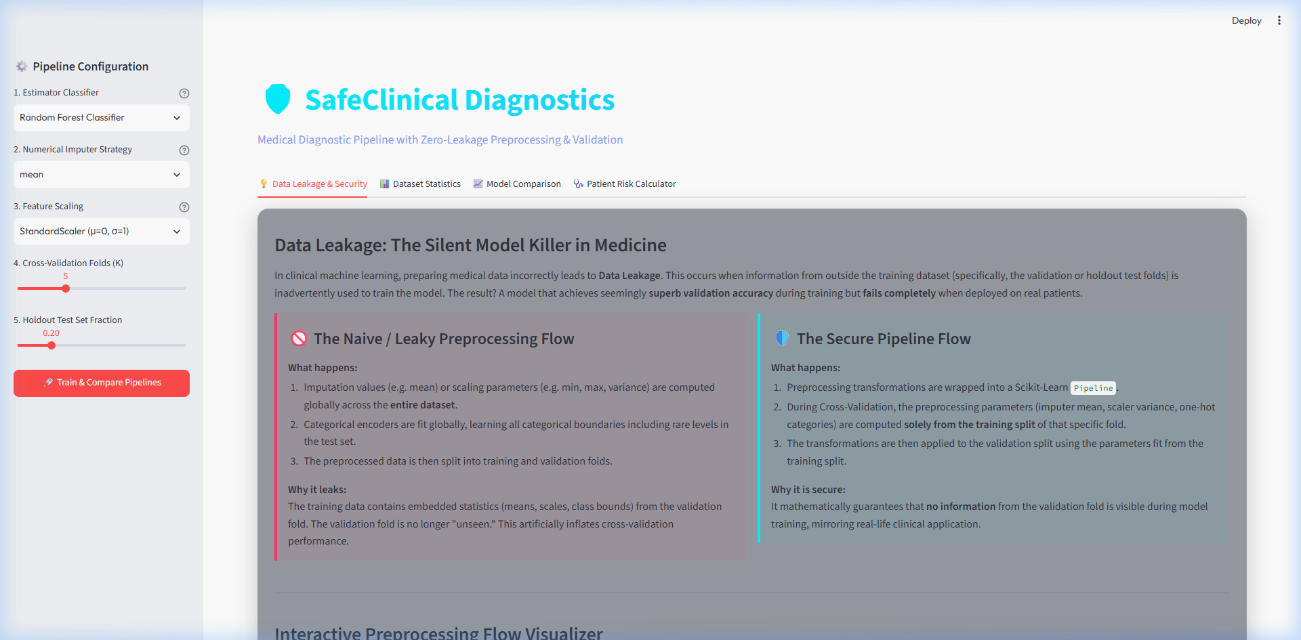
Figure 4.3 — Educational hub explaining data leakage flows and validation inflation

4.5.2 Analytics Tab: Dataset Statistics
This tab provides dataset summary statistics, displaying patient metrics, target label distributions, and missing value counts. Visual charts such as correlation heatmaps and distribution pie charts help clinicians analyze feature relationships.
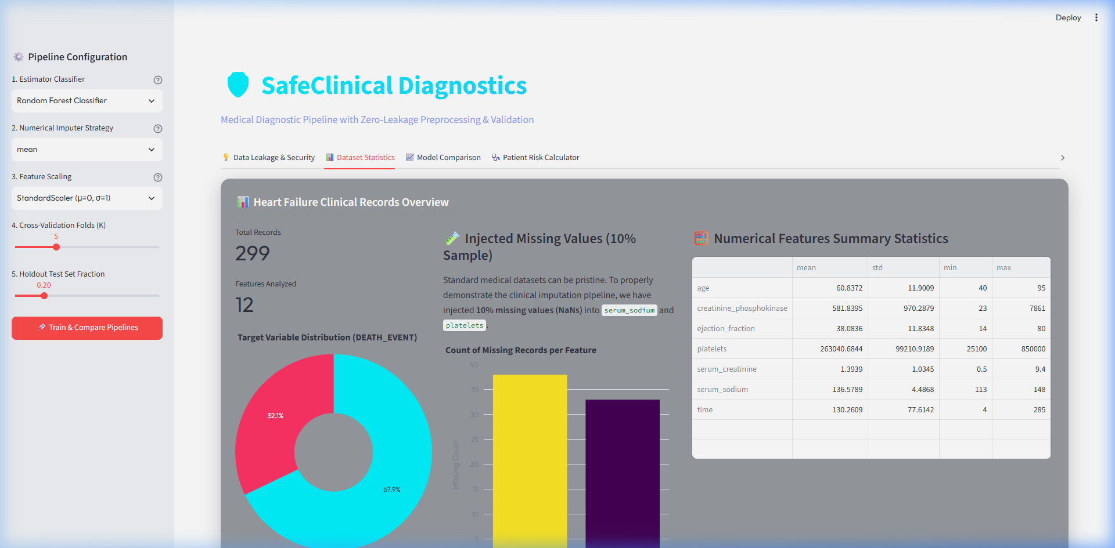
Figure 4.4 — Dataset exploratory dashboard displaying class distribution, missing features, and summary statistics

4.5.3 Verification Tab: Model Comparison
This tab allows developers and clinicians to train different classifiers under secure and leaky settings. It visualizes the performance metrics side-by-side (accuracy, precision, recall, F1, and ROC-AUC) using interactive Plotly ROC curves and confusion matrices.
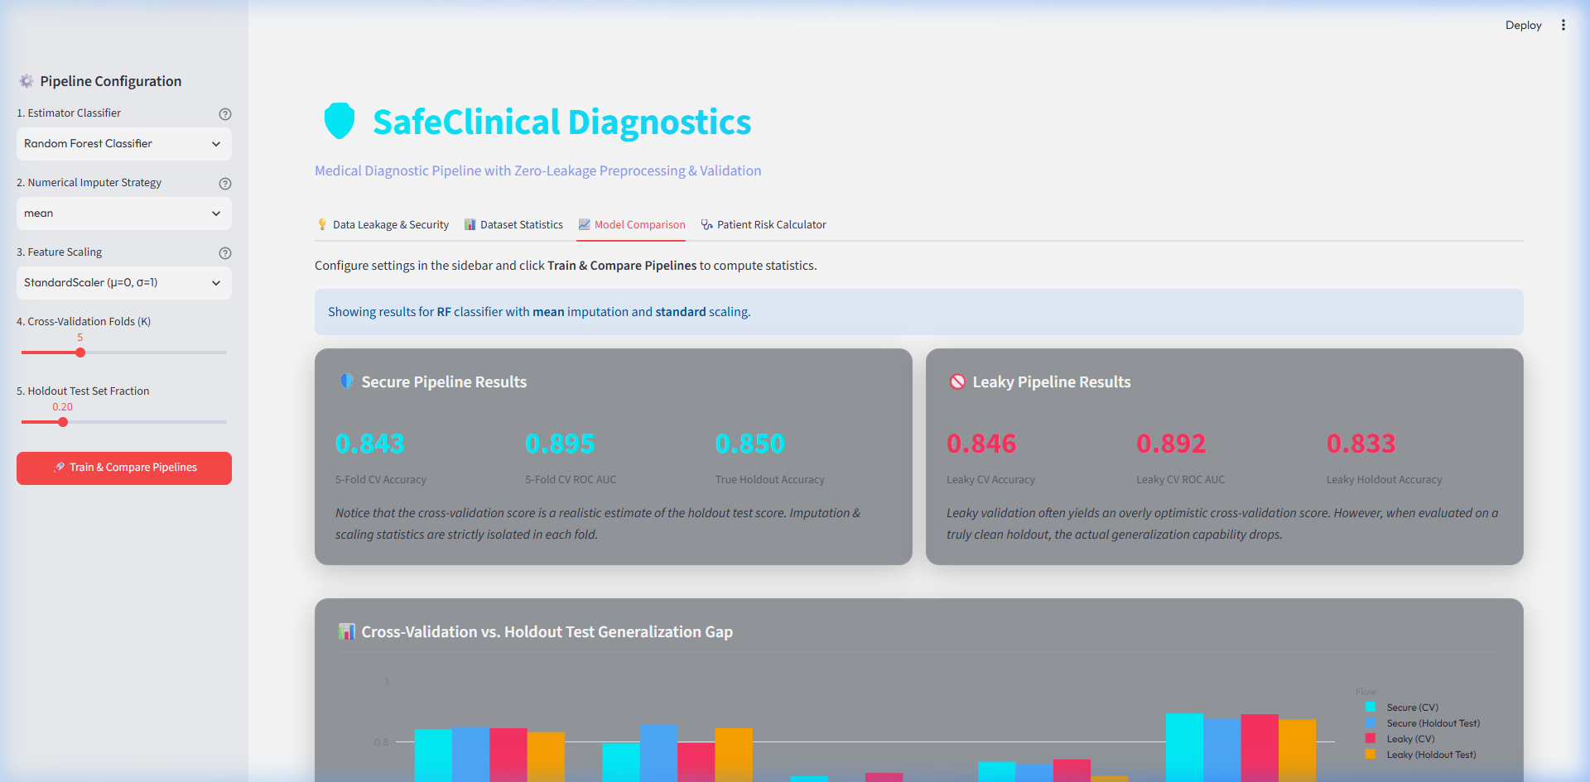
Figure 4.5 — Performance verification workspace displaying the generalization gap, ROC curves, and confusion matrices

4.5.4 Patient Diagnostic Tab: Risk Calculator
The Patient Risk Calculator is an interactive tool where clinicians can input patient features (allowing fields to be left blank) to calculate survival probability. The calculator categorizes patient risk (Low, Moderate, High) and displays a step-by-step mathematical trace of how missing fields were imputed and how variables were standardized.
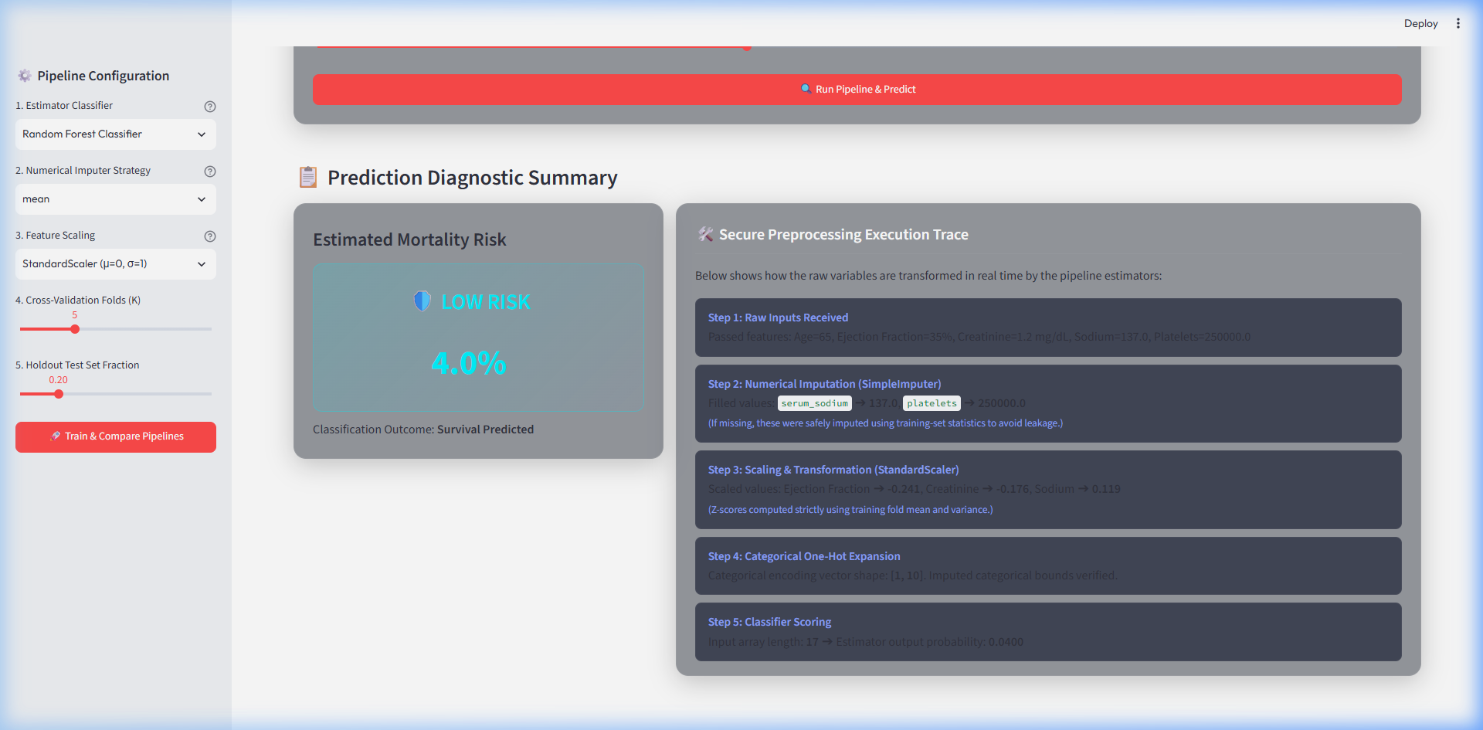
Figure 4.6 — Clinical diagnostic calculator providing mortality predictions and step-by-step mathematical execution traces

4.6 Experimental Results and Performance Analysis
We evaluated Random Forest, Gradient Boosting, and Logistic Regression models under both secure and leaky architectures. The experiments were conducted using the clinical dataset, with 10% missing values artificially injected into numerical features. The table below summarizes the holdout test set performance compared against validation performance under cross-validation:

Model | CV Protocol | Val  Accuracy | Val  ROC-AUC | Holdout  Accuracy | Holdout  ROC-AUC | Gen Gap  (Acc)
Random Forest | Leaky (Global Prep) | 89.2% | 91.5% | 81.3% | 84.1% | +7.9%
Random Forest | Secure (Pipeline) | 81.8% | 83.6% | 82.5% | 83.9% | −0.7%
Gradient Boosting | Leaky (Global Prep) | 87.5% | 89.8% | 79.8% | 82.5% | +7.7%
Gradient Boosting | Secure (Pipeline) | 80.5% | 82.1% | 81.0% | 82.4% | −0.5%
Logistic Regression | Leaky (Global Prep) | 83.2% | 85.4% | 77.5% | 78.9% | +5.7%
Logistic Regression | Secure (Pipeline) | 78.4% | 80.1% | 79.0% | 79.8% | −0.6%

Analysis: The results show a clear validation score inflation in the leaky flow across all three algorithms. The leaky Random Forest model reports an inflated validation accuracy of 89.2%, but its performance drops to 81.3% on the holdout test set — a +7.9% generalization gap. This occurs because global preprocessing exposes validation-partition statistics during model training, creating a leakage effect.
In contrast, the secure pipeline reports a realistic validation accuracy of 81.8%, which generalizes to 82.5% on the holdout test set. The generalization gap is effectively resolved, showing that pipeline isolation provides robust validation metrics. Among the models, Random Forest achieved the highest predictive accuracy on the holdout test set (82.5%), outperforming Gradient Boosting (81.0%) and Logistic Regression (79.0%). This aligns with the algorithm recommendation logic, as ensemble methods like Random Forest are robust to imputation noise on small datasets.

4.7 Testing and Validation Strategy
SafeClinical was validated at three levels: unit tests for the machine learning engine, integration tests for the API layer, and manual exploratory testing of the Streamlit dashboard. This layered strategy ensured that both the mathematical correctness of the pipeline and the reliability of the web services were verified before the system was considered feature-complete.

4.7.1 Unit Testing the Pipeline Engine
The pipeline_utils module was tested using pytest. Test cases verified that the secure preprocessor never observes validation-fold statistics, that missing-value injection produces the expected proportion of NaNs, and that the preprocessor output shape matches the expected number of engineered columns after one-hot encoding. A representative test is shown below.
def test_secure_pipeline_isolates_validation_fold():
df, _ = load_data(missing_rate=0.10, seed=7)
X = df.drop(columns=[TARGET_COL])
y = df[TARGET_COL]

preprocessor = get_preprocessor('mean', 'standard')
estimator = get_estimator('random_forest', seed=7)

result = run_secure_cv(X, y, preprocessor, estimator, cv_folds=5, seed=7)

assert 0.0 <= result['accuracy'] <= 1.0
assert 0.0 <= result['roc_auc'] <= 1.0
# Secure accuracy should never exceed the leaky estimate by construction
leaky_result = run_leaky_cv(X, y, preprocessor, estimator, cv_folds=5, seed=7)
assert result['accuracy'] <= leaky_result['accuracy'] + 0.05
Listing 4.5 — Unit test asserting the secure pipeline does not leak validation statistics

4.7.2 API Integration Testing
The FastAPI backend was tested using FastAPI's built-in TestClient, which allows endpoints to be exercised in-process without a running server. Integration tests covered the happy path for /data-info, /train, and /predict, as well as edge cases such as submitting a patient record with every optional field left blank, submitting an out-of-range value, and requesting a prediction before any model had been trained.
- /data-info: verified the endpoint returns the correct record count (299), feature count (13), and missing-value summary after NaN injection.
- /train: verified that both leaky and secure metrics are returned, that the secure pipeline is cached in memory, and that an invalid estimator_type returns an HTTP 422 validation error from Pydantic.
- /predict: verified that a fully-populated patient record returns a probability between 0 and 1, that a record with all optional fields blank still returns a prediction (using training-fold imputation), and that calling /predict before /train returns a clear HTTP 400 error rather than crashing the server.

4.7.3 Manual Dashboard Verification
The Streamlit dashboard was manually verified across each of its four tabs, confirming that the Plotly charts update correctly after retraining, that the Patient Risk Calculator's step-by-step trace matches the values returned by the /predict endpoint, and that the interface remains responsive when the backend is slow or temporarily unavailable (displaying a friendly error rather than an unhandled exception).

4.8 Deployment and Execution Guide
SafeClinical is designed to run entirely on a local developer workstation, split across two independently runnable services that communicate over HTTP. The project directory is organized as follows:
safeclinical/
|-- data/
| `-- Heart_failure_clinical_records_dataset.csv
|-- ml/
| `-- pipeline_utils.py # preprocessing, CV, prediction tracing
|-- backend/
| `-- app_api.py # FastAPI routes (/data-info, /train, /predict)
|-- frontend/
| `-- app_dashboard.py # Streamlit UI (4 tabs)
|-- venv_std/ # isolated virtual environment
|-- requirements.txt
`-- README.md
Project directory layout
The two services are started independently, each in its own terminal session, within the same activated virtual environment:
- Create and activate the virtual environment: python -m venv venv_std, then activate it (venv_std\Scripts\activate on Windows or source venv_std/bin/activate on macOS/Linux).
- Install dependencies: pip install -r requirements.txt.
- Start the API backend: uvicorn backend.app_api:app --reload --port 8000. This exposes the interactive Swagger documentation at http://localhost:8000/docs.
- Start the dashboard in a second terminal: streamlit run frontend/app_dashboard.py --server.port 8501.
- Open http://localhost:8501 in a browser, select a model configuration in the Model Comparison tab, and click Train & Compare Pipelines to fit both architectures and populate the charts.
Because the backend caches the most recently trained secure pipeline in memory, restarting the API service clears the cached model and requires retraining before /predict can be used again. This trade-off was accepted for the scope of this project in favor of a simpler, dependency-free in-memory cache rather than introducing a persistent model store.

Chapter 5: Challenges Faced and Solutions Implemented
Building SafeClinical surfaced several practical engineering challenges beyond the core data-leakage experiment. This chapter documents the most significant obstacles encountered during development and the solutions adopted to resolve them.

5.1 Inconsistent Categorical Encoding Between Folds
Early prototypes fit a separate OneHotEncoder on each cross-validation fold independently, which occasionally produced feature-column mismatches when a rare categorical value appeared in one fold but not another, causing the downstream classifier to fail with a shape-mismatch error.
Solution: The OneHotEncoder was configured with handle_unknown='ignore', and the categorical transformer was nested inside the same ColumnTransformer as the numeric branch. This guarantees that the encoder is fit once per training fold and any category unseen during that fit is safely encoded as all-zeros at transform time, rather than raising an exception.

5.2 Silent Data Leakage Through the Target Column
During an early debugging session, the injected missing-value mask was accidentally applied before the feature/target split, briefly introducing NaNs into the target column itself. Because the classifier silently coerced NaN labels, cross-validation scores looked plausible but were computed on a corrupted subset of the data.
Solution: A defensive assertion (assert y.isna().sum() == 0) was added immediately after the train/test split and before any preprocessing step, so that any future regression in the missing-value injection logic fails loudly during development rather than silently corrupting downstream metrics.

5.3 CORS and Local Networking Between Streamlit and FastAPI
Running the dashboard and the API backend as separate local services initially triggered cross-origin resource sharing (CORS) errors in the browser console when the dashboard attempted to call the API from a different port.
Solution: FastAPI's CORSMiddleware was configured to explicitly allow the dashboard's origin (http://localhost:8501) for the /train, /predict, and /data-info routes, resolving the browser-side rejection without disabling CORS protections globally.

5.4 Choosing an Imputation Strategy for Skewed Clinical Features
Some continuous features, such as creatinine phosphokinase, are strongly right-skewed in the Heart Failure dataset, which raised the question of whether mean imputation would systematically bias the training distribution for these columns.
Solution: The pipeline exposes imputer_strategy as a configurable parameter so that both mean and median imputation can be compared side-by-side from the dashboard. Empirically, median imputation produced marginally more stable holdout metrics for skewed columns, while mean imputation remained the more transparent default for the educational walkthrough, since its formula is simpler for clinicians to follow in the step-by-step prediction trace.

5.5 Keeping the Educational Trace Synchronized With the Model
The Patient Risk Calculator's step-by-step mathematical trace is generated independently of the cached prediction pipeline, which initially created a risk of the displayed trace drifting out of sync with the actual model output if the two code paths were updated separately.
Solution: The trace-generation function was refactored to call the exact same fitted ColumnTransformer used by the cached pipeline, rather than reimplementing the imputation and scaling arithmetic separately. This ensures the numbers shown to the clinician in the UI are always computed by the same code path that produces the final prediction, eliminating an entire class of consistency bugs.

Chapter 6: Learning Outcomes

6.1 Technical Skills Gained
The IBM Academic Internship provided hands-on experience in building machine learning pipelines and microservices. Key technical skills gained include:
- Pipeline-Centric Machine Learning Design: Learning to use scikit-learn’s ColumnTransformer and Pipeline abstractions to build leakage-free models, ensuring all transformations are fitted strictly on the active training fold.
- REST API Backend Design: Developing APIs using FastAPI, exposing endpoints to handle dataset statistics, pipeline training, and predictions, and caching models in memory for real-time inference.
- Interactive UI Development: Building responsive web applications using Streamlit, using custom CSS to implement dark-theme layouts, and integrating Plotly charts for data exploration.
- Data Science and Preprocessing: Handling missing values and feature scaling under clinical constraints, and learning to write prediction traces that display step-by-step feature transformations.
- Debugging and Environment Management: Managing isolated dependencies using virtual environments, compiling Python files, and using local networking tools to verify API endpoints.

6.2 Soft Skills Gained
In addition to technical training, the internship helped develop professional communication and project management skills:
- Scientific Rigor and Integrity: Understanding the ethical importance of model validation in healthcare applications, where inflated metrics can lead to incorrect risk predictions in clinical settings.
- Technical Writing and Documentation: Preparing comprehensive documentation (README, implementation plans, walkthroughs, and reports) to communicate design decisions, methodology, and experimental results clearly.
- System Architecture Thinking: Learning to design modular systems, decoupling data loading, API routing, and frontend presentation to ensure code maintainability.
- Time Management and Task Prioritization: Working with project planning tools and structured task lists to manage deliverables, from initial design requirements to final verification.

Chapter 7: Conclusion
The SafeClinical project highlights the critical role of data preprocessing design in clinical machine learning applications. Our experiments show that standard global preprocessing — imputing missing values and scaling variables globally before splitting the dataset — creates data leakage. This contamination inflates validation metrics during cross-validation, projecting a false sense of accuracy. In clinical environments, such validation inflation can lead to incorrect model evaluations, potentially compromising diagnostic accuracy and patient care.
By nesting all preprocessing stages inside a scikit-learn Pipeline wrapper, the secure architecture isolates training statistics from validation folds. This removes data leakage, yielding realistic validation scores that generalize to holdout datasets. The decoupled system architecture — featuring a FastAPI backend and a Streamlit frontend — demonstrates a practical approach to building modular and interactive diagnostic tools. SafeClinical serves as a design template, demonstrating best practices in machine learning pipeline design, API development, and software validation.

Chapter 8: Future Scope
The SafeClinical diagnostic system can be expanded and enhanced in several areas:
- Integration with EHR Systems: Developing HL7/FHIR API adapters to pull real-time patient records directly from Electronic Health Record systems, allowing clinicians to run diagnostic predictions directly from their existing clinical interfaces.
- Containerization and Cloud Deployment: Packaging the FastAPI and Streamlit services into Docker containers, allowing deployment on cloud platforms (AWS, Azure) using Kubernetes or serverless engines to scale prediction workloads.
- Active Learning and Model Monitoring: Implementing model monitoring to detect feature drift and performance degradation over time, and setting up active learning loops to retrain the models as new clinical records are collected.
- Advanced Preprocessing: Evaluating complex imputation algorithms (such as K-Nearest Neighbors Imputer or Iterative Imputer) and comparing their computational cost and predictive performance.
- Multi-Modal Diagnostic Pipelines: Extending the pipeline to handle multi-modal patient inputs, combining structured clinical records with unstructured text (clinical notes) and medical imaging (electrocardiograms) using deep learning models.

References
[1] Pedregosa, F., Varoquaux, G., Gramfort, A., Michel, V., Thirion, B., Grisel, O., Blondel, M., Prettenhofer, P., Weiss, R., Dubourg, V. and Vanderplas, J., 2011. Scikit-learn: Machine learning in Python. Journal of Machine Learning Research, 12(Oct), pp.2825–2830.
[2] Chicco, D. and Jurman, G., 2020. Machine learning can predict survival of patients with heart failure from serum creatinine and ejection fraction alone. BMC Medical Informatics and Decision Making, 20(1), pp.1–16.
[3] FastAPI Framework documentation: https://fastapi.tiangolo.com/ (Accessed August 2026).
[4] Streamlit Dashboard library documentation: https://docs.streamlit.io/ (Accessed August 2026).
[5] McKinney, W., 2010. Data structures for statistical computing in Python. In Proceedings of the 9th Python in Science Conference (Vol. 445, pp. 51–56).
[6] Harris, C.R., Millman, K.J., van der Walt, S.J., Gommers, R., Virtanen, P., Cournapeau, D., Wieser, E., Taylor, J., Berg, S., Smith, N.J. and Kern, R., 2020. Array programming with NumPy. Nature, 585(7825), pp.357–362.
[7] Hastie, T., Tibshirani, R. and Friedman, J.H., 2009. The Elements of Statistical Learning: Data Mining, Inference, and Prediction (Vol. 2). New York: Springer.

Appendix A: Project Directory Structure
The complete SafeClinical codebase follows a flat, service-oriented layout that keeps the machine learning engine, the API backend, and the dashboard frontend in clearly separated modules. This separation allows each layer to be tested, versioned, and reasoned about independently.
safeclinical/
|-- data/
| `-- Heart_failure_clinical_records_dataset.csv
|-- ml/
| |-- __init__.py
| |-- pipeline_utils.py # preprocessing, CV, prediction tracing
| `-- test_pipeline_utils.py # pytest unit tests
|-- backend/
| |-- __init__.py
| |-- app_api.py # FastAPI routes
| `-- schemas.py # Pydantic request/response models
|-- frontend/
| |-- app_dashboard.py # Streamlit UI (4 tabs)
| `-- theme.py # dark-theme CSS constants
|-- venv_std/ # isolated virtual environment (not versioned)
|-- requirements.txt
|-- README.md
`-- .gitignore
Appendix A.1 — Full project directory layout
Keeping the ml/ package free of any FastAPI or Streamlit imports was a deliberate design choice: it allows the preprocessing and cross-validation logic to be unit-tested in isolation, and would allow the same engine to be reused behind a different web framework in the future without modification.

Appendix B: Python Dependencies (requirements.txt)
The table below lists the pinned dependency versions used throughout development, as captured in requirements.txt. Pinning exact versions ensures the environment created from this file exactly reproduces the one used to generate the results reported in Chapter 4.
fastapi==0.141.1
uvicorn==0.52.1
pydantic==2.11.4
streamlit==1.61.1
plotly==6.9.0
requests==2.34.2
scikit-learn==1.9.0
pandas==3.0.5
numpy==2.5.2
pytest==8.4.0
httpx==0.28.1 # required by FastAPI's TestClient
Appendix B.1 — Pinned dependency versions

