|  |
| --- |
| **PUNE INSTITUTE OF COMPUTER TECHNOLOGY, PUNE - 411043** |
| **Department of Computer Engineering**  **S.No.-27, Pune Satara Road, Dhankawadi, Pune-411043** |



**Project Based Learning-II (AY 2021-22)**

**210260**

**Sem- II Batch- G2**

**Date- 12/05/2022**

Group members:

**Maitreyee Khunte (21245)**

**Kartiki Kotawar (21246)**

**Bhakti Mahurkar (21252)**

**Anushka Nalawade (21258)**

Lab Teacher Name: **Prof. Parag Jambhulkar**

Title of project

**“HOSTEL MANAGEMENT SYSTEM”**

**-CERTIFICATE-**

This is to certify that the work incorporated in the report entitled **“HOSTEL MANAGEMENT SYSTEM”** is carried out by Ms. Nalawade Anushka Shashikant(Roll No-21258), who is part of a group of students for Project under the subject ***Project Based Learning*** during A.Y. **2021-22**.

Such material has not been submitted to any other University/ Institute for any financial support. The literature related to the problem investigated has been appropriately cited and duly acknowledged wherever facilities and suggestions have been availed of.

**Date: 12/05/2022 Name & Sign of Project Guide**

**Place:** PUNE Prof. P. J. Jambhulkar

**Prof. Rutuja Kulkarni Dr. G. V. Kale**

**Name & Sign of PBL Coordinator Name & Sign of Head of Department**

**ABSTRACT**

As the name specifies “HOSTEL MANAGEMENT SYSTEM” is a software developed for managing various activities in the hostel. For the past few years, the number of educational institutions are increasing rapidly. Thereby the number of hostels are also increasing for the accommodation of the students studying in this institution. And hence there is a lot of strain on the person who are running the hostel and software’s are not usually used in this context. This particular project deals with the problems on managing a hostel and avoids the problems which occur when carried manually.

Identification of the drawbacks of the existing system leads to the designing of computerized system that will be compatible to the existing system with the system which is more user friendly and more GUI oriented. We can improve the efficiency of the system, thus overcome the drawbacks of the existing system.

* Less human error
* Strength and strain of manual labour can be reduced
* High security
* Data redundancy can be avoided to some extent
* Data consistency
* Easy to handle
* Easy data updating
* Easy record keeping
* Back up data can be easily generated

**ACKNOWLEDGEMENT**

I would like to express my special thanks of gratitude to my teacher Prof. Parag Jambhulkar and our principal Dr. R. Sreemathy who gave me the golden opportunity to do this project named “HOSTEL MANAGEMENT SYSTEM” . It helped me in doing a lot of Research and I came to know about a lot of things related to this topic.

Finally, I would also like to thank my parents and friends who helped me a lot in finalizing this project within the limited time frame.

Place: Pune Name of Student (In capital) & Sign

ANUSHKA SHASHIKANT NALAWADE

**TABLE OF CONTENT**

|  |  |  |
| --- | --- | --- |
| **Chapter No.** | **Title** | **Page no.** |
| **1.** | **INTRODUCTION** | **6** |
| **2.** | **DESCRIPTION** | **10** |
| **3.** | **FLOWCHART, USE CASE DIAGRAM AND ARCHITECTURAL DIAGRAM** | **14** |
| **4.** | **IMPLEMENTATION DETAILS** | **17** |
| **5.** | **CONCLUSION** | **22** |
| **6.** | **REFERENCES** | **23** |

**Chapter 1**

**INTRODUCTION**

We have got two hostels in our institute, which consist of one boy’s hostel and one girl’s hostel. All these hostels at present are managed manually by the hostel office. The Registration form verification to the different data processing is done manually.

Thus, there are a lot of repetitions which can be easily avoided. And hence there is a lot of strain on the person who are running the hostel and software’s are not usually used in this context. This particular project deals with the problems on managing a hostel and avoids the problems which occur when carried manually.

Identification of the drawbacks of the existing system leads to the designing of computerized system that will be compatible to the existing system with the system which is more user friendly and more GUI oriented. We can improve the efficiency of the system, thus overcome the drawbacks of the existing system.

**1.1 Motivation**

As students, we can very well understand the problems which we face in our daily life. To have a paper-less hostel management system for maintaining the student details is the need of the hour for faster and convenient data management.

Analyst can examine alternative methods to implement the system and their resource needs. A cost-benefit analysis should be carried out for each alternative and given to the management. An efficient Hostel management system will provide a systematic control over hostel activities. Verifies the students’ applications and creates a merit list on the basis of pre-defined hostel room allocation rules and helps the staff to allocate rooms & wings. Thus, provides systematic control over hostel processes.

Also, provides an accurate student data management. Creates a centralized database of student information including their personal information such as name, address, guardian's mobile number, etc. The information can be accessed by the hostel warden or any other authority at any given point in time.

Another advantage of hostel management system is complete student security. Keeps tab on visitors’ in-and-out time, name & other details of their visitors, thus induces a disciplined life & ensures transparency & complete student security in the hostel campus.

**1.2 Objectives**

In current scenario all the details related to people living in hostels are managed by humans manually and by the help of pen and paper. Everything is so complex because it is not easy to handle all the information of the various people living in a hostel by the help of registers.

* Maintain the students as hostellers and waiting list students separately
* Student will no longer apply for their hostels manually
* The warden can see and access the student’s data
* Process allotment list
* Admin can send the approval notification to every approved student via email
* Insert student’s details to the hosteller’s record when the allotment is confirmed by the admin deleted when vacation is confirmed or after the course end date
* Admin can edit notice board and each student can view it.

**1.3 Scope of the project**

The following depicts the features of Hostel Management System:

* Online admission, the software entirely automates the student registration process. With the hostel management software login portal, students from any geographical region can apply to avail hostel facilities online.
* Room Allocation, the staff can define room allocation rules and allot the vacant rooms to students depending on their requirements in real-time. The student hostel management software also enables the wardens to transfer students’ rooms in case of any discrepancy.
* Visitor Management records, the hostel management software for higher education institutions manages the records of visitors by keeping a track of their intent or purpose to visit the hostel, their relation with the student and thus, ensures only authorized people get entry into the hostel premises.
* Hostel reports, the hostel staff and authorities can generate reports like room wise list of students, vacant room report, students’ complete information.

**1.4 Intended Audience**

The students face a lot of problems while they are staying in their hostels. Thus, we want to automate the entire hostel management so that they can enjoy staying at hostels. The management system is mainly built for the wardens who can keep track of every student’s information and room details without any paper work.

**Chapter 2**

**DESCRIPTION**

The product will run as a website wherein when the concerned person will be presented the home page of the website. The user will be asked to login with the valid credentials provided by the concerned authorities. We have separate logins for students and for the management team members.

Firstly, the when a student logs in into the website, he/she will be provided with various functionalities like completing their registration by filling in their details, they can view their profile as and when required. Also, the student will be provided with asset of rules and regulations for residing in a hostel, the student can also raise an issue regarding any non-functional resources or any type of problems.

The students can also apply for an out pass specifying the reason of their absence and much more.

Secondly, the wardens can login using the same page and will be directed to the homepage. The wardens have the authority to make changes in the student details and add a new entry or delete an existing one.

We have also provided a visitor section wherein the visitor has to specify its details and the reason for the visit. This ensures every student’s safety. The user can log out of the system whenever necessary.

**2.1 Functional Requirements**

* Administrator Module:

The administrator can edit the details of the students and modify the student records conveniently. Also, the administrator can allot different students to different rooms and also keep a track of any visitors to the hostel thus ensuring student safety.

* User Module:

It allows the different users to access the registration forms and view their profiles. The user can also raise any complaint or issue concerning him/her and also view the rules and regulations of the hostel. The user may apply for an out pass which specifies the reason in detail and the period of absence.

* Hostel Module:

As the student’s course is over, they will vacate their rooms. So, it is required for the administrator to remove their records from the database tables. This section includes the option for the room vacation and deletion of the particular record from the database.

* Registration Module:

This section provides a form to the students which can be filled by them and viewed later the view profile menu. This is submitted to the Hostel authorities can be verified by them before allotting them to the respective hostel rooms.

* Visitor Module:

This section provides a facility to the management team to keep a track of the visitors to the hostel. It includes filling a form that accepts the visitor’s mobile number, relation with the student, reason for visit, and much more.

**2.2 Non-functional Requirements**

* Performance Requirements:

Some performance requirements identified is listed below:

* The database shall be able to accommodate a thousand record to store.
* The software shall support use of multiple users at a time.
* There are no other specific performance requirements that will affect development.
* Safety Requirements:

The database may get crashed at any certain time due to virus or operating system failure. Therefore, it is required to take the database backup.

* Security Requirements:

Some of the factors that are identified to protect the software from accidental or malicious access, use, modification, destruction, or disclosure are described below.

* Keep specific log or history data sets.
* Assign certain functions to different modules.
* Restrict communications between some areas of the program.
* Check data integrity for critical variables.
* Later version of the software will incorporate encryption techniques in the user/license authentication process.

**2.3 Operating Environment**

* Hardware Configuration:

1. Intel® Pentium® Gold Processor 7505
2. Intel® UHD Graphics
3. 8 GB, 1 x 8 GB, DDR4, 2666 MHz
4. 256 GB, M.2, PCIe NVMe, SSD
5. 39.6-cm. display (1920X1080)

* Software Configuration:

1. OS: Windows
2. Frontend: HTML, CSS
3. Backend: Django
4. Database: MySQL
5. Web-browser: Chrome
6. IDE: Visual Studio Code

**Chapter 3**

**FLOWCHART**

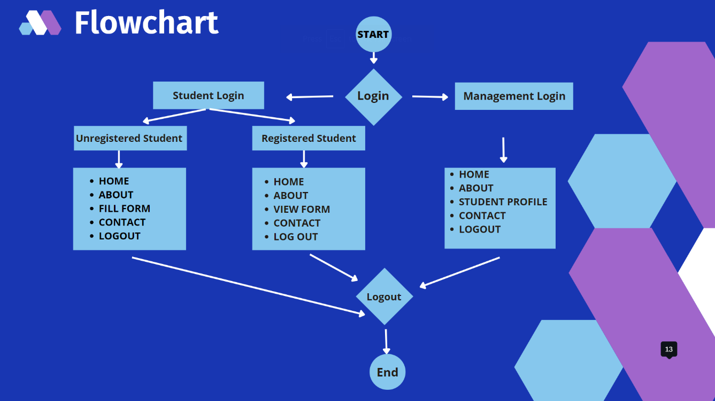

**Use case diagram**

**  
Admin**

**Registered**

**Student**



**Unregistered**

**Student**

**Architectural diagram**

DATABASE

SIGN-UP

SIGN IN

STUDENT LOGIN

ADMIN LOGIN

NOT FILLED FORM

FILLED FORM

HOME

SEARCH STUDENT DATA, RULES

OPTION OF FILLING FORM, VISITOR FORM, RULES

SEE FILLED FORM, VISITOR FORM, RULES

LOG OUT

**Chapter 4**

**IMPLEMENTATION DETAILS ALONG WITH SCREENSHOTS**

**Login Page**

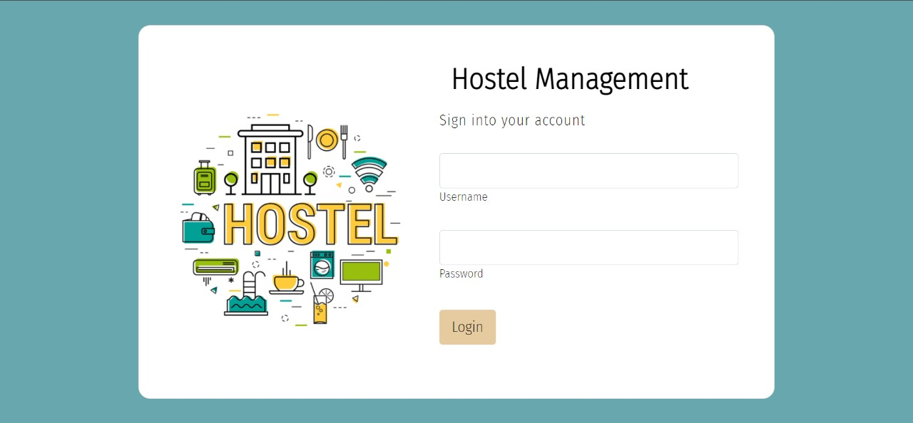

**Home Page**

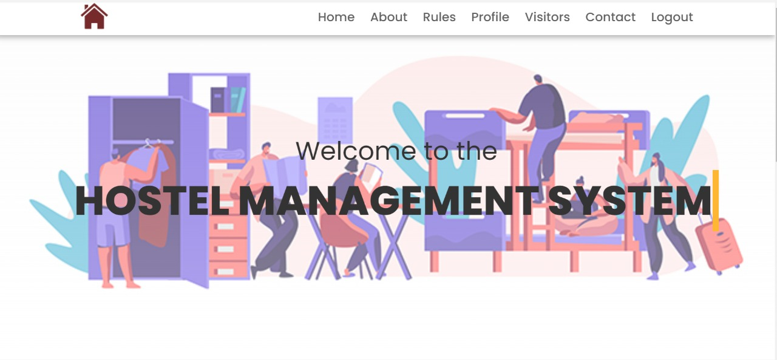

**Contact Us Page**

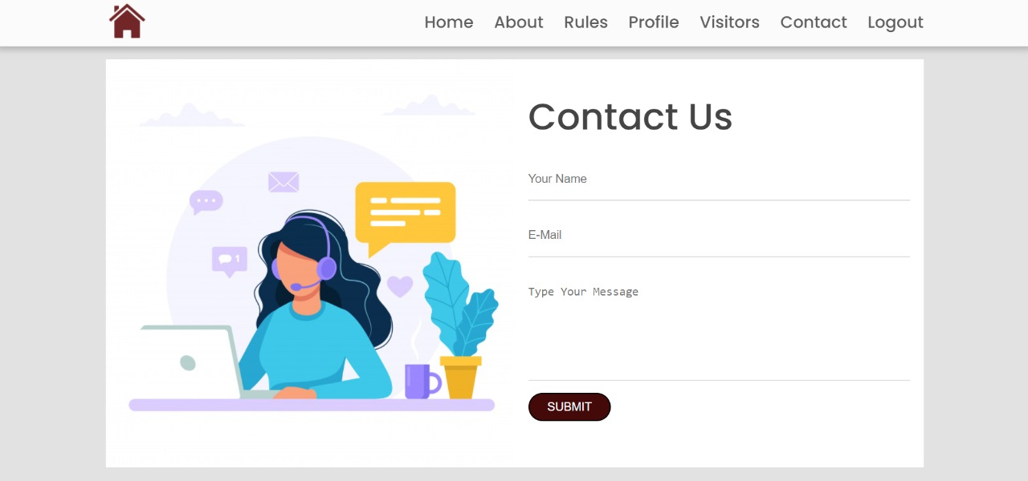

**About Us Page**

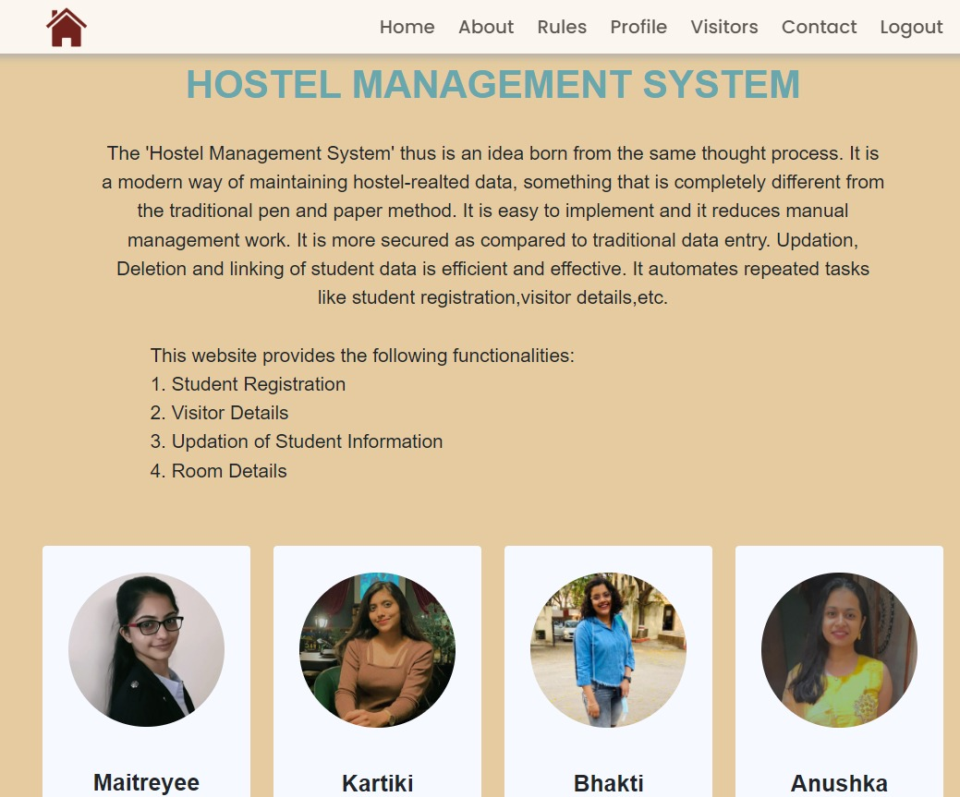

**Rulebook Page**

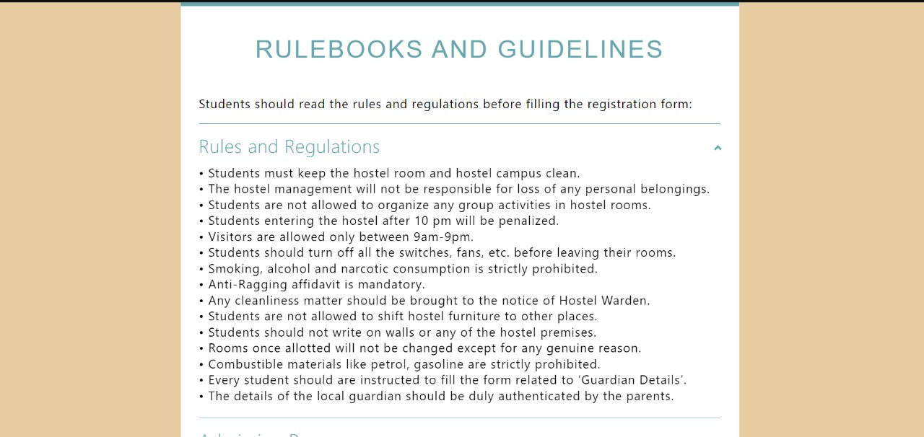

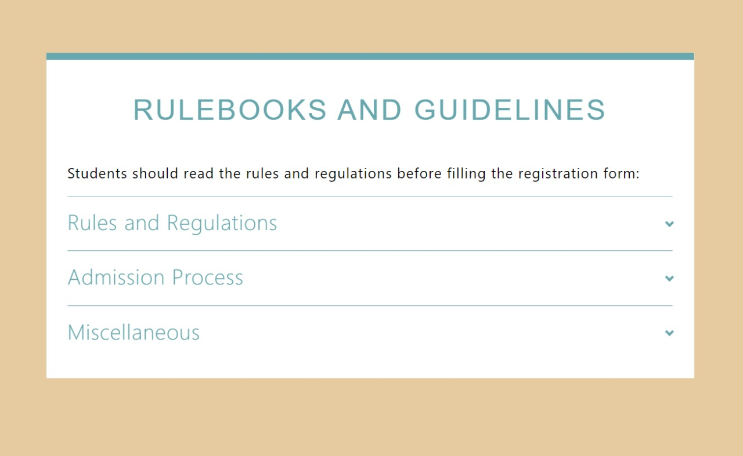

**Visitor Registration Form**

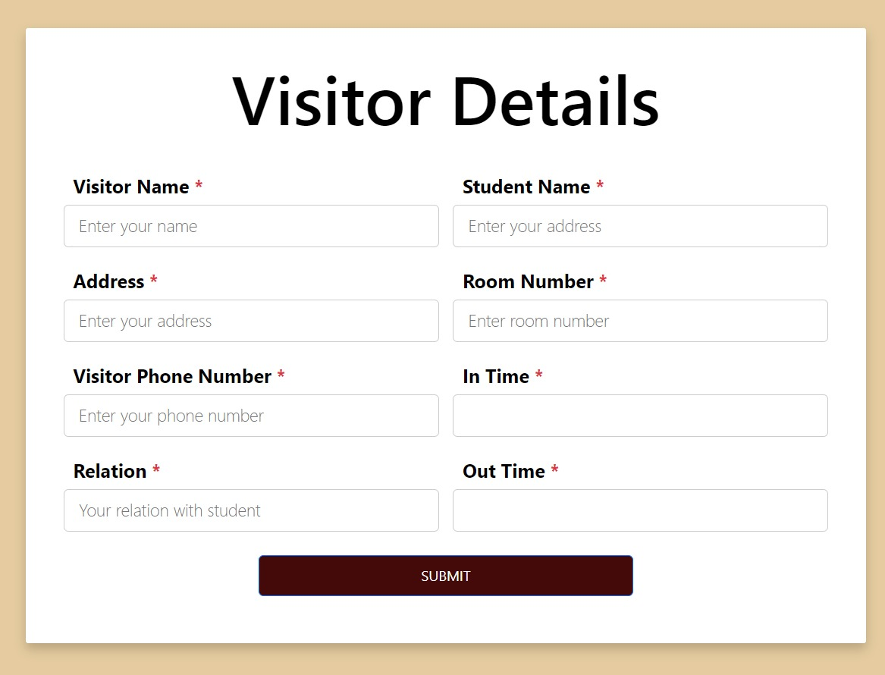

**Complain Form**

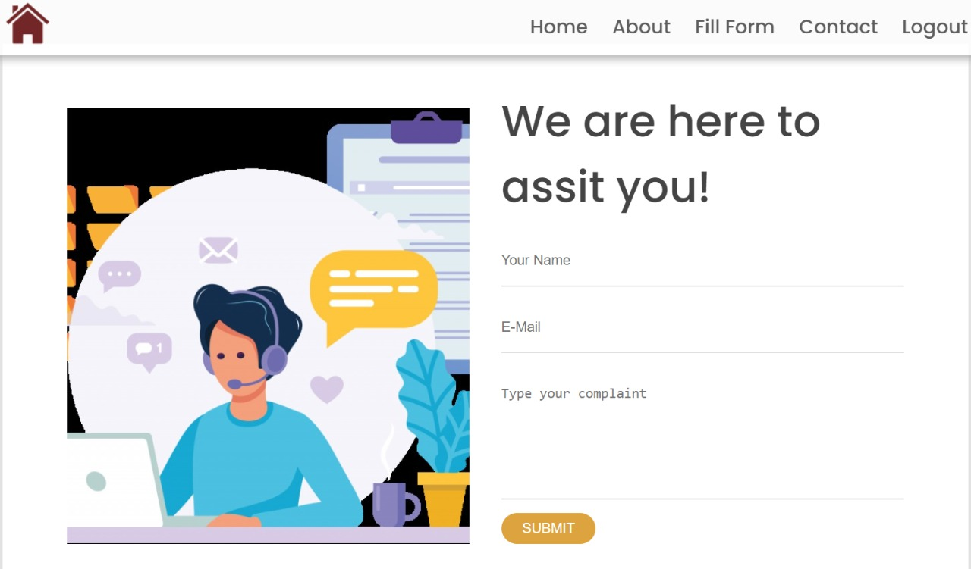

**Student Details Form**

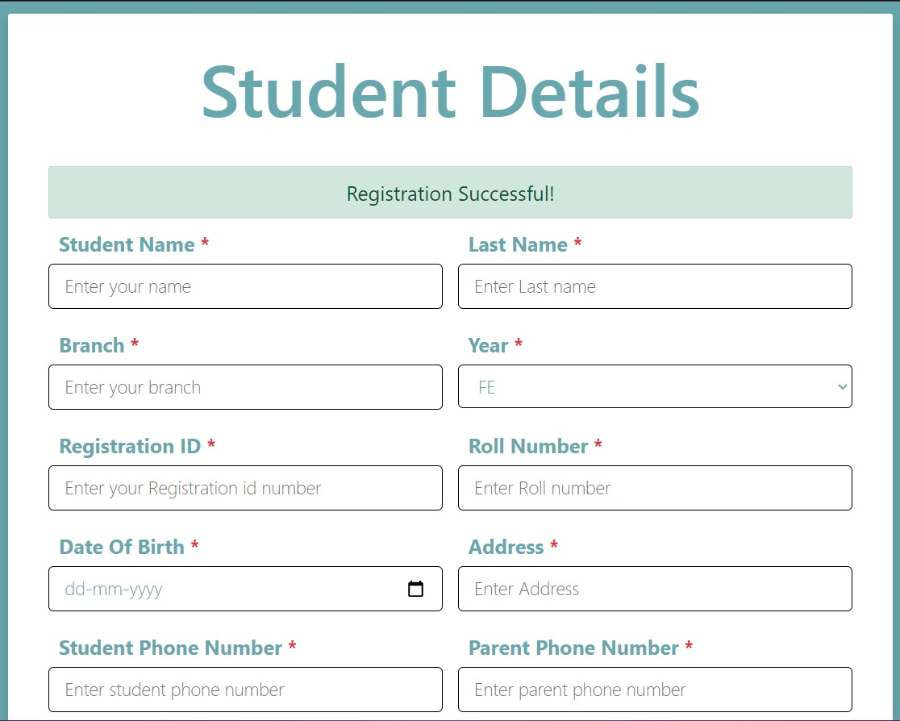

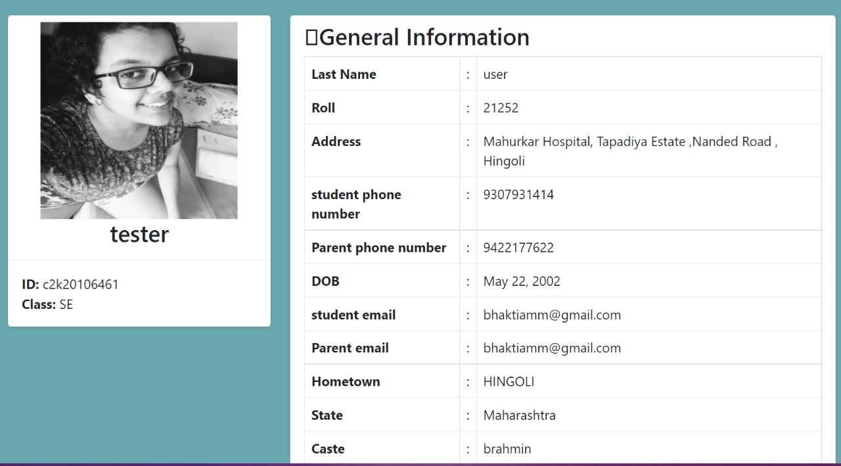

**Chapter 5**

**CONCLUSION**

Hostel Management is a user-friendly and Customization software for student Hostel. Hostel management system has been developed to manage and automate the over-all processing of any large student hostel.

Hostel management system project is capable of managing hostel rooms, student records and room allocation process etc. Hostel management system is a user-friendly and customize software for providing support for providing support for hostel admin.

**Chapter 6**

**REFERENCES**

* <https://www.academia.edu/37916010/Software_Requirements_Specification_for_Hostel_Management_System_Lab_Section_COE13_Lab_Instructor>
* [https://www.iitms.co.in/higher-education-erp/hostel-management/](%20https:/www.iitms.co.in/higher-education-erp/hostel-management/)
* <https://www.slideshare.net/farhanamusthafa/online-hostel-management-system-proposal>
* <https://www.studocu.com/row/document/university-of-peshawar/introdcution-to-computing/hostel-management-system/5921876>
* <http://www.judiciary.go.ug/files/Hostel%20system%20management(1).pdf>
* <https://123projectlab.com/33-hostel-management-system/>