|  |  |
| --- | --- |
| **Ex No:**01 | **CREATION OF PORTFOLIO WEBSITE** |
| **Date:02.08.2023** |

**Aim:**

To create personal portfolio website using react.js.

**Components:**

In ‘src’ folder create the following components:

1.App.js

2.aboutme.js

3.contact.js

4.Project.js

5.header.js

6.App.css

**1.App.js**

importReactfrom'react';

import'./App.css';

importHeaderfrom'./routes/header';

importAboutfrom'./routes/aboutme';

import  Contactfrom'./routes/contact';

functionApp() {

  return (//

    <divclassName="App">

      <Header/>

      <mainclassName="App-main">

        <About/>

      </main>

      <Contact/>

    </div>

  );

}

exportdefaultApp;

**2.aboutme.js**

importReactfrom'react';

importimgfrom'./photo.jpg';

constAbout= () => {

  return (

    <sectionclassName="about">

      <h2>About Me</h2>

      <p>

        Hi, I’m Vigneshwaran. I’m a App Developer.

      </p>

      <imgsrc={img}alt='my photo'  width={200}height={200}/>

    </section>

  );

};

exportdefaultAbout;

**3**.**contact.js**

importReactfrom'react';

constContact= () => {

  return (

    <footerclassName="contact">

      <p>Contact me at: vigneshwaran.p2021@kgkite.ac.in </p>

    </footer>

  );

};

exportdefaultContact;

**5.header.js**

importReactfrom'react';

constHeader= () => {

  return (

    <headerclassName="header">

      <h1>My Portfolio</h1>

    </header>

  );

};

exportdefaultHeader;

**6.App.css**

/* App.css */

body {

  font-family: Arial, sans-serif;

  margin: 0;

  padding: 0;

  background-color: #f5f5f5;

}

.App {

  text-align: center;

}

.header {

  background-color: bisque;

  color: #fff;

  padding: 2rem;

}

.App-main {

  padding: 2rem;

}

.about,

.projects,

.project {

  margin-bottom: 1.5rem;

  padding: 1.5rem;

  background-color: #fff;

  border-radius: 8px;

  box-shadow: 02px4pxrgba(0, 0, 0, 0.1);

}

.projecta {

  color: #007bff;

}

**OUTPUT:**

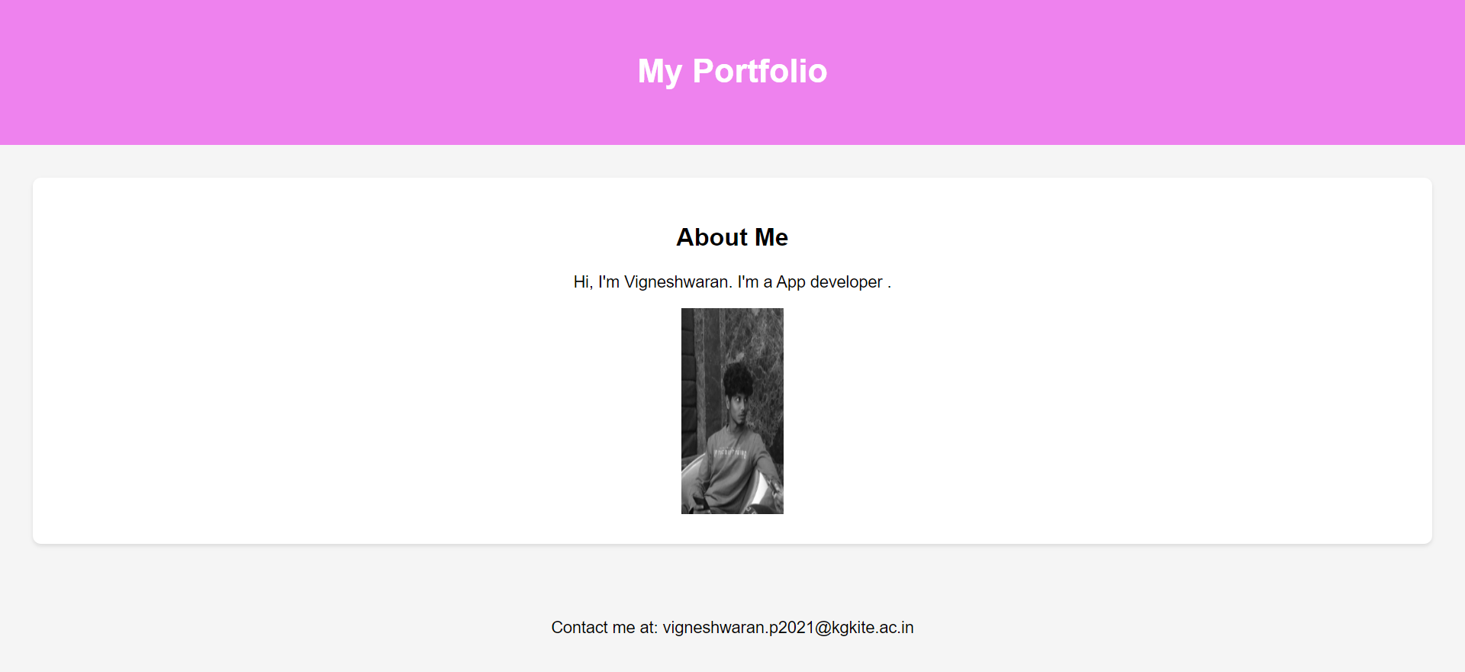

**Result:**

Thus the creation of portfolio website using react.js is successfully completed and the output is verified.