DDL (DATA DEFINITION LANGUAGE)- related to database

CREATE
ALTER
DROP
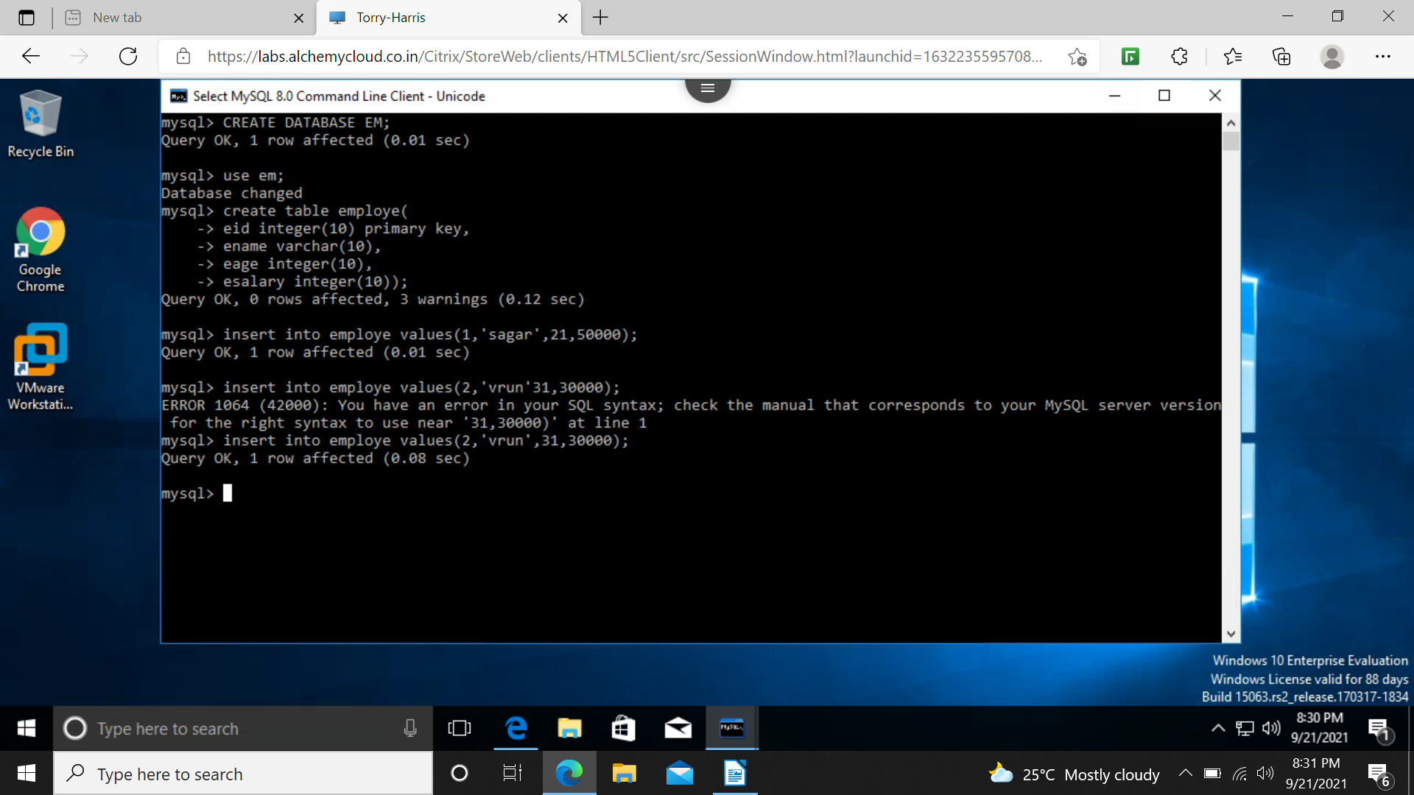

creating data base and adding values
dropping or deleting database

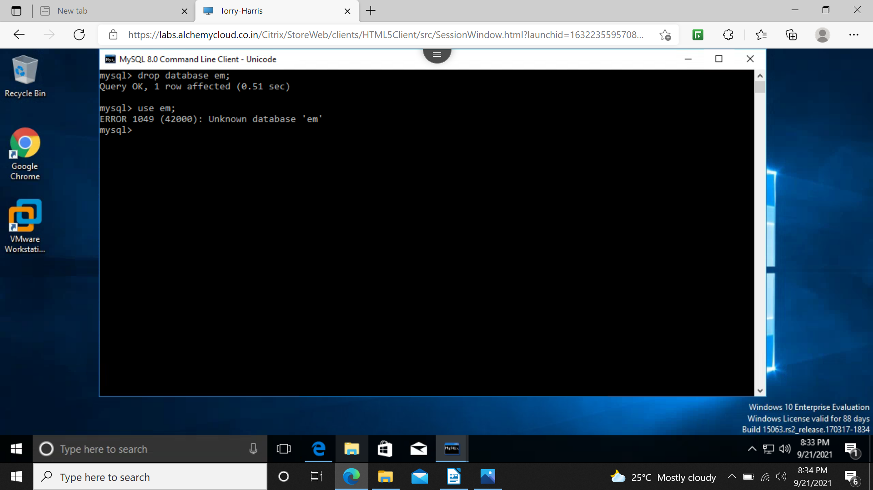
DATA MANIPULATION LANGUAGE(DML) – RELATED TO DATA INSIDE DATABASE

INSERT
DELETE
UPDATE
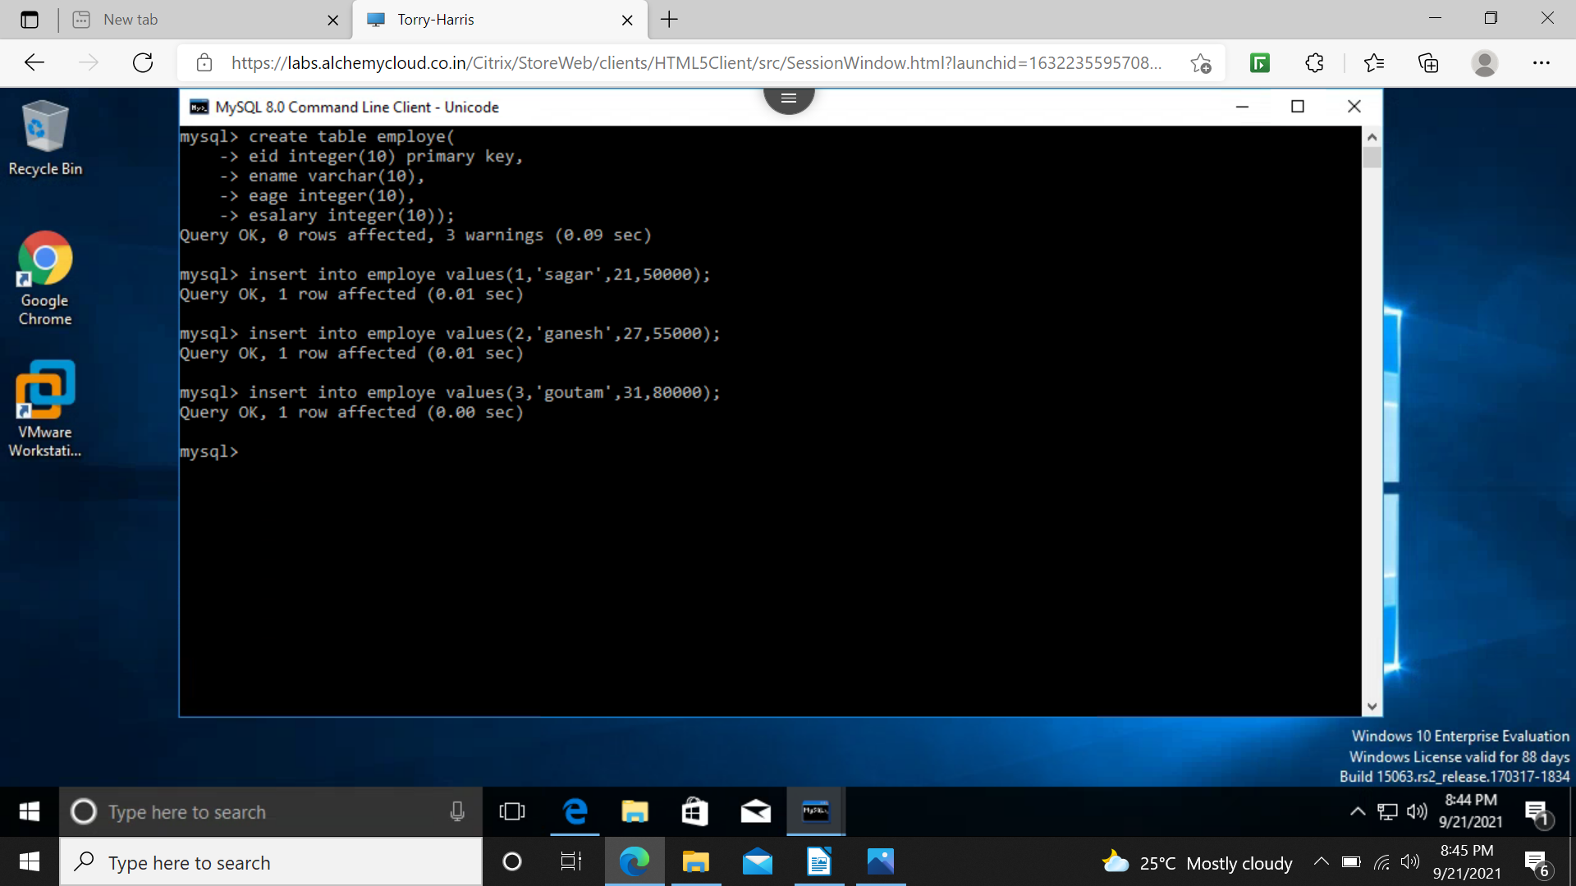

inserting with primary key(unique + not null)
update statement

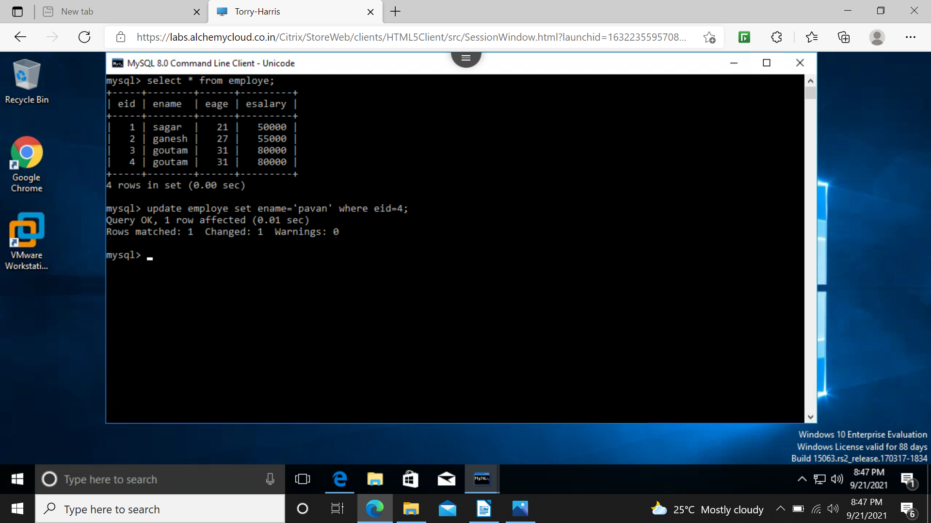
delete statement

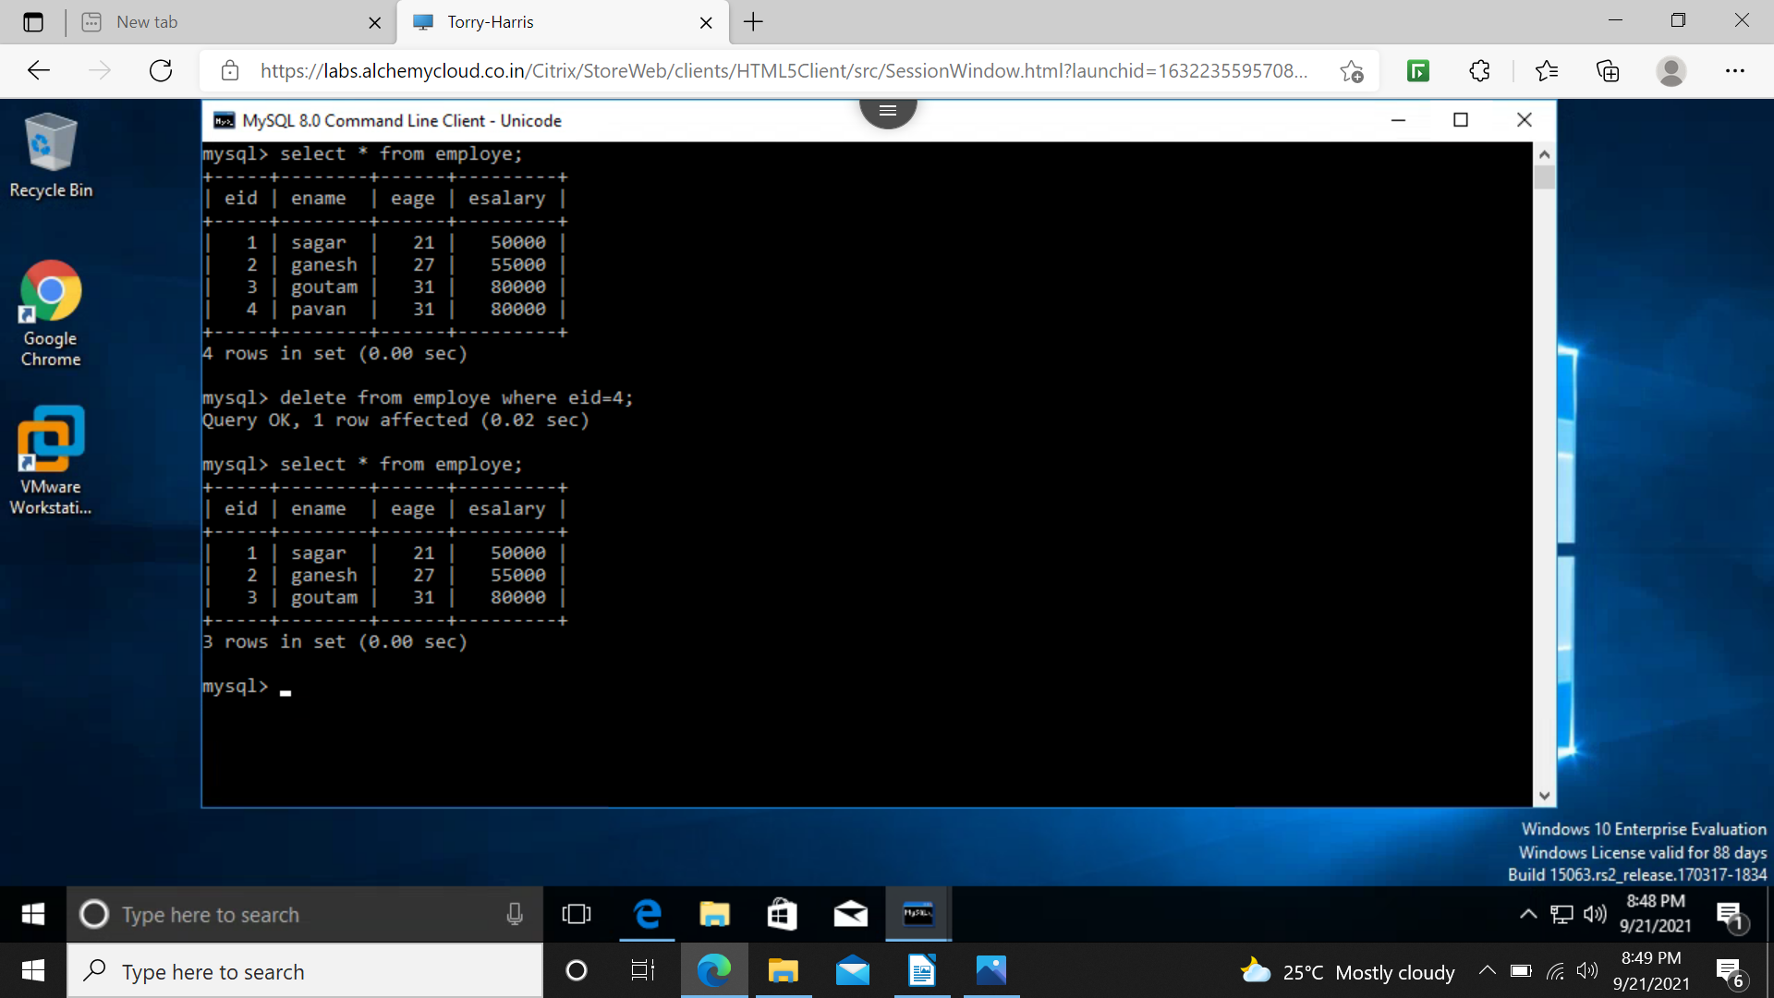
DATA QUERY LANGUAGE(DQL)

EXAMPLE- SELECT statement

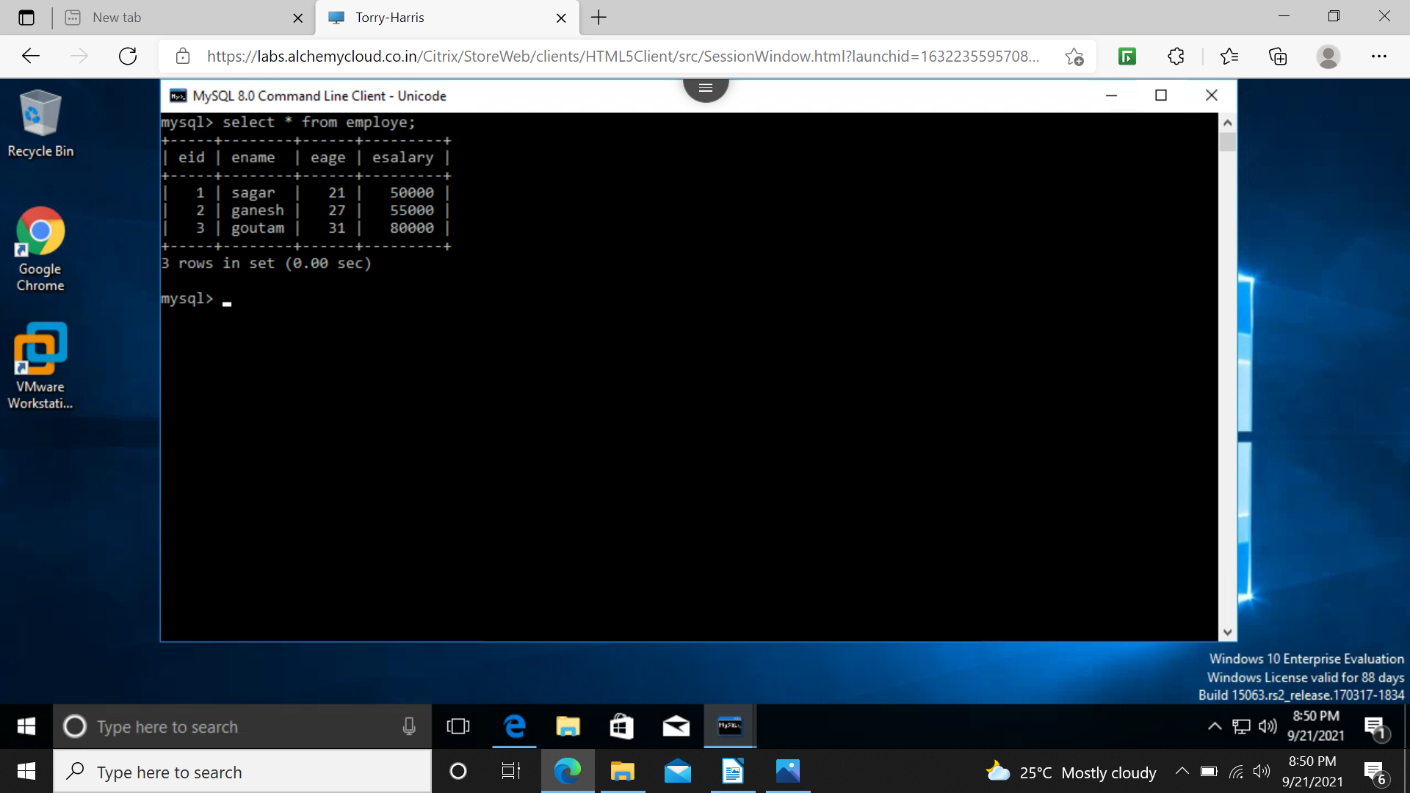
alter table add or drop column
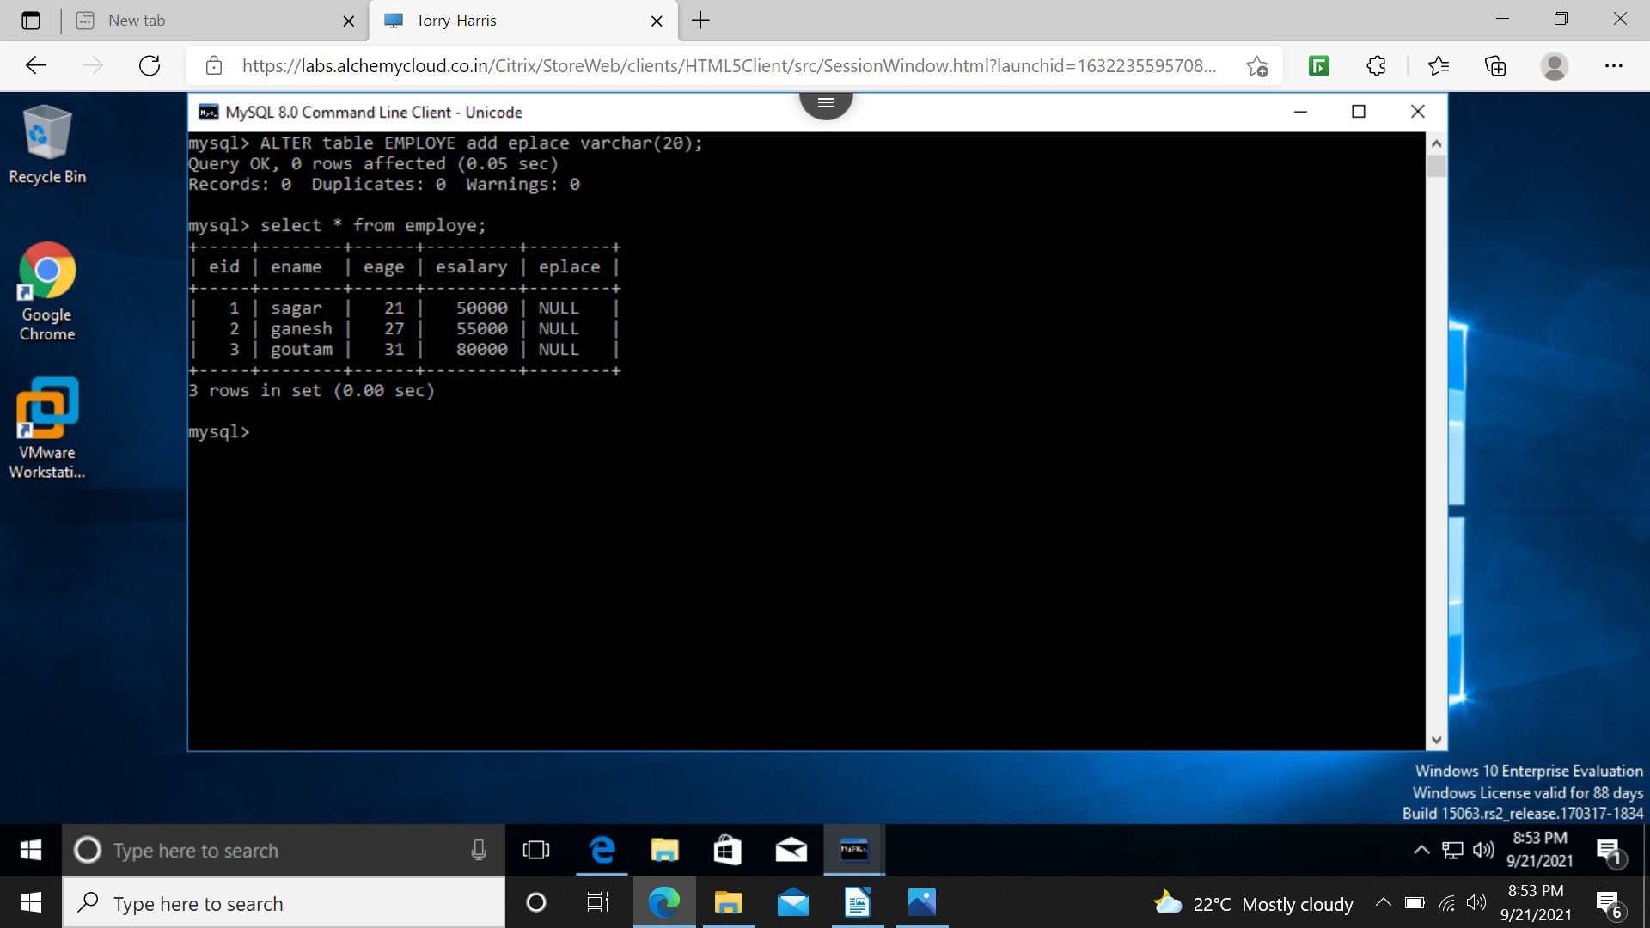
null will be shown , from update statement we can update values in place of null
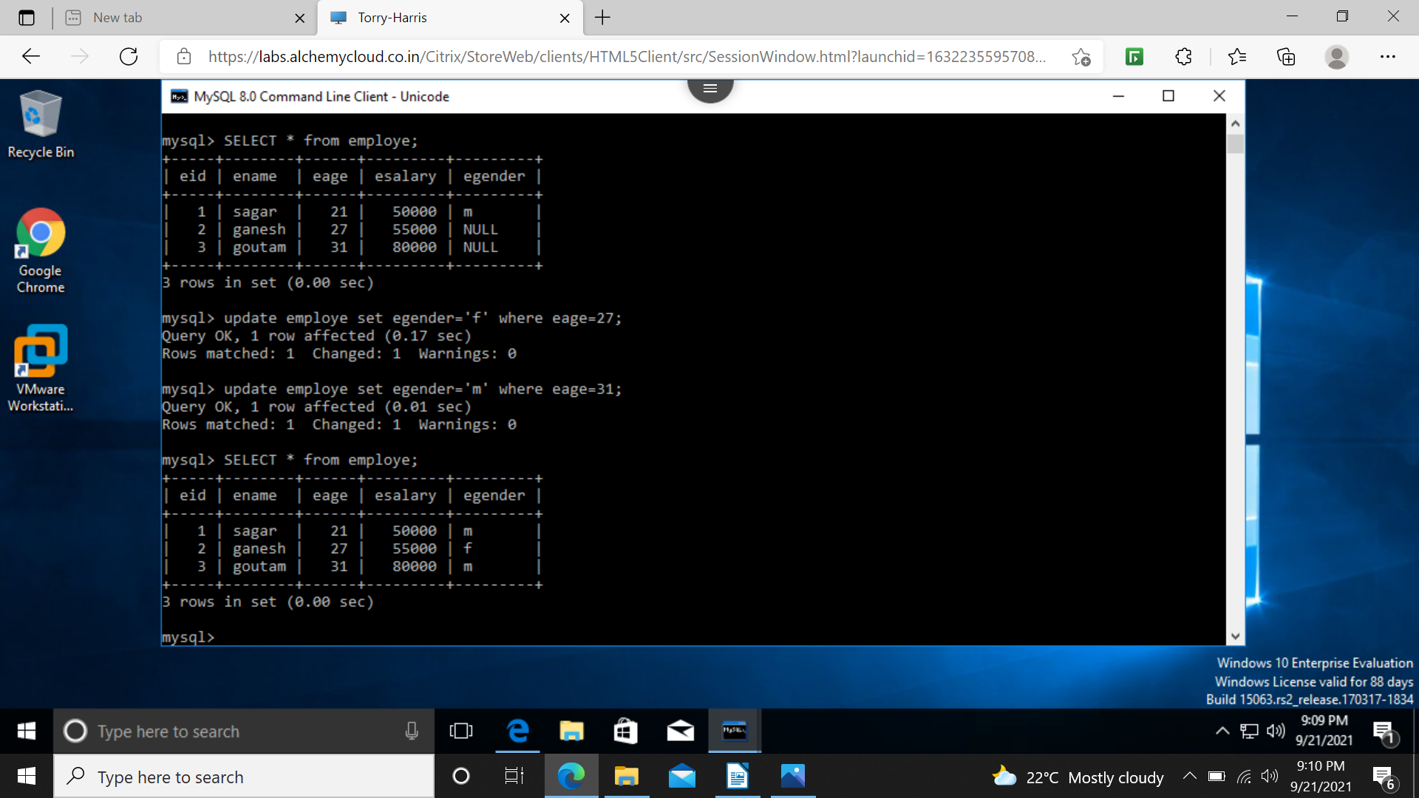
alter table and drop column

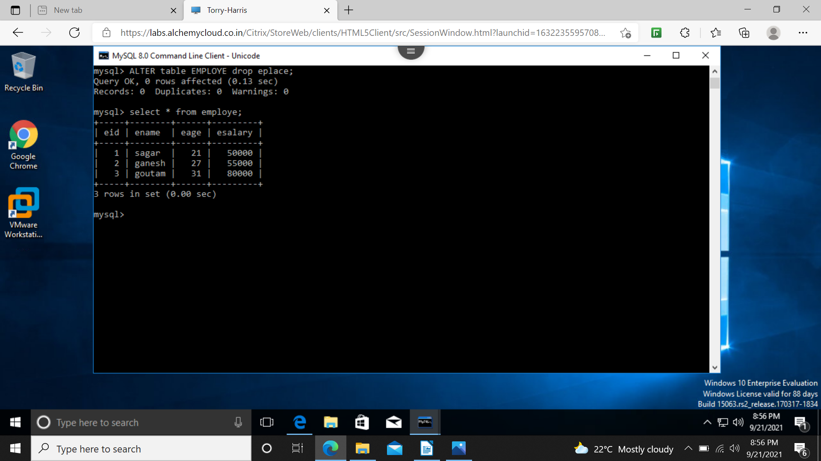
AGGREGATE FUNCTIONS

COUNT
MIN
MAX
AVG
SUM

1 COUNT

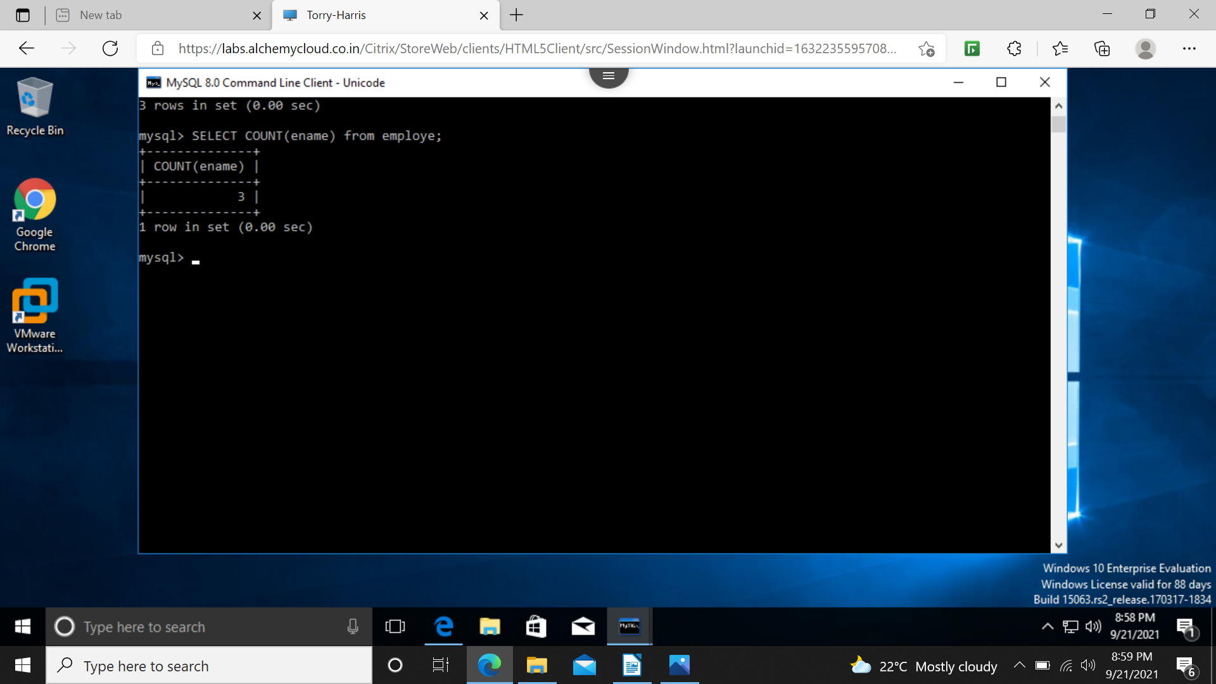
min and max

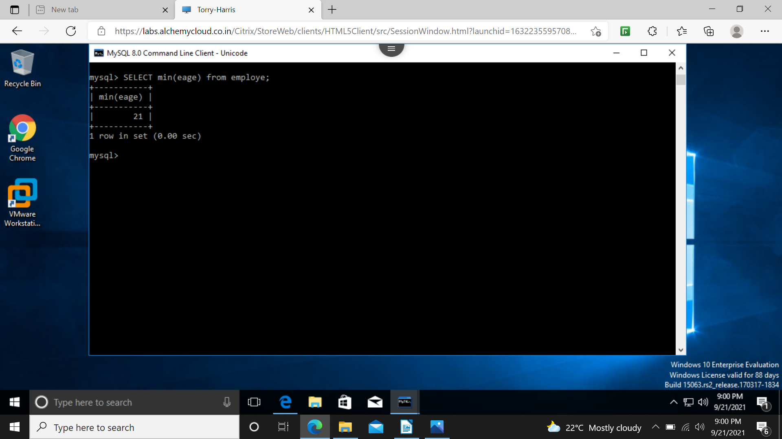
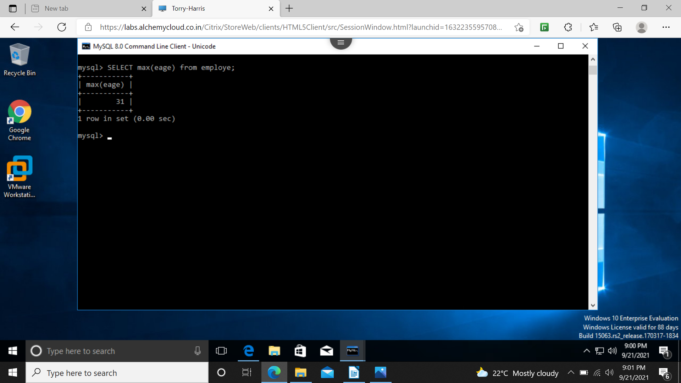
avg and sum and distinct

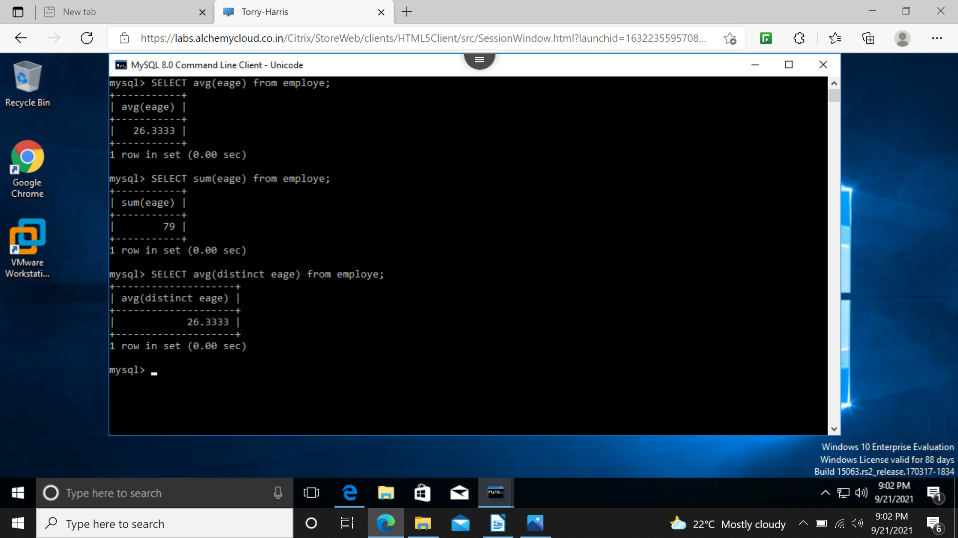

group by

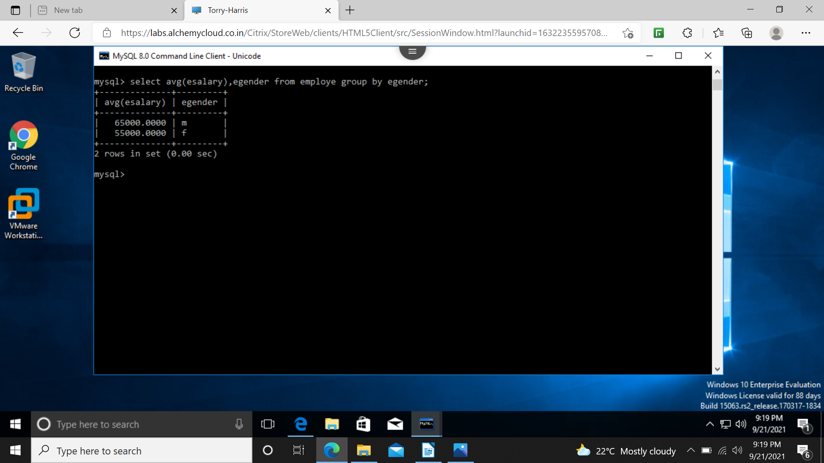

having clause

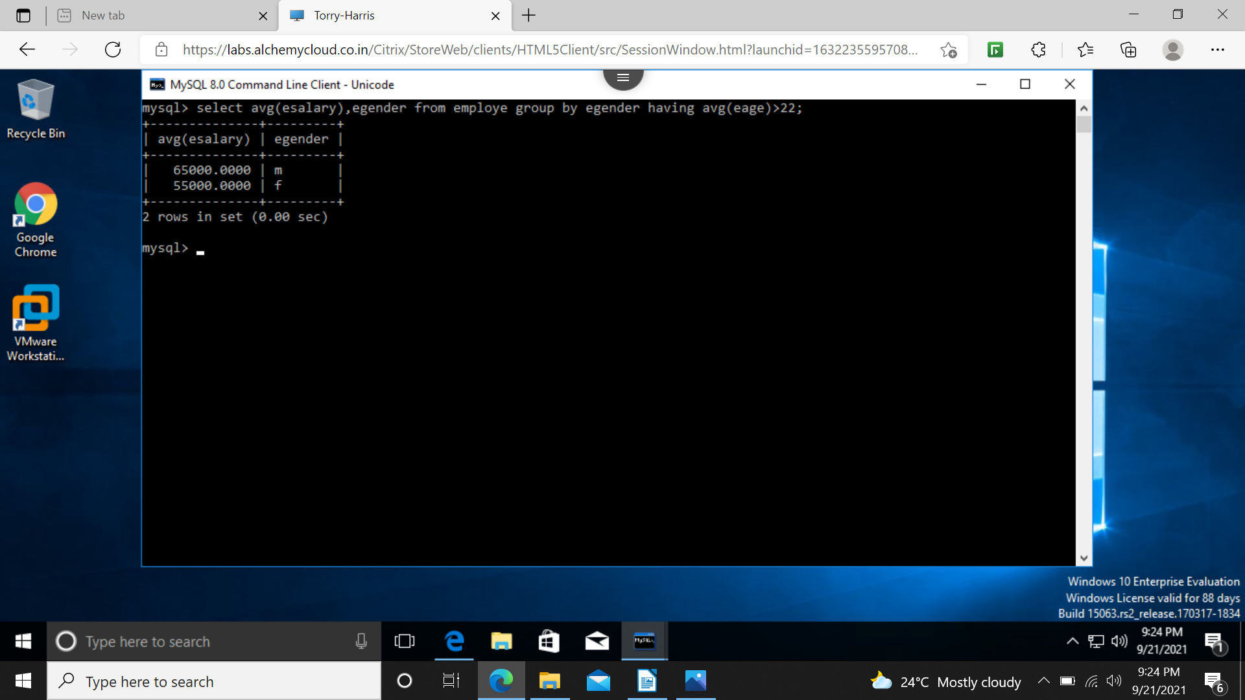
order by

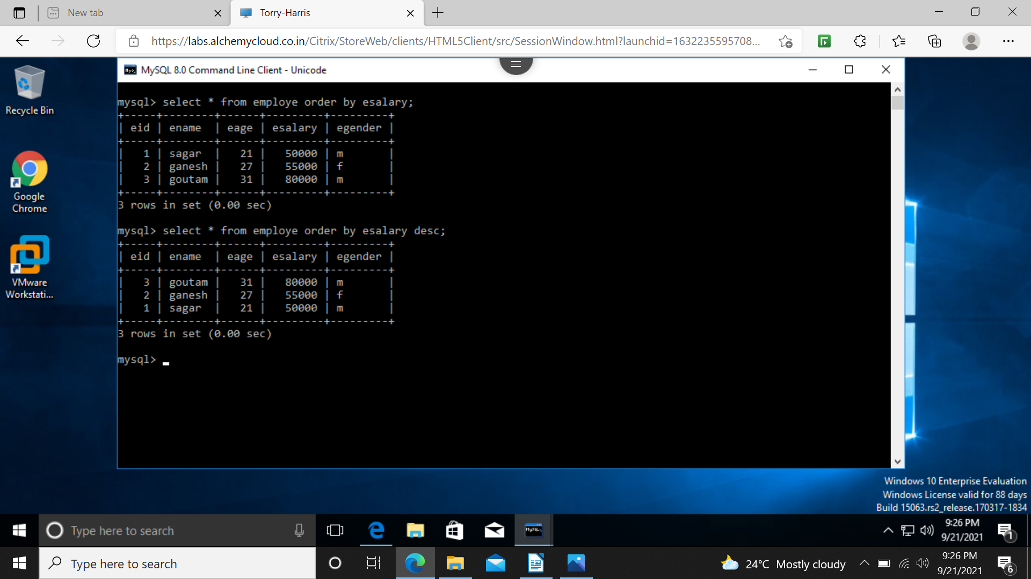
PRIMARY KEY

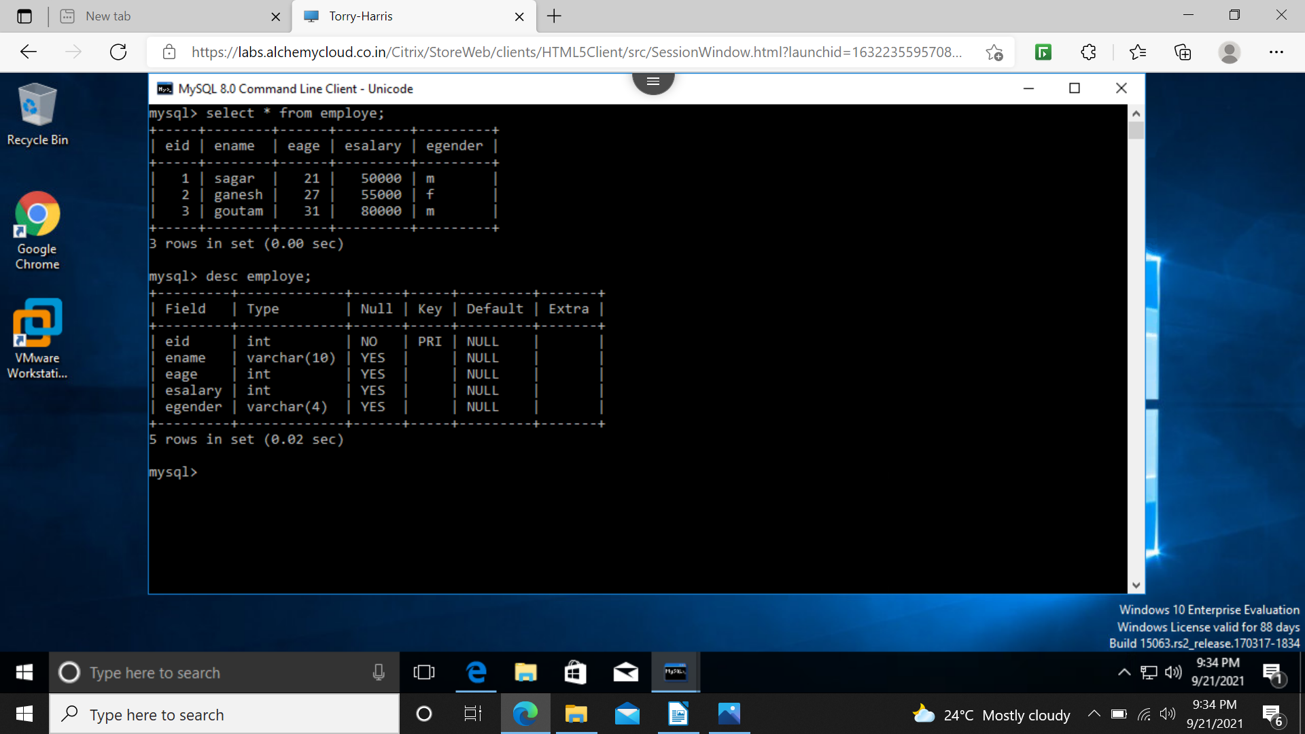
foreign key

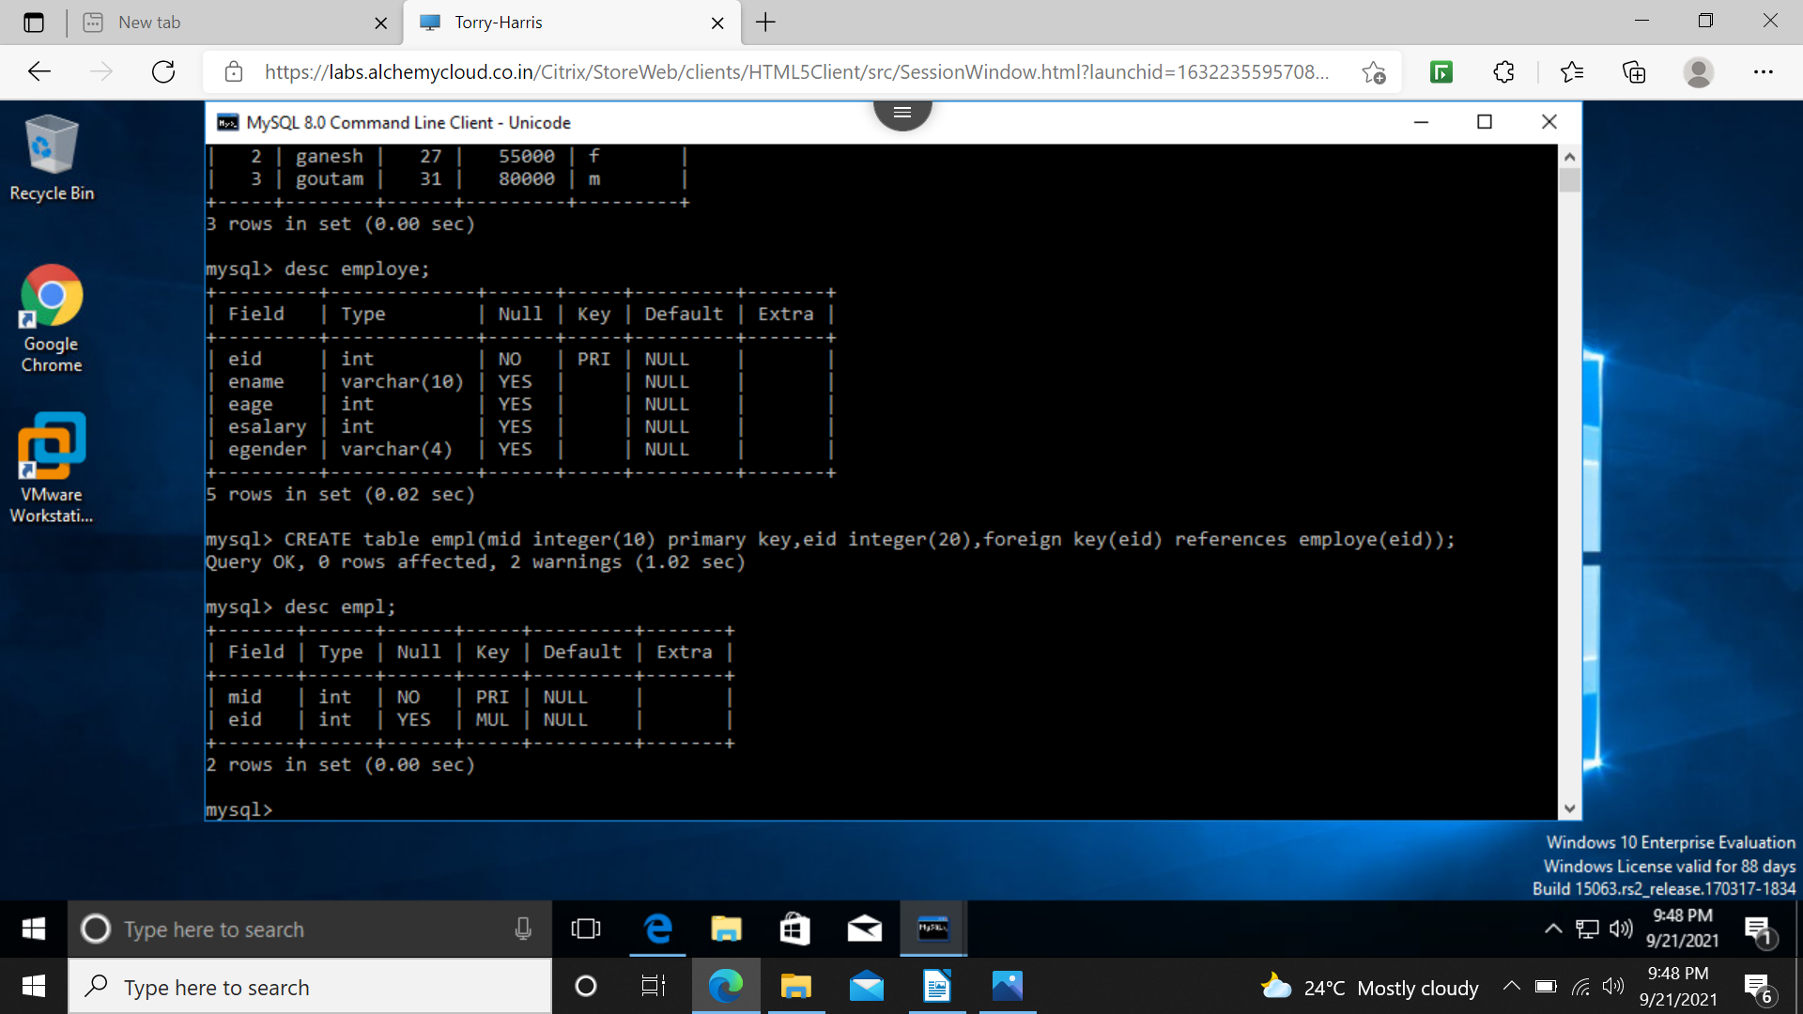
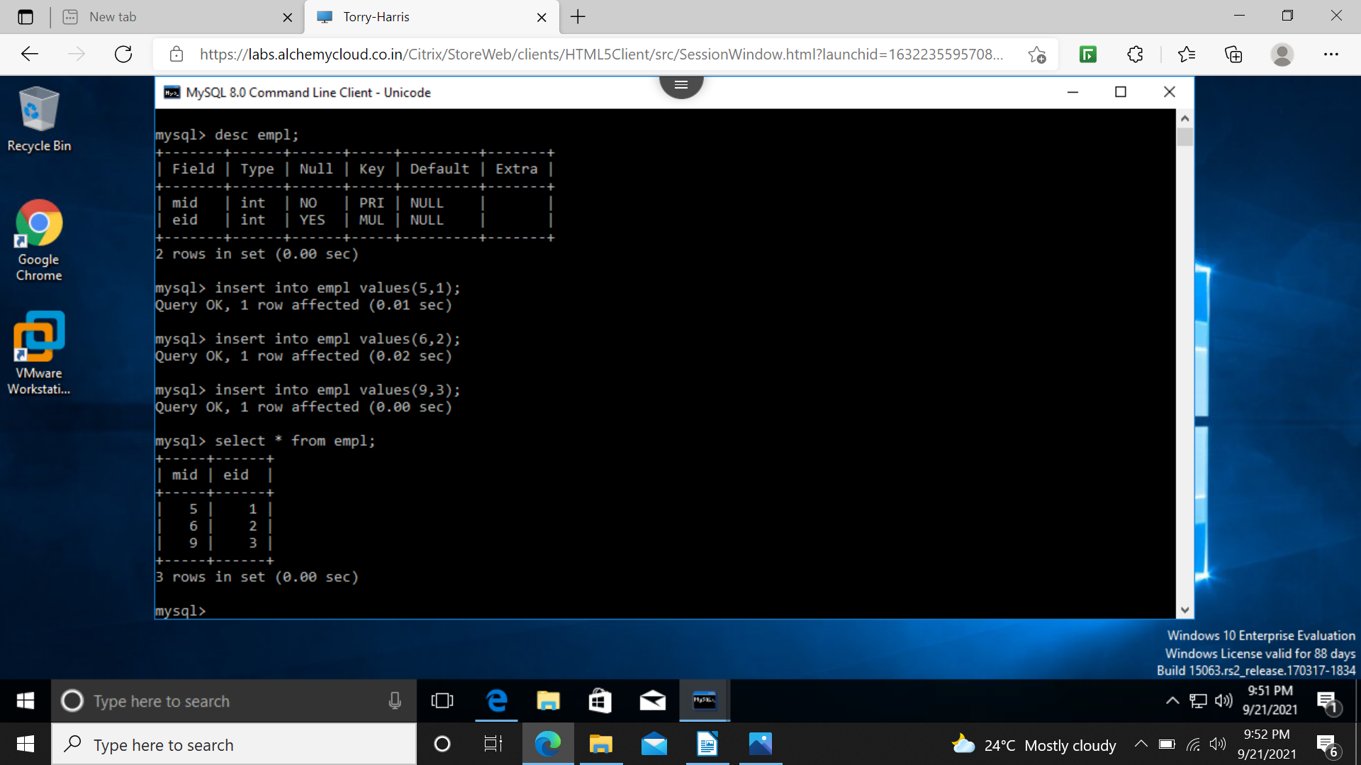
not null - no values should be blank or null

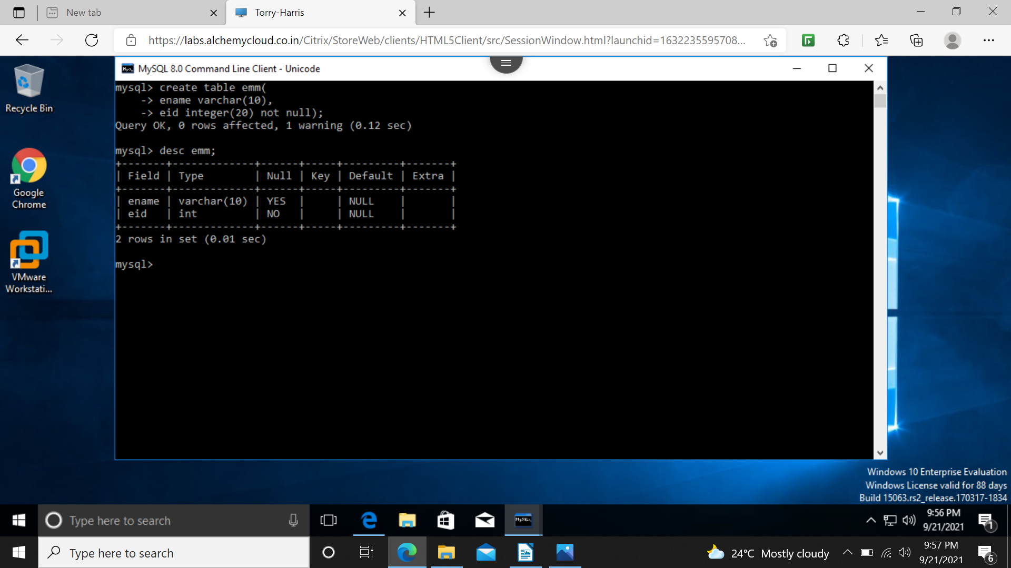

unique – every value should be unique

ex – college id

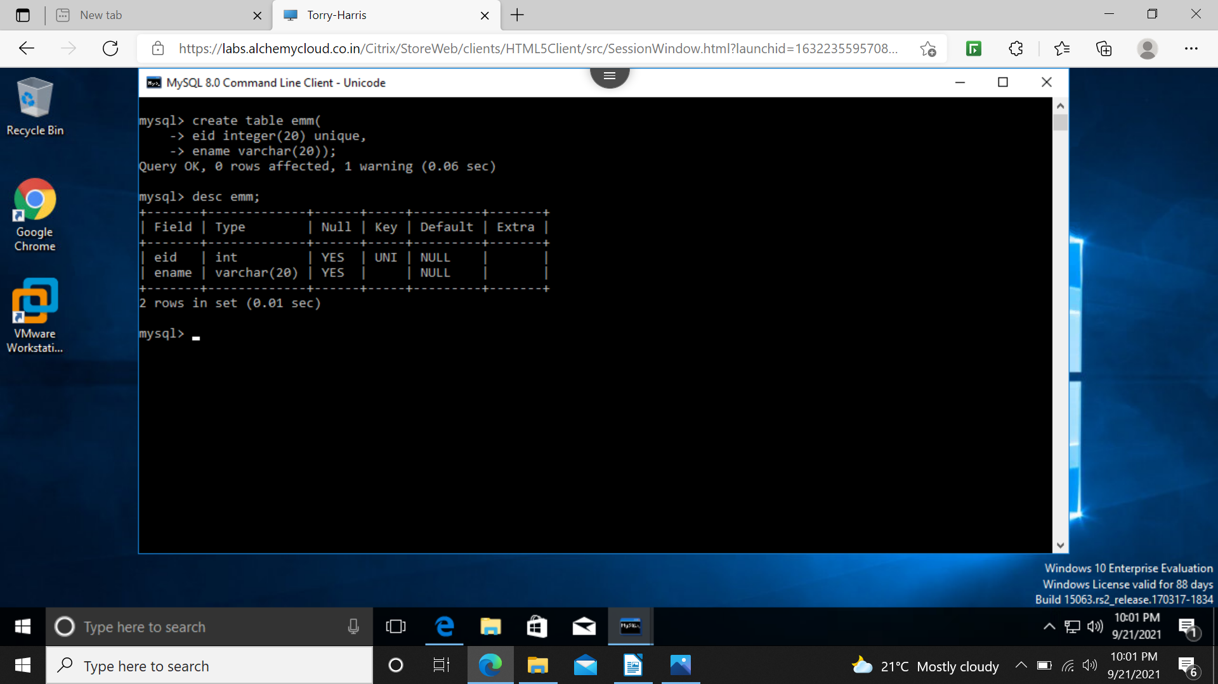
default



