3 types of quotes
“ $a“ - the value of $a is displayed

‘$a’ - everything is taken as string and output will be
$a

“hai hello” `date` - here date is taken as command
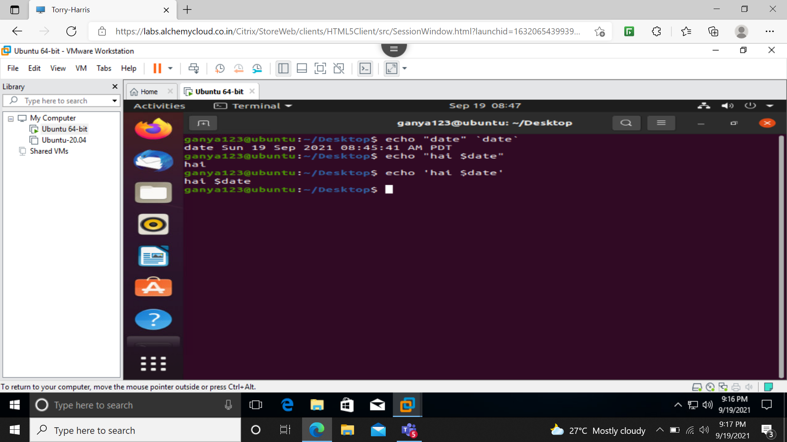
$# - prints number of command line arguments
$$ - prints process id of the shell
$@ - all command line arguments are printed
$? - return code like exit
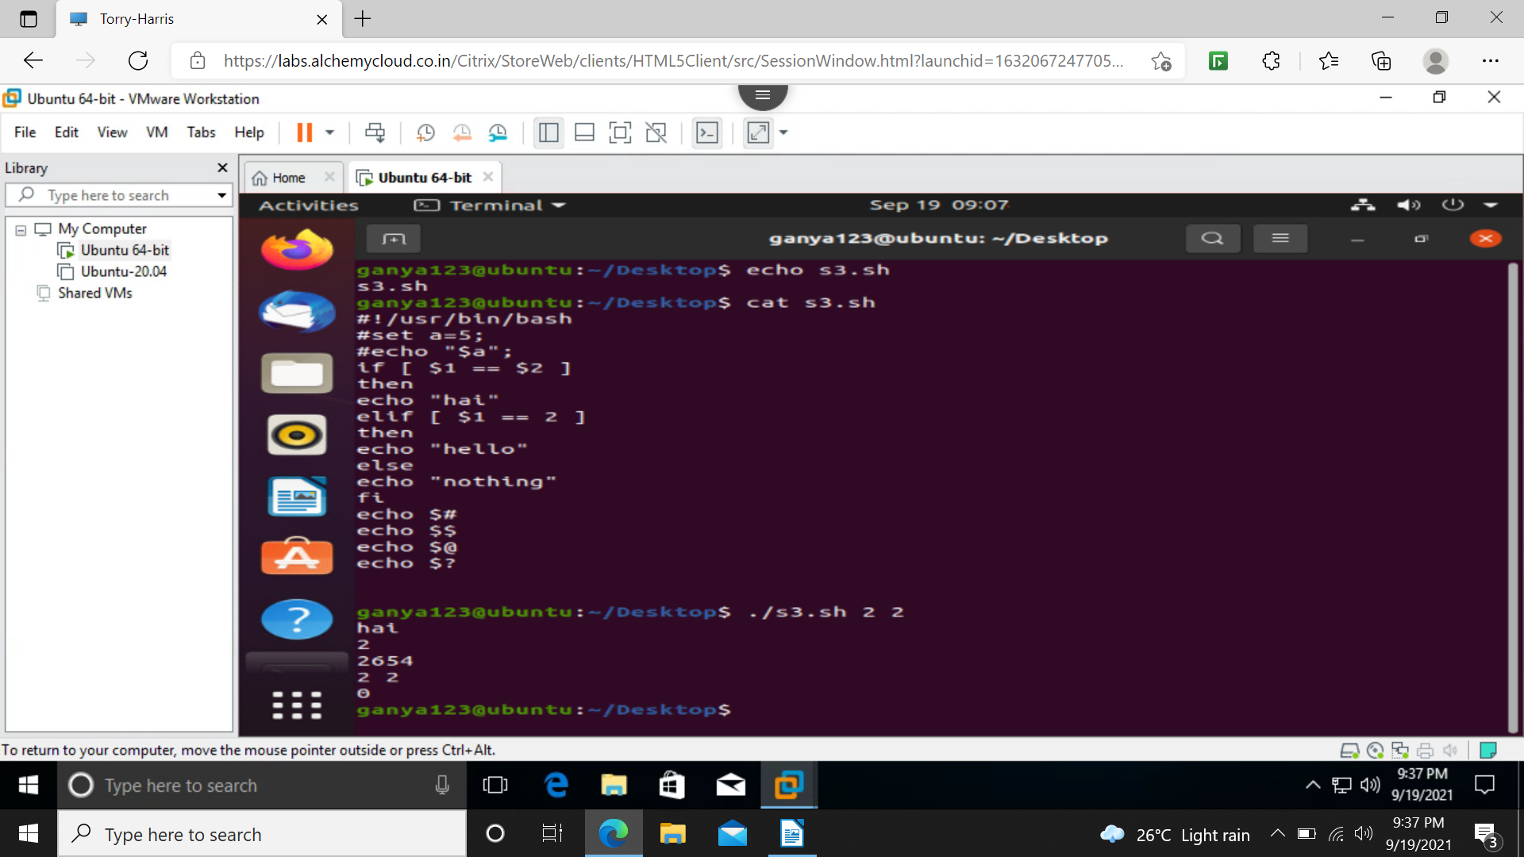
program to print first command ,second command and number of command line arguments and all command lines
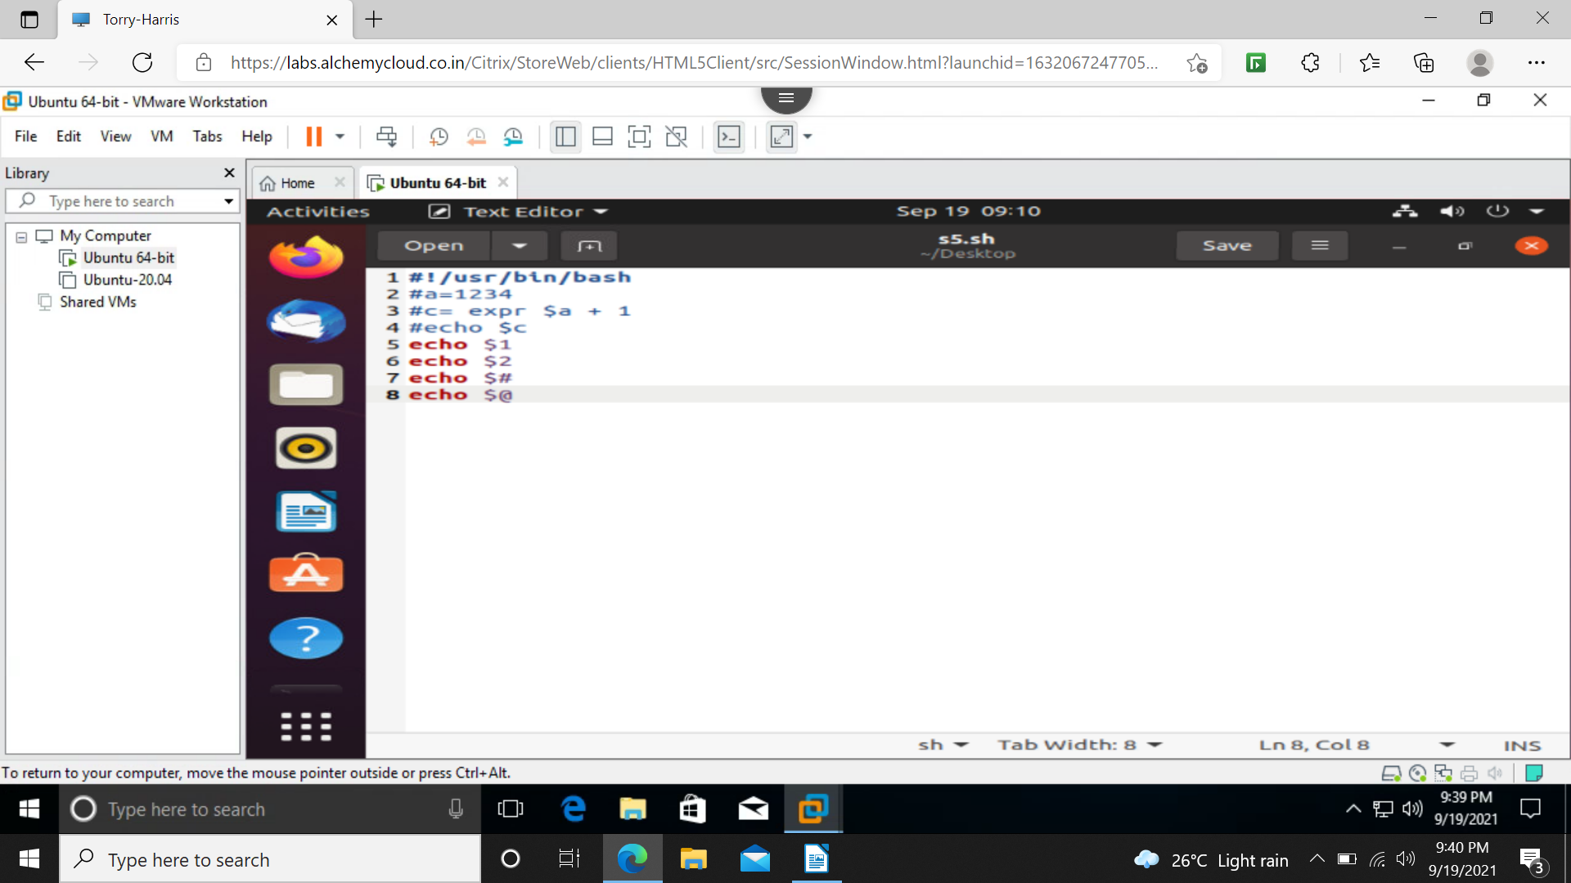
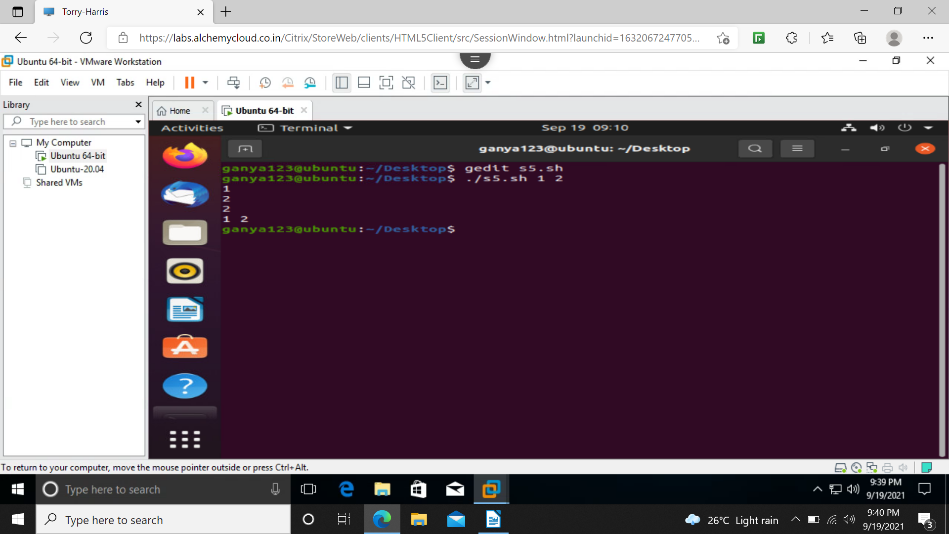

program for positive or negative
for numbers
-ne not equal
-eq equal to
-lt less than
-gt greater than
-le less than or equal to
-ge greater than or equal to

for strings
str1 == str2
str1 != str2
str1 = str2
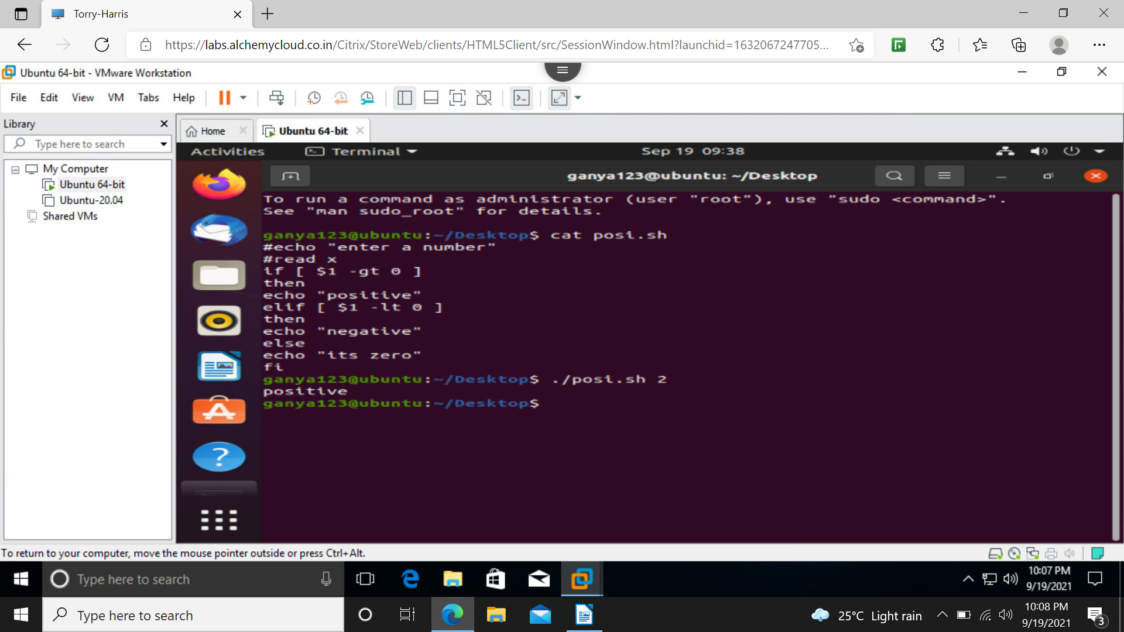
if statement

if [condition]:
then
command1
else
default statement
fi

if else

if [condition]:
then
command1
elif [condition]
then
command2
else
default statement
fi

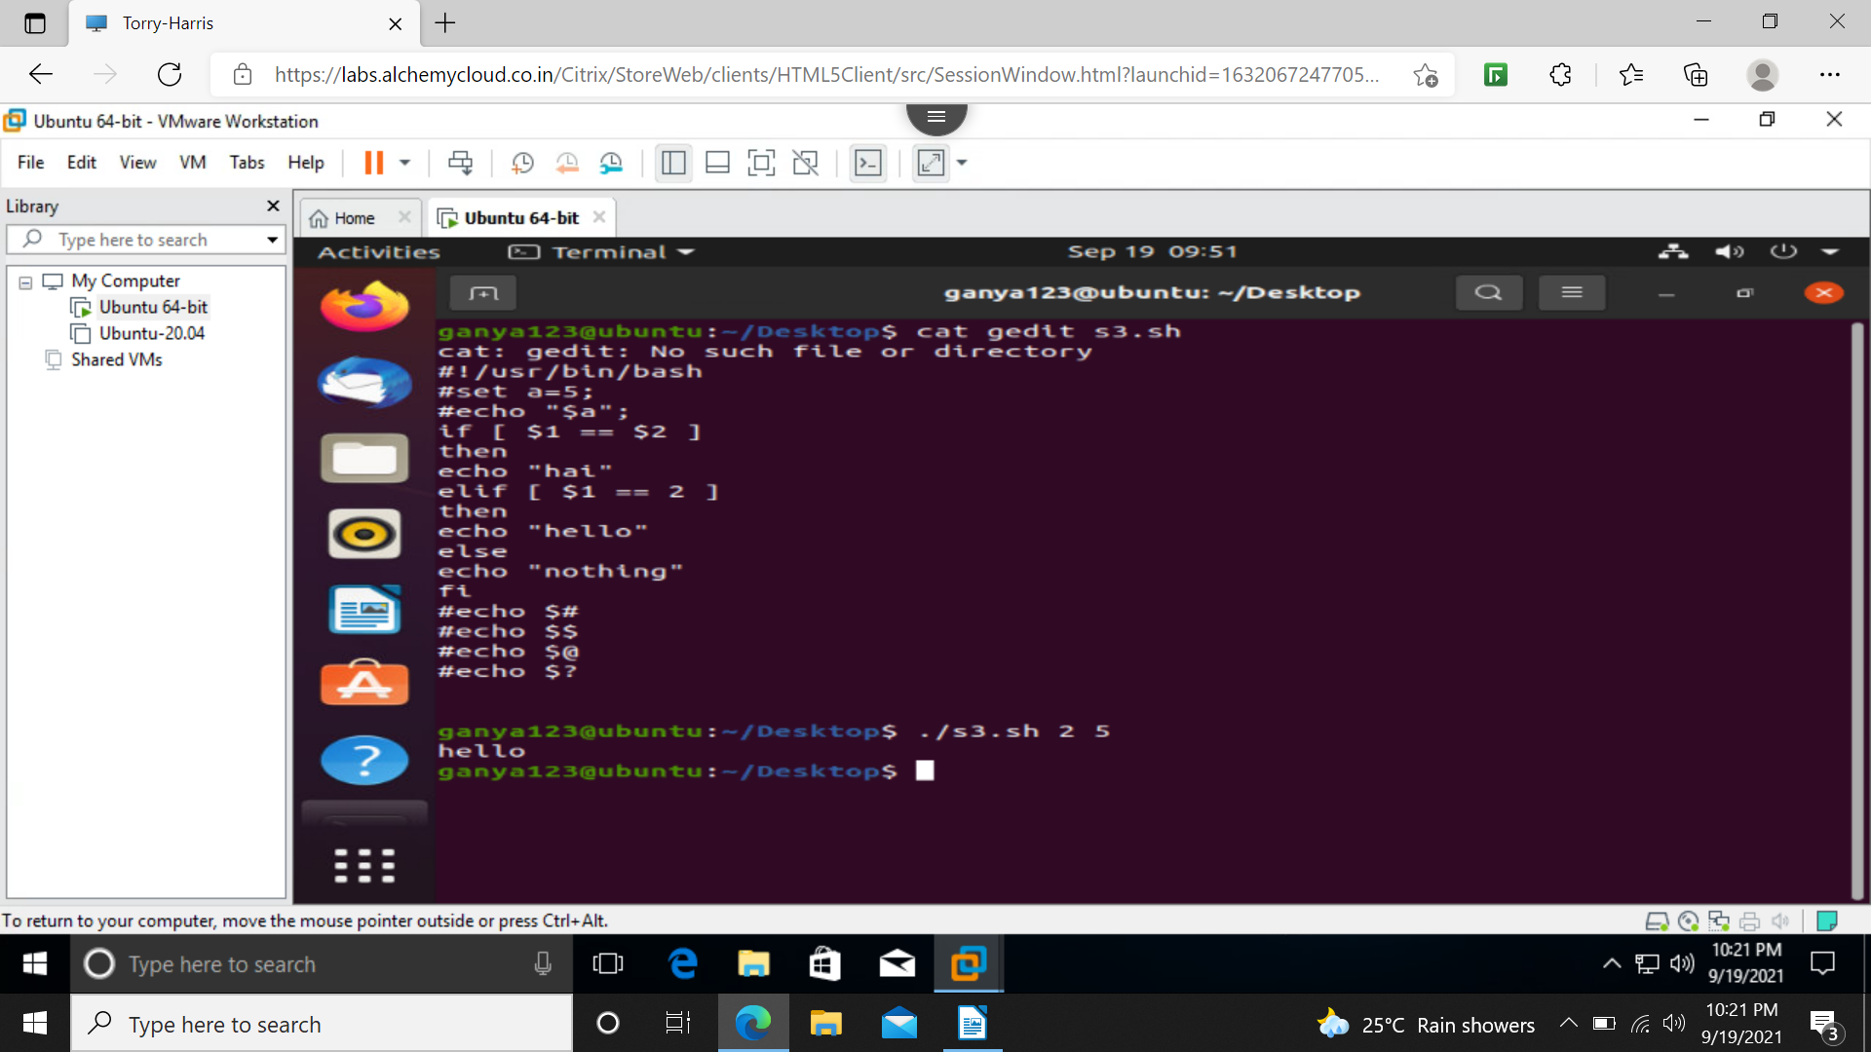
program for if else statement
for loop

for [condition]
do
commands
done

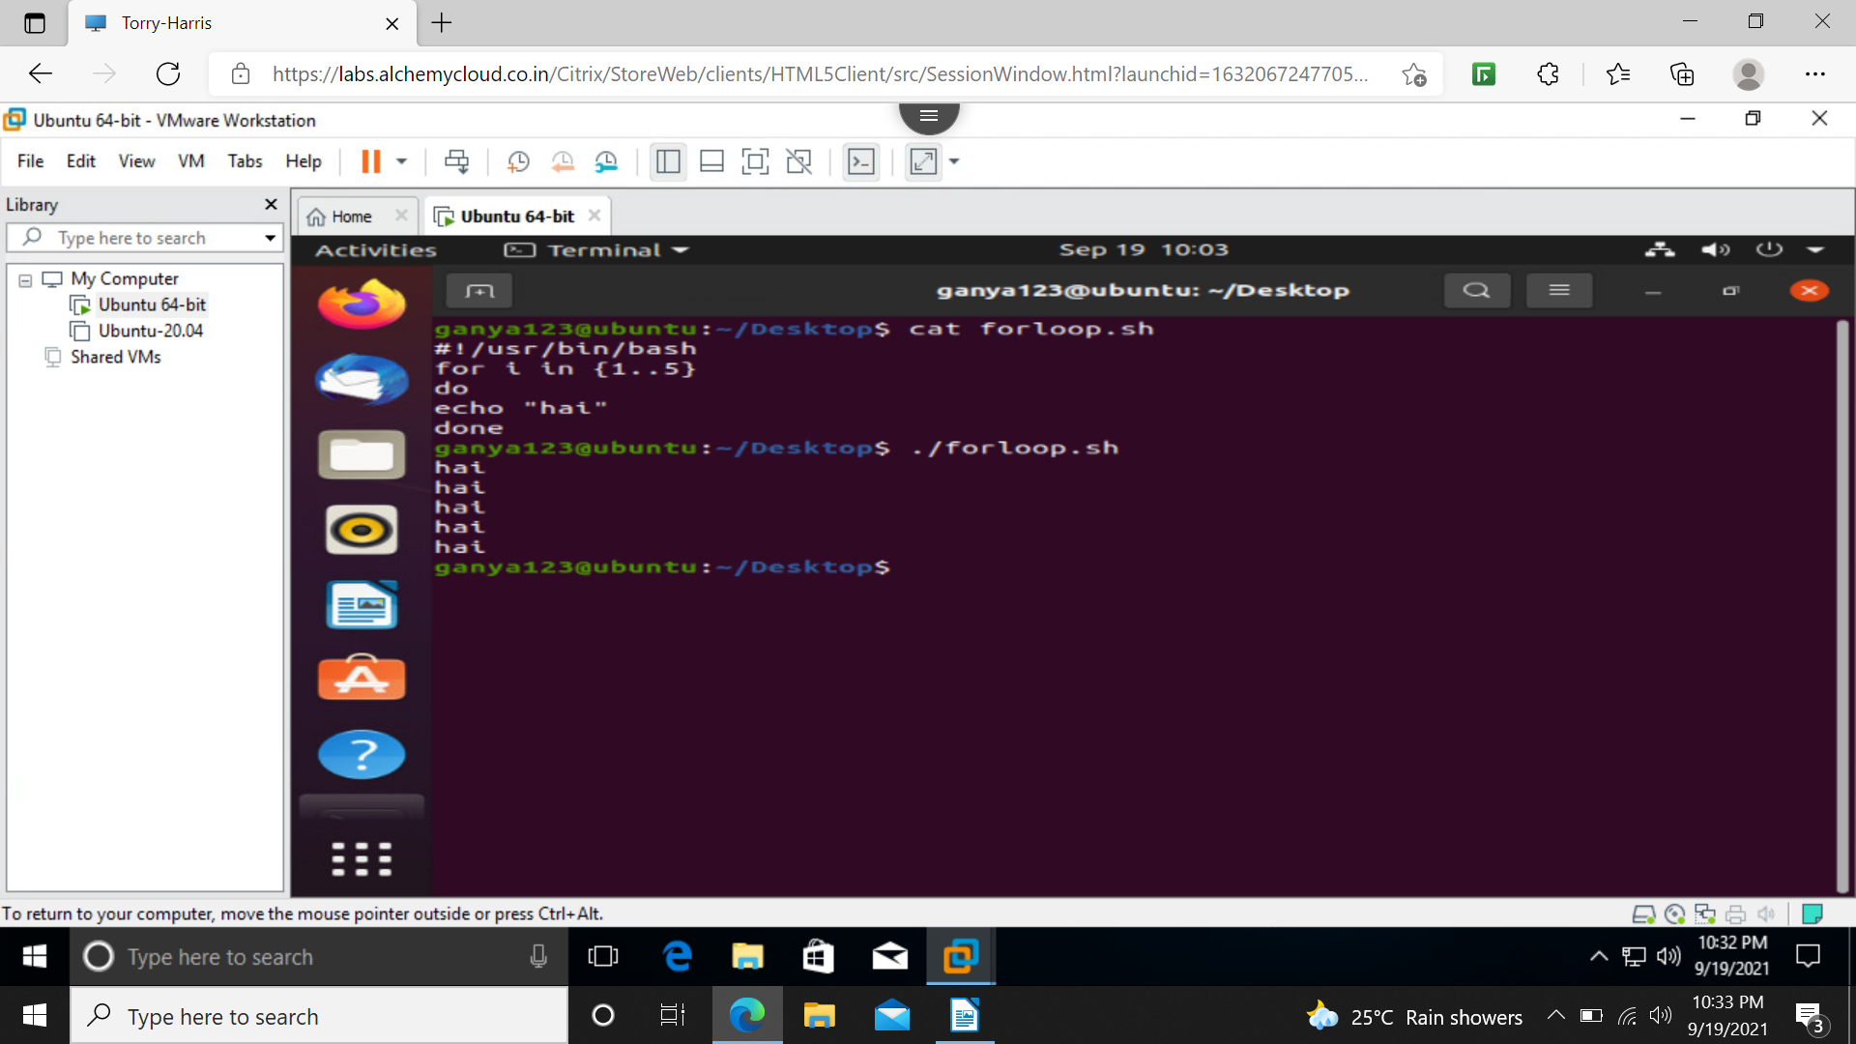
for loop
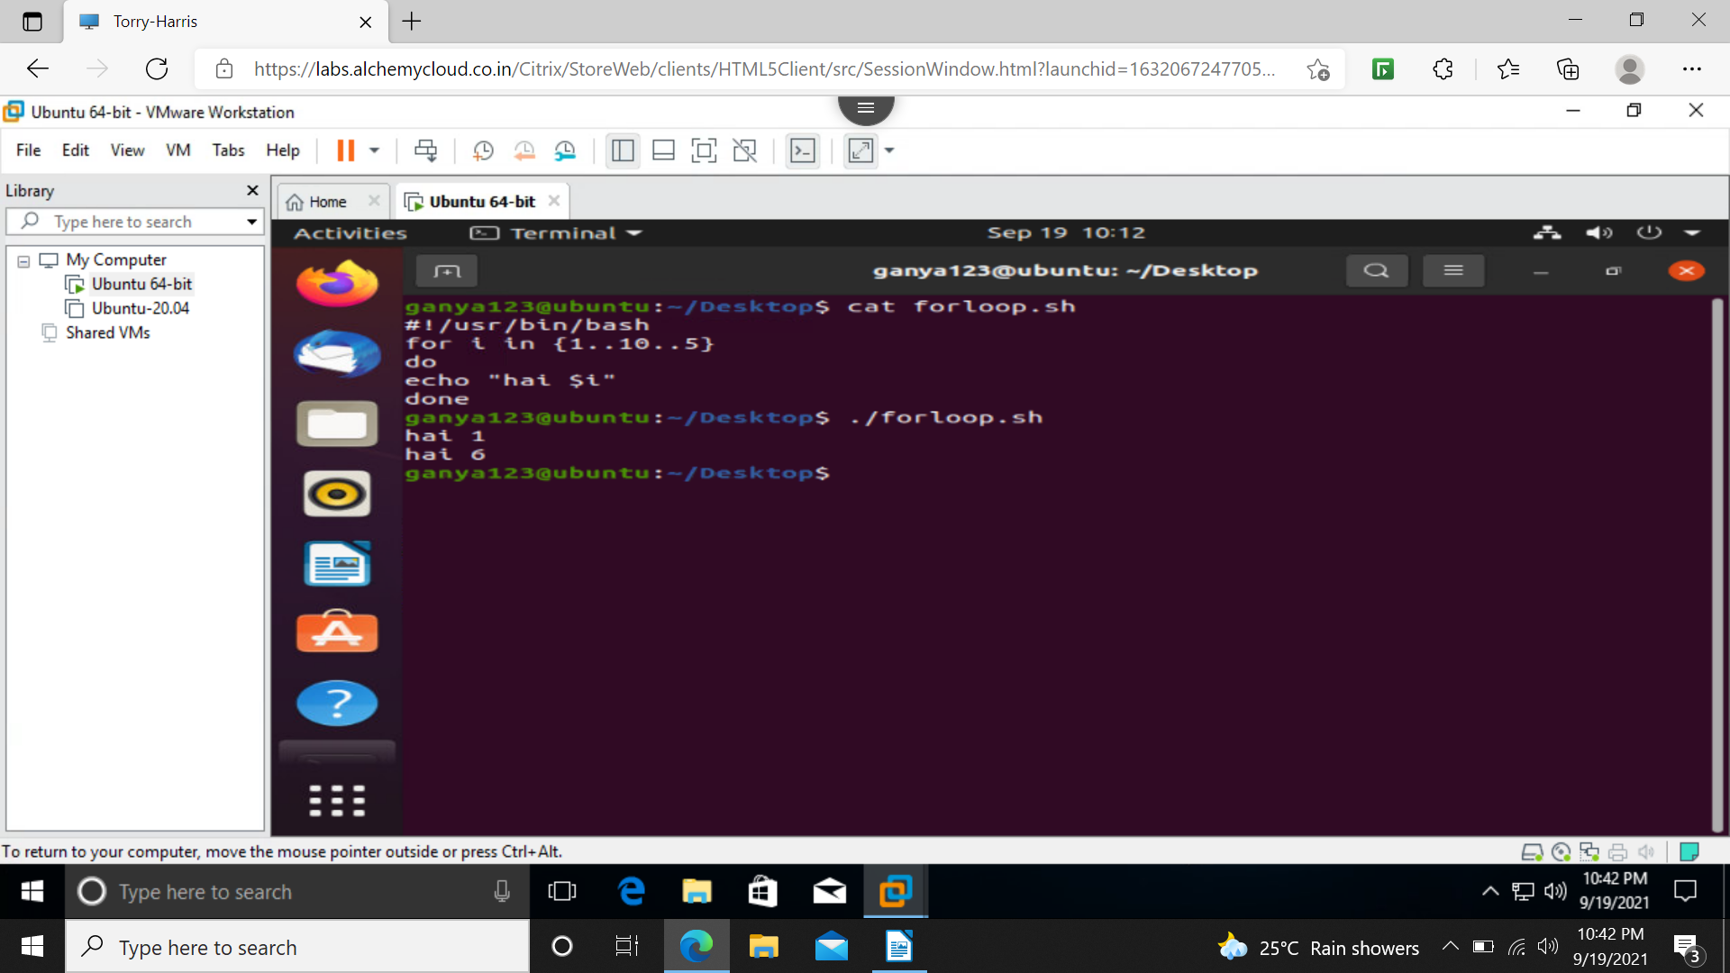
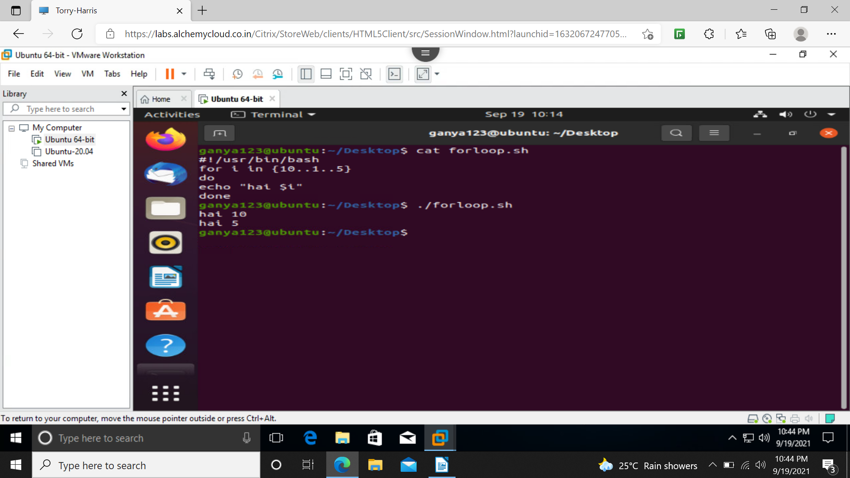
it can also be done like
for(( i=1; i<=n; i++))
do
command1
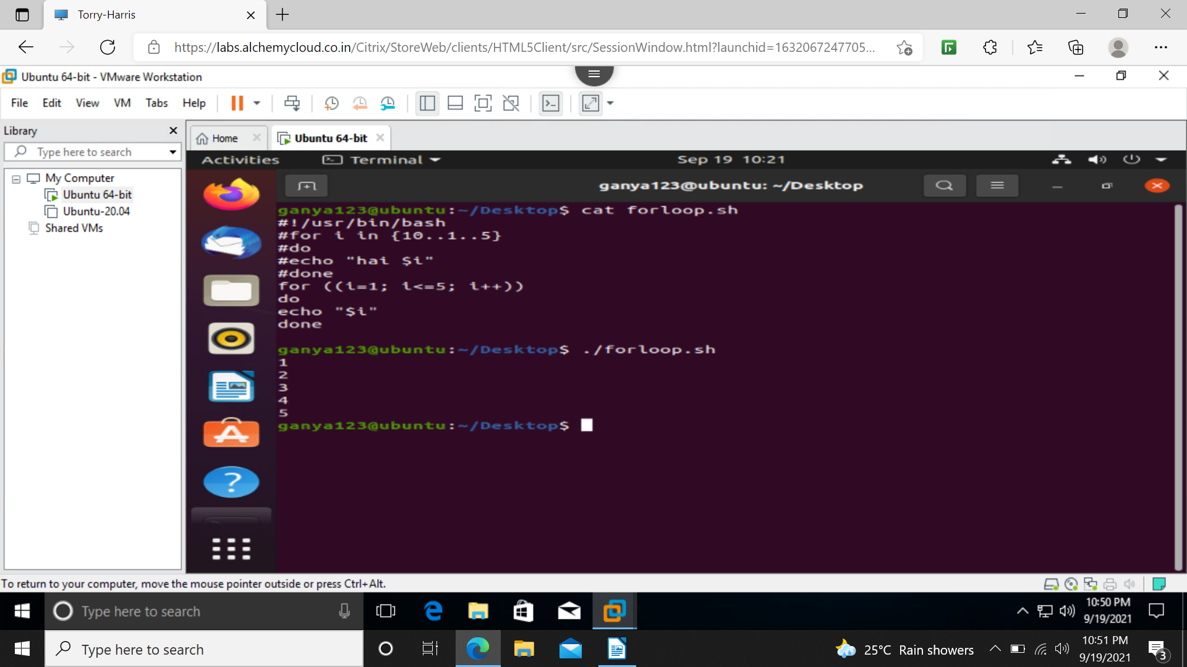
done

while loop

while [condition]
do
command1
done

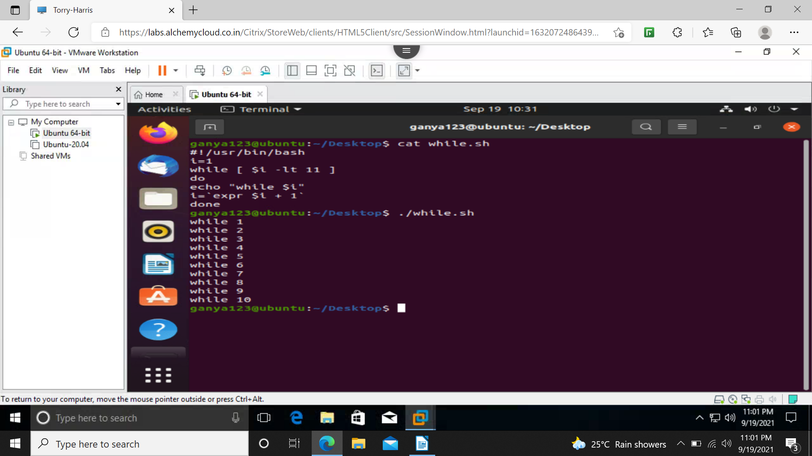
until is opposite of while

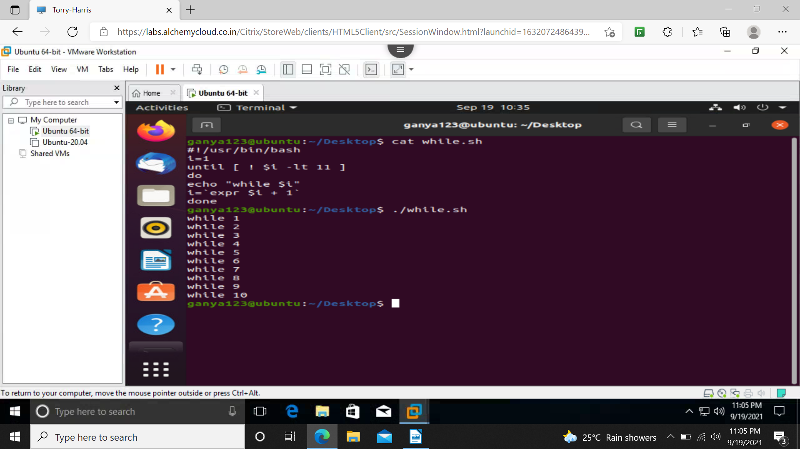
function
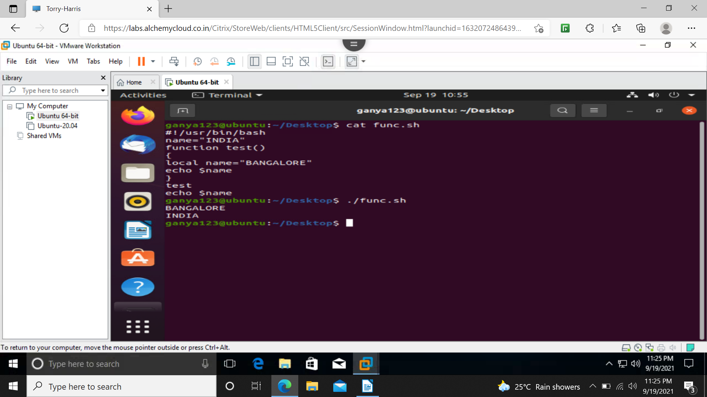
break – stops the iteration and comes out of loop
continue – stops the current iteration and moves to next iteration


