Touch- file will get created but it will not open

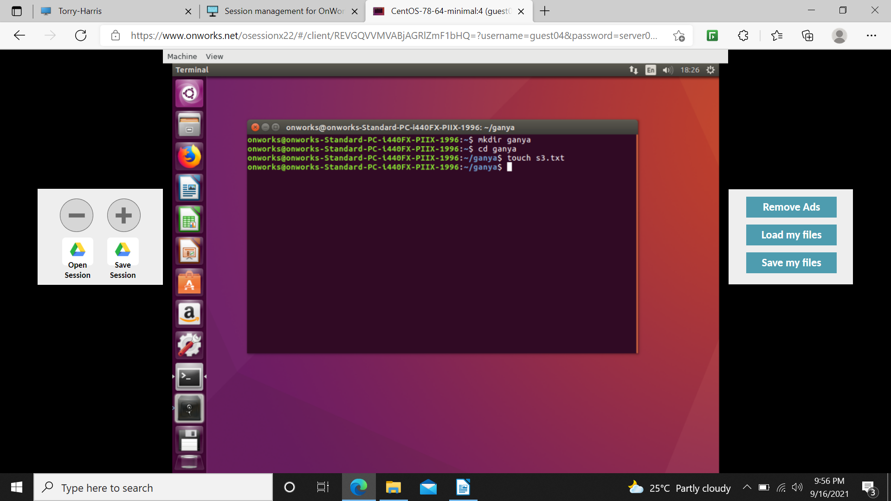

find -type d (displays directory)
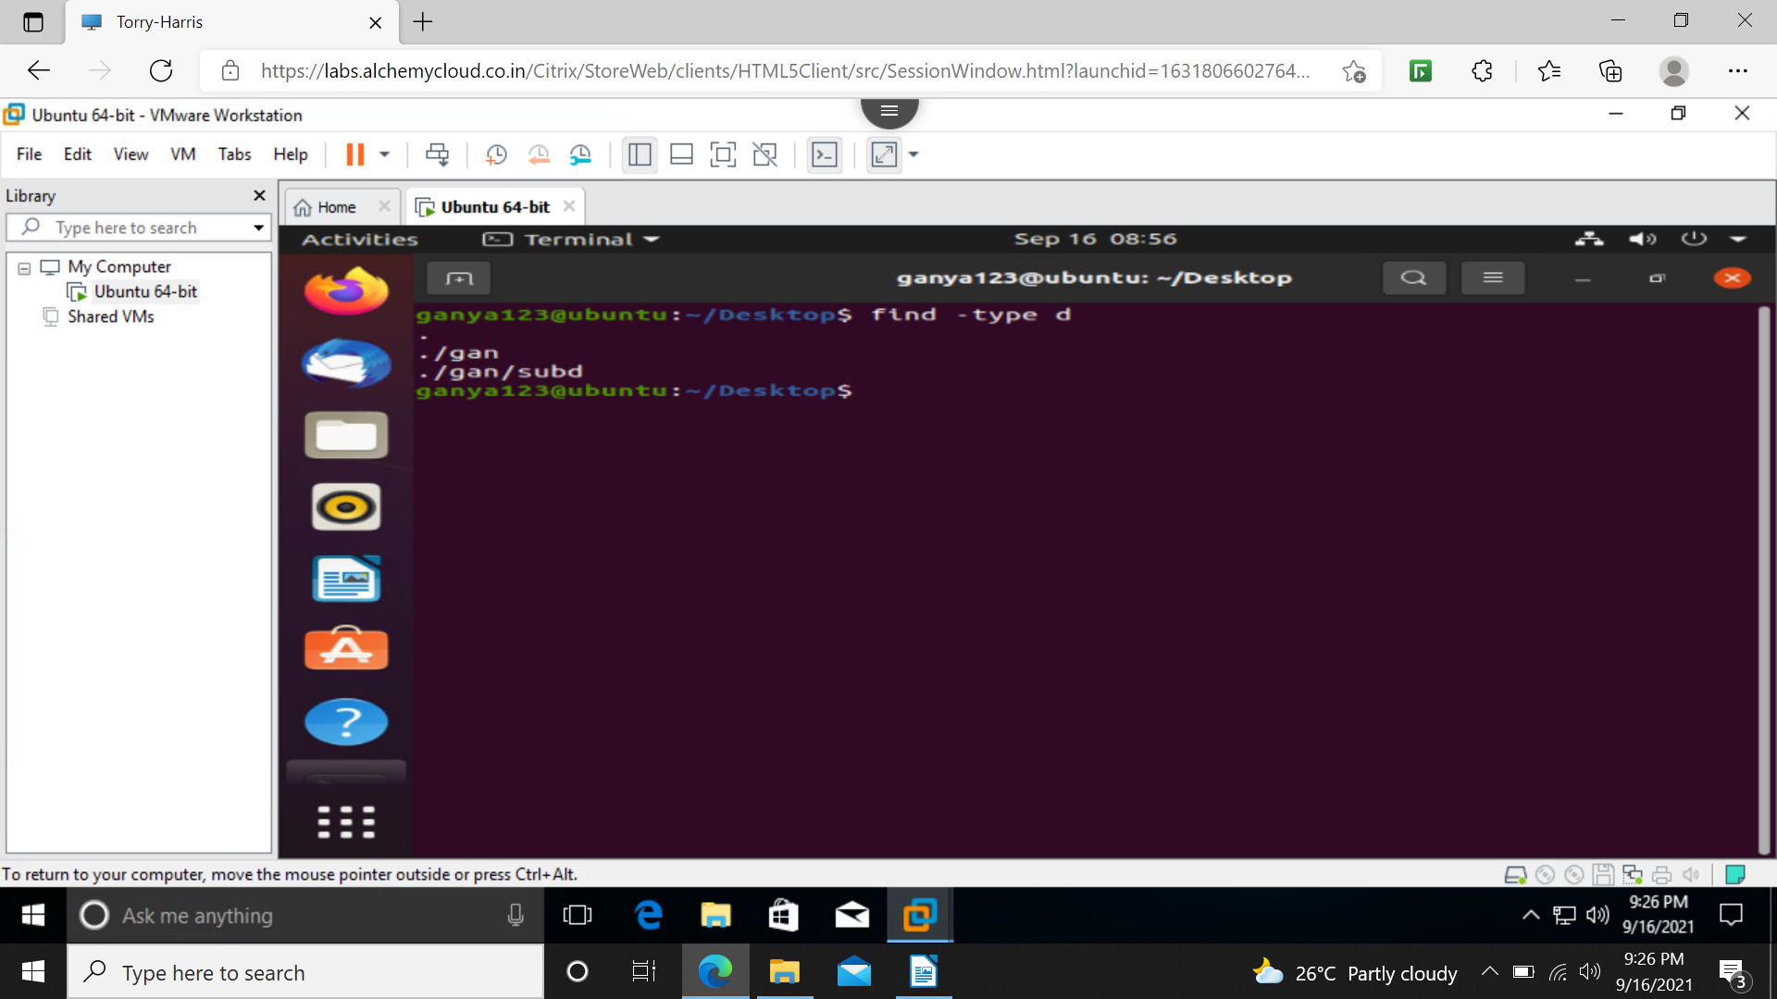
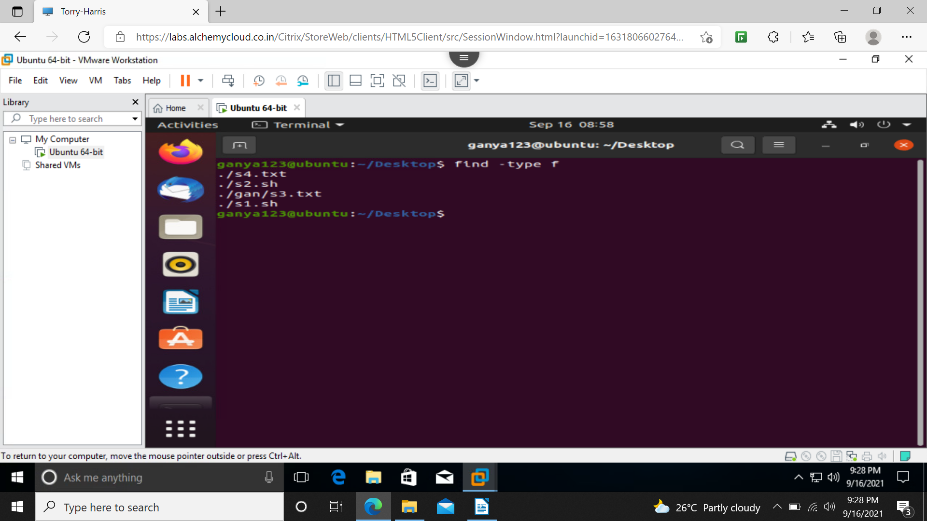
find -type f(display only files)

find . -type f -name s4.txt(in current directory and sub directory search for s4.txt)
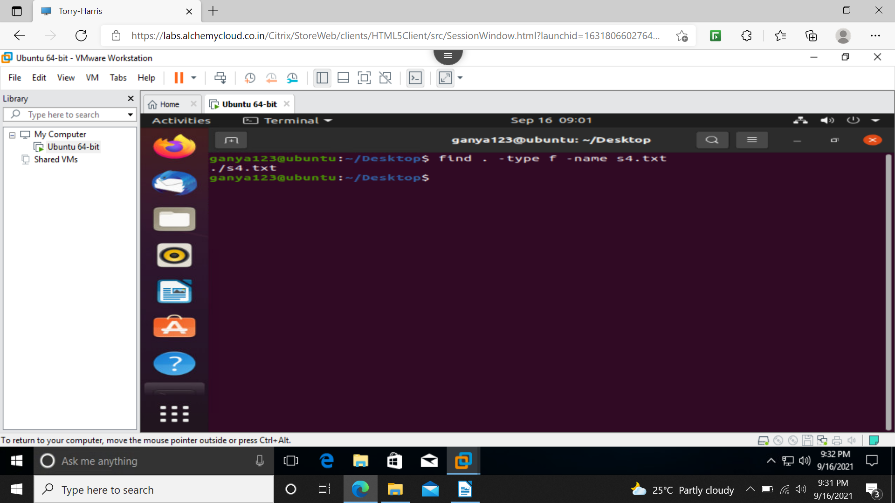

find . -type f -iname demo1.txt(both upper and lower case are displayed)
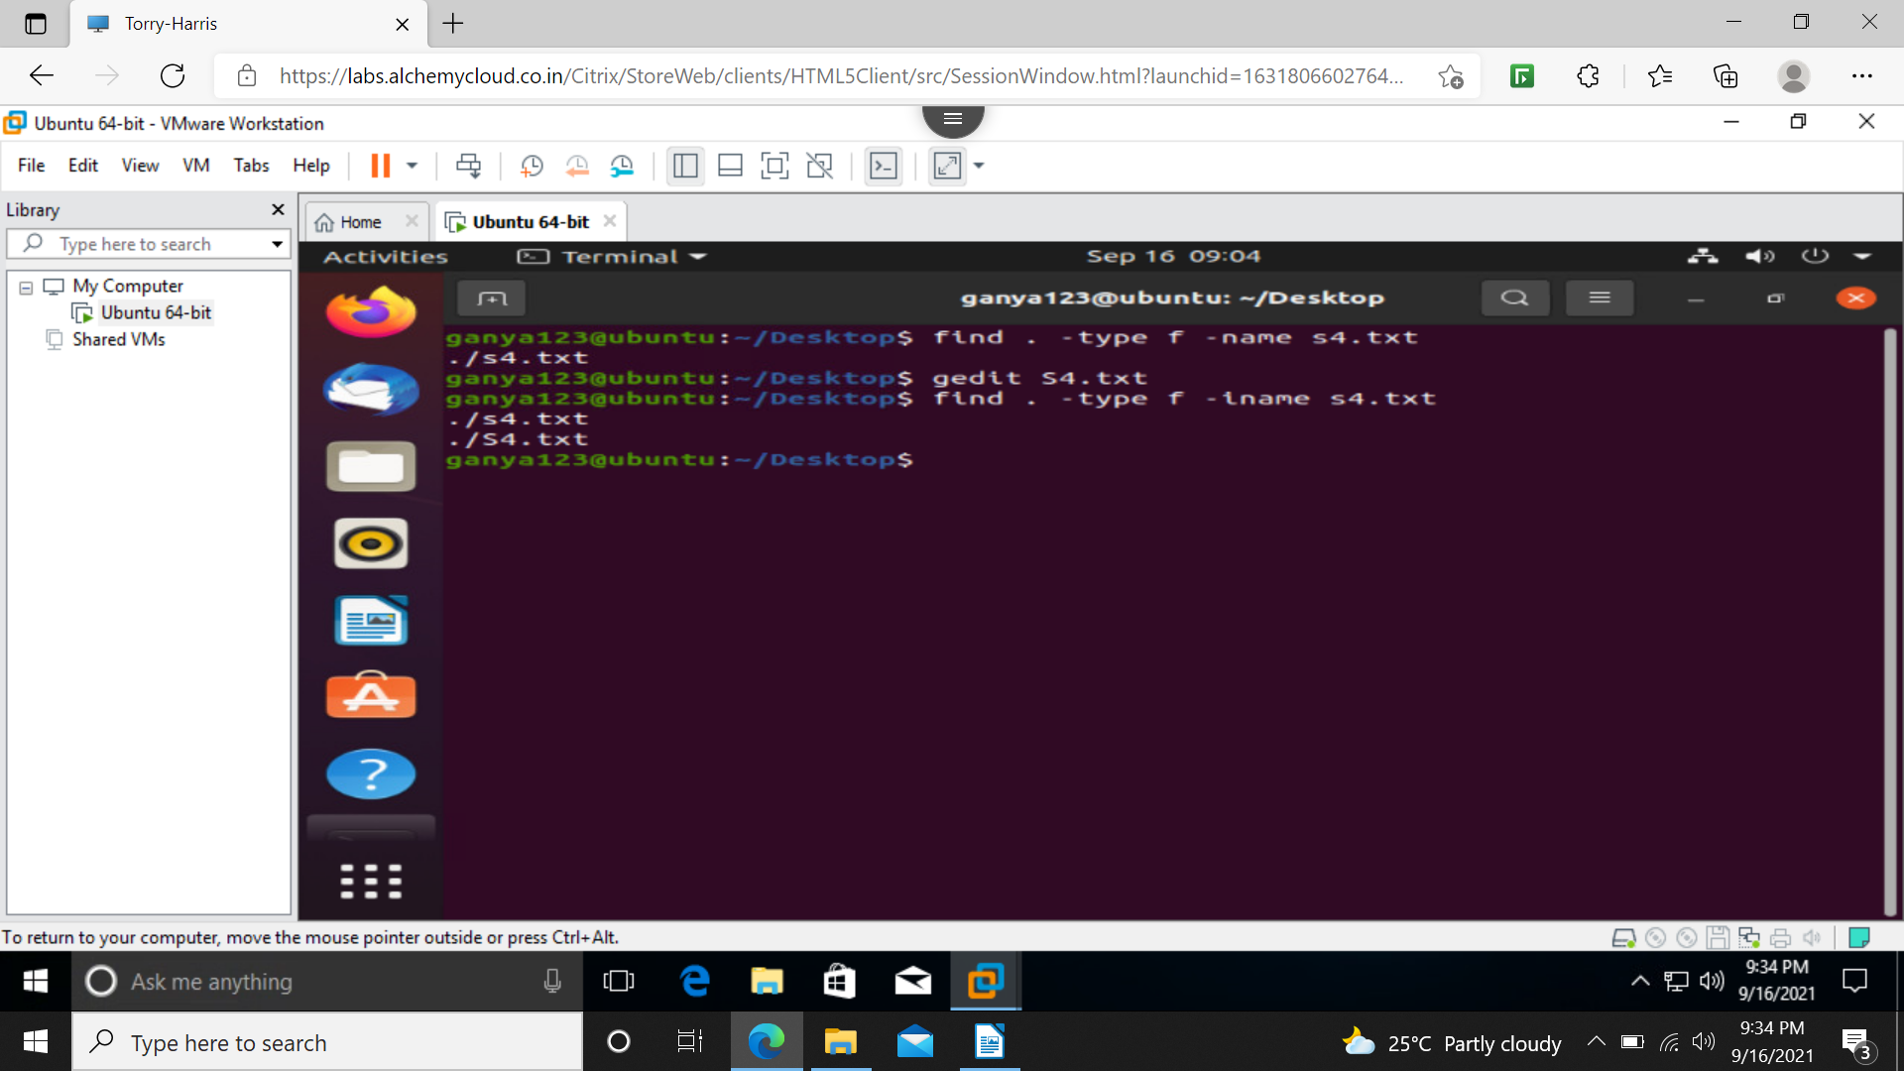
find . -type f -perm 777(files having 777 permission are displayed)
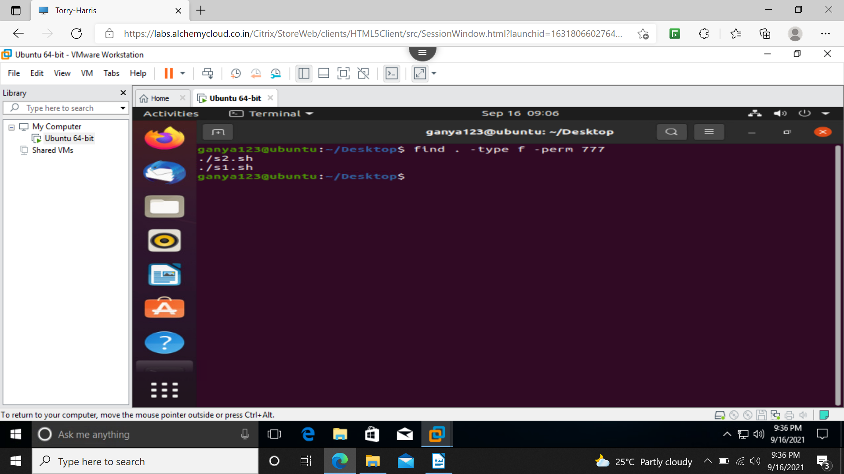
find . -type f -perm 0777 -exec chmod 555 {} \;(changing the permission)
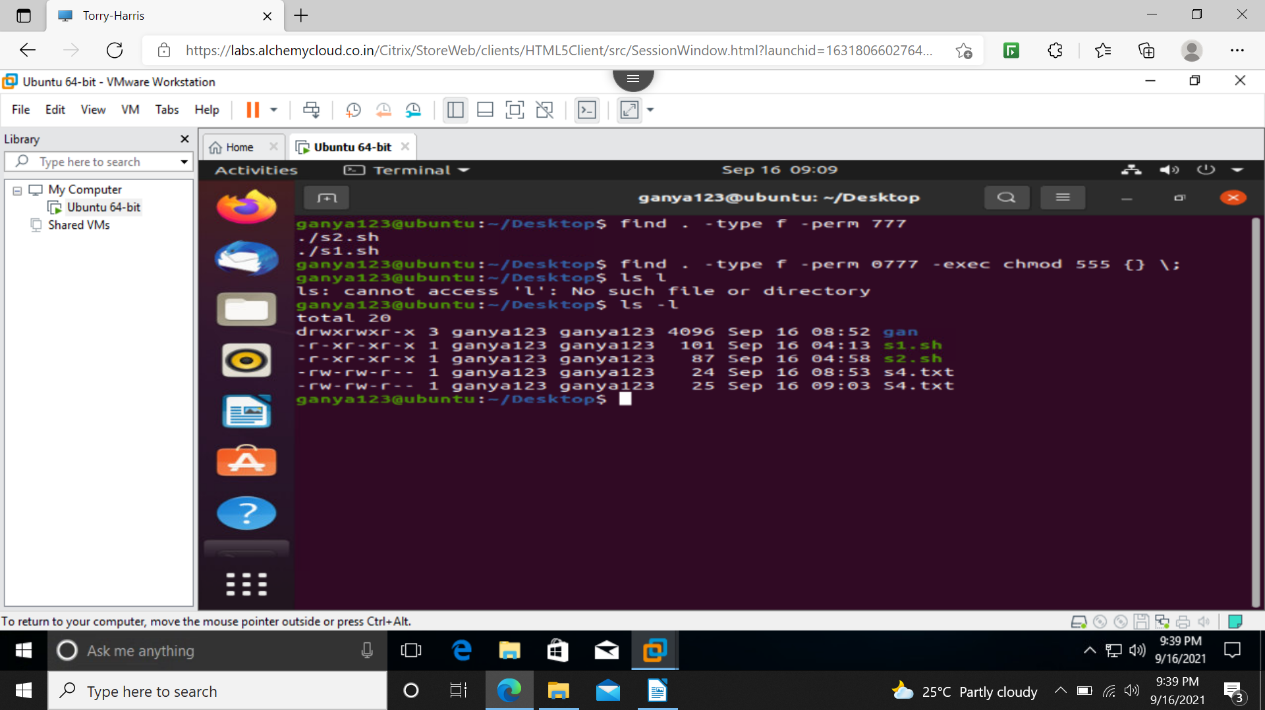
find . -mtime -1(within 24 hours) find . -mtime +1(24hours and after 24 hours)
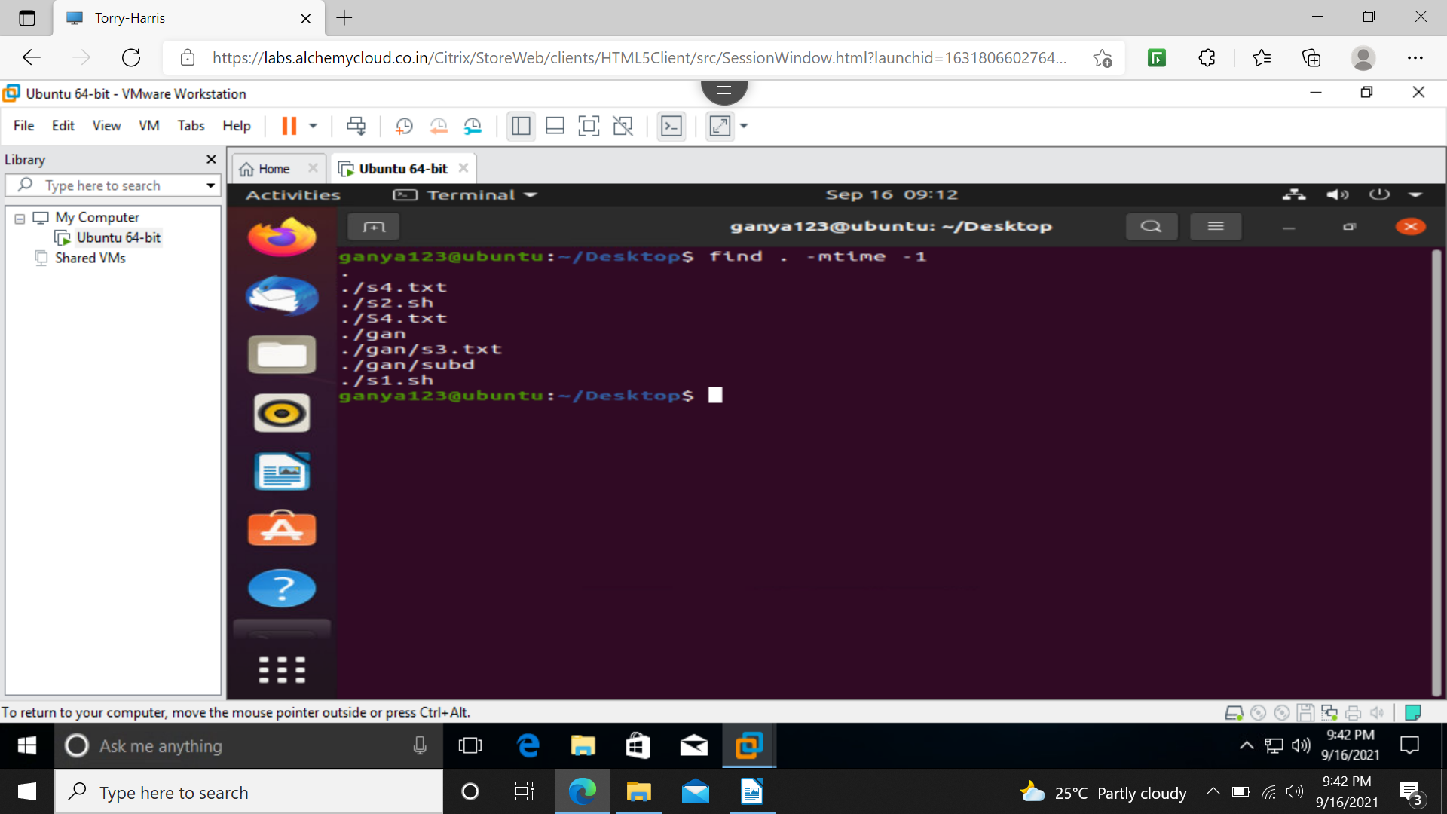
find . -mmin -1(before 1 min) find . -mmin +1(1min and after 1 min)
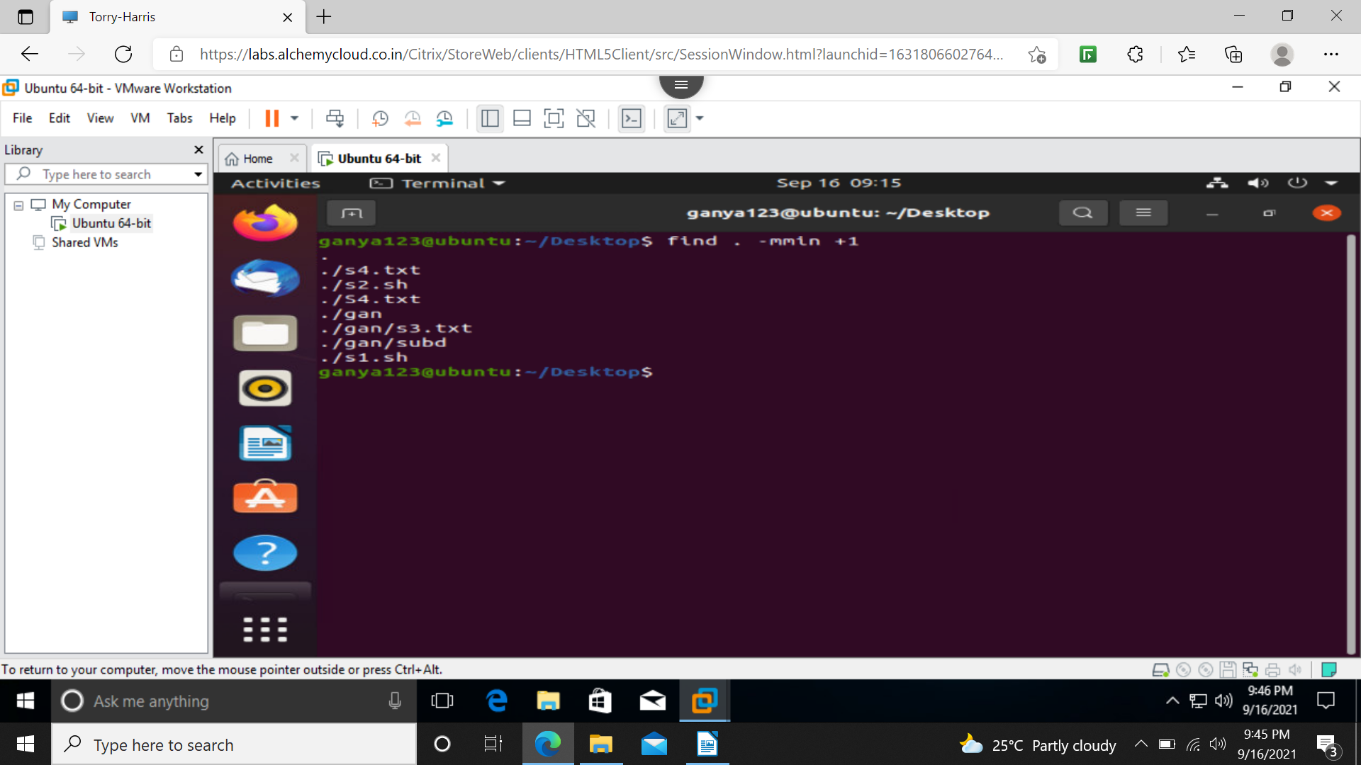
find . -size 1M (more than 1MB) find . -size -1M(less than 1MB)
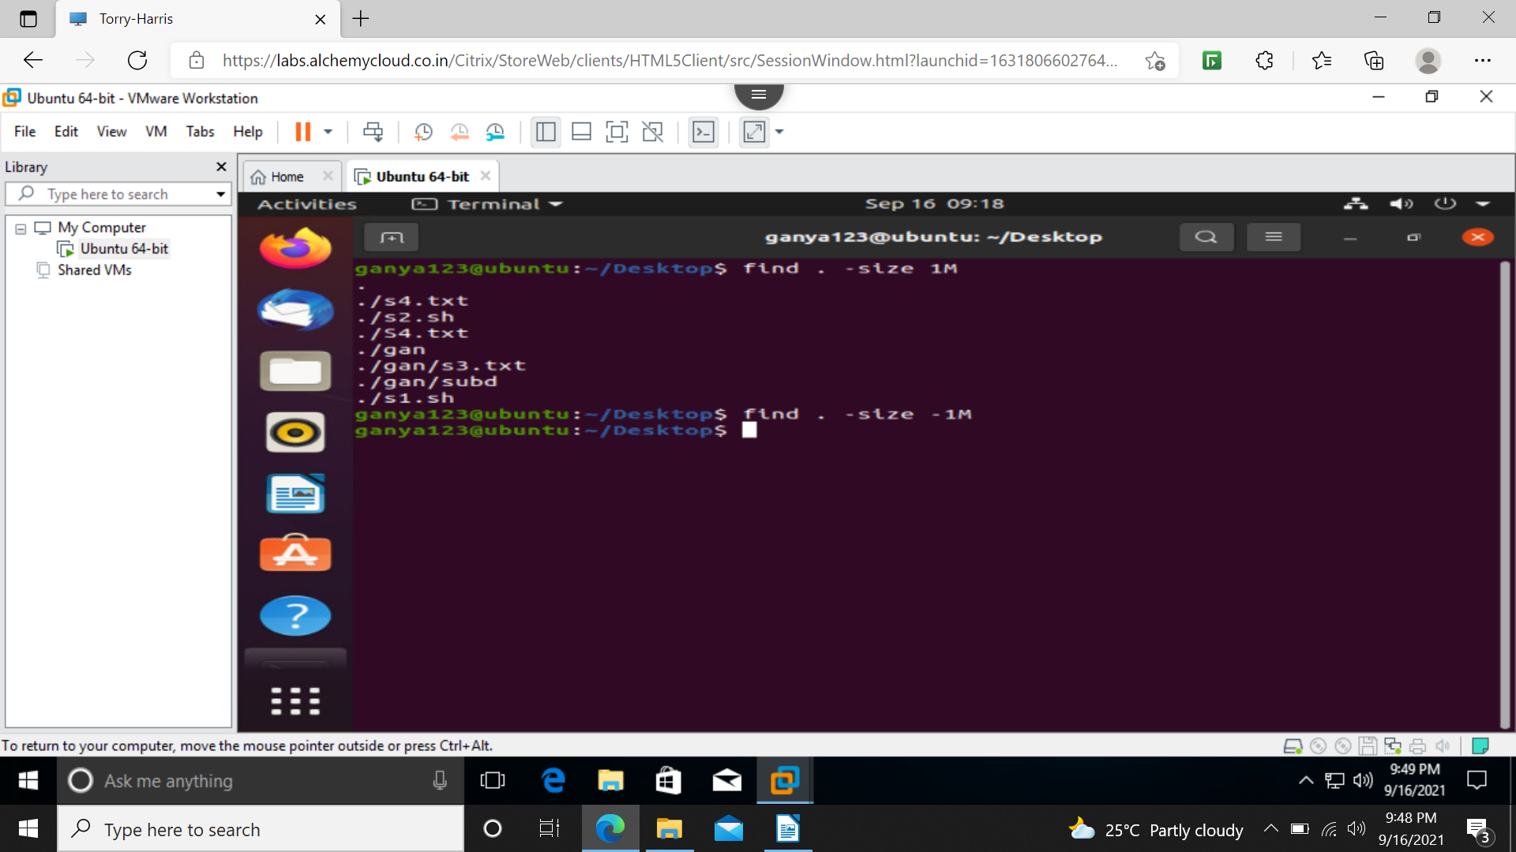

find . -type f -name “d*”(STARTING d FOLLOWED BY ANYTHING)
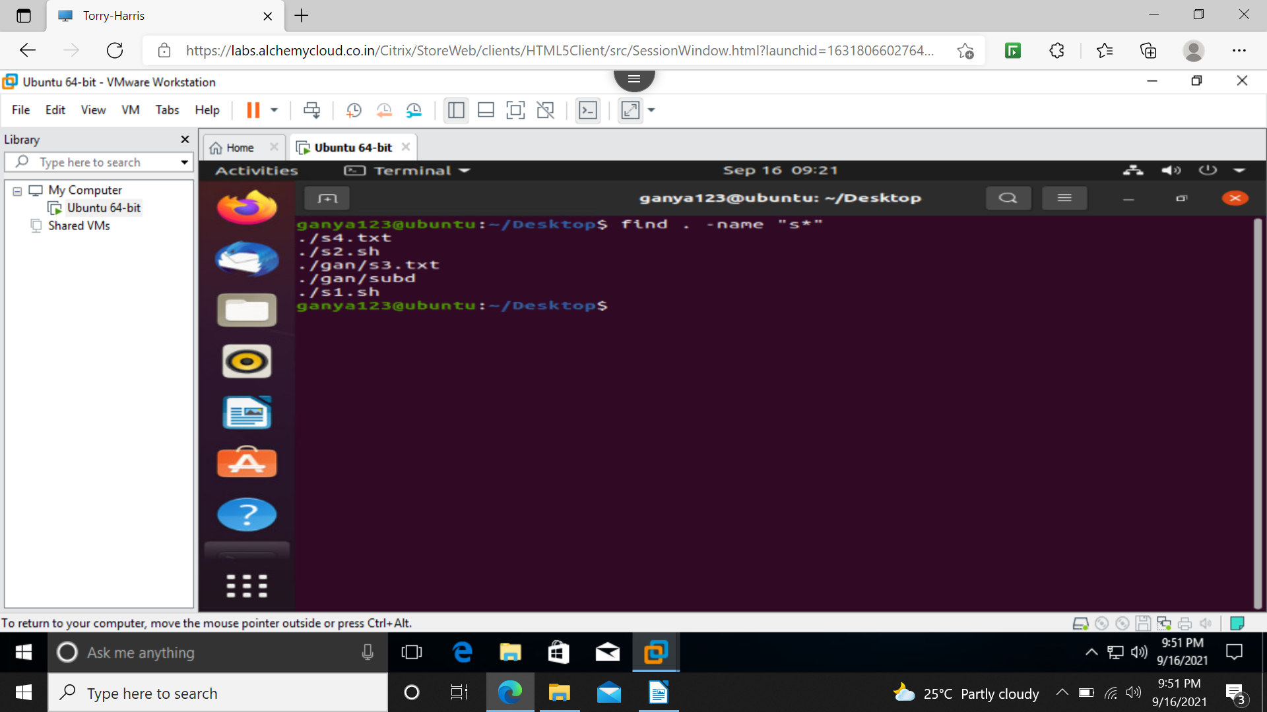
concatination
input from user
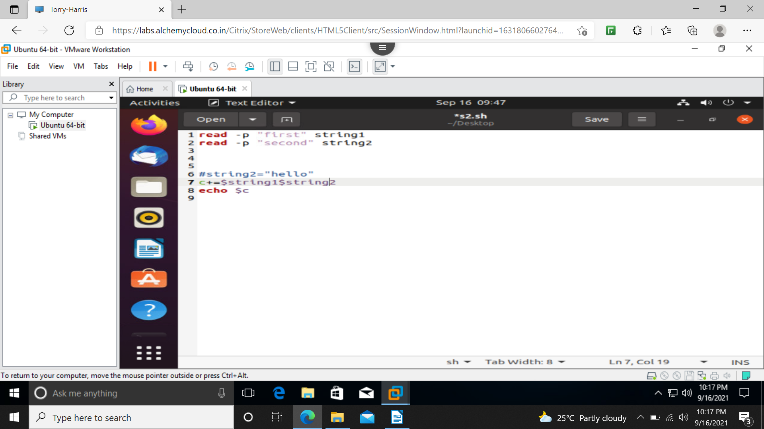
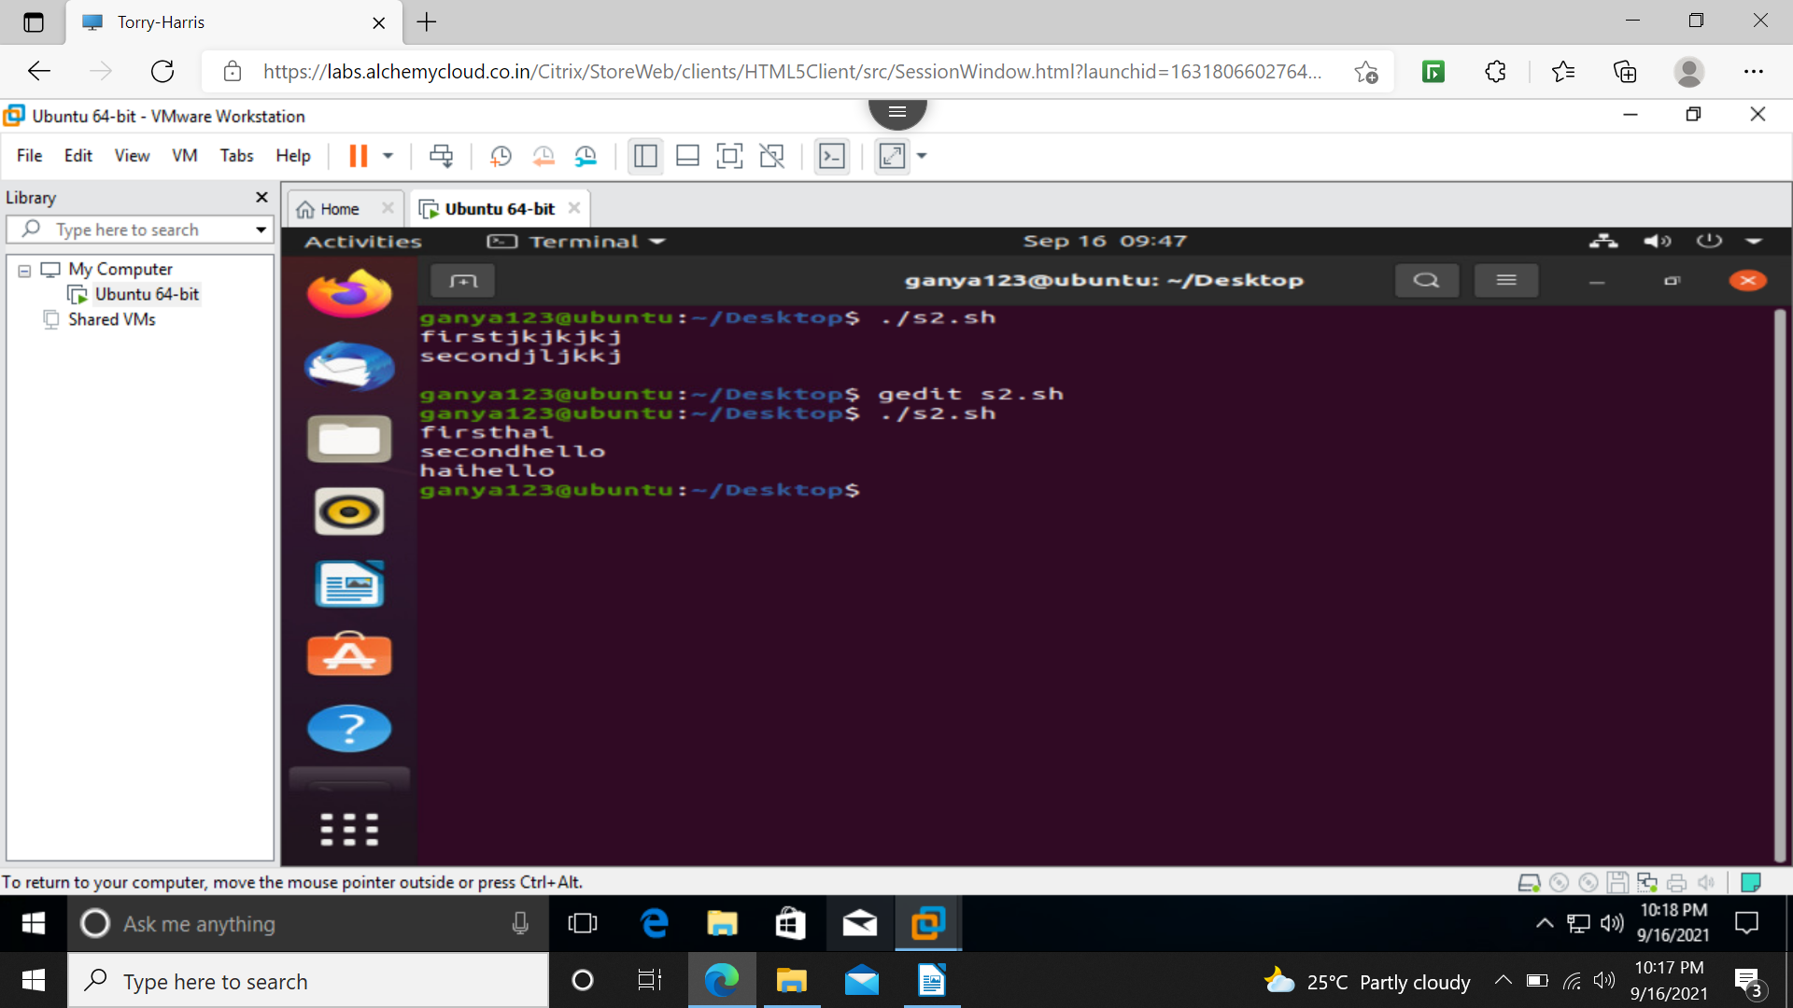
cocatination
command line
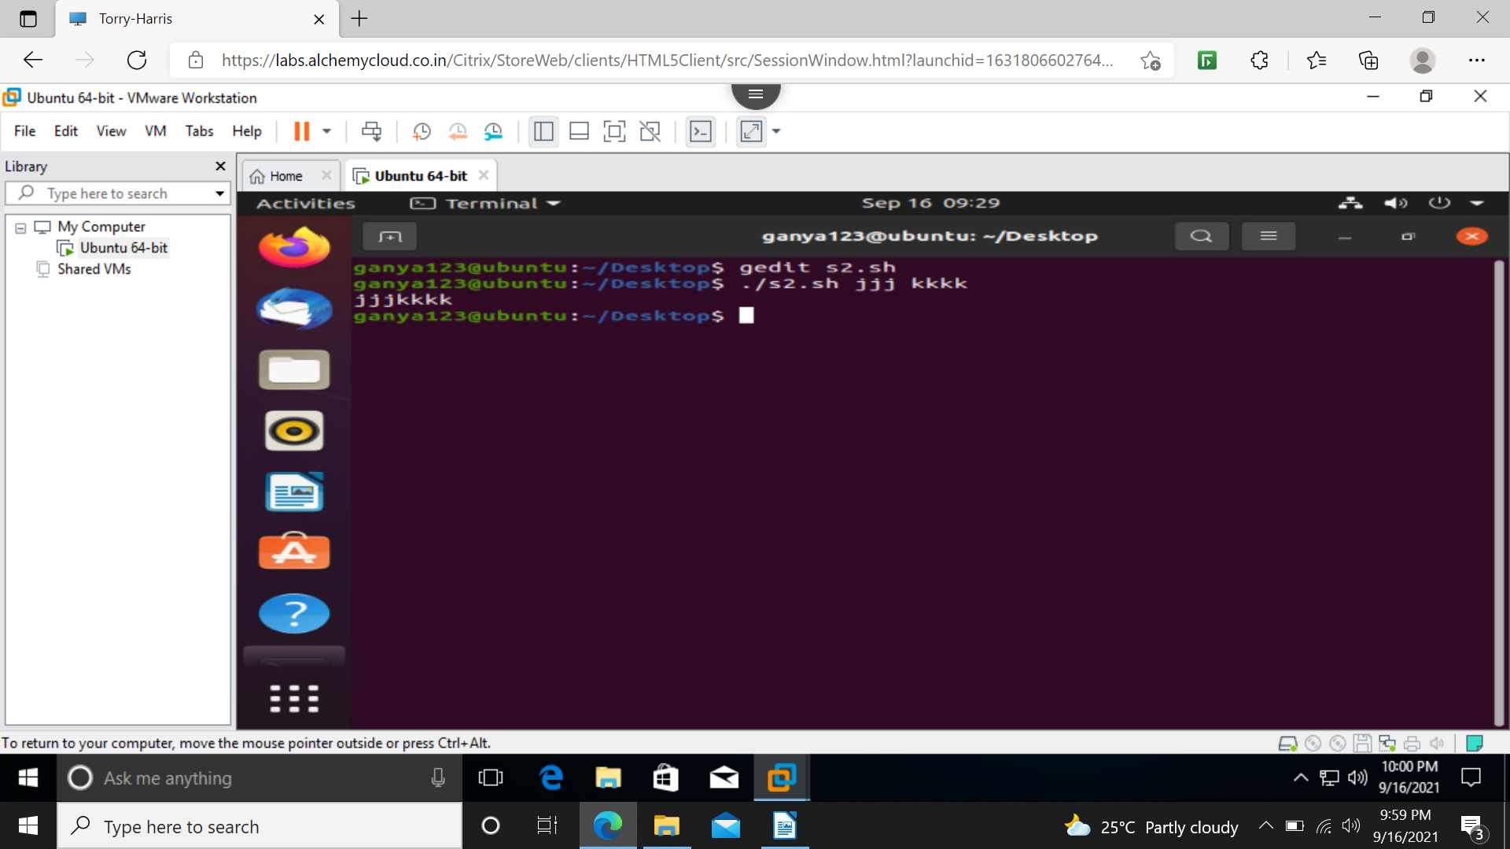
concatination
direct input
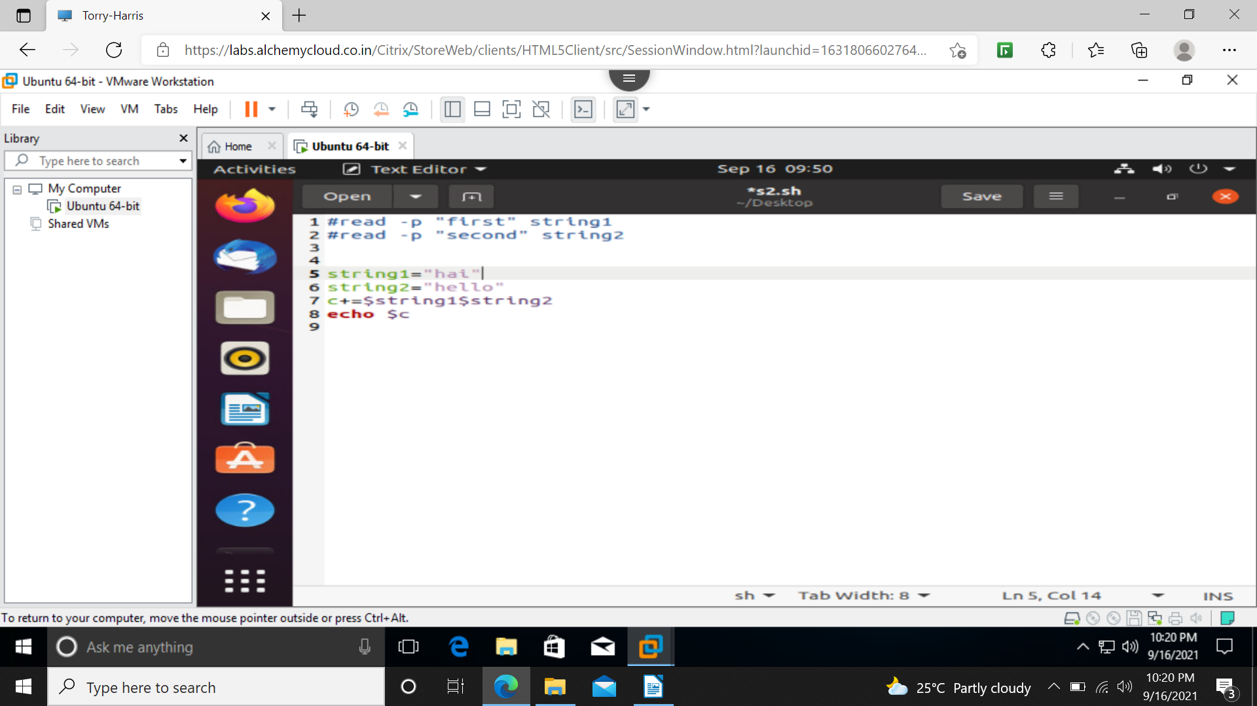
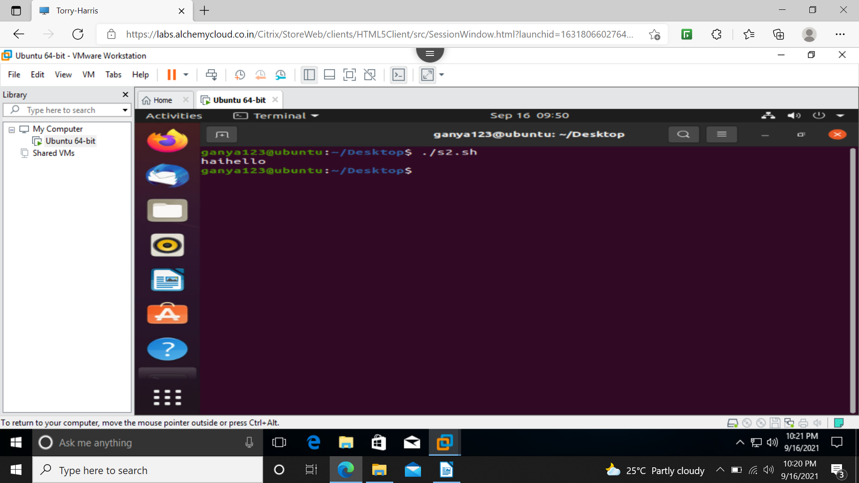
addition
input from user
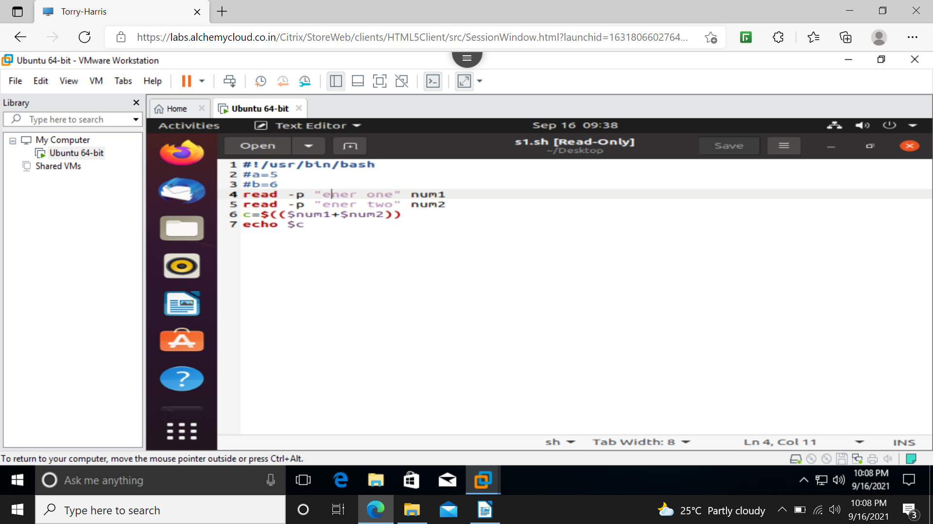
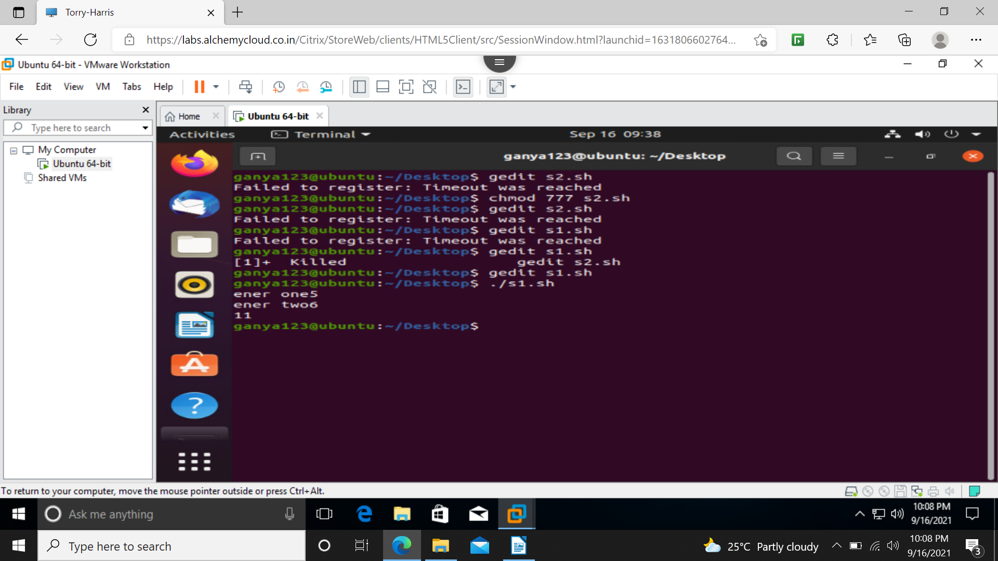
addition
directly specifying the values
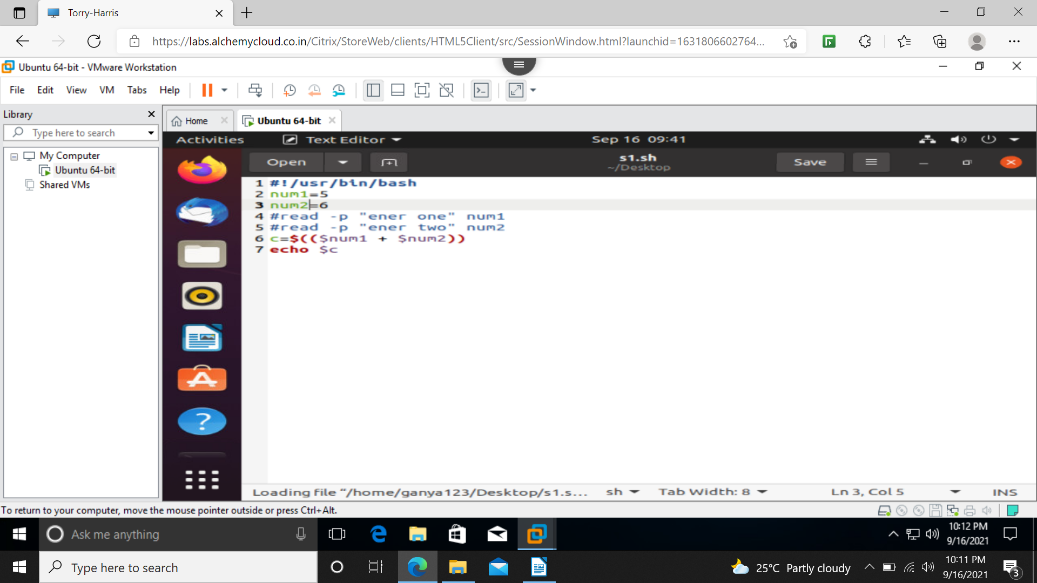
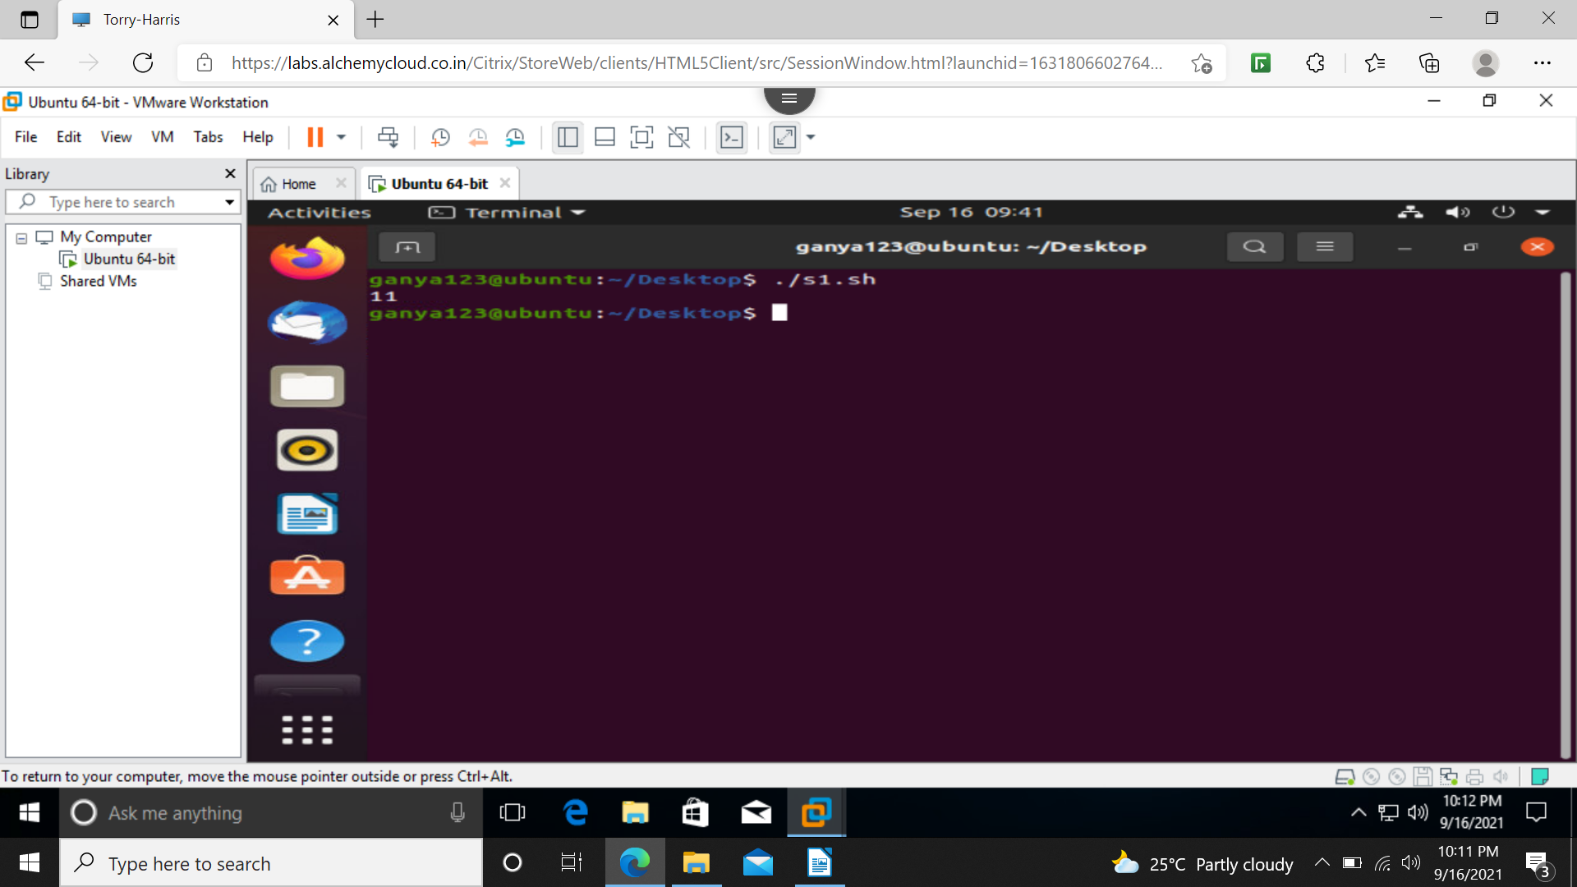
addition
command line input
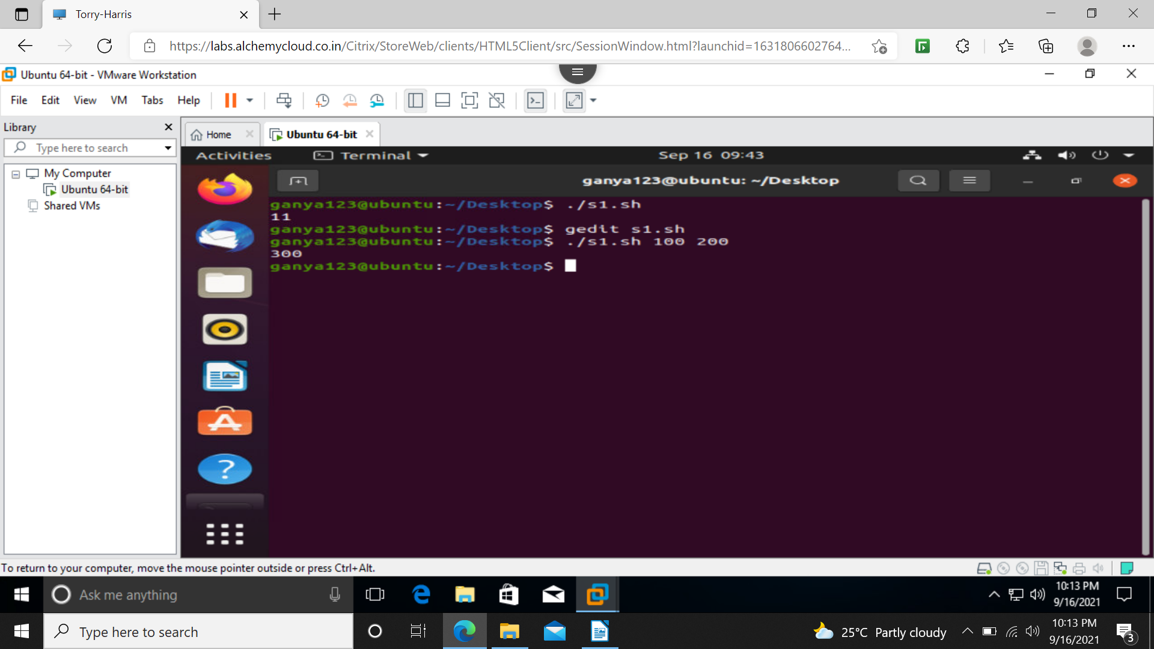
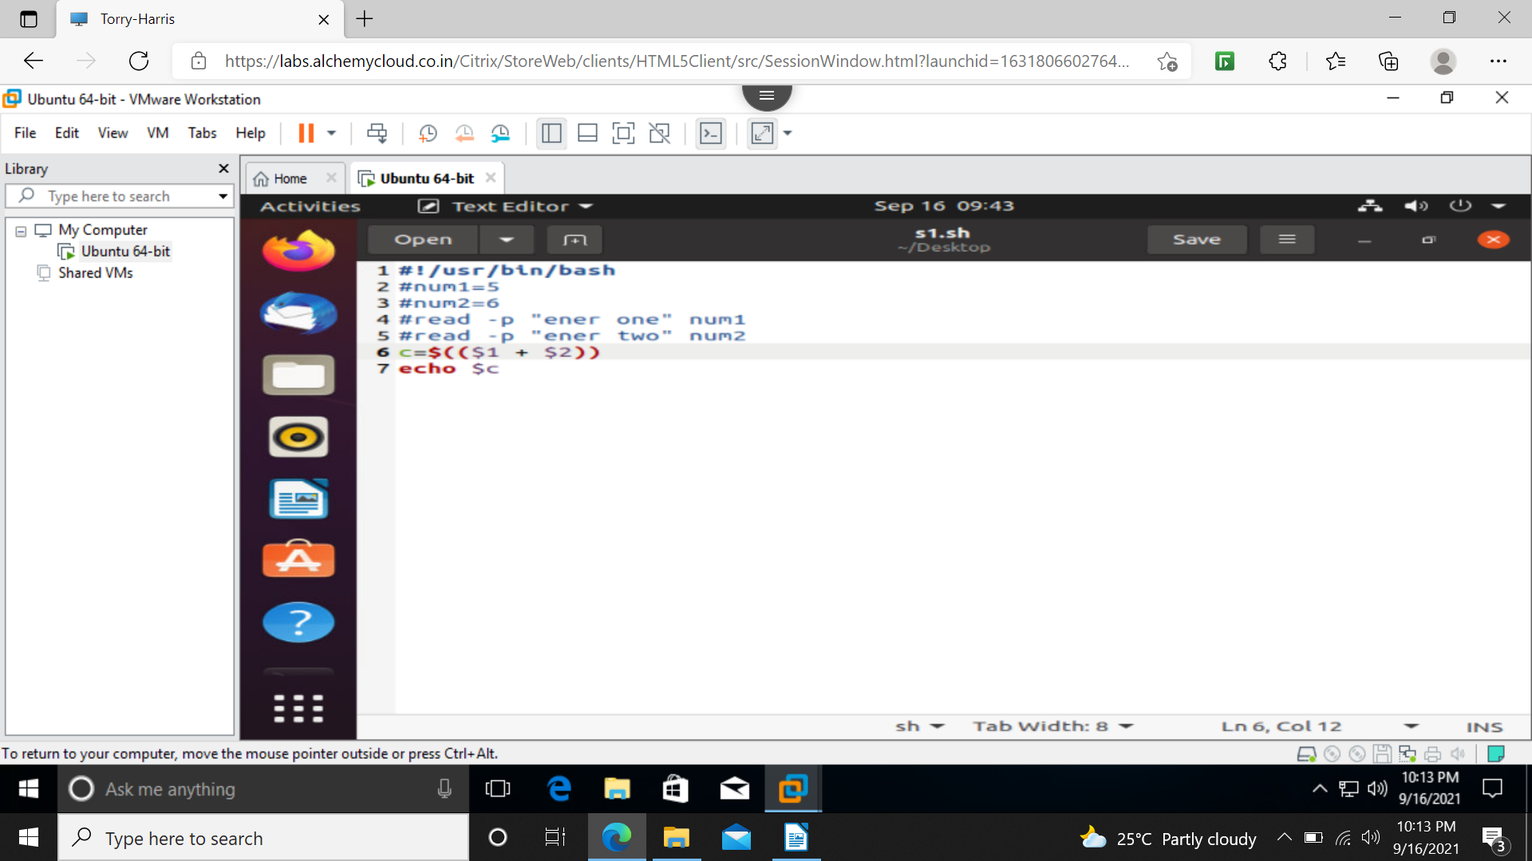
printing a word(main thing is to change the permission of file)


