1 create a table
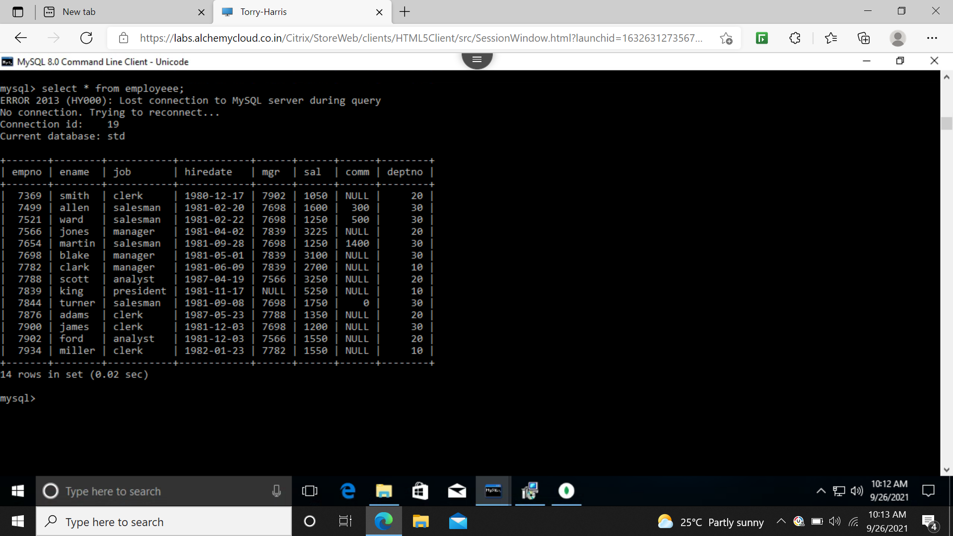
2 select the employees in department 30
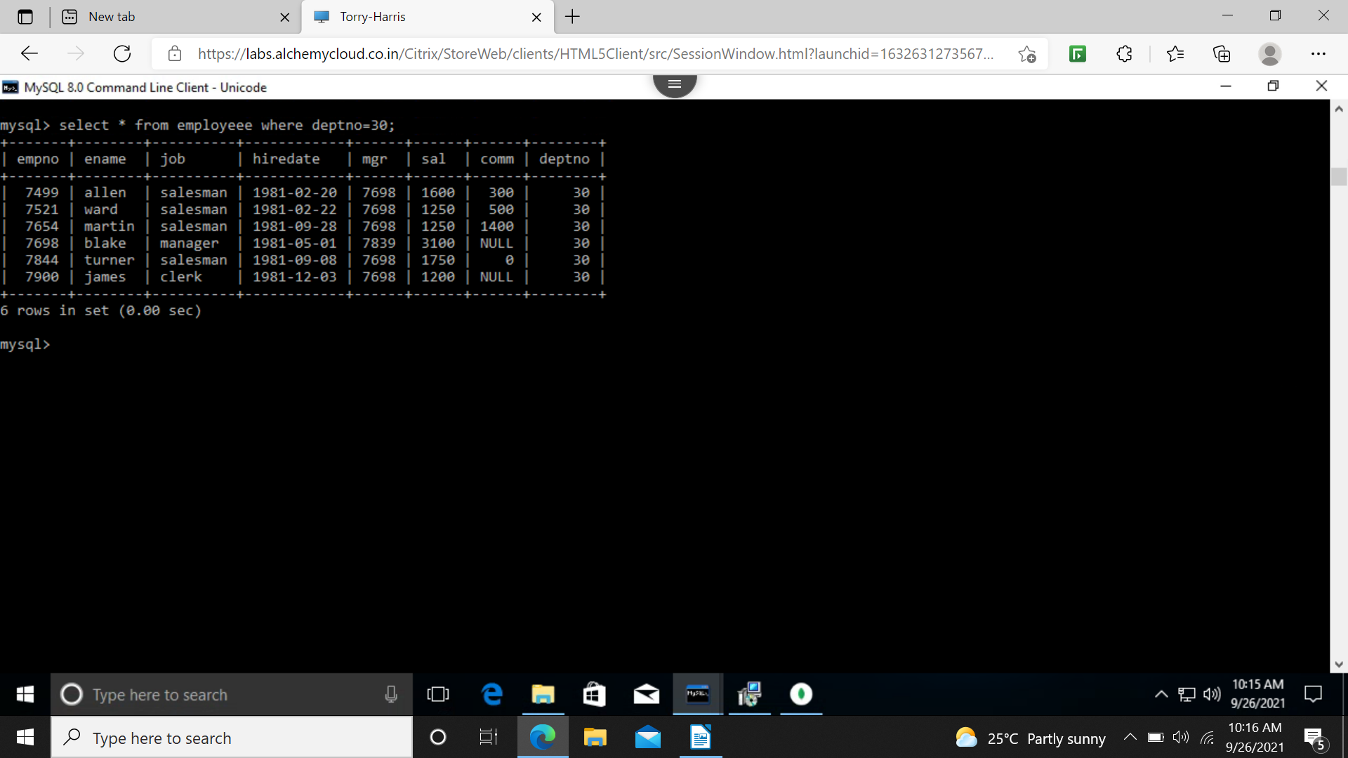
3 list the names,numbers and department of all clerk
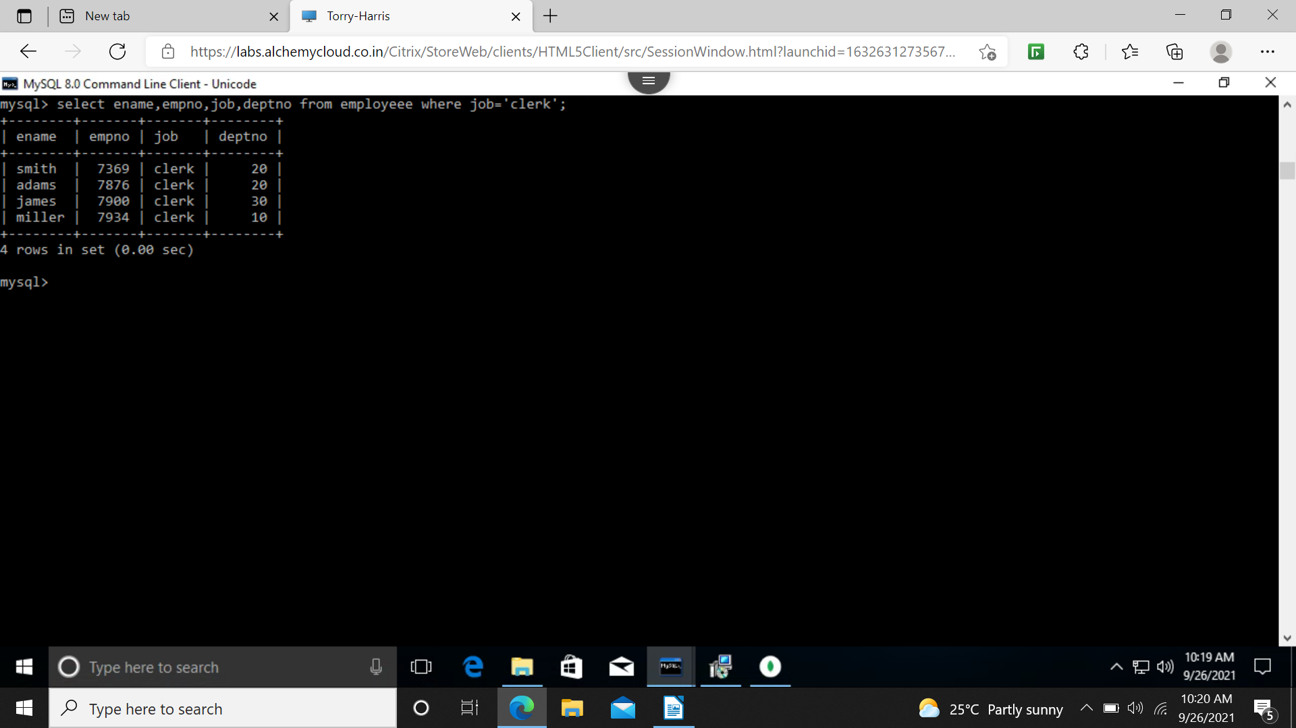
4 find the department no and names of employee of all department with deptno>20
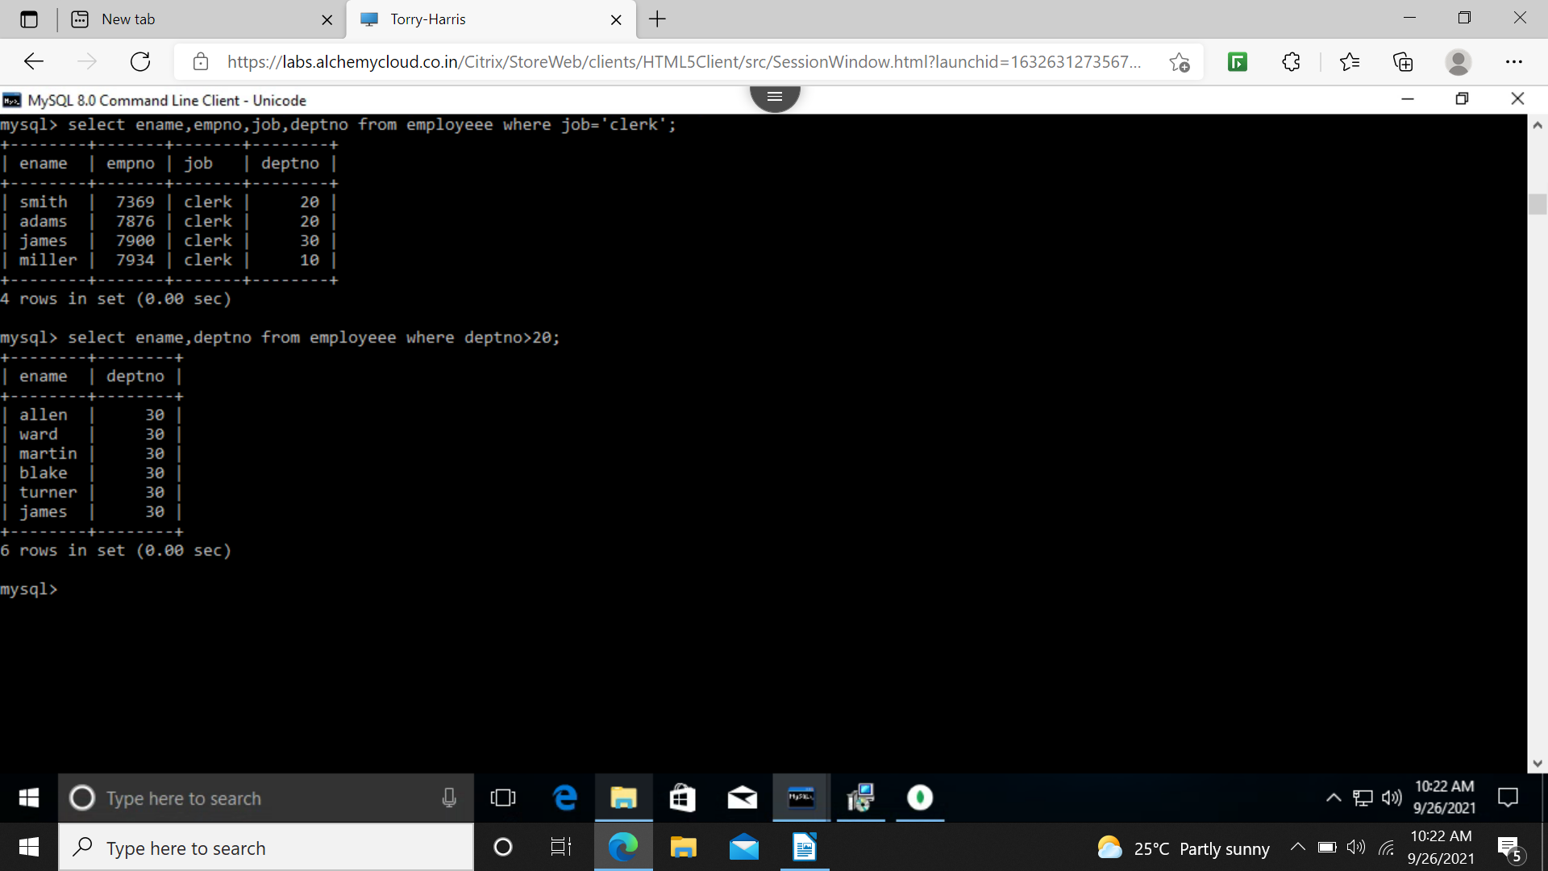
5 find employees whose commission is greater than their salary
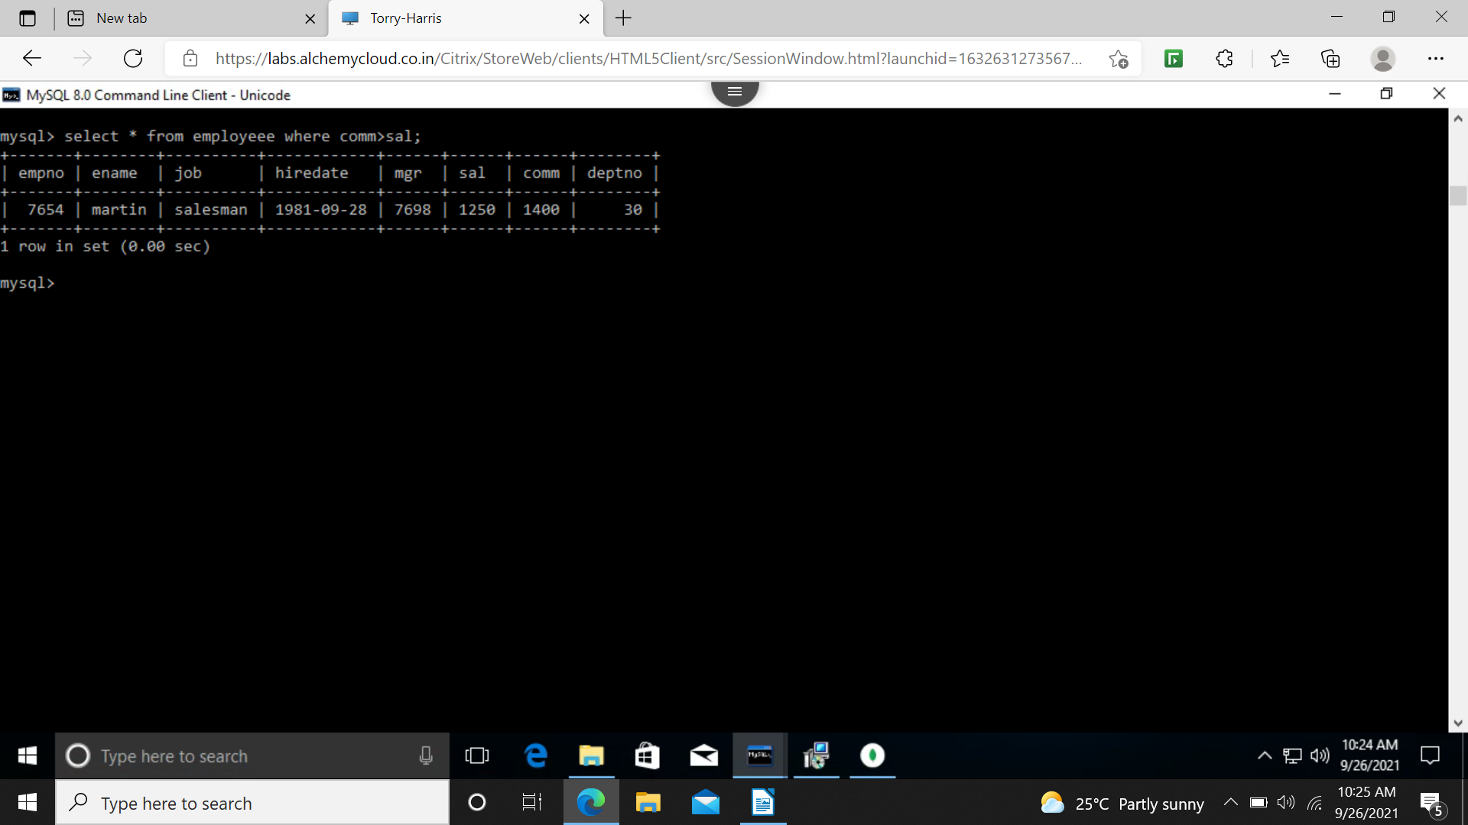
6 find the employees whose commission is greater than 60% of their salary
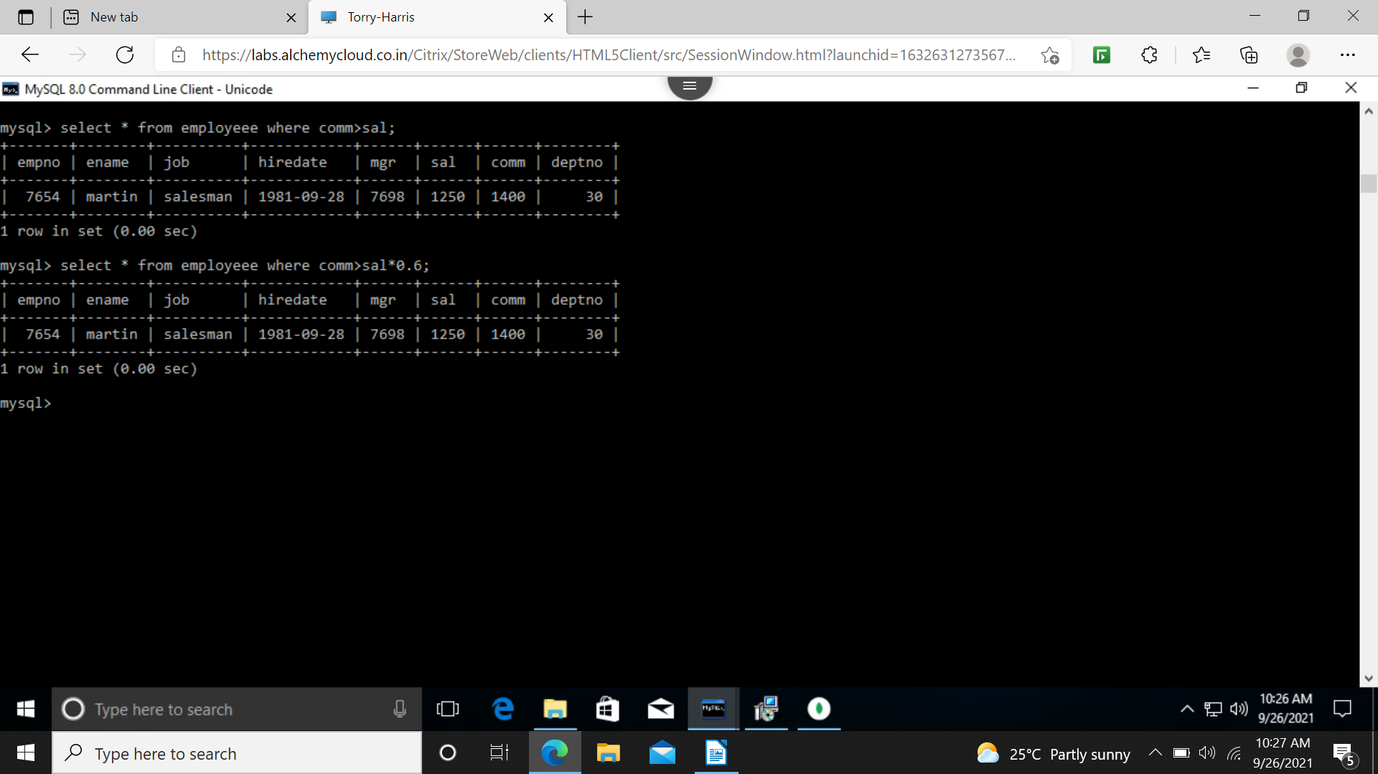
7 list name,job and salary of all employees in department 20 and earn more than 2000
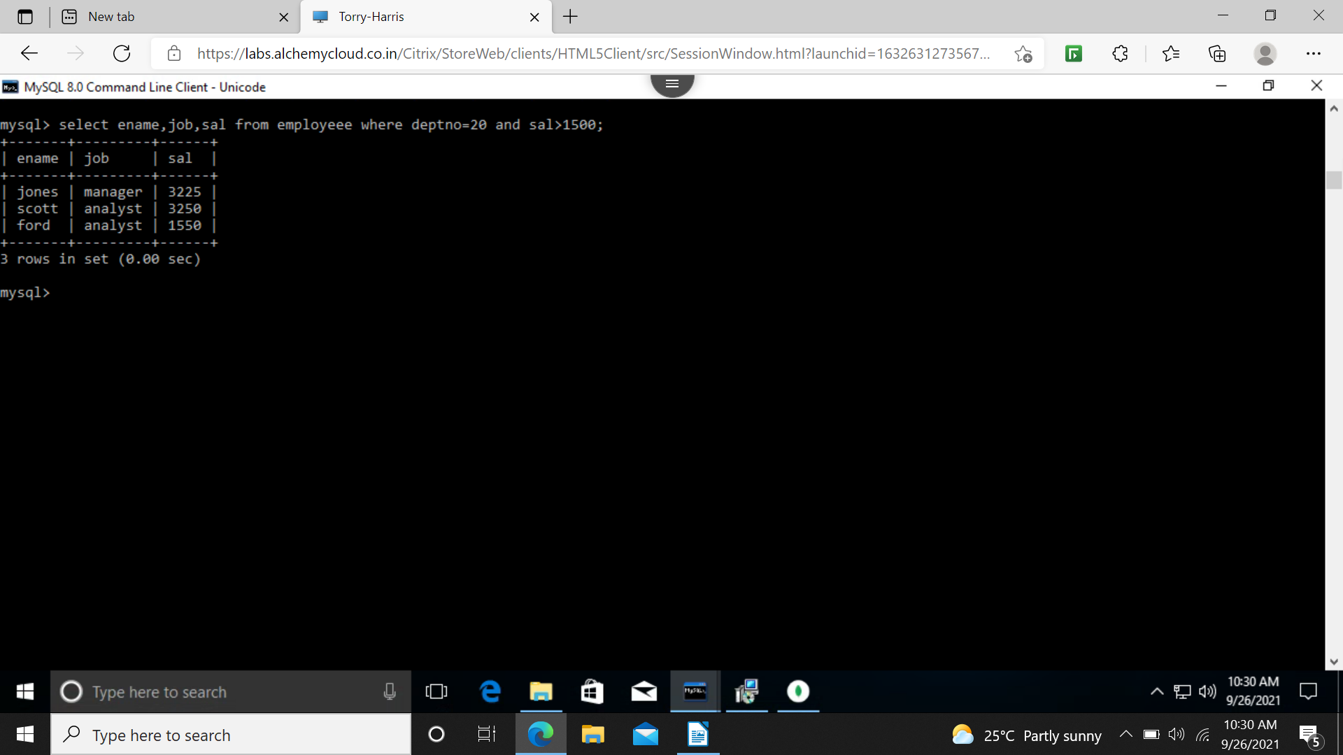
8 find all salesman in department 30 whose salary > 1500
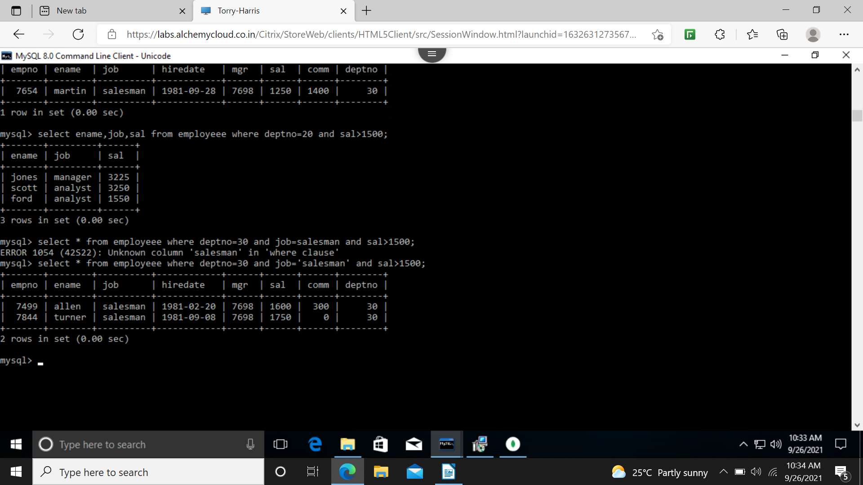
9 find all employee whose designation is either manager or president
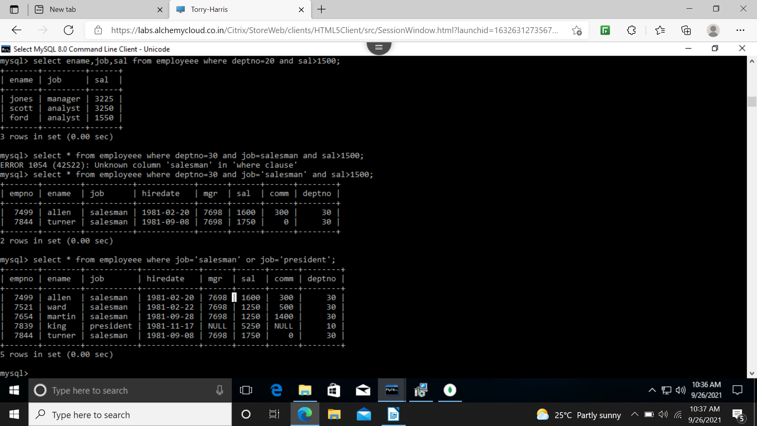
10 final all managers who are not in department 30
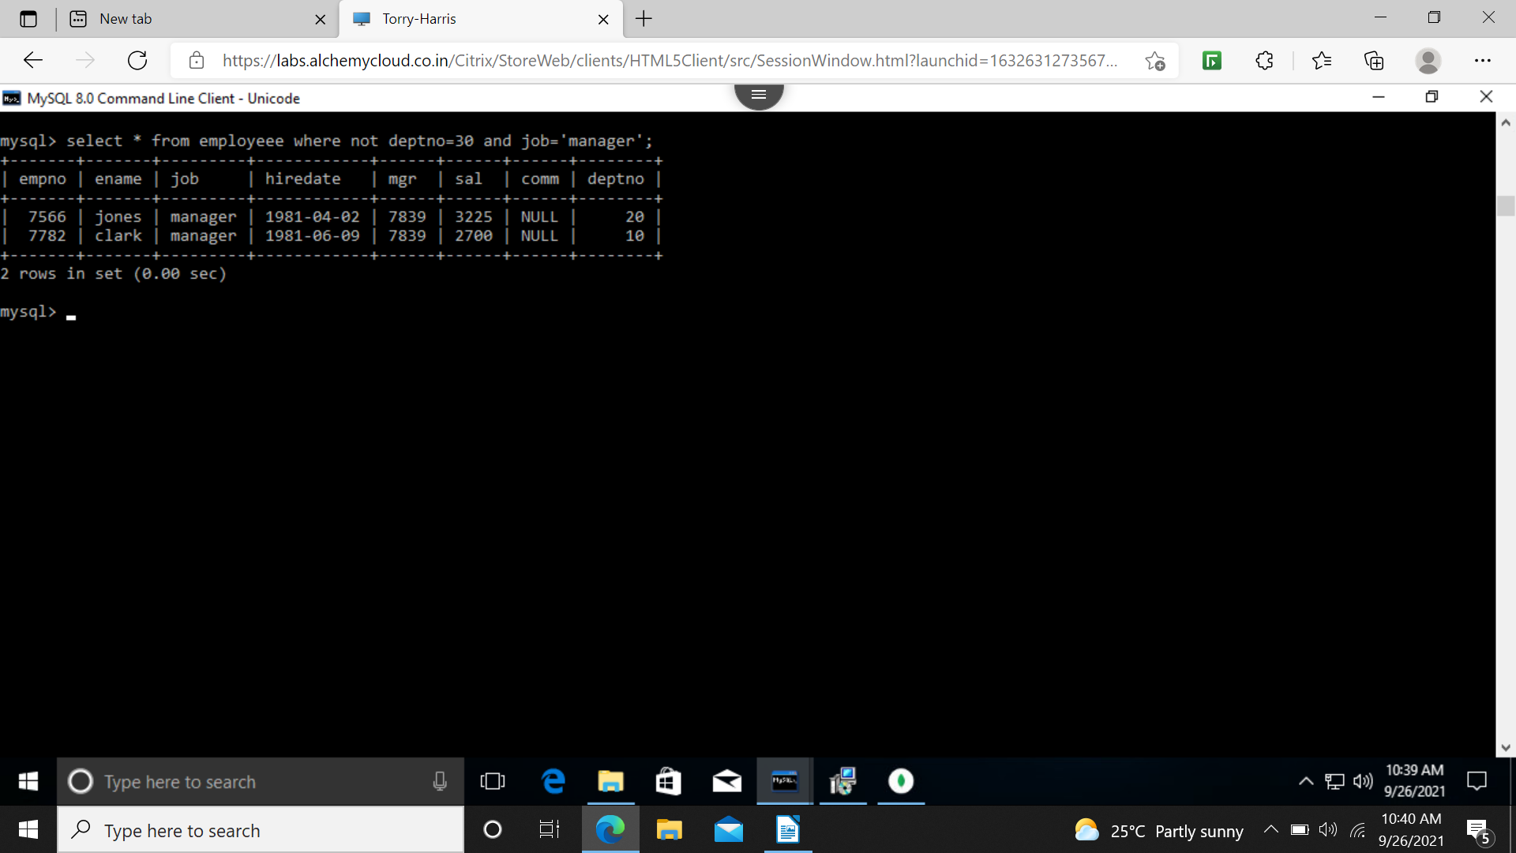
11 find all details of managers and clerks in dept 20
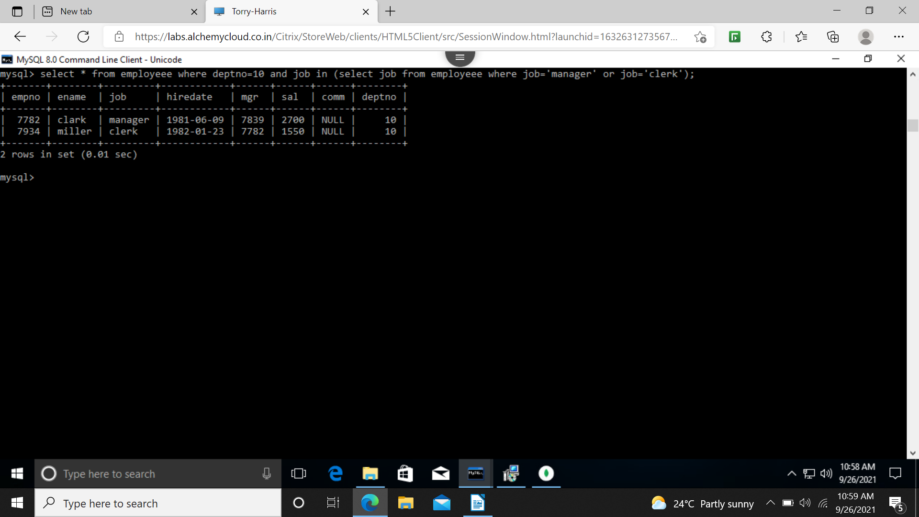
12 find all details of all managers in any dept and clerk of dept 20
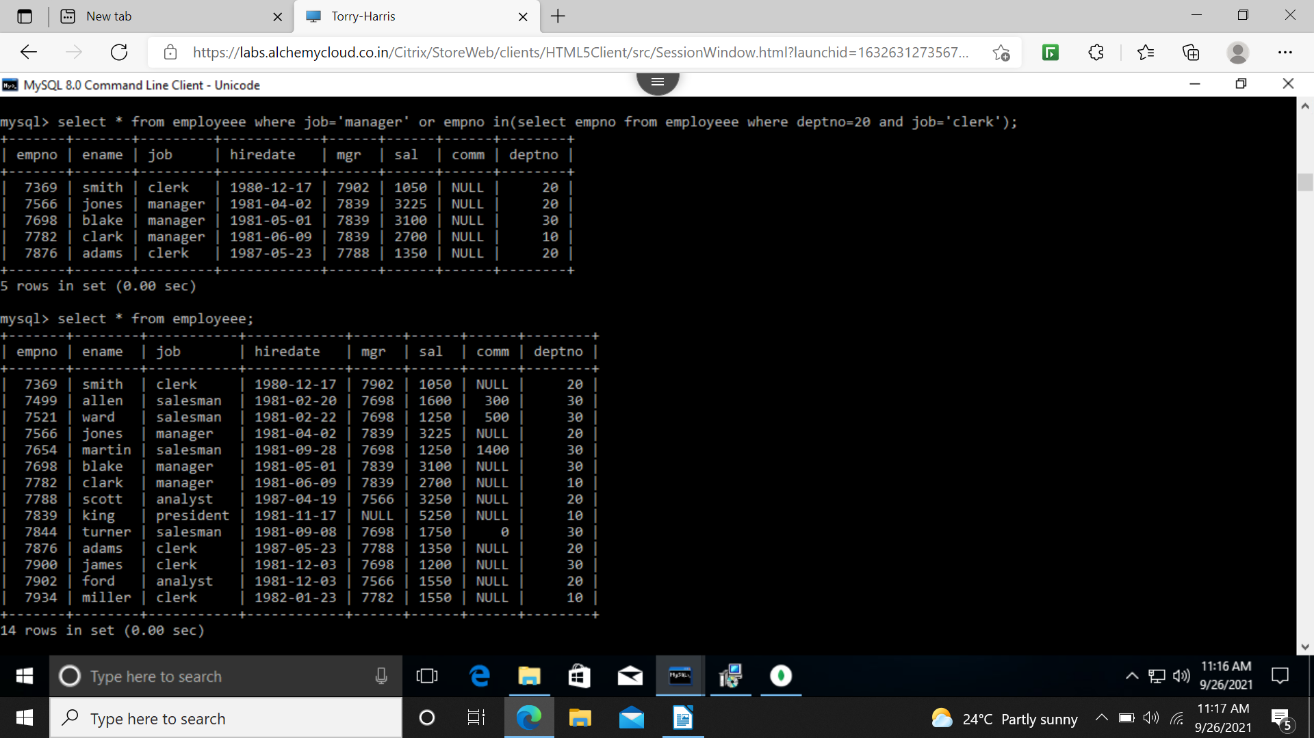
13
select * from employee where not job=’manager’ and not job=’clerk’ and deptno=10 or sal>2000;

14 employee in department 20 neither clerk nor managers

15 names of employee earn between 1200 and 1400
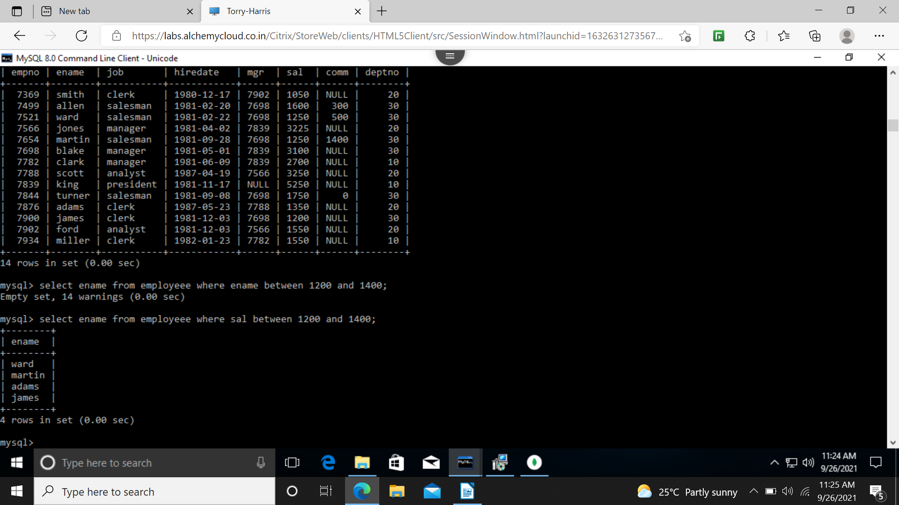
16 find the employees who are clerk , analysts or salesman
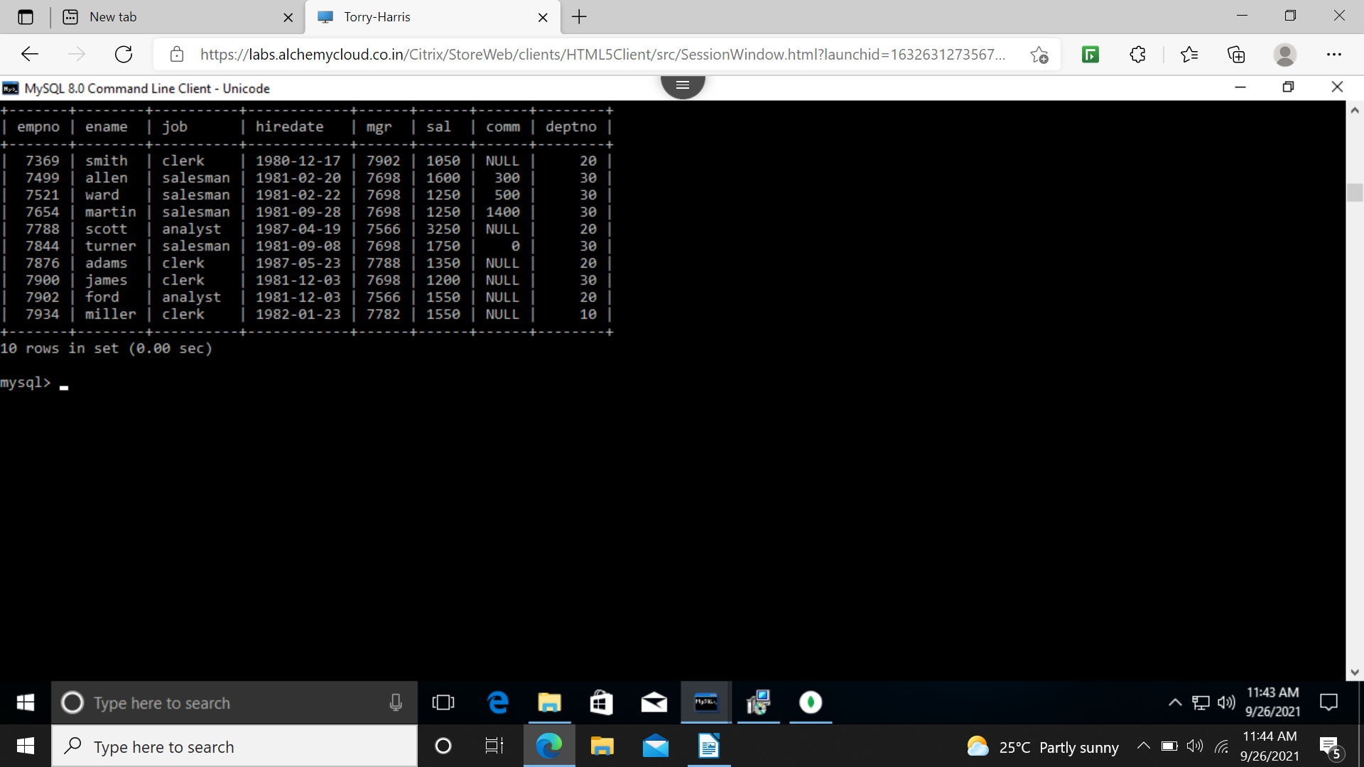
17 find the employees who are not clerk ,not analysts or not salesman
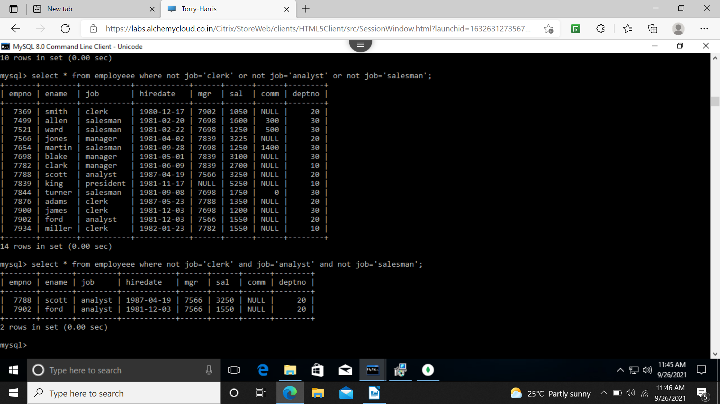
18 find employees who dint receive commission
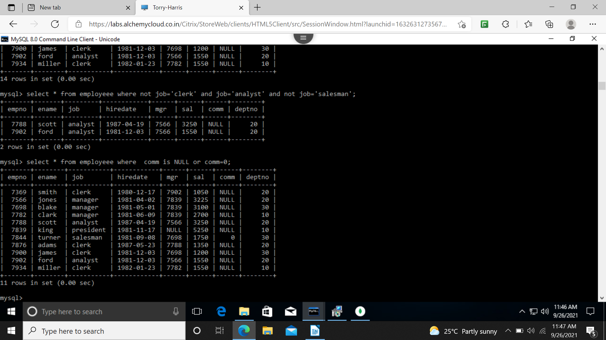
19 find the different jobs of employee receiving commission
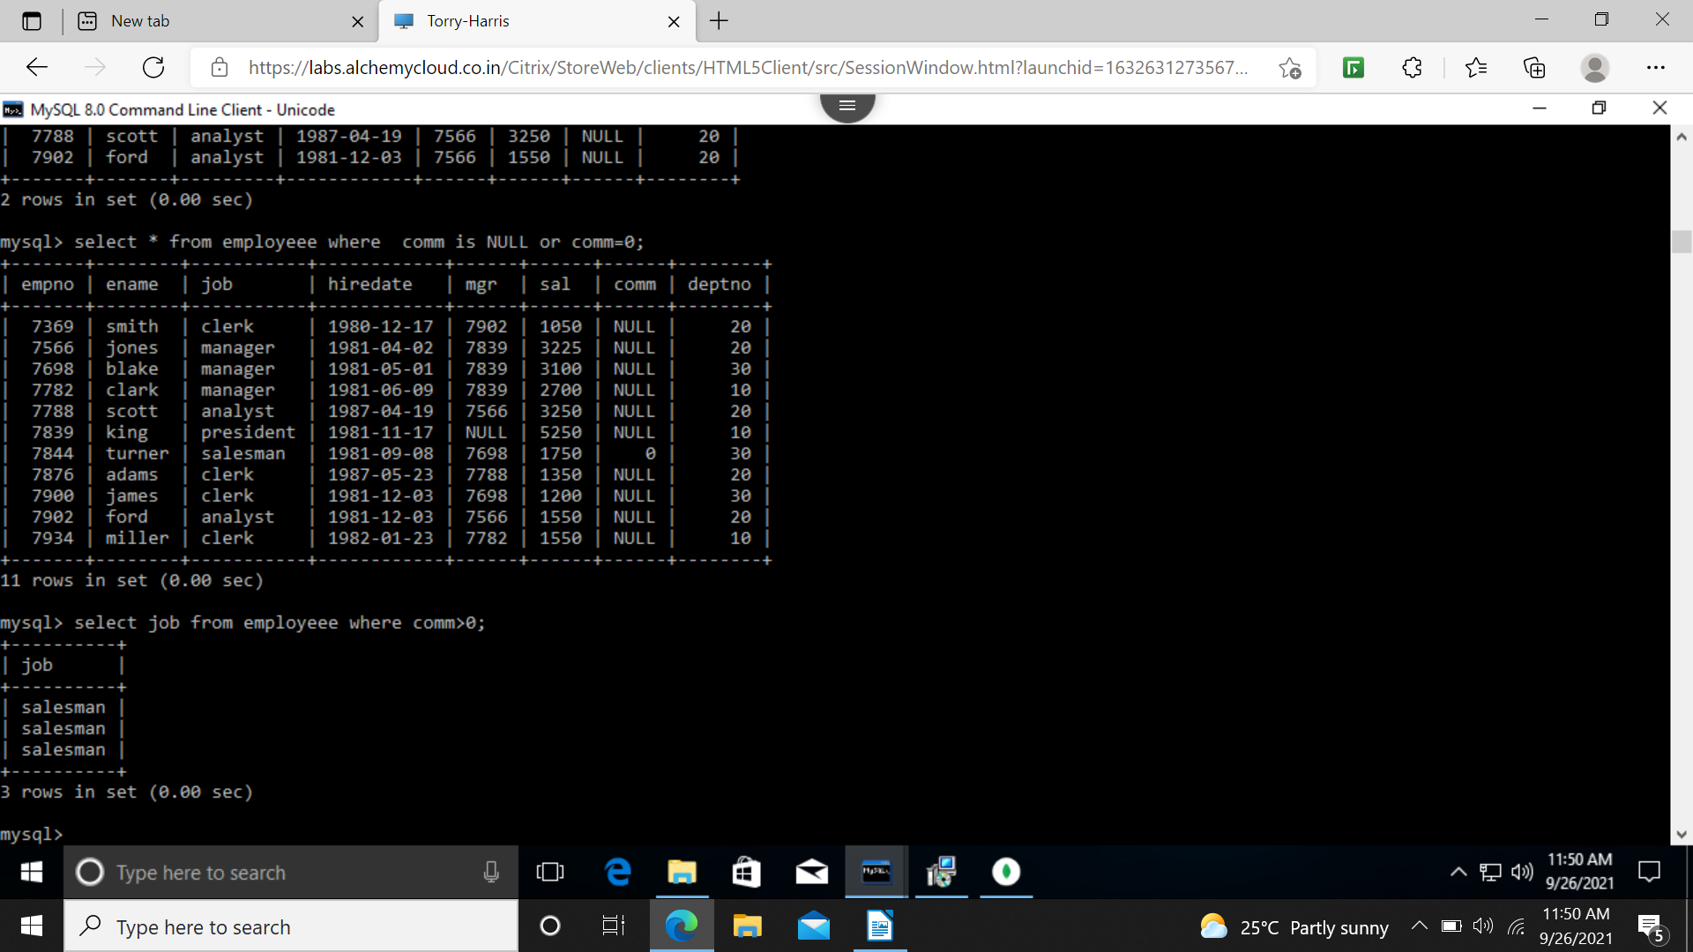
20 employee don't receiving commission and commission<100
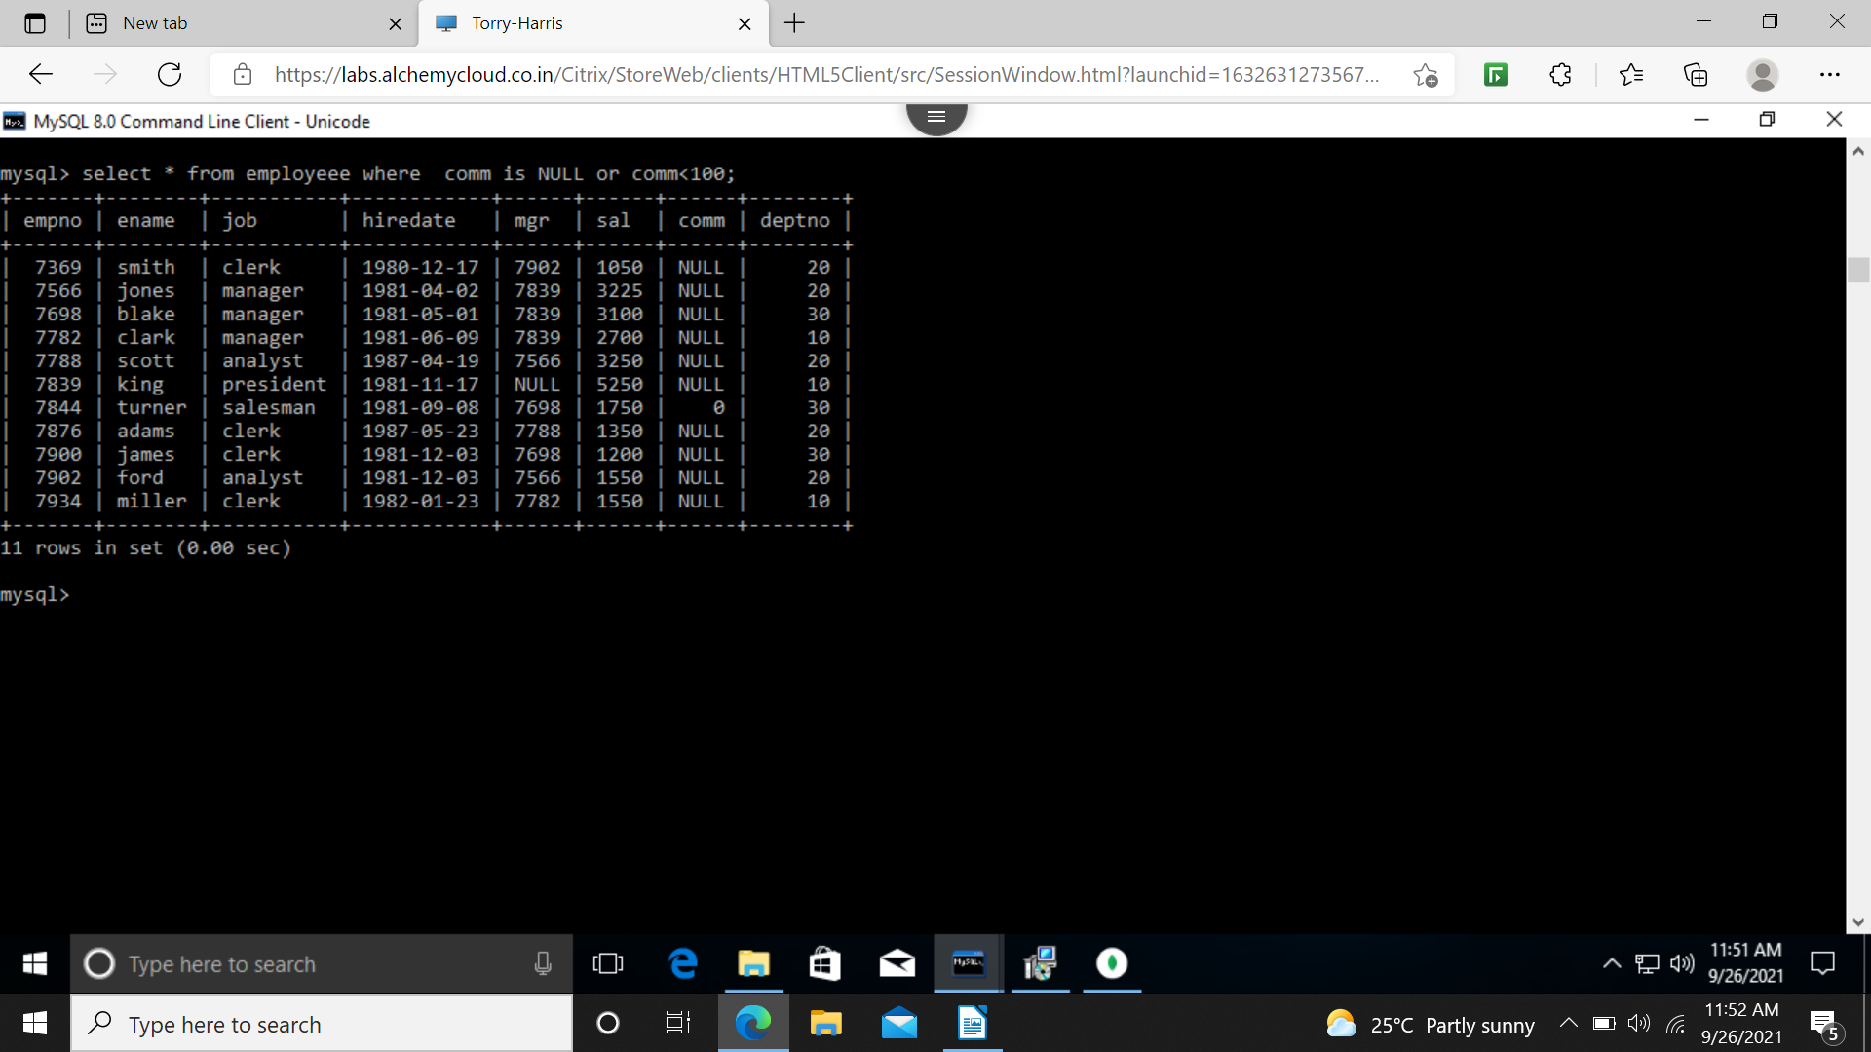
21 employee not receiving commission entitled for a bonus of 250
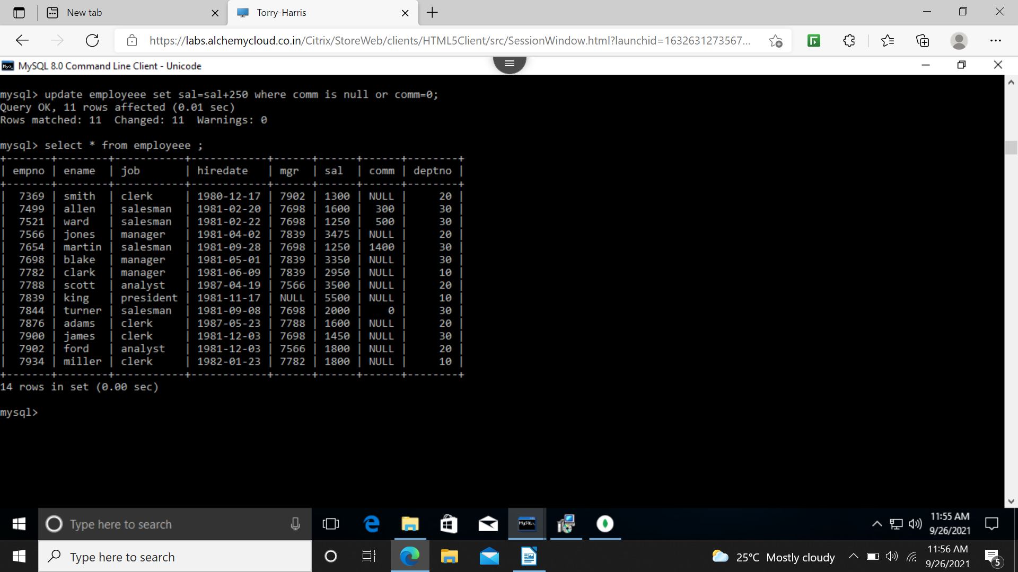
22 employee earning > 2000
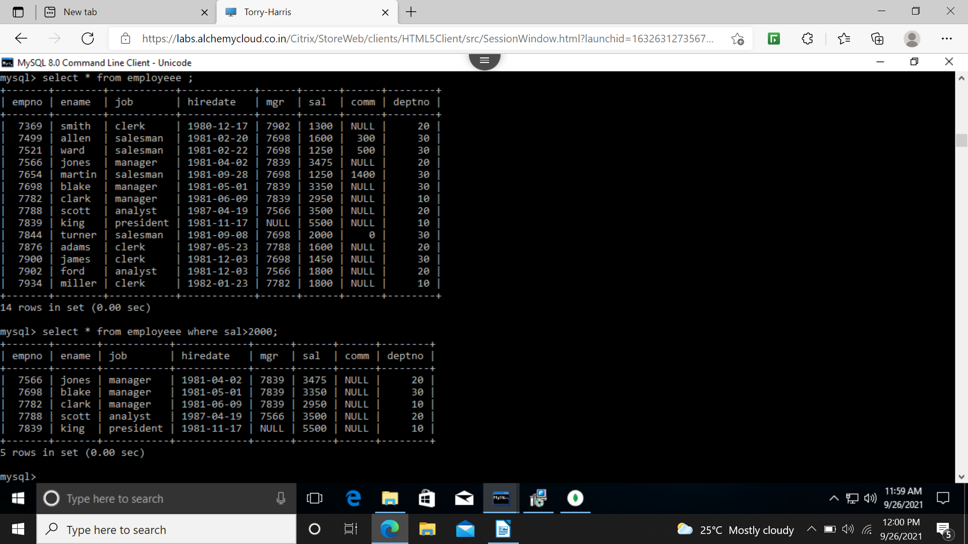
23 find employee whose name ends or starts with ‘m’
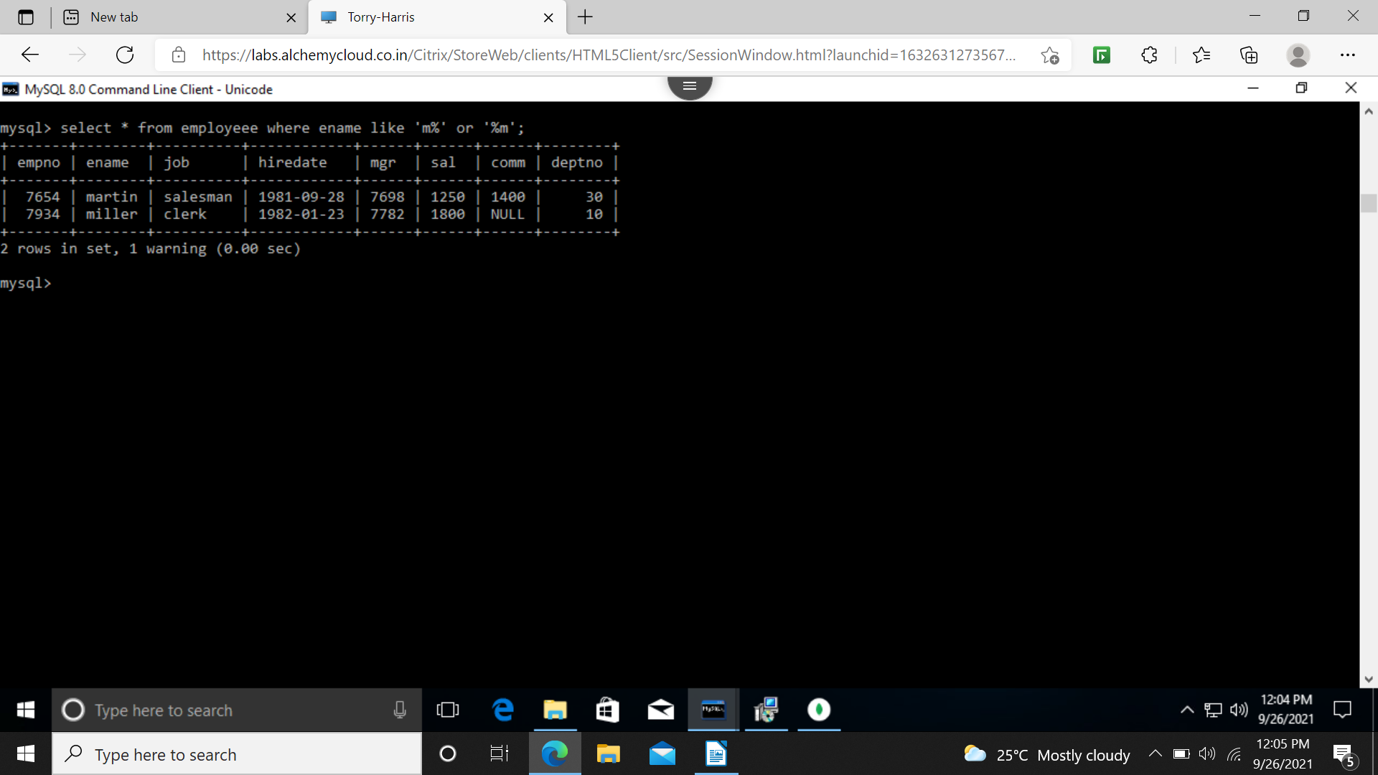
24 find employee whose name contains ‘m’ in any case
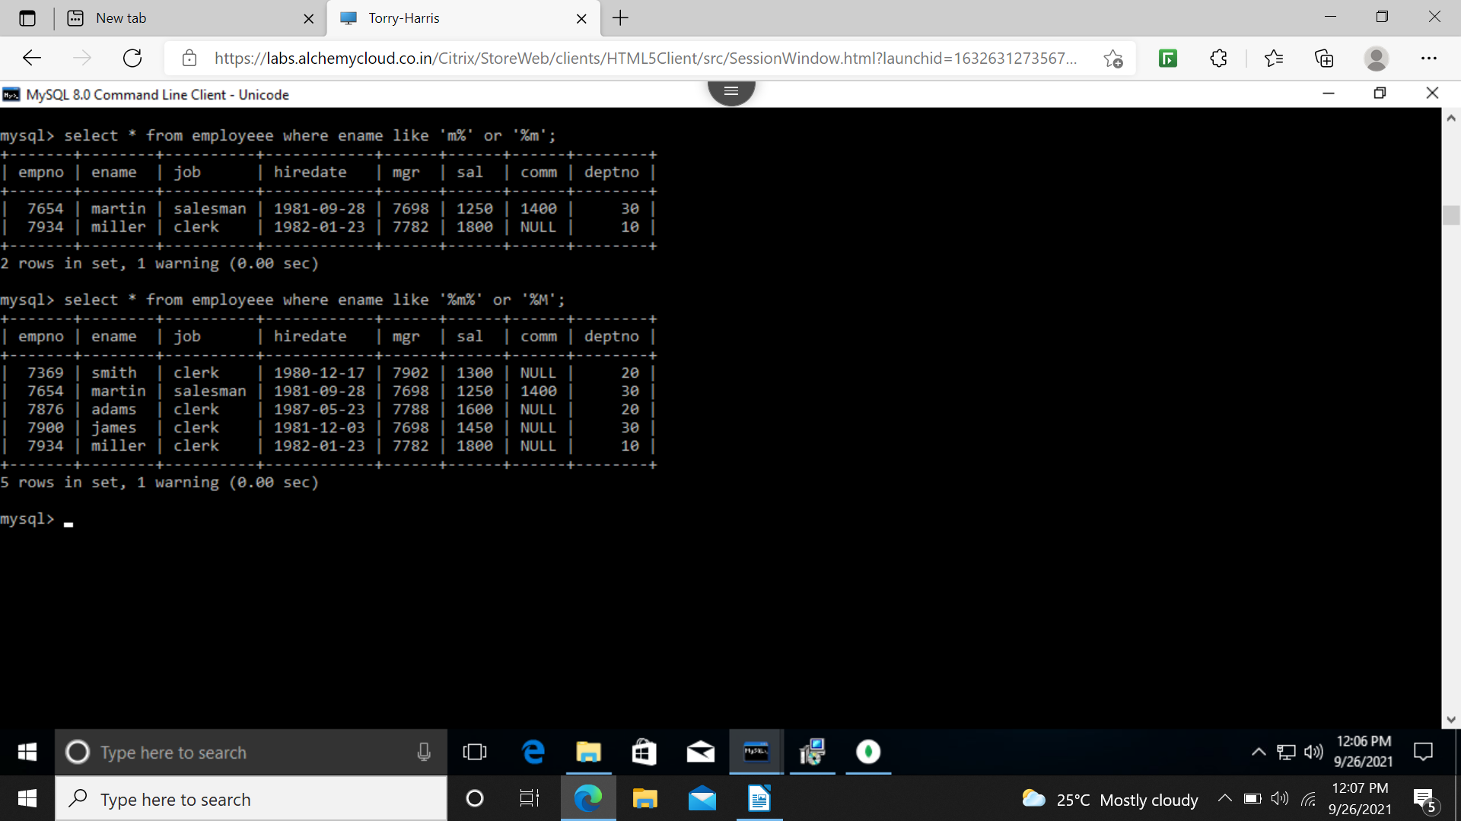

26 employee hired in the month February
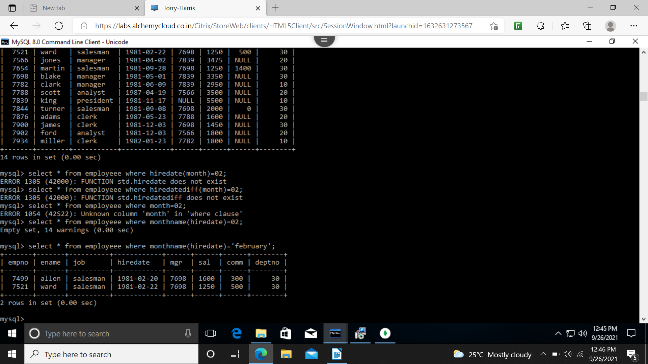
27 find all employee hired in last day of month

28 employee hired more than 2 years ago
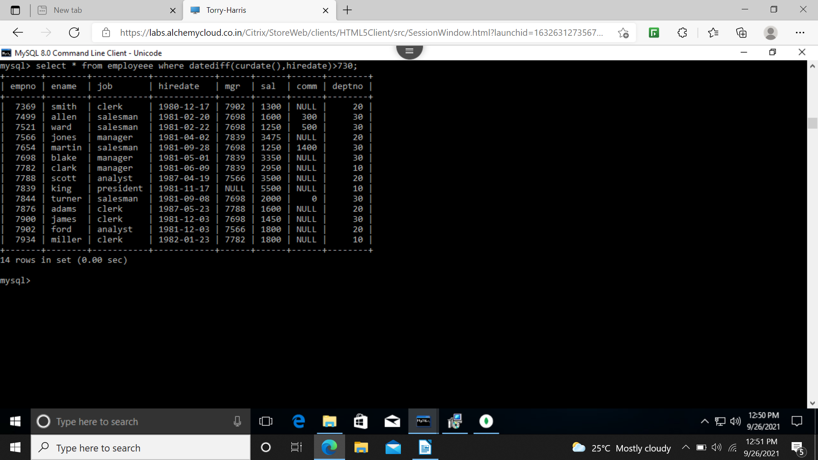
29 managers hired in 1981

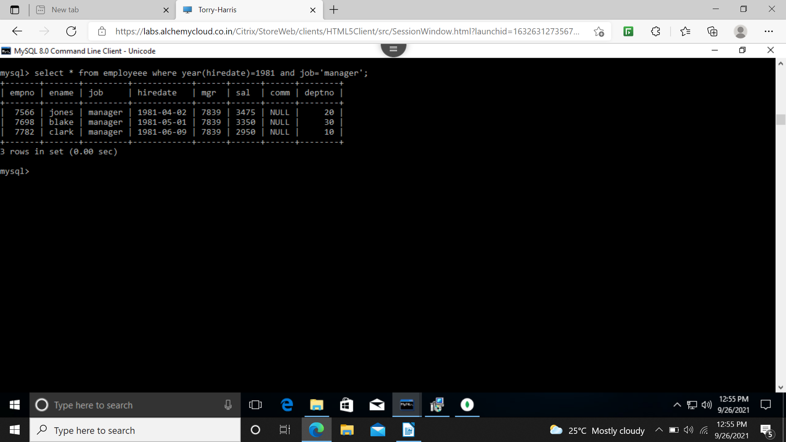
30 display the names and jobs of all employee separated by a space


31display the names of all employees right aligning them to 15 characters
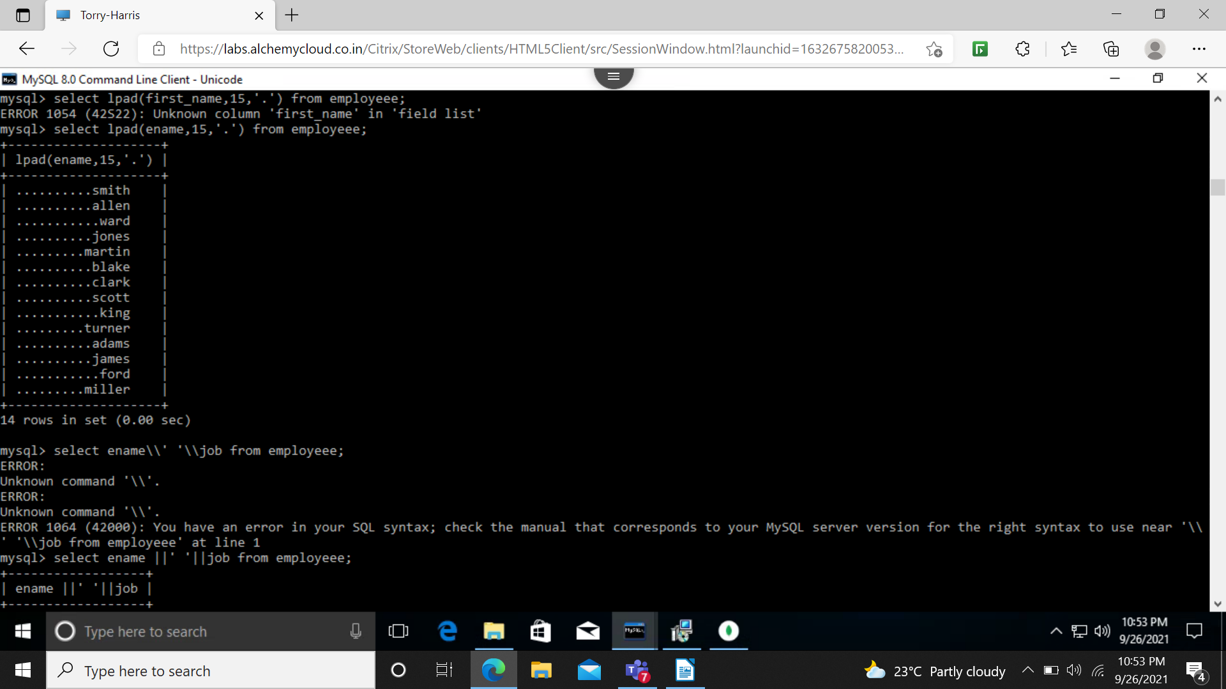
32 display the names of all employees padding them to the right upto 15 characters with ‘*’

33 display names of employee without any leading ‘A’
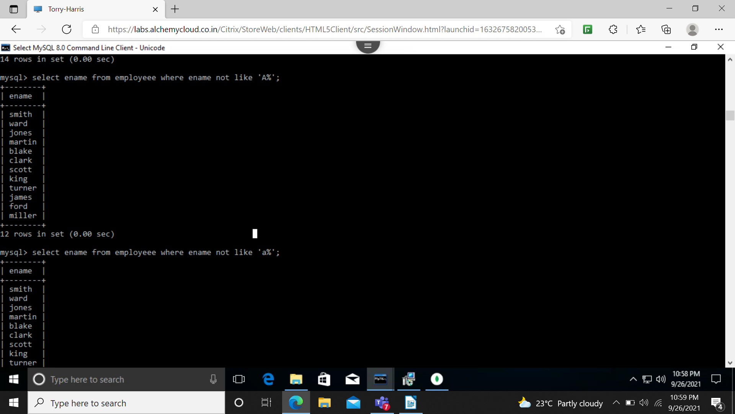
34 names without any trailing ‘r’

35 show the first 3 and last 3 characters of all employee name
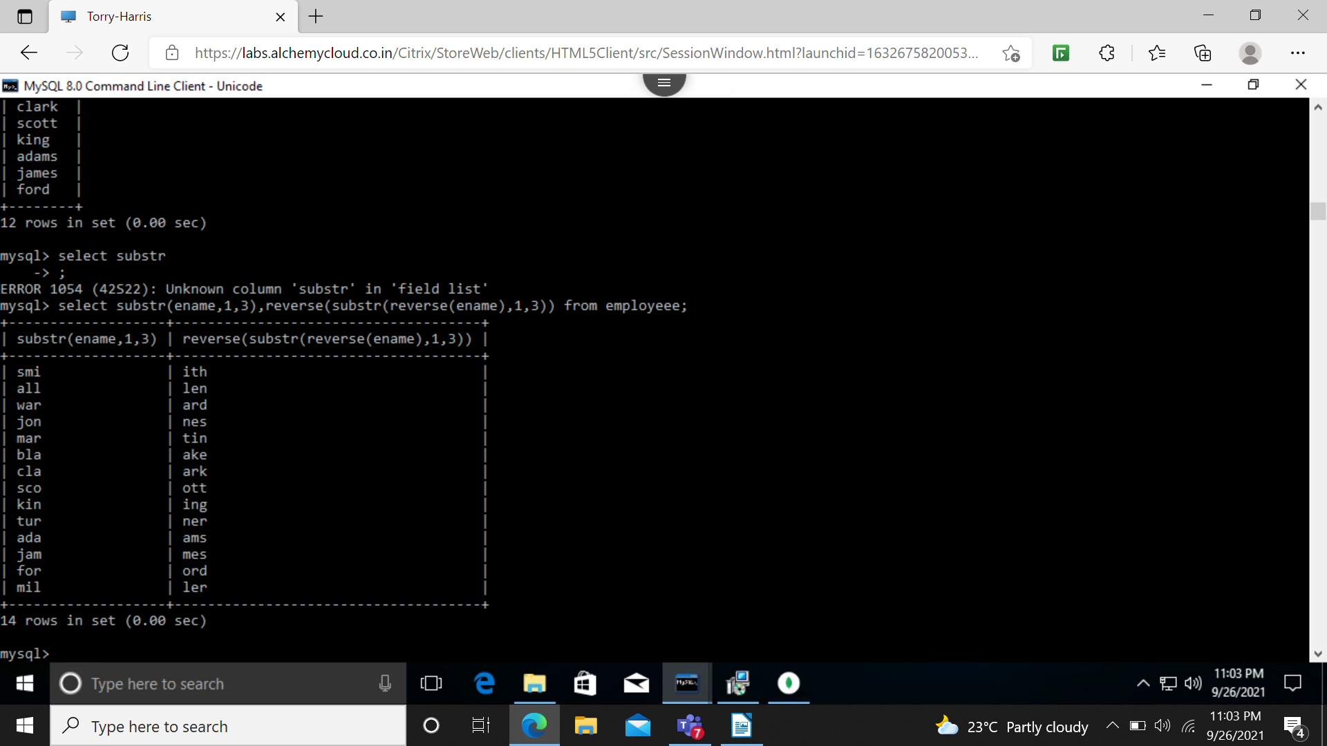
36 replacing A with a
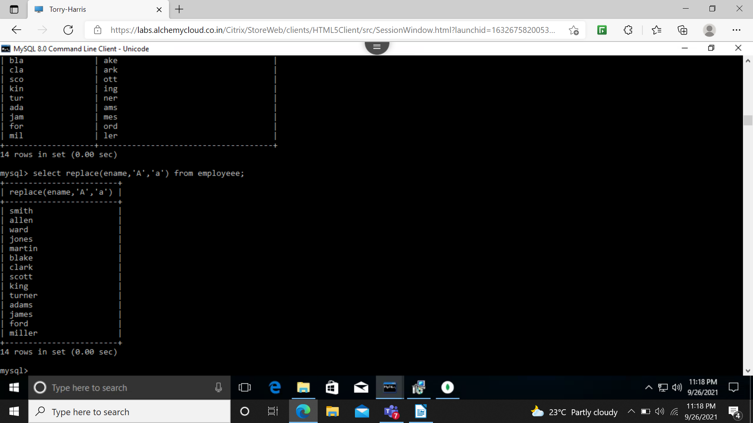

38 rounding to nearest 1000


