DBMSData – raw information / known facts and figures
database – is a collection of data in order
DBMS – it is a software which is used to manage data inside database
RDBMS – relational database management system

basic commands

show databases;//shows which are all the database present
system cls;//clear the screen
create database databasename;//creates a database
use database;//uses or comes to this databases
show tables;// shows whether any tables present inside the database
DESC tablename; description on table row
PRIMARY KEY; it is the constraint no null plus unique
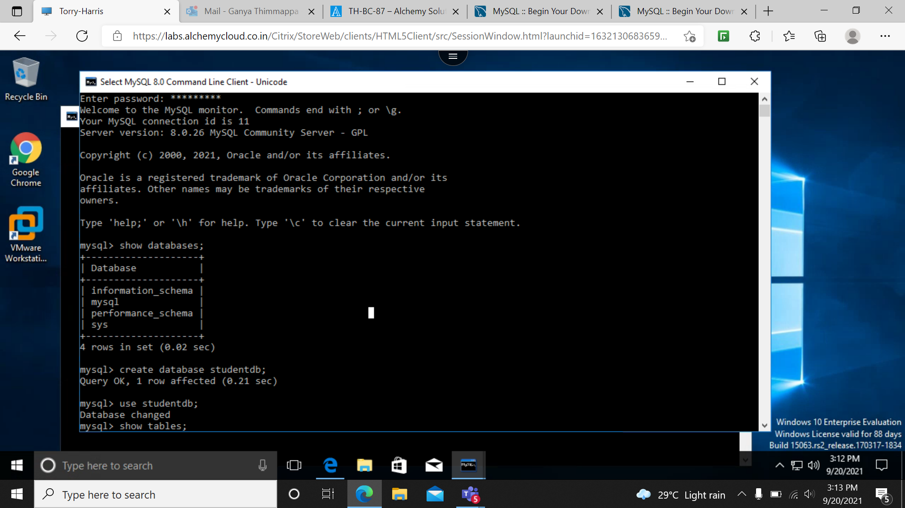
creating database and other basic commands are shown
creating a table and adding values and desc command is shown

create table tablename(
name of attribute type of attribute constraints(optional),

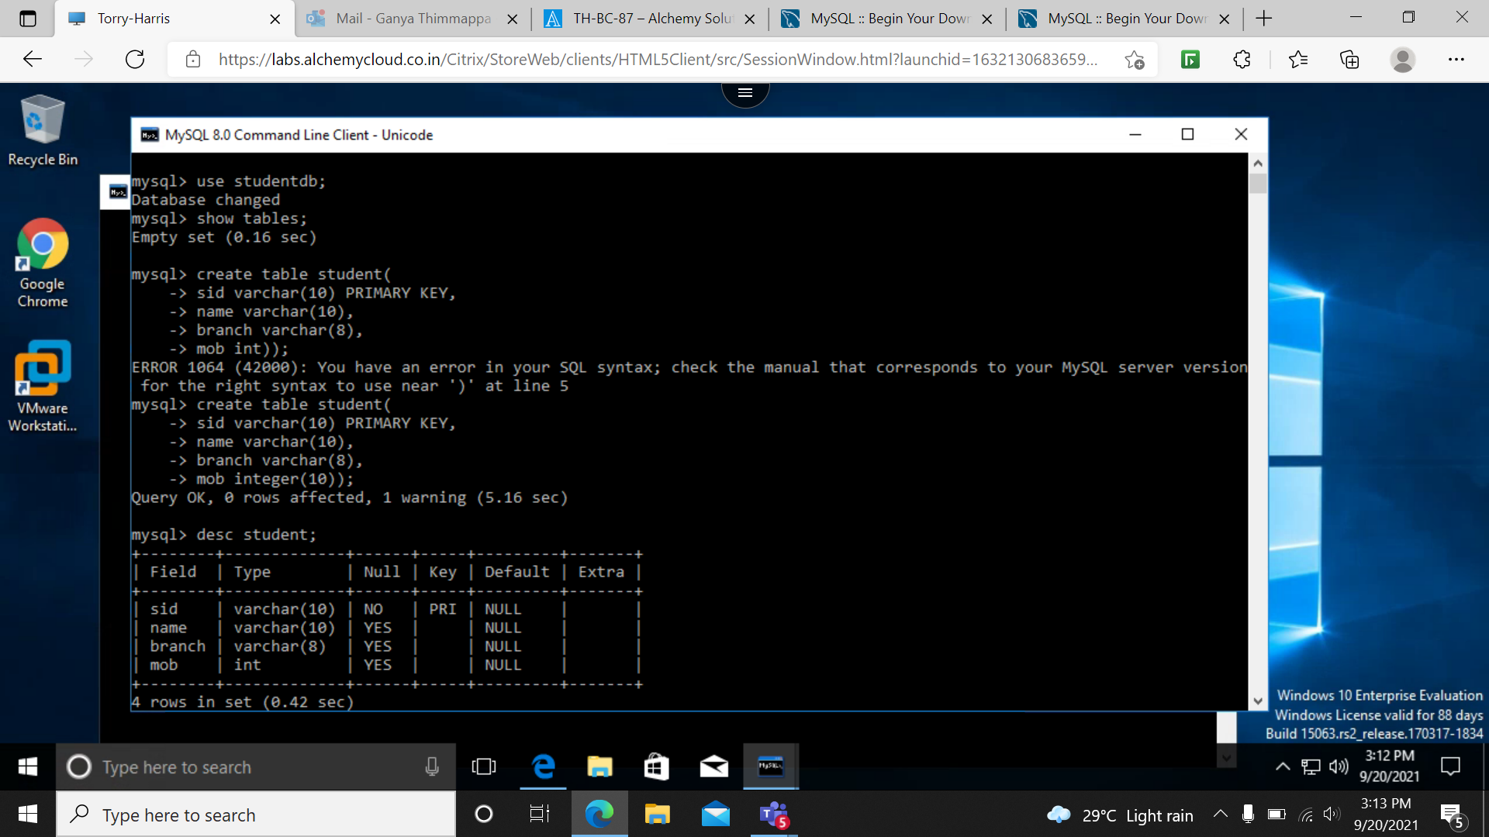
);
inserting values into tables

insert into table name values( type values);
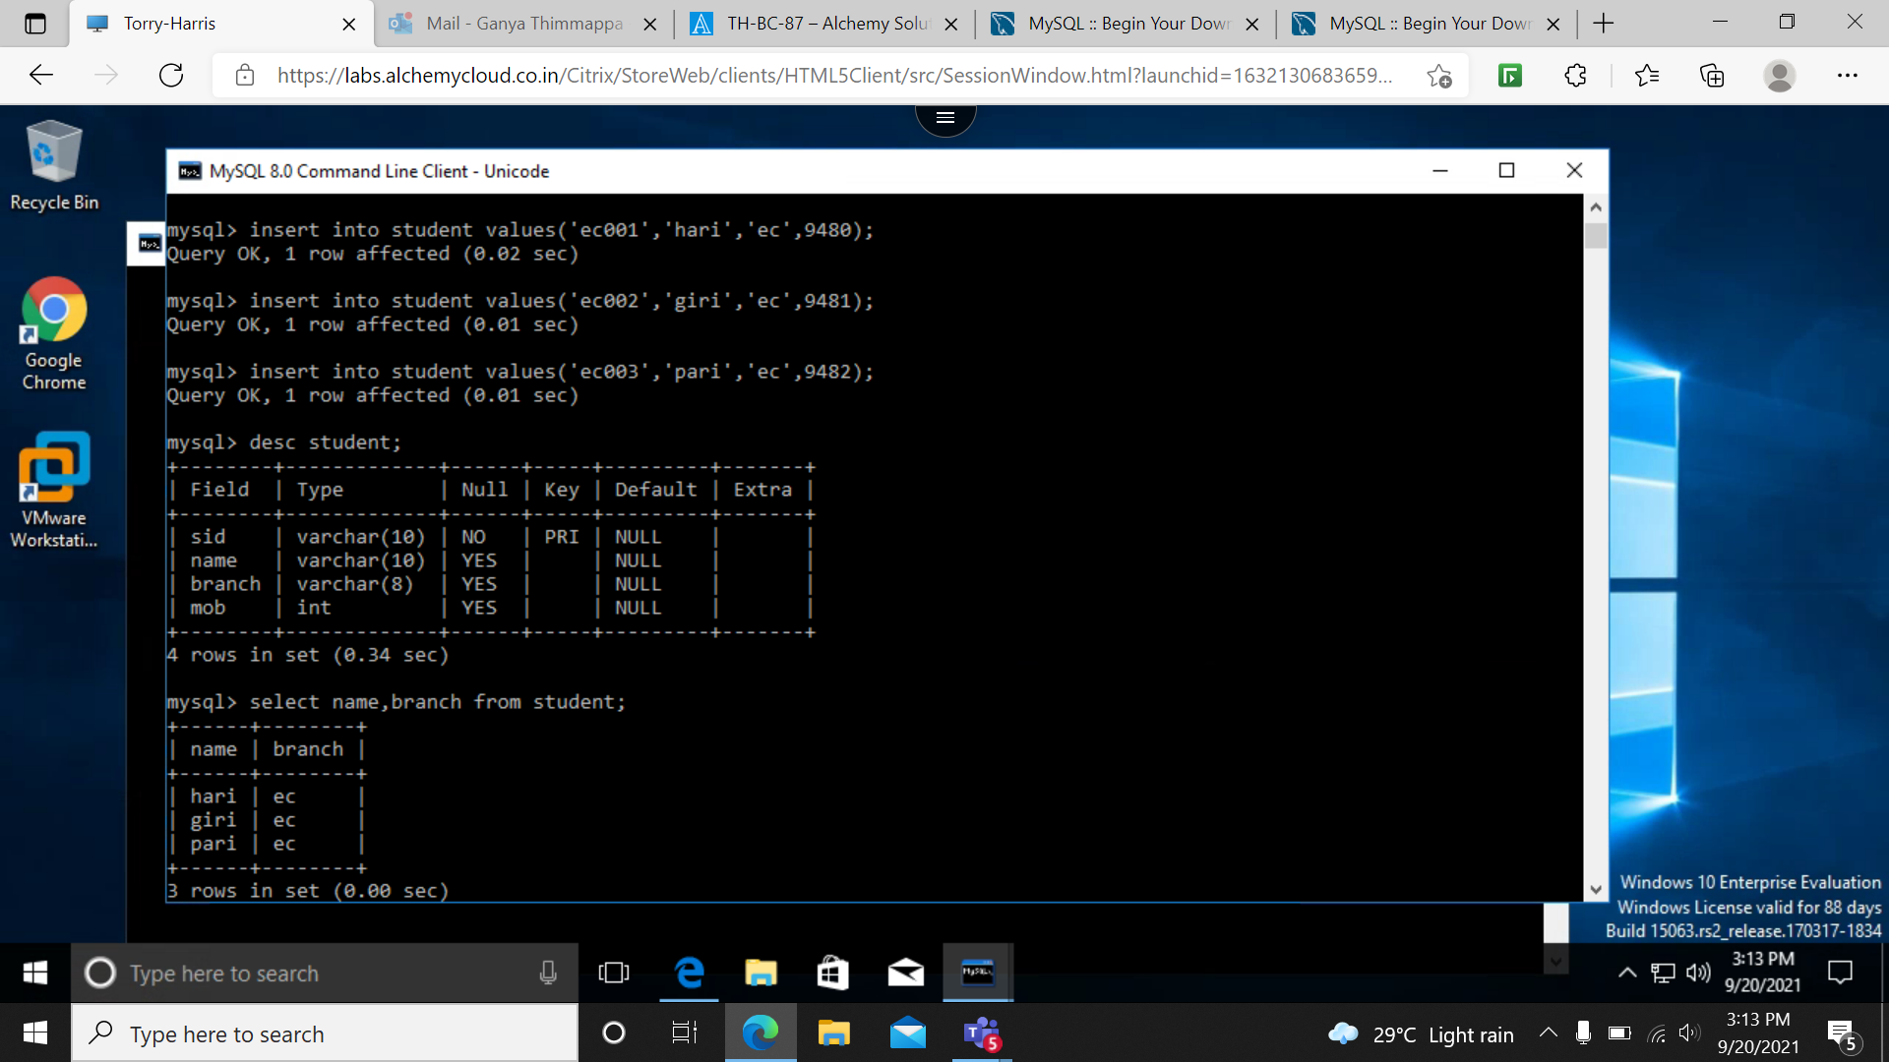
displaying the values

select * from tablename;

in the place of * we can add specific column name

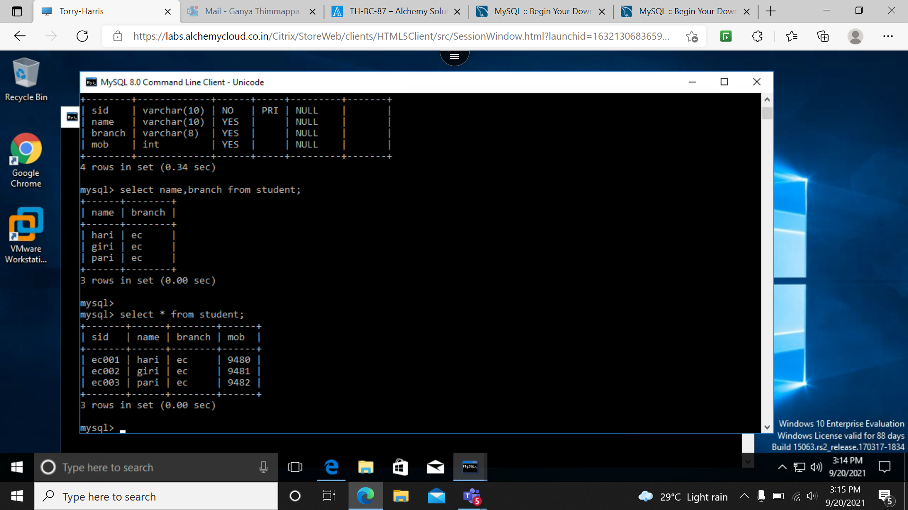
EXAMPLES FOR ENTITY STUDENT , TEACHER AND ADMIN
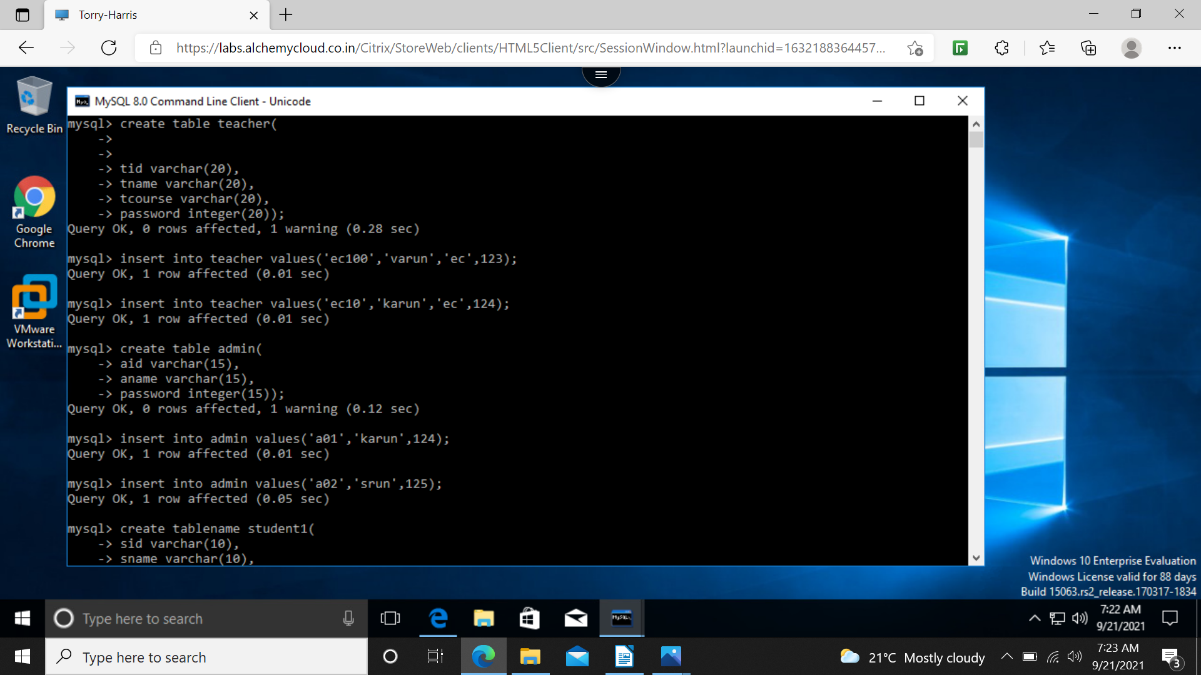
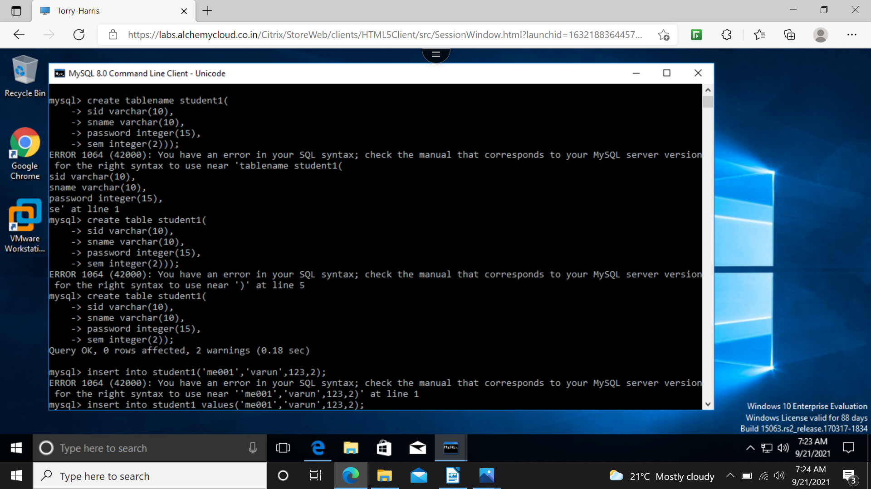
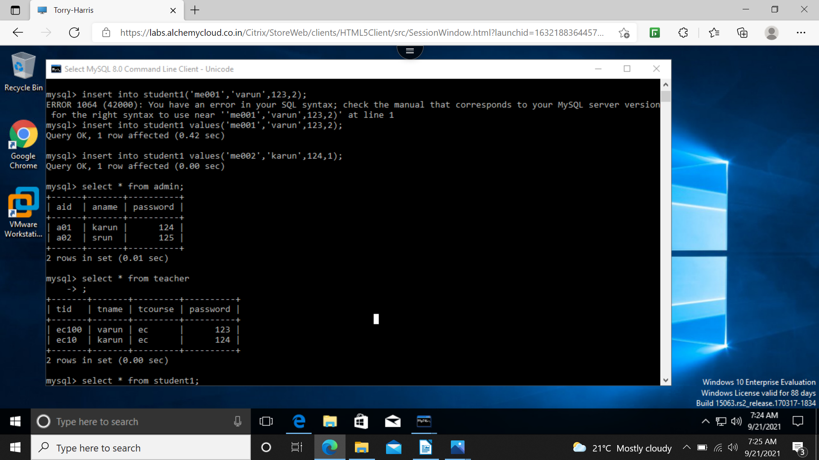
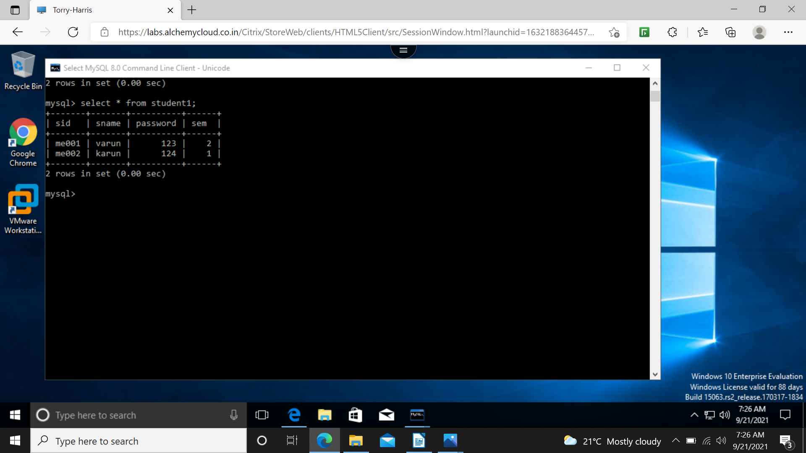
where clause (used as a condition)
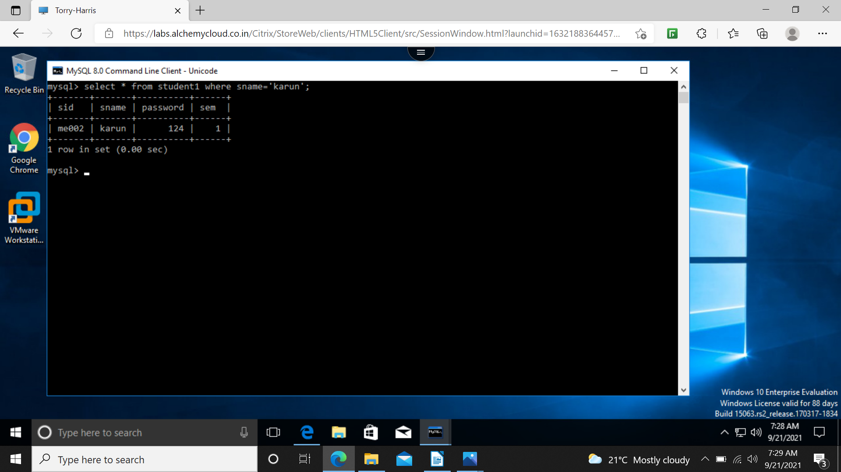
count and group by



