Perceived Risk and Marijuana Use Among Adolescents (NSDUH 2023)
Table of Contents

Background
Adolescent marijuana use is a persistent public health issue. Although use has remained relatively stable, perceived harm from marijuana continues to decrease among youth. Understanding how perceived risk relates to actual use can help inform prevention strategies and targeted public health messaging. This analysis uses the 2023 National Survey on Drug Use and Health (NSDUH) to examine the relationship between perceived risk of weekly marijuana use and past 30-day marijuana use among adolescents ages 12–17. We also explore whether this relationship differs by sex.

Methods

Data Source
Data come from the 2023 NSDUH public-use file. All data cleaning, recoding, and analytic preparation were completed systematically and using reproducible scripts.

Key Variables
Exposure: Perceived risk of smoking marijuana weekly (RSKMRJWK) - Categories: No risk, Slight risk, Moderate risk, Great risk Outcome: Past 30-day marijuana use (MJDAY30A) - Categories: No use, Used Covariate: Sex (IRSEX: Male, Female)

Statistical Analysis
Descriptive statistics summarized the sample and the distribution of exposure, outcome, and covariates. Logistic regression was used to estimate the association between perceived risk and marijuana use. Three models were fit: Unadjusted model Adjusted model including sex Interaction model testing risk × sex Predicted probabilities and ROC curves to assess model performance.

Study Population
The sample included adolescents ages 12–17 with complete information on perceived risk, past 30-day marijuana use, and sex. Exclusion steps were applied. A flow diagram (Figure 1) summarizes how the final analytic dataset was created.

Results

Study Flow and Exclusion Diagram
# Load raw NSDUH data
load("~/Desktop/FA2025/6009/assignment-1-RQ/Github/FP3_NSDUH_AdolescentCannabis/data_raw/NSDUH_2023.Rdata")
# The raw object is named "data"
data_raw <- data
# Step 0: Select only variables used in cleaning (same as 01 script)
data_selected <- data_raw %>%
select(RSKMRJWK, MJDAY30A, IRSEX, AGE3,
YEPMJMO, YFLMJMO, NEWRACE2)
# Step 1: Adolescents only (correct code)
data_adol <- data_selected %>%
filter(AGE3 %in% c(1,2,3))
start_n <- nrow(data_adol)
# Step 2: Exclude missing perceived risk (same as 01)
ex1 <- data_adol %>%
mutate(
RSKMRJWK = as.numeric(RSKMRJWK),
RSKMRJWK = ifelse(RSKMRJWK %in% c(85,94,97,98), NA, RSKMRJWK)
) %>%
drop_na(RSKMRJWK)
n_ex1 <- start_n - nrow(ex1)
# Step 3: Exclude missing marijuana use (same as 01 recode rules)
ex2 <- ex1 %>%
mutate(
MJDAY30A = case_when(
MJDAY30A %in% c(91,93) ~ 0,
MJDAY30A %in% 1:30 ~ 1,
MJDAY30A %in% c(94,97,98) ~ NA_real_
)
) %>%
drop_na(MJDAY30A)
n_ex2 <- nrow(ex1) - nrow(ex2)
# Step 4: Exclude missing sex
ex3 <- ex2 %>% drop_na(IRSEX)
n_ex3 <- nrow(ex2) - nrow(ex3)
# Final analytic sample size
analytic <- ex3
final_n <- nrow(ex3)
start_n; n_ex1; n_ex2; n_ex3; final_n
## [1] 11572
## [1] 305
## [1] 115
## [1] 0
## [1] 11152
# Recode IRSEX properly (1 = Male, 2 = Female)
analytic$IRSEX <- factor(analytic$IRSEX,
levels = c(1,2),
labels = c("Male","Female"))
# Recode AGE3 properly (1,2,3)
analytic$AGE3 <- as.numeric(analytic$AGE3)
# Clean peer disapproval (YFLMJMO)
analytic <- analytic %>%
mutate(
YFLMJMO = as.numeric(YFLMJMO),
YFLMJMO = case_when(
YFLMJMO == 1 ~ 1, # disapprove
YFLMJMO == 2 ~ 0, # neutral/permissive
TRUE ~ NA_real_ # missing
),
YFLMJMO = factor(
YFLMJMO,
levels = c(0,1),
labels = c("Neutral/Permissive", "Disapprove")
)
)
# Clean parent disapproval (YEPMJMO)
analytic <- analytic %>%
mutate(
YEPMJMO = as.numeric(YEPMJMO),
YEPMJMO = case_when(
YEPMJMO %in% c(2,3) ~ 1, # disapprove
YEPMJMO == 1 ~ 0, # neutral
YEPMJMO %in% c(85,94,97,98,99) ~ NA_real_, # missing
TRUE ~ NA_real_
),
YEPMJMO = factor(
YEPMJMO,
levels = c(0,1),
labels = c("Neutral", "Disapprove")
)
)
# Fix perceived risk coding
analytic$RSKMRJWK <- factor(
as.numeric(analytic$RSKMRJWK),
levels = c(1,2,3,4),
labels = c("No risk","Slight risk","Moderate risk","Great risk")
)
Figure 1. Flowchart of exclusions
p <- grViz("digraph flowchart {
node [fontname = Helvetica, shape = rectangle, fontsize = 15]
node1 [label = '@@1']
node2 [label = '@@2']
node3 [label = '@@3']
node4 [label = '@@4']
node1 -> node2 -> node3 -> node4
}
[1]: 'Adolescents ages 12-17 in NSDUH 2023 (N = 11572)'
[2]: 'Excluding missing perceived risk (RSKMRJWK): n excluded = 305; n remaining = 11267'
[3]: 'Excluding missing past 30-day marijuana use (MJDAY30A): n excluded = 115; n remaining = 11152'
[4]: 'Excluding missing sex (IRSEX): n excluded = 0; Final analytic sample = 11152'
")
p
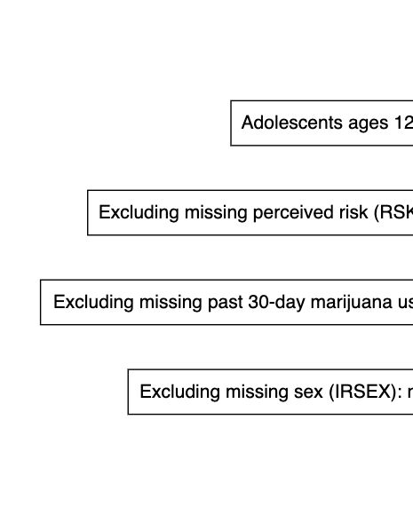 ## DAG
library(dagitty)
dag <- dagitty("
dag {
PerceivedRisk
MarijuanaUse
Age
Sex
PeerDisapproval
ParentDisapproval
PerceivedRisk -> MarijuanaUse
Age -> PerceivedRisk
Age -> MarijuanaUse
Sex -> PerceivedRisk
Sex -> MarijuanaUse
PeerDisapproval -> PerceivedRisk
PeerDisapproval -> MarijuanaUse
ParentDisapproval -> PerceivedRisk
ParentDisapproval -> MarijuanaUse
}
")
coordinates(dag) <- list(
x = c(
Age = 0.1,
Sex = 0.1,
PeerDisapproval = 0.1,
ParentDisapproval = 0.1,
PerceivedRisk = 0.5,
MarijuanaUse = 0.9
),
y = c(
Age = 0.8,
Sex = 0.2,
PeerDisapproval = 0.6,
ParentDisapproval = 0.4,
PerceivedRisk = 0.5,
MarijuanaUse = 0.5
)
)
plot(dag, lwd = 2)
plot(dag)
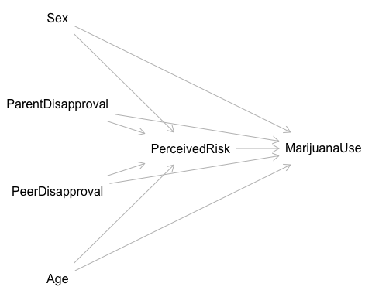

Descriptive Cross-Tabulations
table(analytic$RSKMRJWK)
##
## No risk Slight risk Moderate risk Great risk
## 1328 2778 3538 3508
table(analytic$MJDAY30A)
##
## 0 1
## 10353 799
table(analytic$IRSEX)
##
## Male Female
## 5730 5422
risk_use <- table(analytic$RSKMRJWK, analytic$MJDAY30A)
risk_use
##
## 0 1
## No risk 1006 322
## Slight risk 2447 331
## Moderate risk 3422 116
## Great risk 3478 30
round(prop.table(risk_use, 1) * 100, 1)
##
## 0 1
## No risk 75.8 24.2
## Slight risk 88.1 11.9
## Moderate risk 96.7 3.3
## Great risk 99.1 0.9
Interpretation: - Use prevalence decrease from 24% among adolescents reporting no perceived risk to under 1% among those reporting great risk. - Crude cross-tab shows a strong inverse does-responde pattern. - These patterns support the hypothesis that lower perceived risk is associated with higher past 30 days use.

Table 1. Descriptive Characteristics
library(table1)
label(analytic$AGE3) <- "Age (3-level)"
label(analytic$IRSEX) <- "Sex"
label(analytic$RSKMRJWK) <- "Perceived risk of weekly marijuana use"
label(analytic$YFLMJMO) <- "Peer disapproval of marijuana use"
label(analytic$YEPMJMO) <- "Parental disapproval of marijuana use"
label(analytic$MJDAY30A) <- "Past 30-day marijuana use"
# Table 1.
table1(
~ AGE3 + IRSEX + RSKMRJWK + YFLMJMO + YEPMJMO + MJDAY30A,
data = analytic,
overall = "Total",
rowlabelhead = "Variable",
caption = "Table 1. Descriptive Characteristics of the Analytic Sample"
)
Table 1. Descriptive Characteristics of the Analytic Sample
Variable | Total  (N=11152)
Age (3-level)
Mean (SD) | 2.03 (0.804)
Median [Min, Max] | 2.00 [1.00, 3.00]
Sex
Male | 5730 (51.4%)
Female | 5422 (48.6%)
Perceived risk of weekly marijuana use
No risk | 1328 (11.9%)
Slight risk | 2778 (24.9%)
Moderate risk | 3538 (31.7%)
Great risk | 3508 (31.5%)
Peer disapproval of marijuana use
Neutral/Permissive | 2435 (21.8%)
Disapprove | 8545 (76.6%)
Missing | 172 (1.5%)
Parental disapproval of marijuana use
Neutral | 800 (7.2%)
Disapprove | 10177 (91.3%)
Missing | 175 (1.6%)
Past 30-day marijuana use
Mean (SD) | 0.0716 (0.258)
Median [Min, Max] | 0 [0, 1.00]

Figure 2. Marijuana Use by Perceived Risk
# Ensure MJDAY30A is a factor
analytic$MJDAY30A <- factor(analytic$MJDAY30A,
levels = c(0,1),
labels = c("No use","Any use"))
ggplot(analytic, aes(x = RSKMRJWK, fill = MJDAY30A)) +
geom_bar(position = "fill") +
labs(
title = "Marijuana Use by Perceived Risk (Adolescents, NSDUH 2023)",
x = "Perceived Risk",
y = "Proportion",
fill = "Past 30-Day Use"
) +
theme_bw()
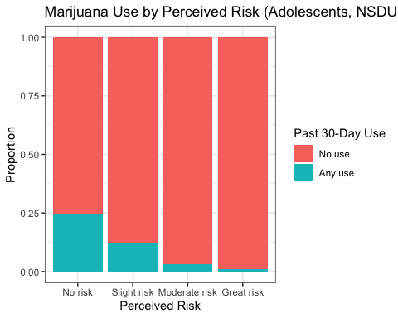 Interpretation: This figure 2. shows a strong inverse relationship between perceived risk and past 30-day marijuana use among adolescents. In the NO RISK group, 322 adolescents reported marijuana use, compared to 1006 who did not use. In the SLIGHT RISK group, 331 reported use and 2447 did not use. In the MODERATE RISK group, 116 reported use and 3442 did not use. In the GREAT RISK group, 30 adolescents reported use and 3478 did not use. As the figure 1. showing, the number of users steadily decreased as perceived risk increased which supports the expected crude association, adolescents who view marijuana as less risk are more likely to have used in the past 30 days.

Logistic Regression Models
Model 1: Unadjusted
model1 <- glm(MJDAY30A ~ RSKMRJWK,
data = analytic,
family = "binomial")
summary(model1)
##
## Call:
## glm(formula = MJDAY30A ~ RSKMRJWK, family = "binomial", data = analytic)
##
## Coefficients:
## Estimate Std. Error z value Pr(>|z|)
## (Intercept) -1.13919 0.06403 -17.792 <2e-16 ***
## RSKMRJWKSlight risk -0.86131 0.08677 -9.926 <2e-16 ***
## RSKMRJWKModerate risk -2.24520 0.11407 -19.682 <2e-16 ***
## RSKMRJWKGreat risk -3.61383 0.19421 -18.608 <2e-16 ***
## ---
## Signif. codes: 0 '***' 0.001 '**' 0.01 '*' 0.05 '.' 0.1 ' ' 1
##
## (Dispersion parameter for binomial family taken to be 1)
##
## Null deviance: 5751.7 on 11151 degrees of freedom
## Residual deviance: 4866.9 on 11148 degrees of freedom
## AIC: 4874.9
##
## Number of Fisher Scoring iterations: 7
odds.n.ends(model1)
## $`Logistic regression model significance`
## Chi-squared d.f. p
## 884.782 3 <.001
##
## $`Contingency tables (model fit): frequency predicted`
## Number observed
## Number predicted 1 0 Sum
## 1 0 0 0
## 0 799 10353 11152
## Sum 799 10353 11152
##
## $`Count R-squared (model fit): percent correctly predicted`
## [1] 92.83537
##
## $`Model sensitivity`
## [1] 0
##
## $`Model specificity`
## [1] 1
##
## $`Predictor odds ratios and 95% CI`
## OR 2.5 % 97.5 %
## (Intercept) 0.32007952 0.28193506 0.36240162
## RSKMRJWKSlight risk 0.42260646 0.35648370 0.50096833
## RSKMRJWKModerate risk 0.10590588 0.08439815 0.13203731
## RSKMRJWKGreat risk 0.02694845 0.01805003 0.03875056
Intepretation: Adolescents who perceived slight, moderate, or great risk of marijuana use had lower odds of reporting past 30-day marijuana use compared with those reporting no risk (reference). - the odds of past 30 days marijuana use among adolescents who perceive slight risk are 0.42 times the odds among those who report no risk. - the odds of past 30 days marijuana use among adolescents who perceive moderate risk are 0.11 times the odds among those who report no risk. - the odds of past 30 days marijuana use among adolescents who perceive great risk are 0.027 times the odds among those who report no risk. The overall model has p value less than 0.05 which means perceived risk strongly predicts marijuana use. The correct classification rate is 92.8%, due to the low prevalence of use.
Model 2: Adjusted for Age and Sex
model2 <- glm(MJDAY30A ~ RSKMRJWK + AGE3 + IRSEX,
data = analytic,
family = "binomial")
summary(model2)
##
## Call:
## glm(formula = MJDAY30A ~ RSKMRJWK + AGE3 + IRSEX, family = "binomial",
## data = analytic)
##
## Coefficients:
## Estimate Std. Error z value Pr(>|z|)
## (Intercept) -3.48967 0.17001 -20.526 < 2e-16 ***
## RSKMRJWKSlight risk -0.92018 0.08990 -10.235 < 2e-16 ***
## RSKMRJWKModerate risk -2.17096 0.11678 -18.591 < 2e-16 ***
## RSKMRJWKGreat risk -3.43083 0.19604 -17.500 < 2e-16 ***
## AGE3 0.89980 0.06013 14.965 < 2e-16 ***
## IRSEXFemale 0.46010 0.07958 5.782 7.38e-09 ***
## ---
## Signif. codes: 0 '***' 0.001 '**' 0.01 '*' 0.05 '.' 0.1 ' ' 1
##
## (Dispersion parameter for binomial family taken to be 1)
##
## Null deviance: 5751.7 on 11151 degrees of freedom
## Residual deviance: 4566.9 on 11146 degrees of freedom
## AIC: 4578.9
##
## Number of Fisher Scoring iterations: 7
odds.n.ends(model2)
## $`Logistic regression model significance`
## Chi-squared d.f. p
## 1184.828 5 <.001
##
## $`Contingency tables (model fit): frequency predicted`
## Number observed
## Number predicted 1 0 Sum
## 1 0 0 0
## 0 799 10353 11152
## Sum 799 10353 11152
##
## $`Count R-squared (model fit): percent correctly predicted`
## [1] 92.83537
##
## $`Model sensitivity`
## [1] 0
##
## $`Model specificity`
## [1] 1
##
## $`Predictor odds ratios and 95% CI`
## OR 2.5 % 97.5 %
## (Intercept) 0.03051100 0.02174579 0.04235595
## RSKMRJWKSlight risk 0.39844675 0.33401682 0.47518764
## RSKMRJWKModerate risk 0.11406821 0.09043296 0.14298364
## RSKMRJWKGreat risk 0.03236008 0.02160446 0.04671575
## AGE3 2.45911753 2.18900174 2.77106434
## IRSEXFemale 1.58423814 1.35597012 1.85251474
Intepretation: After adjusting for age and sex, perceived risk remains a strong independent predictor, and age shows a major driver of use. Female also show higher reported use than males. - The odds of use for adolescents perceiving slight risk are 0.40 times the odds among those perceiving no risk, after adjusting for age and sex. - The odds of use for adolescents perceiving moderate risk are 0.11 times the odds among those perceiving no risk, after adjusting for age and sex. - The odds of use for adolescents perceiving great risk are 0.03 times the odds among those perceiving no risk, after adjusting for age and sex. - Each one-unit increase in age is associated with a 2.46-fold higher odds of marijuana use. - Females have 1.58 times the odds of marijuana use compared with males.
Likelihood Ratio Test
lmtest::lrtest(model1, model2)
## Likelihood ratio test
##
## Model 1: MJDAY30A ~ RSKMRJWK
## Model 2: MJDAY30A ~ RSKMRJWK + AGE3 + IRSEX
## #Df LogLik Df Chisq Pr(>Chisq)
## 1 4 -2433.4
## 2 6 -2283.4 2 300.05 < 2.2e-16 ***
## ---
## Signif. codes: 0 '***' 0.001 '**' 0.01 '*' 0.05 '.' 0.1 ' ' 1
As the results shown, adding age and sex significantly improves model fit (p-value < 0.05). These covariates explain variation in marijuana use beyond perceived risk alone.
Model 3: Full Adjusted (demographics + peer + parent)
complete_data <- analytic %>%
mutate(
MJDAY30A = factor(MJDAY30A, levels = c("No use", "Any use"))
) %>%
dplyr::select(MJDAY30A, RSKMRJWK, AGE3, IRSEX, YFLMJMO, YEPMJMO) %>%
drop_na()
# check size
nrow(complete_data)
## [1] 10944
model3 <- glm(MJDAY30A ~ RSKMRJWK + AGE3 + IRSEX + YFLMJMO + YEPMJMO,
data = complete_data,
family = "binomial")
summary(model3)
##
## Call:
## glm(formula = MJDAY30A ~ RSKMRJWK + AGE3 + IRSEX + YFLMJMO +
## YEPMJMO, family = "binomial", data = complete_data)
##
## Coefficients:
## Estimate Std. Error z value Pr(>|z|)
## (Intercept) -1.95837 0.19396 -10.097 < 2e-16 ***
## RSKMRJWKSlight risk -0.60074 0.09867 -6.089 1.14e-09 ***
## RSKMRJWKModerate risk -1.39769 0.12705 -11.002 < 2e-16 ***
## RSKMRJWKGreat risk -2.48818 0.20698 -12.021 < 2e-16 ***
## AGE3 0.71616 0.06473 11.064 < 2e-16 ***
## IRSEXFemale 0.35229 0.08511 4.139 3.48e-05 ***
## YFLMJMODisapprove -1.64336 0.09864 -16.660 < 2e-16 ***
## YEPMJMODisapprove -0.73783 0.10421 -7.080 1.44e-12 ***
## ---
## Signif. codes: 0 '***' 0.001 '**' 0.01 '*' 0.05 '.' 0.1 ' ' 1
##
## (Dispersion parameter for binomial family taken to be 1)
##
## Null deviance: 5623.4 on 10943 degrees of freedom
## Residual deviance: 3983.0 on 10936 degrees of freedom
## AIC: 3999
##
## Number of Fisher Scoring iterations: 7
odds.n.ends(model3)
## $`Logistic regression model significance`
## Chi-squared d.f. p
## 1640.414 7 <.001
##
## $`Contingency tables (model fit): frequency predicted`
## Number observed
## Number predicted 1 0 Sum
## 1 87 73 160
## 0 693 10091 10784
## Sum 780 10164 10944
##
## $`Count R-squared (model fit): percent correctly predicted`
## [1] 93.00073
##
## $`Model sensitivity`
## [1] 0.1115385
##
## $`Model specificity`
## [1] 0.9928178
##
## $`Predictor odds ratios and 95% CI`
## OR 2.5 % 97.5 %
## (Intercept) 0.14108820 0.09605046 0.2055143
## RSKMRJWKSlight risk 0.54840623 0.45201457 0.6655372
## RSKMRJWKModerate risk 0.24716650 0.19221697 0.3163945
## RSKMRJWKGreat risk 0.08306115 0.05432322 0.1226301
## AGE3 2.04656338 1.80523031 2.3268875
## IRSEXFemale 1.42232175 1.20423827 1.6813056
## YFLMJMODisapprove 0.19332902 0.15909489 0.2342392
## YEPMJMODisapprove 0.47815204 0.39004128 0.5868997
Intepretation: Peer disapproval has a stronger protective association than parental disapproval. - The odds of use for adolescents perceiving slight risk are 0.55 times the odds among those perceiving no risk, after adjusting for age, sex, peer disapproval, and parental disapproval. - The odds of use for adolescents perceiving moderate risk are 0.25 times the odds among those perceiving no risk, after adjusting for age, sex, peer disapproval, and parental disapproval. - The odds of use for adolescents perceiving great risk are 0.08 times the odds among those perceiving no risk, after adjusting for age, sex, peer disapproval, and parental disapproval. - Each one-unit increase in age is associated with a 2-fold higher odds of marijuana use. - Females have 1.42 times the odds of marijuana use compared with males. - Adolescents who report that their friends disapprove of marijuana use have 0.19 times the odds of using, compared with those whose peers are neutral/permissive. - Adolescents whose parents disapprove have 0.48 times the odds of using compared with those whose parents are neutral.
Likelihood Ratio Test (Adjusted vs Interaction)
# before doing the llr test, adjust model 2
model2_adj <- glm(MJDAY30A ~ RSKMRJWK + AGE3 + IRSEX,
data = complete_data,
family = "binomial")
summary(model2_adj)
##
## Call:
## glm(formula = MJDAY30A ~ RSKMRJWK + AGE3 + IRSEX, family = "binomial",
## data = complete_data)
##
## Coefficients:
## Estimate Std. Error z value Pr(>|z|)
## (Intercept) -3.49717 0.17321 -20.190 < 2e-16 ***
## RSKMRJWKSlight risk -0.94080 0.09129 -10.306 < 2e-16 ***
## RSKMRJWKModerate risk -2.17413 0.11751 -18.501 < 2e-16 ***
## RSKMRJWKGreat risk -3.46123 0.19941 -17.358 < 2e-16 ***
## AGE3 0.90596 0.06119 14.807 < 2e-16 ***
## IRSEXFemale 0.46723 0.08059 5.798 6.72e-09 ***
## ---
## Signif. codes: 0 '***' 0.001 '**' 0.01 '*' 0.05 '.' 0.1 ' ' 1
##
## (Dispersion parameter for binomial family taken to be 1)
##
## Null deviance: 5623.4 on 10943 degrees of freedom
## Residual deviance: 4457.9 on 10938 degrees of freedom
## AIC: 4469.9
##
## Number of Fisher Scoring iterations: 7
odds.n.ends(model2_adj)
## $`Logistic regression model significance`
## Chi-squared d.f. p
## 1165.515 5 <.001
##
## $`Contingency tables (model fit): frequency predicted`
## Number observed
## Number predicted 1 0 Sum
## 1 0 0 0
## 0 780 10164 10944
## Sum 780 10164 10944
##
## $`Count R-squared (model fit): percent correctly predicted`
## [1] 92.87281
##
## $`Model sensitivity`
## [1] 0
##
## $`Model specificity`
## [1] 1
##
## $`Predictor odds ratios and 95% CI`
## OR 2.5 % 97.5 %
## (Intercept) 0.03028291 0.02144449 0.04229656
## RSKMRJWKSlight risk 0.39031605 0.32631366 0.46676053
## RSKMRJWKModerate risk 0.11370729 0.09002225 0.14274610
## RSKMRJWKGreat risk 0.03139102 0.02080499 0.04559083
## AGE3 2.47431251 2.19808274 2.79414747
## IRSEXFemale 1.59557460 1.36300000 1.86952537
lmtest::lrtest(model2_adj, model3)
## Likelihood ratio test
##
## Model 1: MJDAY30A ~ RSKMRJWK + AGE3 + IRSEX
## Model 2: MJDAY30A ~ RSKMRJWK + AGE3 + IRSEX + YFLMJMO + YEPMJMO
## #Df LogLik Df Chisq Pr(>Chisq)
## 1 6 -2228.9
## 2 8 -1991.5 2 474.9 < 2.2e-16 ***
## ---
## Signif. codes: 0 '***' 0.001 '**' 0.01 '*' 0.05 '.' 0.1 ' ' 1
As a result, it clearly showed that adding peer and parental disapproval substantially improves model fit. These are highly important predictors of adolescent marijuana use.

Table 2. Adjusted Odds Ratios for Past 30-Day Marijuana Use (Model 3)
# Clean variable label map
label_map <- c(
"RSKMRJWKSlight risk" = "Slight risk vs No risk",
"RSKMRJWKModerate risk" = "Moderate risk vs No risk",
"RSKMRJWKGreat risk" = "Great risk vs No risk",
"AGE3" = "Age (per category)",
"IRSEXFemale" = "Female vs Male",
"YFLMJMO" = "Peer disapproval (yes vs no)",
"YEPMJMO" = "Parental disapproval (yes vs no)",
"RSKMRJWKSlight risk:IRSEXFemale" = "Interaction: Slight risk × Female",
"RSKMRJWKModerate risk:IRSEXFemale" = "Interaction: Moderate risk × Female",
"RSKMRJWKGreat risk:IRSEXFemale" = "Interaction: Great risk × Female"
)
# Table 2
model3_df <- data.frame(
Variable = rownames(exp(cbind(OR = coef(model3), confint(model3)))),
exp(cbind(OR = coef(model3), confint(model3)))
)
model3_df <- model3_df[model3_df$Variable != "(Intercept)", ]
model3_df$Variable <- label_map[model3_df$Variable]
colnames(model3_df) <- c("Variable","OR","Lower 95% CI","Upper 95% CI")
model3_df
## Variable OR Lower 95% CI
## RSKMRJWKSlight risk Slight risk vs No risk 0.54840623 0.45201457
## RSKMRJWKModerate risk Moderate risk vs No risk 0.24716650 0.19221697
## RSKMRJWKGreat risk Great risk vs No risk 0.08306115 0.05432322
## AGE3 Age (per category) 2.04656338 1.80523031
## IRSEXFemale Female vs Male 1.42232175 1.20423827
## YFLMJMODisapprove <NA> 0.19332902 0.15909489
## YEPMJMODisapprove <NA> 0.47815204 0.39004128
## Upper 95% CI
## RSKMRJWKSlight risk 0.6655372
## RSKMRJWKModerate risk 0.3163945
## RSKMRJWKGreat risk 0.1226301
## AGE3 2.3268875
## IRSEXFemale 1.6813056
## YFLMJMODisapprove 0.2342392
## YEPMJMODisapprove 0.5868997
Model 4: Interaction Model (RSKMRJWK X IRSEX)
model4 <- glm(MJDAY30A ~ RSKMRJWK * IRSEX + AGE3 + YFLMJMO + YEPMJMO,
data = complete_data,
family = "binomial")
summary(model4)
##
## Call:
## glm(formula = MJDAY30A ~ RSKMRJWK * IRSEX + AGE3 + YFLMJMO +
## YEPMJMO, family = "binomial", data = complete_data)
##
## Coefficients:
## Estimate Std. Error z value Pr(>|z|)
## (Intercept) -1.92606 0.20333 -9.473 < 2e-16 ***
## RSKMRJWKSlight risk -0.53477 0.13739 -3.892 9.93e-05 ***
## RSKMRJWKModerate risk -1.66465 0.20813 -7.998 1.26e-15 ***
## RSKMRJWKGreat risk -2.97697 0.39606 -7.516 5.63e-14 ***
## IRSEXFemale 0.30108 0.14592 2.063 0.0391 *
## AGE3 0.71257 0.06475 11.006 < 2e-16 ***
## YFLMJMODisapprove -1.63742 0.09859 -16.608 < 2e-16 ***
## YEPMJMODisapprove -0.73877 0.10421 -7.089 1.35e-12 ***
## RSKMRJWKSlight risk:IRSEXFemale -0.11318 0.19403 -0.583 0.5597
## RSKMRJWKModerate risk:IRSEXFemale 0.41298 0.25899 1.595 0.1108
## RSKMRJWKGreat risk:IRSEXFemale 0.72226 0.46209 1.563 0.1180
## ---
## Signif. codes: 0 '***' 0.001 '**' 0.01 '*' 0.05 '.' 0.1 ' ' 1
##
## (Dispersion parameter for binomial family taken to be 1)
##
## Null deviance: 5623.4 on 10943 degrees of freedom
## Residual deviance: 3975.6 on 10933 degrees of freedom
## AIC: 3997.6
##
## Number of Fisher Scoring iterations: 8
odds.n.ends(model4)
## $`Logistic regression model significance`
## Chi-squared d.f. p
## 1647.757 10 <.001
##
## $`Contingency tables (model fit): frequency predicted`
## Number observed
## Number predicted 1 0 Sum
## 1 87 73 160
## 0 693 10091 10784
## Sum 780 10164 10944
##
## $`Count R-squared (model fit): percent correctly predicted`
## [1] 93.00073
##
## $`Model sensitivity`
## [1] 0.1115385
##
## $`Model specificity`
## [1] 0.9928178
##
## $`Predictor odds ratios and 95% CI`
## OR 2.5 % 97.5 %
## (Intercept) 0.14572050 0.09738471 0.2161642
## RSKMRJWKSlight risk 0.58580204 0.44737713 0.7668497
## RSKMRJWKModerate risk 0.18925695 0.12411578 0.2812976
## RSKMRJWKGreat risk 0.05094685 0.02129647 0.1029720
## IRSEXFemale 1.35132019 1.01512825 1.7990779
## AGE3 2.03922390 1.79870492 2.3186242
## YFLMJMODisapprove 0.19448181 0.16005747 0.2356118
## YEPMJMODisapprove 0.47770335 0.38967554 0.5863468
## RSKMRJWKSlight risk:IRSEXFemale 0.89299285 0.61053419 1.3065619
## RSKMRJWKModerate risk:IRSEXFemale 1.51132162 0.91555342 2.5315182
## RSKMRJWKGreat risk:IRSEXFemale 2.05908947 0.86959818 5.4571674
Intepretation: - Interaction terms: - For slight risk, females have 0.89 times the odds compared with males at the same perceived risk level. This is not statistically significant due to p-value >0.05. - For moderate risk, females have 1.51 times the odds compared with males at the same perceived risk level. This is not statistically significant due to p-value >0.05. - For great risk, females have 2.06 times the odds compared with males at the same perceived risk level. This is not statistically significant due to p-value >0.05. Although perceived risk was strongly associated with lower marijuana use within both males and females, the sex × perceived risk interaction term was not statistically significant.
Likehood Ratio Test (full model vs interaction model)
lmtest::lrtest(model3, model4)
## Likelihood ratio test
##
## Model 1: MJDAY30A ~ RSKMRJWK + AGE3 + IRSEX + YFLMJMO + YEPMJMO
## Model 2: MJDAY30A ~ RSKMRJWK * IRSEX + AGE3 + YFLMJMO + YEPMJMO
## #Df LogLik Df Chisq Pr(>Chisq)
## 1 8 -1991.5
## 2 11 -1987.8 3 7.3426 0.06174 .
## ---
## Signif. codes: 0 '***' 0.001 '**' 0.01 '*' 0.05 '.' 0.1 ' ' 1
Intepretation: The interaction model does not significantly outperform Model 3. Sex does not significantly modify the relationship between perceived risk and marijuana use.

Table 3. Interaction Model of Perceived Risk × Sex (Model 4)
model4_df <- data.frame(
Variable = rownames(exp(cbind(OR = coef(model4), confint(model4)))),
exp(cbind(OR = coef(model4), confint(model4)))
)
model4_df <- model4_df[model4_df$Variable != "(Intercept)", ]
model4_df$Variable <- label_map[model4_df$Variable]
colnames(model4_df) <- c("Variable","OR","Lower 95% CI","Upper 95% CI")
model4_df
## Variable
## RSKMRJWKSlight risk Slight risk vs No risk
## RSKMRJWKModerate risk Moderate risk vs No risk
## RSKMRJWKGreat risk Great risk vs No risk
## IRSEXFemale Female vs Male
## AGE3 Age (per category)
## YFLMJMODisapprove <NA>
## YEPMJMODisapprove <NA>
## RSKMRJWKSlight risk:IRSEXFemale Interaction: Slight risk × Female
## RSKMRJWKModerate risk:IRSEXFemale Interaction: Moderate risk × Female
## RSKMRJWKGreat risk:IRSEXFemale Interaction: Great risk × Female
## OR Lower 95% CI Upper 95% CI
## RSKMRJWKSlight risk 0.58580204 0.44737713 0.7668497
## RSKMRJWKModerate risk 0.18925695 0.12411578 0.2812976
## RSKMRJWKGreat risk 0.05094685 0.02129647 0.1029720
## IRSEXFemale 1.35132019 1.01512825 1.7990779
## AGE3 2.03922390 1.79870492 2.3186242
## YFLMJMODisapprove 0.19448181 0.16005747 0.2356118
## YEPMJMODisapprove 0.47770335 0.38967554 0.5863468
## RSKMRJWKSlight risk:IRSEXFemale 0.89299285 0.61053419 1.3065619
## RSKMRJWKModerate risk:IRSEXFemale 1.51132162 0.91555342 2.5315182
## RSKMRJWKGreat risk:IRSEXFemale 2.05908947 0.86959818 5.4571674

Assumption checking
library(car)
vif(model3)
## GVIF Df GVIF^(1/(2*Df))
## RSKMRJWK 1.141250 3 1.022265
## AGE3 1.026495 1 1.013161
## IRSEX 1.019456 1 1.009681
## YFLMJMO 1.193358 1 1.092409
## YEPMJMO 1.143196 1 1.069203
All values were < 2, indicating no meaningful multicollinearity.

MInfluential Observations (Cook’s D, leverage, dfbetas)
library(broom)
diag_m3 <- augment(model3) %>%
mutate(index = 1:n())
# cook's distance plot
plot(model3, which = 4, id.n = 3, col = "pink")
abline(h = 1, col = "pink", lty = 2)
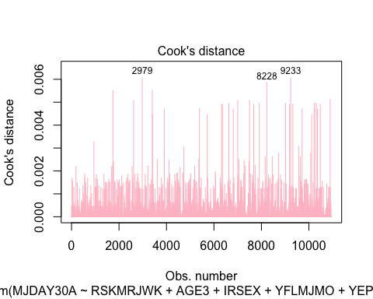
# identify observations above cutoff points (cook's distance)
sum(diag_m3$.cooksd > 1)
## [1] 0
# Leverage (hat values)
plot(model3, which = 5, id.n = 3)
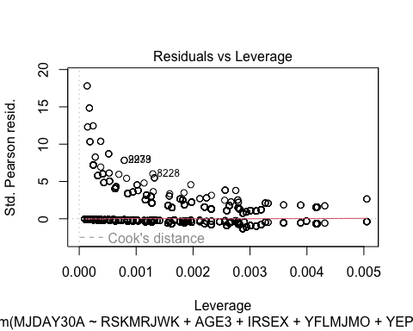
# dfbetas summary
summary(dfbetas(model3))
## (Intercept) RSKMRJWKSlight risk RSKMRJWKModerate risk
## Min. :-0.0743394 Min. :-7.793e-02 Min. :-7.557e-02
## 1st Qu.:-0.0013594 1st Qu.:-1.508e-03 1st Qu.:-2.206e-03
## Median :-0.0003905 Median :-1.218e-05 Median : 2.759e-05
## Mean :-0.0003266 Mean :-2.394e-04 Mean :-3.578e-04
## 3rd Qu.: 0.0016088 3rd Qu.: 2.155e-04 3rd Qu.: 6.559e-04
## Max. : 0.1672559 Max. : 7.320e-02 Max. : 1.240e-01
## RSKMRJWKGreat risk AGE3 IRSEXFemale
## Min. :-0.0527151 Min. :-0.1195725 Min. :-0.0657480
## 1st Qu.:-0.0017710 1st Qu.:-0.0014824 1st Qu.:-0.0014380
## Median : 0.0001339 Median : 0.0005948 Median : 0.0002811
## Mean :-0.0003546 Mean : 0.0003216 Mean : 0.0001076
## 3rd Qu.: 0.0008122 3rd Qu.: 0.0021596 3rd Qu.: 0.0016303
## Max. : 0.2081081 Max. : 0.0597011 Max. : 0.0611493
## YFLMJMODisapprove YEPMJMODisapprove
## Min. :-0.0595608 Min. :-1.132e-01
## 1st Qu.:-0.0029745 1st Qu.:-2.602e-04
## Median :-0.0007934 Median :-1.164e-04
## Mean :-0.0005571 Mean :-3.346e-04
## 3rd Qu.:-0.0001515 3rd Qu.: 2.353e-05
## Max. : 0.1241177 Max. : 7.219e-02
Cook’s D, leverage, and dfbetas indicated no influential observations. However, a few cases had slightly higher leverage values, but their Cook’s D values were extremely small (<0.01), showing they might have minimal influence on parameter estimates. No data points required removal.

Goodness of fit (Hosmer–Lemeshow)
library(ResourceSelection)
hoslem.test(
x = as.numeric(complete_data$MJDAY30A) - 1, # convert to 0/1
y = fitted(model3)
)
##
## Hosmer and Lemeshow goodness of fit (GOF) test
##
## data: as.numeric(complete_data$MJDAY30A) - 1, fitted(model3)
## X-squared = 23.748, df = 8, p-value = 0.002525
The Hosmer-Lemeshow test was statistically significant (p=0.0025), which is above less than 0.05. This suggests some lack of calibration. The reason could be the sample size is large above 11,000, and the HLT is sensitive to flag any minor deviations, so this would be fine. Visual dianostics (ROC AUC = 0.88) and predicted probability plots both acceptable overall model performance. The model is acceptable fit.

Linearity of the logit (AGE3)
model3_age_test <- glm(
MJDAY30A ~ RSKMRJWK + IRSEX + YFLMJMO + YEPMJMO +
AGE3 + I(AGE3 * log(AGE3)),
data = complete_data,
family = binomial
)
summary(model3_age_test)
##
## Call:
## glm(formula = MJDAY30A ~ RSKMRJWK + IRSEX + YFLMJMO + YEPMJMO +
## AGE3 + I(AGE3 * log(AGE3)), family = binomial, data = complete_data)
##
## Coefficients:
## Estimate Std. Error z value Pr(>|z|)
## (Intercept) -4.66390 0.89073 -5.236 1.64e-07 ***
## RSKMRJWKSlight risk -0.59641 0.09866 -6.045 1.49e-09 ***
## RSKMRJWKModerate risk -1.39432 0.12710 -10.970 < 2e-16 ***
## RSKMRJWKGreat risk -2.47639 0.20711 -11.957 < 2e-16 ***
## IRSEXFemale 0.34949 0.08509 4.107 4.00e-05 ***
## YFLMJMODisapprove -1.63087 0.09851 -16.556 < 2e-16 ***
## YEPMJMODisapprove -0.75372 0.10434 -7.224 5.06e-13 ***
## AGE3 3.09423 0.75762 4.084 4.42e-05 ***
## I(AGE3 * log(AGE3)) -1.35483 0.42675 -3.175 0.0015 **
## ---
## Signif. codes: 0 '***' 0.001 '**' 0.01 '*' 0.05 '.' 0.1 ' ' 1
##
## (Dispersion parameter for binomial family taken to be 1)
##
## Null deviance: 5623.4 on 10943 degrees of freedom
## Residual deviance: 3972.5 on 10935 degrees of freedom
## AIC: 3990.5
##
## Number of Fisher Scoring iterations: 7
The linearity-in-the-logit assumption applies only to continuous predictors. In this study, age represents three discrete adolescent age groups (12-13, 14-15, 16-17). It functions as an ordinal categorical variable, and therefore the linearity assumption does not apply. A box-tidwell applied, adn reached statistical significance; however, age is not a true continuous measures, this result is not meaningful. All other predictors were categorical, so the linearity assumption was not relevant, and no violations were detected for variables to which the assumption applies.

Model Performance
Predicted Probabilities (full adjusted Model)
odds.n.ends(model3, predProbPlot = TRUE)
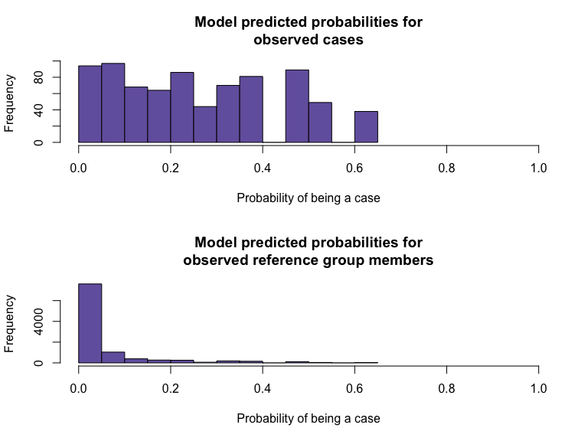
## $`Logistic regression model significance`
## Chi-squared d.f. p
## 1640.414 7 <.001
##
## $`Contingency tables (model fit): frequency predicted`
## Number observed
## Number predicted 1 0 Sum
## 1 87 73 160
## 0 693 10091 10784
## Sum 780 10164 10944
##
## $`Count R-squared (model fit): percent correctly predicted`
## [1] 93.00073
##
## $`Model sensitivity`
## [1] 0.1115385
##
## $`Model specificity`
## [1] 0.9928178
##
## $`Predictor odds ratios and 95% CI`
## OR 2.5 % 97.5 %
## (Intercept) 0.14108820 0.09605046 0.2055143
## RSKMRJWKSlight risk 0.54840623 0.45201457 0.6655372
## RSKMRJWKModerate risk 0.24716650 0.19221697 0.3163945
## RSKMRJWKGreat risk 0.08306115 0.05432322 0.1226301
## AGE3 2.04656338 1.80523031 2.3268875
## IRSEXFemale 1.42232175 1.20423827 1.6813056
## YFLMJMODisapprove 0.19332902 0.15909489 0.2342392
## YEPMJMODisapprove 0.47815204 0.39004128 0.5868997
ROC Curve (full adjusted Model)
odds.n.ends(model3, rocPlot = TRUE)
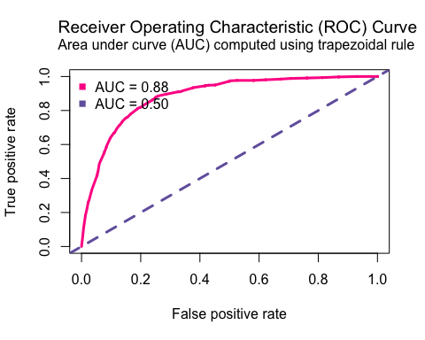
## $`Logistic regression model significance`
## Chi-squared d.f. p
## 1640.414 7 <.001
##
## $`Contingency tables (model fit): frequency predicted`
## Number observed
## Number predicted 1 0 Sum
## 1 87 73 160
## 0 693 10091 10784
## Sum 780 10164 10944
##
## $`Count R-squared (model fit): percent correctly predicted`
## [1] 93.00073
##
## $`Model sensitivity`
## [1] 0.1115385
##
## $`Model specificity`
## [1] 0.9928178
##
## $`Predictor odds ratios and 95% CI`
## OR 2.5 % 97.5 %
## (Intercept) 0.14108820 0.09605046 0.2055143
## RSKMRJWKSlight risk 0.54840623 0.45201457 0.6655372
## RSKMRJWKModerate risk 0.24716650 0.19221697 0.3163945
## RSKMRJWKGreat risk 0.08306115 0.05432322 0.1226301
## AGE3 2.04656338 1.80523031 2.3268875
## IRSEXFemale 1.42232175 1.20423827 1.6813056
## YFLMJMODisapprove 0.19332902 0.15909489 0.2342392
## YEPMJMODisapprove 0.47815204 0.39004128 0.5868997
Predicted Probabilities (Interaction Model)
odds.n.ends(model4, predProbPlot = TRUE)
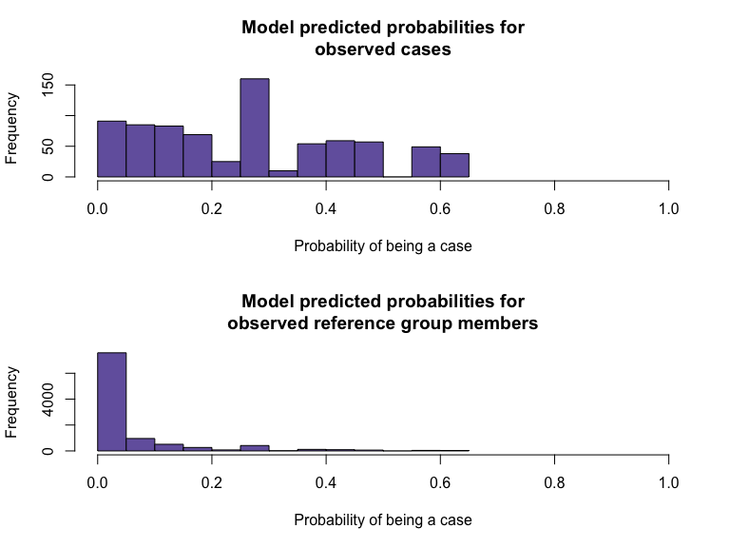
## $`Logistic regression model significance`
## Chi-squared d.f. p
## 1647.757 10 <.001
##
## $`Contingency tables (model fit): frequency predicted`
## Number observed
## Number predicted 1 0 Sum
## 1 87 73 160
## 0 693 10091 10784
## Sum 780 10164 10944
##
## $`Count R-squared (model fit): percent correctly predicted`
## [1] 93.00073
##
## $`Model sensitivity`
## [1] 0.1115385
##
## $`Model specificity`
## [1] 0.9928178
##
## $`Predictor odds ratios and 95% CI`
## OR 2.5 % 97.5 %
## (Intercept) 0.14572050 0.09738471 0.2161642
## RSKMRJWKSlight risk 0.58580204 0.44737713 0.7668497
## RSKMRJWKModerate risk 0.18925695 0.12411578 0.2812976
## RSKMRJWKGreat risk 0.05094685 0.02129647 0.1029720
## IRSEXFemale 1.35132019 1.01512825 1.7990779
## AGE3 2.03922390 1.79870492 2.3186242
## YFLMJMODisapprove 0.19448181 0.16005747 0.2356118
## YEPMJMODisapprove 0.47770335 0.38967554 0.5863468
## RSKMRJWKSlight risk:IRSEXFemale 0.89299285 0.61053419 1.3065619
## RSKMRJWKModerate risk:IRSEXFemale 1.51132162 0.91555342 2.5315182
## RSKMRJWKGreat risk:IRSEXFemale 2.05908947 0.86959818 5.4571674
ROC Curve (Interaction Model)
odds.n.ends(model4, rocPlot = TRUE)
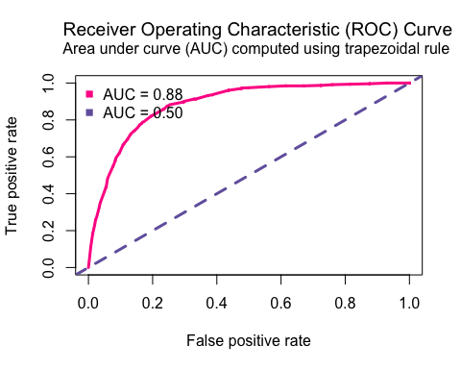
## $`Logistic regression model significance`
## Chi-squared d.f. p
## 1647.757 10 <.001
##
## $`Contingency tables (model fit): frequency predicted`
## Number observed
## Number predicted 1 0 Sum
## 1 87 73 160
## 0 693 10091 10784
## Sum 780 10164 10944
##
## $`Count R-squared (model fit): percent correctly predicted`
## [1] 93.00073
##
## $`Model sensitivity`
## [1] 0.1115385
##
## $`Model specificity`
## [1] 0.9928178
##
## $`Predictor odds ratios and 95% CI`
## OR 2.5 % 97.5 %
## (Intercept) 0.14572050 0.09738471 0.2161642
## RSKMRJWKSlight risk 0.58580204 0.44737713 0.7668497
## RSKMRJWKModerate risk 0.18925695 0.12411578 0.2812976
## RSKMRJWKGreat risk 0.05094685 0.02129647 0.1029720
## IRSEXFemale 1.35132019 1.01512825 1.7990779
## AGE3 2.03922390 1.79870492 2.3186242
## YFLMJMODisapprove 0.19448181 0.16005747 0.2356118
## YEPMJMODisapprove 0.47770335 0.38967554 0.5863468
## RSKMRJWKSlight risk:IRSEXFemale 0.89299285 0.61053419 1.3065619
## RSKMRJWKModerate risk:IRSEXFemale 1.51132162 0.91555342 2.5315182
## RSKMRJWKGreat risk:IRSEXFemale 2.05908947 0.86959818 5.4571674
Intepretation: - Most non-using groups had predicted probabilities below 0.10. - Most using groups had predicted probabilities between 0.10 and 0.60. - Overall, this is acceptable because marijuana use is a low proportion in the dataset. - ROC curves showed strong model discrimination, which models distinguish between users and non-users. - Low sensitivity is acceptable because the proportion of users in the group is low. Specificity remains high, so ROC curves show strong performance. - Model 3 and Model 4 show identical predicted probabilities and ROC curves that match the non-significant sex interaction result.

Discussion
Perceived risk of smoking marijuana once or twice a week was strongly and associated with past 30-day use among adolescents. Youth who viewed marijuana as more harmful had substantially lower odds of recent use, indicating a clear dose–response relationship. This association continued after adjusting for age, sex, peer disapproval, and parental disapproval. Testing for effect modification showed that the perceived risk–use association was similar for males and females. Although the point estimates differed very slightly, particularly in the moderate- and great-risk categories, the sex × perceived risk interaction was not statistically significant. These findings suggest that perceived risk impacts marijuana use similarly for both male and female adolescents. Peer and parental disapproval were also strongly associated with lower marijuana use. Adolescents whose friends disapproved of marijuana use had the lowest odds of reporting past-month use, highlighting the major influence of peer norms during adolescence.

Reproducibility
All data cleaning, descriptive analysis, and Modeling scripts are stored in the project repository: - 01_data_cleaning.R - 02_descriptive_analysis.R - 03_modeling.R - 04_logistic_models.R Workflow follows reproducible research practices with transparent version control and structured outputs.

