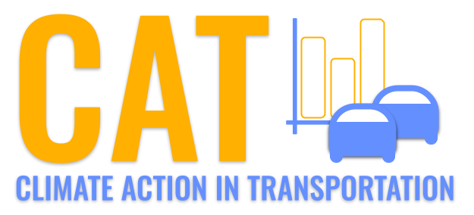 

**PM10 Emissions in White County, 2015**  
Made with CAT VISUALIZER by Gao Labs @ Cornell University.

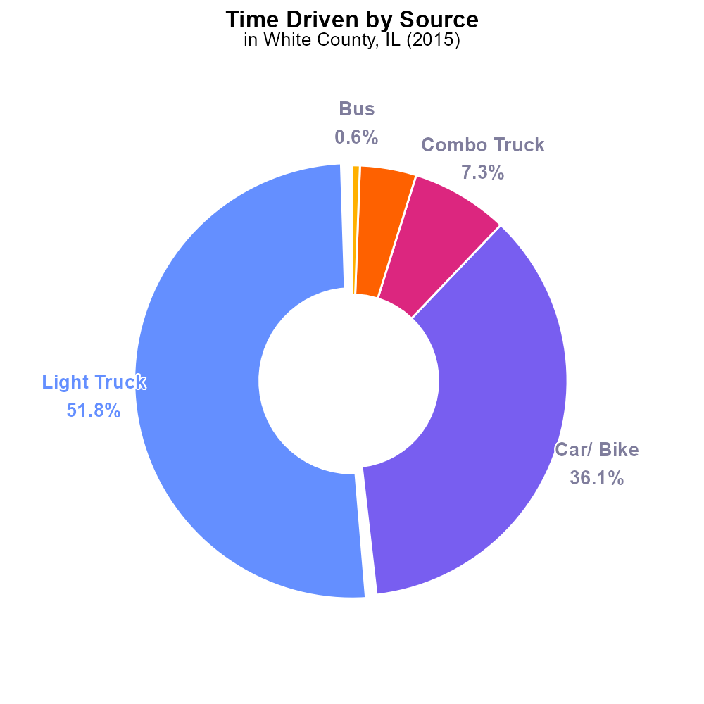

## Keywords

Primary Exhaust PM10; Total emissions; On-road transportation; White County; IL; 2015

## Highlights

* Analysis of on-road transportation emissions in White County, IL in 2015.
* Examining primary exhaust PM10 levels and their impact on air quality.
* Evaluation of the total amount of PM10 emitted by on-road vehicles.
* Understanding the environmental implications of transportation emissions.
* Providing insights for future mitigation strategies for cleaner air in the region.

# Introduction

The report aims to analyze the primary exhaust PM10 emissions from on-road transportation in White County, IL, specifically focusing on the total emissions recorded in 2015. As a critical component of air pollution, PM10 particles have significant implications for public health and environmental quality.

By assessing the levels of PM10 emitted by on-road vehicles, this study seeks to provide valuable insights into the extent of pollution caused by transportation activities in the region. Understanding these emissions is essential for developing effective strategies to mitigate the environmental impact and improve air quality for residents of White County.

# Time Driven by Vehicle Type

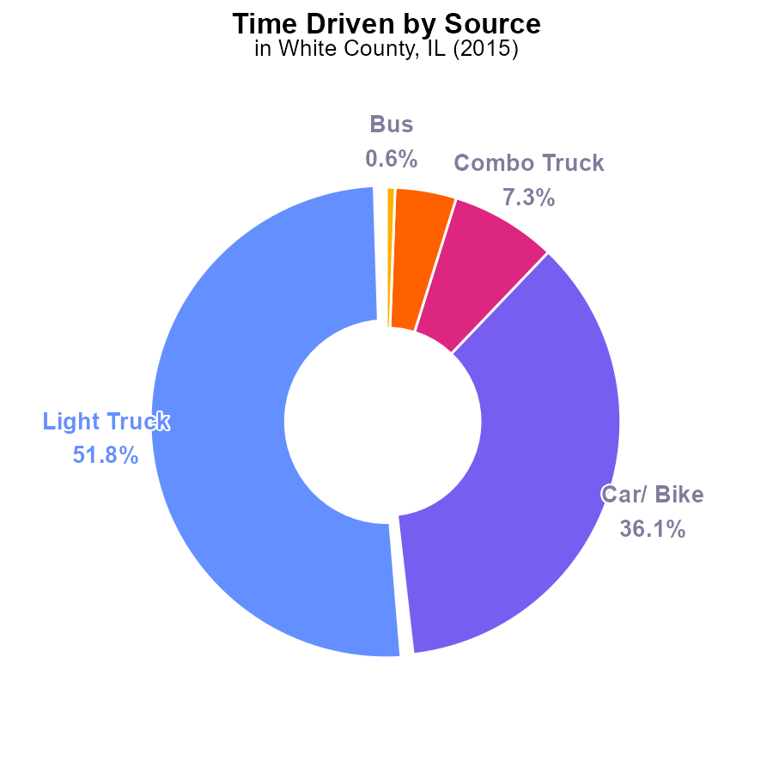

## Findings

* In 2015, Light Trucks contributed 51.8% of PM10 emissions in White County, IL
* Cars/Bikes accounted for 36.1% of total PM10 emissions in the area that year
* Combo Trucks, Heavy Trucks, and Buses combined were responsible for only 12.1% of PM10 emissions

## Recommendations

To lower PM10 emissions in White County, IL, focus should be on reducing emissions from Light Trucks and Cars/Bikes, as they collectively contribute to 87.9% of total emissions. Implementing stricter emission standards for these vehicles or promoting the use of electric vehicles could help significantly reduce pollution levels in the region.

# Vehicle Starts by Vehicle Type

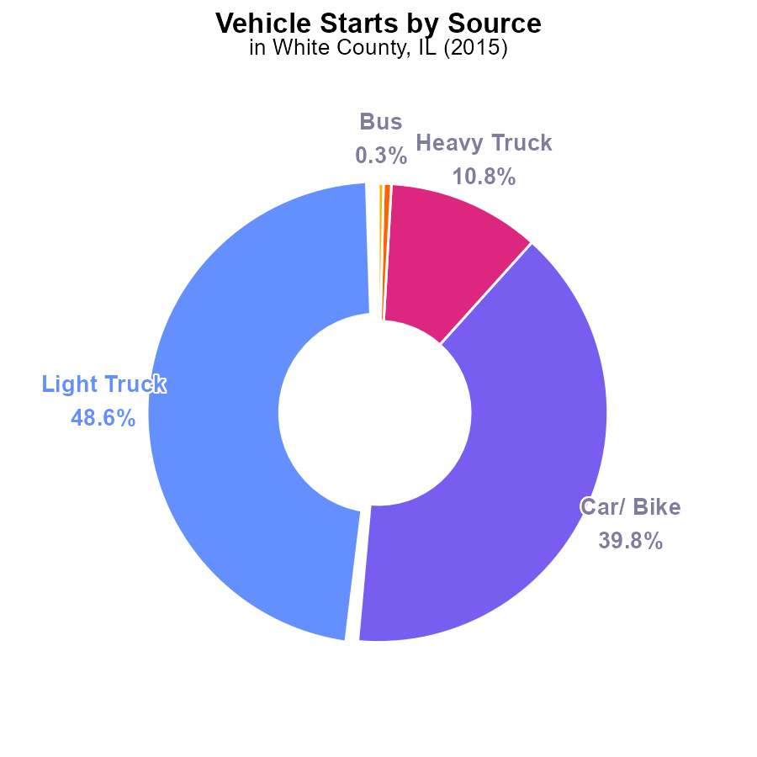

## Findings

* Light trucks are responsible for 48.6% of the PM10 emissions from vehicle starts.
* Cars and bikes contribute 39.8% of the total PM10 emissions from vehicle starts.
* Heavy trucks only account for 10.8% of the PM10 emissions from vehicle starts.

## Recommendations

To lower PM10 emissions from vehicle starts in White County, IL, the focus should be primarily on reducing emissions from light trucks and cars/bikes, which together contribute 88.4% of the total emissions. Implementing emission control measures for these vehicle types could significantly reduce overall pollution levels.

# Vehicle Miles Traveled over Time for Buses

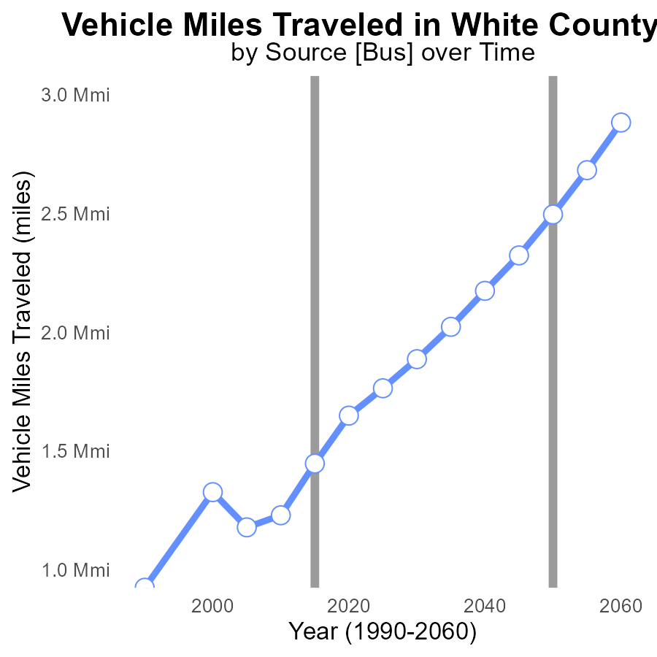

## Findings

* From 2000 to 2035, vehicle miles traveled increased by 53.8% in White County, IL.
* PM10 emissions were consistently higher than the benchmark difference in each year.
* Between 2000 and 2035, the benchmark difference decreased by 59.6%.

## Recommendations

To lower emissions, the county should invest in public transportation, carpooling incentives, and bike-friendly infrastructure to reduce vehicle miles traveled. Implement stricter emission standards and promote electric vehicles to decrease PM10 emissions.

# Idling Overall over Time

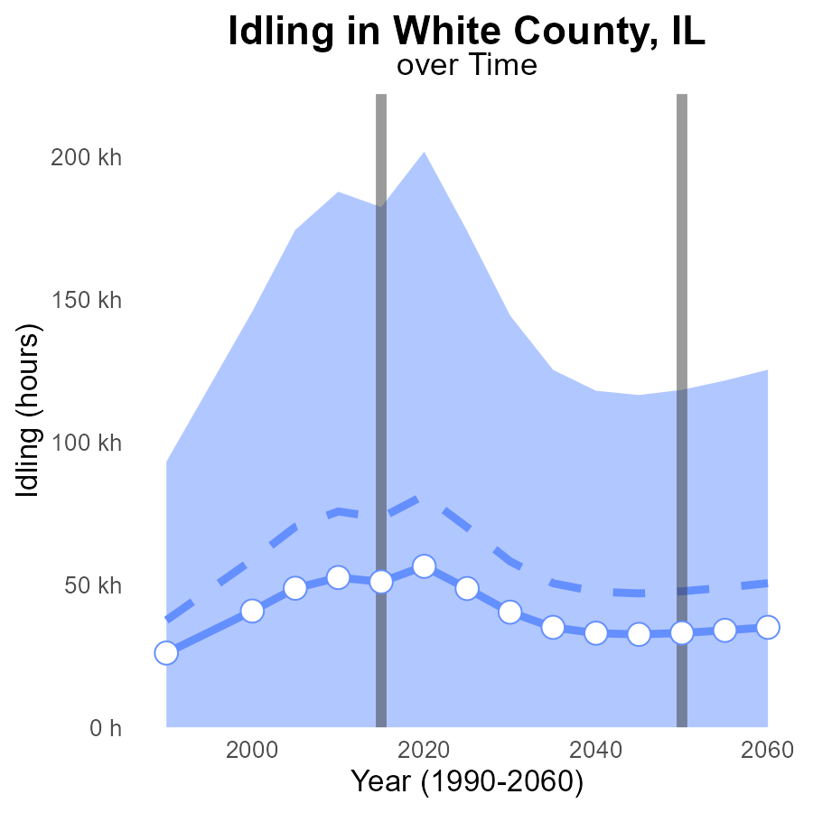

## Findings

* PM10 emissions in White County, IL from idling have decreased steadily from 2000 to 2035.
* The emissions in this area were consistently below the median area and the upper 75th percentile of areas.
* The benchmark difference indicates White County is performing better than the benchmark across all years.

## Recommendations

To further reduce PM10 emissions from idling vehicles in White County, IL, policies such as implementing stricter idling regulations, promoting electric vehicles, and incentivizing public transportation could be considered. Regular monitoring and public awareness campaigns are also crucial.

# Time Driven Mapped by Area

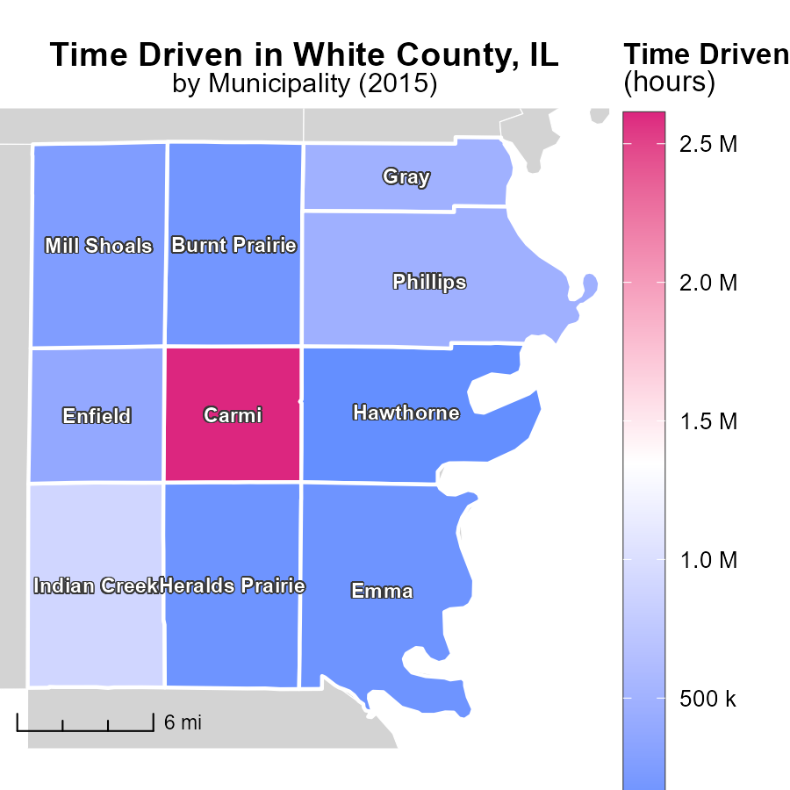

## Findings

* Carmi, IL had the highest total emissions with 2.6 million hours.
* Mill Shoals, IL had a median of 259.3 thousand hours of emissions.
* Hawthorne, IL had the lowest emissions with 86.2 thousand hours.

## Recommendations

To reduce emissions, focus on implementing energy-efficient technologies in high emitting areas such as Carmi, IL. Improve transportation infrastructure to lower emissions in Mill Shoals, IL. Encourage sustainable practices in Hawthorne, IL to maintain low emissions.

# Idling Mapped by Area

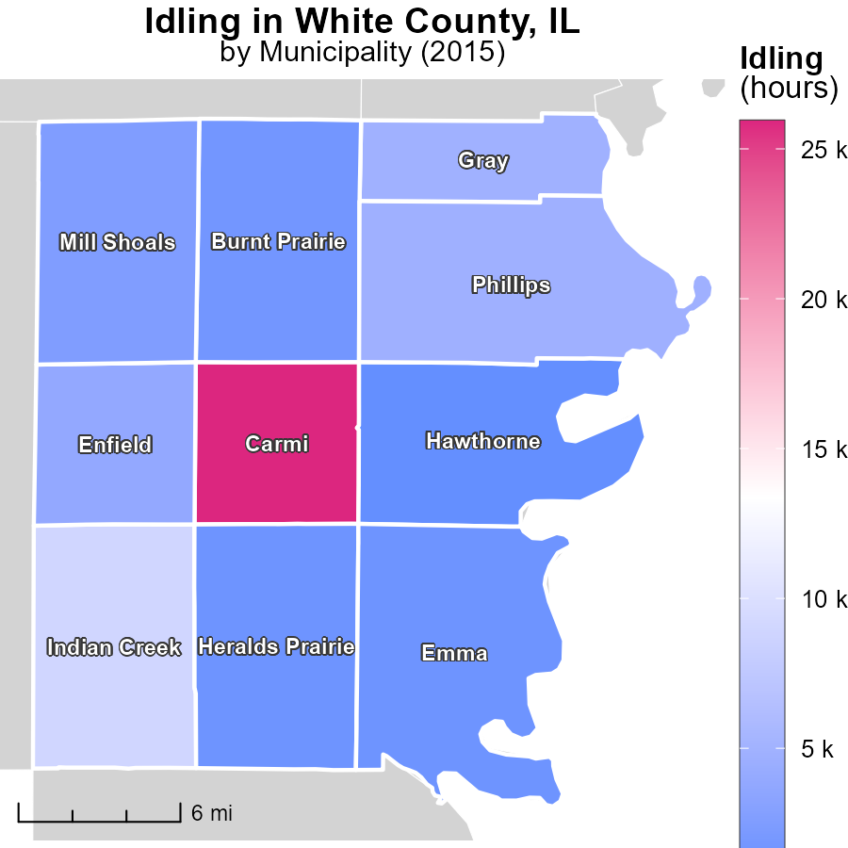

## Findings

* The maximum idling time in Carmi, IL in 2015 was 25.9 thousand hours.
* The median idling time in Mill Shoals, IL was 2.6 thousand hours.
* The minimum idling time in Hawthorne, IL was 855.3 hours.

## Recommendations

To reduce idling emissions, implementing idling reduction technologies in vehicles in Carmi, IL where the maximum idling time was recorded can significantly help decrease emissions. Encouraging the adoption of more fuel-efficient practices in Mill Shoals, IL and Hawthorne, IL where idling times were still substantial can also contribute to emissions reduction.

# Vehicle Starts by Fuel Type over Time

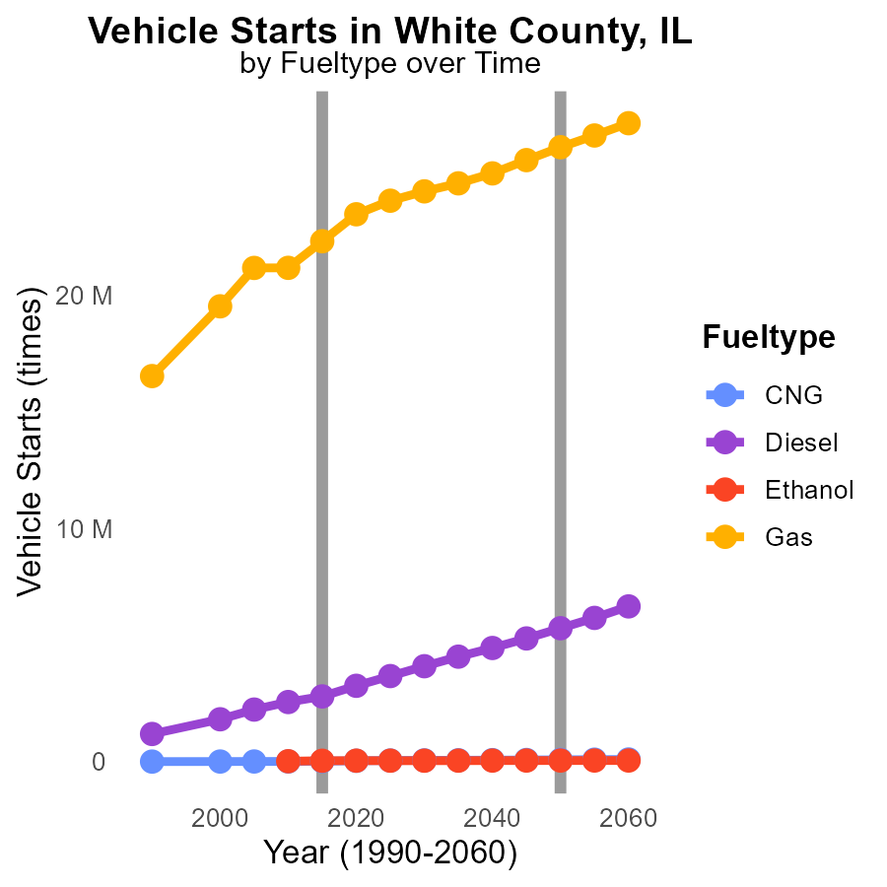

## Findings

* Diesel emissions decreased by 41.1% from 2005 to 2025.
* Gas emissions increased by 14.2% from 2005 to 2025.
* CNG and Ethanol emissions showed a consistent decrease over the years.

## Recommendations

To lower emissions, consider incentives for transitioning vehicle starts from Diesel to CNG or Ethanol, and encourage the use of cleaner fuel types like CNG and Ethanol to sustain the decreasing trend.

# Emissions Rate (per mile) by Vehicle Type over Time

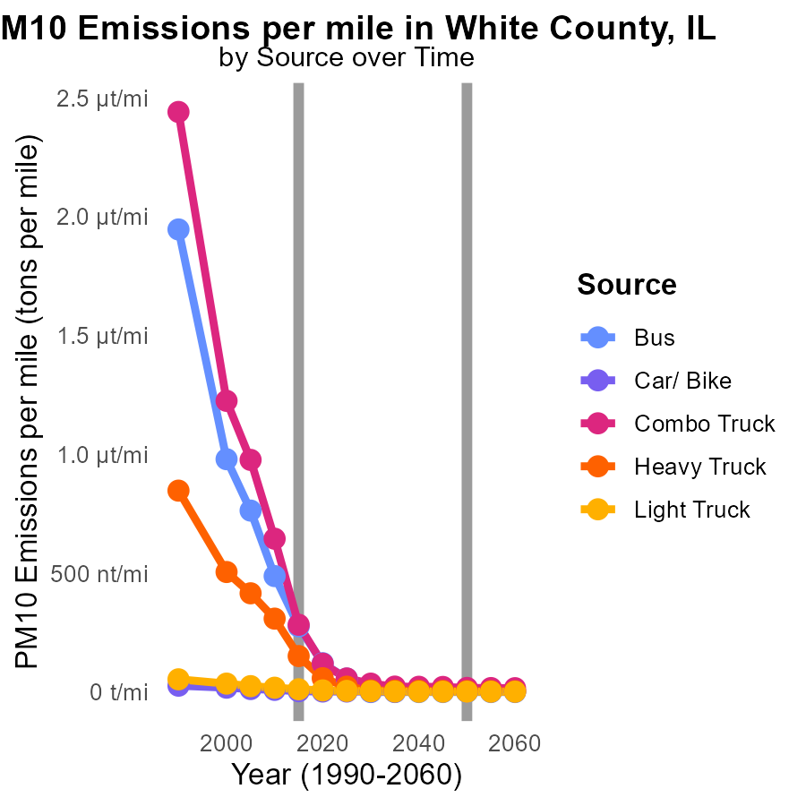

## Findings

* Combo Truck emissions decreased by 94% from 2005 to 2025.
* Heavy Truck emissions reduced by 95% between 2005 and 2025.
* Bus emissions decreased by 93% over the period 2005-2025.

## Recommendations

To further reduce emissions, focus on promoting public transport, transitioning to cleaner fuel alternatives for trucks, and implementing stricter emissions standards for all vehicles.

# Areas Ranked by Vehicle Miles Traveled

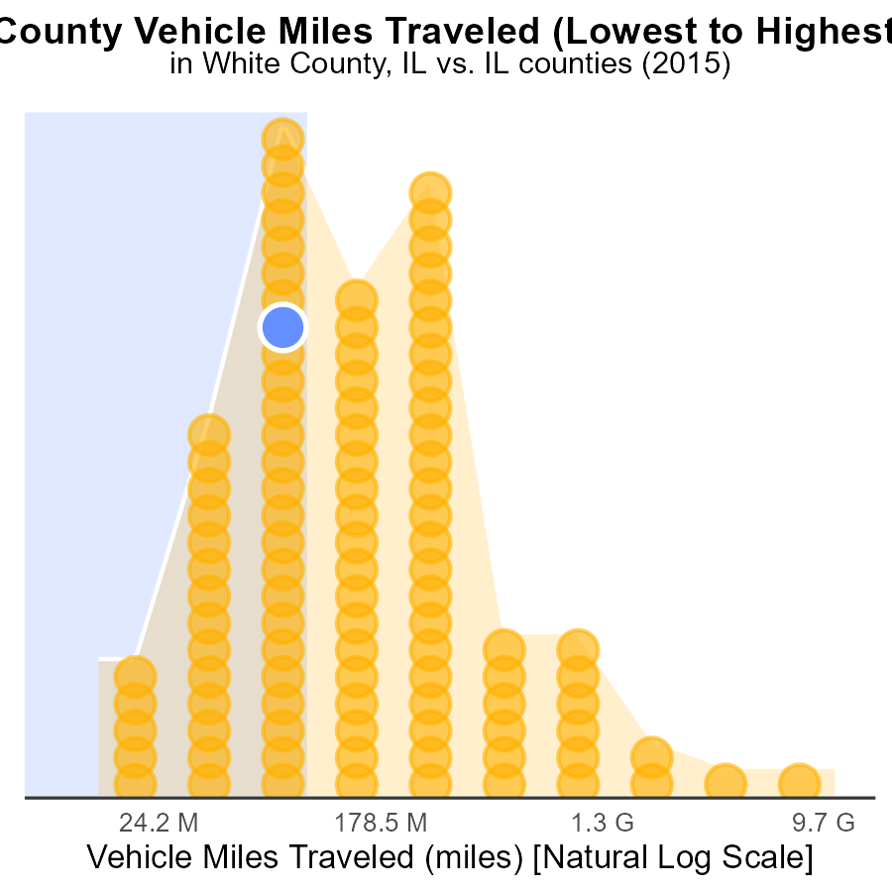

## Findings

* Cook county had the highest VMT with 29.6 billion miles, ranking 102nd in percentile.
* Hardin county had the lowest VMT with 37.9 million miles, ranking 1st in percentile.
* Saline county had the highest percentile of 37.3% with 260.9 million VMT.

## Recommendations

To lower emissions, focus on reducing vehicle miles traveled. Encourage carpooling, public transport, and biking. Implement policies promoting telecommuting to decrease the reliance on personal vehicles.

# Areas Ranked by Idling

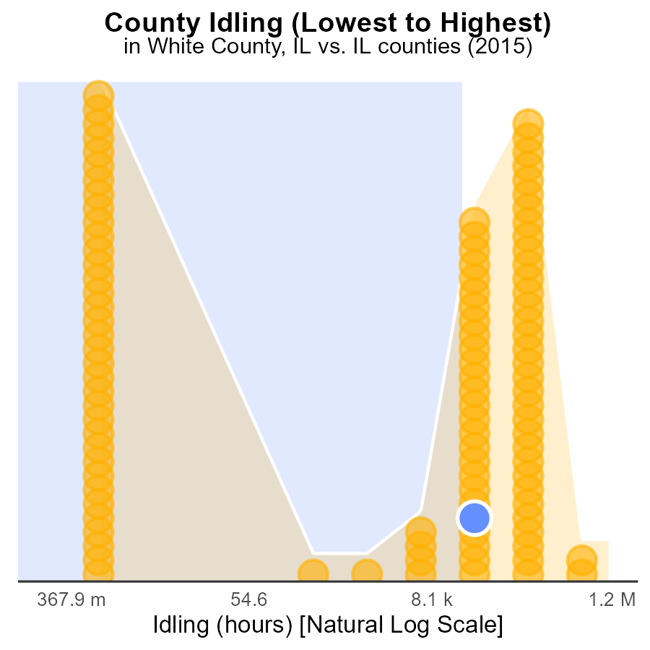

## Findings

* The county with the highest idle hours for PM10 emissions in 2015 was Cook with 3.0 million hours.
* White County had 51.0 thousand idle hours, ranking 46th in the list, contributing to 45.1% of the total idle hours.
* Brown County did not have any idling hours recorded for PM10 emissions in 2015, ranking the lowest at 1st place with 0.0 hours.

## Recommendations

To lower PM10 emissions, strategies should focus on reducing idle hours in counties with the highest contribution - like Cook County - by implementing policies to encourage less idling, promoting alternative transportation methods, and educating the public on the environmental impacts of idling.

# Conclusion

In conclusion, the data from White County, IL, in 2015 shows that Light Trucks and Cars/Bikes are the primary contributors to PM10 emissions. By implementing stricter emission standards for these vehicles and promoting the use of electric vehicles, significant reductions in pollution levels can be achieved. Furthermore, initiatives to reduce vehicle miles traveled, invest in public transportation, and encourage sustainable practices can help lower emissions and improve air quality in the region. Policies focusing on reducing idle hours in areas with high contributions, transitioning to cleaner fuel alternatives, and promoting public transport can further aid in decreasing PM10 emissions across the county. Overall, a comprehensive approach involving multiple strategies is necessary to combat the growing issue of air pollution in White County, IL.

Reducing emissions from on-road transportation remains a critical goal for White County, IL, given the alarming data on PM10 emissions in 2015. By targeting the major contributors like Light Trucks and Cars/Bikes, the county can make significant strides in improving air quality. Additionally, addressing idling emissions, transitioning to cleaner fuel types, and promoting sustainable transportation practices are essential steps towards achieving a greener and healthier environment for residents. With a coordinated effort involving policy changes, public awareness campaigns, and technological advancements, White County can work towards a cleaner and more sustainable future.

# About This Report

Data based on MOVES estimates collected by the Climate Action in Transportation program at Cornell University. Demographic data sourced from the US Census's American Community Survey 5-year estimates. This report was generated with the help of AI.

# References

* U.S. Census Bureau. (2023). American Community Survey 5-year estimates: Detailed tables. Retrieved from https://data.census.gov
* U.S. Environmental Protection Agency. (2024). Motor Vehicle Emission Simulator (MOVES 4.0) [Software]. Retrieved from https://www.epa.gov/moves