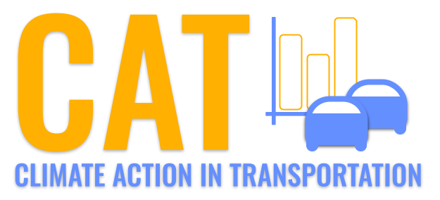 

**NOx Emissions in Lawrence County, 2040**  
Made with CAT VISUALIZER by Gao Labs @ Cornell University.

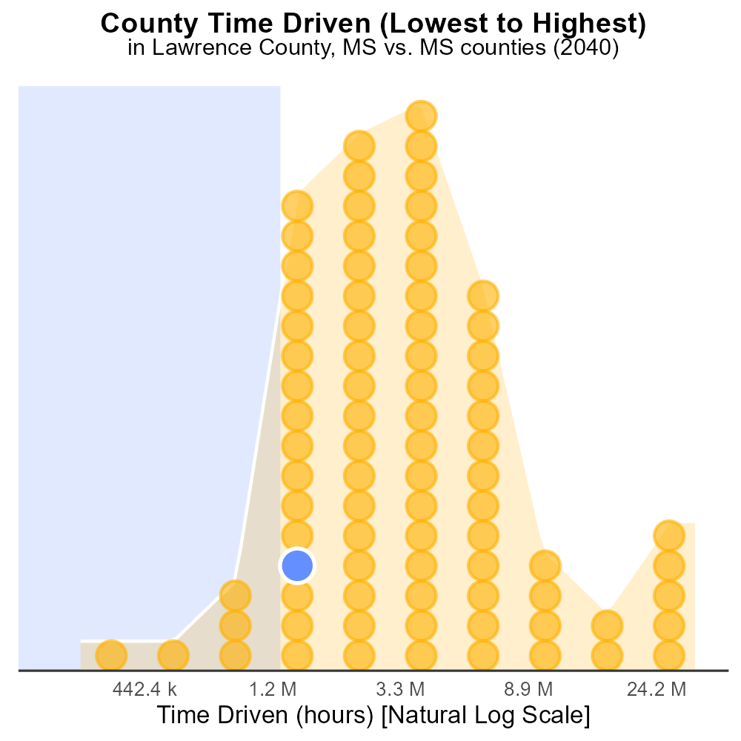

## Keywords

Oxides of Nitrogen; NOx emissions; on-road transportation; Lawrence County; 2040; environmental impact

## Highlights

* Study examines NOx emissions from on-road vehicles in Lawrence County, MS in 2040.
* Focus on environmental implications and potential health risks associated with NOx.
* Analysis aims to identify trends and potential mitigation strategies for NOx emissions.
* Data obtained to project future scenarios and inform policy decisions.
* Results expected to provide insights into effects of transportation on air quality.

# Introduction

This report delves into the examination of Oxides of Nitrogen (NOx) emissions from on-road transportation in Lawrence County, MS, specifically focusing on the year 2040. NOx emissions, arising predominantly from vehicle exhaust, have significant implications for air quality and public health. With an increasing concern for environmental sustainability, understanding the trends and impacts of NOx emissions is crucial for informed policy-making and mitigation strategies.

By projecting future scenarios and analyzing data trends, this study aims to shed light on the potential environmental and health risks associated with NOx emissions in Lawrence County. The findings are anticipated to provide valuable insights into the effects of on-road transportation on air quality and public health, guiding efforts towards a cleaner and healthier environment for the community.

# Emissions Rate (per vehicle) by Road Type

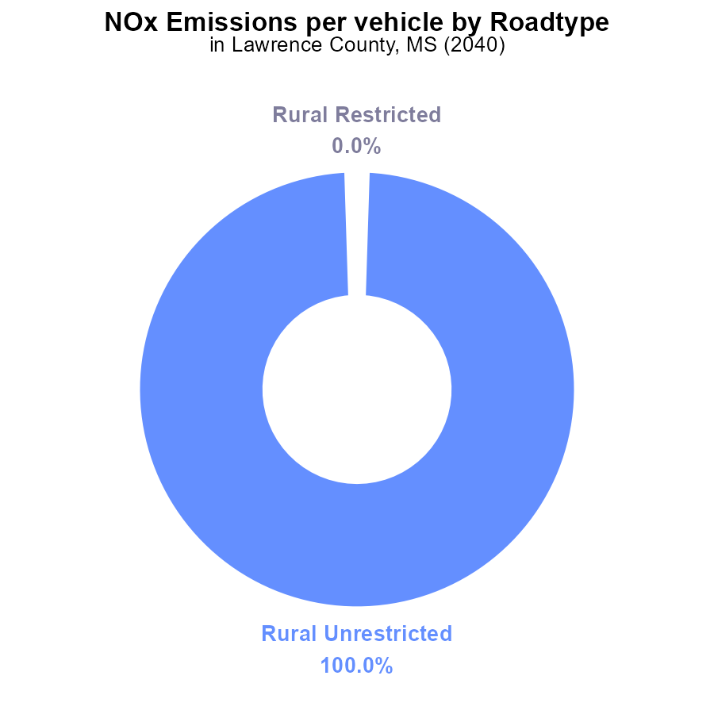

## Findings

* The NOx emissions per vehicle in Lawrence County, MS in 2040 for Rural Unrestricted areas are 2.5 tons per vehicle.
* There are no NOx emissions from vehicles in Rural Restricted, Urban Restricted, and Urban Unrestricted areas in 2040.
* Rural Unrestricted areas contribute 100% of the NOx emissions per vehicle in Lawrence County, MS in 2040.

## Recommendations

To lower NOx emissions in Lawrence County, MS, focus on reducing emissions from vehicles in Rural Unrestricted areas by implementing stricter emission standards, promoting the use of cleaner fuels, and increasing public transportation options.

# Vehicle Starts by Fuel Type

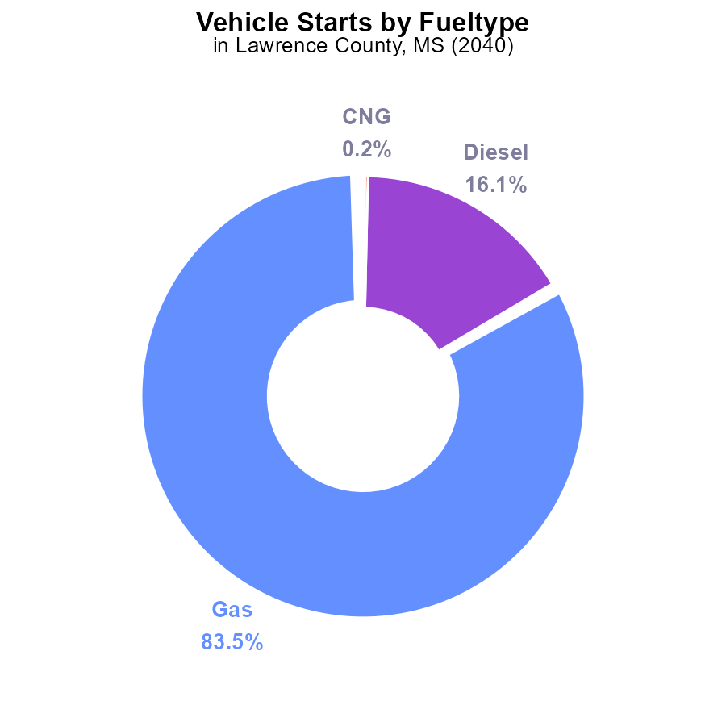

## Findings

* Gas vehicles contribute 83.5% of NOx emissions from vehicle starts in Lawrence County in 2040.
* Diesel vehicles contribute 16.1% of NOx emissions from vehicle starts in Lawrence County in 2040.
* Alternative fuel types like CNG and Ethanol contribute less than 1% combined to NOx emissions from vehicle starts in Lawrence County in 2040.

## Recommendations

To lower NOx emissions, encourage the adoption of cleaner fuel alternatives like CNG and Ethanol, alongside implementing stricter emission standards for gas and diesel vehicles.

# Vehicles over Time for Passenger Vehicles

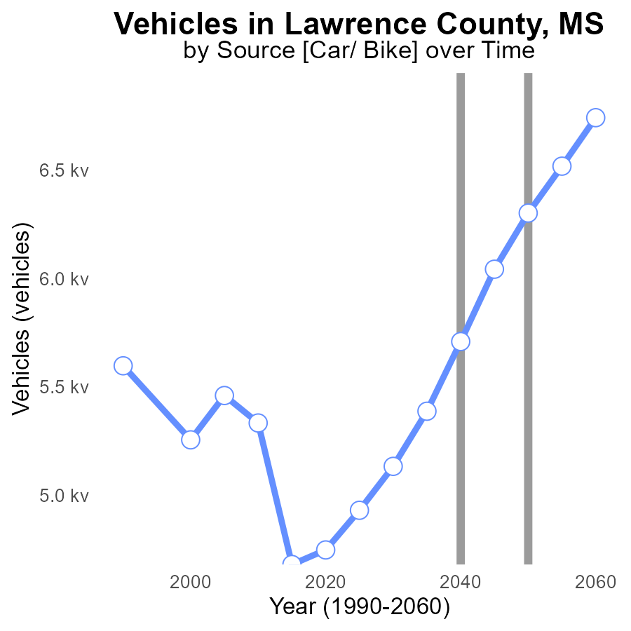

## Findings

* NOx emissions from vehicles in Lawrence County are forecasted to increase from 4.8k in 2020 to 6.7k in 2060.
* The benchmark difference is decreasing over time from 1549.9 in 2020 to -438.9 in 2060, indicating progress in reducing emissions.
* Emission reductions are most significant between 2040 and 2060, with a decrease of 1153.5 in benchmark difference.

## Recommendations

To lower NOx emissions, Lawrence County should prioritize transitioning to electric vehicles, improving public transportation, and enforcing stricter emission standards for vehicles.

# Vehicles Overall over Time

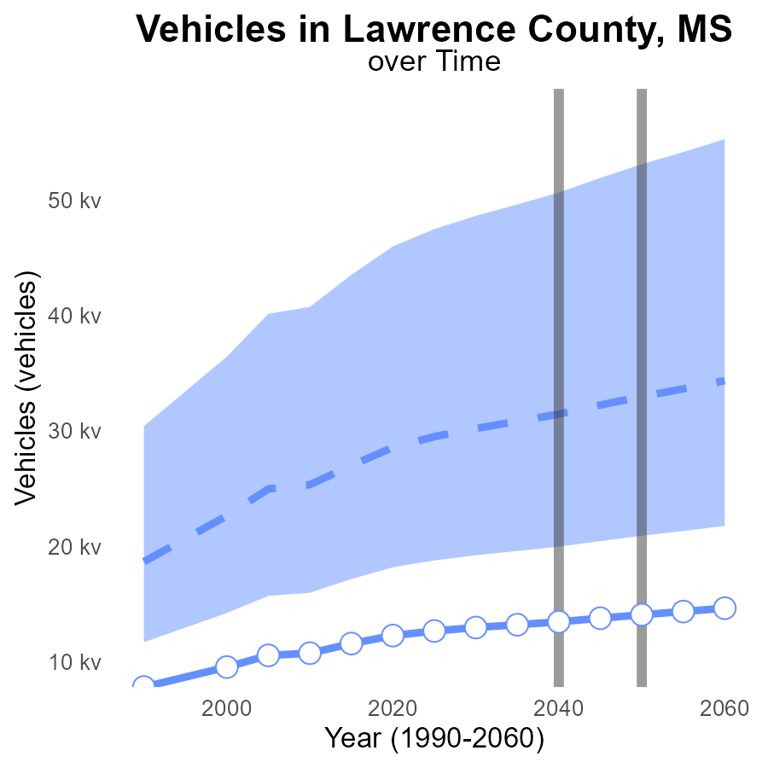

## Findings

* NOx emissions from vehicles in Lawrence County are projected to decrease over the next four decades.
* The difference from the median area NOx emissions will increase slightly by 2060.
* Benchmark difference for NOx emissions in 2055 shows a decrease compared to the median area.

## Recommendations

To lower NOx emissions further, policymakers should promote the adoption of electric vehicles, invest in public transportation infrastructure, and implement stricter vehicle emissions standards to surpass the benchmark differences.

# Emissions Rate (per mile) Mapped by Area

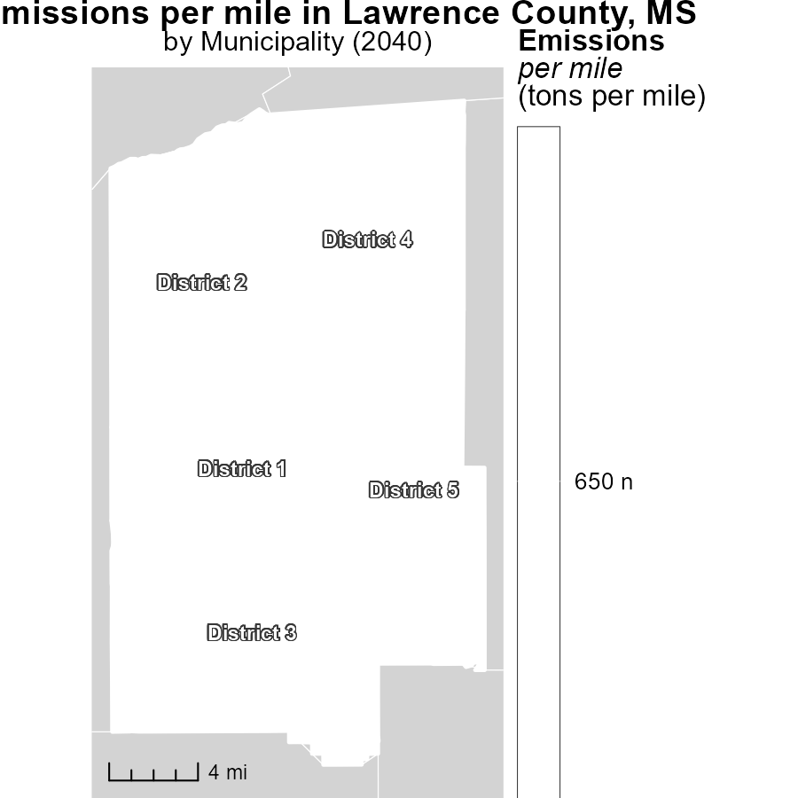

## Findings

* District 1, MS has the highest emissions per mile at 650.0 tons
* District 3, MS has a median emissions rate at 650.0 tons per mile
* District 5, MS exhibits the lowest emissions per mile at 650.0 tons

## Recommendations

Policymakers should focus on implementing stricter emission control measures in District 1 to reduce levels. District 3 must maintain its median position, while solutions to decrease emissions have to be investigated in District 5.

# Emissions Rate (per capita) in My Region

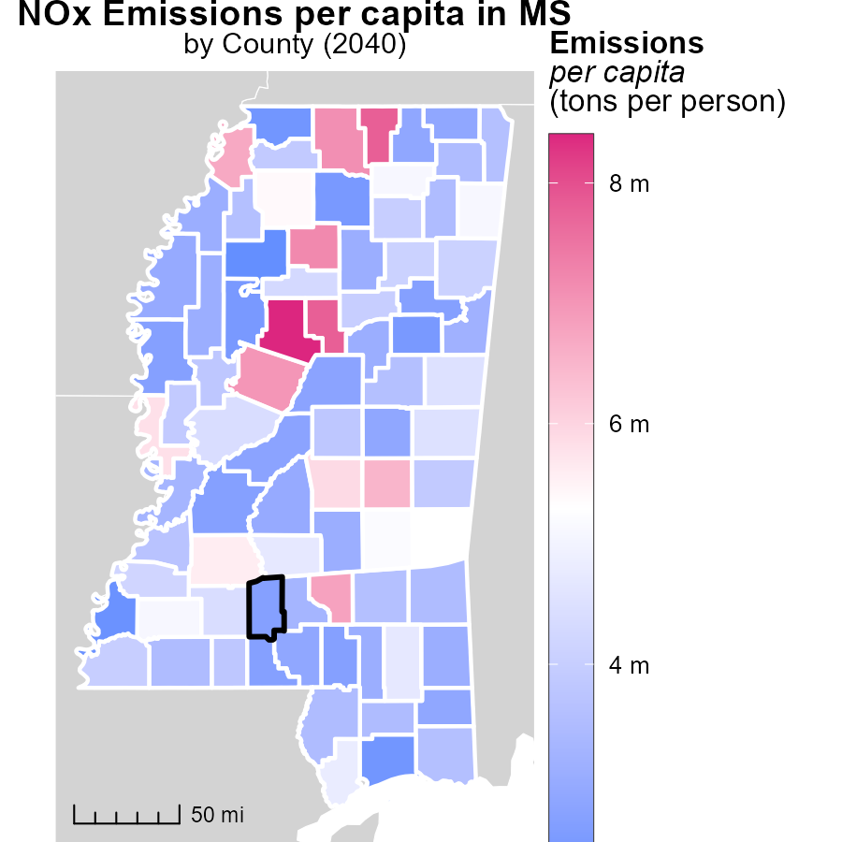

## Findings

* Carroll County, MS emits a maximum of 8.4 tons of CO2 per person
* Quitman County, MS emits a median of 3.6 tons of CO2 per person
* Tallahatchie County, MS emits a minimum of 2.2 tons of CO2 per person

## Recommendations

To lower emissions, focus on Carroll County to reduce its high emissions significantly. Support Quitman County to maintain its emissions level stable. Provide assistance to Tallahatchie County to ensure emissions stay low.

# Emissions Rate (per vehicle) by Road Type over Time

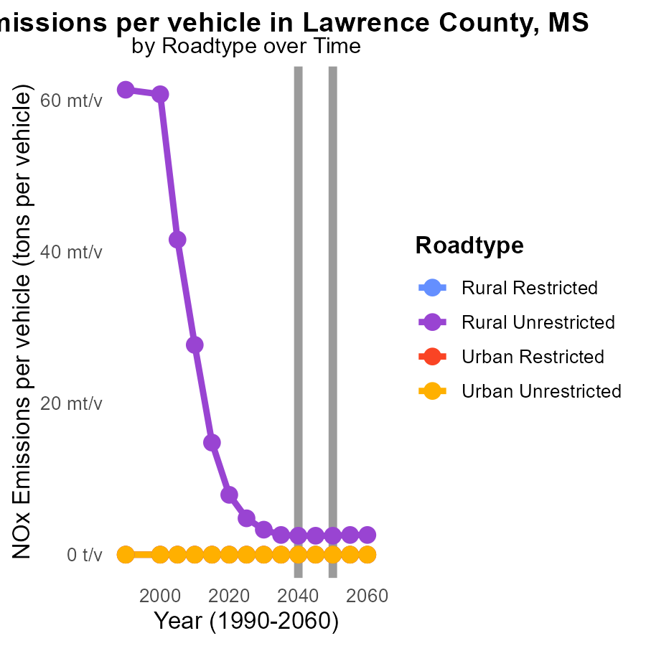

## Findings

* NOx emissions are highest in 'Rural Unrestricted' areas in 2030 with 3.3 tons per vehicle.
* Significant reductions in NOx emissions are projected by 2050 across all road types in Lawrence County, MS.
* Urban areas have zero NOx emissions by 2050, showing effective emission control measures.

## Recommendations

To further decrease emissions, focus on implementing similar control measures in 'Rural Unrestricted' areas as in urban regions. Invest in cleaner technologies and stricter regulations for vehicles in rural settings.

# Population by Road Type over Time

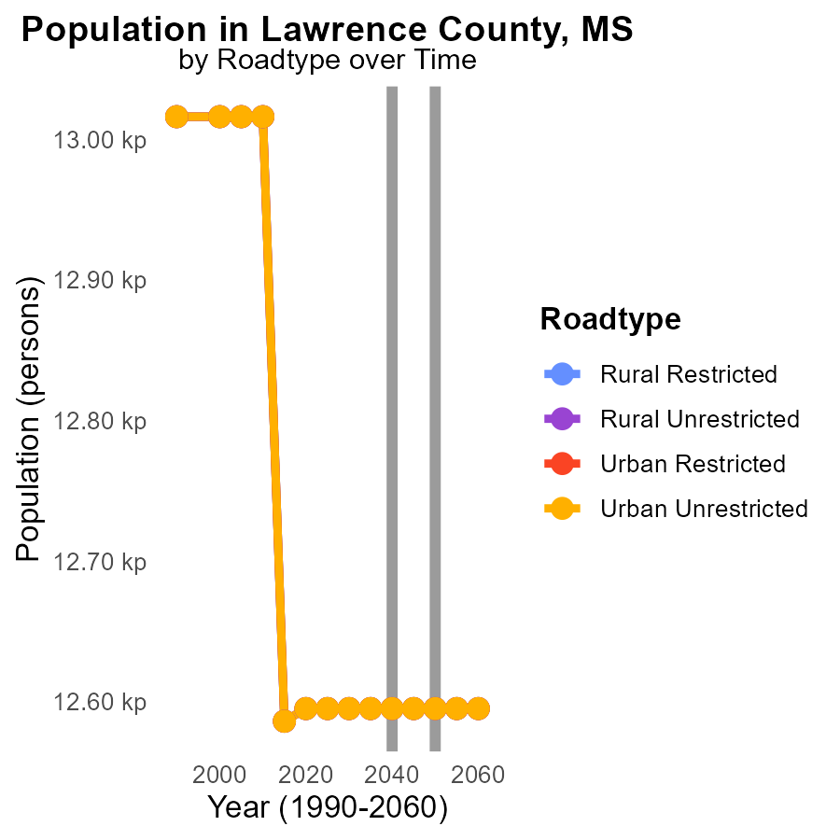

## Findings

* Emissions of NOx are consistent from 2030 to 2050 across all road types in Lawrence County, MS, at 12.6 k.
* The population size does not impact NOx emissions as there is no observed change in emissions regardless of the population size.
* NOx emissions remain stable from 2030 to 2050 in Lawrence County, MS, showing no reduction or increase.

## Recommendations

To lower NOx emissions in Lawrence County, MS, other strategies need to be considered beyond population control or road type. Implementing clean energy initiatives, promoting public transportation, and enforcing stringent emission standards on vehicles can help reduce NOx levels despite the current consistency in emissions data.

# Areas Ranked by Time Driven

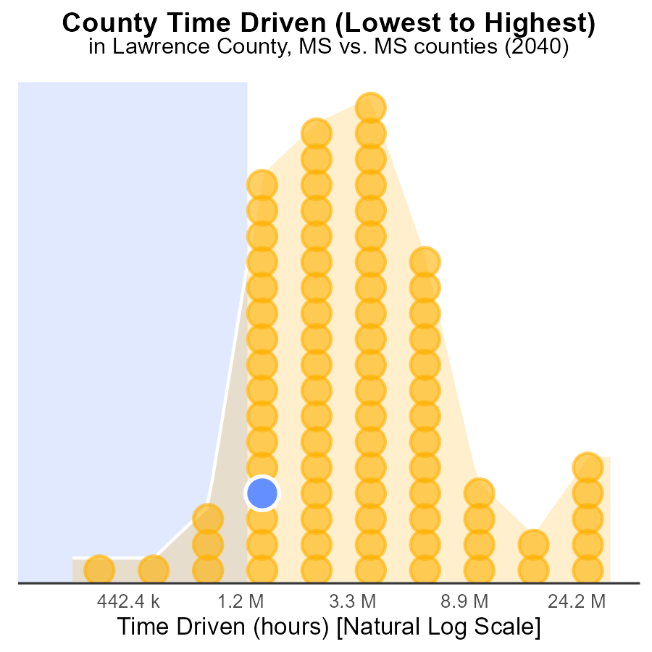

## Findings

* Hinds county has the highest NOx emissions with 92.2 million source hours.
* Issaquena county has the lowest NOx emissions with 727.8 thousand source hours.
* Hinds county alone contributes to 100% of NOx emissions among the listed counties.

## Recommendations

To lower NOx emissions, focus on reducing source hours in Hinds county through stricter emission regulations and promoting cleaner technologies. Encourage data-driven policies.

# Areas Ranked by Vehicle Starts

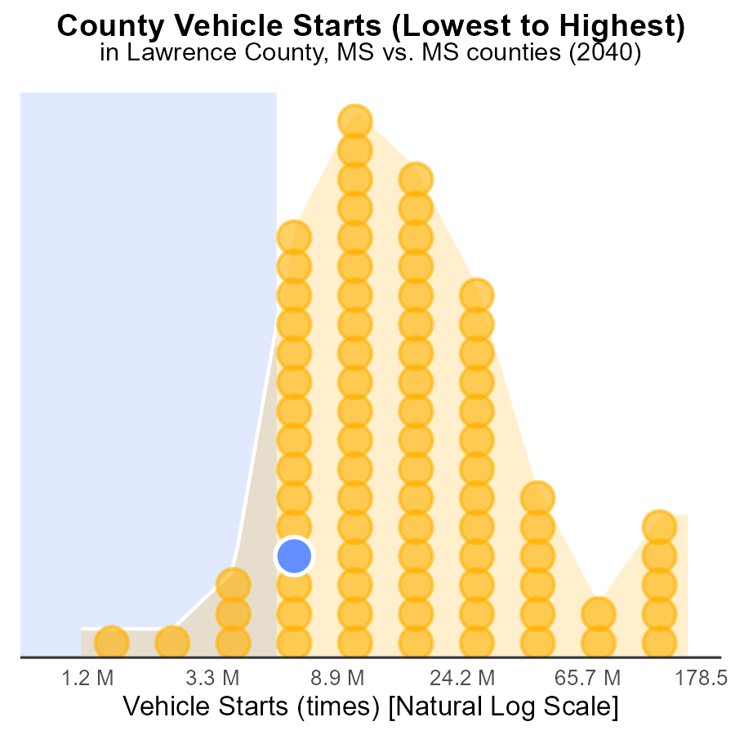

## Findings

* Hinds county had the highest number of vehicle starts with 403.1 million, constituting 100.0%.
* Issaquena county had the lowest number of vehicle starts with 3.1 million, accounting for 1.2%.
* Wilkinson county had the highest percentage of vehicle starts at 12.2% with 15.5 million starts.

## Recommendations

To lower NOx emissions, implementation of strict vehicle emission standards and promoting public transportation in high-traffic counties like Hinds is advised. Encouraging alternative transportation methods in counties with low vehicle starts, such as Issaquena, can help reduce emissions significantly.

# Conclusion

In conclusion, the current NOx emissions situation in Lawrence County, MS in 2040 is predominantly attributed to Rural Unrestricted areas, with 100% of the emissions per vehicle originating from this road type. Gas vehicles are the primary contributors to NOx emissions in the county, indicating a need for stricter emission standards and a transition to cleaner fuel alternatives. While diesel vehicles also play a role, the focus should be on reducing emissions from gas-powered vehicles for substantial impact.

The data suggests a positive trend in emissions reduction efforts, with forecasts indicating a decrease in NOx emissions over the next few decades. To accelerate this progress, strategies like transitioning to electric vehicles, enhancing public transportation options, and enforcing stringent emission regulations are recommended. By prioritizing areas with the highest emissions rates, such as District 1 and Hinds County, and supporting regions with lower emissions levels like Tallahatchie County and Issaquena County, significant strides can be made in mitigating NOx emissions in Lawrence County, ultimately leading to a cleaner and healthier environment for all residents.

# About This Report

Data based on MOVES estimates collected by the Climate Action in Transportation program at Cornell University. Demographic data sourced from the US Census's American Community Survey 5-year estimates. This report was generated with the help of AI.

# References

* U.S. Census Bureau. (2023). American Community Survey 5-year estimates: Detailed tables. Retrieved from https://data.census.gov
* U.S. Environmental Protection Agency. (2024). Motor Vehicle Emission Simulator (MOVES 4.0) [Software]. Retrieved from https://www.epa.gov/moves