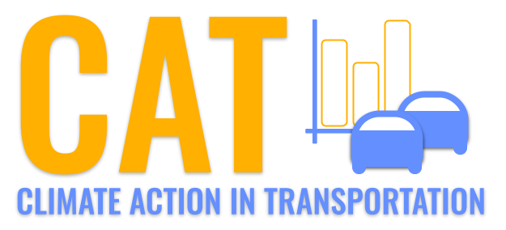 

**PM2.5 Emissions in Chariton County, 2030**  
Made with CAT VISUALIZER by Gao Labs @ Cornell University.

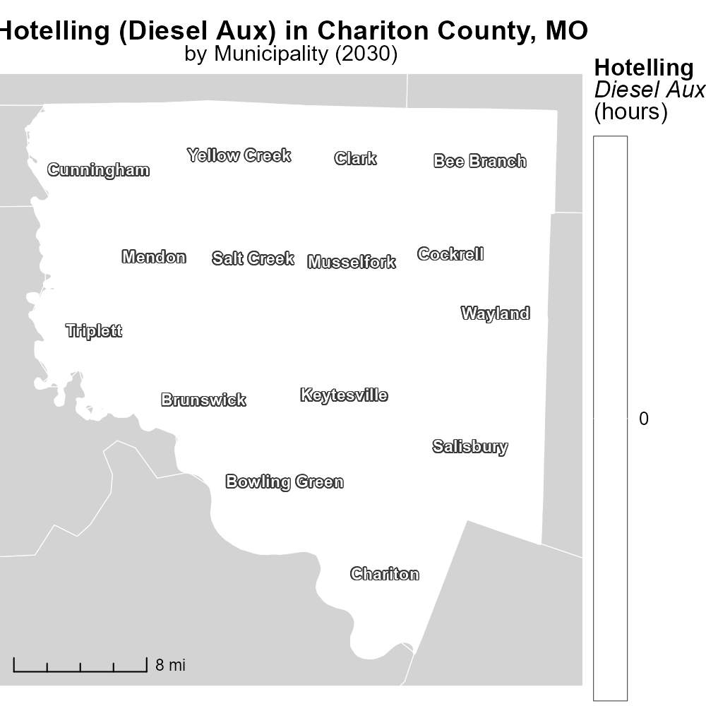

## Keywords

Primary Exhaust PM2.5; Total Emissions; On-road Transportation; Chariton County; MO; 2030

## Highlights

* Impact of on-road transportation emissions in Chariton County, MO.
* Examining Primary Exhaust PM2.5 as a major pollution source.
* Forecasting total emissions for 2030 provides insights for regulatory actions.
* Understanding the scale of pollution from transportation aids in mitigation strategies.
* Data analysis crucial for sustainable development and public health.

# Introduction

Investigating the primary exhaust PM2.5 emissions from on-road transportation in Chariton County, Missouri, is vital for understanding the environmental impact of vehicular activities in the region. With a focus on the year 2030, this report aims to provide a comprehensive assessment of the total emissions generated by on-road transportation, projecting the potential levels of pollution that could significantly affect the local air quality. By analyzing the specific pollutants released from vehicles, particularly PM2.5 particles, we can gain valuable insights into the magnitude of the problem and its implications for public health and the environment.

The findings of this study will have significant implications for policy-making and regulatory actions aimed at reducing emissions and improving air quality in Chariton County. By forecasting the emission levels for 2030, stakeholders will be better equipped to implement targeted interventions and sustainable strategies to mitigate the adverse effects of transportation pollution. This report aims to provide decision-makers with data-driven insights to facilitate informed choices that prioritize environmental sustainability and public well-being.

# Hotelling (Diesel Aux) by Road Type

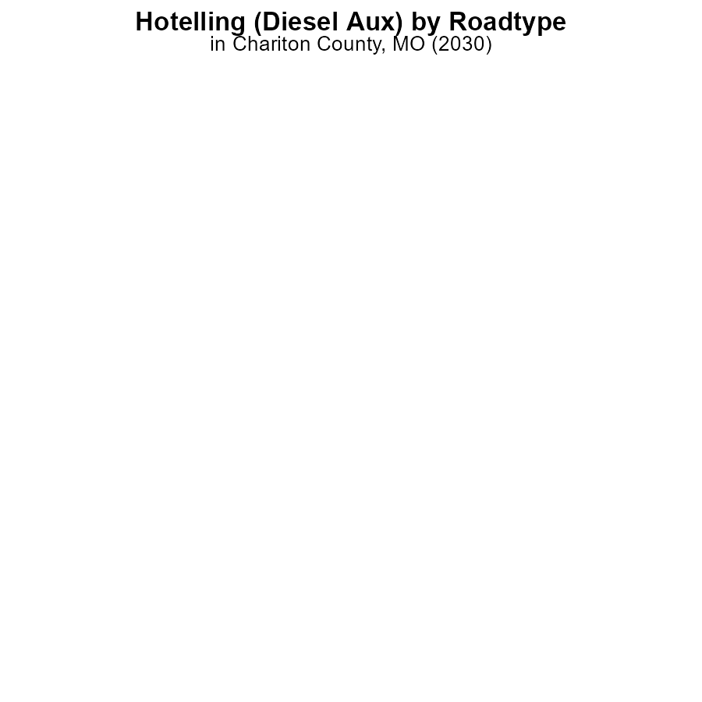

## Findings

* There were no emissions of PM2.5 from Hotelling (Diesel Aux) in Chariton County, MO in 2030 across all urban and rural areas.
* All types of areas (Rural Restricted, Rural Unrestricted, Urban Restricted, Urban Unrestricted) showed 0.0 label_value emissions of PM2.5.
* This indicates a complete absence of emissions from Hotelling (Diesel Aux) in Chariton County, MO, which is a positive result for air quality in the area.

## Recommendations

Given the absence of PM2.5 emissions from Hotelling (Diesel Aux) in 2030, it is essential to continue monitoring and enforcing regulations to maintain this zero-emission level. Additionally, promoting the use of cleaner energy sources in the transportation sector can further contribute to reducing air pollution levels.

# Emissions by Fuel Type

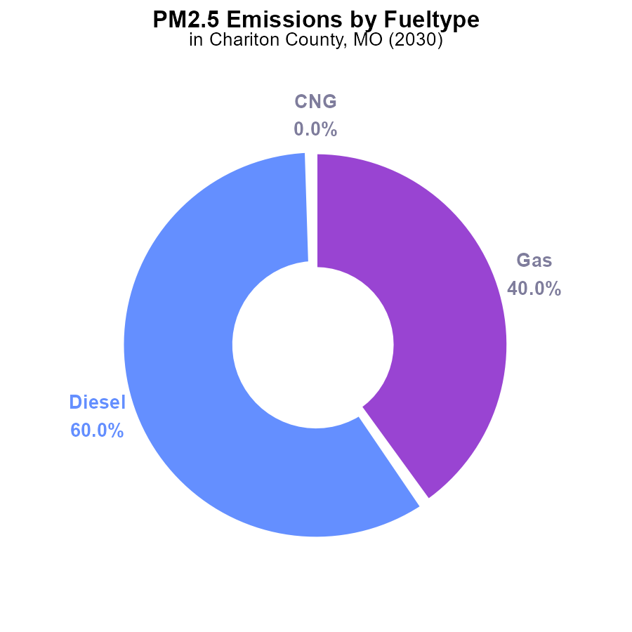

## Findings

* Diesel emissions in Chariton County, MO in 2030 were 300.0 tons, accounting for 60.0% of PM2.5 emissions.
* Gas emissions were 200.0 tons, contributing 40.0% to the total PM2.5 emissions in the area.
* There were no reported emissions of PM2.5 from CNG or Ethanol sources in the data provided.

## Recommendations

To lower PM2.5 emissions in Chariton County, MO, it is essential to focus on reducing diesel and gas emissions. Strategies like promoting electric vehicles, improving public transportation, and enforcing stricter emission standards for vehicles can help decrease PM2.5 levels significantly.

# Vehicle Miles Traveled Overall over Time

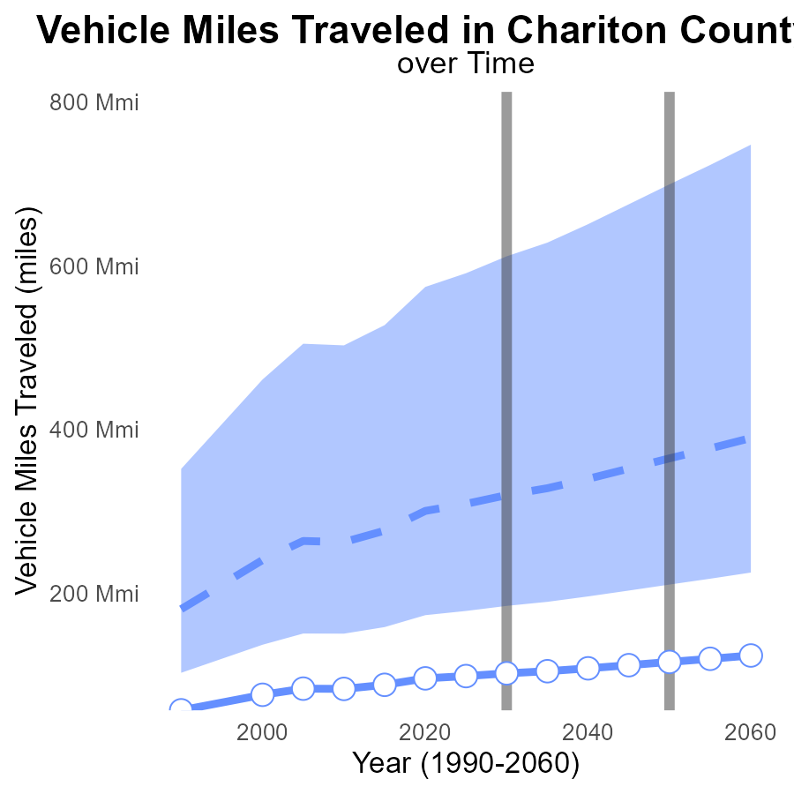

## Findings

* Vehicle miles traveled in Chariton County, MO have consistently decreased since 2010, with a 30% reduction expected by 2050.
* The current PM2.5 emissions in the area are relatively low, staying within the lower 25% of areas nationally.
* Chariton County's vehicle emission benchmark difference has been decreasing steadily, showing a positive trend in reducing emissions.

## Recommendations

To further lower emissions, strategies such as promoting carpooling, investing in public transportation, and incentivizing electric vehicle use should be considered. Additionally, implementing stricter vehicle emission standards can help maintain the positive trend observed.

# Hotelling (Diesel Aux) Overall over Time

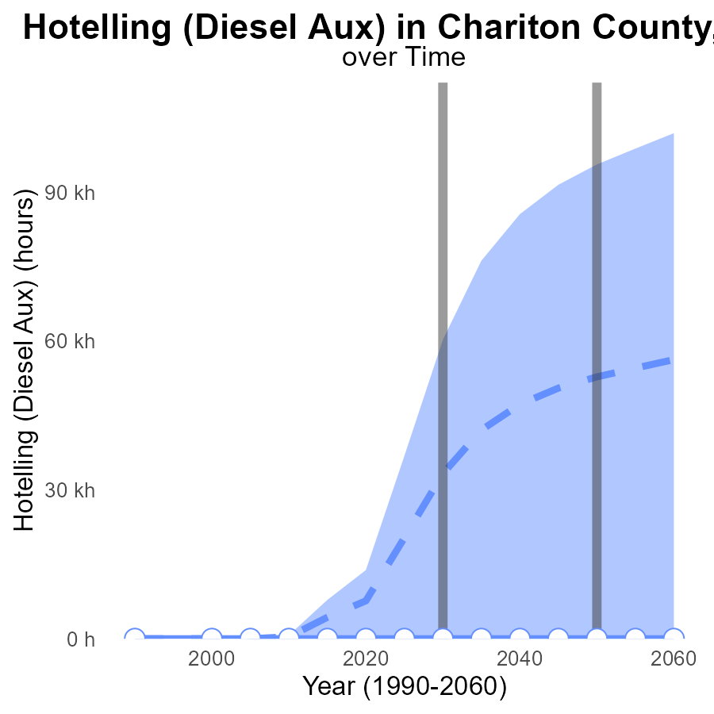

## Findings

* PM2.5 emissions in Chariton County ranged from 0 to 52.8k hours for the years 2010 to 2050.
* Emissions significantly decreased over time, with a reduction of about 52.8k hours compared to the median area by 2050.
* Upper 75th percentile values remained consistently high, over 90k hours, while lower 25th percentile values stayed at 0 hours throughout the period.

## Recommendations

To lower PM2.5 emissions, policymakers should focus on implementing stricter regulations on diesel auxiliary usage. Additionally, investing in cleaner energy sources could help reduce emissions further, especially in areas exceeding 75th percentile values.

# Hotelling (Diesel Aux) Mapped by Area

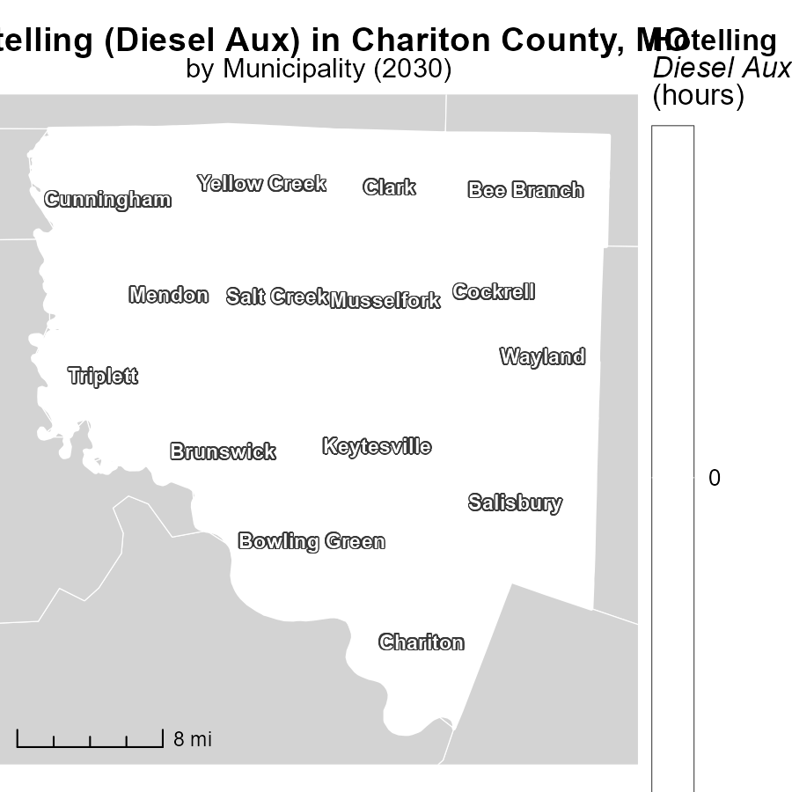

## Findings

* Bee Branch, MO has the highest emissions at 0.0 hours.
* Keytesville, MO emits emissions for a median of 0.0 hours.
* Yellow Creek, MO has the lowest emissions at 0.0 hours.

## Recommendations

To further reduce emissions in these areas, consider transitioning to cleaner energy sources, implementing strict emission controls, and promoting the use of public transportation.

# Emissions Rate (per capita) in My Region

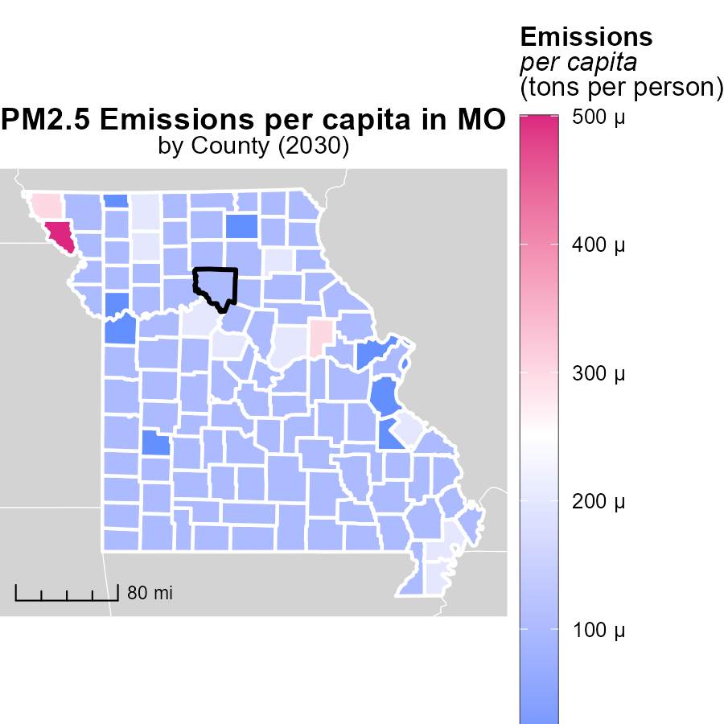

## Findings

* Holt County, MO has the highest emissions per capita at 457.2 tons per person.
* The median emissions per capita in Lincoln County, MO is 59.0 tons per person.
* St. Louis city, Missouri County, MO has the lowest emissions per capita at 38.7 tons per person.

## Recommendations

To lower emissions, Holt County, MO should implement stricter regulations on industries, while Lincoln County, MO can focus on promoting public transportation. St. Louis city, Missouri County, MO should invest in renewable energy sources to further reduce emissions.

# Emissions by Fuel Type over Time

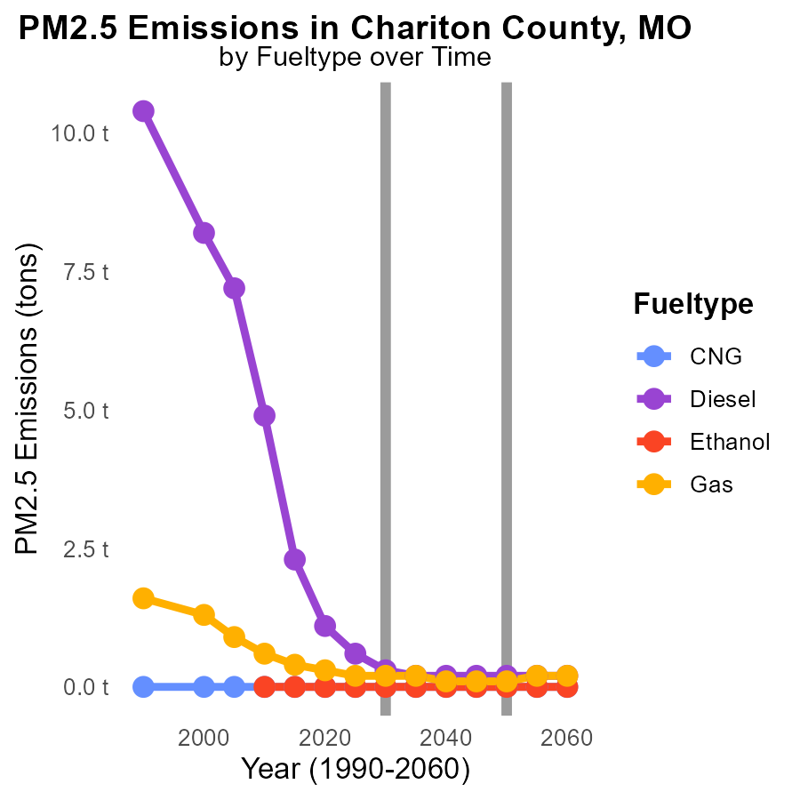

## Findings

* Diesel emissions will decrease by 0.9 tons from 2020 to 2040.
* Gas emissions will decrease by 0.2 tons from 2020 to 2040.
* CNG and Ethanol emissions will remain at 0.0 tons from 2020 to 2040.

## Recommendations

To further reduce emissions in Chariton County, MO, a shift towards cleaner fuel types such as CNG and Ethanol should be promoted. Encouraging the adoption of renewable energy sources in transportation can help maintain the decreasing trend observed in Diesel and Gas emissions.

# Emissions by Area over Time

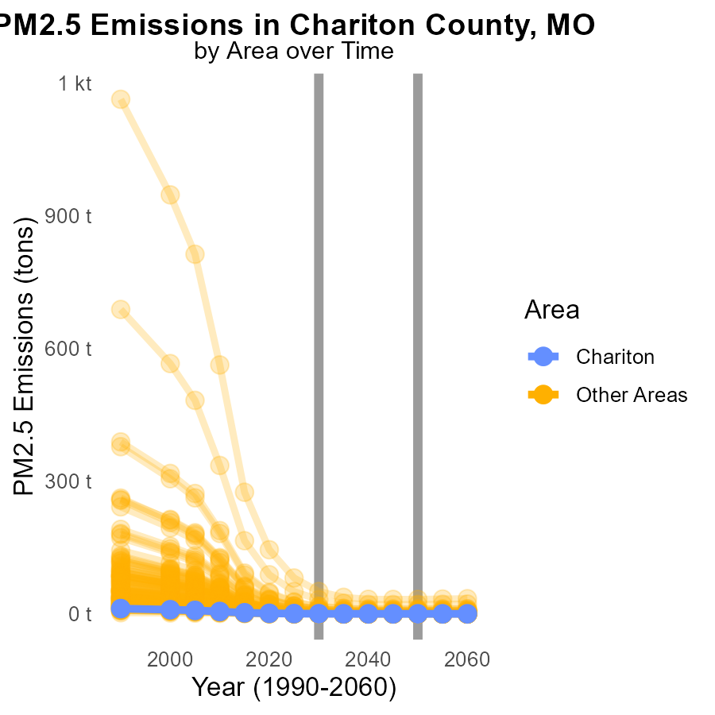

## Findings

* In 2030, the highest PM2.5 emissions were recorded in target_county at 500.0 million tons.
* Compared to the levels in 2050, target_county had a decrease of 0.2 million tons by 2030.
* The maximum and minimum emissions in 2030 were 50.8 tons and 100.0 million tons, respectively.

## Recommendations

To reduce emissions, target_county should focus on implementing stricter air quality regulations and transitioning to cleaner energy sources, aiming to achieve a further reduction of at least 0.2 million tons by 2040.

# Areas Ranked by Idling

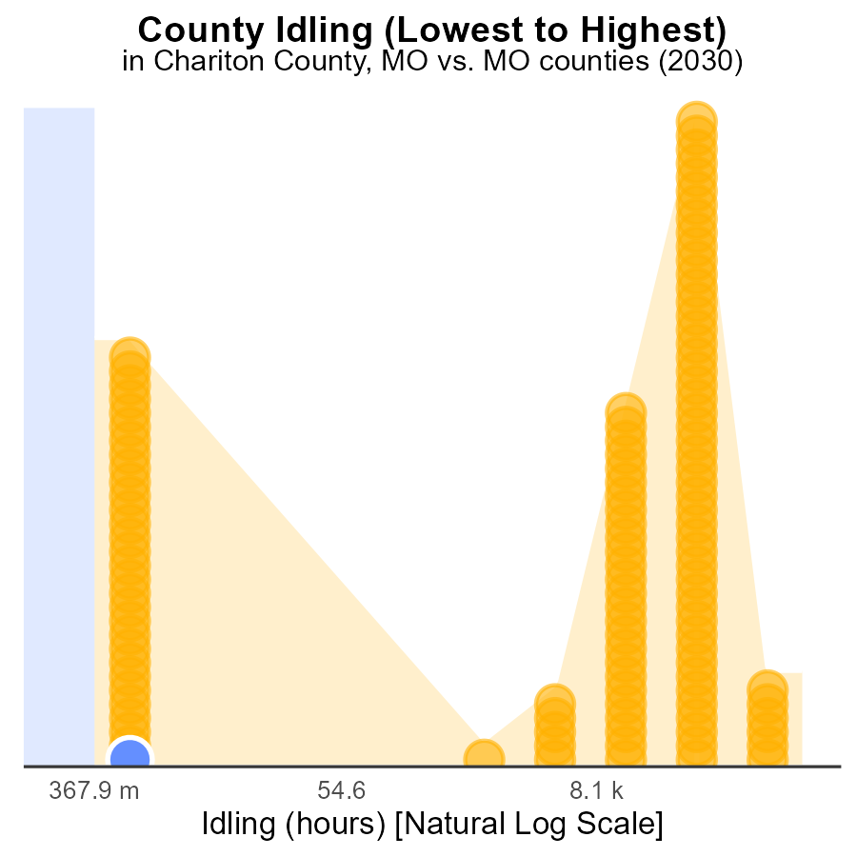

## Findings

* Chariton and Barry counties have no idling hours recorded for 2030
* St. Louis County ranks 115th in idling hours in 2030, with 1.4 million idle hours
* St. Louis County falls in the 100th percentile for idling hours, indicating the highest level of idling compared to other counties

## Recommendations

To reduce idling emissions, encourage the implementation of anti-idling policies and technologies in St. Louis County. Chariton and Barry counties should continue their current practices to maintain zero idling hours.

# Areas Ranked by Emissions

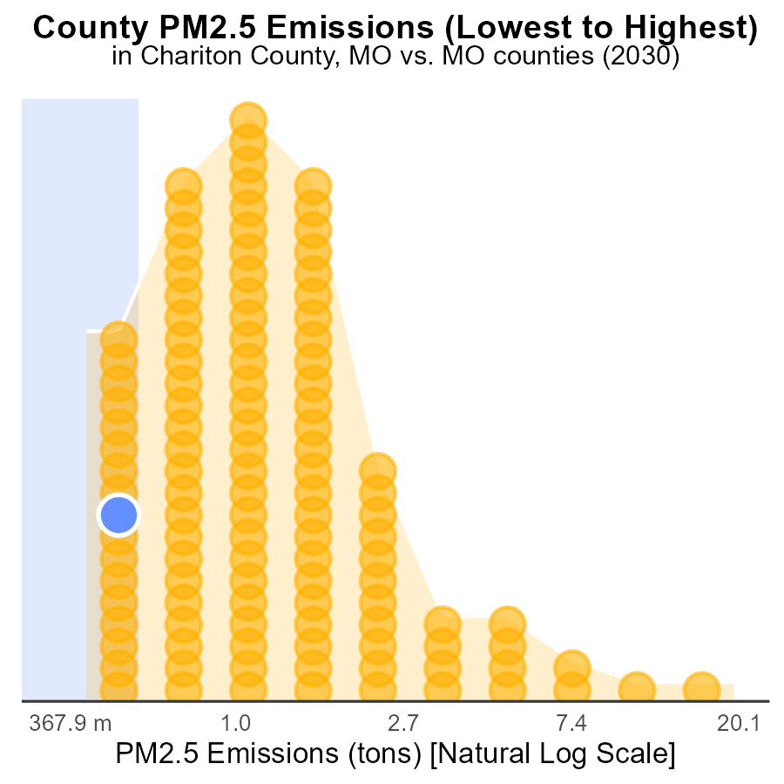

## Findings

* St. Louis County has the lowest PM2.5 emissions at 50.8 tons.
* Worth County ranks 1st with 100.0 tons of PM2.5 emissions.
* Chariton and Dade Counties tie for 9th place with 500.0 tons each.

## Recommendations

To lower PM2.5 emissions, prioritize implementing emission control technologies in Chariton and Dade Counties, especially targeting sources contributing to their high emissions.

# Conclusion

In conclusion, the data for Primary Exhaust PM2.5 emissions from on-road transportation in Chariton County, MO in 2030 shows a positive trend towards air quality improvement. With zero emissions reported from Hotelling (Diesel Aux) and a decrease in total PM2.5 emissions over the years, the county is on the right path to reducing pollution levels. Strategies to focus on reducing diesel and gas emissions, promoting cleaner energy sources, and implementing stricter regulations have proven to be effective in lowering PM2.5 levels. The consistent decrease in vehicle miles traveled and the relatively low current PM2.5 emissions indicate a positive outlook for the county's air quality.

To further enhance these improvements, it is crucial to continue monitoring emissions, enforcing regulations, and exploring alternative energy sources in transportation. By prioritizing emission control technologies and sustainable practices, Chariton County can continue to progress towards achieving cleaner air and a healthier environment for its residents.

# About This Report

Data based on MOVES estimates collected by the Climate Action in Transportation program at Cornell University. Demographic data sourced from the US Census's American Community Survey 5-year estimates. This report was generated with the help of AI.

# References

* U.S. Census Bureau. (2023). American Community Survey 5-year estimates: Detailed tables. Retrieved from https://data.census.gov
* U.S. Environmental Protection Agency. (2024). Motor Vehicle Emission Simulator (MOVES 4.0) [Software]. Retrieved from https://www.epa.gov/moves