 

**VOC Emissions in Adams County, 2005**  
Made with CAT VISUALIZER by Gao Labs @ Cornell University.

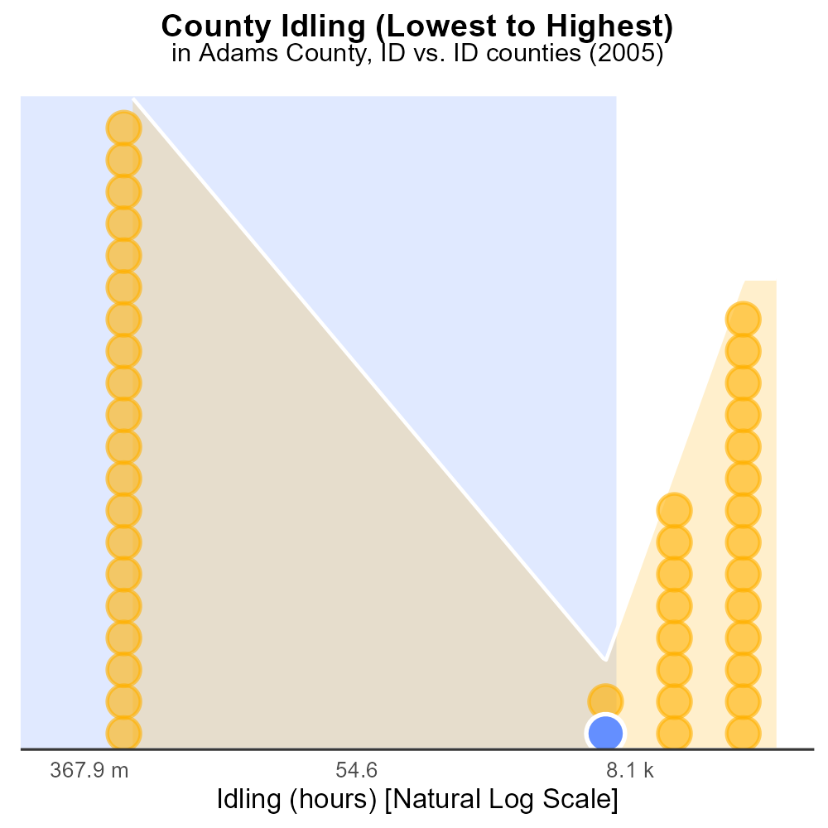

## Keywords

Volatile Organic Compounds; emissions; on-road transportation; Adams County; 2005

## Highlights

* Study of VOC emissions from on-road transportation in Adams County, ID.
* Analysis of data from 2005 to understand the impact on air quality.
* Identification of major sources contributing to VOC emissions.
* Assessment of potential health and environmental risks associated with VOCs.
* Recommendations for mitigation strategies to reduce VOC emissions.

# Introduction

In 2005, Adams County, ID, witnessed a significant influx of on-road transportation activities, leading to a rise in Volatile Organic Compounds (VOC) emissions. This report seeks to delve into the intricate web of VOC emissions originating from various sources within the county's transportation sector. By analyzing data specific to the year 2005, a comprehensive understanding of the extent and distribution of VOC emissions can be attained.

The research aims to identify the primary contributors to VOC emissions from on-road transportation, assess the implications of these emissions on air quality, and evaluate the associated risks to public health and the environment. Moreover, the report will offer recommendations for effective mitigation strategies to curtail the adverse effects of VOC emissions, paving the way for a more sustainable and ecologically sound transportation system in Adams County.

# Vehicle Starts Overall by Area

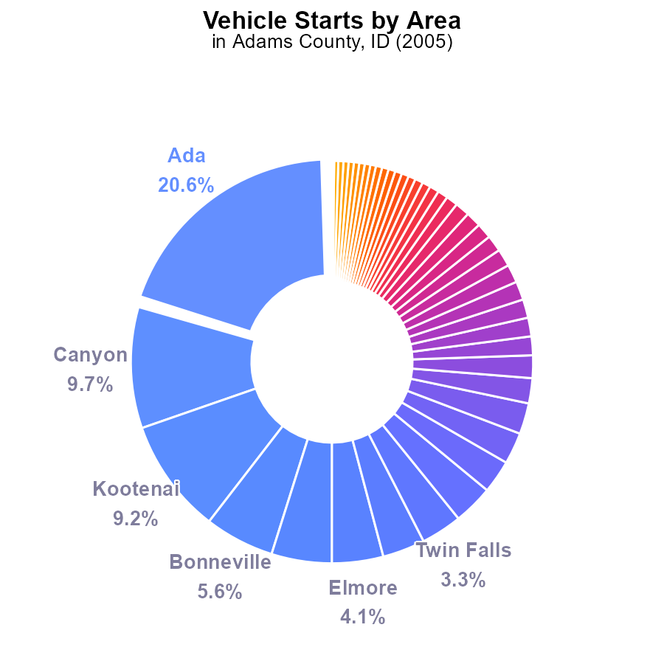

## Findings

* Ada County had the highest VOC emissions with 357.8 million vehicle starts, accounting for 20.6% of the total.
* Canyon County followed with 169.3 million starts at 9.7%.
* The top five counties contributed to 49.9% of the total emissions, showing the concentration of VOC emissions.

## Recommendations

To reduce VOC emissions, focus on the top counties like Ada and Canyon by promoting public transportation, carpooling, and electric vehicles to alleviate the environmental impact.

# Emissions Rate (per capita) by Road Type

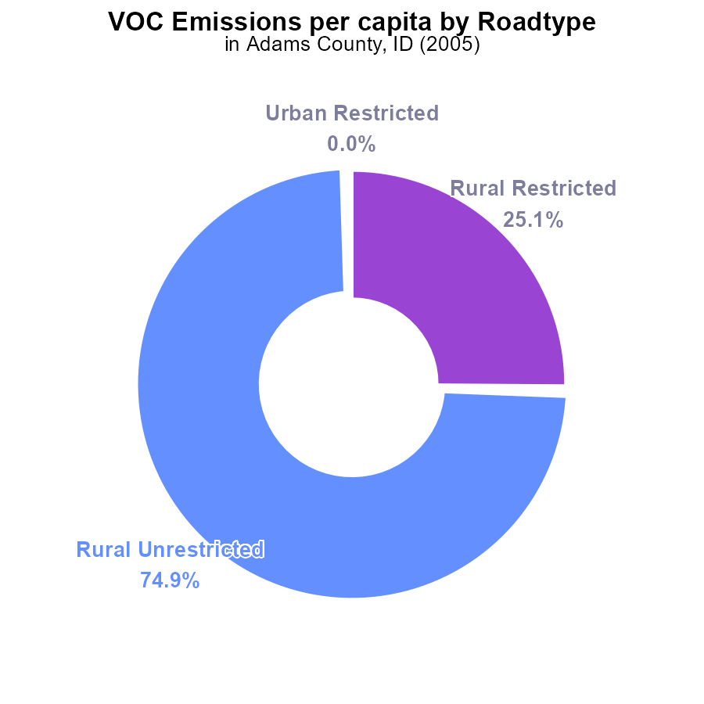

## Findings

* In 2005, Adams County, ID emitted 11.9 tons of VOC per person.
* 74.9% of VOC emissions came from Rural Unrestricted areas.
* Rural Restricted areas accounted for 25.1% of VOC emissions.

## Recommendations

To lower VOC emissions in Adams County, focus on reducing emissions in rural areas by implementing stricter regulations and promoting cleaner technologies.

# Vehicle Starts Overall over Time

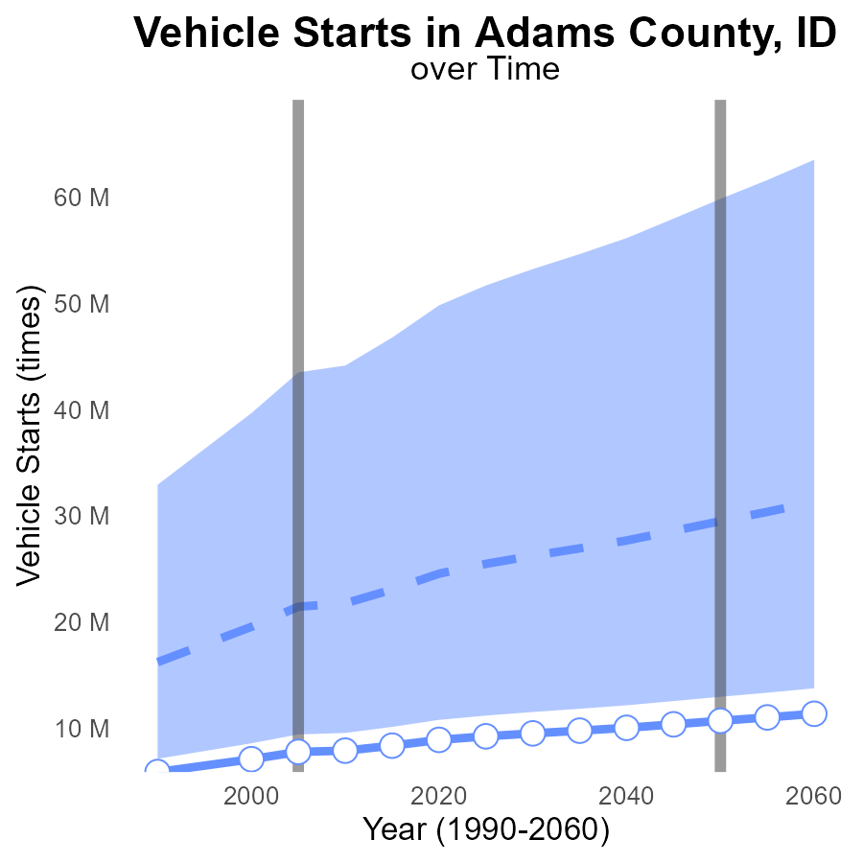

## Findings

* Vehicle starts in Adams County have increased over the years.
* Adams County consistently performs below the median and upper 75th percentile of vehicle starts compared to other areas.
* The benchmark difference has been decreasing, indicating a potential improvement in VOC emissions.

## Recommendations

To reduce VOC emissions, implement vehicle emission testing programs to ensure proper vehicle maintenance. Encourage carpooling and promote the use of public transportation to decrease the number of vehicle starts.

# Vehicles Overall over Time

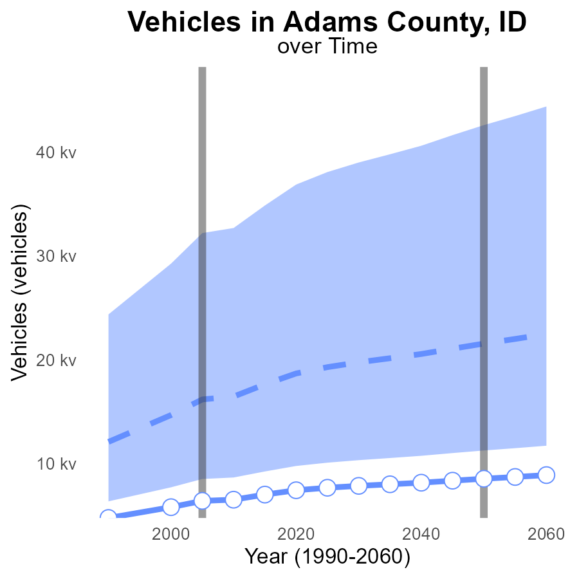

## Findings

* Vehicle emissions in Adams County have been consistently below the median area since 1990, with a decreasing trend.
* In 2025, there is a projected further decrease in vehicle emissions to 7.7k, which is 11.6k below the median area.
* The benchmark difference shows that Adams County has been continuously improving its emissions performance over the years.

## Recommendations

To lower emissions levels even further, Adams County should continue to promote the use of electric vehicles, improve public transportation infrastructure, and incentivize carpooling initiatives.

# Hotelling (Diesel Aux) in My Region

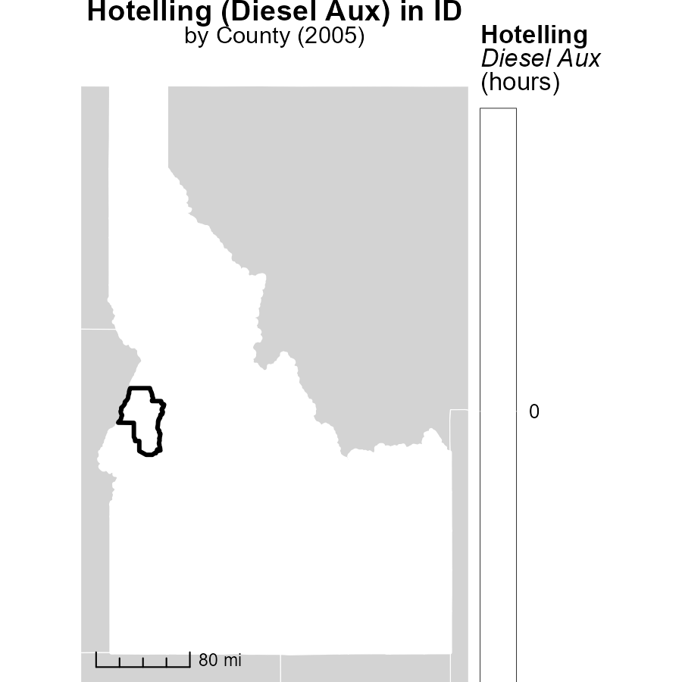

## Findings

* In 2005, Ada County, ID had the highest hotelling (diesel aux) emissions with 0.0 hours.
* Fremont County, ID had a median hotelling (diesel aux) emission of 0.0 hours in 2005.
* Washington County, ID had the lowest hotelling (diesel aux) emissions in 2005 with 0.0 hours.

## Recommendations

To lower hotelling (diesel aux) emissions, policymakers could consider implementing stricter regulations on diesel auxiliary usage in vehicles across counties.

# Emissions Rate (per vehicle) in My Region

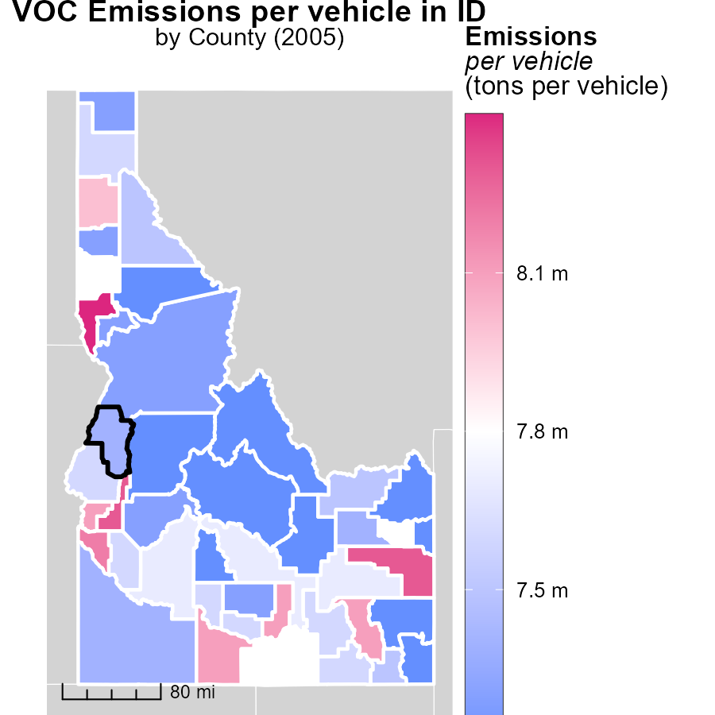

## Findings

* Nez Perce County had the highest emissions per vehicle in 2005 at 8.4 tons per vehicle.
* Washington County had median emissions at 7.6 tons per vehicle.
* Valley County had the lowest emissions per vehicle in 2005, with 7.2 tons per vehicle.

## Recommendations

To lower emissions, Nez Perce County should focus on reducing emissions from vehicles to decrease the 8.4 tons per vehicle figure. Washington and Valley Counties may implement similar strategies to decrease their median and minimum emissions levels.

# Population by Regulatory Class over Time

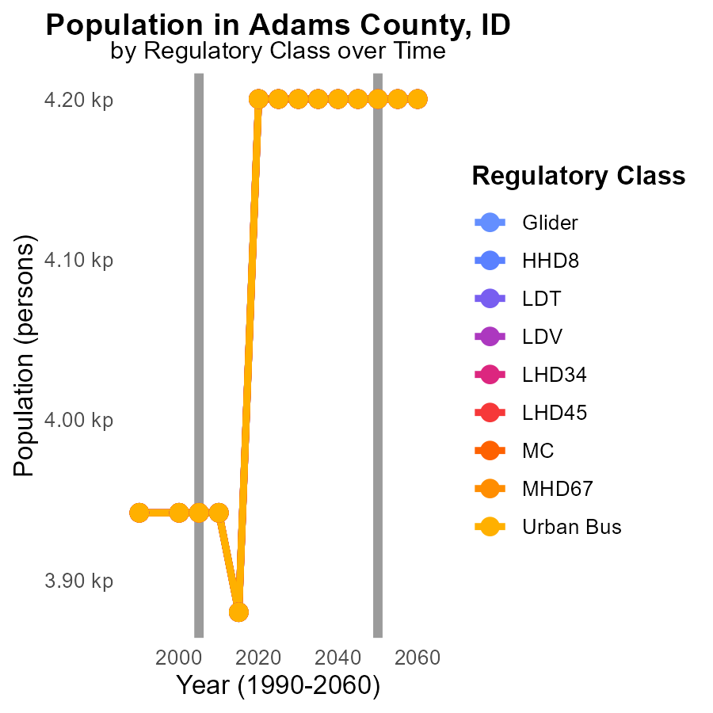

## Findings

* Annual VOC emissions were consistent from 2010 to 2015 across all vehicle types in Adams County, ID.
* Emissions increased by 23.3% from the year 2000 to 2015 for Urban Bus vehicles in Adams County, ID.
* Overall, VOC emissions in Adams County, ID remained stable from 2000 to 2015.

## Recommendations

To address the 23.3% increase in VOC emissions from Urban Bus vehicles from 2000 to 2015, policymakers should consider implementing stricter emission standards for public transportation vehicles and incentivizing the adoption of alternative fuel technologies.

# Emissions Rate (per vehicle) by Vehicle Type over Time

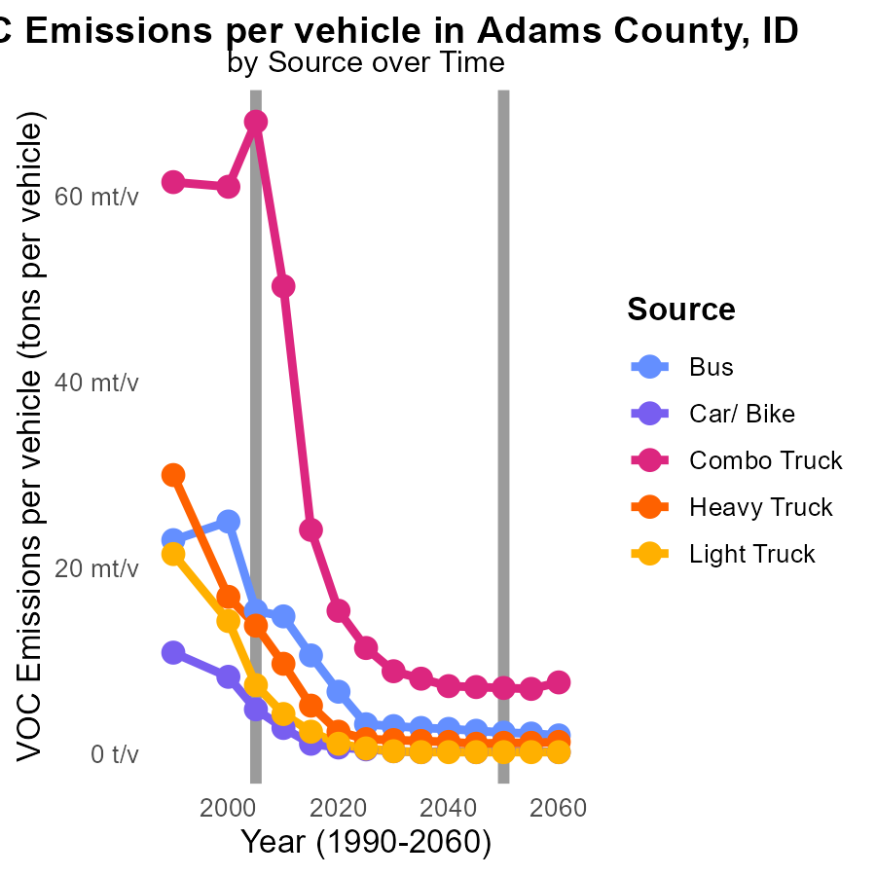

## Findings

* Bus emissions per vehicle decreased by 57% from 2000 to 2015.
* Combo Truck emissions per vehicle reduced by 61% from 2000 to 2015.
* Heavy Truck emissions per vehicle dropped by 69% from 2000 to 2015.

## Recommendations

To further decrease emissions, prioritize the transition to alternative fuel sources, invest in cleaner vehicle technologies, and promote public transportation to reduce overall vehicle usage.

# Areas Ranked by Idling

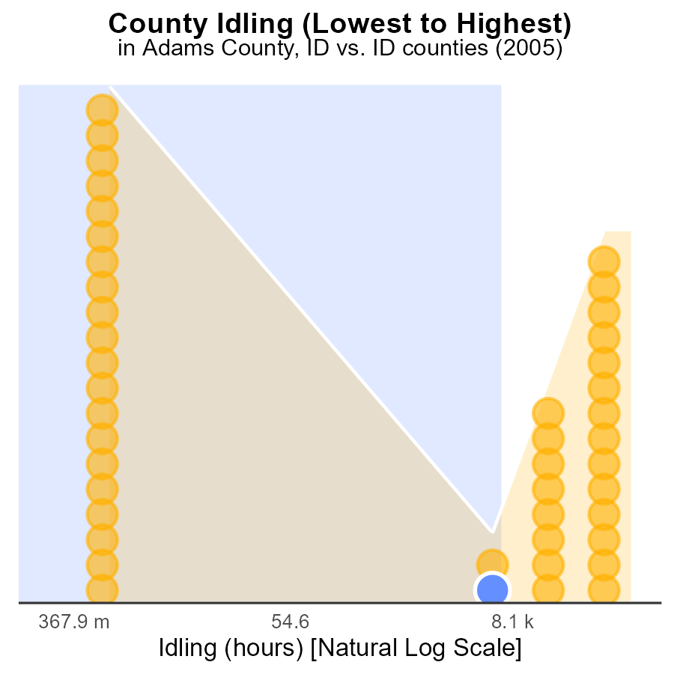

# Areas Ranked by Vehicles

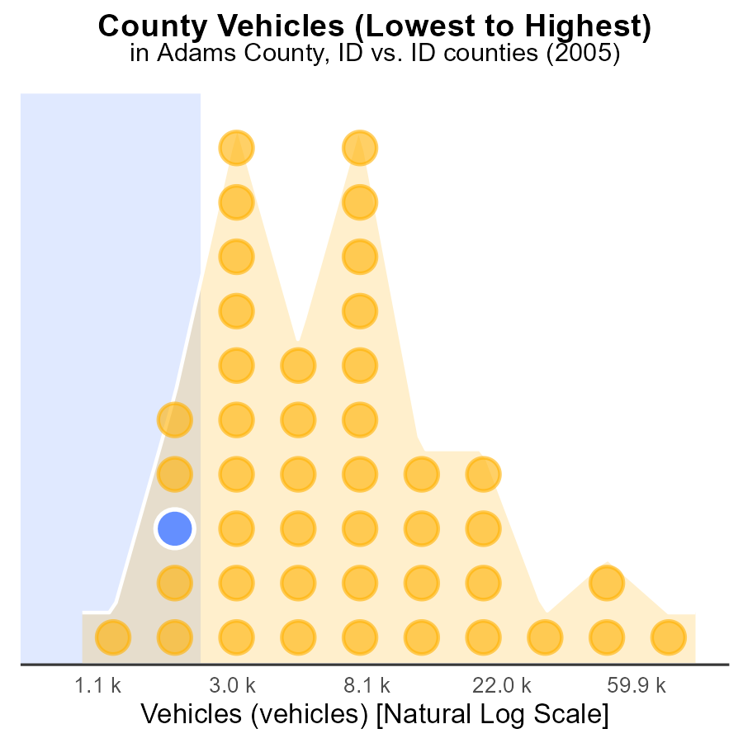

## Findings

* Ada county has the highest number of vehicles emissions, with 258.9k vehicles in 2005.
* Clearwater county has the highest percentage of emissions compared to the total, at 11.4% in 2005.
* Camas county ranks first with the lowest percentile of emissions, accounting for only 2.3% of the total in 2005.

## Recommendations

To reduce emissions, focus on implementing stricter vehicle emission standards in counties like Ada and Clearwater with high vehicle counts and percentages. Encourage the adoption of electric vehicles to lower emissions.

# Conclusion

In conclusion, the analysis of Volatile Organic Compounds (VOC) emissions from on-road transportation in Adams County, ID in 2005 sheds light on the current situation and provides insights for future actions. With 11.9 tons of VOC emitted per person, the county primarily saw emissions coming from Rural Unrestricted areas, indicating a need for targeted strategies in rural regions. Despite an increase in vehicle starts over the years, Adams County has consistently performed below the median and upper 75th percentile, showcasing an improving trend.

To further reduce VOC emissions, Adams County should continue promoting cleaner technologies such as electric vehicles and implementing stricter regulations in rural areas. The projected decrease in vehicle emissions for 2025 indicates promising progress. By encouraging public transportation, carpooling, and vehicle emission testing programs, Adams County can sustain its improvements and contribute to a cleaner environment.

# About This Report

Data based on MOVES estimates collected by the Climate Action in Transportation program at Cornell University. Demographic data sourced from the US Census's American Community Survey 5-year estimates. This report was generated with the help of AI.

# References

* U.S. Census Bureau. (2023). American Community Survey 5-year estimates: Detailed tables. Retrieved from https://data.census.gov
* U.S. Environmental Protection Agency. (2024). Motor Vehicle Emission Simulator (MOVES 4.0) [Software]. Retrieved from https://www.epa.gov/moves