 

**CO Emissions in Lafayette County, 2050**  
Made with CAT VISUALIZER by Gao Labs @ Cornell University.

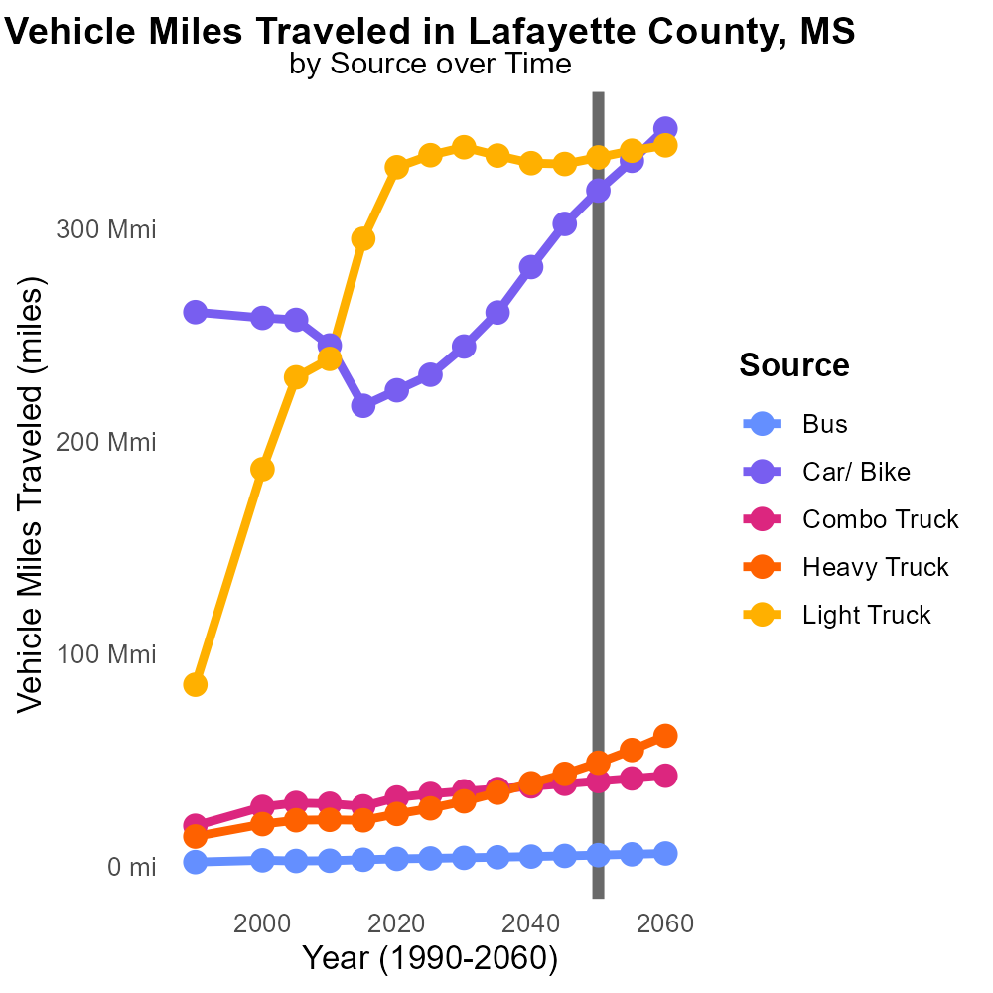

## Keywords

Carbon Monoxide emissions; on-road transportation; Lafayette County; MS; 2050

## Highlights

* Examining CO emissions from on-road transportation in 2050 in Lafayette County, MS.
* Assessing the environmental impact of transportation in a specific region.
* Focusing on ways to reduce harmful emissions for a sustainable future.
* Understanding the implications of CO emissions on air quality and public health.
* Exploring strategies for mitigating CO emissions from on-road vehicles.

# Introduction

In 2050, as concerns over air pollution and climate change continue to grow, it is crucial to closely examine the levels of Carbon Monoxide (CO) emissions stemming from on-road transportation in Lafayette County, MS. This report aims to provide a comprehensive analysis of the environmental impact of transportation activities in this specific region, with a particular focus on the year 2050.

By investigating the sources and trends of CO emissions from vehicles on local roads, we can assess the current state of air quality and its implications for public health. Furthermore, this study will explore potential strategies and technologies that can be implemented to reduce harmful emissions, paving the way for a cleaner and more sustainable future.

# Time Driven by Road Type

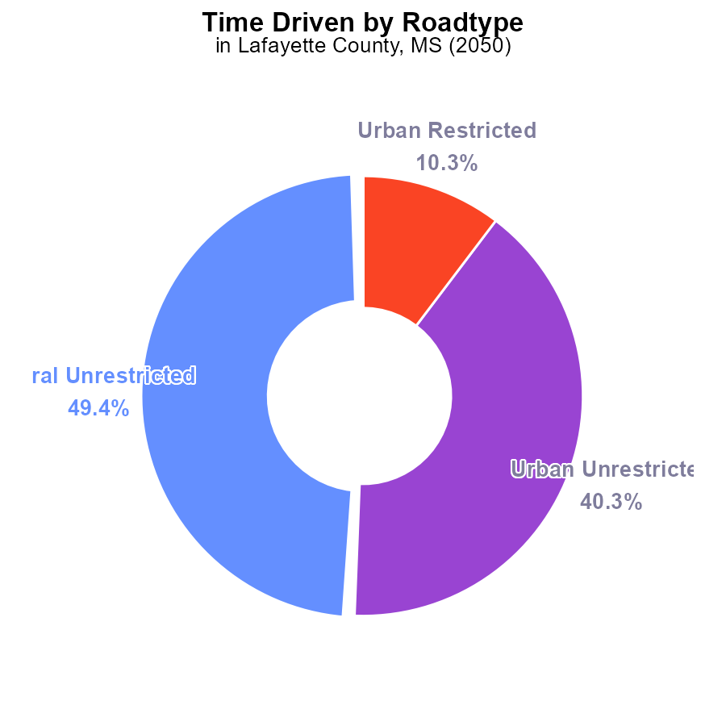

## Findings

* Urban unrestricted emissions account for 40.3% of total CO emissions in Lafayette County
* Rural unrestricted emissions account for 49.4% of total CO emissions in Lafayette County
* Rural restricted emissions are negligible at 0.0% of total CO emissions

## Recommendations

To reduce CO emissions, focus on policies targeting urban and rural unrestricted sources, which together contribute 89.7% of total emissions. Consider promoting cleaner transportation options and stricter emission standards for industries in these areas.

# Emissions Rate (per capita) by Vehicle Type

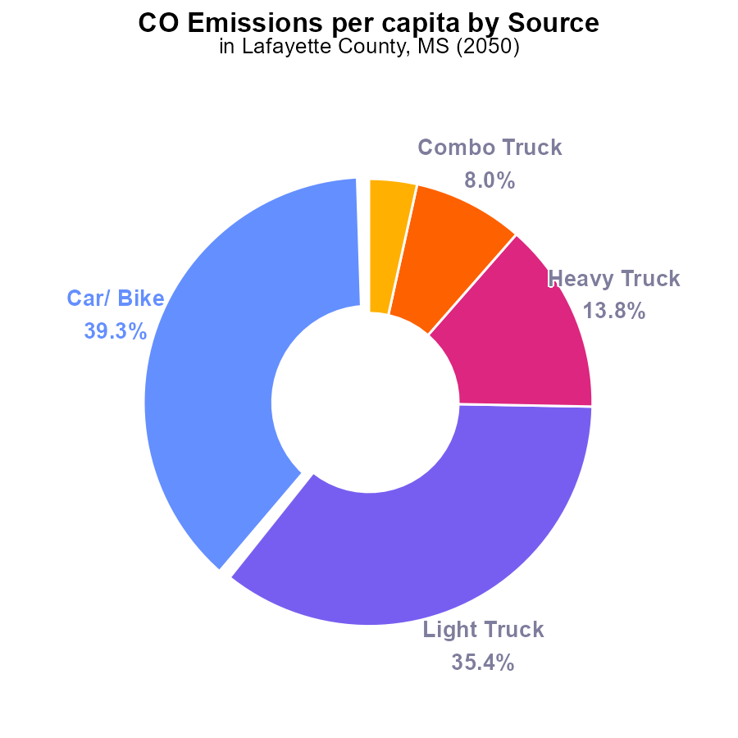

## Findings

* Cars and bikes contribute 39.3% of total CO emissions per capita.
* Light trucks contribute 35.4% of total CO emissions per capita.
* Heavy trucks contribute 13.8% of total CO emissions per capita.

## Recommendations

To lower CO emissions per capita in Lafayette County, MS, focus on reducing emissions from cars, light trucks, and heavy trucks. Encourage the adoption of electric vehicles, promote public transportation like buses, and implement stricter emission standards for all types of trucks.

# Emissions Rate (per capita) over Time for Buses

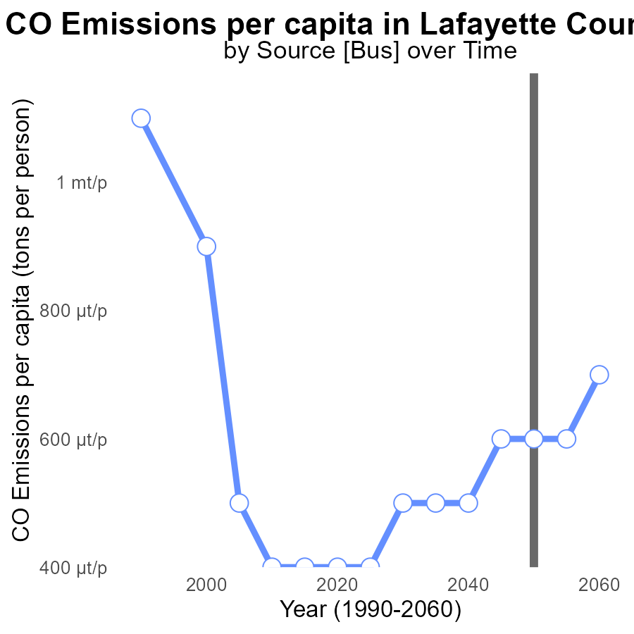

## Findings

* Emissions per capita in Lafayette County, MS are projected to increase steadily over the next 30 years.
* The benchmark difference remains relatively consistent, with slight fluctuations, indicating a slow rate of change.
* A decrease in emissions per capita is anticipated around 2060.

## Recommendations

To lower emissions in Lafayette County, policies should focus on implementing renewable energy sources, promoting public transportation, and enforcing stricter emission regulations on industries.

# Vehicle Miles Traveled Overall over Time

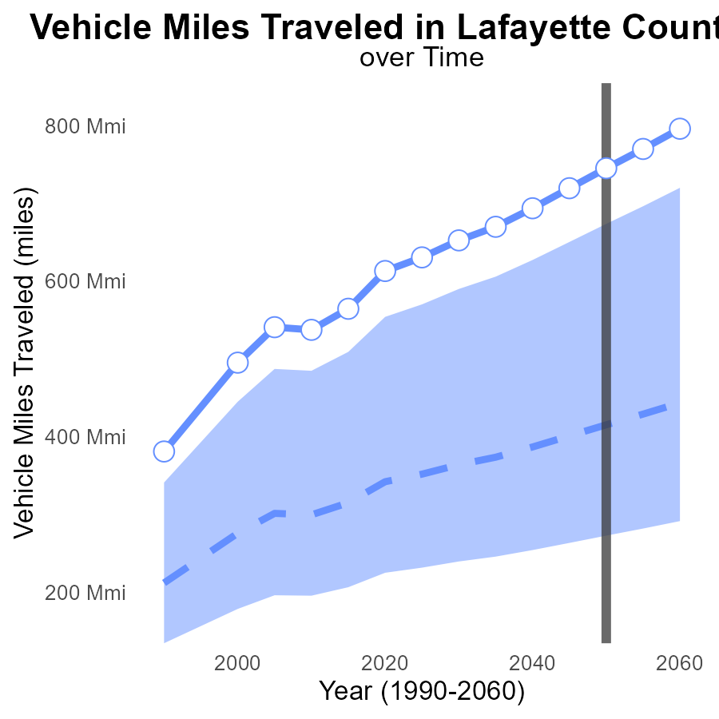

## Findings

* Vehicle miles traveled in Lafayette County, MS, are projected to increase steadily over the next 30 years.
* By 2050, vehicle miles traveled are expected to reach 745.2 million, a 78.2% increase from the median area.
* The benchmark difference indicates Lafayette County's VMT will exceed the upper 75th percentile of areas by 2050.

## Recommendations

To lower emissions, policymakers should prioritize investment in public transportation infrastructure to reduce reliance on personal vehicles. Implementing policies such as carpooling incentives, congestion pricing, and promoting telecommuting can also help decrease VMT and emissions.

# Emissions Rate (per mile) in My Region

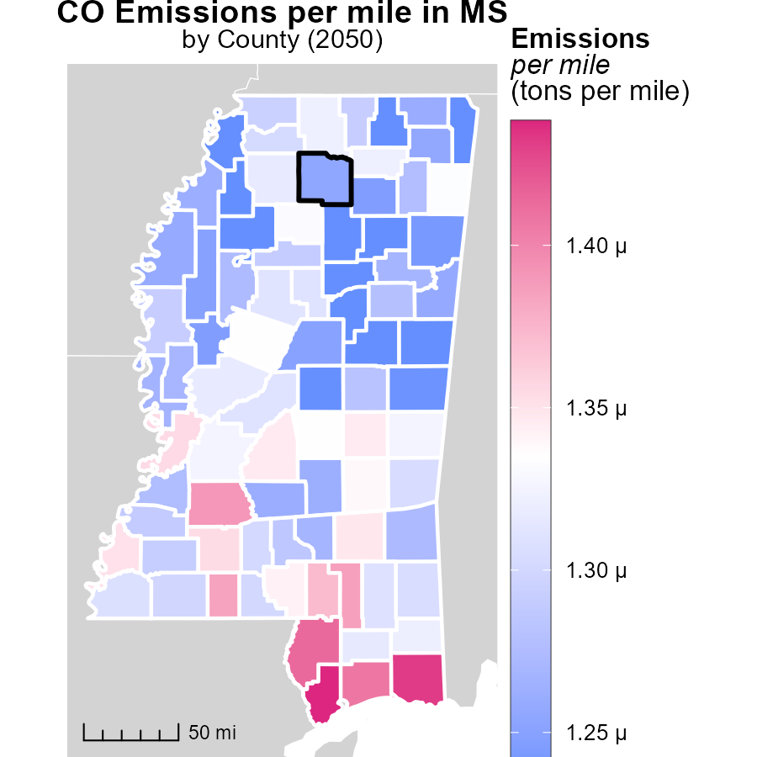

## Findings

* Hancock County, MS emits the highest at 1.4 tons per mile
* Washington County, MS has a median emission of 1.3 tons per mile
* Quitman County, MS emits the least at 1.2 tons per mile

## Recommendations

To reduce emissions, Hancock County, MS could implement vehicle emission testing programs, Washington County, MS could focus on promoting carpooling initiatives, and Quitman County, MS could incentivize the use of electric vehicles.

# Population Mapped by Area

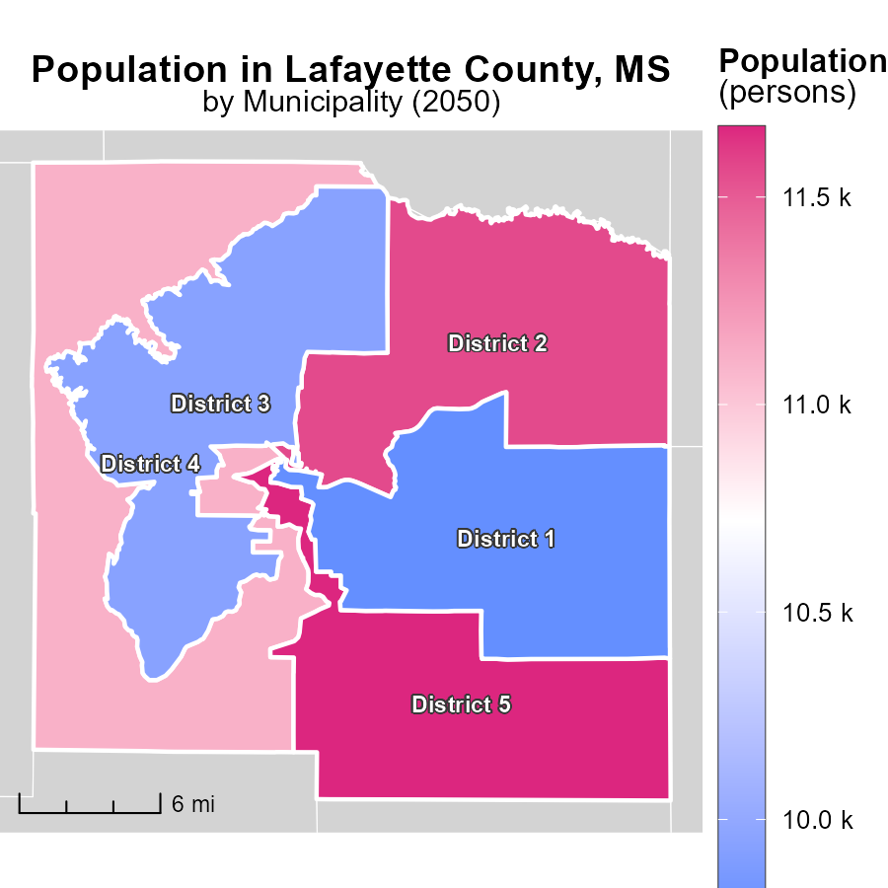

## Findings

* District 5 has the highest population with 11.7k persons.
* District 1 has the lowest population with 9.8k persons.
* District 4 has a median population with 11.1k persons.

## Recommendations

To reduce emissions, focus on high-density districts such as District 5 by promoting public transportation and implementing energy-efficient initiatives. Encourage sustainable practices in District 4 and 1 to maintain emission levels.

# Hotelling (Engines Off) by Road Type over Time

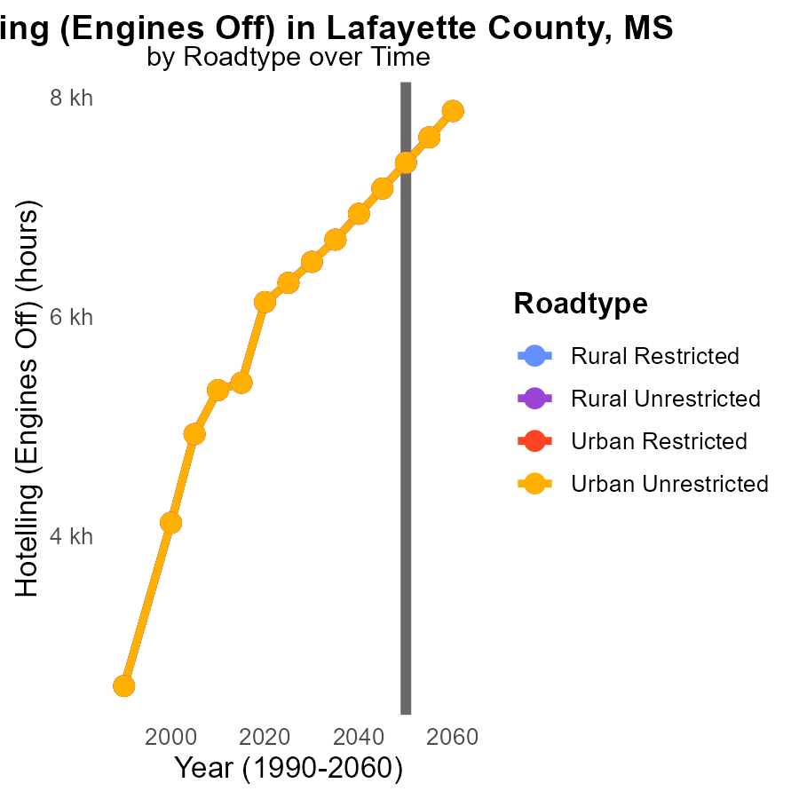

## Findings

* Emissions are projected to increase by 6.3% in rural restricted areas from 2040 to 2060.
* Emissions in urban unrestricted areas are forecasted to decrease by 6.4% between 2050 and 2060.
* Overall, emissions are expected to decrease by 6.4% in urban areas compared to a 6.3% increase in rural areas by 2060.

## Recommendations

To lower emissions, focus on urban areas where emissions are projected to decrease. Encourage the adoption of cleaner technologies and invest in sustainable transport infrastructure.

# Vehicle Miles Traveled by Vehicle Type over Time

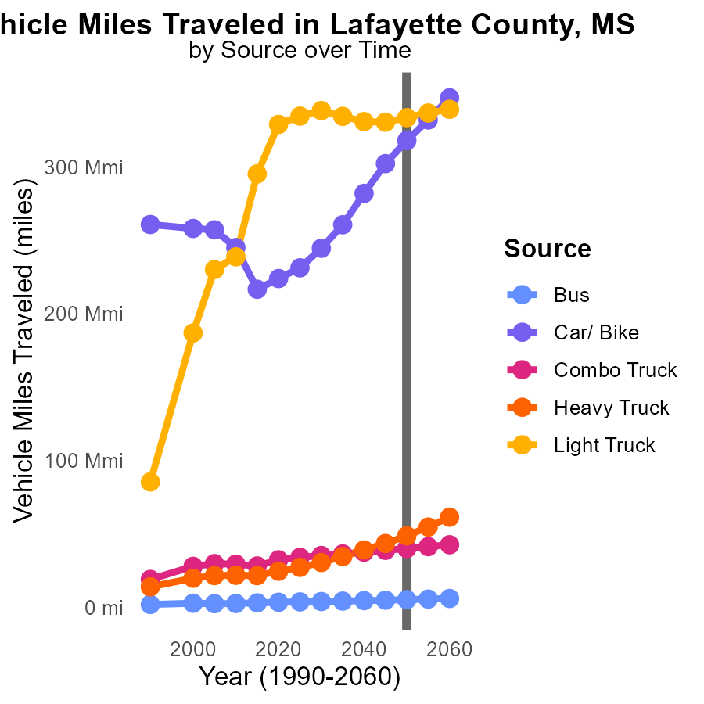

## Findings

* By 2060, bus miles traveled will increase by 1.5 million (29% rise) compared to 2050.
* Car and bike miles are projected to rise by 21.1% to 347.0 million by 2060.
* Heavy truck miles show the highest increase by 12682205.2 from 2050 to 2060 (a 26.1% increase).

## Recommendations

To lower emissions, public transport infrastructure should be improved to reduce the reliance on personal vehicles. Implementing measures to promote carpooling and biking can help decrease car usage. Investing in eco-friendly technologies for heavy trucks can significantly reduce emissions.

# Areas Ranked by Emissions Rate (per mile)

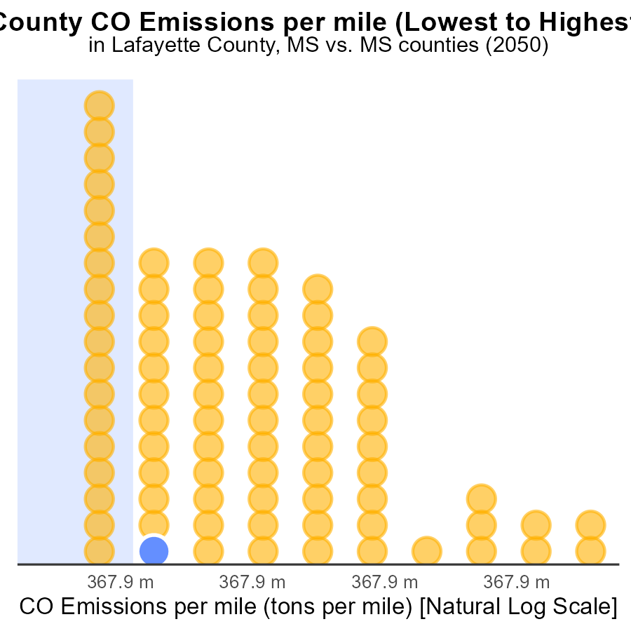

## Findings

* Counties Lafayette, Attala, and Prentiss have similar emissions per mile at 1.3 tons, ranking 18th, 19th, and 20th, respectively.
* Quitman has the lowest emissions per mile at 1.2 tons, ranking 1st with the lowest emissions percentage of 1.2%.
* Hancock has the highest emissions per mile at 1.4 tons, ranking 82nd with emissions at the 100th percentile.

## Recommendations

To lower emissions, focus on high-ranking counties Lafayette, Attala, Prentiss, and Hancock by promoting carpooling, investing in public transportation, and encouraging the use of electric vehicles to reduce emissions per mile.

# Areas Ranked by Hotelling (Engines Off)

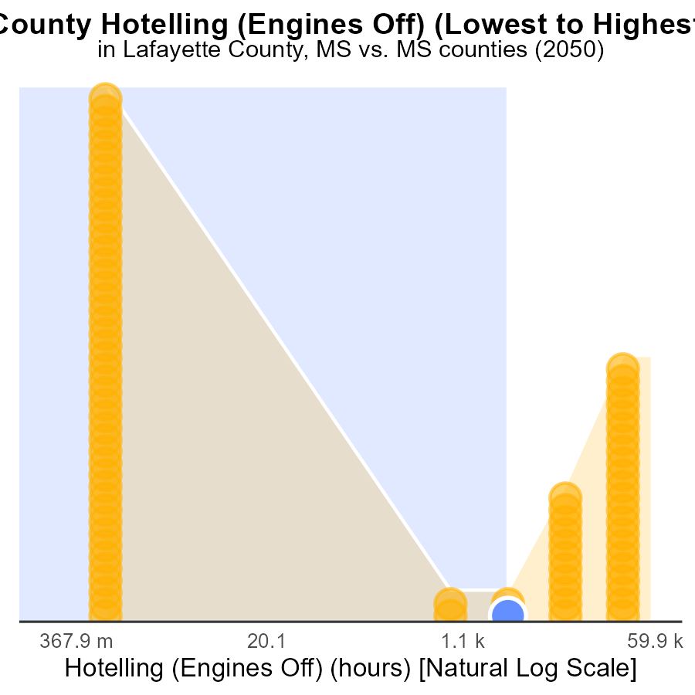

## Findings

* Hinds county had the highest CO emissions with 150.7 k hours.
* Adams county had the lowest CO emissions with 0.0 hours.
* Pontotoc county had the highest percentile of emissions at 59.8%.

## Recommendations

Policymakers should focus on implementing stricter regulations in Hinds county to reduce emissions significantly. In Adams county, initiatives to maintain zero emissions should be continued to set an example for others. Additionally, Pontotoc county should undertake targeted emission reduction strategies to bring down its high percentile.

# Conclusion

In conclusion, the data from Lafayette County, MS in 2050 highlights the significant contribution of urban and rural unrestricted emissions to the total CO emissions, underscoring the need for targeted policies in these areas.

The report suggests focusing on promoting cleaner transportation options and stricter emission standards for industries to reduce emissions effectively. By targeting cars, light trucks, and heavy trucks, which collectively account for the majority of CO emissions per capita, encouraging the adoption of electric vehicles, public transportation, and enforcing stringent regulations, emissions can be lowered.

Furthermore, projections indicate a steady increase in emissions over the next three decades, emphasizing the urgency of implementing renewable energy sources, public transportation infrastructure investments, and stringent emission regulations to combat rising emissions. By concentrating on areas with high emissions per mile and population densities, while also addressing the forecasted changes in emissions by region and transportation mode, policymakers can work towards a more sustainable and environmentally friendly future for Lafayette County, MS.

# About This Report

Data based on MOVES estimates collected by the Climate Action in Transportation program at Cornell University. Demographic data sourced from the US Census's American Community Survey 5-year estimates. This report was generated with the help of AI.

# References

* U.S. Census Bureau. (2023). American Community Survey 5-year estimates: Detailed tables. Retrieved from https://data.census.gov
* U.S. Environmental Protection Agency. (2024). Motor Vehicle Emission Simulator (MOVES 4.0) [Software]. Retrieved from https://www.epa.gov/moves